IRIS FLOWER CLASSIFICATION
Python • Git & GitHub • Automated Testing • CI/CD
Project Report
Jashan Shah
J054

1. Introduction
This project demonstrates a small machine-learning workflow for classifying Iris flower species with a Decision Tree classifier. It combines Python project setup, dependency management with uv, model execution, pytest-based automated tests, Git version control, GitHub repository management, and a GitHub Actions continuous-integration workflow.

2. Tools and Technologies
Python, scikit-learn, pytest, uv, Git, GitHub, GitHub Actions, and GitHub Desktop.

3. Project Setup and Dependencies
The project directory and source/test folders are created first. The project is initialized with uv, and scikit-learn and pytest are added as dependencies. The virtual environment and lock file support repeatable setup.
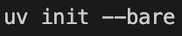
Figure 1. Initializing the project with uv.
Figure 2. Creating the README and .gitignore files.
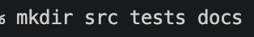
Figure 3. Creating the source, tests, and documentation directories.
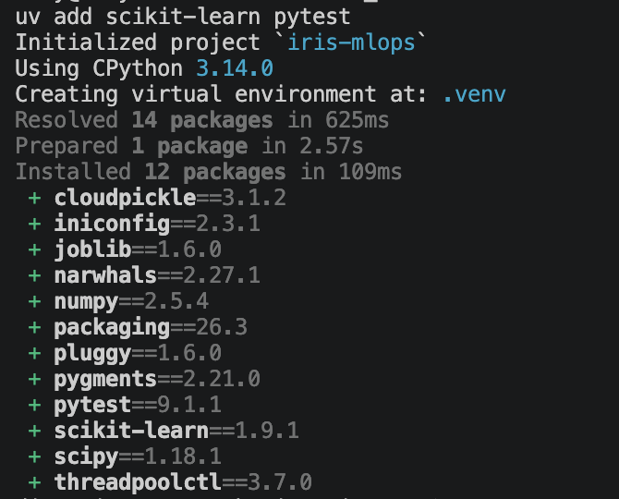
Figure 4. Installing scikit-learn and pytest and resolving dependencies.

4. Model Implementation and Execution
The model loads the built-in Iris dataset, splits it into training and test sets, trains a Decision Tree classifier, and evaluates predictions using accuracy. The captured run reports an accuracy of 0.93 on 30 test samples.
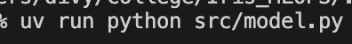
Figure 5. Running the model script.
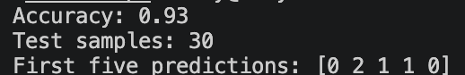
Figure 6. Model output: accuracy 0.93, 30 test samples, and sample predictions.

5. Automated Testing
The pytest suite contains four tests covering successful training, test-data dimensions, valid class labels, and model accuracy/predictions. The screenshots show all four tests passing.
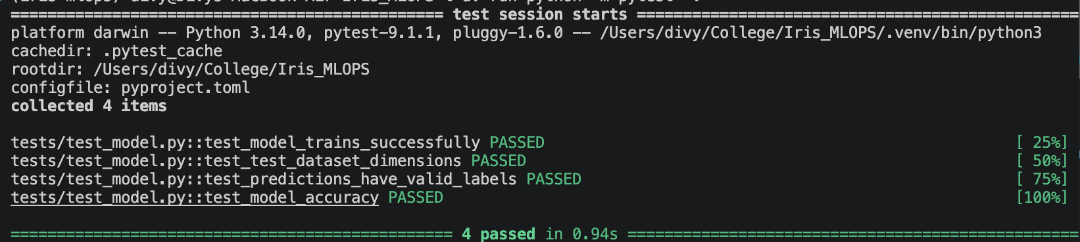
Figure 7. All four automated tests pass.
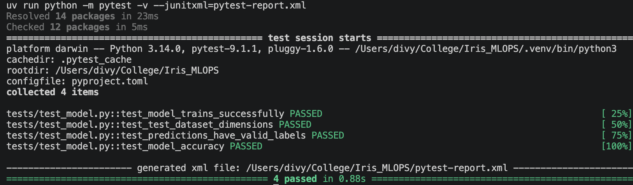
Figure 8. Pytest output and the generated JUnit XML test report.

6. Git Version Control and Initial Commit
Git is initialized on the main branch. The project files are reviewed and staged, then committed as the initial project snapshot. The screenshots include the repository status and commit summary.
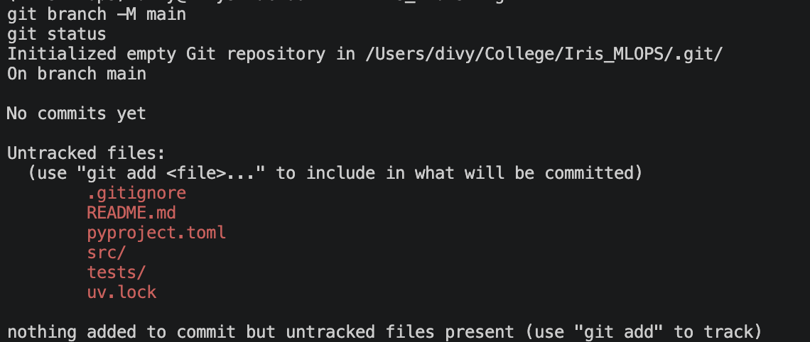
Figure 9. Initial repository status before files are committed.
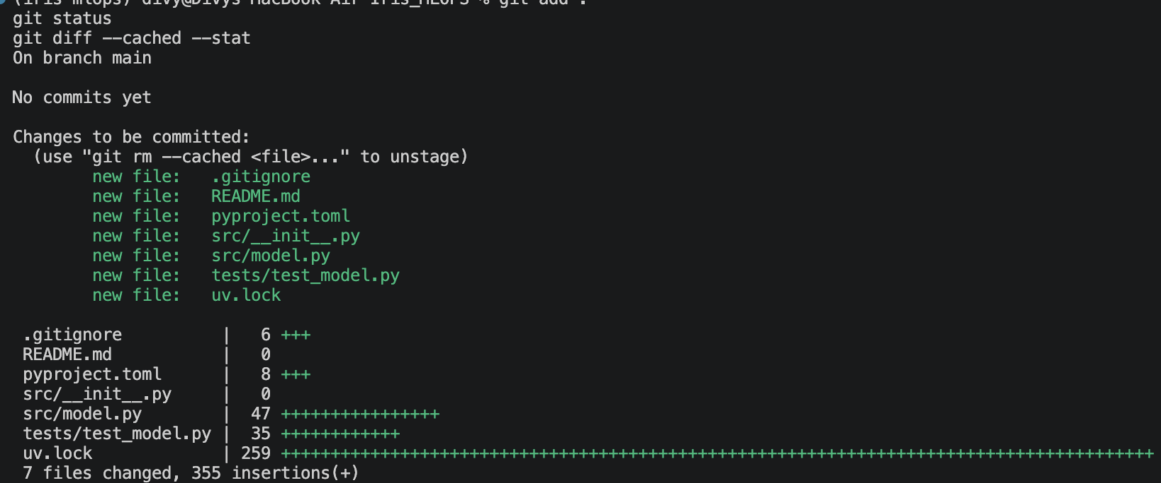
Figure 10. Reviewing the staged files and change summary.
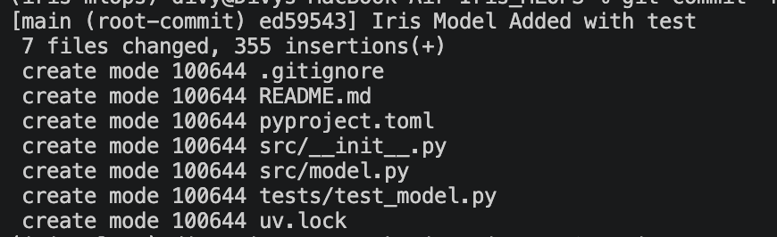
Figure 11. Initial commit containing the model, tests, configuration, lock file, and README.

7. Continuous Integration with GitHub Actions
A GitHub Actions workflow is added to run the test suite on pushes and pull requests targeting main. The workflow checks out the repository, installs uv and Python, synchronizes locked dependencies, runs pytest, and uploads the JUnit XML report as an artifact.
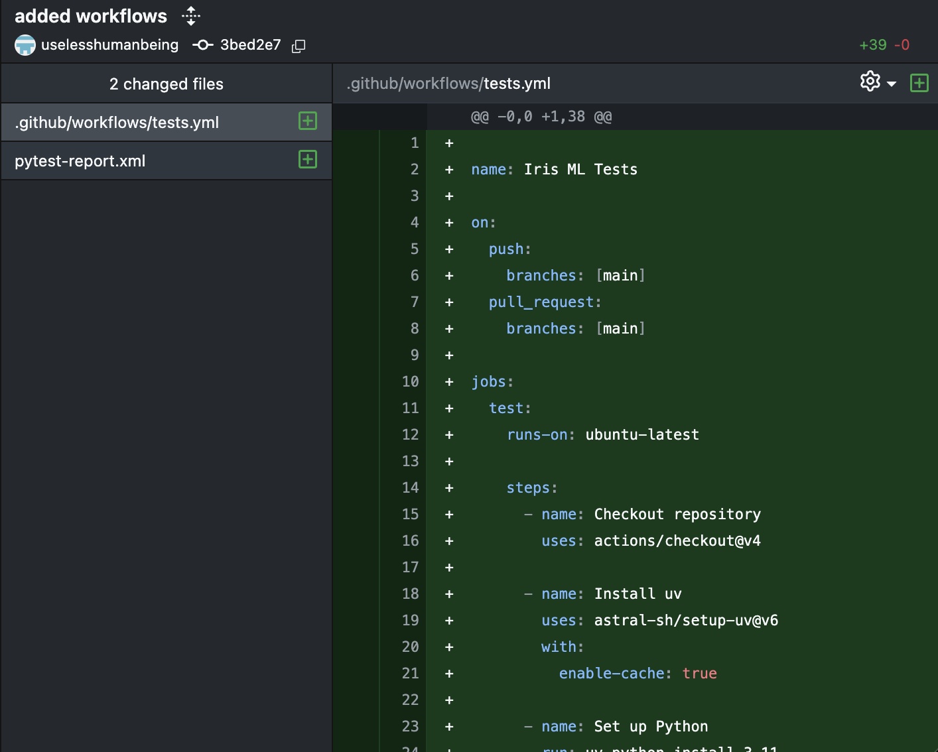
Figure 12. Adding the GitHub Actions workflow and test-report artifact configuration.
A temporary change that removed the model code caused the workflow to fail. Restoring the model implementation allowed the workflow to pass again. This demonstrates that the CI workflow detects a broken project and validates the corrected version.
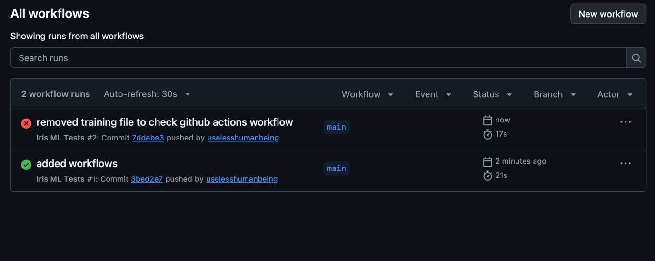
Figure 13. Workflow history showing the failed run after a temporary breaking change and a later successful run.
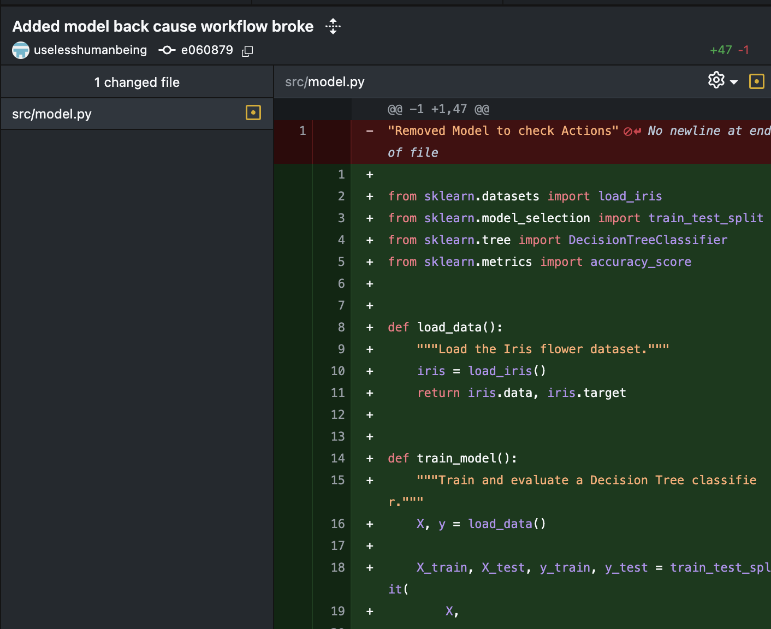
Figure 14. Restoring the model implementation in the repository.
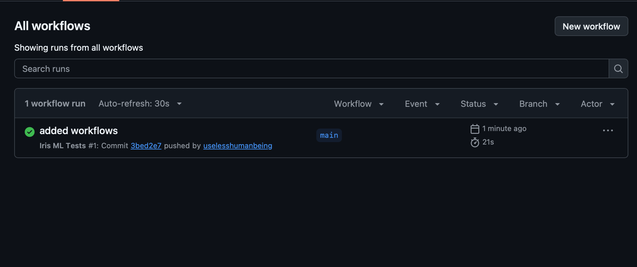
Figure 15. GitHub Actions showing a successful workflow run.

8. Documentation and Repository History
The README documents the project overview, technologies, directory structure, setup, execution, testing, and CI workflow. GitHub Desktop is used to review the repository history and tracked files.
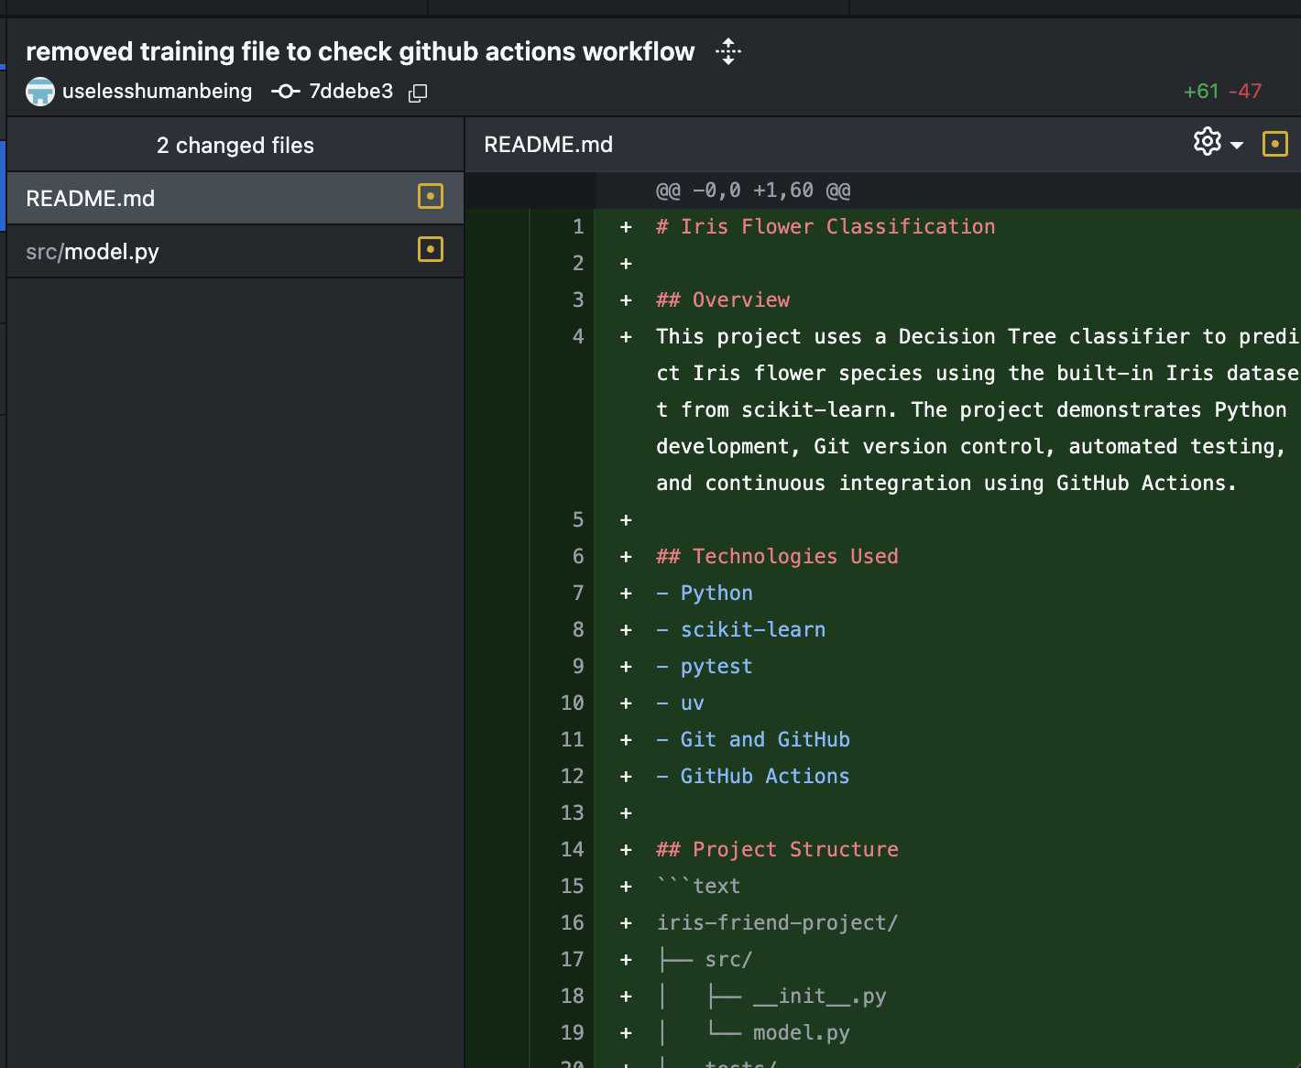
Figure 16. README documentation update and successful workflow status.
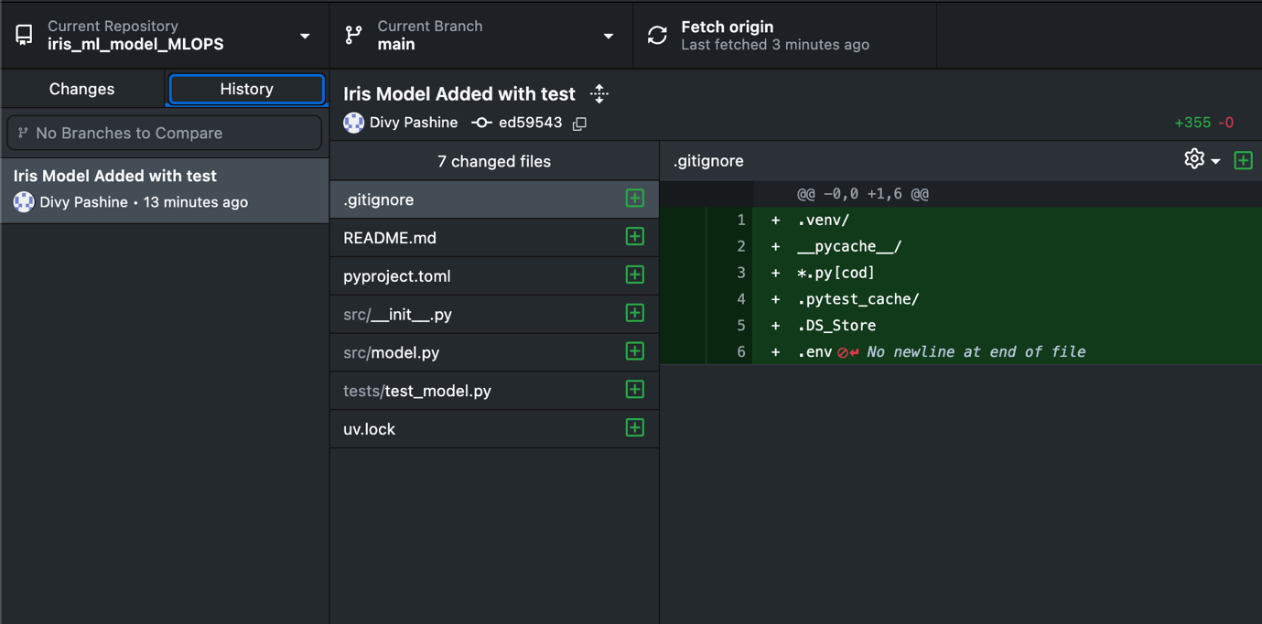
Figure 17. GitHub Desktop repository history and project files.

9. Results
The captured model run achieved 0.93 accuracy on the 30-sample test set. All four pytest tests passed in the recorded run, and the final GitHub Actions screenshot shows a successful CI run. The workflow also produces a JUnit XML report artifact when the workflow reaches the test/report steps.

10. Conclusion
The project demonstrates the end-to-end workflow for organizing a Python ML project, managing dependencies, validating behavior with automated tests, tracking changes with Git, documenting the project, and running tests automatically through GitHub Actions.
Note: The terminal screenshots visibly contain the local path/name “Iris_MLOPS” and some GitHub screenshots show a different account/repository naming context. The report orders and explains the supplied evidence without altering the screenshots. If this report is intended to document Jashan Shah’s separate repository specifically, replace any screenshots that belong to the earlier/original repository with matching screenshots from Jashan’s own repository.

