soniccontrol Help Page

Welcome to the simple and short manual for sonic**control**, a lightweight Graphic User Interface for controlling the sonic**catch** or sonic**wipe**.

# Installation

The software is currently being provided via a pre-compiled executable in a zipped folder with further resources for the application. The current way of installing is to simply extract the zip file and put it somewhere in your filesystem (preferably into your home folder). After that, you can right-click the *SonicControl.exe* file and make a shortcut to your desktop.

# Usage

Before starting the application, make sure that the device you want to control is switched to Serial Mode. After you launched sonic**control**, you will be greeted with the connection tab. Here you can choose the device you want to connect to. The device will be shown as a *COM* with a succeeding number after that.

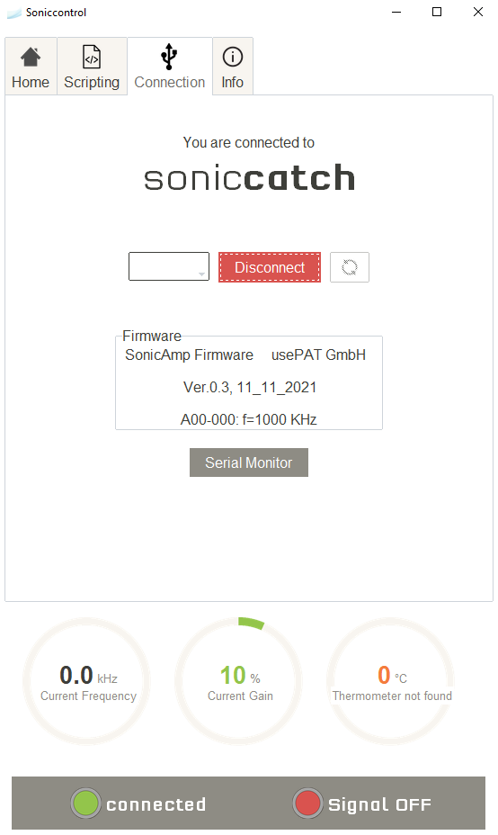After you chose the corresponding device and clicked the *Connect* button, the application will change its appearance, indicating that the connection was successful. At this point you will be able to use all other tabs.

## Connection Tab

Here you can see the concrete device you are connected to. Other than that, there is a *Serial Monitor* Button that opens a command line interface. This feature is used for internal applications and development, so it is better to just ignore the button.

## Scripting Tab

The scripting tab is one of the most useful features in the sonic**control**. It enables you to use to control the state of your sonic**catch** or sonic**wipe** with very simple commands and loop this behavior. For the most part, Usepat will provide you with a script, that is customized to your use-case. If you still are interested in writing your own scripts, here is a simple guide for that:

Screenshot 1: Connection Tab

### Commands:

|  |  |  |  |
| --- | --- | --- | --- |
| **Command** | **Description** | **Argument Description** | **Example** |
| on | Turns the ultrasound signal output on | None | on |
| off | Turns the ultrasound signal output off | None | off |
| frequency | Changes the frequency of the ultrasound output | Integer value between 50000 and 6000000 Hz | frequency 1200000 |
| gain | In the case of a soniccatch, changes the current gain to a Value passed as an argument | Integer between 0 and 150% | gain 75 |
| hold | Holds the current state of the device for several second(s) or milliseconds | Integer between 1 and 10000 and an <s> for seconds or <ms> for milliseconds | hold 5s |
| ramp | Creates a frequency ramp, for the ultrasound signal | See ramp description | ramp 1000000 1200000 1000 100ms |
| startloop | Tells the program, that a loop block starts | Integer between 1 and 10000 times or ***inf*** for endless loops | startloop 3 |
| endloop | Tells the program, that a loop block has ended | None | endloop |

Ein Bild, das Text enthält.
Due to the fact, that the ramp and startloop commands are more complicated than others, follows a further detailed description about them.

Ramp:

The ramp command directs the application to set the frequency of the ultrasound signal output from a start frequency and ramp it up to an end frequency with a corresponding resolution and time delay. So, in case of a command:

ramp 1000000 1200000 1000 100ms, sonic**control** sets the ultrasound frequency to 1MHz and increases it with 1kHz every 100ms until 1.2MHz was set up. Please be aware of the strict format the command should be used with. The argument should have 4 numbers delimited with a white space. Additionally, you have the possibility to tell the time unit in which the value is written.

Startloop:

The startloop command tells the program, that the following commands between the startloop and endloop commands should be treated as a loop-block. The commands that are in that block would be executed several times, provided by the argument passed to the command. Here follows an example:

Figure 2: Scripting Tab

startloop 3

frequency 2400200

gain 120

hold 5s

endloop

The preceding example would be executed three times. Here is another example with nested and endless loops:

startloop inf

ramp 50000 2000000 1000 100ms

startloop 5

on

frequency 1900000

hold 1000ms

endloop

endloop

The first startloop has the argument inf, that lets the loop run endlessly until the user manually stops the script. The nested loop startloop 5, lets the block run 5 times every cycle of the initial loop startloop inf.

### Data

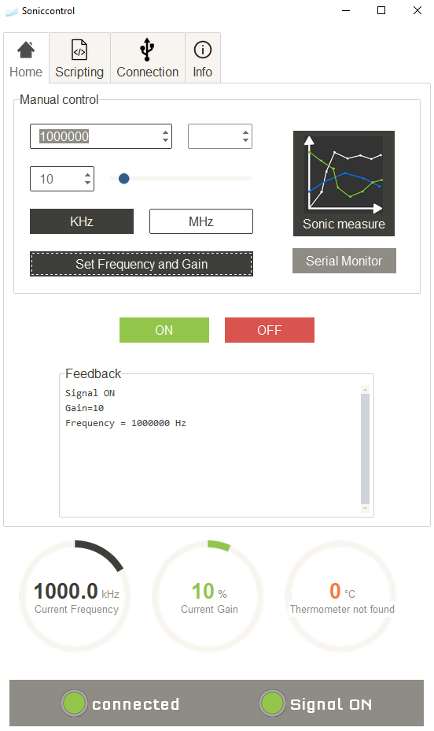Every time the user runs a script, soniccontrol generates a log file specifically for the scripting window. This file is located under the *<SonicControl>\ScriptingSequence* Folder The name of the log file starts with data about the current time and ends with *sequence.log*. Additionally, sonic**control** writes a status log-file, that tells you the exact value of the frequency and gain at any point of usage

## Home tab

This tab is probably the most important for you. Here you can easily set up every available parameter for your device. The tooltips and buttons are self-explanatory except for sonic**measure**.

Screenshot 3: Home Tab for soniccatch

#### sonic**measure**

This feature enables the user to ramp up from a start to end frequency in a certain resolution (in the same nature as the ramp command from the scripting tab) with the addition to collect voltage, amperage and phase data. This data is then plotted respectively.

Ein Bild, das Tisch enthält.
The data is automatically stored in the *\SonicControl\Spectra* folder in a *csv* format.

Screenshot 4: Home Tab for sonicwipe

Screenshot 5: SonicMeasure

## Info Tab

The info tab currently does not provide any necessary functions other than a help button, that opens this file. Do not hesitate to open the help page, if you are lost in the process of using a sonic**wipe** or sonic**catch**.