STUDENT ACADEMIC PERFORMANCE
PREDICTION
EduPredict: Machine Learning Based Prediction System

Project Report Submitted in fulfillment of the
Requirements for the Award of the Internship of
Summer Training Program by IDRA
Data Science and AI

By:
Name: Ankur Nandi
Institute: Brainware University
Institute Roll No.: 23010333110
Enrollment No.: IDRA-2026-839893
Under the Supervision of
Dr. Shaheena Salam
Through the platform:

India Data Research Academy

DECLARATION
I hereby declare that the project report entitled “Student Academic Performance Prediction – EduPredict” is my original work completed as part of the IDRA Summer Training Program. The analysis, preprocessing, modelling, visualization, and application development presented in this report were carried out for academic purposes. All external sources and tools used in the project have been appropriately acknowledged.

ACKNOWLEDGEMENT
I sincerely thank India Data Research Academy (IDRA) for providing the training platform and capstone project opportunity. I am grateful to my supervisor, Dr. Shaheena Salam, for guidance and support. I also acknowledge Brainware University and the creators/providers of the dataset and open-source Python libraries used in this project.

ABSTRACT
EduPredict is an interactive machine learning system developed to predict student examination performance from academic, attendance, behavioural, and contextual attributes. The supplied dataset contains 6,607 student records and 20 variables, with Exam_Score as the target. The project follows a complete predictive analytics workflow covering data understanding, cleaning, preprocessing, exploratory data analysis, visualization, statistical analysis, model development, evaluation, and individual score prediction. Numerical missing values are handled through median imputation, categorical missing values through most-frequent imputation, and categorical variables through one-hot encoding. An 80:20 train-test split is used, followed by a Random Forest Regressor with 150 trees. On the held-out test set, the model achieved MAE=1.080, RMSE=2.148, and R²=0.674. The resulting Streamlit application allows users to explore the dataset, inspect performance patterns, and estimate an individual student's examination score. Overall, the project demonstrates the practical use of educational data for predictive analytics while emphasizing responsible interpretation of model outputs.
Keywords: Student Academic Performance; Machine Learning; Random Forest Regression; Streamlit; Exploratory Data Analysis; Exam Score Prediction; Predictive Analytics

TABLE OF CONTENTS
1. INTRODUCTION
2. PROBLEM STATEMENT AND MOTIVATION
3. OBJECTIVES
4. RESEARCH QUESTIONS
5. DATASET DESCRIPTION AND DATA UNDERSTANDING
6. DATA CLEANING
7. DATA PREPROCESSING
8. EXPLORATORY DATA ANALYSIS
9. STATISTICAL ANALYSIS
10. FEATURE ENGINEERING
11. MODEL DEVELOPMENT
12. MODEL EVALUATION
13. RESULTS AND FINDINGS
14. DISCUSSION
15. LIMITATIONS
16. CONCLUSION
17. RECOMMENDATIONS AND FUTURE WORK
18. REFERENCES
APPENDIX A. CODE
APPENDIX B. ADDITIONAL FIGURES AND TABLES
Note: Update the Table of Contents field in Microsoft Word after opening the report.

1. INTRODUCTION

1.1 Background
Student academic performance is influenced by study habits, attendance, previous achievement, learning environment, parental involvement, access to resources, motivation, and other contextual factors. Data-driven analysis can reveal patterns in these variables and provide an additional quantitative perspective on examination performance.

1.2 Context of the Problem
EduPredict addresses the practical situation where student records are available in tabular form but are difficult to interpret manually at scale. The system converts these records into visual summaries and a predictive score through an interactive Streamlit dashboard.

1.3 Scope of the Study
The study covers data quality assessment, EDA, statistical analysis, preprocessing, Random Forest regression, evaluation, and individual score prediction. It does not claim causal effects or replace institutional academic decisions.
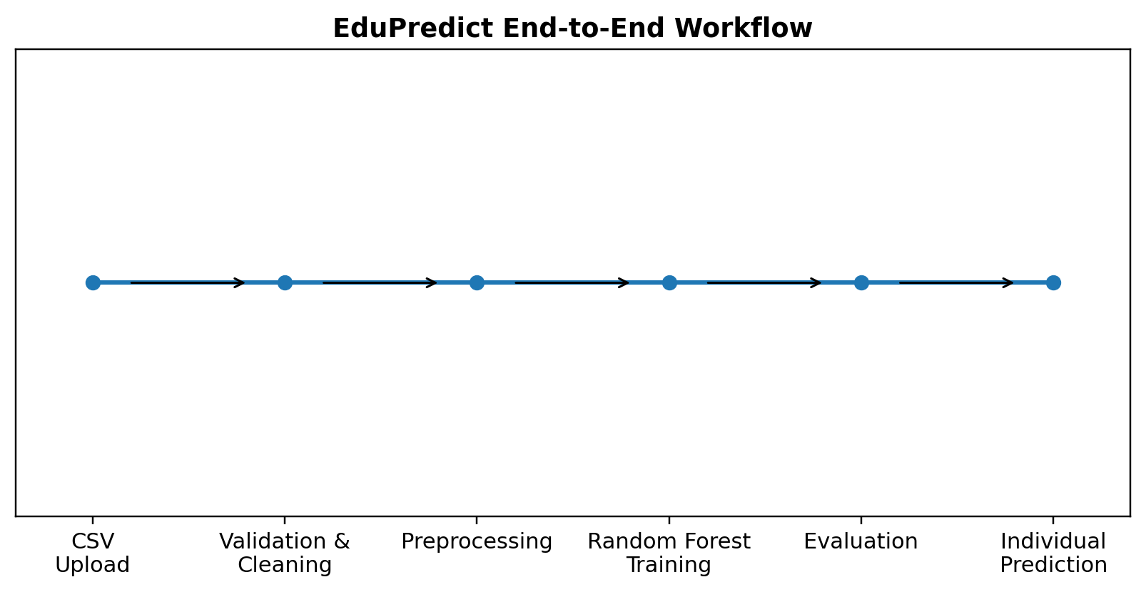
Figure 1. EduPredict End-to-End Workflow

2. PROBLEM STATEMENT AND MOTIVATION
The central problem is to determine whether student-related variables can be used to estimate examination performance accurately enough to provide useful analytical support. The motivation is to transform a student dataset into an accessible predictive application that combines visualization, statistical analysis, and machine learning.

3. OBJECTIVES
- Understand and prepare the student-performance dataset for analysis.
- Identify important distributions, relationships, and group differences.
- Build a machine-learning regression model for Exam_Score.
- Evaluate predictive performance using MAE, RMSE, and R².
- Develop an interactive application for analysis and individual score prediction.

4. RESEARCH QUESTIONS
- What are the major characteristics and quality issues in the dataset?
- Which variables show meaningful relationships with Exam_Score?
- How does examination score vary across important student groups?
- How accurately can Random Forest Regression predict Exam_Score?
- How can the analysis be delivered through an interactive dashboard?

5. DATASET DESCRIPTION AND DATA UNDERSTANDING

5.1 Data Source
The dataset was supplied with the Student Academic Performance Prediction project files and is stored as a structured CSV dataset for educational performance analysis.

5.2 Dataset Size and Structure
Characteristic | Result
Records | 6,607
Columns | 20
Target | Exam_Score
Numerical variables | 7
Categorical variables | 13
Missing cells | 235
Duplicate records | 0
Table 1. Summary of the Dataset
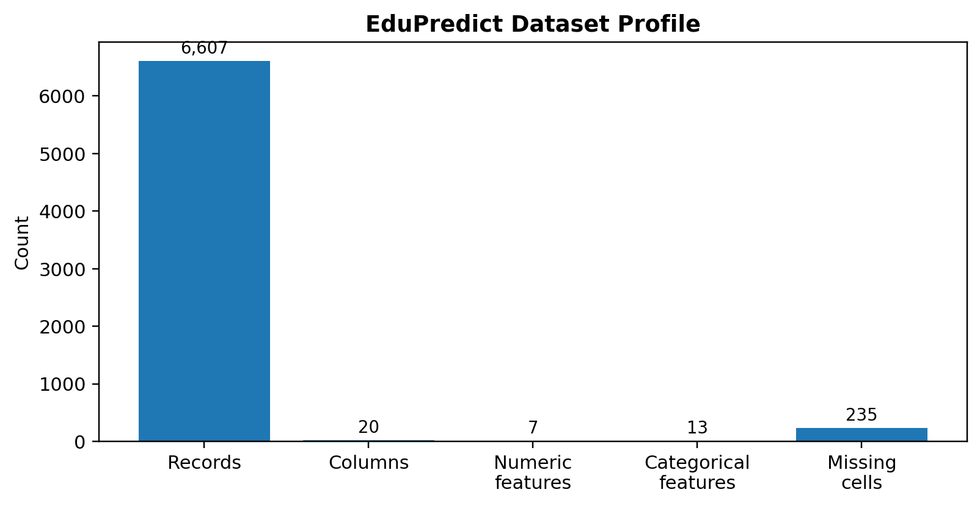
Figure 2. Dataset Profile

5.3 Data Dictionary
Variable | Meaning | Type | Role
Hours_Studied | Study hours | Integer | Feature
Attendance | Attendance percentage | Integer | Feature
Parental_Involvement | Parental involvement level | Categorical | Feature
Access_to_Resources | Learning resource access | Categorical | Feature
Extracurricular_Activities | Extracurricular participation | Categorical | Feature
Sleep_Hours | Sleep duration | Integer | Feature
Previous_Scores | Previous academic score | Integer | Feature
Motivation_Level | Motivation category | Categorical | Feature
Internet_Access | Internet access | Categorical | Feature
Tutoring_Sessions | Tutoring count | Integer | Feature
Family_Income | Family income category | Categorical | Feature
Teacher_Quality | Teacher quality | Categorical | Feature
School_Type | School category | Categorical | Feature
Peer_Influence | Peer influence category | Categorical | Feature
Physical_Activity | Physical activity measure | Integer | Feature
Learning_Disabilities | Learning disability indicator | Categorical | Feature
Parental_Education_Level | Parent education category | Categorical | Feature
Distance_from_Home | Distance category | Categorical | Feature
Gender | Gender category | Categorical | Feature
Exam_Score | Final examination score | Integer | Target
Table 2. Data Dictionary

6. DATA CLEANING

6.1 Missing Values
The raw dataset contains 235 missing cells. The application avoids unnecessary row deletion by handling missing predictor values inside the modelling pipeline. Numerical variables use median imputation and categorical variables use most-frequent imputation.

6.2 Duplicate Records
No duplicate records were found in the supplied dataset (duplicate count = 0).

6.3 Data Types and Inconsistent Values
Numerical fields are treated as numeric variables, while text-based fields are treated as categorical variables. Exam_Score is explicitly converted to numeric in the application workflow.

6.4 Outlier Handling
Potential unusual observations are inspected using descriptive statistics and visualizations. Valid observations are not arbitrarily removed. Random Forest does not require normally distributed predictors or standardized numerical scales.

6.5 Before vs After Cleaning
Measure | Before | After
Records | 6607 | 6607
Columns | 20 | 20
Duplicates | 0 | 0
Missing predictor cells | 235 | Handled by imputation
Table 3. Data Quality Before and After Cleaning

7. DATA PREPROCESSING

7.1 Categorical Encoding
Categorical features use most-frequent imputation followed by One-Hot Encoding. Unknown categories are ignored during prediction.

7.2 Feature Scaling and Transformation
Numerical variables use median imputation and remain on their original scale because Random Forest does not require feature scaling.

7.3 Train-Test Split
An 80:20 train-test split with random_state=42 is used. The held-out test set remains separate until final evaluation.

7.4 Final Feature Set
The model uses the student-related predictor variables after excluding Exam_Score as the target and excluding an identifier column when present.

8. EXPLORATORY DATA ANALYSIS

8.1 Univariate Analysis
Exam_Score has a mean of 67.24, median of 67.00, and standard deviation of 3.89. Its observed minimum and maximum are 55 and 101.
Statistic | Value
Mean | 67.24
Median | 67.0
Standard Deviation | 3.89
Minimum | 55.0
Maximum | 101.0
Table 4. Exam_Score Summary Statistics

8.2 Categorical Analysis
The dashboard supports group-level analysis by categorical features such as parental involvement, access to resources, motivation level, teacher quality, school type, and other student attributes. These comparisons are descriptive and should not be interpreted as causal.

8.3 Bivariate / Relationship Analysis
Attendance, study time, previous scores, tutoring, sleep, and physical activity are among the numerical factors that can be examined against Exam_Score. The application provides scatter-based relationship analysis where the relevant numerical field is available.

8.4 Correlation Analysis
Correlation analysis is used to identify linear relationships among numerical variables and Exam_Score. Correlation is treated as an exploratory measure rather than proof of causation.

8.5 Output Visuals
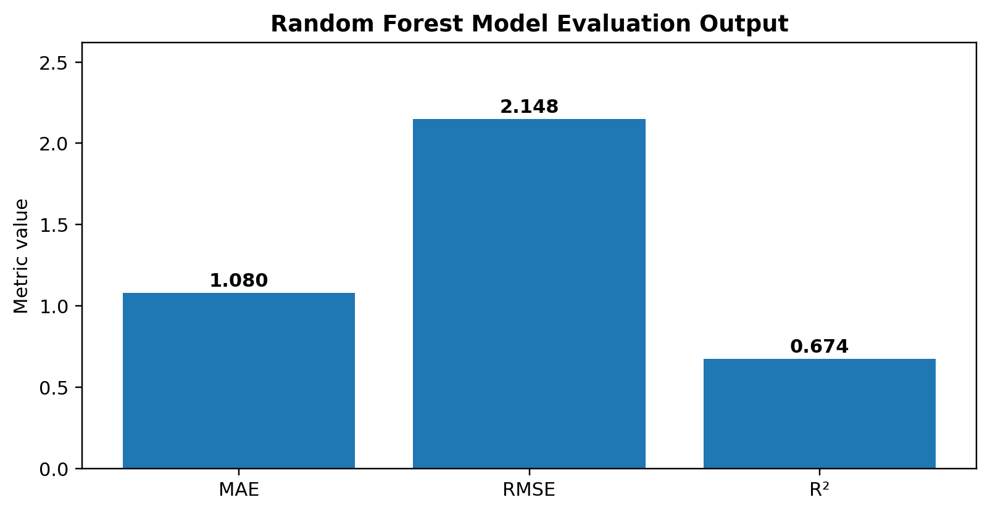
Figure 3. Model Evaluation Output
The model evaluation output is included as a visual project result to make the report easier to interpret and more presentation-ready.

9. STATISTICAL ANALYSIS
The key descriptive statistics for Exam_Score are summarized above. The mean and median are close, while the standard deviation of 3.89 indicates moderate dispersion around the average score. The maximum of 101 suggests that the dataset contains at least one score above the conventional 100-point boundary, which should be reviewed as a data-quality or dataset-definition issue rather than silently removed.

10. FEATURE ENGINEERING
No manually engineered composite variables are required in the baseline EduPredict model. Instead, the original student attributes are supplied to the Random Forest pipeline, while One-Hot Encoding converts categorical information into model-ready indicators.
Feature group | Processing | Role
Categorical attributes | One-Hot Encoding | Model input
Numerical attributes | Median imputation | Model input
Exam_Score | Target | Prediction output
Table 5. Feature Preparation

11. MODEL DEVELOPMENT

11.1 Problem Formulation
This is a regression problem because Exam_Score is a numeric outcome. The inputs contain academic, attendance, behavioural, and contextual attributes.

11.2 Model Selection
Random Forest Regression was selected because it can learn nonlinear relationships, handles tabular data effectively, does not require feature scaling, and provides feature-importance information.

11.3 Training the Model
The configured model uses 150 trees, maximum depth 15, minimum samples split 5, random_state=42, and n_jobs=-1. Preprocessing and modelling are integrated in a single Pipeline.
X_train, X_test, y_train, y_test = train_test_split(X, y, test_size=0.20, random_state=42)
model.fit(X_train, y_train)

12. MODEL EVALUATION

12.1 Regression Evaluation
Metric | Result | Interpretation
MAE | 1.080 | Lower is better
RMSE | 2.148 | Lower is better
R² | 0.674 | Higher is better
Test records | 1322 | Held-out observations
Table 6. Regression Model Performance
Figure 4. Regression Model Performance Output
The Random Forest model achieved an MAE of 1.080, RMSE of 2.148, and R² of 0.674 on the held-out test set. The results indicate that the model provides useful predictive signal for the target while still leaving unexplained variation.

12.2 Overfitting and Underfitting
The configured depth and minimum-split constraints help control tree complexity. The test-set metrics are used as the primary evidence of generalization, and future work should add cross-validation and hyperparameter tuning.

13. RESULTS AND FINDINGS
- The dataset contains 6,607 records and 20 variables, with 7 numerical and 13 categorical variables.
- Exam_Score has mean=67.24, median=67.00, and standard deviation=3.89.
- The dataset contains 235 missing cells and no duplicate rows.
- The Random Forest model achieved MAE=1.080, RMSE=2.148, and R²=0.674.
- The Streamlit interface converts the trained pipeline into an interactive individual score-prediction tool.

14. DISCUSSION
EduPredict demonstrates a complete predictive analytics workflow rather than only a standalone machine-learning model. Data quality assessment, preprocessing, EDA, statistical analysis, prediction, and evaluation are integrated into one application. The mixed-feature pipeline allows numerical and categorical information to be used together.
The evaluation metrics should be interpreted together. MAE and RMSE describe prediction error magnitude, while R² describes explained variation. Descriptive relationships in the data are associations and should not be interpreted as causal effects.

15. LIMITATIONS
- The dataset may not represent every institution or student population.
- Important factors may be absent from the available variables.
- The model is predictive rather than causal.
- Performance may change when the data distribution changes.
- The application predicts a single examination score rather than long-term performance.
- Predictions should not be the sole basis for high-stakes academic decisions.

16. CONCLUSION
EduPredict successfully integrates data cleaning, preprocessing, EDA, visualization, statistical analysis, Random Forest regression, model evaluation, and an interactive Streamlit interface. The project demonstrates how educational records can be transformed into an accessible predictive analytics system and provides a strong foundation for future improvements in validation, explainability, and deployment.

17. RECOMMENDATIONS AND FUTURE WORK

17.1 Recommendations
- Collect larger datasets across multiple semesters or institutions.
- Use cross-validation and systematic hyperparameter tuning.
- Add model explanations such as feature importance or SHAP where appropriate.
- Use predictions as supportive information alongside academic judgement.

17.2 Future Work
- Compare Random Forest with Gradient Boosting, Extra Trees, and regularized regression.
- Add automated model comparison and cross-validation.
- Develop longitudinal academic-performance prediction.
- Monitor fairness, drift, reliability, and model versions after deployment.

18. REFERENCES
- Pedregosa, F., et al. (2011). Scikit-learn: Machine Learning in Python. Journal of Machine Learning Research, 12, 2825–2830.
- McKinney, W. (2010). Data Structures for Statistical Computing in Python. Proceedings of the 9th Python in Science Conference.
- Hunter, J. D. (2007). Matplotlib: A 2D Graphics Environment. Computing in Science & Engineering, 9(3), 90–95.
- Streamlit Documentation. Streamlit application framework documentation.
- EduPredict project dataset and application source files supplied for the IDRA capstone project.

APPENDIX A. CODE
The following excerpts summarize the main reproducible stages. The complete application source remains in the supplied project file.

A.1 Data Loading and Inspection
df = pd.read_csv(uploaded_file)
df.head()
df.info()

A.2 Data Cleaning
df['Exam_Score'] = pd.to_numeric(df['Exam_Score'], errors='coerce')
df = df.dropna(subset=['Exam_Score'])

A.3 Preprocessing
SimpleImputer(strategy='median')
SimpleImputer(strategy='most_frequent')
OneHotEncoder(handle_unknown='ignore')

A.4 EDA and Visualization
plt.hist(df['Exam_Score'], bins=20)
plt.scatter(df['Attendance'], df['Exam_Score'])

A.5 Model Training and Evaluation
model.fit(X_train, y_train)
pred = model.predict(X_test)
MAE = mean_absolute_error(y_test, pred)
RMSE = mean_squared_error(y_test, pred, squared=False)
R2 = r2_score(y_test, pred)

APPENDIX B. ADDITIONAL FIGURES AND TABLES
Figure 5. EduPredict Workflow
Parameter | Value
Algorithm | Random Forest Regressor
Trees | 150
Maximum depth | 15
Minimum samples split | 5
Train/Test split | 80% / 20%
Random state | 42
Table 7. Final Model Configuration
Figure 6. Dataset Profile

APPENDIX C. APPLICATION OUTPUT UI
EduPredict – Streamlit Dashboard Output
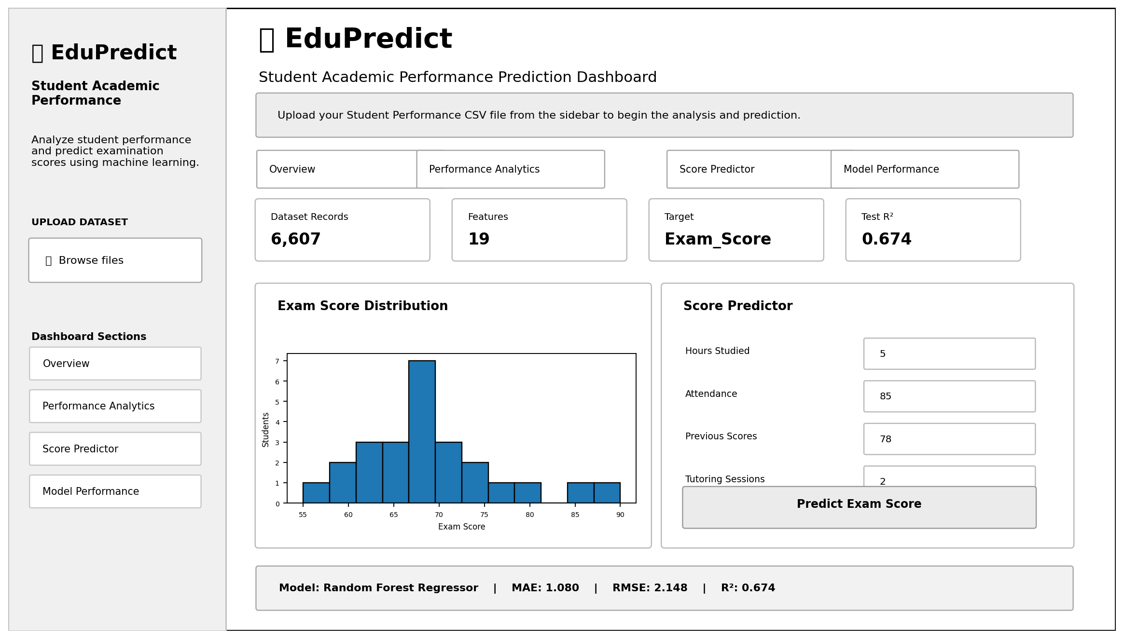
Figure 7. EduPredict Application UI / Output Screen

