Excel upload configurations steps

Getting the error

ModuleError: failed to load 'cc/spreadsheetimporter/v1_0_0/Component.js' from sesmassuploadapp.sesappwithexcel/webapp/thirdparty/customcontrol/spreadsheetimporter/v1_0_0/Component.js: 404

Scenario:
I am using BAS with UI5 version 1.120.1 in Fiori elements Object page but getting the below error

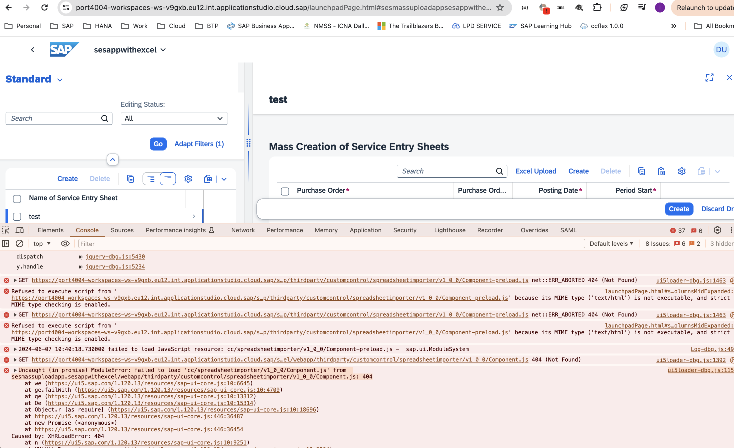

Network Tab
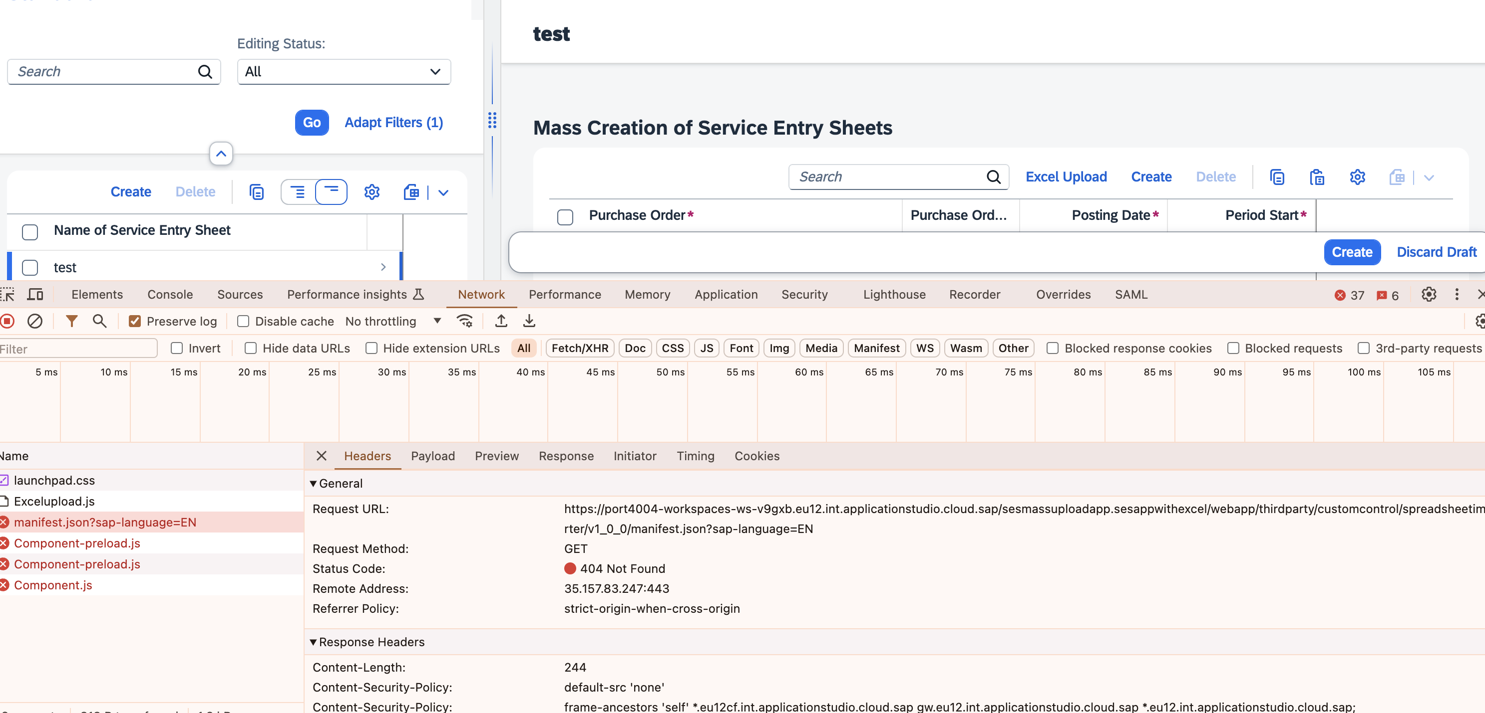

Manifest.json file
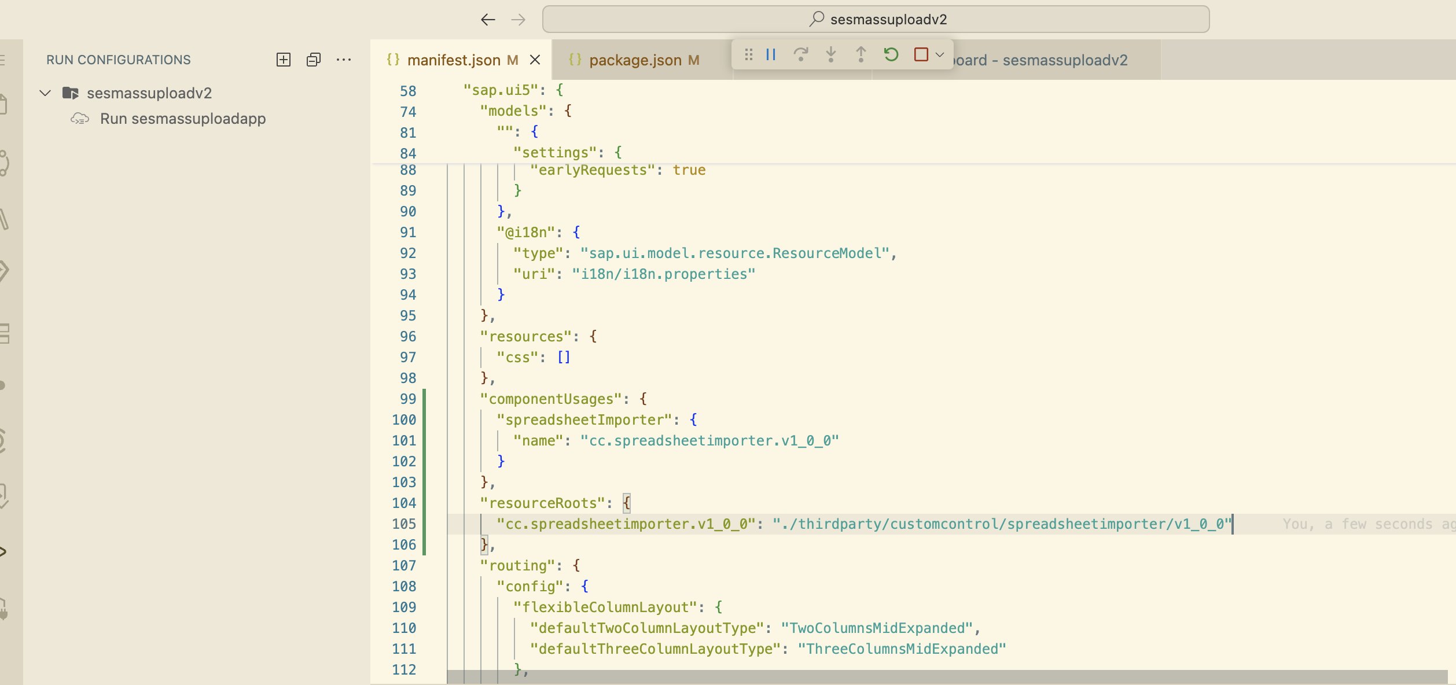

Package.json
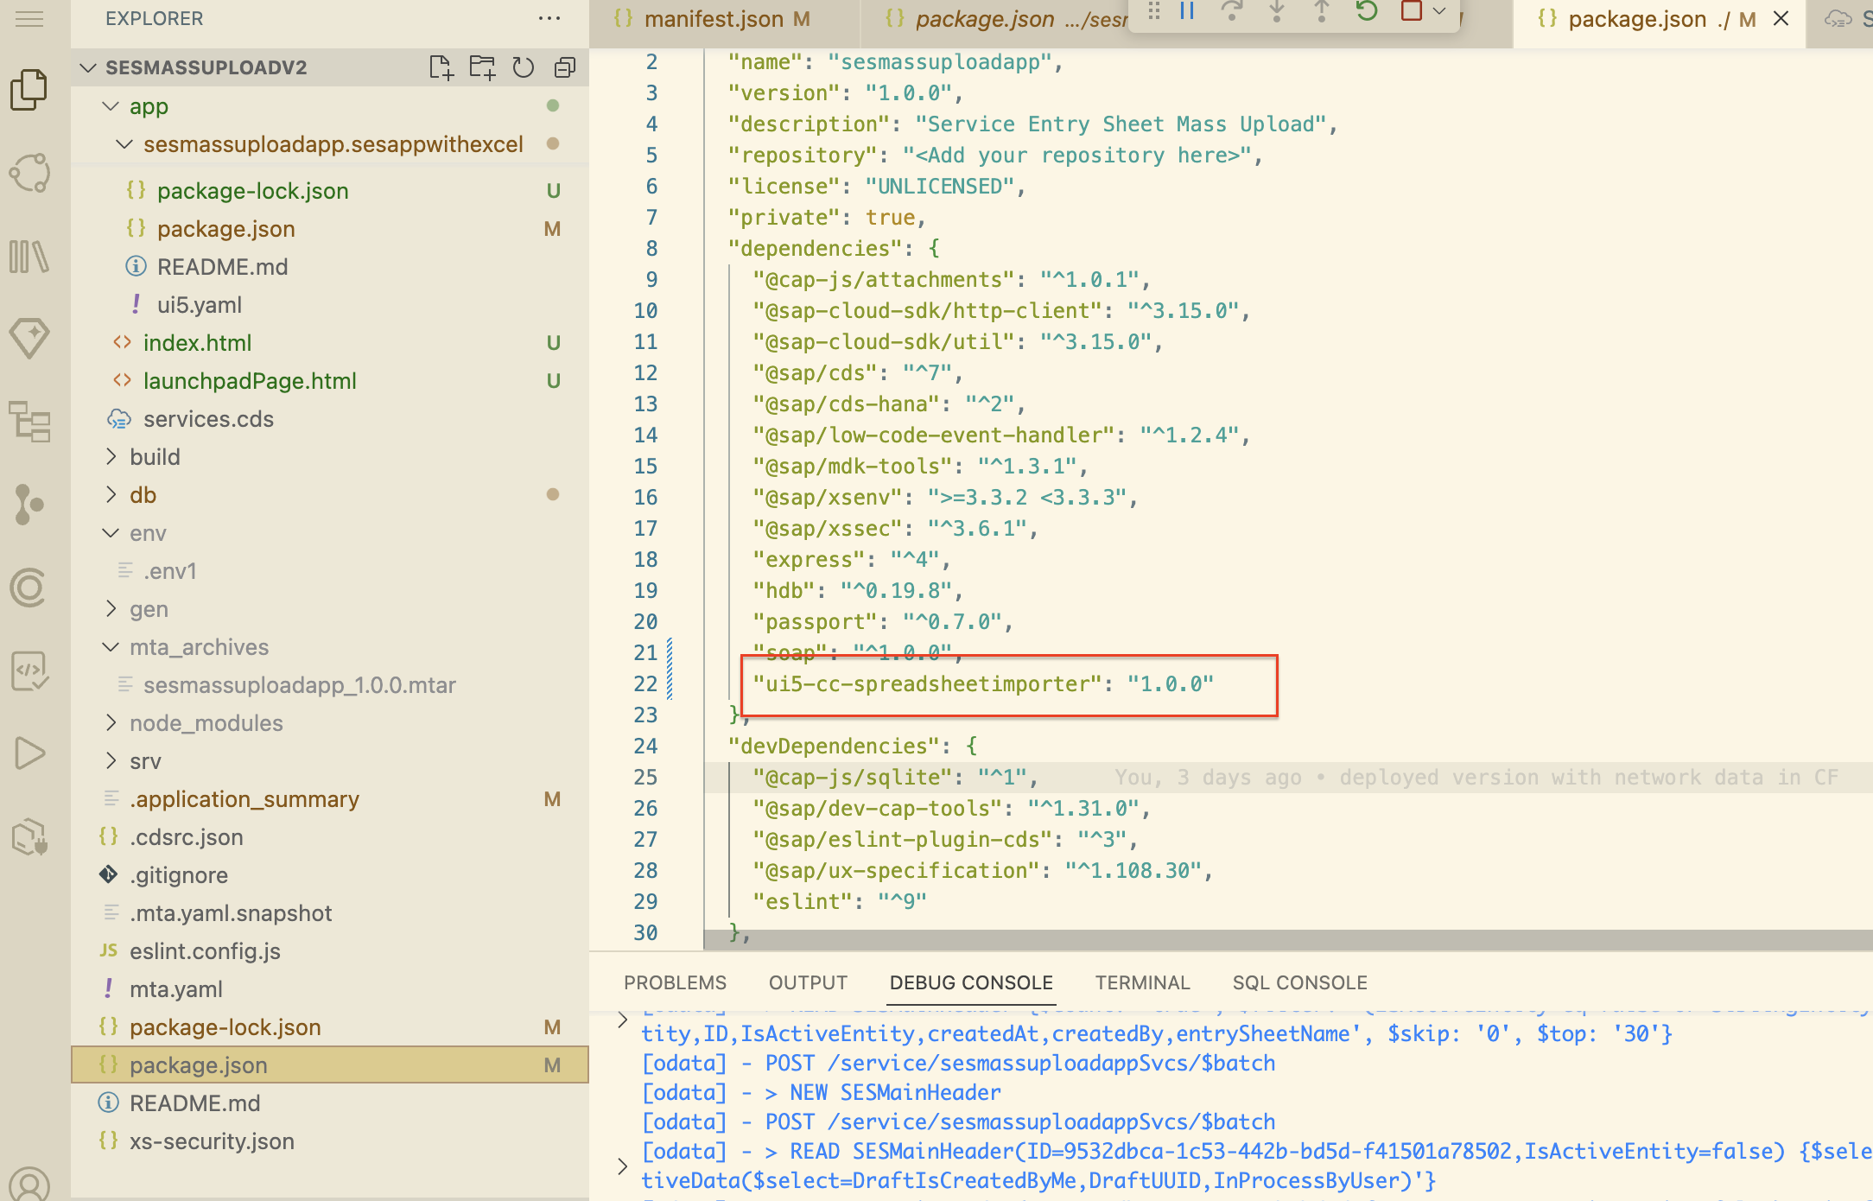

Excel Upload button logic
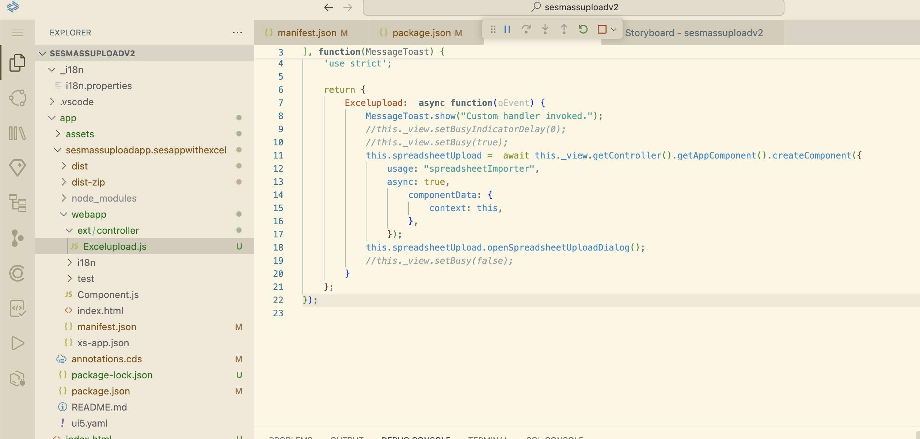

NPM installed node module
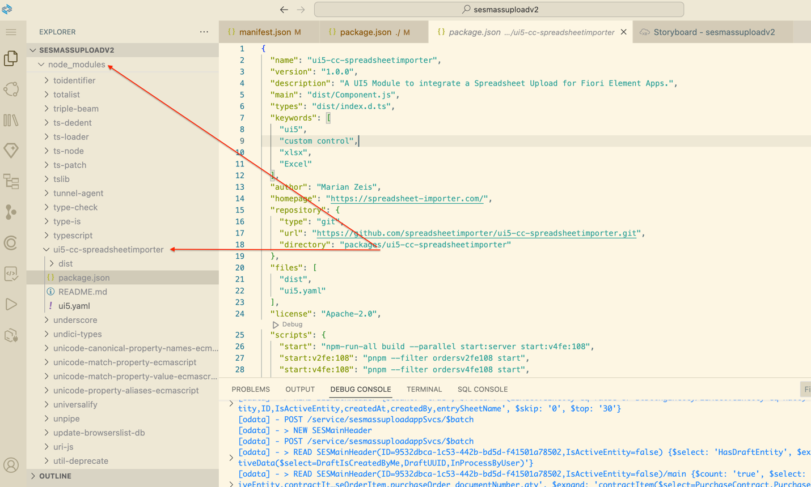

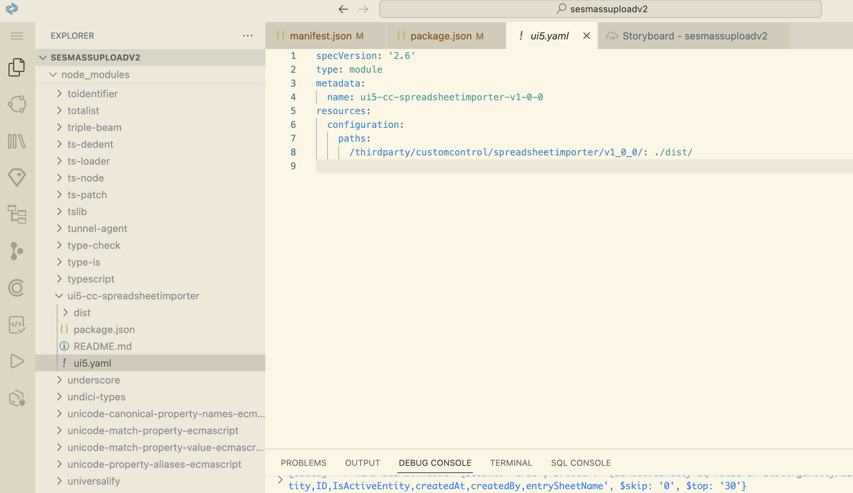

Setup:
I followed below steps to install spreadsheetimporter in BAS
- npm install ui5-cc-spreadsheetimporter
- Updated manifest.json file with resourceRoots and componentUsages
- Added custom button excel upload in objectpage table

