Note admin-appsharedusers: 8
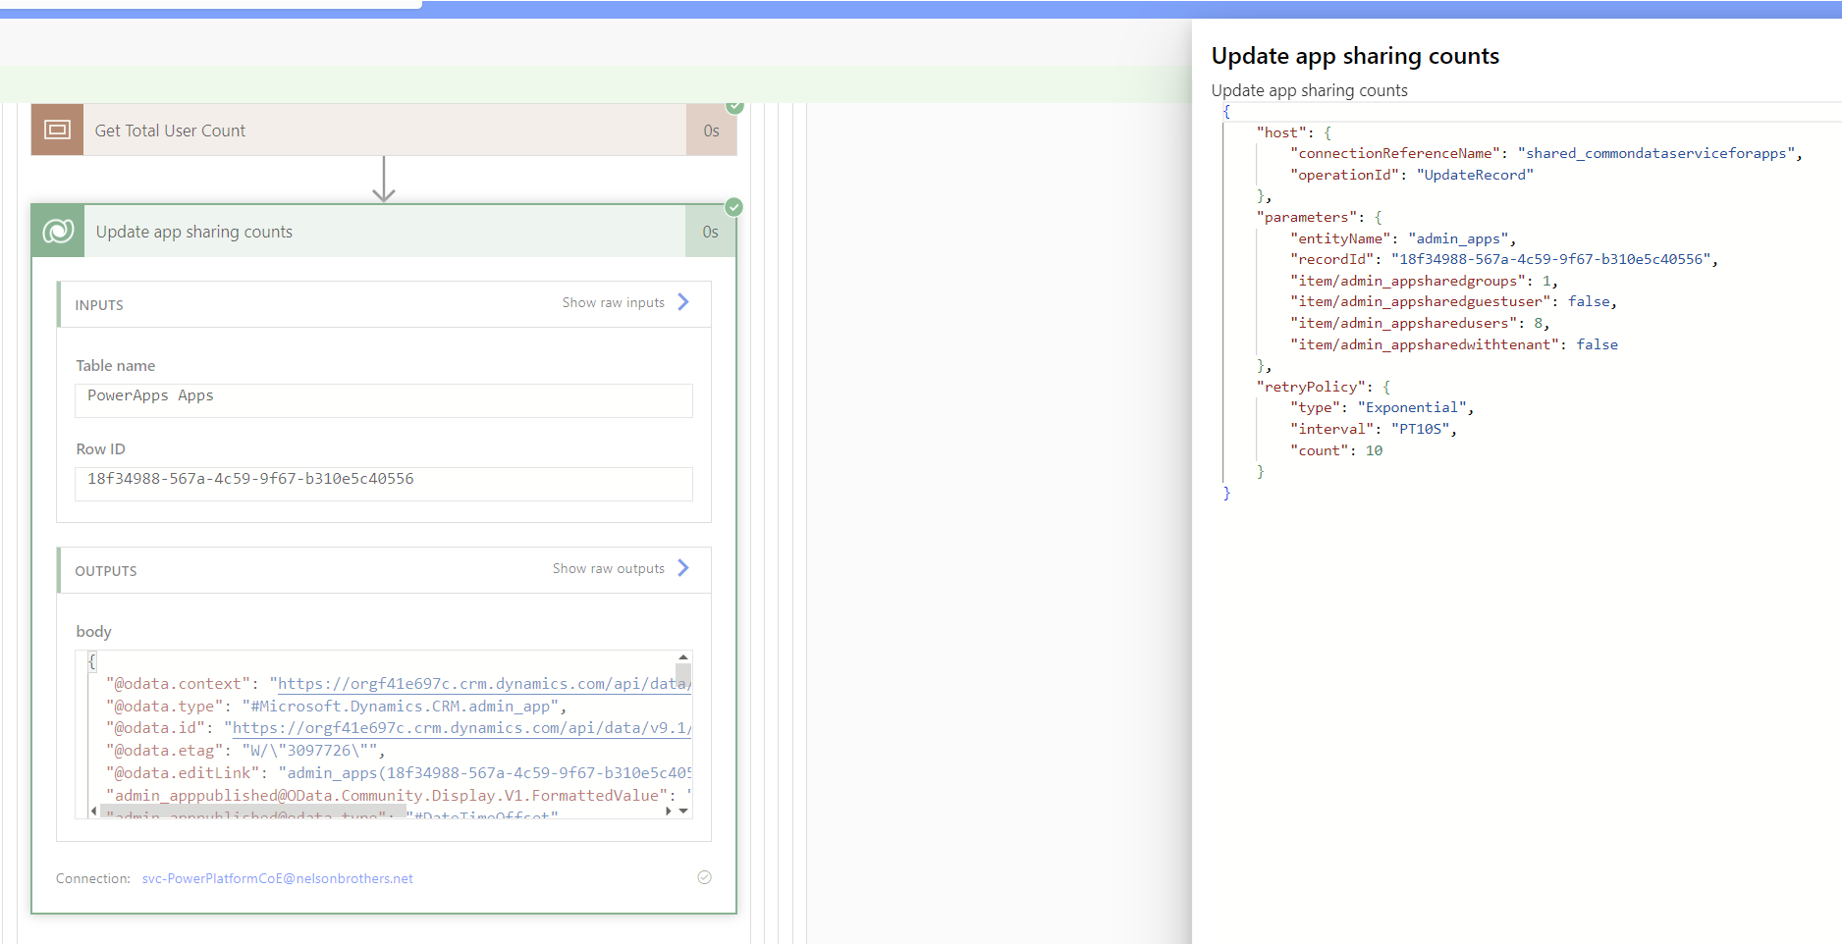

Table results shared counts not being populated:

Power BI may be using the deprecated column:
