Replication Document:
 | - Edit elements in the diagram does not regenerate the thumbnail
1. Moved elements in the diagram and  Autosaved | 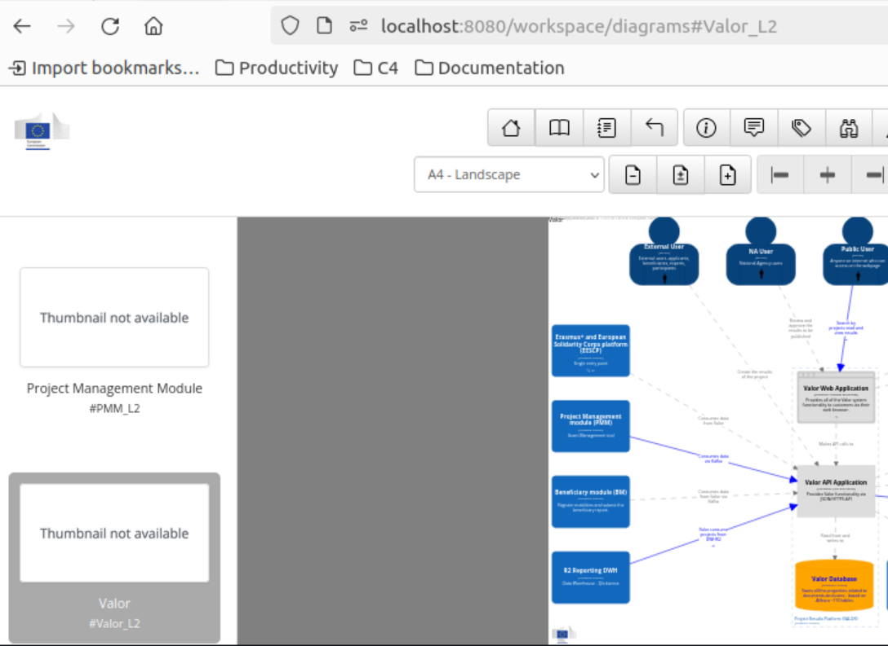  
Expected result:  Thumbnail to be regenerated | Failed to regenerate the thumbnails  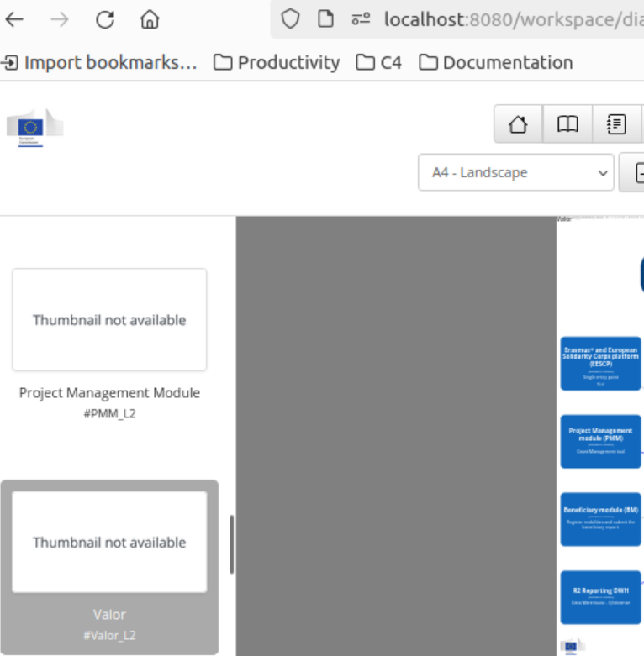
 | - Renaming the .structurizr folder, does not regenerate the thumbnails
1. Renamed folder .structurizr into xxxx.structurizr  Expected result: to regenerate the thumbnails | 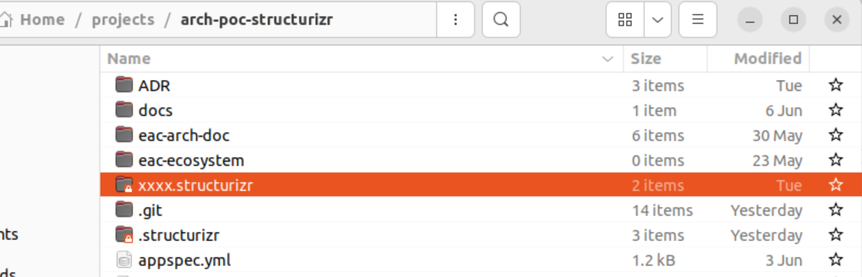  
2.Automatically a new folder .structurizr has been created with no thumbnail images | 
 | - TERMINAL Log
TERMINAL Log | simandr@U-2QT5ZNS8G89YC:~/projects/arch-poc-structurizr$ ./lite.sh  [sudo] password for simandr:  Sorry, try again.  [sudo] password for simandr:  Standard Commons Logging discovery in action with spring-jcl: please remove commons-logging.jar from classpath in order to avoid potential conflicts  2024-06-19T15:00:02.548Z INFO 1 --- [ main] com.structurizr.lite.StructurizrLite : Starting StructurizrLite using Java 21.0.3 with PID 1 (/usr/local/structurizr-lite.war started by root in /)  2024-06-19T15:00:02.566Z INFO 1 --- [ main] com.structurizr.lite.StructurizrLite : No active profile set, falling back to 1 default profile: "default"  Standard Commons Logging discovery in action with spring-jcl: please remove commons-logging.jar from classpath in order to avoid potential conflicts  2024-06-19T15:00:10.409Z WARN 1 --- [ main] o.a.l.i.v.VectorizationProvider : Java vector incubator module is not readable. For optimal vector performance, pass '--add-modules jdk.incubator.vector' to enable Vector API.  WARNING: A restricted method in java.lang.foreign.Linker has been called  WARNING: java.lang.foreign.Linker::downcallHandle has been called by the unnamed module  WARNING: Use --enable-native-access=ALL-UNNAMED to avoid a warning for this module  2024-06-19T15:00:10.863Z WARN 1 --- [ main] c.structurizr.dsl.StructurizrDslParser : !constant has been deprecated and will be removed in a future release - please use !const or !var instead  2024-06-19T15:00:10.865Z WARN 1 --- [ main] c.structurizr.dsl.StructurizrDslParser : !constant has been deprecated and will be removed in a future release - please use !const or !var instead  2024-06-19T15:00:10.866Z WARN 1 --- [ main] c.structurizr.dsl.StructurizrDslParser : !constant has been deprecated and will be removed in a future release - please use !const or !var instead  2024-06-19T15:00:12.371Z INFO 1 --- [ main] com.structurizr.lite.StructurizrLite : Started StructurizrLite in 10.662 seconds (process running for 11.889)  2024-06-19T15:00:12.377Z INFO 1 --- [ main] com.structurizr.lite.StructurizrLite : ***********************************************************************************  2024-06-19T15:00:12.377Z INFO 1 --- [ main] com.structurizr.lite.StructurizrLite : _____ _ _ _  2024-06-19T15:00:12.378Z INFO 1 --- [ main] com.structurizr.lite.StructurizrLite : / ____| | | | (_)  2024-06-19T15:00:12.378Z INFO 1 --- [ main] com.structurizr.lite.StructurizrLite : | (___ | |_ _ __ _ _ ___| |_ _ _ _ __ _ _____ __  2024-06-19T15:00:12.379Z INFO 1 --- [ main] com.structurizr.lite.StructurizrLite : \___ \| __| '__| | | |/ __| __| | | | '__| |_ / '__|  2024-06-19T15:00:12.379Z INFO 1 --- [ main] com.structurizr.lite.StructurizrLite : ____) | |_| | | |_| | (__| |_| |_| | | | |/ /| |  2024-06-19T15:00:12.380Z INFO 1 --- [ main] com.structurizr.lite.StructurizrLite : |_____/ \__|_| \__,_|\___|\__|\__,_|_| |_/___|_|  2024-06-19T15:00:12.381Z INFO 1 --- [ main] com.structurizr.lite.StructurizrLite :  2024-06-19T15:00:12.381Z INFO 1 --- [ main] com.structurizr.lite.StructurizrLite : Structurizr Lite  2024-06-19T15:00:12.387Z INFO 1 --- [ main] com.structurizr.lite.StructurizrLite : - build: 2024.06.18 (2024-06-18T10:11:32Z)  2024-06-19T15:00:12.388Z INFO 1 --- [ main] com.structurizr.lite.StructurizrLite : - structurizr-java: v2.1.3  2024-06-19T15:00:12.388Z INFO 1 --- [ main] com.structurizr.lite.StructurizrLite : - structurizr-dsl: v2.1.3  2024-06-19T15:00:12.389Z INFO 1 --- [ main] com.structurizr.lite.StructurizrLite : - structurizr-import: v2.1.3  2024-06-19T15:00:12.391Z INFO 1 --- [ main] com.structurizr.lite.StructurizrLite : - structurizr-graphviz: v2.1.3  2024-06-19T15:00:12.392Z INFO 1 --- [ main] com.structurizr.lite.StructurizrLite :  2024-06-19T15:00:12.392Z INFO 1 --- [ main] com.structurizr.lite.StructurizrLite : Workspace path: /usr/local/structurizr  2024-06-19T15:00:12.393Z INFO 1 --- [ main] com.structurizr.lite.StructurizrLite : Workspace filename: workspace[.dsl|.json]  2024-06-19T15:00:12.393Z INFO 1 --- [ main] com.structurizr.lite.StructurizrLite : Workspaces: 1  2024-06-19T15:00:12.394Z INFO 1 --- [ main] com.structurizr.lite.StructurizrLite : URL:  2024-06-19T15:00:12.394Z INFO 1 --- [ main] com.structurizr.lite.StructurizrLite : Auto-save interval: 5000ms  2024-06-19T15:00:12.395Z INFO 1 --- [ main] com.structurizr.lite.StructurizrLite : Auto-refresh interval: 0ms  2024-06-19T15:00:12.417Z INFO 1 --- [ main] com.structurizr.lite.StructurizrLite : Graphviz (dot): true  2024-06-19T15:00:12.418Z INFO 1 --- [ main] com.structurizr.lite.StructurizrLite : ***********************************************************************************  2024-06-19T15:00:12.418Z INFO 1 --- [ main] com.structurizr.lite.StructurizrLite : MIT License  2024-06-19T15:00:12.418Z INFO 1 --- [ main] com.structurizr.lite.StructurizrLite :  2024-06-19T15:00:12.418Z INFO 1 --- [ main] com.structurizr.lite.StructurizrLite : Copyright (c) 2024 Structurizr Limited  2024-06-19T15:00:12.419Z INFO 1 --- [ main] com.structurizr.lite.StructurizrLite :  2024-06-19T15:00:12.419Z INFO 1 --- [ main] com.structurizr.lite.StructurizrLite : Permission is hereby granted, free of charge, to any person obtaining a copy  2024-06-19T15:00:12.420Z INFO 1 --- [ main] com.structurizr.lite.StructurizrLite : of this software and associated documentation files (the "Software"), to deal  2024-06-19T15:00:12.420Z INFO 1 --- [ main] com.structurizr.lite.StructurizrLite : in the Software without restriction, including without limitation the rights  2024-06-19T15:00:12.421Z INFO 1 --- [ main] com.structurizr.lite.StructurizrLite : to use, copy, modify, merge, publish, distribute, sublicense, and/or sell  2024-06-19T15:00:12.421Z INFO 1 --- [ main] com.structurizr.lite.StructurizrLite : copies of the Software, and to permit persons to whom the Software is  2024-06-19T15:00:12.422Z INFO 1 --- [ main] com.structurizr.lite.StructurizrLite : furnished to do so, subject to the following conditions:  2024-06-19T15:00:12.422Z INFO 1 --- [ main] com.structurizr.lite.StructurizrLite :  2024-06-19T15:00:12.423Z INFO 1 --- [ main] com.structurizr.lite.StructurizrLite : The above copyright notice and this permission notice shall be included in all  2024-06-19T15:00:12.423Z INFO 1 --- [ main] com.structurizr.lite.StructurizrLite : copies or substantial portions of the Software.  2024-06-19T15:00:12.424Z INFO 1 --- [ main] com.structurizr.lite.StructurizrLite :  2024-06-19T15:00:12.424Z INFO 1 --- [ main] com.structurizr.lite.StructurizrLite : THE SOFTWARE IS PROVIDED "AS IS", WITHOUT WARRANTY OF ANY KIND, EXPRESS OR  2024-06-19T15:00:12.425Z INFO 1 --- [ main] com.structurizr.lite.StructurizrLite : IMPLIED, INCLUDING BUT NOT LIMITED TO THE WARRANTIES OF MERCHANTABILITY,  2024-06-19T15:00:12.425Z INFO 1 --- [ main] com.structurizr.lite.StructurizrLite : FITNESS FOR A PARTICULAR PURPOSE AND NONINFRINGEMENT. IN NO EVENT SHALL THE  2024-06-19T15:00:12.426Z INFO 1 --- [ main] com.structurizr.lite.StructurizrLite : AUTHORS OR COPYRIGHT HOLDERS BE LIABLE FOR ANY CLAIM, DAMAGES OR OTHER  2024-06-19T15:00:12.426Z INFO 1 --- [ main] com.structurizr.lite.StructurizrLite : LIABILITY, WHETHER IN AN ACTION OF CONTRACT, TORT OR OTHERWISE, ARISING FROM,  2024-06-19T15:00:12.427Z INFO 1 --- [ main] com.structurizr.lite.StructurizrLite : OUT OF OR IN CONNECTION WITH THE SOFTWARE OR THE USE OR OTHER DEALINGS IN THE  2024-06-19T15:00:12.427Z INFO 1 --- [ main] com.structurizr.lite.StructurizrLite : SOFTWARE.  2024-06-19T15:00:12.428Z INFO 1 --- [ main] com.structurizr.lite.StructurizrLite : ***********************************************************************************  2024-06-19T15:12:36.673Z WARN 1 --- [nio-8080-exec-9] c.structurizr.dsl.StructurizrDslParser : !constant has been deprecated and will be removed in a future release - please use !const or !var instead  2024-06-19T15:12:36.674Z WARN 1 --- [nio-8080-exec-9] c.structurizr.dsl.StructurizrDslParser : !constant has been deprecated and will be removed in a future release - please use !const or !var instead  2024-06-19T15:12:36.675Z WARN 1 --- [nio-8080-exec-9] c.structurizr.dsl.StructurizrDslParser : !constant has been deprecated and will be removed in a future release - please use !const or !var instead  2024-06-19T15:13:21.579Z WARN 1 --- [nio-8080-exec-3] c.structurizr.dsl.StructurizrDslParser : !constant has been deprecated and will be removed in a future release - please use !const or !var instead  2024-06-19T15:13:21.582Z WARN 1 --- [nio-8080-exec-3] c.structurizr.dsl.StructurizrDslParser : !constant has been deprecated and will be removed in a future release - please use !const or !var instead  2024-06-19T15:13:21.583Z WARN 1 --- [nio-8080-exec-3] c.structurizr.dsl.StructurizrDslParser : !constant has been deprecated and will be removed in a future release - please use !const or !var instead  2024-06-19T15:15:22.497Z WARN 1 --- [nio-8080-exec-7] c.structurizr.dsl.StructurizrDslParser : !constant has been deprecated and will be removed in a future release - please use !const or !var instead  2024-06-19T15:15:22.508Z WARN 1 --- [nio-8080-exec-7] c.structurizr.dsl.StructurizrDslParser : !constant has been deprecated and will be removed in a future release - please use !const or !var instead  2024-06-19T15:15:22.509Z WARN 1 --- [nio-8080-exec-7] c.structurizr.dsl.StructurizrDslParser : !constant has been deprecated and will be removed in a future release - please use !const or !var instead  2024-06-19T17:00:44.395Z WARN 1 --- [nio-8080-exec-3] c.structurizr.dsl.StructurizrDslParser : !constant has been deprecated and will be removed in a future release - please use !const or !var instead  2024-06-19T17:00:44.395Z WARN 1 --- [nio-8080-exec-3] c.structurizr.dsl.StructurizrDslParser : !constant has been deprecated and will be removed in a future release - please use !const or !var instead  2024-06-19T17:00:44.395Z WARN 1 --- [nio-8080-exec-3] c.structurizr.dsl.StructurizrDslParser : !constant has been deprecated and will be removed in a future release - please use !const or !var instead  2024-06-20T06:22:09.539Z WARN 1 --- [nio-8080-exec-4] c.structurizr.dsl.StructurizrDslParser : !constant has been deprecated and will be removed in a future release - please use !const or !var instead  2024-06-20T06:22:09.544Z WARN 1 --- [nio-8080-exec-4] c.structurizr.dsl.StructurizrDslParser : !constant has been deprecated and will be removed in a future release - please use !const or !var instead  2024-06-20T06:22:09.544Z WARN 1 --- [nio-8080-exec-4] c.structurizr.dsl.StructurizrDslParser : !constant has been deprecated and will be removed in a future release - please use !const or !var instead

