BCP Path:
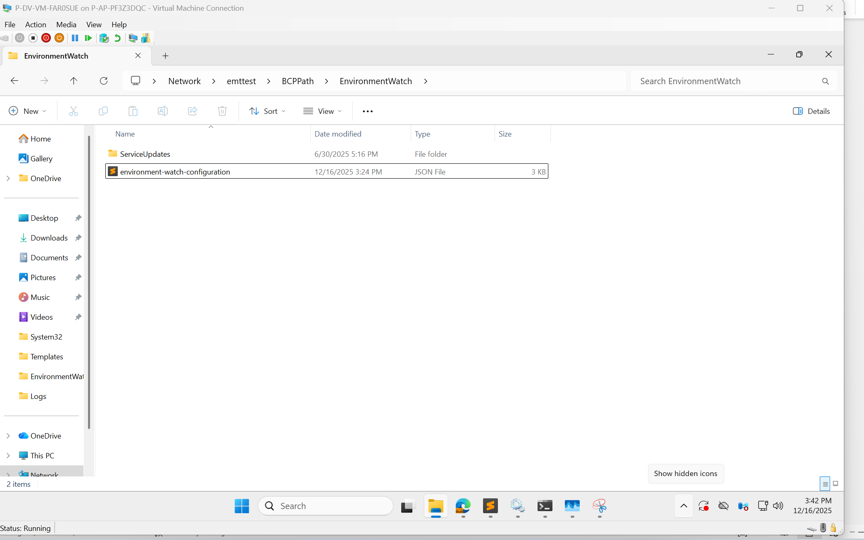

Before custom json configuration for slack notification, we have to setup few things as below:
Have to create slack app using:
https://api.slack.com/apps
Next step, would be Go To Settings of Channel. Select OAuth & Permissions
A request will be sent to the administrator, upon approval of the request for OAuth & Permissions token, then we can proceed with next step.
Create Slack channel for which slack notification should be sent.
Add above created Slack app as below in slack channel chat
/invite @slackAppName
Custom Json configuration using above credentials.
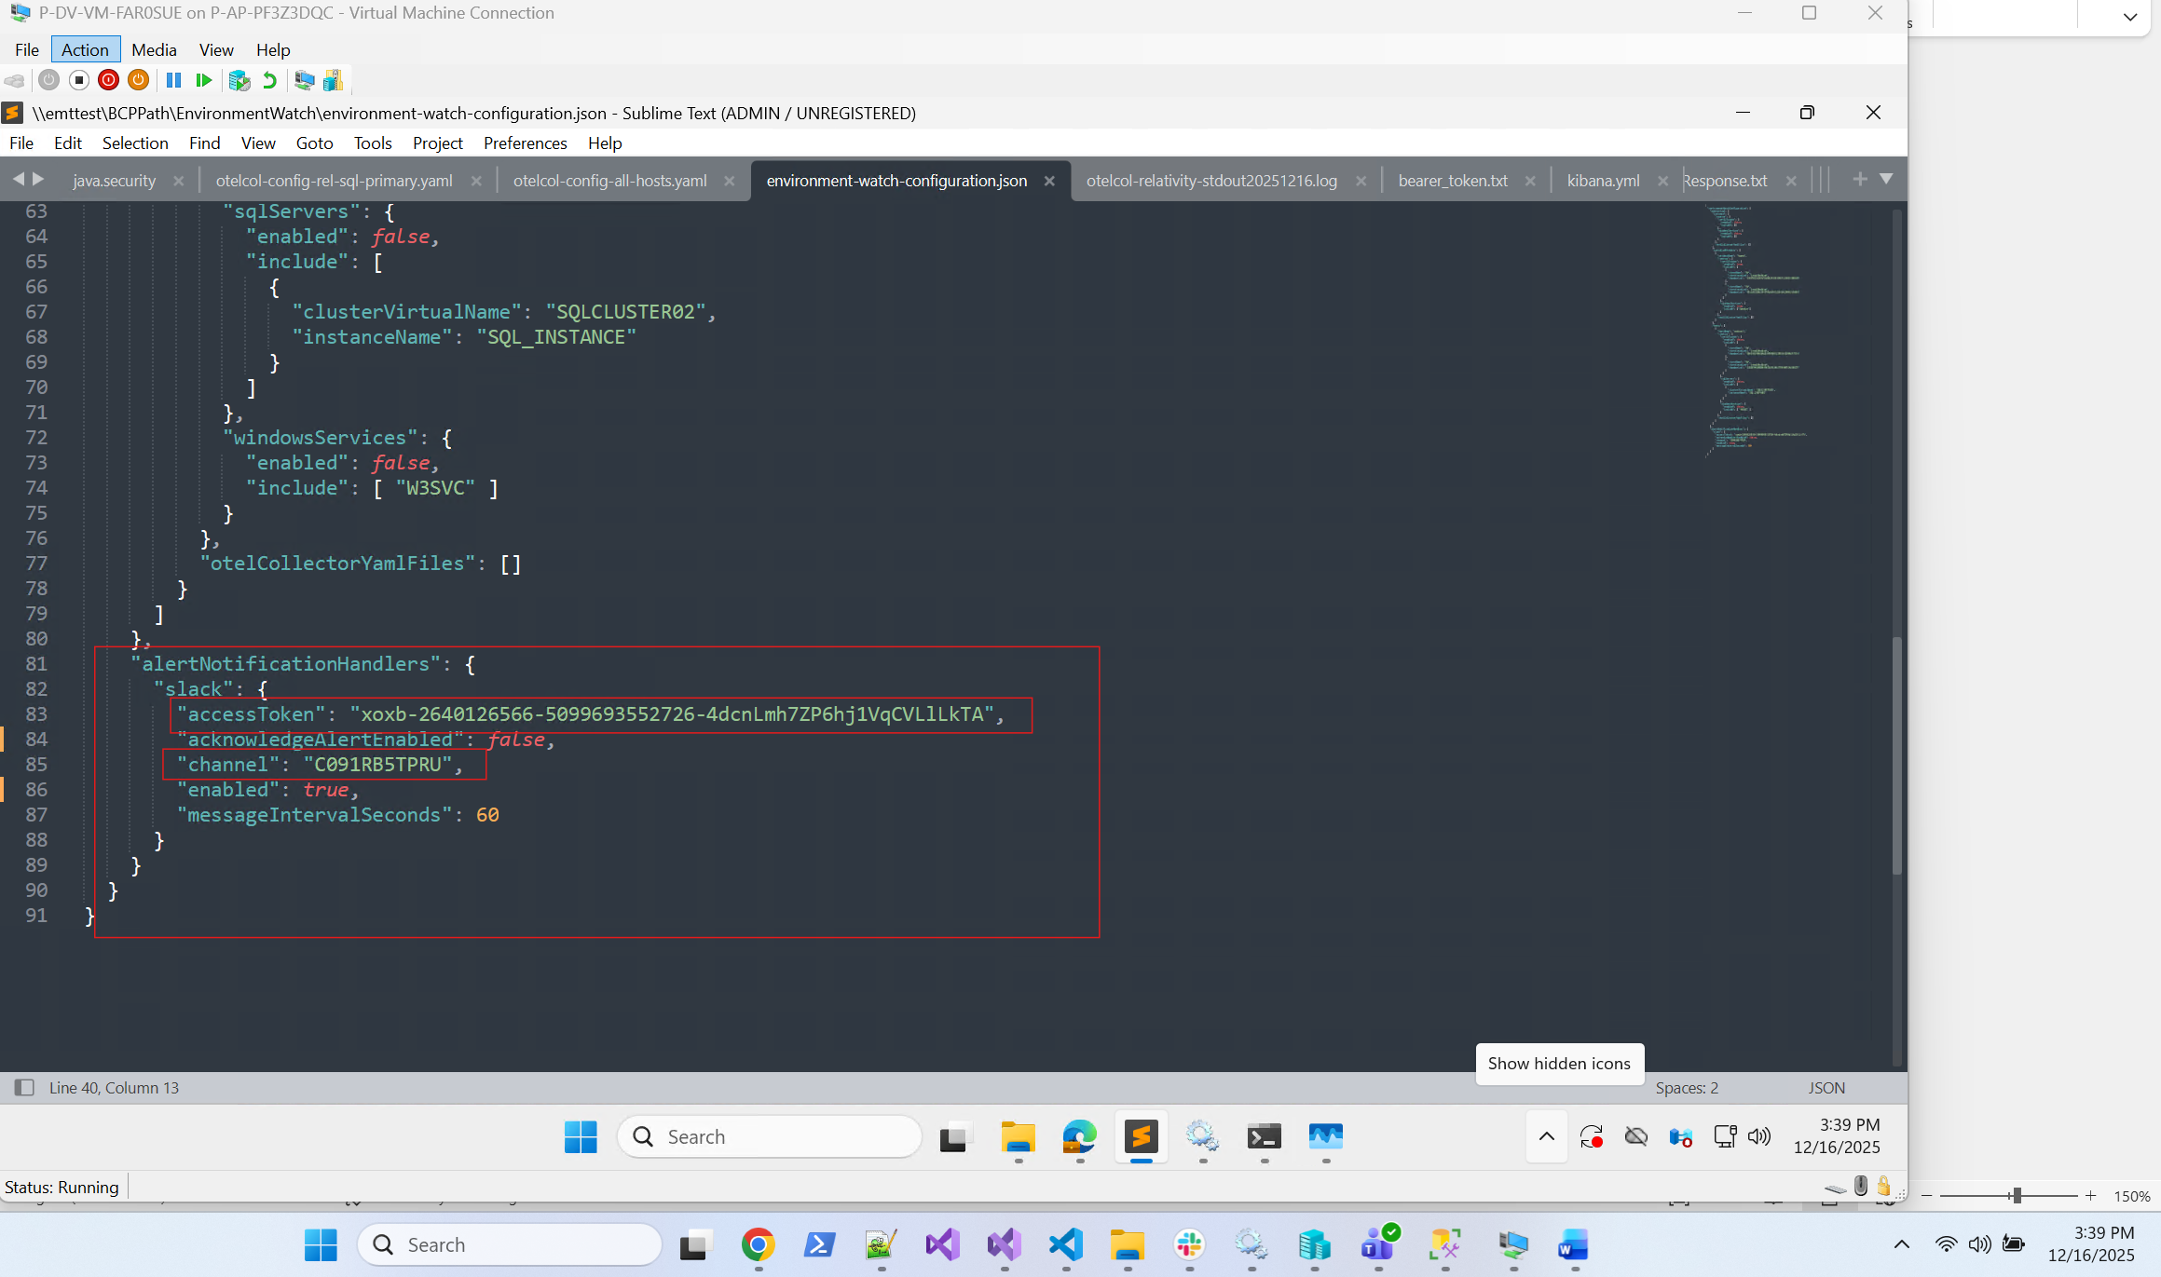
Provide slack channel id and access token as above snippet. Trigger any alert in the Kibana and slack notification will be received in the slack channel.
