**[Navicat15最新版本破解 亲测可用！！！](https://www.cnblogs.com/laoshuai/p/13517172.html)**

**1、下载Navicat Premium**[**#**](https://www.cnblogs.com/laoshuai/p/13517172.html#797518463)

官网https://www.navicat.com.cn/下载最新版本下载安装

**2、链接：[https://pan.baidu.com/s/1T-AM8tubtUOBZn3PMhYLYA](https://pan.baidu.com/s/1T-AM8tubtUOBZn3PMhYLYA" \t "_blank)**[**#**](https://www.cnblogs.com/laoshuai/p/13517172.html#778313740)

提取码：zo5g（安装包和破解包都有）

**3、激活Navicat Premium**[**#**](https://www.cnblogs.com/laoshuai/p/13517172.html#2706550850)

先把Navicat安装好  
然后把破解工具Navicat\_Keygen\_Patch解压， 以管理员身份运行  
[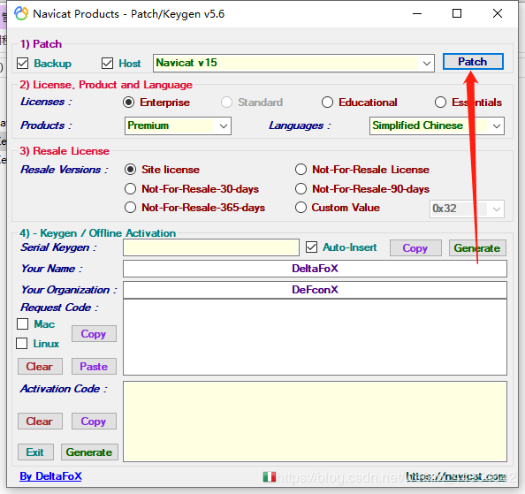](https://img2020.cnblogs.com/blog/1407082/202008/1407082-20200817134342865-212514800.png)

**4.点击patch 弹出窗口，找到navicat下载的目录选择navicat，点击打开[#](https://www.cnblogs.com/laoshuai/p/13517172.html" \l "3066576710)**

[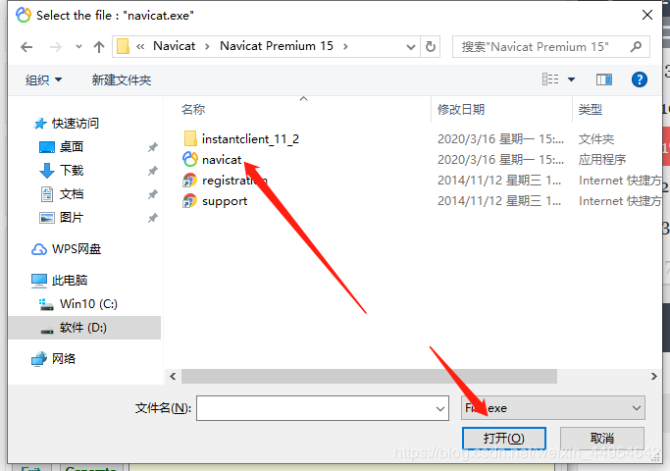](https://img2020.cnblogs.com/blog/1407082/202008/1407082-20200817134421848-814137324.png)

**5.显示为下图就是破解成功了[#](https://www.cnblogs.com/laoshuai/p/13517172.html" \l "3967597242)**

[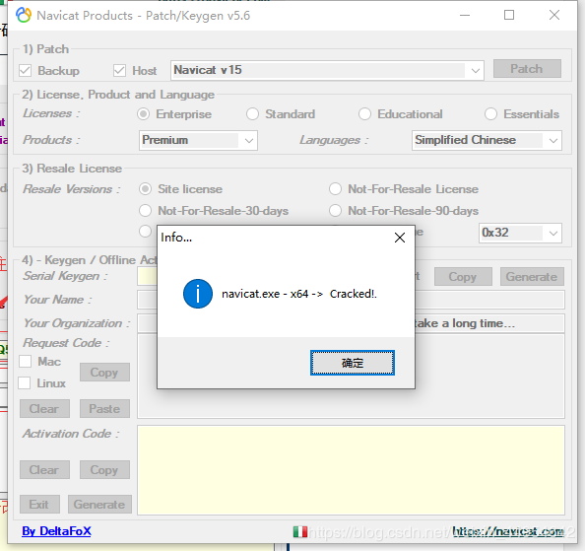](https://img2020.cnblogs.com/blog/1407082/202008/1407082-20200817134433244-918413008.png)

**5.1.点击Generate**[**#**](https://www.cnblogs.com/laoshuai/p/13517172.html#3429430830)

**5.2.出现序列码[#](https://www.cnblogs.com/laoshuai/p/13517172.html" \l "222154683)**

**5.3.点击Copy**[**#**](https://www.cnblogs.com/laoshuai/p/13517172.html#1446042156)

[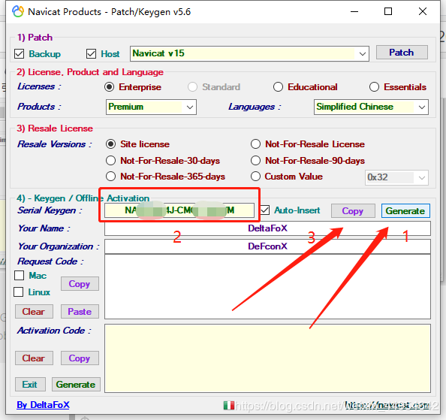](https://img2020.cnblogs.com/blog/1407082/202008/1407082-20200817134445278-689681058.png)

**6.然后打开navicat**[**#**](https://www.cnblogs.com/laoshuai/p/13517172.html#2599168157)

[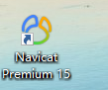](https://img2020.cnblogs.com/blog/1407082/202008/1407082-20200817134458436-319113361.png)

**7.第一次打开会提示注册和试用，由于作者是破解过了，我就不截图了，你们第一次打开的时候点击注册，然后把刚才copy的序列码复制进去，点击激活。**[**#**](https://www.cnblogs.com/laoshuai/p/13517172.html#4230626782)

[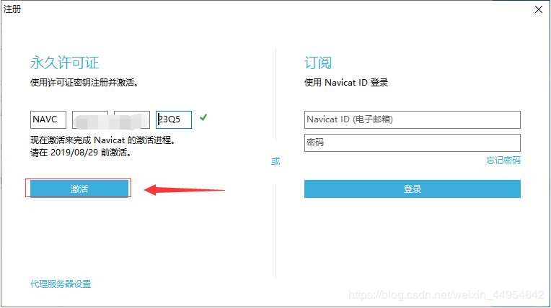](https://img2020.cnblogs.com/blog/1407082/202008/1407082-20200817134505826-2129085652.png)

**8.选择手动激活**[**#**](https://www.cnblogs.com/laoshuai/p/13517172.html#2280376325)

[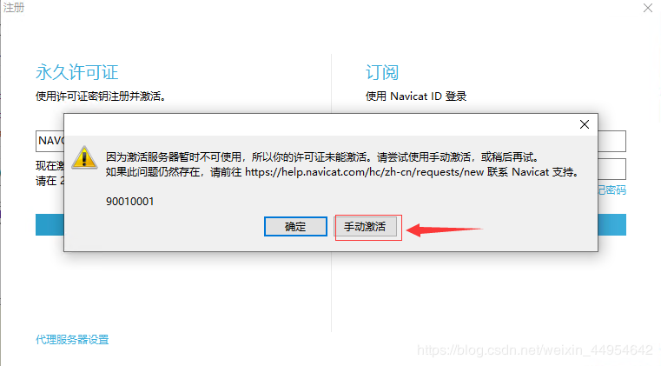](https://img2020.cnblogs.com/blog/1407082/202008/1407082-20200817134514334-944341877.png)

**9.然后会生成一大串请求码**[**#**](https://www.cnblogs.com/laoshuai/p/13517172.html#1232018187)

[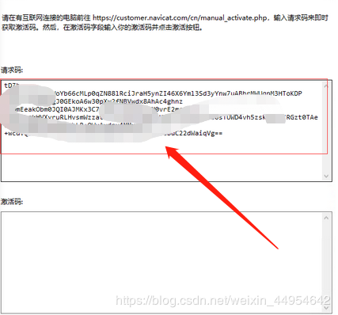](https://img2020.cnblogs.com/blog/1407082/202008/1407082-20200817134522149-1369727733.png)

**10.复制请求码到注册机中的Request Code中，点击Activation Code下的generate，生成激活码**[**#**](https://www.cnblogs.com/laoshuai/p/13517172.html#2048575370)

[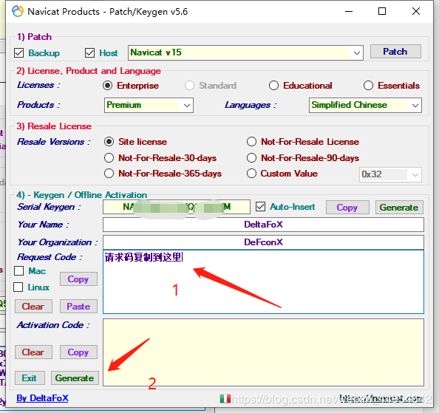](https://img2020.cnblogs.com/blog/1407082/202008/1407082-20200817134531876-1265159097.png)  
[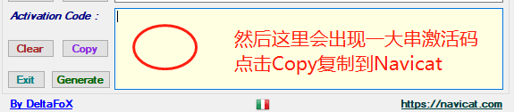](https://img2020.cnblogs.com/blog/1407082/202008/1407082-20200817134543144-345547815.png)  
[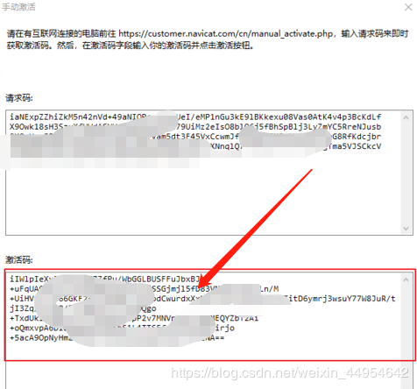](https://img2020.cnblogs.com/blog/1407082/202008/1407082-20200817134554359-145466432.png)

点击激活！！！  
然后再次打开就可以啦，破解成功，嘿嘿！  
————————————————

作者CSDN地址：<https://me.csdn.net/weixin_44954642>