Lifecycle

Intro

- last time:
  - intents internal and external
- this time:
  - life cycle
    - hide this from the user
  - loaders for handling life cycle

why lifecycle?

- You move around the OS with intents
- android kills low priority background apps, so you need to handle these deaths

Android Activity Lifecycle

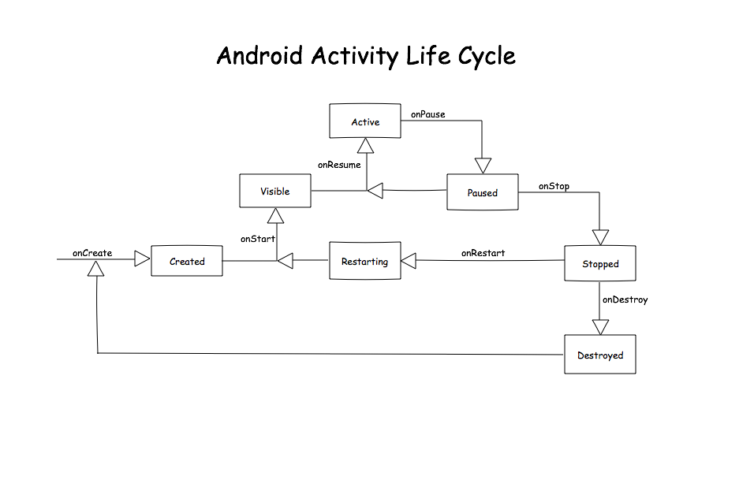
- Active: has focus (getting input from user)
- Paused: activity lost focus (permissions for ex)
- Stopped: activity invisible (changed apps for example)

Retro on the Android Activity Lifecycle

- you don’t need to make active updates when the app is paused (pause a video or game for example)
- When your app is stopped, the user can’t see the app at all. Stop all processes related to the UI, you don’t need them.

Exercise: lifecycle events

- done
explanation

- whenever a device configuration (like in a screen rotation) changes lifecycle events happen
- text views aren’t automatically saved through event state changes
  - use onSaveInstanceState to save data through the lifecycel
  - use parcelables to add complex data to onSaveinstanceState

app termination

- android doesn’t kill small apps (so they won’t get onStop)

Preparing for Termination

- make sure your app can be brought back to the same state do this in onStop()

Persisting Data With an old Friend (12)

- user input is saved though lifecycle events, your printed data (text view) is not
  - save this stuff with a savedInstanceState’s bundle
  - restore the data in onCreate using the bundle

AsyncTask and Loaders

- edge case:
  - activity starts a thread
  - activity dies
  - thread returns to zombie activity
    - even though the user can’t use this activity, the thread keeps it alive!
- another edge case:
  - activity is born and starts a thread
  - activity dies
  - activity is reborn and starts another thread
- Loaders solve this problem:
  - Loaders are regestered in the LoaderManager by ID
  - the LoaderManager uses AsyncTaskLoader to persist loads through lifecycle events
    - this has an initLoader(), and an onLoadFinished()

Leveraging loaders

- TO ACTUALLY USE A LOADER (to replace the AsyncTask):
  - create a Loader ID
  - write Loader Callback functions
  - initialize a LoaderManager
- see T05b.02-Exercise-AddAsyncTaskLoader for an example

Caching with Loaders

- Loaders aren’t automatically persistant across onStop (navigation away from the activity)
- caching and redelivering the existing result makes loaders persistant across onStop

Conclusion

- lifecycle:
  - system health
  - user expectations

