**This is a test document for Nexathon redact project.**

It's not only writers who can benefit from this free online tool. If you're a programmer who's working on a project where blocks of text are needed, this tool can be a great way to get that. It's a good way to test your programming and that the tool being created is working well.

Am available on call 6392454863

Above are a few examples of how the random paragraph generator can be beneficial. The best way to see if this random paragraph picker will be useful for your intended purposes is to give it a try. Generate a number of paragraphs to see if they are beneficial to your current project.

Pan number might be this ABCDE1234F  
  
London is my address

If you do find this paragraph tool useful, please do us a favor and let us know how you're using it. It's greatly beneficial for us to know the different ways this tool is being used so we can improve it with updates. This is especially true since there are times when the generators we create get used in completely unanticipated ways from when we initially created them. If you have the time, please send us a quick note on what you'd like to see changed or added to make it better in the future.

my very own addhar card 1234-5678-9101

**Name**: John Doe

**Address**: 123 Main St, Springfield

**Address:** London

Phone Number: 6392454863

Emailund: john.doe@example.com

Aadharrs: 123456789101

PAN Card: ABCDE1234F

**API Key**:

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

**This is my photo lets see what’s sensitive here:**  
  




  
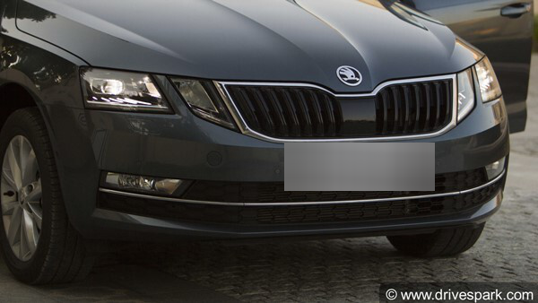

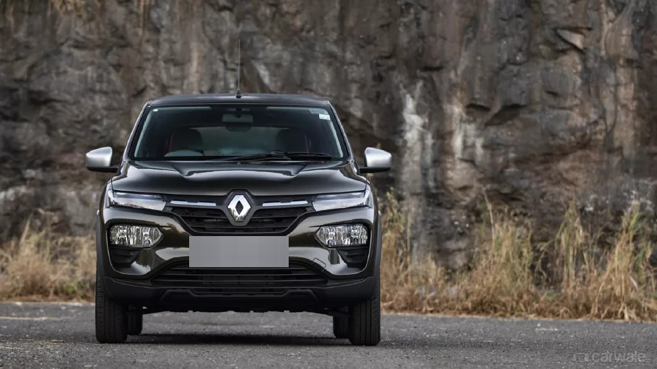  
  
These were my personal car collections

And my personal vehicle number is UP50BH5703  
  
  
Here are some of autographs i got:  
  
