Budgeting Guru

Application Design

Inessa Carroll

Klevin Doda

James Downer

**Problem**

Our customer is seeking an app that will make maintaining a family budget easier, more intuitive and timelier than through spreadsheet methods. The primary concern of the customer is the inclusion of automated statistics graphs as well as visual aids to remind him of his goals and to inform him of his respective progress. The customer is looking for an app that can be used by a family such that each participant is promptly informed of purchases made by the others and is able to instantly see the family’s progress in each budgeting category.

**Solution**

The purpose of the BudgetingGuru mobile application is to help families of users intuitively manage income and expenses. This will be accomplished using fillable tables as well as goal trackers and statistic graphs. Each participant will have their own account that is tied to a larger family account in which each user shares the family’s common registers, goals and statistics.

The app will contain the following:

* Expense categories to logically group transactions together
* Category goals as well as instant reminders and warnings to provide each user with a source of accountability
* Fillable/editable tables to facilitate adding and updating transactions
* Statistics charts and other graphics to intuitively summarize how well both each user is keeping to his/her goals
* The ability to create a family account as well as register users under the same family account
* Cloud storage to maintain user accounts and family records across multiple devices

Additional logic will be written, which may include:

* Downloadable spreadsheets to keep the cloud storage at a minimum and to provide each user with a local copy of his/her data
* A web application to allow each user to access his/her account—including goals, transactions, etc.—using a desktop browser

**Team Members**

Inessa Carroll bethebestone@mail.ru 208-497-4898

Klevin Doda dodaklevin@gmail.com 208-419-5597

James Downer jamesdanieldowner@gmail.com 702-823-6560

**Interface Design**

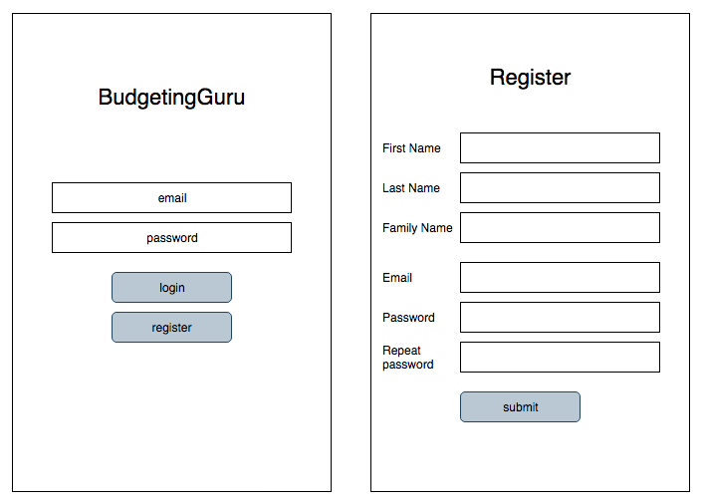

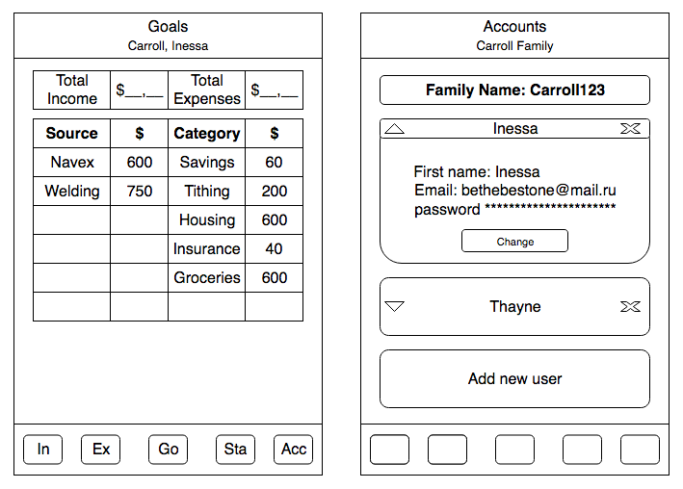

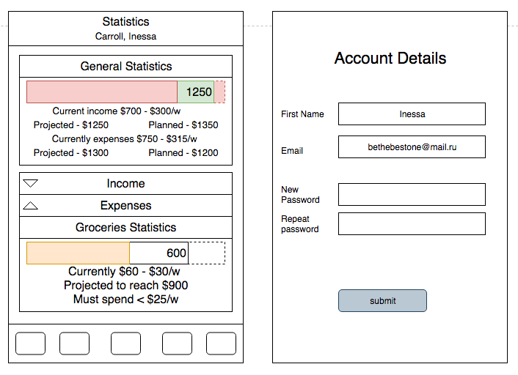

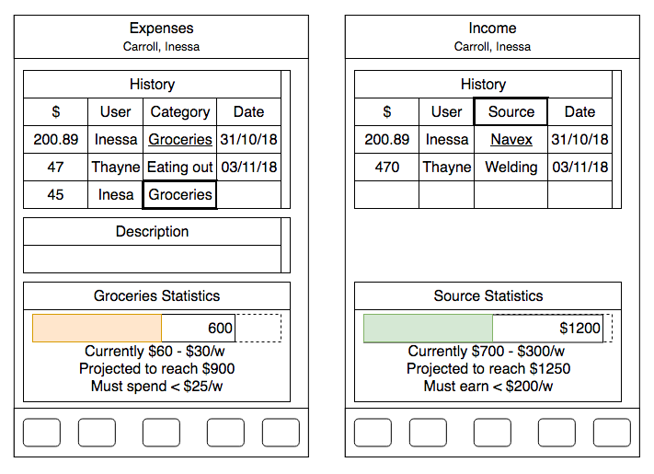

**Model Design**

The solution is designed around a shared family account with users attached to that account. As such, virtually all data structures included in the business logic are ultimately accessed via a **Family** class with each **User** class containing his/her personal transactions, as follows:

* The **Family** will contain a map of multiple **Users** as well as a list of **Goals**
* Each **Goal** will have what **Category** it falls under as well as the amount (i.e. a spending limit)
* Each **User** will have a list of **Expense Transactions** as well as **Income Transactions**
* The **Transaction** will contain the most basic information affecting the family budget, including when the transaction occurred, how much it was, etc.  
  Additional information will be included as needed:
  + **Income Transactions** will include the payor
  + **Expense Transactions** will include the payee, the item purchased, and what **Category** the transaction falls under
* The family may need the ability to add custom **Categories**

To calculate statistics and goal progress, the **Family** object’s data will be retrieved from the cloud database and iteratively compiled from each **User** object.

**Model (Minified UML)**

