genzthoitrang

Thoitranggenz#123

[Phatcute583@gmail.com](mailto:Phatcute583@gmail.com)

Tenten@123

Freehost@123

Byet@123

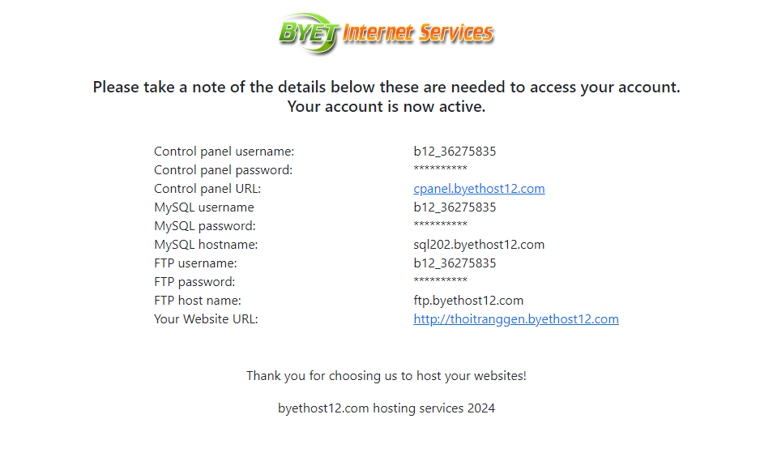

<https://ifastnet.com/activate_3.php?username=b12_36275835&email=phatcute582@gmail.com&hash=e0f3205777bd7c070e6081faf4732035&autoinstall=&script_url=&domain=byethost12.com&logo=http://byet.org/images/bhlogonew.png&sql=sql202&script_username=&server_name=thoitranggen.byethost12.com>