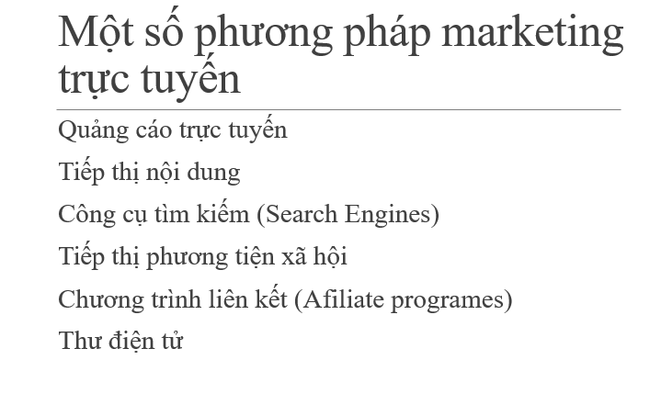

Hiệu quả, chi phí, tg