Login to www.eliteonline.in
Entre your user name and password
Go to My Applications Leave portal
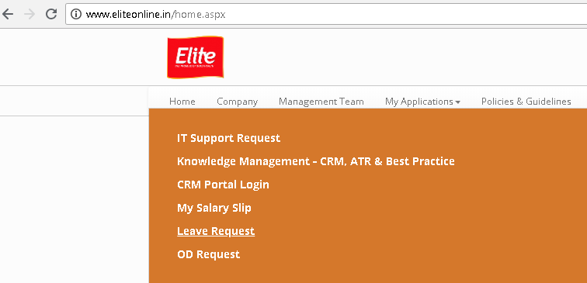
You can see the leave details as below screen:

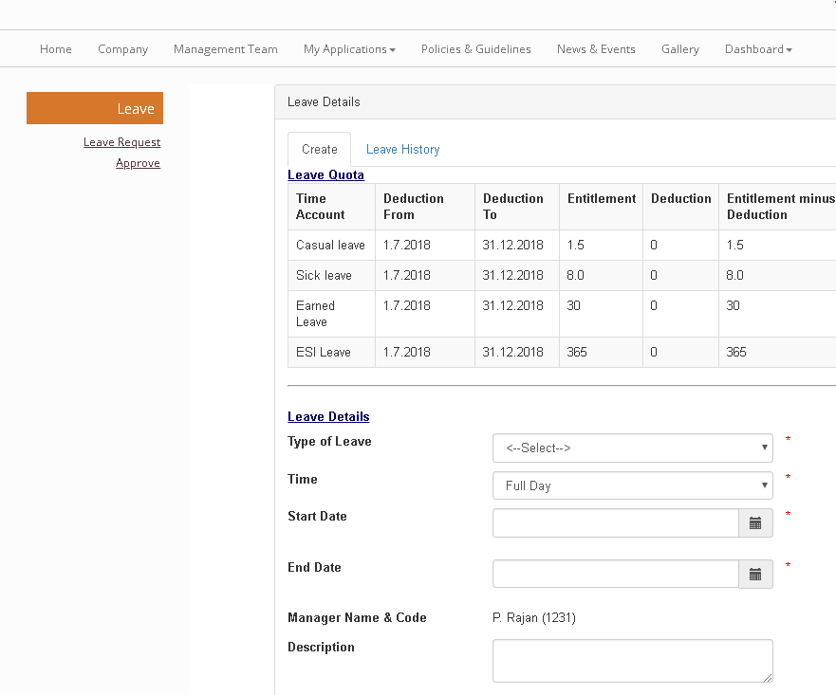
Entre type of leave, time, date and reason for leave and click on send for approval.
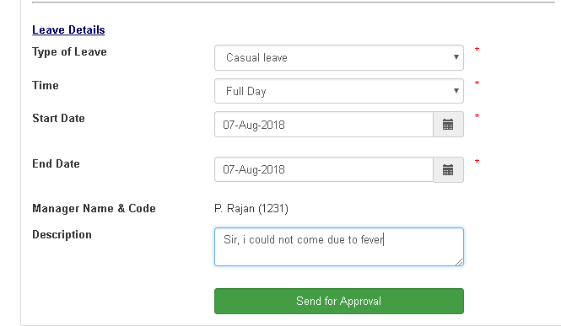
Employee can see the result in leave history once the reporting head is approved the leave.
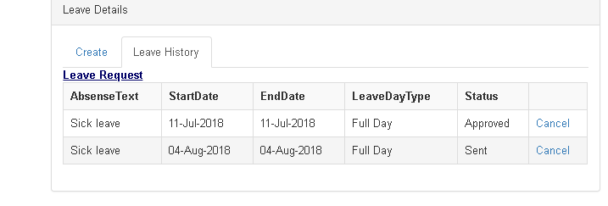

Note: Approved leave can be cancelled. For that go to leave history click on cancel

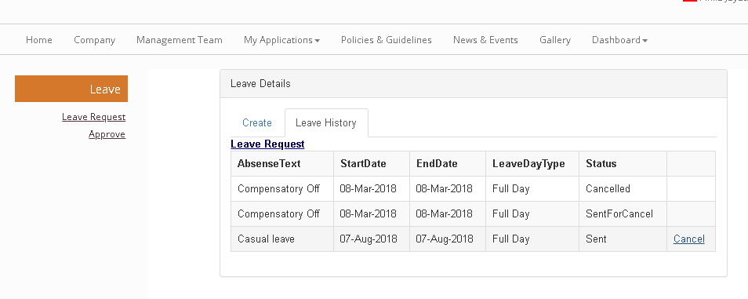

Reporting head needs to approve the cancel leave .
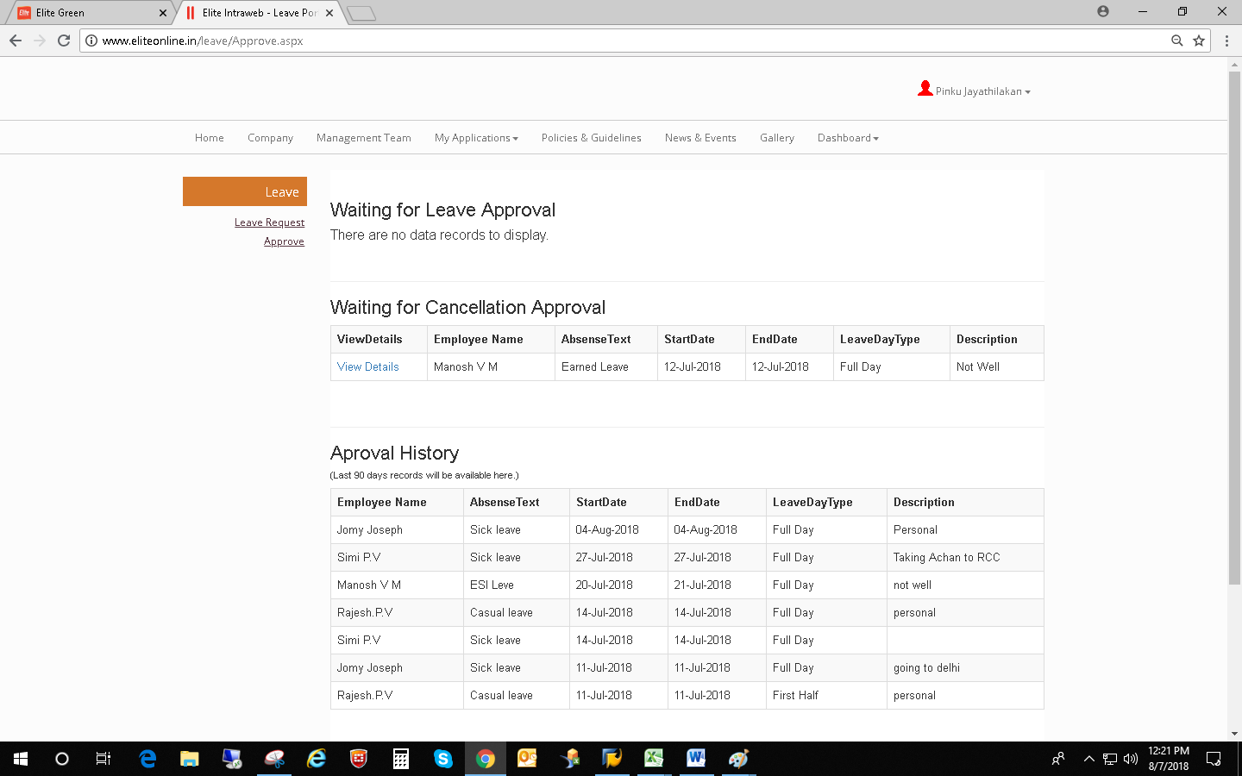
Approve leave by Reporting head:
Click on Approve tab
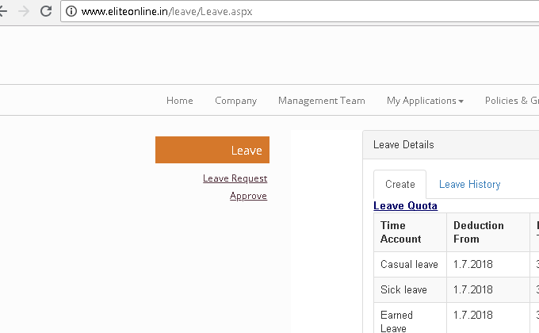
You can either approve or reject one by one.

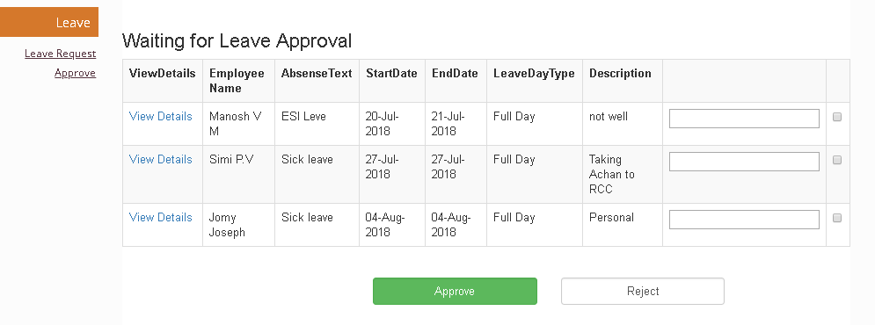

OD portal:
Choose OD portal enter the details as per the requirements and submit
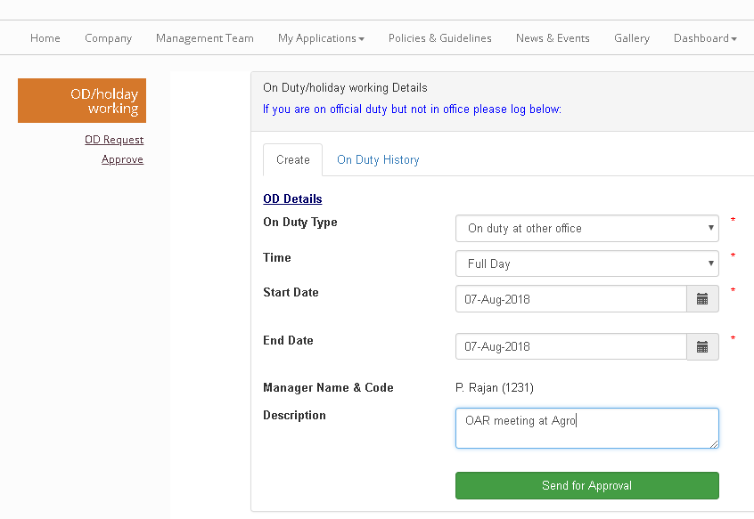

Reporting head can approve or reject the request

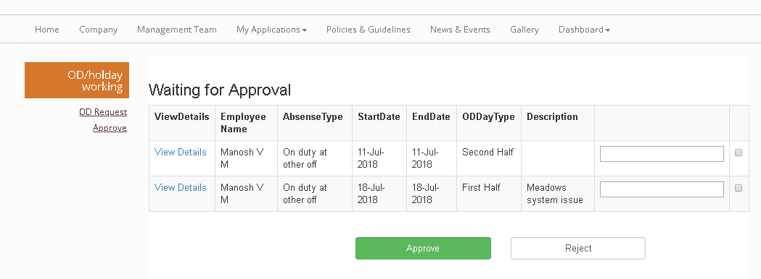

Note: OD cancellation can be done

