# **KBU KARABUK UNIVERSITY**

Kılavuzlar Köyü Öte Karşı Üniversite Kampüsü Merkez Karabük



## PROJECT REPORT ON

**LIBRARY MANAGEMENT SYSTEM**

**MAHAMAT NOUR MAHAMAT ABDRAMAN**

**Student Number : 1810213015**

**HÜSNA POYRAZ**

**Student Number : 2017010213060**

UNDER GUIDANCE OF

## Mrs. NESRİN AYDIN ATASOY

SUBMITTED IN PARTIAL FULFILLMENT OF THE REQUIREMENT OF THE LMS PROJECT OF THE DEGREE OF BCE 5th SEMESTER

## BACHELOR OF COMPUTER ENGINEERING

DECEMBER 2020

# **TABLE OF CONTENTS**

|  |  |  |
| --- | --- | --- |
| **SL No** | **Content** | **Page No** |
| **1** | SYNOPSIS | 3 |
| **2** | SYSTEM REQUIREMENTS | 6 |
| **3** | SYSTEM ANALYSIS | 8 |
| **4** | INTRODUCTION TO LIBRARY MANAGEMENT SYSTEM | 12 |
| **5** | SYSTEM DESIGN | 14 |
| **6** | DATA FLOW DIAGRAM | 16 |
| **7** | FLOW-CHART DIAGRAM | 18 |
| **8** | TABLE DESIGN | 20 |
| **9** | SCREENSHOTS | 22 |
| **10** | FUTURE WORK | 33 |
| **11** | LIMITATION | 35 |
| **12** | CONCLUSION | 35 |
| **13** | BIBLIOGRAPHY | 37 |

**SYNOPSIS**

**Synopsis**

### Objective

With the growing information technology industry, automation of their system and management is desired by all kind of commercial enterprises. As the name suggest Library Management System will deal in the entire requirement needed for managing the activities of College Library. It will deal with the process of maintaining data about the books and many other things as well as transactions which are taking place in the library with respect to the Issue, Cataloguing, Searching and Return of the books.

Library Management System maintains the record of books in the library, issue, purchasing and return process of the books in the library. Here we are primarily concerned with management of books of library. In this project we identify the need for computer-based Library Management Systems.

This software project is developed using C# as the front end and SQL as a back-end. The SQL database stores various book related details.

Hence this covers the following issues:

* Maintains data about the books of the library.
* Arranging data in logical order for easy maintenance.
* Collection of data about books which are issued and requirement for purchasing.
* To provide various search options to know the availability of books in the Library.
* Data about books which are lost.
* Generation of various reports according to the management request i.e. Cataloguing, Searching etc.

**Swihart Stanley S** and **Hefley Beryl F** have defined the term ‘library automation’ as “the processing of certain routine clerical function in the library with the assistance of computer or other mechanized or semi-automatic equipment”. It may also be defined as a process of mechanization of all the housekeeping operation of a library which is repetitive in nature. The housekeeping operation includes acquisition, cataloguing, circulation, serial control, references and administration work.

Automation is a technique to make a system automated, i.e. self-active. For this the electronic machines are used to automate the libraries. By automation, libraries activities such as acquisition, circulation, serial control, information retrieval, cataloguing and indexing can be mechanized by using library software’s.

The Library Automation means:

* Computerization of the entire house keeping operation of the library.
* Operate a computerization library management system.
* Offer new services based on the technologies and also integrate the traditional library operations in the era.

### Abstract

The purpose of this project is to design for new library management system to replace their existing manual, paper-based system. The new system is to control the following information:

* + Books information;
  + Student information;
  + Booking in progress and termination.

These services are to be provided in an efficient, cost effective manner, with the goal of reducing the time and resources currently required for such tasks.

A significant part of the operation of any Library involves the acquisition, management and timely retrieval of great volumes of information. This information typically involves customer personal information, book information and status. All of this information must be managed in an efficient and cost wise fashion so that an institution's resources may be effectively utilized. The library management system will automate the management of the college/institution making it more efficient and error free. It aims at standardizing data, consolidating data ensuring data integrity and reducing inconsistencies.

## The Automated System Have Following Benefits OverManual System

* **Data handling:** It captures the information from different sources, presents it systematically and organizes its storage for efficient retrieval.
* **Quality control:** Paper work would totally be eliminated in the new system as failure data is directly fed into system.
* **System reliability:** System is very reliable as no skipping, missing of data is possible.
* **Maintenance:** No data mismatching is possible due to various checks incorporated in the system.
* **Accuracy:** The data provided by the system will be accurate as all Processing steps are algorithmic and computer based.
* **Centralized Storage:** The data is Processed and stored at central location.
* **Security:** The data is processed and stored using .net framework based application. Hence all the security features related to .net framework are used.

**SYSTEM REQUIREMENTS**

**HARDWARE REQUIREMENTS**

Processor: Intel core i3 or above

RAM: 4GB RAM or above

Monitor: 15” Color Monitor

Keyboard Mouse

**SOFTWARE REQUIREMENT**

Operating system: Windows 7 /or upgrade

Developing Tool: C#

Database: SQL Server Database

**SYSTEM ANALYSIS**

### Introduction to system analysis

System analysis is a process of gathering and interpreting facts, diagnosing problems and the information to recommend improvements on the system.

It is a problem-solving activity that requires intensive communication between the system users and system developers. System analysis or study is an important phrase of any system development process.

The system is studied to the Minutes detail and analyzed. The system analyst plays the role of the interrogator and dwells deep into working of the present system. The system is viewed as a whole and the input to the system are identified the outputs from the organizations are traced to the various processes.

System analysis concerned with becoming aware of the problem, identifying the element and decisional variables, analyzing and synthesizing the various factors and determining an optimal or at least a satisfactory solution or program of action.

A detailed study of the process must by various techniques like interviews, Questionnaires etc. The data collected by these sources must be scrutinized to a Conclusion. The conclusion is an understanding of how the system functions. This system is called the existing system. Now the existing system is subjected to close study and problem areas are identified. The designer now functions as a problem solver and tries to sort out the difficulties that the enterprise faces.

Solution is given as proposals. The proposal is then weighed with the existing system analytically and the best one is selected. The proposal is presented to the User for an endorsement by the user. The proposal is reviewed on user request and suitable changes are made. This is loop that and as soon as the is satisfied with proposal.

### Existing system

The activity of taking book from library can prove to be a rather difficult task. In the existing system of our college/institution, all the operations are done manually which leads to a huge slowdown in the task treatment. Added to this, is the concern in the consultation of the data already written or recorded in the register’s notebook. This work is very tedious and causes considerable irregularity when there is a loss of documents.

* Lack of security of data;
* Large volume of physical documents to collect and exploit;
* More man powers.

### Proposed system

Limitations faced in the existing system can be overcome with the concept of the new Library Management System.

All tasks performed manually can be done with computerized systems nowadays. Today Library System management has become the most efficient way to take a book very fast.

### Features of the system:

* **System Admin Login:**

It is a portal for the system administrator. With this account it manages and has access to the entire system. the management of students, books, taking book operation are his main function. It can also add a new books and student.

### Book screen:

The book screen is a screen that allows the admin to have an overview to all the books and also manage the book by adding, deleting and update the table and to assign book to a student.

### Student screen:

The student screen is a screen that allows the system admin to have an overview on the student status and also manages the information operations on the students such as: adding, delete and update information about students.

### Feasibility study

Feasibility study is conducted once the problem is clearly understood. Feasibility study is a high-level capsule version of the entire system analysis and design process. The objective is to determine quickly at a minimum expense how to solve a problem. The purpose of feasibility is not to solve the problem but to determine if the problem is worth solving.

The system has been tested for feasibility in the following points:

* + Technical Feasibility;
  + Economic Feasibility;
  + Operational Feasibility.

### A- Technical Feasibility

The project entitles "Library Management System” is technically feasible. The more important thing is given to the hardware interaction part of the system. The assessments of the technical feasibility center on the existing to what extent, it can support the proposed addition. This was based on an outline design of the system requirements in turns of inputs, files, programs, procedures and staffs. It involves financial considerations to accommodate technical enhancements.

### B- Economic Feasibility

Economic analysis is the most frequently used method for evaluating the effectiveness of a proposed system. It’s more commonly known as cost benefit analysis, the procedure to determine the benefits and saving that are expected from a candidate system and compare with costs. If the benefits outweigh costs, the decision is made to design and implement the system. Otherwise, make alternations in the proposed system.

The innovation of the new system has much influence on the economical side of the company. Manuel system is highly cost driven due to high labor costs. Thus, the system is economically feasible.

### C- Operational Feasibility

In this project, the management will know the details of each project where he may be presented and the data will be maintained as decentralized.

**INTRODUCTION TO LIBRARY**

**MANAGEMENT SYSTEM**

Today, computer science is the medium of knowledge and communication in all fields, whether its economic, scientific or medical. It has become one of the strategic challenges for our society. Today any company that wants to increase its performance is obliged to invest in computer tool because this investment will have an impact on the development and competitiveness of the company.

The library management detail in management of records. The records include books which are required by different students accordingly. Maintaining these records manually becomes difficult thus we are proving such system a computerized backend.

In this system each member is provided with a member code and all the records are maintained in a table along with the member’s code. Any information can be accessed according to member-code anytime from the table and also at the time of issuing books.

**SYSTEM DESIGN**

In this phase a logical system is built which fulfils the given requirements. Design phase of the software development deals with transforming the student requirement into a logically working system. Normally, design is performed in the following throw step:

### Primary design phase

In this phase, the system is design at block level. The block is created based on analysis done in problem identification phase. Different block is created for different functions emphasis is put on minimizing the information flow between blocks. Thus, all activities, which require more interaction, are kept in one block

### Secondary design phase

In the secondary phase the detailed design of every block is performed.

### The general task involved in the design are the following:

* Design various blocks for overall system processes
* Design smaller, compact and workable modules in each block
* Design various database structures.
* Specify details of programs to achieve desired functionality
* Perform documentation of the design
* System reviews

### User interface design

User Interface Design is concerned with the dialogue between a user and the computer. It’s a concerned with everything from the system starting or logging into the system to the eventually presentation of the desired inputs and outputs. The overall flow of screens and message is called a dialogue.

The following steps are various guidelines for user Interface design

* The system user should always be aware of what to do next.
* The screen should be formatted so that various types of information, instructions and messages always appear in the same general display area.
* Message, instructions or information should be displayed long enough to allow the system user to read them.
* Use display attributes sparingly.
* The system user should never get an operating system message or fatal error.

**DATA FLOW DIAGRAM**

**Admin**

**Student**

**Login**

**Issue books**

**Return books**

**Students**

**Books**

**Category**

**d**

**sys**

**Manages modules**

**FLOW-CHART DIAGRAMS**

Success

Exit

View Students

Add Student

View Books

Add Book

Login

Home Page

Book Details

Return Book

Issue Book

Students

Books

Dashboard

Error

Username

&&

Password

Book Search

START

**TABLE DESIGN**

|  |  |  |  |  |  |  |  |  |
| --- | --- | --- | --- | --- | --- | --- | --- | --- |
| FIELD NAME | ID | BOOKS NAME | BOOKS AUTHOR | BOOKS PUBLICATION | BOOKS PURCHASE | BOOK PRICE | BOOKS QUANTITY | AVAILABLE QUANTITY |
| DATA TYPE | INT | VARCHAR | VARCHAR | VARCHAR | DATE | INT | INT | INT |

**Book info**

**Issue book**

|  |  |  |  |  |  |  |  |  |  |  |
| --- | --- | --- | --- | --- | --- | --- | --- | --- | --- | --- |
| FIELD NAME | ID | STD ENROLL | STD NAME | STD DEPT | STD SEM | STD CONT | STD EMAIL | BOOKS NAME | BOOKS ISSUE | BOOKS RETURN |
| DATA TYPE | INT | INT | VARCHAR | VARCHAR | INT | INT | VARCHAR | VARCHAR | DATE | DATE |

**Library admin**

|  |  |  |  |  |  |  |
| --- | --- | --- | --- | --- | --- | --- |
| FIELD NAME | ID | FULL NAME | USERNAME | PASSWORD | EMAIL | CONTACT |
| DATA TYPE | INT | VARCHAR | VARCHAR | VARCHAR | VARCHAR | INT |

**Student info**

|  |  |  |  |  |  |  |  |  |
| --- | --- | --- | --- | --- | --- | --- | --- | --- |
| FIELD NAME | ID | STD NAME | STD IMAGE | STD ENROLL | STD DEPT | STD SEM | STD CONTACT | STD EMAIL |
| DATA TYPE | INT | VARCHAR |  | INT | VARCHAR | INT | INT | VARCHAR |

**SCREENSHOTS**

### Home Page

### LOGIN PAGE

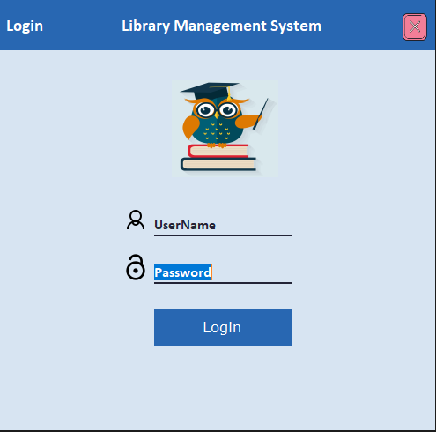

### DASHBOARD PAGE

### 

### ADD BOOK PAGE

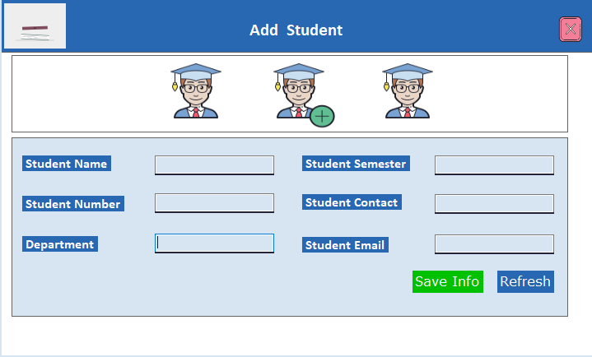

### VIEW BOOK PAGE

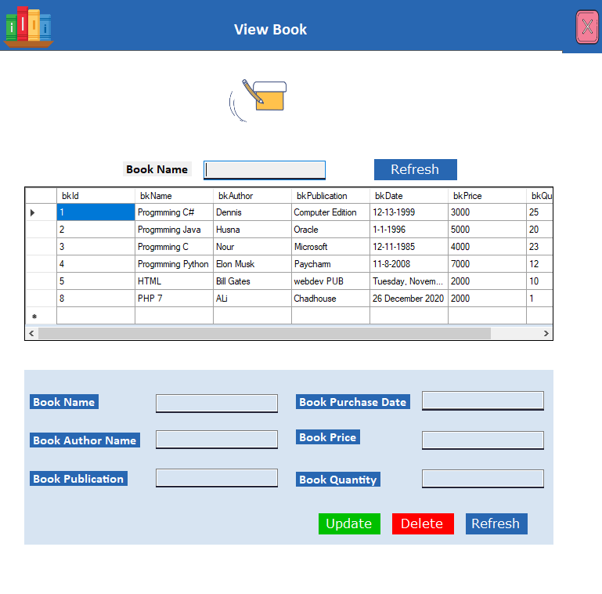

### ADD STUDENT PAGE



### VIEW STUDENT PAGE

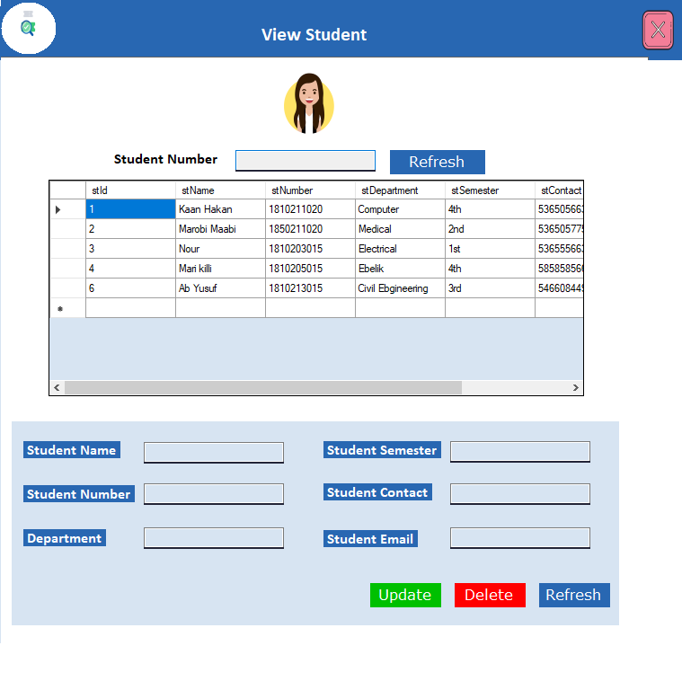

### ISSUE BOOK PAGE

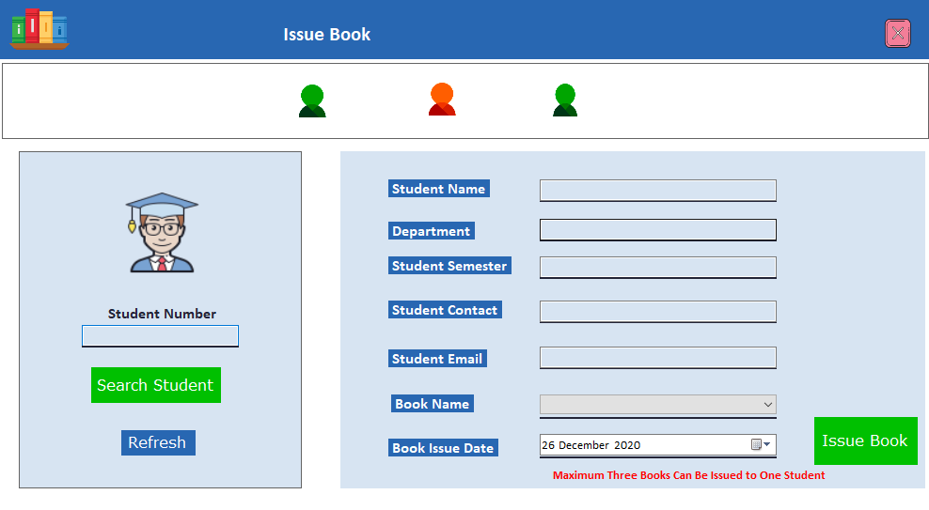

### RETURN BOOK PAGE

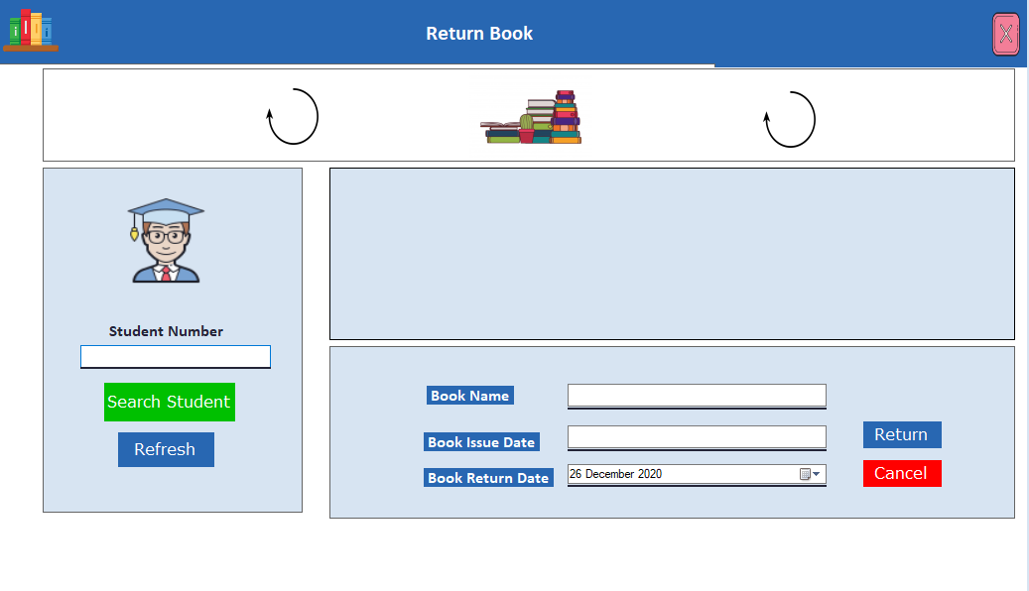

### COMPLETE BOOK DETAIL PAGE

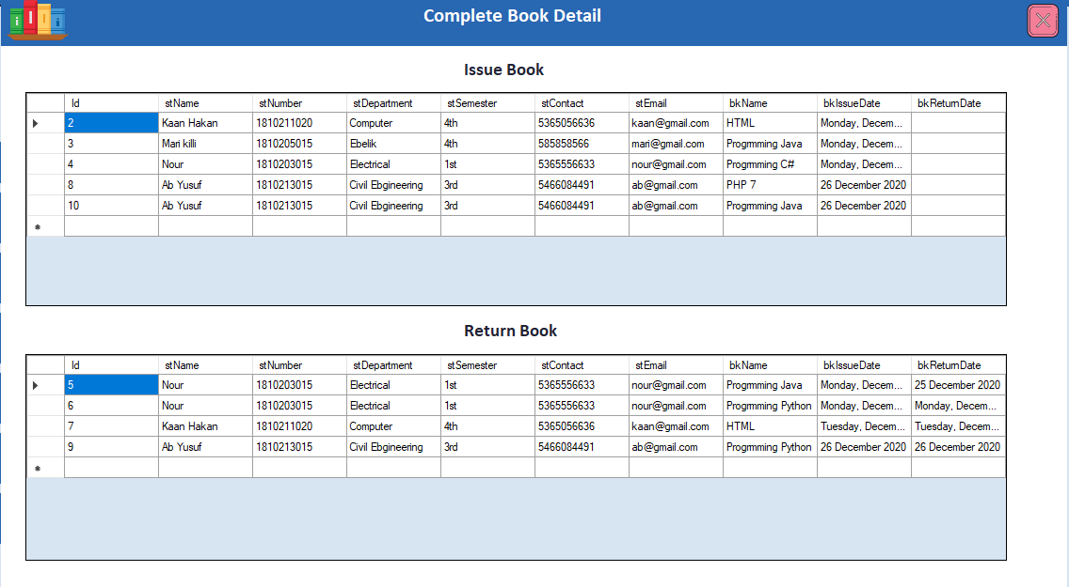

**Future work**

**Future work**

* + Make the system online based
  + Adding email verification option
  + Remember password option
  + Limitless data operation will be added
  + Students will issue and return book by themselves

**Student Dashboard**

**LIMITATION**

**AND**

**CONCLUSION**

**LIMITATION**

This application has Perform the limited activity of College Library Management System .These limitation are following:-

* This application do not support the networking.
* It maintained the limited operation of data.
* Reporting is not in well formed

**CONCLUSION**

Library Management Program has been created keeping in mind the needs of Small and Medium scale libraries. It’s efficient software that includes all the basic functionalities like making data entries for new books, newspapers and magazines, registering a new user, editing and deleting records that are required for smooth functioning of a library. Additionally the user login and book history are also stored and can be accessed by the administrator. It also facilitates the librarian to create new user groups and edit their access levels and functions (like that of the assistants).

**BIBLIOGRAPHY**

* + [www.youtube.com](http://www.youtube.com/)
  + [www.google.com](http://www.google.com/)