Internal stakeholders. An internal stakeholder are people that directly linked directly to the project. Because we don't have a company we don't have employees other than ourselves. So we, as members of our team are the only internal stakeholders this project has. The basic expectations of our group is that the project will be delivered on time, will satisfy its target audience, and will be egliable for the good mark.
External stakeholders. Other people who are not associated with the team but can affect the project in some way are potential external stakeholders. There are several common big groups of external stakeholders:
- Customers are the biggest external stakeholder group, which directly contribute to the project's success. The main expectation for our customers is to get a product that will improve the quality of their life and reduce the costs associated with food.
- Because our project is non-commercial in nature, we don't have any investors, shareholders, or vendors that can benefit from this project and be invested in it. At least initially. But potentially, if the project becomes popular and the team grows into a startup, it can create potential interest for this group. So we can assume that at least some investors can expect this project to become popular, and provide high ROI for this project in the long term.
- In some sense, we can say that the government can be viewed as a stakeholder because the social effect of our application. We can make an assumption that the government expects this project to cause some positive effects (healthy eating can increase the quality of life, potentially boost average life expectancy of the populous, and ease the financial burden for some people) without any associated costs.
- Because our project is digital and doesn't have any physical medium, our potential suppliers are application stores or hosting services that provide access to our application. Even if they don't necessarily earn any money from this product, they can benefit from our product. Our suppliers can expect our application serve as an advertisment and indirectly increase popularity of their own service.
- We can view other developers and publishers as external stakeholders. For example, some food service can be interested in cooperation that will benefit their project as well. This group can expect this mutually benefiting bussiness to increase the own profits and popularity.

Competitors:
- Epicurious (https://www.epicurious.com/)
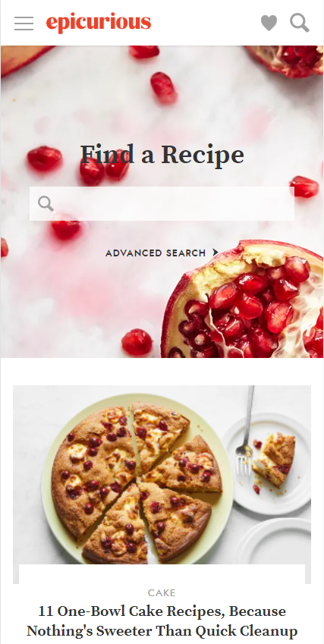

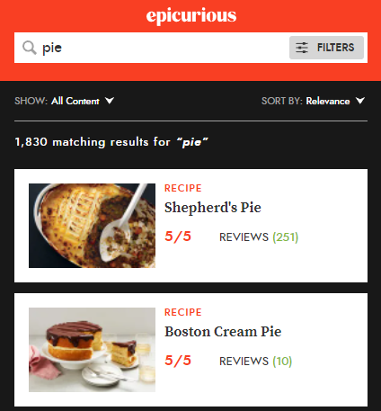

Pic. 2 – Sidebar / Functionality

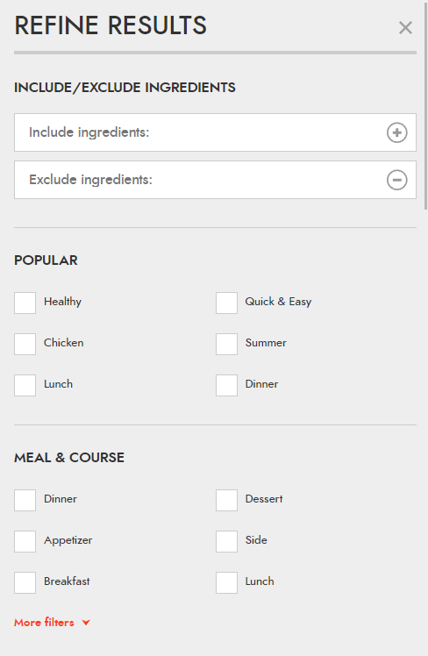
Pic.1 – Main page (Search, popular recipes)

Pic. 3 – Search page results + filter button Pic. 4 – Search filters( popularity, meal, ingridiendts, cuisine, holiday, techniques)
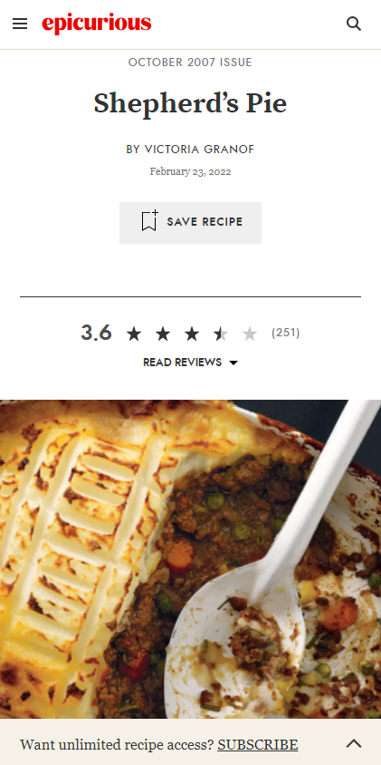
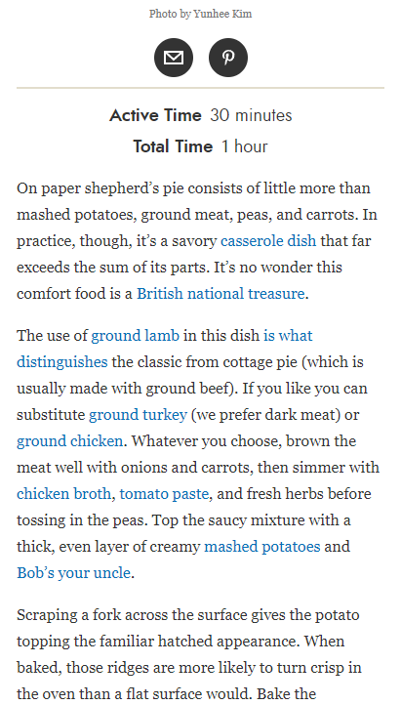

Pic. 5 – Recipe page (name, rating, date, pic) Pic. 6 – Recipe page (time + descr.)
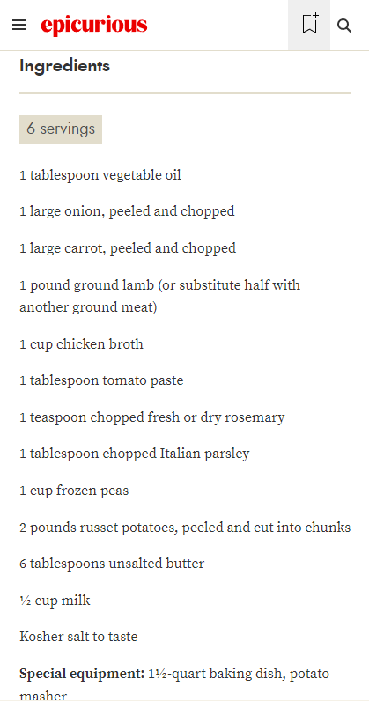
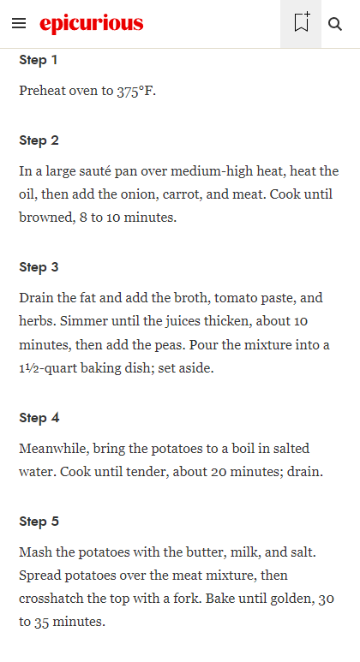

Pic. 7 – Recipe page (ingredients) Pic. 8 – Recipe page (steps)
- All recipes (https://www.allrecipes.com/)
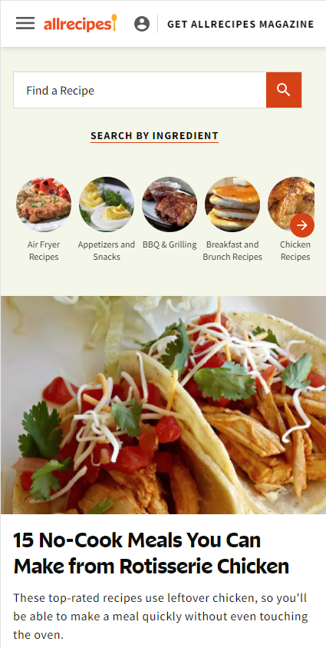
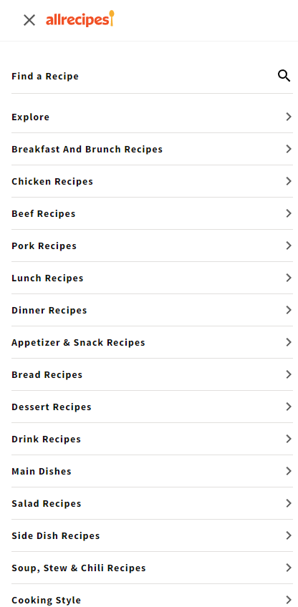

Pic.9 – Main page (Search, popular recipes) Pic.10 – Menu (Different recipe categories)
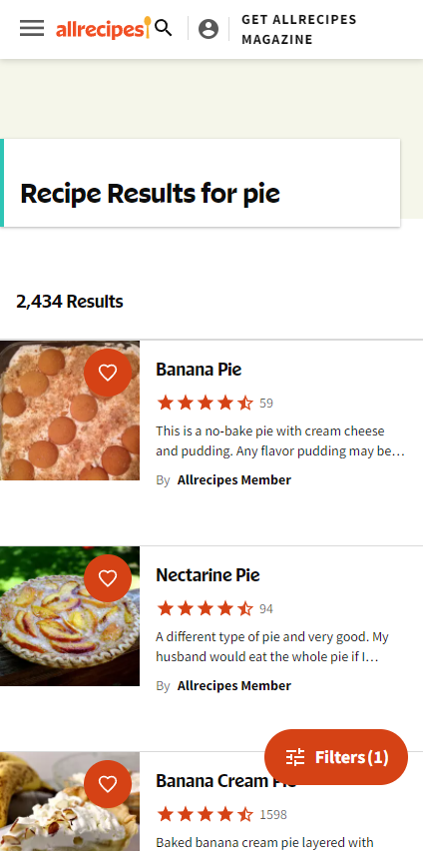
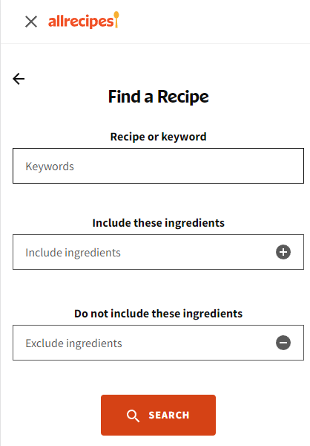

Pic. 11 – Recipe search + ingredients filter Pic. 12 – Recipe search results

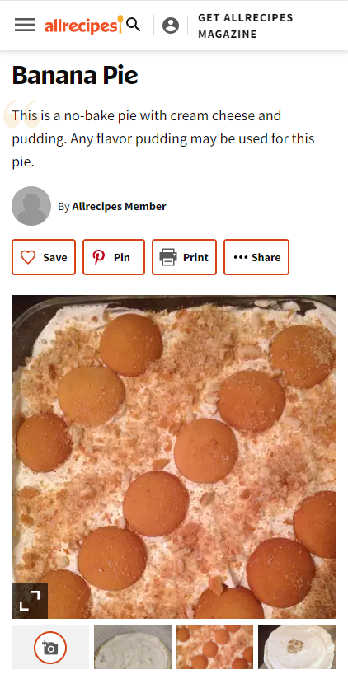
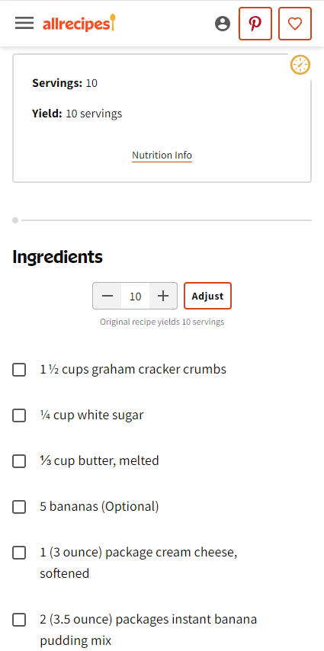

Pic. 13 – Recipe page (name, pics) Pic. 14 – Recipe page (ingredients, adjusting)
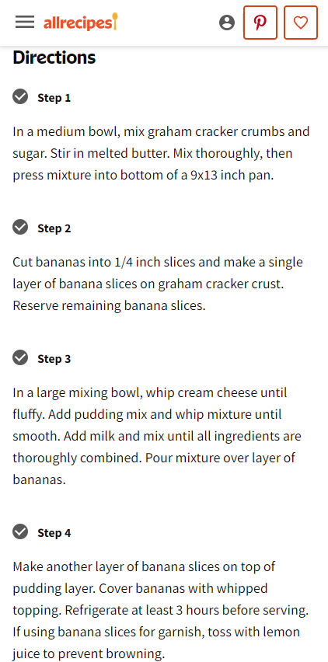
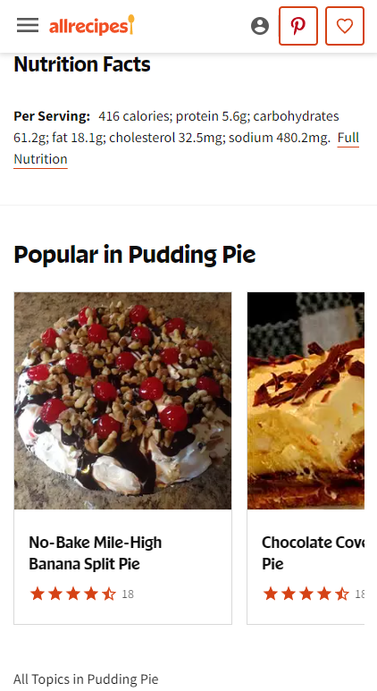

Pic. 15 – Recipe page (directions) Pic. 16 – Recipe page (Nutrition Facts + other)
- Yummly ()
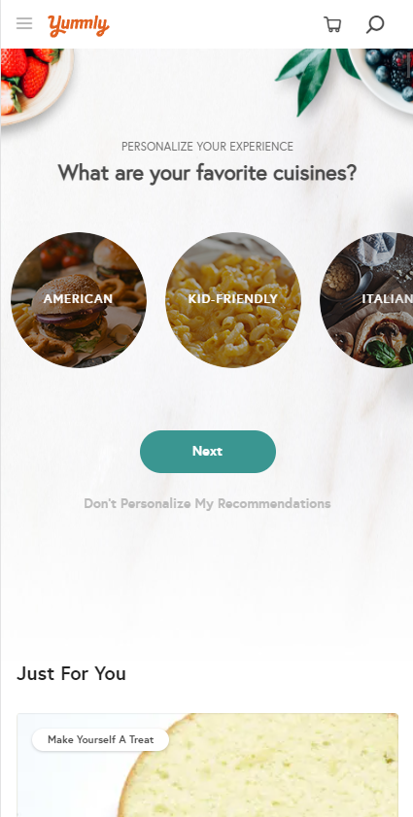
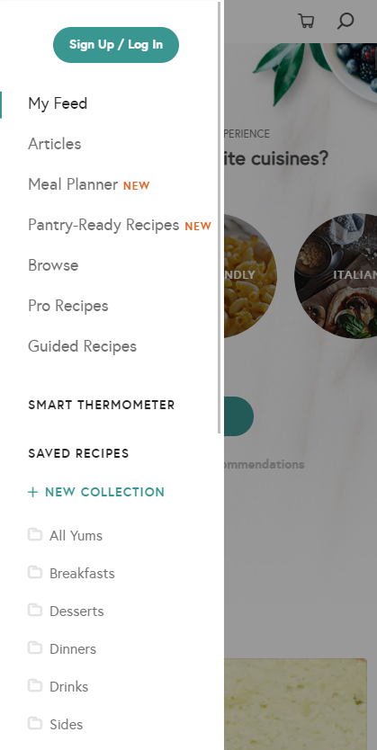

Pic. 17 – Main page (Recommendations) Pic. 18 – Menu (Articles, Planner, Recipes)

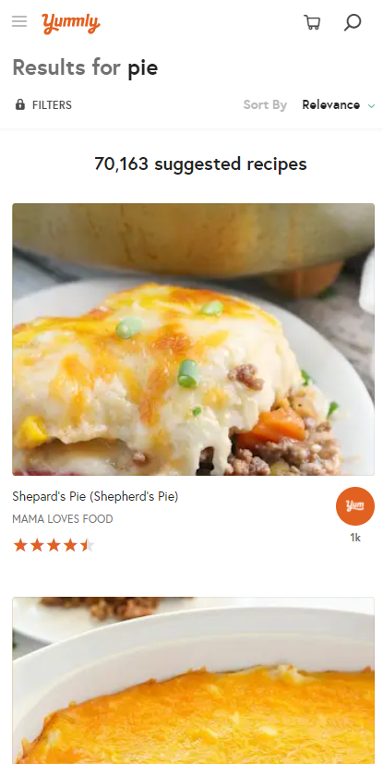

Pic. 19 – Recipe search Pic. 20 – Recipe search results (filter locked)
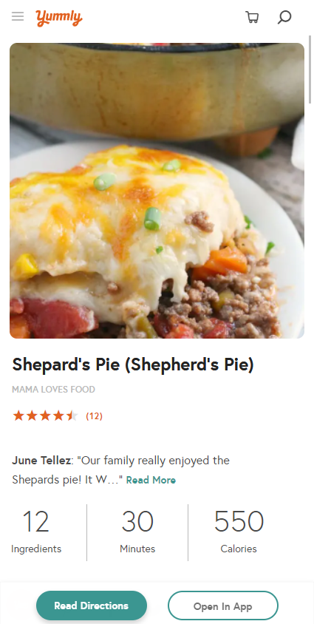
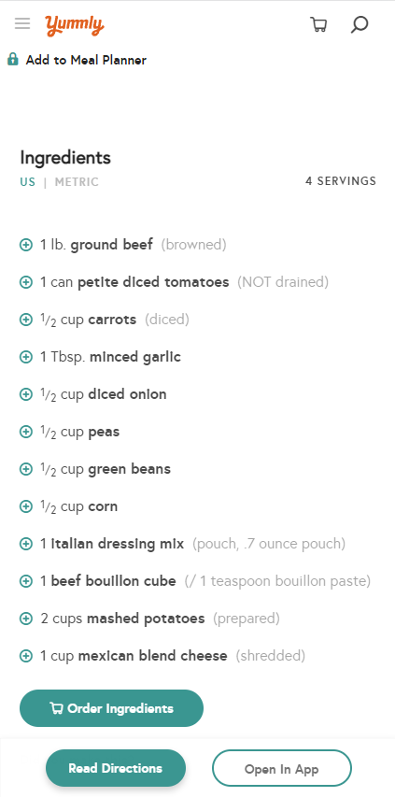

Pic. 21 – Recipe page (pic, name, rating, info) Pic. 22 – Recipe page (add to planer, ingredients)
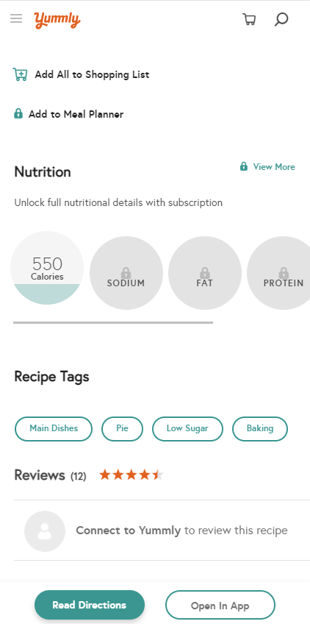
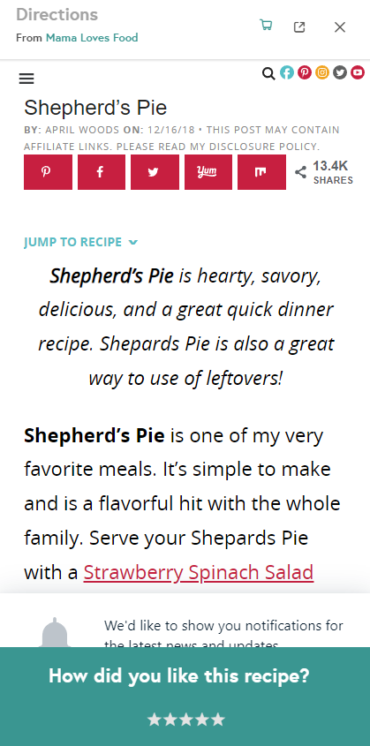

Pic. 23 – Recipe page (nutrition, tags, rating) Pic. 24 – Recipe page (directions)

