“Under the Pyramids” cipher:
1) Write your message in shape of pyramid (1st row – 1 letter, 2nd row – 2 letters, etc), we can use delimiter symbol (for example – dot) to separate words, and if the last row is incomplete – fill it with random characters after the last delimiter.
Example: “Meet me in cafe at 5 am” will look something like “meet.me.in.cafe.at.5.am”, and in “complete pyramid” form:
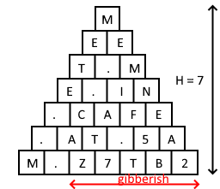
Fig. 1 – Formatted message

2) Calculate Height of the pyramid, our example has height – 7;

3) Now, we move from the characters to the numbers: we use number for each character (a – 1, b – 2, ..., z – 26, after the letters we use numbers, so ‘0’ – 27, ‘1’ – 28, …, ‘9’ – 36, and finally delimiter symbol – 37).
Our formatted message will look like this in number form.
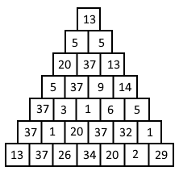
Fig.2 – Formatted message in number form

3) To encrypt message, we will go from top to bottom, and add number to each “cell” based on the height and current “iteration”. If height is odd we “encrypt” from “left to right”, if height is even – “from right to left”. When we reach the end of the “column” we start from the next one.
For example: In our case encryption will look something like that
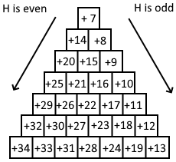
Fig.3 – “Pyramid” cypher

4) We update numbers of our “formatted” message using cypher. When we go over the last index – loop over, so I can just update numbers like this: n = (n + update) modulo 37
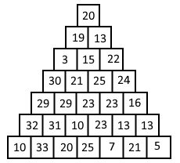
Fig.4 – Cyphered message in number form

5) Now we transform message from numbers back to characters and print it from top to bottom, from left to right: “tsmcov3uyx22wwp54jwmmj6tygue”

6) To decypher the message we reverse the steps: write message in the pyramid form, top to down, left to right. After that, we move from the characters to numbers. Then we check the height. Next step, we deduct numbers, starting from the top – for the top of the pyramid we deduct the height of the pyramid. If height is odd – move from left to right and vice versa if height is even, increasing the value deduced by 1. Last step is to move back to the characters and write the message, dropping the gibberish part (if any) at the end.

