MEMES – THE DNA OF THE SOUL

1 Aims, objectives and background

1.1 Project background
“The Only Constant in Life Is Change” - these words are associated with the ancient Greek philosopher Heraclitus[1]. But the truth of that phrase is still very relevant today, and it can be associated with every aspect of our life, and culture is no exception. Technology made a very big impact on our lives, and the digital era requires appropriate “digital” culture. Internet memes are phenomena that started as a simple idea that grew into something bigger.
The oxford dictionary defines a meme as “an idea that is passed from one member of society to another, not in the genes but often by people copying it” or “an image, a video, a piece of text, etc. that is passed very quickly from one internet user to another, often with slight changes that make it humorous” for the internet meme[2]. I have been fascinated with this topic, but unfortunately, it doesn't get enough coverage in scientific papers. Even among these scares papers, the majority of works related to social implications like cultural shifts and public taste[3]. But there are not many works that tap into the reasons why some images or videos become cult classics, while others struggle to become even relatively popular. There are some works that focus on the popularity of the other digital content from the independent creators (like YouTube videos or Twitter posts) but not that much is going on for the internet memes[4].
Because of this, I decided to use statistical and data science techniques to analyze the internet meme data and try to find the reasons behind their popularity.

1.2 Aims and objectives
Understanding the reasons behind popularity can help us better understand ourselves: what is catching our interest, how do our preferences change with time, what preferences are general for the wide audience and what is better suited for the specific groups? My aim for this research is to analyze the big body of statistical data for internet memes, identify the popular trends among them and determine the factors that can explain their popularity (or lack of it). To analyze the memes I plan to investigate the metadata that comes along with each internet meme and try to find the potential correlation between these metadata pieces and popularity.
To reach these aims I plan completion of the following objectives:
- Discover and acquire the dataset that will be appropriate for the task;
- Decide on methodology and metrics that will be used to analyze the popularity and the underlying factors;
- Explore, verify and format the dataset for the further analysis;
- Inspect and analyze the data: check what data do we have, how it can be used to achieve our goal, and what possible information we can gather from it;
- Make a conclusions about the link between the popularity and other factors and lay out the foundation for further analysis in this research field;
It should be noted, that in scope of this work I will focus on the metadata and correlation between different factors. The semantic analysis is out of the scope of this research, but I will give some implications, that will connect this research with the idea of one focused on the content of memes.

1.3 Data relevance and ethics of use
The first challenge for this research is to find suitable data for the analysis. As I stated before, internet memes are mostly just an image with a few lines of text, and such content is not very informative. There is a possibility to use machine learning to analyze different images, read the text content from them, and use NLP methods to carry out sentiment analysis.
One problem with content research is that many images used are copyright protected, and it can be hard to find the original because memes are prime examples of so-called remix culture[5]. Another problem is that the content of the memes can be not very ethical: there are a lot of memes that may be described as discriminating based on race, gender, age, religious beliefs, and so on[6]. Because of this, I decided to analyze not memes themselves but rather metadata that carries some additional but valuable information. This way, I will be able to evade potential problems associated with unethical data and don't need to worry about intellectual property because metadata is not a subject to copyright [ 7, https://digitalcommons.unl.edu/cgi/viewcontent.cgi?article=1060&context=scholcom]. For the same reason, I don't experience any risks associated with the use of personal information because these statistics are anonymous.
Because internet memes are folklore in nature, there is no single source that we can trace back to collect the required data. But hopefully, several resources keep track and aggregate internet memes (at least a big chunk of it) that we can use to get related information. I looked up several resources, but they still describe my decision based on the three biggest ones.
First one: “Know your Meme” is a website that serves as a database of internet memes and other popular online materials[8]. It is dedicated to documenting Internet phenomena, storing a big amount of data, categorizing it, and such can provide a solid foundation for this work. The only problem with using this source is that it is designed for viewing purposes, and there is no easy access to the database – no direct download links, no API to get it through.
The second potential data source I analyzed is “Memebase”[9] – it is the same idea as the previous one, but worse. There is almost no metadata besides information about the authorship and origin, and also no reliable way to pull out data. So even if I decide to scrape this web resource, there is not much to work with.
The last source I want to discuss is “Imgflip”[10] – This resource is a little bit different. It is focused on the creation of images, animations, charts, etc. But it also contains a great number of internet memes as templates and has a popularity rating. The problem with this source is the same as with the last one – this resource is more concerned with the content of the memes, and doesn't provide a lot of information to work with (even the popularity score is hidden for the user) in terms of metadata analysis.
Based on this, I decided to collect data from the “Know your Meme” website because this resource had the maximum amount of information about the memes and had a very big database of entries. Initially, I scraped data from this website, but after a little search and analysis, I decided to use the dataset scraped from this website by other people[11]. I compared my dataset to this one: the data scraped by me was fresher but less numerous (I will explain this later). But even this old data contains all information required to analyze the factors of popularity, so I decided to use already scrapped data because, In my case, the quantity is more important than having a little bit more up-to-date data.
The quality and quantity of data directly affect the results of the analysis. A big dataset lowers the chance of the variance in the data and thus increases the accuracy[12]. There are more than 25 hundred entries from the period of more than 10 years in my dataset. It contains memes of different types that have been collected from different sources – this ensures a minimal risk of any type of bias associated with skewed data acquisition. Most of the data is statistical by nature and doesn't have any negative implications, but there is a possibility that some names of the memes, origin places, and some tags are provocative, irresponsible, contain strong words, cover suggestive topics, and such. So I think this dataset is recommended for the mature audience because it can cause a moderate impact on the viewer. In terms of intellectual property – anyone who wants to use this dataset for themselves is required to comply with the terms and conditions of the data source. As for the analysis – it compiles existing data. Theoretically, it can be copyrighted if it creates something new, but this is not the case [13, https://libguides.library.kent.edu/data-management/copyright].

2 Data acquisition and modification
2.1 Preparation
In case of this work I used several Python libraries and modules. To make this all possible we start from importing and setting them up.
from socket import timeout
import requests
import urllib3
from bs4 import *
import time
import concurrent.futures
import pandas as pd

2.2 Data acquisition
As I stated before, initially I decided to scrape the internet meme data from the website “Know Your Meme” [14]. Each page of the website consists of 16 links to the different meme entries. So I split the work in three steps: I iterate over number of pages, for each page I collect the links to individual meme pages, and in the end I iterate over every single entry page and scrape the required data from here and store this a file. I used a simple script to get this data.
First one is the function to get the links from the single meme page:
def getLinksFromPage(pageNum):
Next one expands upon the previous one. It helps to collect links from all pages in specified range:
def getLinks(startPage, numOfPages):
This function is designed to scrape the data from the link to the individual meme page:
def linkToStr(link):
To scrape the data from several pages at once I used this function:
def linksToStr(links):
The final function is the one that stores all data scraped (to the CSV file) for the future use:
def saveMemes(startPage, numOfPages):

2.3 Web scraping the data
Now, let me scrape some data to demonstrate the concept in work. I tested on the first page of the popular memes page (https://knowyourmeme.com/memes/popular/page/1).
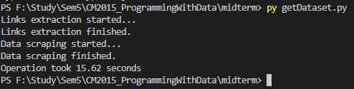
2.3 Alternate source
I was able to get the data, but the problem arose when I modified it to increase performance of the data scraping scripts I used (I increased the number of threads and lowered the sleep timeouts to mere seconds). The “DDOS protection” of the website blocked my IP address several times for suspicion of malevolent activity.
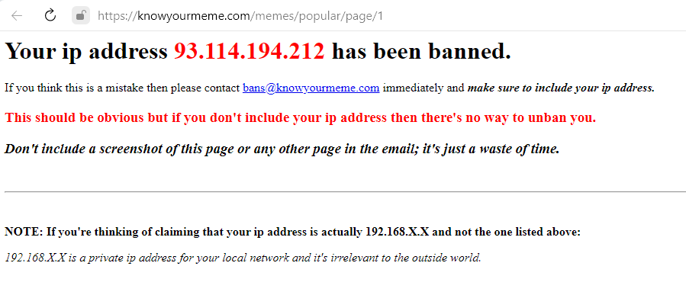
So I was left with 2 options: to collect data in small portions over long time frame or find another solution. I started with the option one and tried to find some other way to get access to their data other than scraping. Luckily, I was able to find that someone already scrapped a great amount of meme data from this site and put it on the “Kaggle” website [15,https://www.kaggle.com/datasets/podsyp/a-lot-of-memes-info-stats]. The only downside is that this dataset is a bit outdated (2020), but because my aim is to find possible correlation between factors and analyze the effect rather than trends and preferences, it is good enough.

2.4 Data cleaning and modification
To make the dataset satisfy the size requirement (10 MB limit) I dropped two last columns (origin,other_text) that contain text explanations of origin and references. This information add a lot of weight (in megabytes) to the dataset, and not likely affecting the popularity of the meme itself. The data is stored in the CSV format, so I use “Pandas” library to read it, transform it into the data-frame and drop last columns.
# Read file, select all columns except the last two and save it to CSV file
df = pd.read_csv('memes_dataset.csv')
df = df.iloc[:, :-2]
df.to_csv('new_file.csv', index=False)
IMPORTANT: The file that is attached to this report represent the data right after this truncation, but before any additional modifications!
Now, let's load this dataset file, read it as dataset and check our data.
df = pd.read_csv('new_file.csv')
print(df.head(10))
The data looks like this:
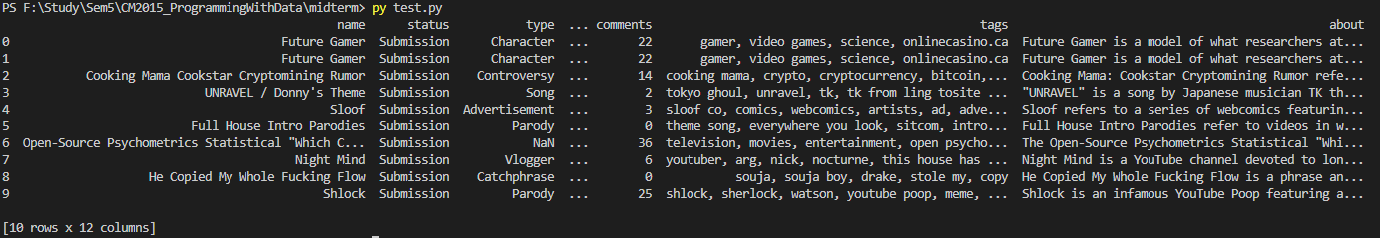
First thing that catches my eye is duplicate data in first two rows. I experienced the same problem while scrapped some data. As I understand it this happens when you scrape the data in small portions in different time periods. So this duplicate entries are just a “ghosts” that represent the same meme page with the data from the different time period. To prove this I checked the data from the first two entries
print(df.head(2))
and the only difference is the views count (and the difference is not that significant):
To remove duplicate entries I started by sorting all entries by their view count and removed the ones that have the lower view count. After that I group up the data by the name to check that all duplicates been eliminated successfully:
df = df.sort_values('views', ascending=False)
df = df.drop_duplicates(subset='name', keep='first')
df = df.groupby(by=['name'])['name'].count().sort_values(ascending=False)
print(df.head(10))

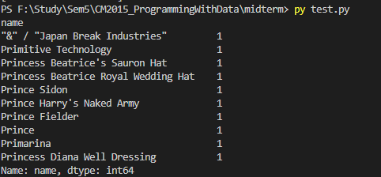
After rows been cleaned up, I move to the individual columns and check the data types. Lets check columns up using data types property of the data frame:
print(df.dtypes)
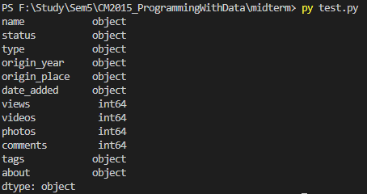
First column – 'name' contains the names of the memes and stores data as Pandas 'object' data type (basically python “string”). I don't modify this column, because there is no real suitable alternative to this datatype representation. Besides, we don't use the names to calculate the correlation, or categorize our data (each name is unique), so no modification here.
The next column – 'status' describes the state of recognition of the meme. There are 3 states of the memes in the “Know your meme” database: “submission” - represents the new meme entry that is currently being evaluated, “deadpool” is the status of the rejected meme (because the entry is incomplete or not very noticeable) and “confirmed” is the approved meme status. This column is also the 'object' data type, but here it requires modification, because I plan to measure if memes status correlates with it's popularity (in terms of view count). To do this, I create category type and change the status column datatype to this category:
status_type = pd.CategoricalDtype(
categories=['Submission', 'Deadpool', 'Confirmed'], ordered=False)
df['status'] = df['status'].astype(status_type)
Third column - “type” is the tag that helps identify the main idea of the meme. But the difference is, there is no real predefined categories, so the number of tags is not limited to the few available options, and some entries doesn't even have a type. But even in this case, because there are some repeating values it is much better to modify the data type. This way I can save some memory space and lower the time required to analyze this column. First of all, I change all 'missing' values to the 'Undefined' tag, then create category and after that modify the column data type.
df['type'] = df['type'].fillna('Undefined')
memeType_type = pd.CategoricalDtype(
categories=df['type'].unique(), ordered=True)
df['type'] = df['type'].astype(memeType_type)
Next column - “origin_year” holds the year that meme originated. Default datatype for this column is also 'object', and we have several options to change it. First of all, because the year is basically a number, I can cast it to integer (int64). It can reduce the size required to store this data and help with some mathematical operations, but the thing is – we don't need it (we don't add year's together or multiple them). It can be modified to the date type, but better option is, again, changing this column to the category type, because it will allow us to utilize resources the best way. But another problem with this column is that there are many invalid or suspicious values. So to deal with it, I decided to leave only memes that are originated in the period of the century (starting from the 2020, because this dataset is a little bit outdated). All origin year values higher that 2020 or lower than 1920 is be set to 'Unknown'. Then I create the categorical type, and change column type to this category:
df['origin_year'] = df['origin_year'].map(lambda val: val if val != 'Unknown' and int(
val) >= 1920 and int(val) <= 2020 else 'Unknown')
year_type = pd.CategoricalDtype(
categories=sorted(df['origin_year'].unique()), ordered=True)
df['origin_year'] = df['origin_year'].astype(year_type)
The “Origin_place” column is similar to the previous one, but only store string values representing original source of the meme. Some of this tags are repetitive, others are not. To gain advantage of using the categorical type I decided to change origin places that only show once to “Other”.
popular_origin = df['origin_place'].value_counts().gt(1)
popular_origin = popular_origin.loc[popular_origin == True].index.to_list()
df['origin_place'] = df['origin_place'].map(
lambda val: val if val in popular_origin else 'Other')
And after that, create category and change data-type:
origin_type = pd.CategoricalDtype(
categories=df['origin_place'].unique(), ordered=True)
df['origin_place'] = df['origin_place'].astype(origin_type)
Next column - “Date_added” contains the date of the meme submission in as string (JS date time format). First of all, I need to change the format from the string date to the pandas date-time.
df['date_added'] = pd.to_datetime(df['date_added'], utc=True, format="")
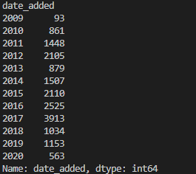
Because type casting finished successfully – it means that there are no “wrong” values (like out of range day, month, hours, etc.) in there. All I need to check is that all years are look realistic. I use this script to check and confirm my assumption. So I don't need to remove or change column values.
print(df['date_added'].groupby(df['date_added'].dt.year).count())
But the problem is, the dates themselves are not very helpful in terms of correlation analysis, especially comparing them against a numerical value. Hopefully, we can use the fact that every date-time can be translated to the number (number of seconds from the initial time) that is more handy to our cause:
df['date_added'] = pd.to_numeric(df['date_added'])
The “views” column shows how much times the meme page been opened, while “videos”, “photos” and “comments” show additional user content associated with certain meme. All this columns store data as integers (LINK TO PIC 3), so we don't need to modify the column datatype, but check that there are no negative values:
print(df[["views", "videos", "photos", "comments"]].sort_values(
["views", "videos", "photos", "comments"]))
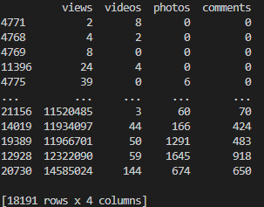
Everything is fine, all values are valid and ready for the analysis.
The “tags” column contains the list of tags in the string form. The string data type is okay, but in the current form it recognize the string as a single value. Now I need to separate each string into the list of individual tags, but before that, I also switch all possible 'NaN' values to the the single 'none...' tag (I use existing one) :
df['tags'] = df['tags'].fillna('none...')
df['tags'] = df['tags'].map(lambda str: str.split(', '))
Now, I can access every single tag in every row, which I will do later.
Last column - “about” contains the information from the aforementioned section of the meme page. This data stored as single long string, we don't need to modify the datatype, only check the modify invalid values – switch all 'NaN' values and change invalid values (line-breakers).
df['about'] = df['about'].fillna('No data...')
df['about'] = df['about'].map(
lambda str: 'No data...' if '\r\n' in str else str)
Now, as I finished the modification of data, I can start the analysis.

3 Dataset analysis
3.1 Data processing pipeline
Let me start from explaining a little bit about how I plan to analyze the data. The main idea is to find what factors affect the popularity of the meme entry. To measure the popularity of the meme I use the views number. And to explore the correlation between different factors and the viewer count I decided to use linear regression analysis. So in my model the view count is the dependent variable, and tested factor is the predictor variable (independent variable). But the problem is - not all factors are easy to evaluate in numerical terms and use them for the regression model. Because of this, for some factors I will try use some tricks to either make them suitable for this type of analysis or find another way to analyze them and find come possible link.
I will be testing assumption that there is exist a correlation between different factors and the view count. To make this analysis we make a several assumptions:
    - The relation between the view count and the each tested factor is linear – we assume that change in factor value creates the same change in the view count.
    - There is no auto correlation (value doesn't depend upon it's own previous values) – our dataset is not a time series, so there is negligible chance of autocorrelation.
    - There is no multicollinearity (when model analyze the effect of several different factors, there is risk that this factors are interdependent) – we will test correlation pairwise, so we have only one independent factor.
    - There is no heteroskedasticity (when series variance changes over a range of measures) - if my findings will find any potential correlation, I will test distribution variance using scatter plots. Heteroskedasticity can be identified by the cone shape of the residuals.
    - Normal distribution of the data (when the data is spread out 'evenly' and follows Gaussian distribution) – the size of my datatype is big enough to make this assumption.
Another thing I must note before the analysis is that there are different 'methods' of the correlation analysis: Pearson, Spearman and Kendall. They all have their uses: Pearson correlation is suitable when we measure correlation between the numeric variables, while the Spearman and Kendall are better suited for ordinal (categorical) variables. Different factors require different methods and I will use both.

3.2 Exploratory analysis
I want to start, by identifying the most popular memes from the dataset. To get the better understanding, I need to visualize this information:
[SCATTER PLOT]
This plot give better insight of distribution of different memes in terms of views, as we clearly see that there are some memes that much more popular that the rest. But the scatter plot doesn't show names, so let identify the names of the top 20 most popular memes we seen early:
[BAR CHART]

As I stated before, it's hard to find the link between the view count and the name itself, but I decided to test this factor using a little trick. I will check not the name itself, but the length of the name. To do it, I need to add the column that stores:
df['name_len'] = df['name'].map(lambda val: len(val))
Now we can try to answer the question“Can it be that the length of the memes name can affect the view count?”. The length of the name is my first factor, that will be tested latter.
Let's visualize the next factor – status:
df.plot.scatter(x='status', y='views', s=10, c='red')

Same for the “type” factor.

HOW YOU WILL EVALUATE YOUR AIMS AND OBJECTIVES BASED ON THE APPROACH

Possible errors – look correlation

Exploratory findings

  - Exploratiry findings from the dataset – statistics analysis \ word cloud
  - Key problem areas of the dataset
  - Rich disscussion about the exploration of the data
  - Evaluation and conclusion based on the findings
  - Critical evaluation of the flaws of the techniques and data

- https://knowyourmeme.com
- [https://www.kaggle.com/datasets/podsyp/a-lot-of-memes-info-stats]

