Part 1: Module coupling and cohesion
For this part, I picked the music visualization example program that we used in the ITP2 module. This program is built based on the principles of OOP and consists of the main program module, six additional modules, and two library files (a big collection of modules). Each original module defined by a constructor function that creates an object:
- "constrolsAndInputs" - the module that handles UI menus and controls
- "playbackButton" - the module that handles the playback button
- "visualisations" - the intermediary module that aggregates information from different visualization modules
- "needles", "spectrum", "wavepattern" - three modules that define different visualization patterns that drawn on the screen
This program is based on the p5 and p5sound js libraries and uses object constructors, functions, basic objects, arrays, variables, and methods that work on them.

For the first example of the module cohesion, we look at the "wavePattern" module. This is a small, simple, and clean module that consists of two elements: name property, which is mostly used as an identifier, and a draw method.
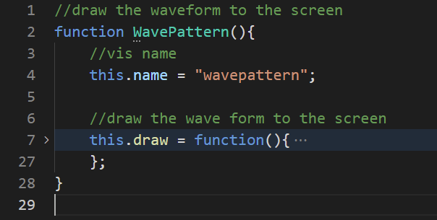
This method handles the visualization of the sound data (variable wave, line 15) in the predetermined logic. Because this module tackles only one single task, it can be used as an example of "functional cohesion", one of the best ones.
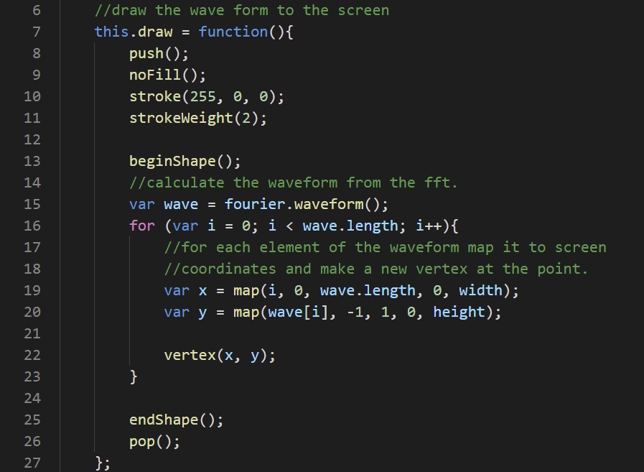
For the second example of the module cohesion, we inspect the "controlsAndInputs" module. It consists of a boolean variable "menuDisplayed", playback button object as an instance of the different module, methods "mousePressed" and "keyPressed" that handle user controls, and methods "menu" and "draw" visualize interface elements.
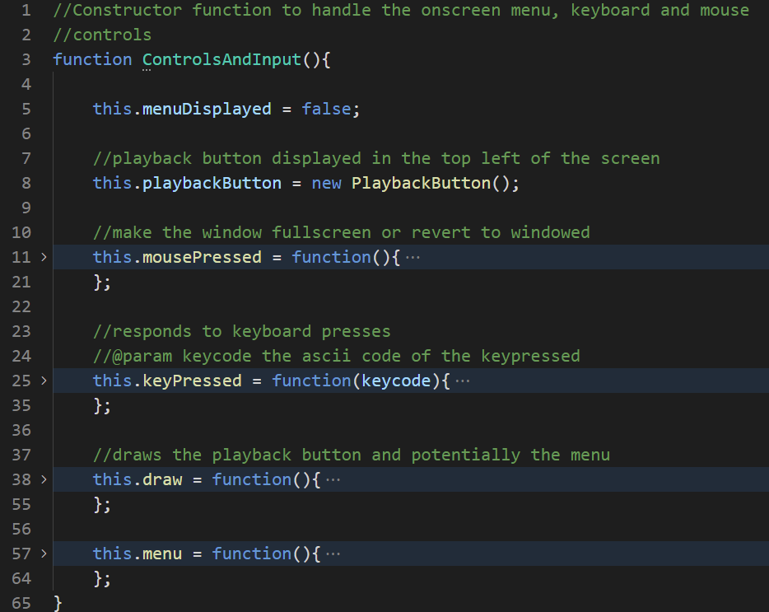
All these different parts do different things and are brought together by the basic idea - to handle user controls. This general idea includes two distinct aspects: visualization and control. But even methods that are related to the same aspect ("mousePressed" and "keyPressed") do different things, despite all their similarities.
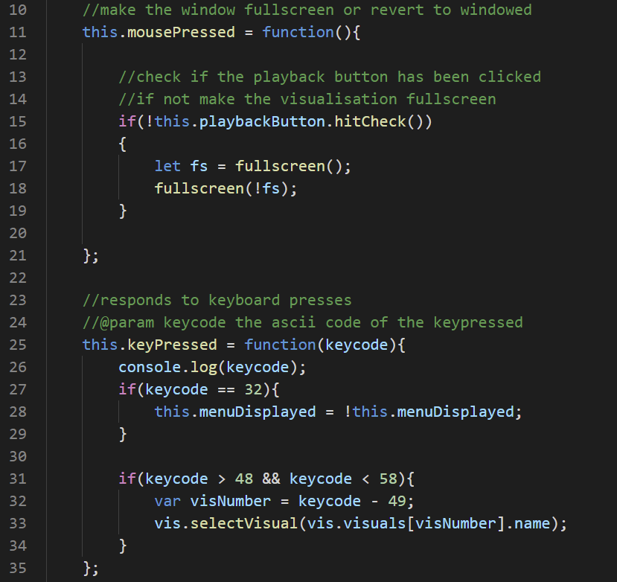
Because of this, I reason that as a whole, this module has "logical cohesion" - one of the less desirable ones.

My first example of the module coupling is the main program module "sketch". It combines all additional modules as well as modules from libraries "p5" and "p5sound" in one environment, so as a whole it can be a great example of the "common environment coupling".
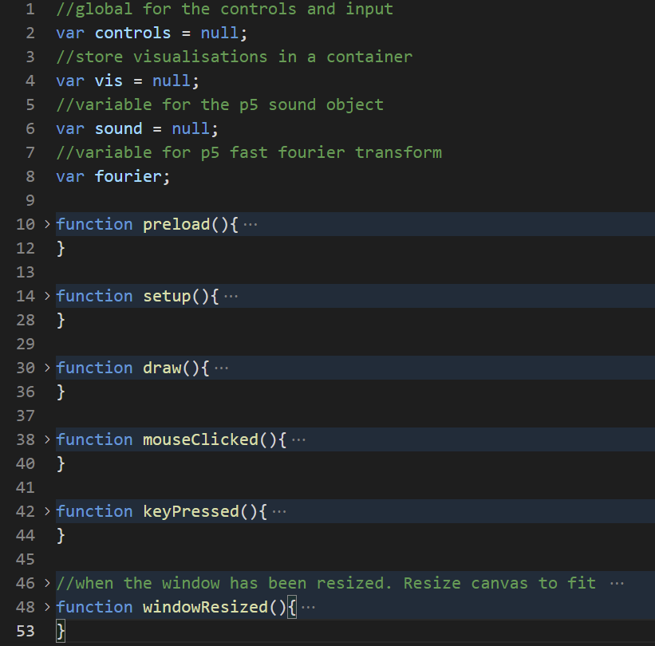
The big environment itself divided into several smaller ones ("preload", "setup", "draw", etc.) with encapsulated local scopes. All local scopes get access to the number of global variables. But the bad thing is - these global variables themselves are dependent on smaller modules, so we get a pretty tangled relation, which is not desirable.
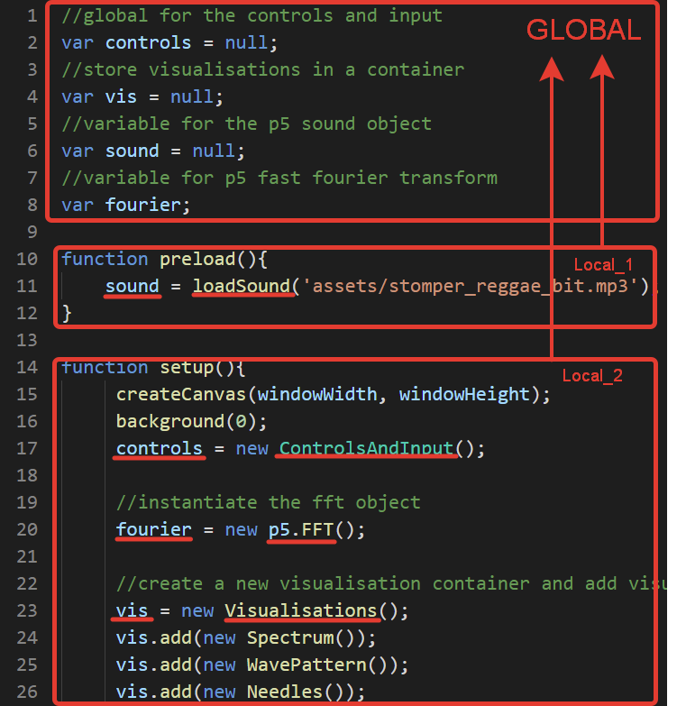 | 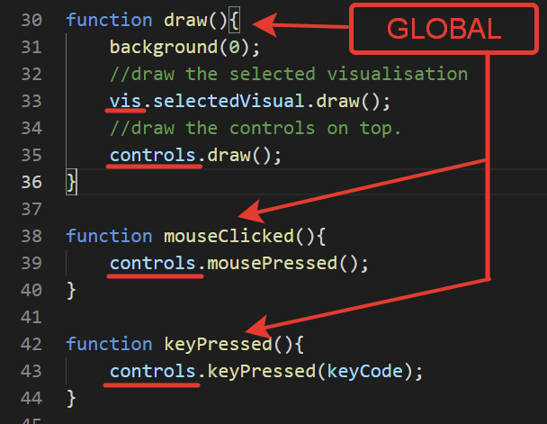

As a more preferable type of module coupling, we can use a small instance inside the "sketch" program - setup function.
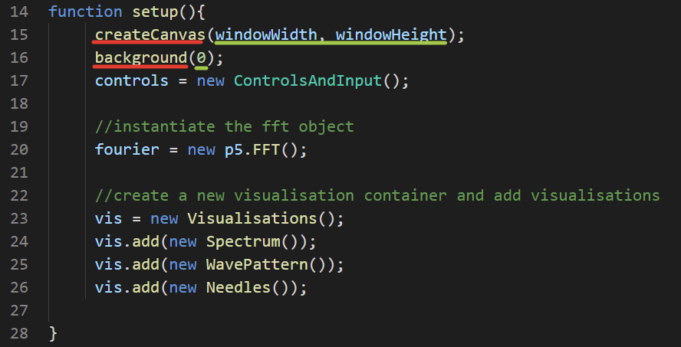
On lines 15 and 17 we can see an example of "data coupling", both "createCanvas" and "background" functions (modules from the "p5" library) take arguments that they later process and use. It should be noted, that this data doesn't affect the control flow of these modules, which is associated with less favorable "control coupling".

Part 2: Unit testing activity
For this task, I chose the python language and statistical program snakestats. In course of this work, I created three sets of tests for different functions that are used to make the Student's t-test.
The first target function I tried to create using test-driven development is the arithmetic mean. The arithmetic mean (or average) is a simple and common function used as a cornerstone for more advanced statistical measures. The first test I wrote is simple - we try to calculate the average of a set of numbers.
TESTS.Py | SNAKESTATS.Py
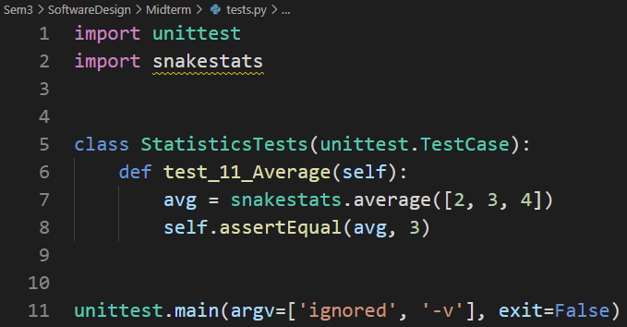 | 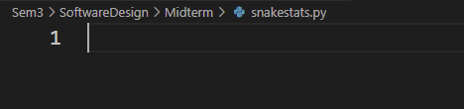
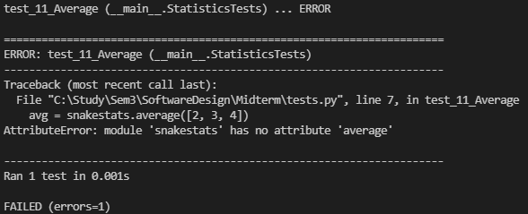
Because the “snakestats” file is empty, the test fails, so now I add some code (minimum required to pass the failed test).
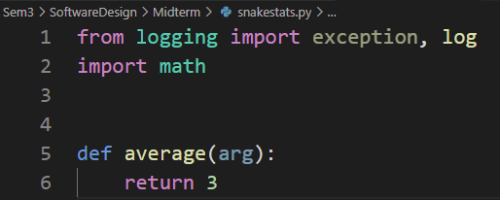
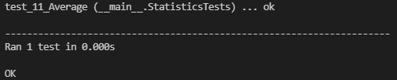
The first test passed successfully, so I create the next one. I decided to try and increase the argument size and values and test again. Because our function only returns a specific integer, it obviously fails.
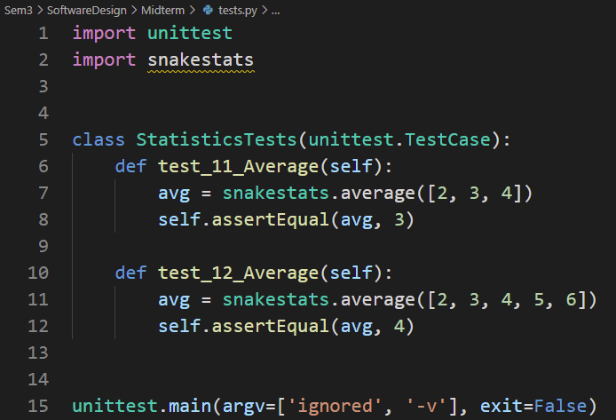
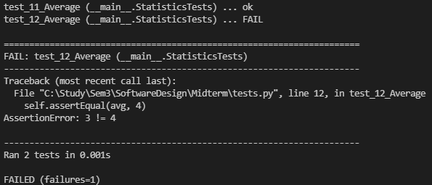
To pass this and other tests, we need to modify it to return the result based on the argument passed to the function.
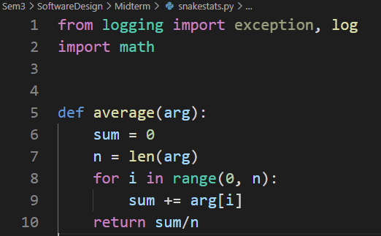
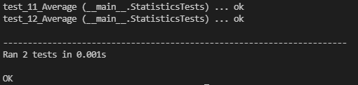
Now, for the final test, I tried passing the wrong argument to push the function into an exception throw.
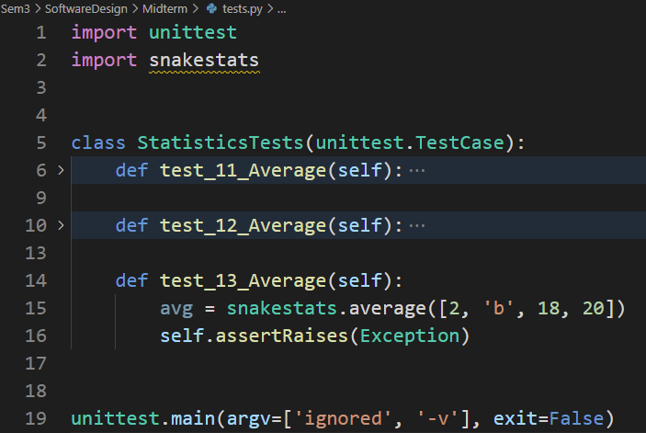
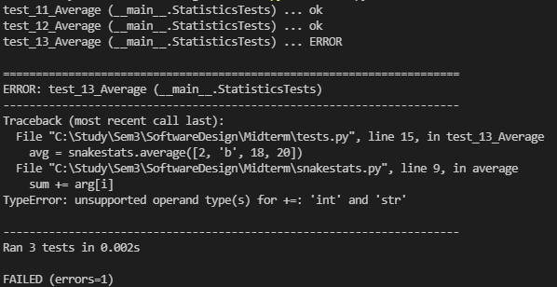
To pass the final test, the function is equipped with the "try" statement, that handles errors associated with arguments (wrong data type, empty array, etc.). And now, the test is successfully passed because the function throws out an exception for the bad input.
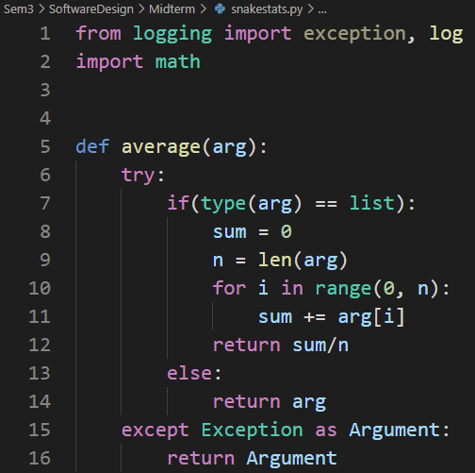
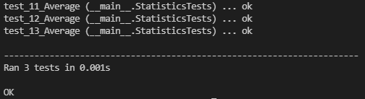
The next set of tests is designed for the "variance" function, which is used to calculate the standard deviation. To calculate variance, we calculate the average sum up the squares on the differences of each number from the average and then divide it by the length of the list. The first test is to calculate the variance of the simple list. As expected, without the code, this test fails.
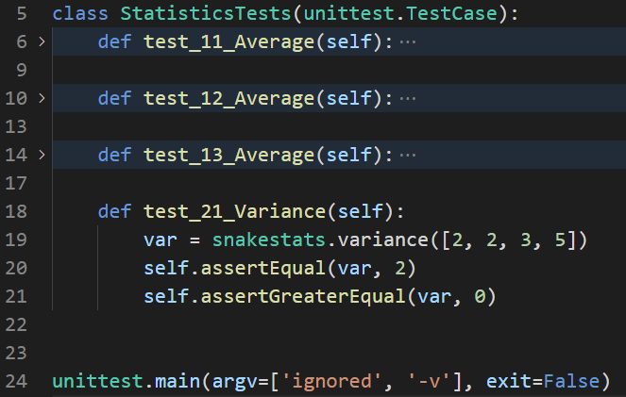 | 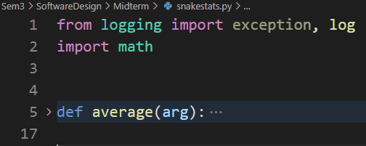
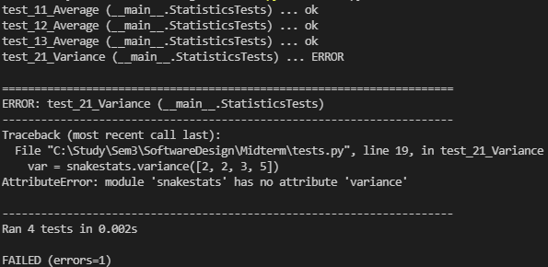
In the same way, our first iteration of the function "variance" returns the value for the tested input without any calculations.
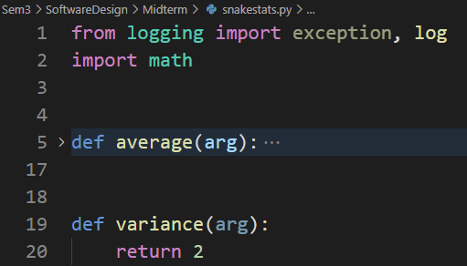
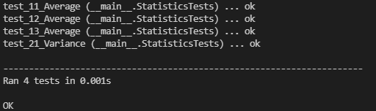
But if we try another input, the function returns with an error, as expected.
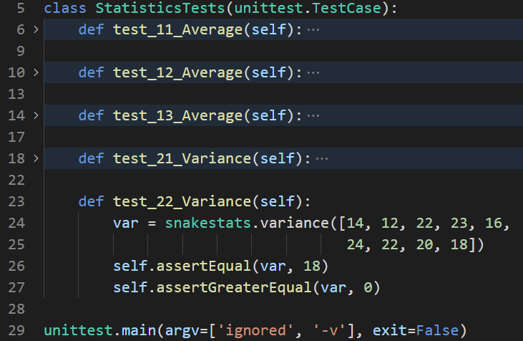
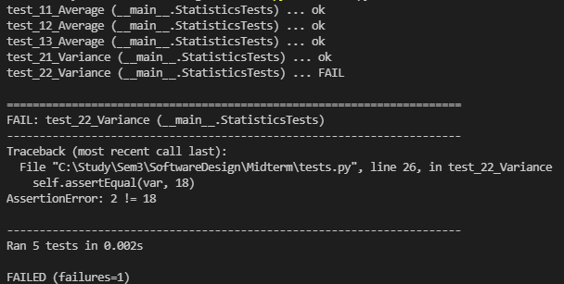
To make our function applicable for any correct input, we modify the function to consider argument values.
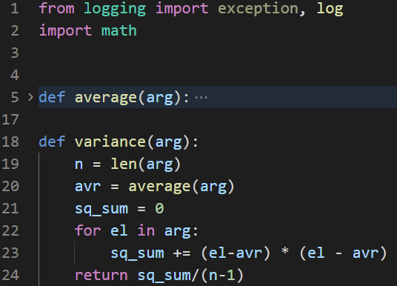
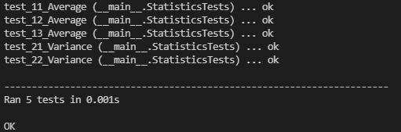
This way, the function will return the correct variance if the user inputs input with numbers, but once again, this function fails for incorrect argument.
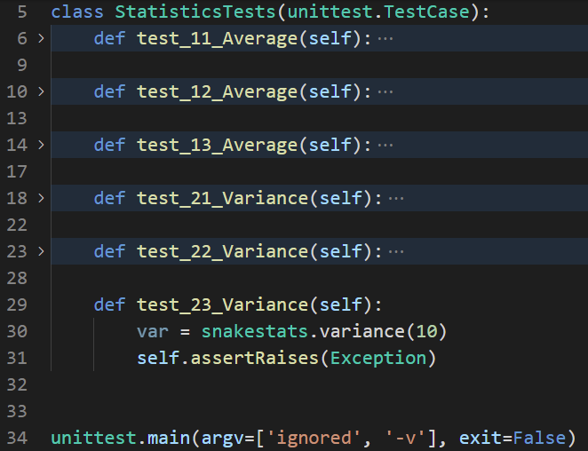
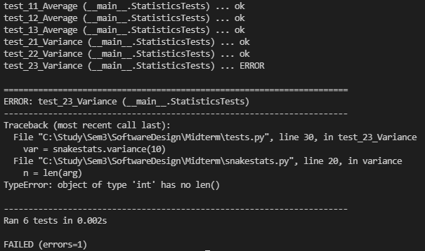
To fix this, we must check for errors and throw exceptions correctly.
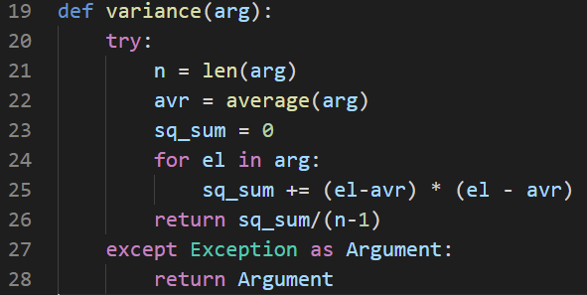
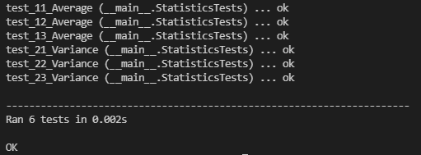
And for the last target function, we pick a "statistics analyzer" that returns True if the correlation is significant. This function shall take the two data sets and critical value, calculate the t-statistic and check it against the t criteria. The first test fails because there is no function yet.
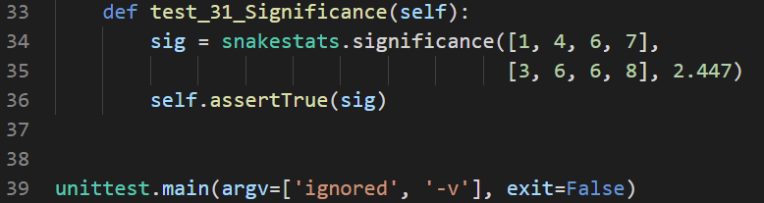 | 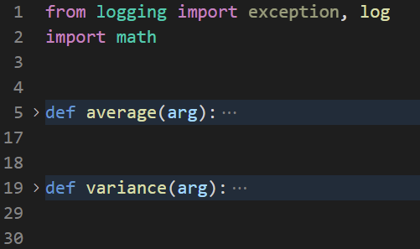
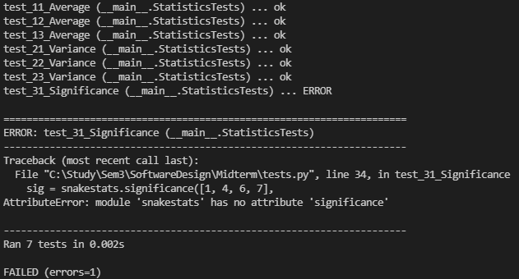
We created the function with one return statement and passed the first test.
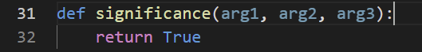
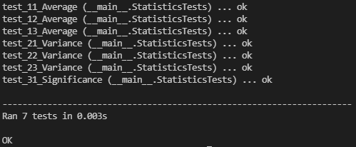
But because there is no formula, the second test fails.

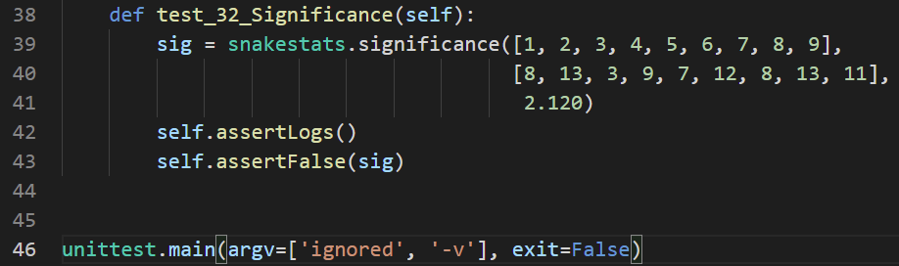
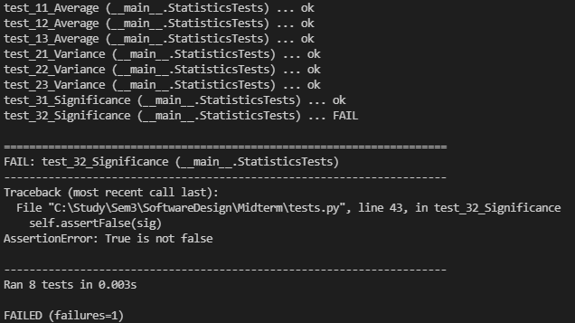
Now we add the correct formula, and the second test passes successfully.
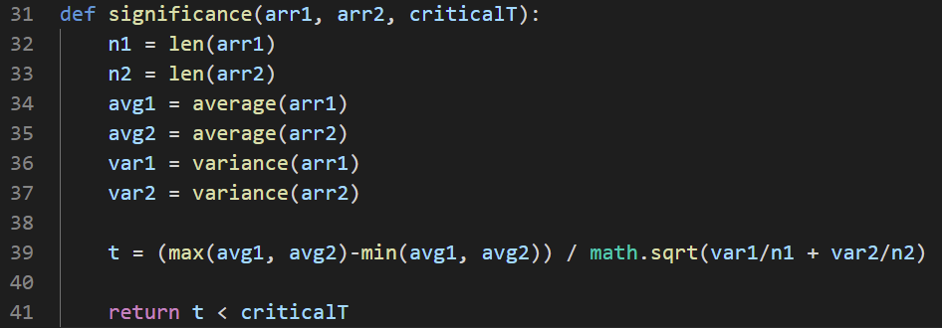
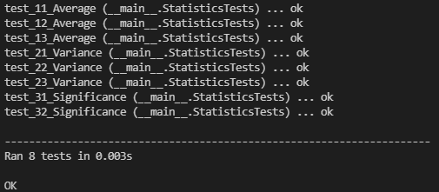
For the last test, we again throw the wrong argument.
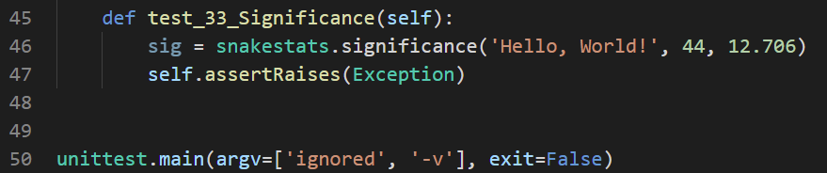
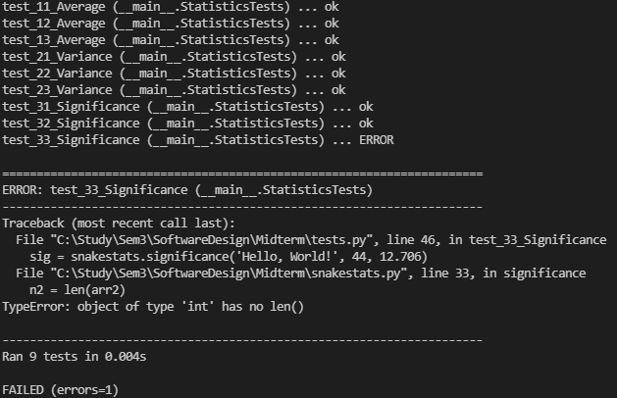
To handle argument problems, we add an exception handler, and finally, pass all tests successfully.
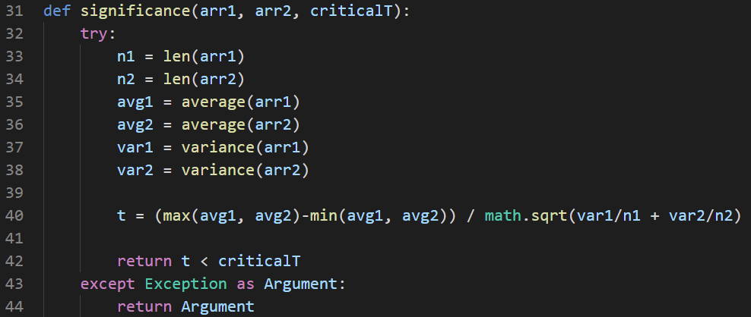
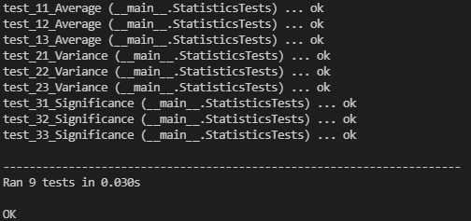

Part 3: Secure programming
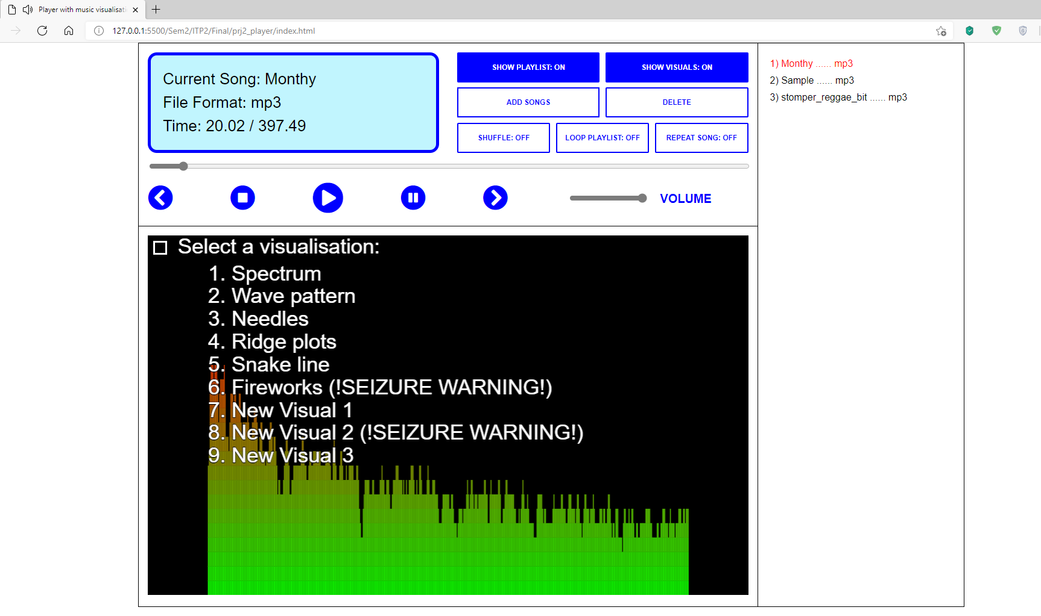
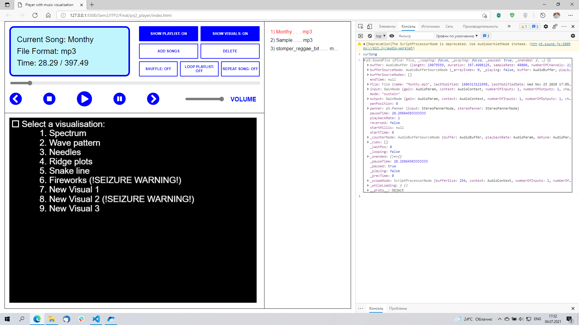
For this part, I will try to analyze potential security problems and suggest potential solutions for the music visualizer app. I created a simple browser-based online audio player with an integrated visualization module.
There are five main categories for security concerns: Input validation, Buffer bounds, and memory, Design that abides by the security principles in software design, Careful use of side resources, and Program output in form of logs and other information.
I start from the secure design perspective: there are many principles, that could be implemented, but I focus on two that I find most vulnerable - "Secure interface" and "Separate data and control". Citing D.A.Wheeler "Secure programming Howto" - "Interface should be minimal (simple as possible), narrow (provide only the functions needed), and non-bypassable". In the current state, the interface is simple and intuitive enough, but because the application is browser-based, it is bypassable. Users can use web-browser functional to access the inner workings of the program.
To prevent this, we could think about switching from the web-based platform to a full-fledged executable file that doesn't depend on another application to work. For example, we can rebuild this application using the Node.js framework to make it a standalone desktop application.
Another serious problem is the lack of OOP principles and the absence of functional separation. In my version, each interface element is tied to the function that directly affects the data that the program uses.
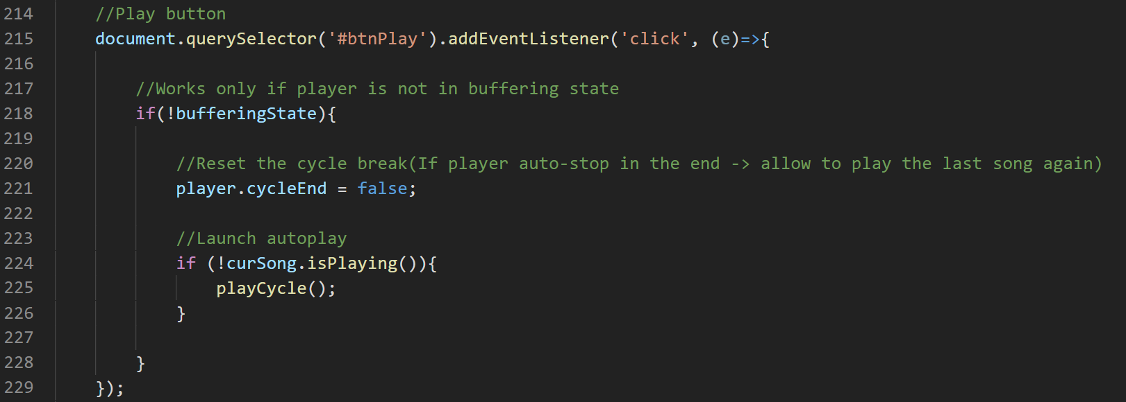
To fix this problem, I propose to refactor the code to follow the Model-View-Controller (MVC) pattern. MVC is based on the separation of the program logic into three major blocks: model - to work with data, view - to create the user interface and register inputs, and controller - that interconnects the other two. We divide the code into three large blocks, encapsulate them and connect them only through the program interface.
The next problem I wish to address is the input data and its validation. One of the features of this application is the data input functionality - the user can add his own songs to play and visualize. But there is no mechanism to validate this input besides the built-in format verification.
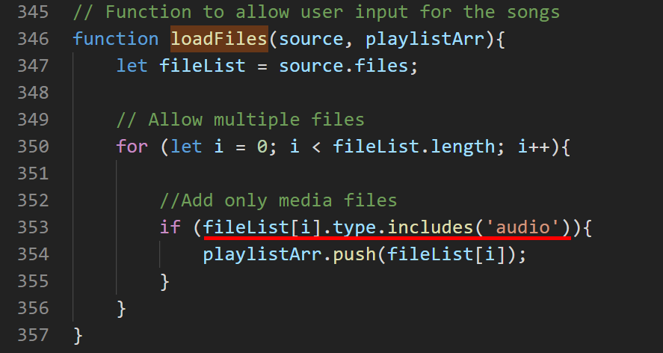
These drawbacks create many possibilities for the potential breacher to cause security problems. One way to validate the input is to implement the name check using regular expressions. Using the RegEx we can filter input to prevent the entry of special symbols, and whitelist only letters and numbers.
The last problem that I tackle is the program output: the player uses the display to show some information and uses the built-in function to show error messages.
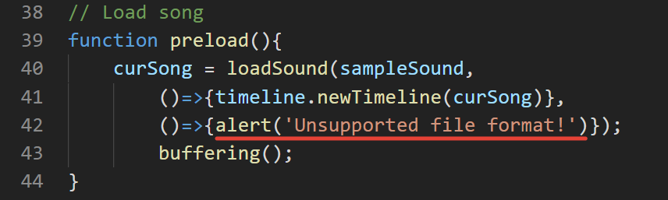
To better adapt recommendations for secure output, I propose to format user messages for the user and incorporate a mechanism to generate more extensive error logs for the developer. The user messages should be short, clear, informative, and has the same string formatting. Logs should store all application settings to help identify the root of the problem and keep his privacy intact.

