AVRO GOLF WEBSITE COPY
Final nine-tile replacement copy — existing layouts preserved
NON-NEGOTIABLE IMPLEMENTATION RULE
Keep every current layout exactly as designed: same sections, card counts, image positions, columns, buttons and FAQ rows. Replace the copy only. Do not remove, add, merge, reorder or redesign tiles.
This document replaces all earlier AVRO Golf copy handoffs.

TILE 1
Hero
ACTION: KEEP THE FULL HERO AND THE EXISTING THREE-PART BOTTOM STRIP.

FINAL REPLACEMENT COPY
CALM PERFORMANCE FOR GOLF
Golf Performance Begins Before the First Swing.
AVRO supports the calm, clear and composed headspace golfers seek before lessons, practice and competition—so they can step into the moment ready.
Primary CTA: Choose Your Formula
Secondary CTA: Shop AVRO
THE PRE-GOLF MINDSET | 01 — PREPARE  Before lessons, practice or play. | 02 — CHOOSE  Calm, Focus or Energy. | 03 — STEP IN READY  Calm. Clear. Composed.
DESIGNER + DEVELOPER NOTE
Replace copy only. Keep the existing hero image, text placement, two buttons and bottom strip.

TILE 2
Pressure Moment
ACTION: KEEP THE CURRENT LEFT-COPY / RIGHT-IMAGE LAYOUT.

FINAL REPLACEMENT COPY
WHEN THE MOMENT GETS BIGGER
Golf can get loud in your head fast.
The first tee. A difficult approach. A lesson where every detail matters. When pressure rises, golfers need more than physical preparation—they need a better way to step into the moment.
Image callout: Approximately 30 minutes before golf.
DESIGNER + DEVELOPER NOTE
Replace copy only. Keep the current image and callout position.

TILE 3
Why AVRO Matters in Golf
ACTION: KEEP THE CURRENT HEADING, SUPPORTING LINE AND THREE-CARD LAYOUT.
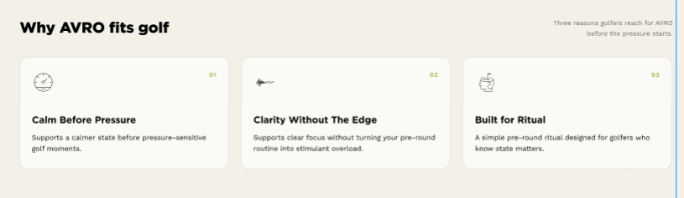
FINAL REPLACEMENT COPY
Why AVRO Matters in Golf
A calm-first platform with a clear role across the modern golf experience.
FOR GOLFERS  A simple way to prepare for the moments when calm, clarity and composure matter. | FOR COACHES  Supports a golfer’s readiness to receive, process and apply feedback. | FOR GOLF BUSINESSES  Adds a differentiated golfer experience designed to strengthen engagement and loyalty.
DESIGNER + DEVELOPER NOTE
Replace copy only. Keep exactly three cards and the existing icons.

TILE 4
How to Use AVRO Before Golf
ACTION: KEEP THE CURRENT DARK SECTION AND THREE-STEP LAYOUT.
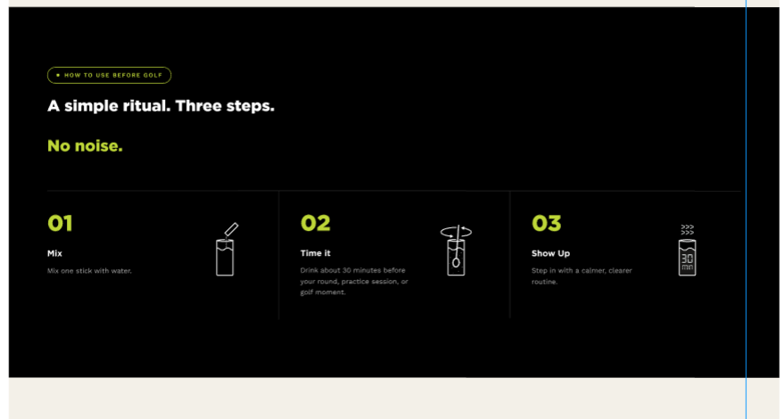
FINAL REPLACEMENT COPY
HOW TO USE AVRO BEFORE GOLF
A simple ritual. Three steps.
Choose. Mix. Time it.
01 — CHOOSE  Select Calm, Focus or Energy based on the moment ahead. | 02 — MIX  Mix one stick with 250–300 mL of water. | 03 — TIME IT  Drink approximately 30 minutes before your lesson, practice session or tee time.
DESIGNER + DEVELOPER NOTE
Replace copy only. Keep three columns, large numbers and icons. Update icons only if needed to match Choose / Mix / Time It.

TILE 5
Science + Formula Logic
ACTION: KEEP THE CURRENT HEADING AND FOUR-CARD LAYOUT.
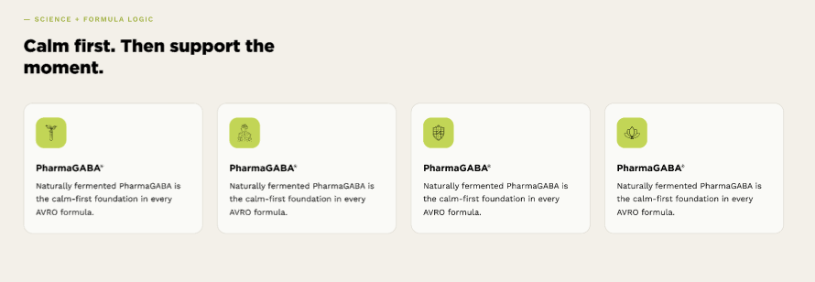
FINAL REPLACEMENT COPY
SCIENCE + FORMULA LOGIC

Box 1 — PharmaGABA® Foundation
Calm Starts Here
Naturally fermented PharmaGABA® is the clinically studied form of GABA at the center of every AVRO formula.

Box 2 — AVRO Calm
Composure When It Matters
PharmaGABA® plus magnesium for golfers who want a calmer, more composed way to prepare for pressure-sensitive moments.

Box 3 — AVRO Focus
Clearer Attention for Learning
PharmaGABA® plus Cognigrape® for lessons, fittings and practice sessions that call for calm, attentive focus.

Box 4 — AVRO Energy
Steady Energy for Demanding Golf Days
PharmaGABA® plus natural caffeine for early tee times, longer rounds and competition days that require more energy.

Calm first. Then support the moment.
Every AVRO formula begins with naturally fermented PharmaGABA®, a clinically studied form of GABA.
PHARMAGABA® FOUNDATION  The calm-first ingredient at the center of Calm, Focus and Energy. | NATURALLY FERMENTED  Produced through a natural fermentation process. | CLINICALLY STUDIED  A studied form of GABA that gives AVRO a credible scientific foundation. | THREE DISTINCT FORMULAS  The shared PharmaGABA® base is paired with ingredients selected for Calm, Focus or Energy.
DESIGNER + DEVELOPER NOTE
Replace the repeated placeholder paragraphs with these four distinct proof points. Keep exactly four cards and the existing icons.

TILE 6
Golf Use Moments
ACTION: KEEP THE CURRENT FOUR IMAGE-CARD LAYOUT UNDER “GOLF USE MOMENTS.”
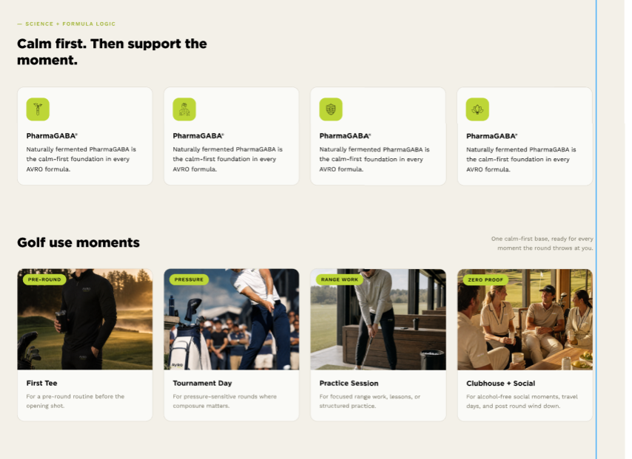
FINAL REPLACEMENT COPY
Golf Use Moments
One calm-first foundation, ready for the moments that shape the golf experience.
FIRST TEE  A simple pre-round ritual before the opening shot. | TOURNAMENT DAY  Preparation for pressure-sensitive rounds when composure matters from the start. | PRACTICE SESSION  For range work, coaching sessions and structured practice. | CLUBHOUSE + SOCIAL  An alcohol-free option for post-round conversations, travel days and social golf moments.
DESIGNER + DEVELOPER NOTE
Replace copy only. Keep all four images, labels and card positions.

TILE 7
Shop AVRO for Golf
ACTION: KEEP THE CURRENT DARK SECTION AND THREE PRODUCT CARDS.
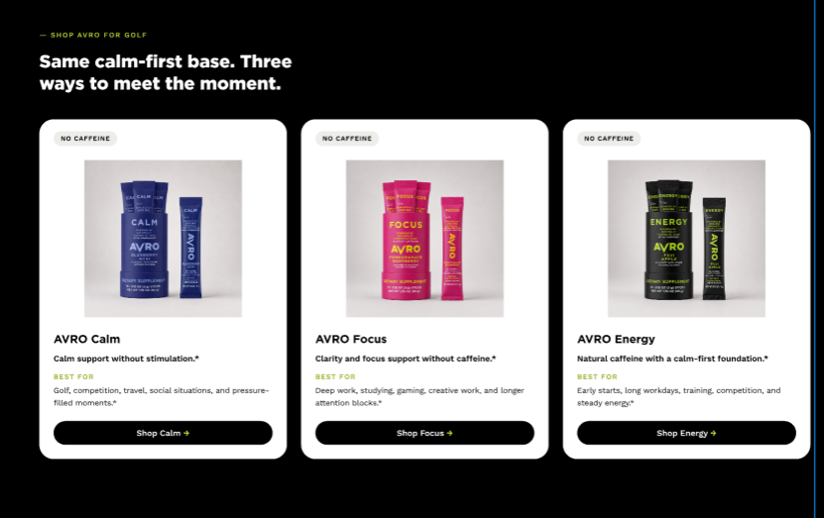
FINAL REPLACEMENT COPY
SHOP AVRO FOR GOLF
Same calm-first base. Three ways to meet the moment.
AVRO CALM — CAFFEINE FREE  Calm support for pressure-sensitive golf moments.  BEST FOR: First tees, tournament rounds, lessons and moments when composure matters.  CTA: Shop Calm | AVRO FOCUS — CAFFEINE FREE  Calm-first preparation with added support for clear, attentive focus.  BEST FOR: Coaching sessions, club fitting, range work and structured practice.  CTA: Shop Focus | AVRO ENERGY — WITH NATURAL CAFFEINE  Calm-first preparation with natural caffeine for demanding golf days.  BEST FOR: Early tee times, longer rounds, travel days and competition.  CTA: Shop Energy
DESIGNER + DEVELOPER NOTE
Replace copy only. Keep product images, card structure and three CTAs. Energy must say WITH NATURAL CAFFEINE—not NO CAFFEINE.

TILE 8
Golf FAQ
ACTION: KEEP THE CURRENT LEFT HEADING AND THREE FAQ ROWS.
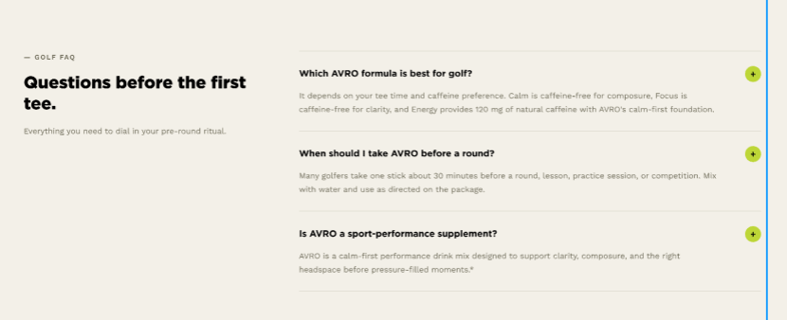
FINAL REPLACEMENT COPY
GOLF FAQ
Questions Before the First Tee.
Straight answers about choosing and using AVRO for golf.
Which AVRO formula is best for golf?
Choose based on the moment ahead. Calm is caffeine-free and designed for composure. Focus is caffeine-free and adds support for clear, attentive focus. Energy combines AVRO’s calm-first foundation with natural caffeine for longer or more demanding golf days.
When should I take AVRO before a round?
Mix one stick with 250–300 mL of water and drink it approximately 30 minutes before a lesson, practice session, tee time or competition. Follow the directions on the package.
What role does AVRO play in golf performance?
AVRO supports the calm, clear and composed headspace golfers seek. It complements coaching, practice, fitting and technology—it does not replace them or claim to improve the swing or score.
DESIGNER + DEVELOPER NOTE
Replace copy only. Keep exactly three accordion rows.

TILE 9
Final Call to Action
ACTION: KEEP THE CURRENT DARK BANNER, THREE BUTTONS AND BACKGROUND GRAPHIC.

FINAL REPLACEMENT COPY
Choose the formula that fits your golf.
Start with calm. Choose Calm, Focus or Energy for the moment ahead.
Buttons: Shop Calm | Shop Focus | Shop Energy
DESIGNER + DEVELOPER NOTE
Replace copy only. Keep all three existing buttons and their current hierarchy.

FINAL PAGE RULES
• Do not change the layout or tile order.
• Do not move copy from one tile to another.
• Do not add a new partnership tile.
• Use PharmaGABA® science primarily in Tile 5.
• Use detailed timing and mixing instructions primarily in Tile 4.
• Keep Calm and Focus labeled caffeine-free. Energy contains natural caffeine.
• AVRO supports golfer preparation and headspace. Coaching, practice, fitting and technology own golf improvement.

