**CONTENT**

1**.**CASE STUDY…………………………………….3

2.DATABASE STRUCTURE………………………5

3.LOGIN…………………………………………….8

4.HOME MANAGER……………………………….11

5.OPEN ACCOUNT…………………………………17

6.MODIFY ACCOUNT……………………………..26

7.DEACTIVATE ACCOUNT……………………….35

8.REACTIVATE ACCOUNT……………………….39

9.DEPOSIT…………………………………………..44

10.WITHDRAW……………………………………..52

11.TRANSACTION………………………………….60

12.TRANSACTION REPORT……………………….70

13.TOTAL MONEY DEPOSITED…………………..74

14.TOTAL MONEY WITHDRAW………………….78

15.TOTAL MONEY TRANSACTED……………….82

16.BALANCE TODAY……………..………………..86

17.CURRENT BALANCE……………………………90

**ACKNOWLEDGEMENT**

I “DIVYANSHU RAJPUT” would like to express my gratitude to all those who gave me the possibility to complete thus project. I want to thank my subject teacher “MR PUSHPRAJ SINGH, PGT(I.P),HOD(COMPUTER SC.)” for giving me such a meaningful and understandable topic in the first instance ,to do neceeary work and to make this project. I had taken much help from [www.google.co.in,www.netbeanside.com](http://www.google.co.in,www.netbeanside.com).

I am deeply indebted to my parents and my classmate whose help and stimulating suggestions and encouragement helped me in all the time of making this project.

And once again I would like to thank all my teachers who helped me a lot in making this project without whose help this would not be materialized.

THANK YOU

**DIVYANSHU RAJPUT**

**XII-A**

**CASE STUDY**

This software of banking contain consists of all relative information on banking via computer. It contains forms such as login for security purpose which has choice for manager, clerk and accountant. Then we have option to do different functions.

We can create account see details of that account ,modify it or activate or deactivate your account.

In transaction you can transact by cheque or cash .You can deposit or withdraw. You can check your current balance any time. You can get total money transaction of the bank today and can also get information about all transaction on any date.

**LOGIN TABLE**

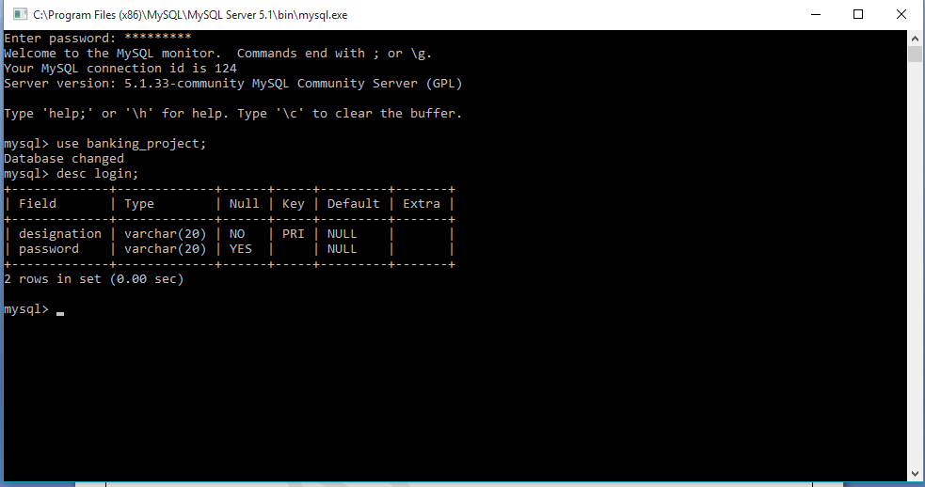

**CUSTOMER TABLE**

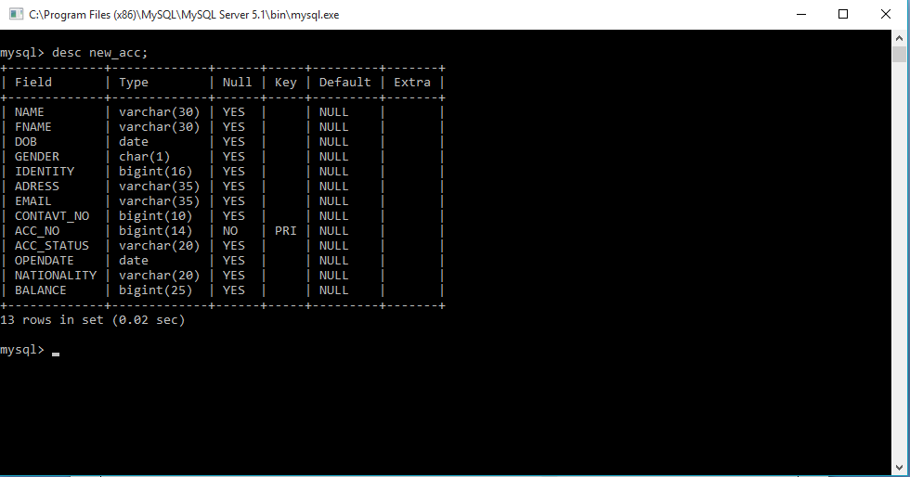

**TRANSACTION TABLE**

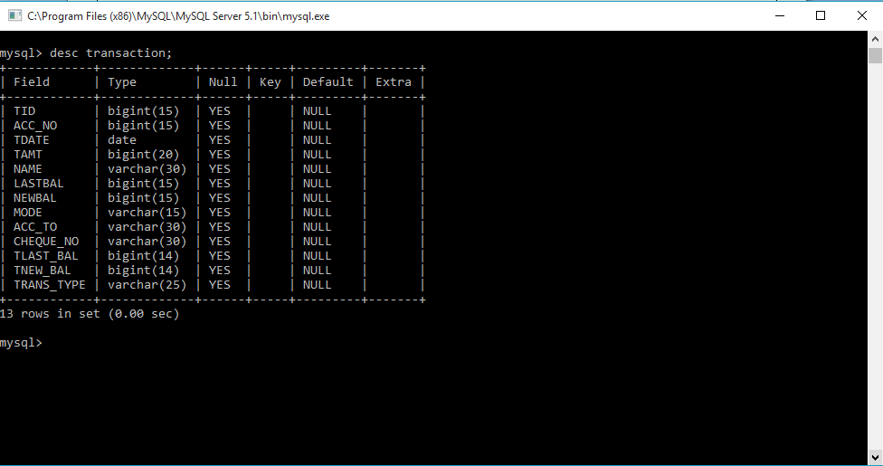

**LOGIN**

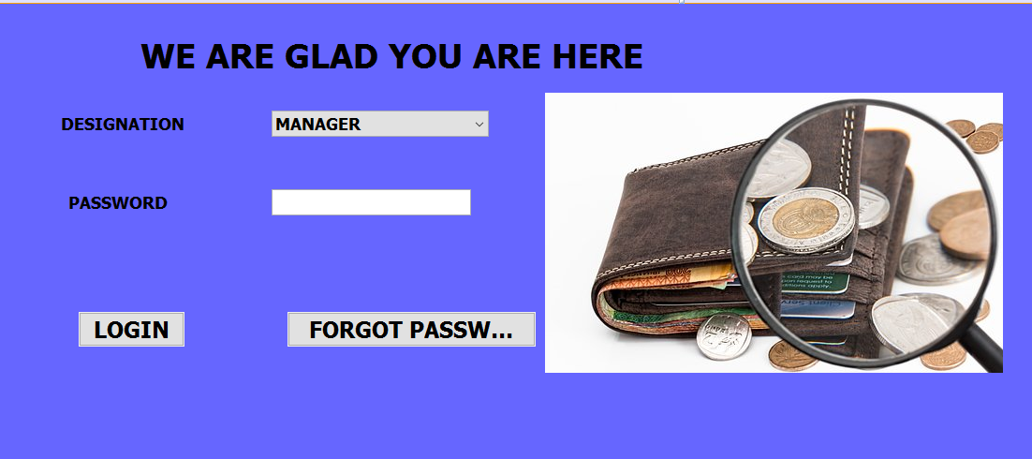

import java.sql.DriverManager;

import java.sql.Statement;

import java.sql.Connection;

import java.sql.ResultSet;

import javax.swing.JOptionPane;

**private void jButton1ActionPerformed(java.awt.event.ActionEvent evt) {**

String post=null; String pass=null;

post=(String)desig.getSelectedItem();

pass=(String)password.getText();

try {

Class.forName("java.sql.DriverManager");

Connection c=(Connection)

DriverManager.getConnection("jdbc:mysql://localhost:3306/BANKING_PROJECT","root","divyanshu");

Statement s=(Statement)c.createStatement();

String q= "(select password from login where designation='"+post+"');";

ResultSet RS=(ResultSet)s.executeQuery(q);

if(RS.next())

{String N=RS.getString("password");

if(N.equals(pass))

{new account_function().setVisible(true);}

else

{JOptionPane.showMessageDialog(null,"Wrong Password");}

}

} catch(Exception e)

{JOptionPane.showMessageDialog(null,e.getMessage());}

}

**private void jButton2MouseClicked(java.awt.event.MouseEvent evt) {**

Object m=desig.getSelectedIndex();

if(m.equals(0))

{JOptionPane.showMessageDialog(null,"61*****"+"HINT");

}

if(m.equals(1))

{JOptionPane.showMessageDialog(null,"*****30"+"HINT");

}

if(m.equals(2))

{JOptionPane.showMessageDialog(null,"*****31"+"HINT");

}

}

**ACCOUNT FUNCTION**

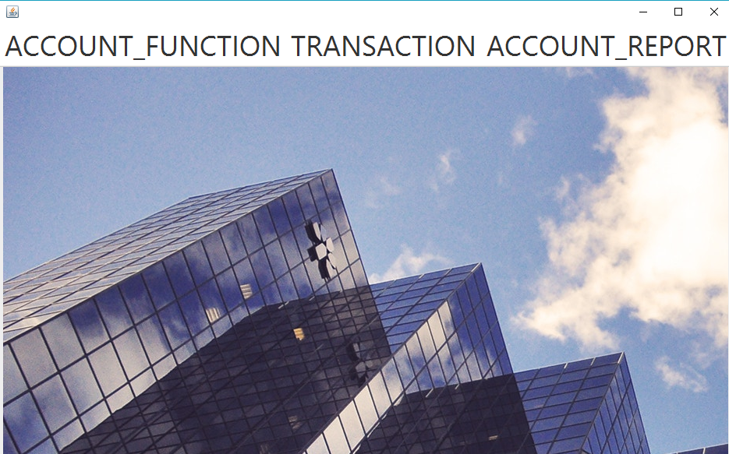

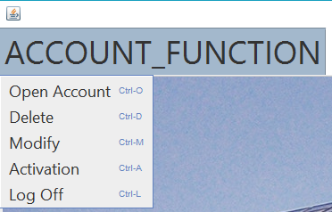

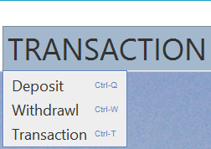

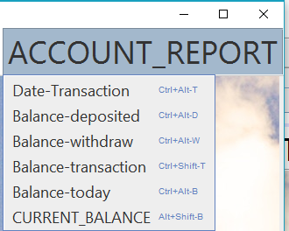

//FOR OPENING ACCOUNT

**private void jMenuItem1ActionPerformed(java.awt.event.ActionEvent evt) {**

new newaccount1().setVisible(true);

this.dispose();

}

//DELETING ACCOUNT

**private void jMenuItem2ActionPerformed(java.awt.event.ActionEvent evt) {**

new DEACTIVATION().setVisible(true);

this.dispose();

}

//MODIFY ACCOUNT

**private void jMenuItem3ActionPerformed(java.awt.event.ActionEvent evt) {**

new MODIFY().setVisible(true);

this.dispose();

}

//REACTIVATION OF ACCOUNT

**private void jMenuItem5ActionPerformed(java.awt.event.ActionEvent evt) {**

new Reactivation().setVisible(true);

this.dispose();

}

//LOGOFF

**private void jMenuItem6ActionPerformed(java.awt.event.ActionEvent evt) {**

this.dispose();

}

//DEPOSIT MONEY

**private void jMenuItem7ActionPerformed(java.awt.event.ActionEvent evt) {**

new deposit().setVisible(true);

this.dispose();

}

//WITHDRAW MONEY

**private void jMenuItem8ActionPerformed(java.awt.event.ActionEvent evt) {**

new withdrawl1().setVisible(true);

this.dispose();

}

//MONEY TRANSFER

**private void jMenuItem9ActionPerformed(java.awt.event.ActionEvent evt) {**

new TRANSACTION().setVisible(true);

this.dispose();

}

//TRANSACTION REPORT

**private void jMenuItem10ActionPerformed(java.awt.event.ActionEvent evt) {**

new TRANSACTION_REPORT().setVisible(true);

this.dispose();

}

//MONEY DEPOSITED TODAY

**private void jMenuItem11ActionPerformed(java.awt.event.ActionEvent evt) {**

new MONEY_DEPOSITED_IN_BANK().setVisible(true);

this.dispose();

}

//MONEY WITHDRAW TODAY

**private void jMenuItem12ActionPerformed(java.awt.event.ActionEvent evt) {**

new total_money_withdraw().setVisible(true);

this.dispose();

}

//MONEY TRANSACTED TODAY

**private void jMenuItem13ActionPerformed(java.awt.event.ActionEvent evt) {**

new MONEY_TRANSACTION_TODAY().setVisible(true);

this.dispose();

}

//CURRENT BALANCE

**private void jMenuItem14ActionPerformed(java.awt.event.ActionEvent evt) {**

new TOTAL_MONEY_TRANSACTED().setVisible(true);

this.dispose();

}

**private void jMenuItem4ActionPerformed(java.awt.event.ActionEvent evt) {**

new CURRENT_BALANCE().setVisible(true);

this.dispose();

}

**ACCOUNT OPENING FORM**

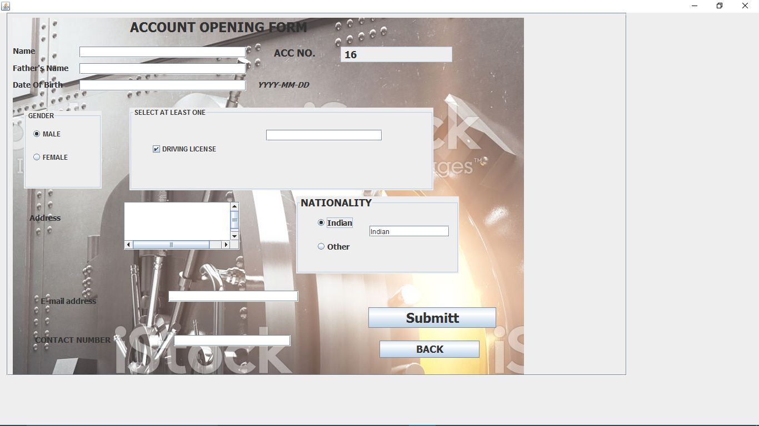

import javax.swing.JOptionPane;

import java.sql.DriverManager;

import java.sql.Statement;

import java.sql.Connection;

import java.sql.ResultSet;

**private void adharActionPerformed(java.awt.event.ActionEvent evt) {**

if(adhar.isSelected())

{

driving.setVisible(false);

ration.setVisible(false);

voter.setVisible(false);

JOptionPane.showMessageDialog(null,"PLEASE ENTER ADHAAR NO");

}

else

{ driving.setVisible(true);

ration.setVisible(true);

voter.setVisible(true);

}

}

**private void voterActionPerformed(java.awt.event.ActionEvent evt) {**

if(voter.isSelected())

{

driving.setVisible(false);

ration.setVisible(false);

adhar.setVisible(false);

JOptionPane.showMessageDialog(null,"PLEASE ENTER YOUR VOTER ID");

}

else

{ driving.setVisible(true);

ration.setVisible(true);

adhar.setVisible(true);

}

}

**private void drivingActionPerformed(java.awt.event.ActionEvent evt) {**

if(driving.isSelected())

{

voter.setVisible(false);

ration.setVisible(false);

adhar.setVisible(false);

JOptionPane.showMessageDialog(null,"PLEASE ENTER LICENSE NO");

}

else

{ driving.setVisible(true);

ration.setVisible(true);

adhar.setVisible(true);

voter.setVisible(true);

}

}

**private void rationActionPerformed(java.awt.event.ActionEvent evt) {**

if(ration.isSelected())

{

voter.setVisible(false);

driving.setVisible(false);

adhar.setVisible(false);

JOptionPane.showMessageDialog(null,"PLEASE ENTER RATION CARD NO");

}

else

{ ration.setVisible(true);

driving.setVisible(true);

adhar.setVisible(true);

voter.setVisible(true); }

}

**private void jButton2ActionPerformed(java.awt.event.ActionEvent evt) {**

int d=0;int abc=0;

String G = null;

if(r1.isSelected()) {

G="M";

d=1;}

if(r2.isSelected())

{

G="F";

d=2;}

if(d==0)

{

JOptionPane.showMessageDialog(null,"please select your gender");}

String n=name.getText();

String fn=fname.getText();

String db=dob.getText();

String adr=addres.getText();

String emil=email.getText();

String no=contactno.getText();

String a=t1.getText();

String b=nation.getText();

if

((n.isEmpty())||(fn.isEmpty())||(G.isEmpty())||(db.isEmpty())||(a.isEmpty())||(adr.isEmpty())||(emil.isEmpty())||(no.isEmpty())||(b.isEmpty()))

{JOptionPane.showMessageDialog(null,"please fill all the entries");}

else {

try{

Class.forName("java.sql.DriverManager");

Connection c=(Connection)DriverManager.getConnection("jdbc:mysql://localhost:3306/BANKING_PROJECT","root","divyanshu");

Statement s=(Statement)c.createStatement();

String q1="select curdate() ;";

ResultSet rs=s.executeQuery(q1);

rs.next();

String date=rs.getString("curdate()");

String q="Insert into NEW_ACC values('"+name.getText()+"','"+fname.getText()+"','"+dob.getText()+"','"+G+"','"+a+"','"+addres.getText()+"','"+email.getText()+"','"+contactno.getText()+"','"+t2.getText()+"','"+"AC"+"','"+ date+"','"+b+"','"+"1000"+"');";

s.executeUpdate(q);

}

catch(Exception e)

{

JOptionPane.showMessageDialog(null,e.getMessage());}

JOptionPane.showMessageDialog(null,"your account has been opened");

}

name.setText(" ");

fname.setText(" ");

dob.setText(" ") ;

t1.setText(" ");

addres.setText(" ");

email.setText(" ");

contactno.setText(" ");

r1.setSelected(false);

r2.setSelected(false);

indian.setSelected(false);

other.setSelected(false);

ration.setSelected(false);

driving.setSelected(false);

adhar.setSelected(false);

voter.setSelected(false);

JOptionPane.showMessageDialog(null,"Your account no.is "+t2.getText());

}

**private void formWindowActivated(java.awt.event.WindowEvent evt) {**

try{

Class.forName("java.sql.DriverManager");

Connection c=(Connection)DriverManager.getConnection("jdbc:mysql://localhost:3306/BANKING_PROJECT","root","divyanshu");

Statement s=(Statement)c.createStatement();

String q2="select curdate();";

String q1="Select max(acc_no) from new_acc;";

ResultSet rs1=s.executeQuery(q1);

rs1.first();

long acc=Long.parseLong(rs1.getString("max(acc_no)"));

acc+=1;

t2.setText(" "+acc);

t2.setEditable(false);

}

catch(Exception e)

{

JOptionPane.showMessageDialog(null,e.getMessage());}

}

**private void otherActionPerformed(java.awt.event.ActionEvent evt) {**

if(other.isSelected())

{JOptionPane.showMessageDialog(this,"Please mention your Nationality");

nation.setText(" ");

}

}

**private void indianActionPerformed(java.awt.event.ActionEvent evt) {**

if(indian.isSelected())

{nation.setText("Indian"); }

}

**private void jButton3ActionPerformed(java.awt.event.ActionEvent evt) {**

new account_function().setVisible(true);

this.dispose();

}

**MODIFY DETAILS**

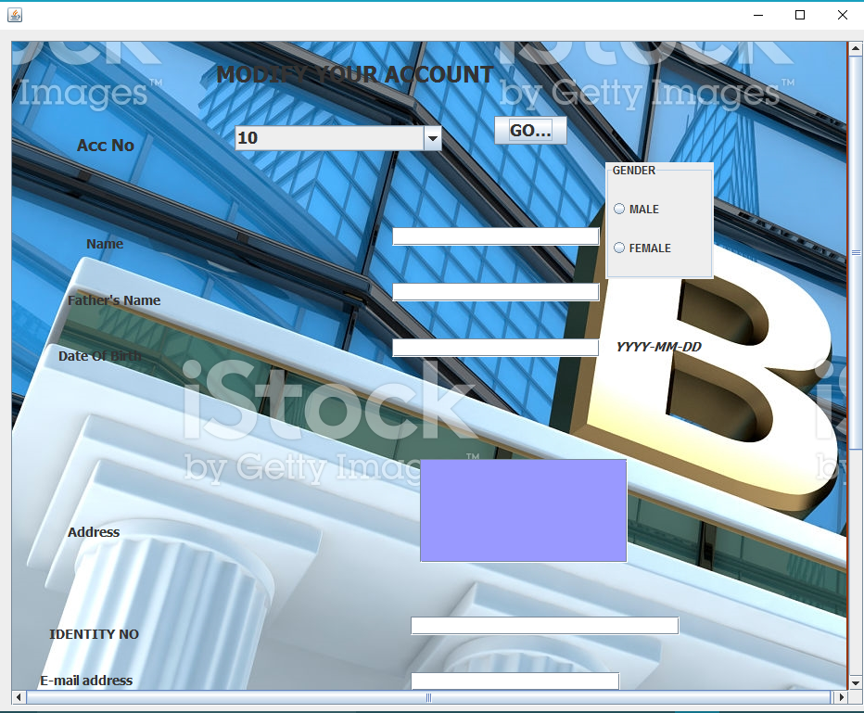

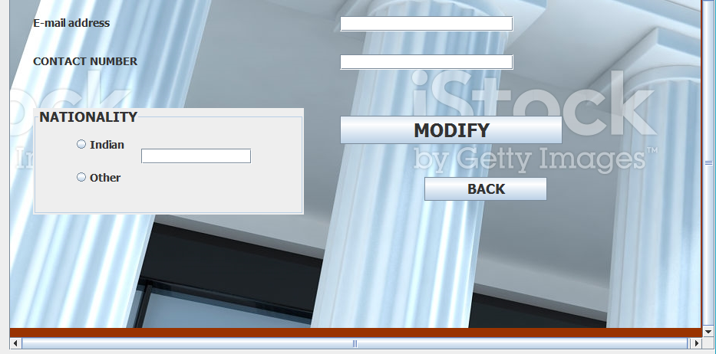

import java.sql.ResultSet;

import javax.swing.JOptionPane;

import java.sql.DriverManager;

import java.sql.Statement;

import java.sql.Connection;

**private void jButton2ActionPerformed(java.awt.event.ActionEvent evt) {**

String a1=(String)cmb.getSelectedItem();

String G = null;

if(r1.isSelected()) {

G="M";

}

if(r2.isSelected())

{

G="F";

}

String n=name.getText();

String fn=fname.getText();

String db=dob.getText();

String adr=addres.getText();

String emil=email.getText();

String no=contactno.getText();

String a=t1.getText();

String b=nation.getText();

if

((n.isEmpty())||(fn.isEmpty())||(G.isEmpty())||(db.isEmpty())||(a.isEmpty())||(adr.isEmpty())||(emil.isEmpty())||(no.isEmpty())||(b.isEmpty()))

{

JOptionPane.showMessageDialog(null,"please fill all the entries");

}

else {

int i= JOptionPane.showConfirmDialog(this,"Are you sure you want to modify the details???? ");

if(i==0)

{

try

{

Class.forName("java.sql.DriverManager");

Connection c=(Connection)DriverManager.getConnection("jdbc:mysql://localhost:3306/BANKING_PROJECT","root","divyanshu");

Statement s=(Statement)c.createStatement();

//JOptionPane.showMessageDialog(this,a1);

String q="update new_acc set name='"+name.getText()+"',fname='"+fname.getText()+"',dob='"+dob.getText()+"',gender='"+G+"',identity='"+a+"',adress='"+addres.getText()+"',email='"+email.getText()+"',contavt_no='"+contactno.getText()+"',nationality='"+b+"' where acc_no='"+a1+"';";

//JOptionPane.showMessageDialog(null,q);

//JOptionPane.showMessageDialog(null,dob);

s.executeUpdate(q);

}

catch(Exception e)

{

JOptionPane.showMessageDialog(null,e.getMessage());

}

JOptionPane.showMessageDialog(null,"THANK YOU!!!! Your account details are modified");

}

if(i==1)

{

JOptionPane.showMessageDialog(this,"Your details are not modified....");}

if(i==2)

{

JOptionPane.showMessageDialog(this,"THANK YOU FOR BEING HERE!!!!!!!");

}

}

}

**private void goActionPerformed(java.awt.event.ActionEvent evt) {**

JOptionPane.showMessageDialog(this,"Your account details are Here");

String a1=(String)cmb.getSelectedItem();

try{

Class.forName("java.sql.DriverManager");

Connection c=(Connection)DriverManager.getConnection("jdbc:mysql://localhost:3306/BANKING_PROJECT","root","divyanshu");

Statement s=(Statement)c.createStatement();

String q="(select * from new_acc where acc_no='"+a1+"');";

ResultSet r=s.executeQuery(q);

while(r.next())

{

String n=r.getString("name");

name.setText(n);

String f=r.getString("fname");

fname.setText(f);

String d=r.getString("DOB");

dob.setText(d);

String gen=r.getString("Gender");

//JOptionPane.showMessageDialog(this,gen);

String gend=gen;

if (gend.equalsIgnoreCase("female"))

{r2.setSelected(true);}

else

{

r1.setSelected(true);

}

String ide=r.getString("Identity");

t1.setText(ide);

String add=r.getString("Adress");

addres.setText(add);

String mail=r.getString("Email");

email.setText(mail);

String no=r.getString("Contavt_no");

contactno.setText(no);

String national=r.getString("nationality");

String na=national;

if(na.equalsIgnoreCase("Indian"))

{in.setSelected(true);

nation.setText(na);

}

else

{ other.setSelected(true);

nation.setText(na);}

}

}

catch(Exception e)

{ JOptionPane.showMessageDialog(null,e.getMessage());}

**private void formWindowActivated(java.awt.event.WindowEvent evt) {**

try{

Class.forName("java.sql.DriverManager");

Connection c=(Connection)DriverManager.getConnection("jdbc:mysql://localhost:3306/BANKING_PROJECT","root","divyanshu");

Statement s=(Statement)c.createStatement();

String q="select acc_no from new_acc;";

ResultSet rs=s.executeQuery(q);

while(rs.next())

{String acc=rs.getString("acc_no");

cmb.addItem(acc);}

}

catch(Exception e)

{ JOptionPane.showMessageDialog(null,e.getMessage());}

}

**private void jButton1ActionPerformed(java.awt.event.ActionEvent evt) {**

new account_function().setVisible(true);

this.dispose();

}

**DEACTIVATE ACCOUNT**

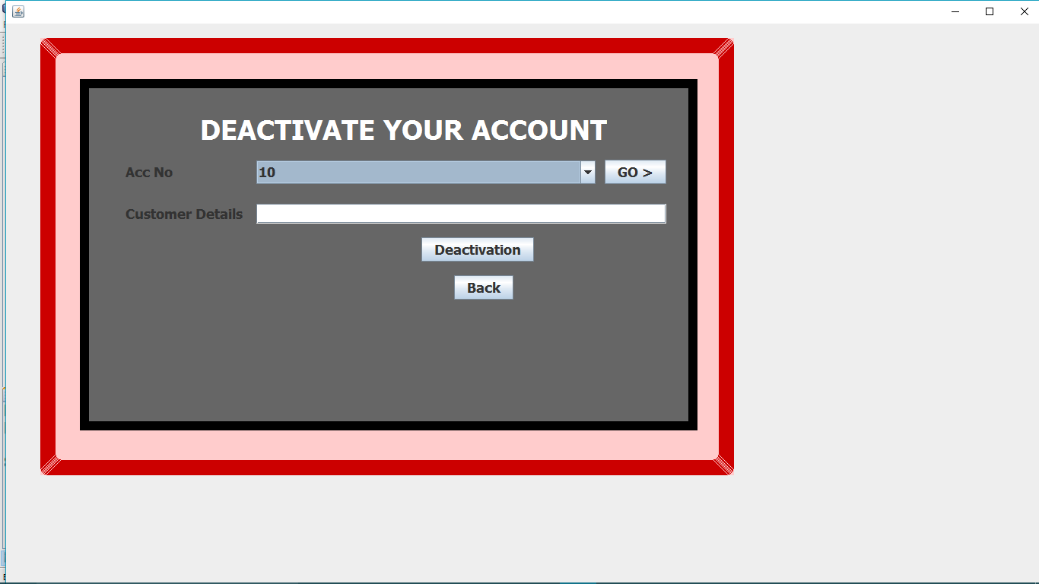

import java.sql.ResultSet;

import javax.swing.JOptionPane;

import java.sql.DriverManager;

import java.sql.Statement;

import java.sql.Connection;

**private void formWindowActivated(java.awt.event.WindowEvent evt) {**

try{

Class.forName("java.sql.DriverManager");

Connection c=(Connection)DriverManager.getConnection("jdbc:mysql://localhost:3306/BANKING_PROJECT","root","divyanshu");

Statement s=(Statement)c.createStatement();

String q="select acc_no from new_acc;";

ResultSet rs=s.executeQuery(q);

while(rs.next())

{String acc=rs.getString("acc_no");

cmb.addItem(acc);}

}

catch(Exception e)

{ JOptionPane.showMessageDialog(null,e.getMessage());}

}

**private void jButton1ActionPerformed(java.awt.event.ActionEvent evt) {**

String a=(String)cmb.getSelectedItem();

try{

Class.forName("java.sql.DriverManager");

Connection c=(Connection)DriverManager.getConnection("jdbc:mysql://localhost:3306/BANKING_PROJECT","root","divyanshu");

Statement s=(Statement)c.createStatement();

String q="(select name from new_acc where acc_no='"+a+"');";

ResultSet r=s.executeQuery(q);

while(r.next())

{String n=r.getString("name");

t1.setText(n);

}}

catch(Exception e)

{JOptionPane.showMessageDialog(null,e.getMessage());

}

}

**private void jButton2ActionPerformed(java.awt.event.ActionEvent evt) {**

String name=t1.getText();

String a=(String)cmb.getSelectedItem();

try{

int i=JOptionPane.showConfirmDialog(null,"Are You sure to Deactivate Your Account??");

if(i==0)

{Class.forName("java.sql.DriverManager");

Connection c=(Connection)DriverManager.getConnection("jdbc:mysql://localhost:3306/BANKING_PROJECT","root","divyanshu");

Statement s=(Statement)c.createStatement();

String q="update new_acc set acc_status='DC' where acc_no='"+a+"';";

s.executeUpdate(q);

JOptionPane.showMessageDialog(null,"Your account is deactivated");}

if(i==1)

{JOptionPane.showMessageDialog(null,"Thanks for using our facilities");

}

if(i==2)

{this.dispose();

}

}

catch(Exception e)

{JOptionPane.showMessageDialog(null,e.getMessage());

}

}

**private void jButton3ActionPerformed(java.awt.event.ActionEvent evt) {**

new account_function().setVisible(true);

this.dispose(); }

**REACTIVATE ACCOUNT**

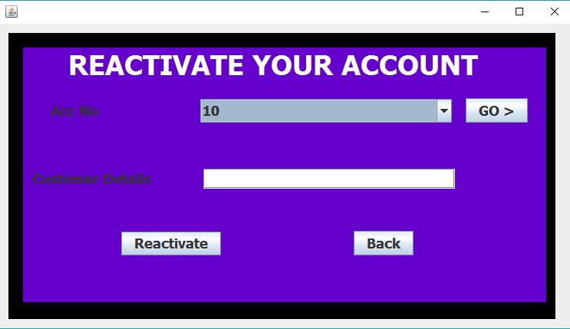

import java.sql.ResultSet;

import javax.swing.JOptionPane;

import java.sql.DriverManager;

import java.sql.Statement;

import java.sql.Connection;

**private void jButton1ActionPerformed(java.awt.event.ActionEvent evt) {**

String a=(String)cmb.getSelectedItem();

try{

Class.forName("java.sql.DriverManager");

Connection c=(Connection)DriverManager.getConnection("jdbc:mysql://localhost:3306/BANKING_PROJECT","root","divyanshu");

Statement s=(Statement)c.createStatement();

String q="(select name from new_acc where acc_no='"+a+"');";

ResultSet r=s.executeQuery(q);

while(r.next()) {

String n=r.getString("name");

t1.setText(n);

}} catch(Exception e) {

JOptionPane.showMessageDialog(null,e.getMessage());

}

}

**private void jButton2ActionPerformed(java.awt.event.ActionEvent evt) {**

String name=t1.getText();

String a=(String)cmb.getSelectedItem();

try{

int i=JOptionPane.showConfirmDialog(null,"Are You sure to Reactivate Your Account??");

if(i==0)

{Class.forName("java.sql.DriverManager");

Connection c=(Connection)DriverManager.getConnection("jdbc:mysql://localhost:3306/BANKING_PROJECT","root","divyanshu");

Statement s=(Statement)c.createStatement();

String q="update new_acc set acc_status='AC' where acc_no='"+a+"';";

String q1="select acc_status from new_acc where acc_no='"+a+"';";

s.executeUpdate(q);

JOptionPane.showMessageDialog(null,"Your account is reactivated");}

if(i==1)

{JOptionPane.showMessageDialog(null,"Thanks for using our facilities");

}

if(i==2)

{this.dispose();

}

}

catch(Exception e)

{JOptionPane.showMessageDialog(null,e.getMessage());

}

}

**private void formWindowActivated(java.awt.event.WindowEvent evt) {**

try{

Class.forName("java.sql.DriverManager");

Connection c=(Connection)DriverManager.getConnection("jdbc:mysql://localhost:3306/BANKING_PROJECT","root","divyanshu");

Statement s=(Statement)c.createStatement();

String q="select acc_no from new_acc;";

ResultSet rs=s.executeQuery(q);

while(rs.next())

{String acc=rs.getString("acc_no");

cmb.addItem(acc);}

String q1="select acc_status from new_acc;";

ResultSet rs1=s.executeQuery(q1);

}

catch(Exception e)

{ JOptionPane.showMessageDialog(null,e.getMessage());}

}

**private void jButton3ActionPerformed(java.awt.event.ActionEvent evt) {**

new account_function().setVisible(true);

this.dispose();

}

DEPOSIT MONEY

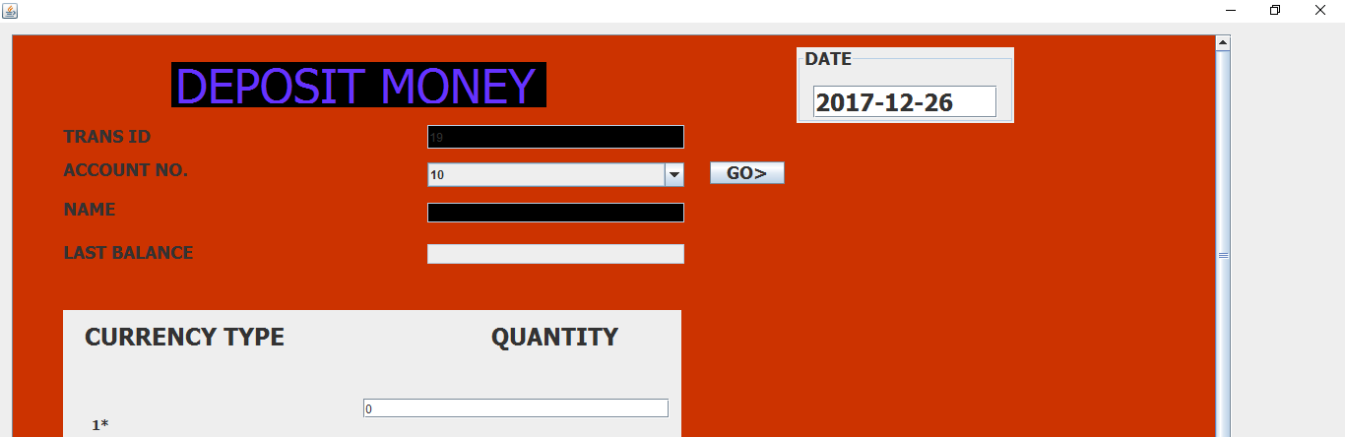

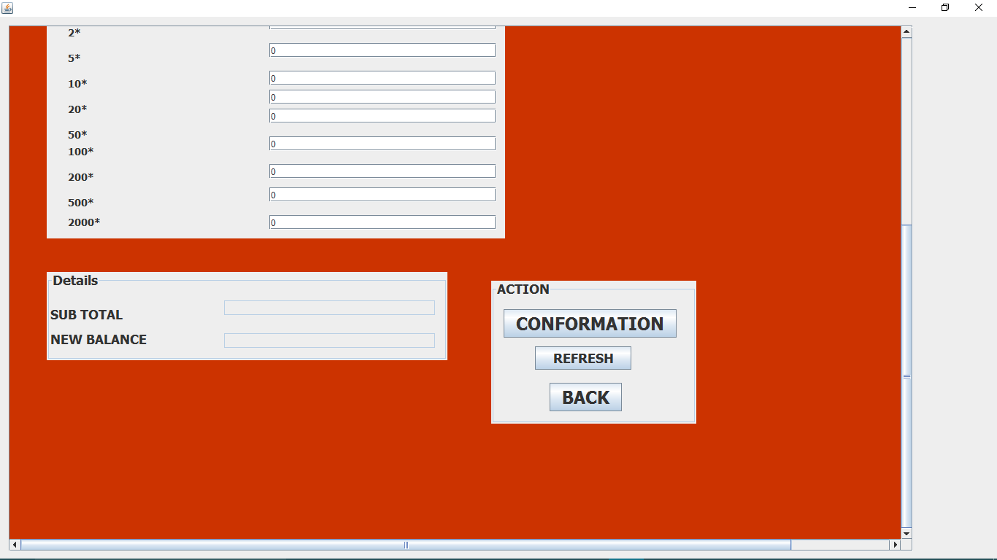

import java.sql.ResultSet;

import javax.swing.JOptionPane;

import java.sql.DriverManager;

import java.sql.Statement;

import java.sql.Connection;

**private void formWindowOpened(java.awt.event.WindowEvent evt) {**

try

{

Class.forName("java.sql.DriverManager");

Connection c=(Connection)DriverManager.getConnection("jdbc:mysql://localhost:3306/BANKING_PROJECT","root","divyanshu");

Statement s=(Statement)c.createStatement();

String q="select*from new_acc;";

ResultSet r=s.executeQuery(q);

int k=0;

while(r.next())

{String acc=r.getString("acc_no");

cmb.addItem(acc);}

}

catch(Exception e)

{

JOptionPane.showMessageDialog(null,e.getMessage());

}

}

**private void formWindowActivated(java.awt.event.WindowEvent evt) {**

long abc;

try

{

Class.forName("java.sql.DriverManager");

Connection c=(Connection)DriverManager.getConnection("jdbc:mysql://localhost:3306/BANKING_PROJECT","root","divyanshu");

Statement s=(Statement)c.createStatement();

String query="select max(tid)from transaction;";

ResultSet rs=s.executeQuery(query);

rs.next();

long acc=Long.parseLong(rs.getString("max(tid)"));

abc=acc+1;

T1.setText(""+abc);

T1.setEditable(false);

String q="select curdate();";

ResultSet rs1=s.executeQuery(q);

rs1.first();

String dat=rs1.getString("curdate()");

date.setText(dat);

T3.setEditable(false);

T4.setEditable(false);

T15.setEditable(false);

T16.setEditable(false);

}

catch(Exception e)

{

JOptionPane.showMessageDialog(null,e.getMessage());

}

}

**private void jButton3ActionPerformed(java.awt.event.ActionEvent evt) {**

String a=(String)cmb.getSelectedItem();

try

{

Class.forName("java.sql.DriverManager");

Connection c=(Connection)DriverManager.getConnection("jdbc:mysql://localhost:3306/BANKING_PROJECT","root","divyanshu");

Statement s=(Statement)c.createStatement();

String q="select*from new_acc where acc_no='"+a+"';";

ResultSet r=s.executeQuery(q);

int k=0;

while(r.next())

{String n=r.getString("name");

String bal=r.getString("balance");

T3.setText(n);

T4.setText(bal);

}

}

catch(Exception e)

{JOptionPane.showMessageDialog(null,e.getMessage());

}

}

**private void confActionPerformed(java.awt.event.ActionEvent evt) {**

String a=(String)cmb.getSelectedItem();

try

{

Class.forName("java.sql.DriverManager");

Connection c=(Connection)DriverManager.getConnection("jdbc:mysql://localhost:3306/BANKING_PROJECT","root","divyanshu");

Statement s=(Statement)c.createStatement();

T3.setEditable(false);

T4.setEditable(false);

T15.setEditable(false);

T16.setEditable(false);

double a1=Double.parseDouble(T5.getText());

double a2=Double.parseDouble(T6.getText());

double a5=Double.parseDouble(T7.getText());

double a10=Double.parseDouble(T8.getText());

double a20=Double.parseDouble(T9.getText());

double a50=Double.parseDouble(T10.getText());

double a100=Double.parseDouble(T11.getText());

double a200=Double.parseDouble(T12.getText());

double a2000=Double.parseDouble(T14.getText());

double a500=Double.parseDouble(T13.getText());

double total=(a1*1+a2*2+a5*5+a10*10+a20*20+a50*50+a100*100+a200*200+a500*500+a2000*2000);

T15.setText(total+" ");

double t=Double.parseDouble(T15.getText());

double bal=Double.parseDouble(T4.getText());

double bal1=bal+total;

T16.setText(bal1+" ");

String balance="update new_acc set balance="+bal1+" where acc_no='"+a+"';";

s.executeUpdate(balance);

String tid=T1.getText();

String tdate=date.getText();

String tamt=T15.getText();

String name=T3.getText();

String lastbal=T4.getText();

String newbal=T16.getText();

String query="insert into transaction values ('"+tid+"','"+a+"','"+tdate+"','"+tamt+"','"+name+"','"+lastbal+"','"+newbal+"','"+"cash"+"','"+a+"','"+"NOT APPLICABLE"+"','"+0+"','"+0+"','"+"DEPOSIT"+"');";

s.executeUpdate(query);

JOptionPane.showMessageDialog(null,"THANK YOU!! YOUR MONEY IS DEPOSITED");

}

catch(Exception e)

{

JOptionPane.showMessageDialog(null,e.getMessage());

}

conf.setEnabled(false);

}

**private void jButton4ActionPerformed(java.awt.event.ActionEvent evt) {**

cmb.setSelectedIndex(-1);

T3.setText("");

T4.setText("");

T5.setText("0");

T6.setText("0");

T7.setText("0");

T8.setText("0");

T9.setText("0");

T10.setText("0");

T11.setText("0");

T12.setText("0");

T13.setText("0");

T14.setText("0");

T15.setText("");

T16.setText("");

conf.setEnabled(true);

}

**private void jButton2ActionPerformed(java.awt.event.ActionEvent evt) {**

new account_function().setVisible(true);

this.dispose(); }

**WITHDRAW MONEY**

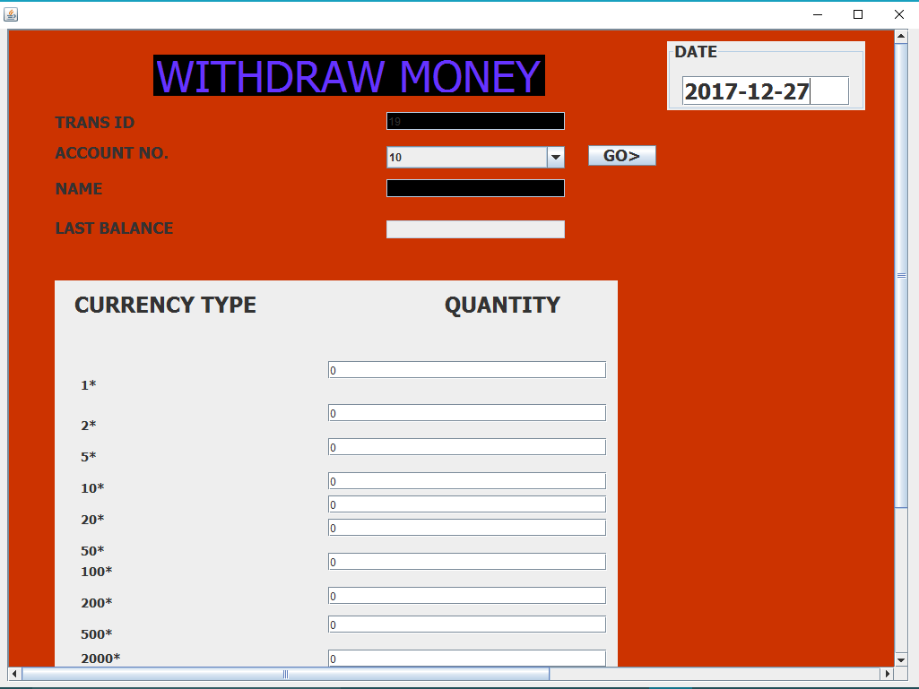

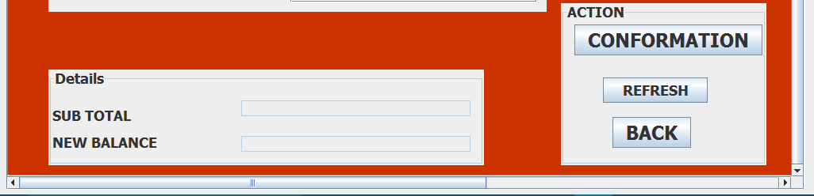

import java.sql.ResultSet;

import javax.swing.JOptionPane;

import java.sql.DriverManager;

import java.sql.Statement;

import java.sql.Connection;

**private void confActionPerformed(java.awt.event.ActionEvent evt) {**

String a=(String)cmb.getSelectedItem();

try {

Class.forName("java.sql.DriverManager");

Connection c=(Connection)DriverManager.getConnection("jdbc:mysql://localhost:3306/BANKING_PROJECT","root","divyanshu");

Statement s=(Statement)c.createStatement();

T3.setEditable(false);

T4.setEditable(false);

T15.setEditable(false);

T16.setEditable(false);

double a1=Double.parseDouble(T5.getText());

double a2=Double.parseDouble(T6.getText());

double a5=Double.parseDouble(T7.getText());

double a10=Double.parseDouble(T8.getText());

double a20=Double.parseDouble(T9.getText());

double a50=Double.parseDouble(T10.getText());

double a100=Double.parseDouble(T11.getText());

double a200=Double.parseDouble(T12.getText());

double a2000=Double.parseDouble(T14.getText());

double a500=Double.parseDouble(T13.getText());

double total=(a1*1+a2*2+a5*5+a10*10+a20*20+a50*50+a100*100+a200*200+a500*500+a2000*2000);

T15.setText(total+" ");

double t=Double.parseDouble(T15.getText());

double bal=Double.parseDouble(T4.getText());

double bal1=bal-total;

if (bal1>0)

{

T16.setText(bal1 + " ");

String balance="update new_acc set balance="+bal1+" where acc_no='"+a+"';";

s.executeUpdate(balance);

String tid=T1.getText();

String tdate=date.getText();

String tamt=T15.getText();

String name=T3.getText();

String lastbal=T4.getText();

String newbal=T16.getText();

String query="insert into transaction values ('"+tid+"','"+a+"','"+tdate+"','"+tamt+"','"+name+"','"+lastbal+"','"+newbal+"','"+"cash"+"','"+a+"','"+"NOT APPLICABLE"+"','"+0+"','"+0+"','"+"WITHDRAW"+"');";

s.executeUpdate(query);

JOptionPane.showMessageDialog(null,"BALANCE WITHDRAWN");

}

else

{JOptionPane.showMessageDialog(null,"SORRY YOU DON'T HAVE ENOUGH BALANCE");

}

}

catch(Exception e)

{

JOptionPane.showMessageDialog(null,e.getMessage());

}

conf.setEnabled(false);

}

**private void jButton3ActionPerformed(java.awt.event.ActionEvent evt) {**

String a=(String)cmb.getSelectedItem();

try {

Class.forName("java.sql.DriverManager");

Connection c=(Connection)DriverManager.getConnection("jdbc:mysql://localhost:3306/BANKING_PROJECT","root","divyanshu");

Statement s=(Statement)c.createStatement();

String q="select*from new_acc where acc_no='"+a+"';";

ResultSet r=s.executeQuery(q);

int k=0;

while(r.next()) {

String n=r.getString("name");

String bal=r.getString("balance");

T3.setText(n);

T4.setText(bal);

}

} catch(Exception e) {

JOptionPane.showMessageDialog(null,e.getMessage());

}

}

**private void formWindowActivated(java.awt.event.WindowEvent evt) {**

long abc;

try

{

Class.forName("java.sql.DriverManager");

Connection c=(Connection)DriverManager.getConnection("jdbc:mysql://localhost:3306/BANKING_PROJECT","root","divyanshu");

Statement s=(Statement)c.createStatement();

String query="select max(tid)from transaction;";

ResultSet rs=s.executeQuery(query);

rs.next();

long acc=Long.parseLong(rs.getString("max(tid)"));

abc=acc+1;

T1.setText(""+abc);

T1.setEditable(false);

String q="select curdate();";

ResultSet rs1=s.executeQuery(q);

rs1.first();

String dat=rs1.getString("curdate()");

date.setText(dat);

T3.setEditable(false);

T4.setEditable(false);

T15.setEditable(false);

T16.setEditable(false);

}

catch(Exception e)

{

JOptionPane.showMessageDialog(null,e.getMessage());

}

}

**private void formWindowOpened(java.awt.event.WindowEvent evt) {**

try

{

Class.forName("java.sql.DriverManager");

Connection c=(Connection)DriverManager.getConnection("jdbc:mysql://localhost:3306/BANKING_PROJECT","root","divyanshu");

Statement s=(Statement)c.createStatement();

String q="select*from new_acc;";

ResultSet r=s.executeQuery(q);

int k=0;

while(r.next())

{String acc=r.getString("acc_no");

cmb.addItem(acc);}

}

catch(Exception e)

{

JOptionPane.showMessageDialog(null,e.getMessage());

}

}

**private void jButton4ActionPerformed(java.awt.event.ActionEvent evt) {**

cmb.setSelectedIndex(-1);

T3.setText("");

T4.setText("");

T5.setText("0");

T6.setText("0");

T7.setText("0");

T8.setText("0");

T9.setText("0");

T10.setText("0");

T11.setText("0");

T12.setText("0");

T13.setText("0");

T14.setText("0");

T15.setText("");

T16.setText("");

conf.setEnabled(true);

}

**private void jButton2ActionPerformed(java.awt.event.ActionEvent evt) {**

new account_function().setVisible(true);

this.dispose();

}

**TRANSACTION**

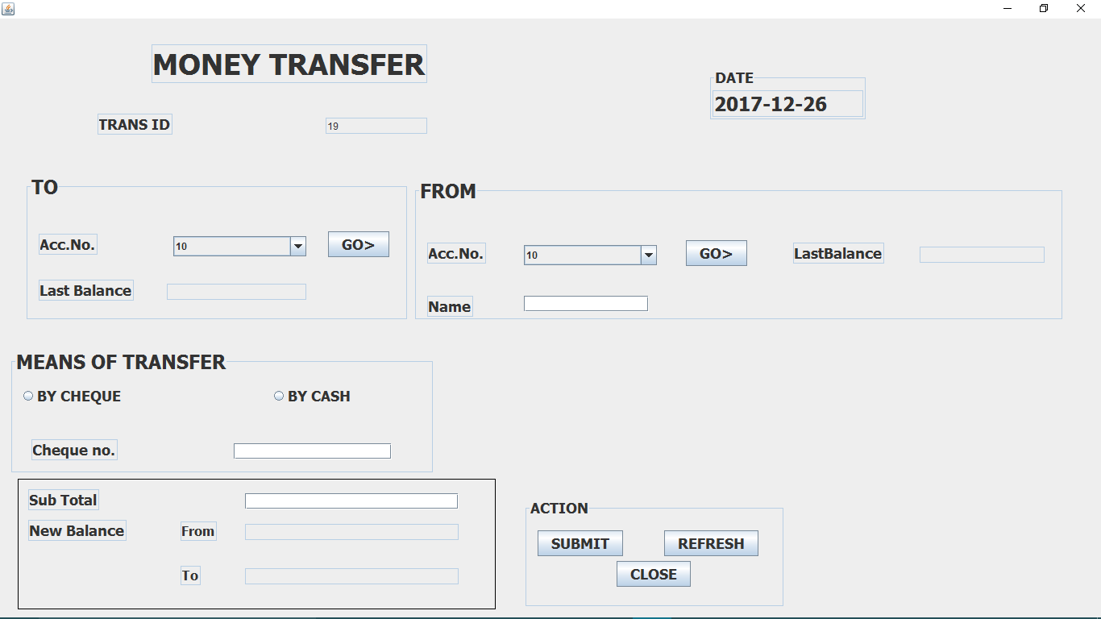

import java.sql.ResultSet;

import javax.swing.JOptionPane;

import java.sql.DriverManager;

import java.sql.Statement;

import java.sql.Connection;

**private void formWindowOpened(java.awt.event.WindowEvent evt) {**

try

{

Class.forName("java.sql.DriverManager");

Connection c=(Connection)DriverManager.getConnection("jdbc:mysql://localhost:3306/BANKING_PROJECT","root","divyanshu");

Statement s=(Statement)c.createStatement();

String q="select*from new_acc;";

ResultSet r=s.executeQuery(q);

while(r.next())

{

String acc=r.getString("acc_no");

cmb1.addItem(acc);

cmb2.addItem(acc);

}

}

catch(Exception e)

{

JOptionPane.showMessageDialog(null,e.getMessage());

}

}

**private void jButton1ActionPerformed(java.awt.event.ActionEvent evt) {**

try

{Object a=cmb1.getSelectedItem();

Class.forName("java.sql.DriverManager");

Connection c=(Connection)DriverManager.getConnection("jdbc:mysql://localhost:3306/BANKING_PROJECT","root","divyanshu");

Statement s=(Statement)c.createStatement();

String q="select*from new_acc where acc_no ='"+a+"';";

ResultSet rs=s.executeQuery(q);

while(rs.next())

{String bal=rs.getString("balance");

lstbal.setText(bal);

}

}

catch(Exception e)

{JOptionPane.showMessageDialog(null,e.getMessage());

}

}

**private void jButton2ActionPerformed(java.awt.event.ActionEvent evt) {**

try

{Object a=cmb2.getSelectedItem();

Class.forName("java.sql.DriverManager");

Connection c=(Connection)DriverManager.getConnection("jdbc:mysql://localhost:3306/BANKING_PROJECT","root","divyanshu");

Statement s=(Statement)c.createStatement();

String q="select*from new_acc where acc_no ='"+a+"';";

ResultSet rs=s.executeQuery(q);

while(rs.next())

{String bal=rs.getString("balance");

String n=rs.getString("name");

name.setText(n);

lbal.setText(bal);

}

}

catch(Exception e)

{JOptionPane.showMessageDialog(null,e.getMessage());

}

}

**private void formWindowActivated(java.awt.event.WindowEvent evt) {**

long abc;

try

{

Class.forName("java.sql.DriverManager");

Connection c=(Connection)DriverManager.getConnection("jdbc:mysql://localhost:3306/BANKING_PROJECT","root","divyanshu");

Statement s=(Statement)c.createStatement();

String query="select max(tid)from transaction;";

ResultSet rs=s.executeQuery(query);

rs.next();

long acc=Long.parseLong(rs.getString("max(tid)"));

abc=acc+1;

tid.setText(""+abc);

tid.setEditable(false);

String q="select curdate();";

ResultSet rs1=s.executeQuery(q);

rs1.first();

String dat=rs1.getString("curdate()");

date.setText(dat);

}

catch(Exception e)

{JOptionPane.showMessageDialog(null,e.getMessage());

}

t1.setEditable(false);

t2.setEditable(false);

t3.setEditable(false);

t4.setEditable(false);

t5.setEditable(false);

t6.setEditable(false);

t7.setEditable(false);

t8.setEditable(false);

t9.setEditable(false);

t10.setEditable(false);

t11.setEditable(false);

t12.setEditable(false);

date.setEditable(false);

lstbal.setEditable(false);

lbal.setEditable(false);

nb1.setEditable(false);

nb2.setEditable(false);

}

**private void submitActionPerformed(java.awt.event.ActionEvent evt) {**

String a = null;

int lbalan=Integer.parseInt(lbal.getText());

int t=Integer.parseInt(total.getText());

String acc=(String) cmb1.getSelectedItem();

String acc1=(String) cmb2.getSelectedItem();

try

{

Class.forName("java.sql.DriverManager");

Connection c=(Connection)DriverManager.getConnection("jdbc:mysql://localhost:3306/BANKING_PROJECT","root","divyanshu");

Statement s=(Statement)c.createStatement();

Statement s1=(Statement)c.createStatement();

int bal=Integer.parseInt(lstbal.getText());

int bal2=Integer.parseInt(lbal.getText());

int bal1=bal+t;

int bal3=bal2-t;

if(lbalan>t)

{if(bal3>0)

{

nb1.setText(""+bal3);

nb2.setText(""+bal1);

String balance="update new_acc set balance="+bal3+" where acc_no='"+acc1+"';";

s.executeUpdate(balance);

String balance1="update new_acc set balance="+bal1+" where acc_no='"+acc+"';";

s.executeUpdate(balance1);

String name1=name.getText();

String txid=tid.getText();

String fbal=nb1.getText();

String tbal=nb2.getText();

String datt=date.getText();

String sbtotal=total.getText();

String tlst=lstbal.getText();

String flst=lbal.getText();

if(chq.isSelected()==true)

{a="cheque";

tchq.setEditable(true);

String cheqno=tchq.getText();

if(cheqno.isEmpty())

{JOptionPane.showMessageDialog(null,"PLEASE ENTER CHEQUE NO");

}

else{

String y="insert into transaction values ('"+txid+"','"+acc1+"','"+datt+"','"+sbtotal+"','"+name1+"','"+flst+"','"+fbal+"','"+a+"','"+acc+"','"+cheqno+"','"+tlst+"','"+tbal+"','"+"transfered"+"');";

s1.executeUpdate(y);}

}

}

if(csh.isSelected()==true)

{ a="cash";

tchq.setEditable(false);

JOptionPane.showMessageDialog(null,a);

String name1=name.getText();

String txid=tid.getText();

String fbal=nb1.getText();

String tbal=nb2.getText();

String datt=date.getText();

String sbtotal=total.getText();

String tlst=lstbal.getText();

String flst=lbal.getText();

String y1="insert into transaction values ('"+txid+"','"+acc1+"','"+datt+"','"+sbtotal+"','"+name1+"','"+flst+"','"+fbal+"','"+a+"','"+acc+"','"+"NOT APPLICABLE"+"','"+tlst+"','"+tbal+"','"+"TRANSFERRED"+"');";

s.executeUpdate(y1);

}

//else {

//JOptionPane.showMessageDialog(null,"Not allowed");

//}

JOptionPane.showMessageDialog(null,"YOUR TRANSACTION IS SUCCESSFUL......THANK YOU!!! FOR USING OUR BANK");}

else

{JOptionPane.showMessageDialog(null,"not having enough balance");

}

}

catch (Exception e)

{JOptionPane.showMessageDialog(null,e.getMessage());}

submit.setEnabled(false);

}

**private void jButton5ActionPerformed(java.awt.event.ActionEvent evt) {**

submit.setEnabled(true);

cmb1.setSelectedIndex(-1);

cmb2.setSelectedIndex(-1);

name.setText(" ");

nb1.setText(" ");

nb2.setText(" ");

total.setText(" ");

lstbal.setText(" ");

lbal.setText(" ");

}

**private void jButton4ActionPerformed(java.awt.event.ActionEvent evt) {**

new account_function().setVisible(true);

this.dispose();

}

**TRANSACTION REPORT**

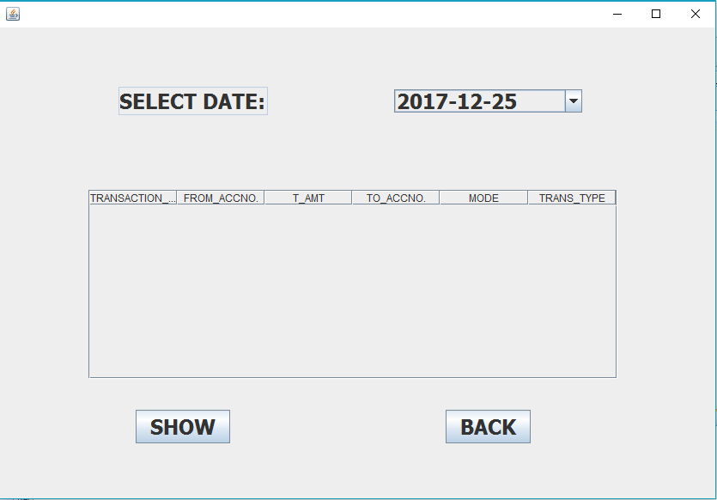

import com.mysql.jdbc.Connection;

import com.mysql.jdbc.Statement;

import java.sql.DriverManager;

import java.sql.ResultSet;

import javax.swing.JOptionPane;

import javax.swing.table.DefaultTableModel;

**private void formWindowActivated(java.awt.event.WindowEvent evt) {**

t1.setEditable(false);

try{

Class.forName("java.sql.DriverManager");

Connection c=(Connection)DriverManager.getConnection("jdbc:mysql://localhost:3306/BANKING_PROJECT","root","divyanshu");

Statement s=(Statement)c.createStatement();

String q="select distinct(tdate) from transaction;";

ResultSet rs=s.executeQuery(q);

while(rs.next())

{String acc=rs.getString("tdate");

cmb.addItem(acc);}

}

catch(Exception e)

{ JOptionPane.showMessageDialog(null,e.getMessage());}

}

**private void jButton1ActionPerformed(java.awt.event.ActionEvent evt) {**

String a=(String)cmb.getSelectedItem();

DefaultTableModel dm=(DefaultTableModel)table.getModel();

int n=dm.getRowCount();

int i;

for(i=0;i<n;i++)

{dm.removeRow(0);

}

try{

Class.forName("java.sql.DriverManager");

Connection c=(Connection)DriverManager.getConnection("jdbc:mysql://localhost:3306/BANKING_PROJECT","root","divyanshu");

Statement s=(Statement)c.createStatement();

String q="select*from transaction where tdate='"+a+"';";

ResultSet rs=s.executeQuery(q);

while(rs.next())

{String transid=rs.getString("tid");

String accno=rs.getString("acc_no");

String tacc=rs.getString("acc_to");

String tamt=rs.getString("tamt");

String md=rs.getString("mode");

String type=rs.getString("trans_type");

dm.addRow(new Object[]{transid,accno,tamt,tacc,md,type});

}

}

catch(Exception e)

{

}

}

**private void jButton2ActionPerformed(java.awt.event.ActionEvent evt) {**

new account_function().setVisible(true);

this.dispose();

}

**MONEY DEPOSITED TODAY**

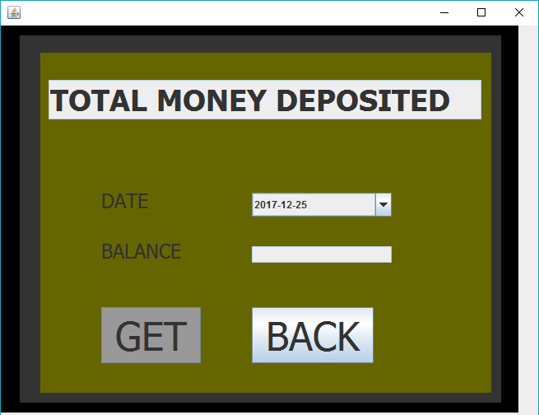

import com.mysql.jdbc.Connection;

import com.mysql.jdbc.Statement;

import java.sql.DriverManager;

import java.sql.ResultSet;

import javax.swing.JOptionPane;

**private void jButton2ActionPerformed(java.awt.event.ActionEvent evt) {**

String D=(String)Date.getSelectedItem();

try

{

Class.forName("java.sql.DriverManager");

Connection c=(Connection)DriverManager.getConnection("jdbc:mysql://localhost:3306/BANKING_PROJECT","root","divyanshu");

Statement s=(Statement)c.createStatement();

String q="select sum(tamt) from transaction where tdate='"+D+"' and trans_type='deposit';";

ResultSet rs=s.executeQuery(q);

while(rs.next())

{String to_bal=rs.getString("sum(tamt)");

t2.setText(to_bal);

}

String a=t2.getText();

if(a.isEmpty()==true)

{

JOptionPane.showMessageDialog(null,"NO MONEY DEPOSITED TODAY");

}

}

catch(Exception e)

{

}

}

**private void formWindowOpened(java.awt.event.WindowEvent evt) {**

t2.setEditable(false);

}

private void formWindowActivated(java.awt.event.WindowEvent evt) {

t12.setEditable(false);

try{

Class.forName("java.sql.DriverManager");

Connection c=(Connection)DriverManager.getConnection("jdbc:mysql://localhost:3306/BANKING_PROJECT","root","divyanshu");

Statement s=(Statement)c.createStatement();

String q="select distinct(tdate) from transaction;";

ResultSet rs=s.executeQuery(q);

while(rs.next())

{String acc=rs.getString("tdate");

Date.addItem(acc);}

}

catch(Exception e)

{ JOptionPane.showMessageDialog(null,e.getMessage());}

}

**private void jButton1ActionPerformed(java.awt.event.ActionEvent evt) {**

new account_function().setVisible(true);

this.dispose();

}

MONEY WITHDRAW TODAY



import com.mysql.jdbc.Connection;

import com.mysql.jdbc.Statement;

import java.sql.DriverManager;

import java.sql.ResultSet;

import javax.swing.JOptionPane;

**private void jButton2ActionPerformed(java.awt.event.ActionEvent evt) {**

String D=(String)Date.getSelectedItem();

try {

Class.forName("java.sql.DriverManager");

Connection c=(Connection)DriverManager.getConnection("jdbc:mysql://localhost:3306/BANKING_PROJECT","root","divyanshu");

Statement s=(Statement)c.createStatement();

String q="select sum(tamt) from transaction where tdate='"+D+"' and trans_type='withdraw';";

ResultSet rs=s.executeQuery(q);

while(rs.next()) {

String to_bal=rs.getString("sum(tamt)");

t2.setText(to_bal);

}

String a=t2.getText();

if(a.isEmpty()==true) {

JOptionPane.showMessageDialog(null,"NO MONEY DEPOSITED TODAY");

}

} catch(Exception e) {

}

}

**private void formWindowActivated(java.awt.event.WindowEvent evt) {**

t12.setEditable(false);

try{

Class.forName("java.sql.DriverManager");

Connection c=(Connection)DriverManager.getConnection("jdbc:mysql://localhost:3306/BANKING_PROJECT","root","divyanshu");

Statement s=(Statement)c.createStatement();

String q="select distinct(tdate) from transaction;";

ResultSet rs=s.executeQuery(q);

while(rs.next())

{String acc=rs.getString("tdate");

Date.addItem(acc);}

}

catch(Exception e)

{ JOptionPane.showMessageDialog(null,e.getMessage());}

}

**private void formWindowOpened(java.awt.event.WindowEvent evt) {**

t2.setEditable(false);

}

**private void jButton1ActionPerformed(java.awt.event.ActionEvent evt) {**

new account_function().setVisible(true);

this.dispose();

}

MONEY TRANSFERRED TODAY

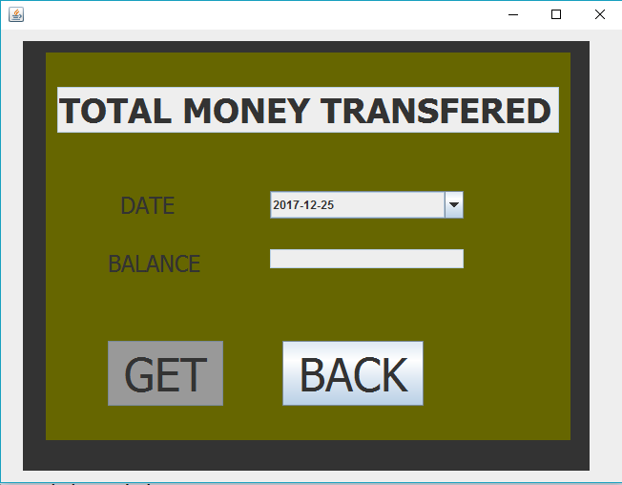

import com.mysql.jdbc.Connection;

import com.mysql.jdbc.Statement;

import java.sql.DriverManager;

import java.sql.ResultSet;

import javax.swing.JOptionPane;

**private void jButton2ActionPerformed(java.awt.event.ActionEvent evt) {**

String D=(String)Date.getSelectedItem();

try {

Class.forName("java.sql.DriverManager");

Connection c=(Connection)DriverManager.getConnection("jdbc:mysql://localhost:3306/BANKING_PROJECT","root","divyanshu");

Statement s=(Statement)c.createStatement();

String q="select sum(tamt) from transaction where tdate='"+D+"' and trans_type='TRANSFERED';";

ResultSet rs=s.executeQuery(q);

while(rs.next()) {

String to_bal=rs.getString("sum(tamt)");

t2.setText(to_bal);

}

String a=t2.getText();

if(a.isEmpty()==true) {

JOptionPane.showMessageDialog(null,"NO MONEY DEPOSITED TODAY");

}

} catch(Exception e) {

}

}

**private void formWindowActivated(java.awt.event.WindowEvent evt) {**

t12.setEditable(false);

try{

Class.forName("java.sql.DriverManager");

Connection c=(Connection)DriverManager.getConnection("jdbc:mysql://localhost:3306/BANKING_PROJECT","root","divyanshu");

Statement s=(Statement)c.createStatement();

String q="select distinct(tdate) from transaction;";

ResultSet rs=s.executeQuery(q);

while(rs.next())

{String acc=rs.getString("tdate");

Date.addItem(acc);}

}

catch(Exception e)

{ JOptionPane.showMessageDialog(null,e.getMessage());}

}

**private void formWindowOpened(java.awt.event.WindowEvent evt) {**

t2.setEditable(false);

}

**private void jButton1ActionPerformed(java.awt.event.ActionEvent evt) {**

new account_function().setVisible(true);

this.dispose();

}

BALANCE-TODAY

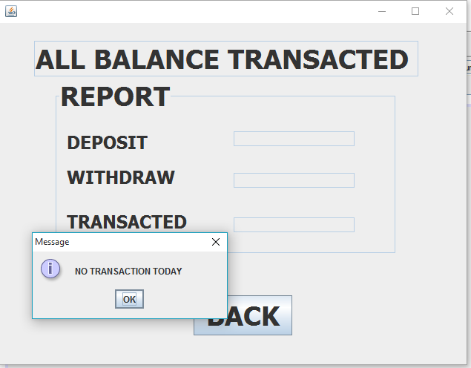

import com.mysql.jdbc.Connection;

import com.mysql.jdbc.Statement;

import java.sql.DriverManager;

import java.sql.ResultSet;

import javax.swing.JOptionPane;

**private void formWindowActivated(java.awt.event.WindowEvent evt) {**

t4.setEditable(false);

}

**private void formWindowOpened(java.awt.event.WindowEvent evt) {**

t1.setEditable(false);

t2.setEditable(false);

t3.setEditable(false);

try

{

Class.forName("java.sql.DriverManager");

Connection c=(Connection)

DriverManager.getConnection("jdbc:mysql://localhost:3306/BANKING_PROJECT","root","divyanshu");

Statement s=(Statement)c.createStatement();

String query="select curdate();";

ResultSet rs1=s.executeQuery(query);

rs1.first();

String date=rs1.getString("curdate()");

String q="select sum(tamt) from transaction where tdate='"+date+"'and trans_type='deposit';";

ResultSet rs=s.executeQuery(q);

while(rs.next())

{String to_bal=rs.getString("sum(tamt)");

t1.setText(to_bal);}

String q1="select sum(tamt) from transaction where tdate='"+date+"'and trans_type='withdraw';";

ResultSet rs2=s.executeQuery(q1);

while(rs2.next())

{String to_bal=rs2.getString("sum(tamt)");

t2.setText(to_bal);}

String q2="select sum(tamt) from transaction where tdate='"+date+"'and trans_type='transfered';";

ResultSet rs3=s.executeQuery(q2);

while(rs3.next())

{String to_bal=rs3.getString("sum(tamt)");

t3.setText(to_bal);}

}

catch(Exception e)

{

}

String a=t1.getText();

String c=t3.getText();String b=t2.getText();

if(a.isEmpty()&&b.isEmpty()&&c.isEmpty())

{JOptionPane.showMessageDialog(null,"NO TRANSACTION TODAY");} }

**private void jButton1ActionPerformed(java.awt.event.ActionEvent evt) {**

new account_function().setVisible(true);

this.dispose();

}

CURRENT BALANCE

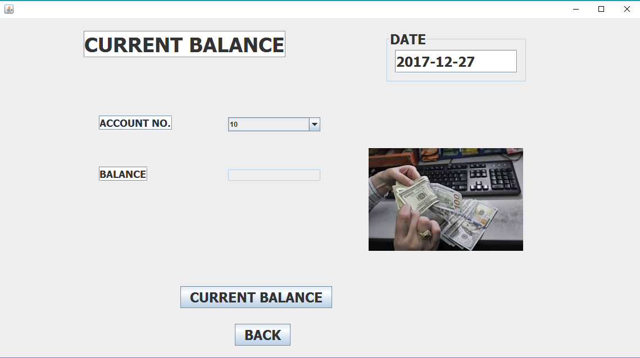

import java.sql.DriverManager;

import java.sql.Statement;

import java.sql.Connection;

import java.sql.ResultSet;

t2.setEditable(false);

try

{

Class.forName("java.sql.DriverManager");

Connection c=(Connection)

DriverManager.getConnection("jdbc:mysql://localhost:3306/BANKING_PROJECT","root","divyanshu");

Statement s=(Statement)c.createStatement();

String q="select curdate();";

ResultSet rs1=s.executeQuery(q);

rs1.first();

String dat=rs1.getString("curdate()");

date.setText(dat);

}

catch(Exception e)

{

}

}

**private void formWindowOpened(java.awt.event.WindowEvent evt) {**

try

{

Class.forName("java.sql.DriverManager");

Connection c=(Connection)

DriverManager.getConnection("jdbc:mysql://localhost:3306/BANKING_PROJECT","root","divyanshu");

Statement s=(Statement)c.createStatement();

String q="select *from new_acc;";

ResultSet r=s.executeQuery(q);

int k=0;

while(r.next())

{String acc=r.getString("acc_no");

cmb.addItem(acc);

}

}

catch(Exception e)

{

}

}

**private void jButton1ActionPerformed(java.awt.event.ActionEvent evt) {**

String a=(String)cmb.getSelectedItem();

try

{

Class.forName("java.sql.DriverManager");

Connection c=(Connection)

DriverManager.getConnection("jdbc:mysql://localhost:3306/BANKING_PROJECT","root","divyanshu");

Statement s=(Statement)c.createStatement();

String qu="select*from new_acc where acc_no='"+a+"';";

ResultSet rs=s.executeQuery(qu);

while(rs.next())

{String to_bal=rs.getString("balance");

t2.setText(to_bal);

}

}

catch(Exception e)

{

}

}

**private void jButton2ActionPerformed(java.awt.event.ActionEvent evt) {**

new account_function().setVisible(true);

this.dispose();

}

**BIBLIOGRAPHY**

* INFORMATICS PRACTICES
* SUMITA ARORA
* DHANPAT RAI&CO.
* NCERT INFORMATICS PRACTICES
* GOOGLE.COM

**REMARKS**