free查看系统内存

df命令是用来查看硬盘的挂载点,以及对应的硬盘容量信息。

du命令来查看硬盘内部的目录或者文件的信息。

无权限下sudo 开头

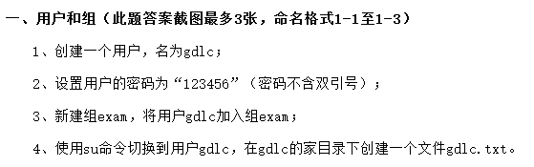

Useradd gdlc

Echo 123456 | passwd –stdin gdlc

Ls –l /home

Groupadd exam

Usermod -g exam gdlc

Tail –n 1 /etc/passwd

Su – gdlc

Touch ~/gdlc.txt

Ls ~/

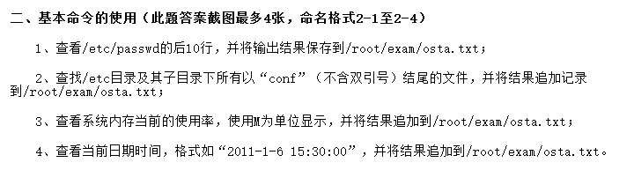

Tail –n 10 /etc/passwd >>/root/exam/osta.txt

Find /etc/ -name “*conf”>>/root/exam/osta.txt

free –h >>/root/exam/osta.txt

date +”%Y-%m-%d %T”>>/root/exam/osta.txt

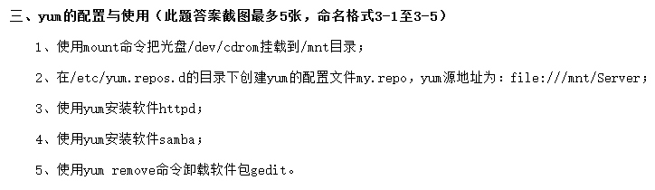

Mount /dev/cdrom /mnt

**df -h**

Cd /etc/yum.repos.d/

Vim my.repo

ls

Yum install httpd

Yum install samba

Yum remove gedit

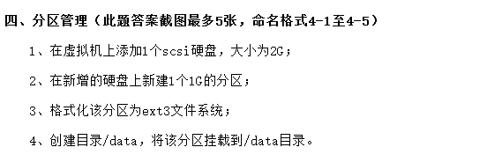

Fdisk /dev/sdb

N

1

+1G

W

Mkfs.ext3 /dev/sdb1

Mkdir /data

Mount /dev/sdb1 /data

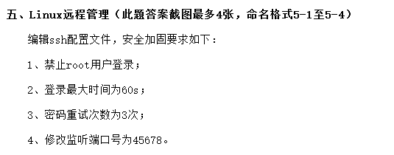

Vim /etc/ssh/sshd_config

改PermitRootLogin no 去#号

改LoginGraceTime 60去#号

改MaxAuthTries 3去#号

改Port 45678去#号



Sudo yum install samba –y

rpm -qa | grep samba

vim  /etc/samba/smb.conf

[public]

comment = samba doc 文件，

path = /samba/doc

public = yes

read only = yes

[work]

Comment=sambawork

Path=/samba/work

browseable = yes

available = yes

admin users = root

valid users =gdlc,@exam

write list=gdlc

public = no

////一下错误

security= share

[share]

comment= share all

path =

browseable = yes

read only = yes

public = yes

writable = no

///////

testparm



 Yum install –y httpd

Cp /usr/share/ht……./httpd.conf.simple

vim  /etc/httpd/conf/httpd.conf

<VirtualHost *:80>

ServerAdmin admin@linuxidc.com

ServerName www.gd-linux.com      //域名

ServerAlias   gd-linux.com  //别名

DocumentRoot  /htdocs/www / /解析上面域名的对应地址

//ErrorLog ${APACHE_LOG_DIR}/error.log

//CustomLog ${APACHE_LOG_DIR}/access.log combined

< /VirtualHost>

<IfModule dir_module>

DirectoryIndex /htdocs/www/download //默认索引

</IfModule>

//Chmod 775 –r /htdocs/www/download

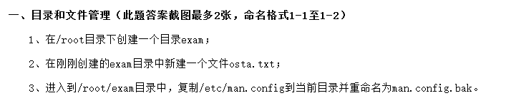

Sudo Mkdir /root/exam

Touch /root/exam/osta.txt

Cd /root/exam

Cp /etc/man.config ./man.config.bak

ls

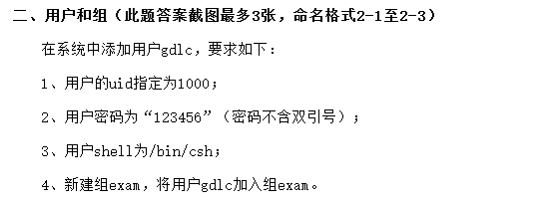

Useradd –g 1000 gdlc

Echo 123456 |passwd –stdin gdlc

Usermod –s /bin/csh gdlc

Groupadd exam

Usermod –g exam gdlc

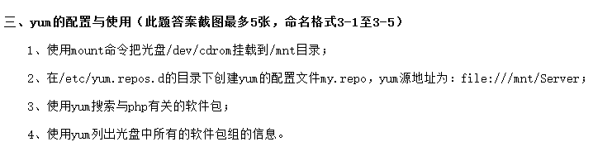

Mount /dev/cdrom /mnt

Df –h

Cd /etc/yum.repos.d/

Vim my.repo

[name]

Name=name

Baseurl=url:// or file:///mnt/Server <ftp://+路径>

Gpgcheck=0

Enabled=1

Yum search php

Yum info || yum list



Vi /etc/fstab

Defaults变为defaults,usrquota

Mount –o remount /

Cd /

quotacheck –amvug

useradd gdlc

edquota –u gdlc

1 soft //30000 1024*3 =3072

1 hard //51200 5120

2 soft 800

2 hard 1000

Quotaon –nv /

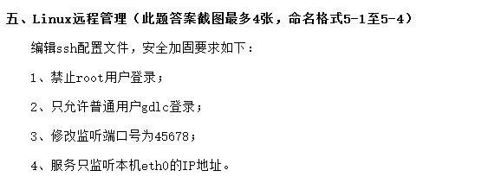

Vim /etc/ssh/sshd_config

改PermitRootLogin no 去#号

AllowUsers gdlc

改Port 45678去#号

*ListenAddress eth0ip*

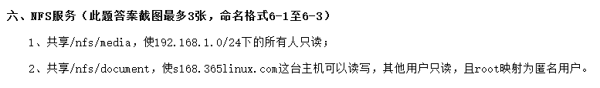

 cat /etc/redhat-release

 uname –r

yum install nfs-utils rpcbind -y

 rpm -qa nfs-utils rpcbind

id nfsnobody

/etc/init.d/rpcbind start

 /etc/init.d/rpcbind status

netstat -lntup |grep rpc

/etc/init.d/nfs start

/etc/init.d/nfs status

rpcinfo -p localhost

ps -ef |egrep "rpc|nfs"

//echo "/etc/init.d/rpcbind start" >>/etc/rc.local

//echo "/etc/init.d/nfs start" >>/etc/rc.local

**vim /etc/exports**

/nfs/media 192.168.1.0/24(ro)

/nfs/document s168.365linux.com(rw) root(ro,root_squash) *(ro)

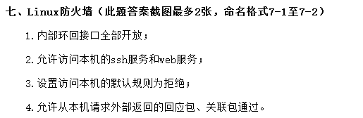

IPTABLES -A INPUT -i lo -p all -j ACCEPT   
IPTABLES -A OUTPUT -o lo -p all -j ACCEPT

//systemctl restart iptables.service

//iptables -L -n

iptables -I INPUT -p tcp --dport 80 -j ACCEPT

iptables -I INPUT -p tcp --dport 22 -j ACCEPT

//systemctl restart iptables.service

//iptables -L -n

iptables –I INPUT –j DROP

//iptables -L -n

iptables -t filter -A INPUT -m state --state ESTABLISHED,RELATED -j ACCEPT

iptables -t filter -A OUTPUT -m state --state ESTABLISHED,RELATED -j ACCEPT

iptables -L -n

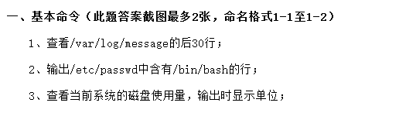

Tail -30 /var/log/message

Grep “/bin/bash” /etc/passwd –print

Df -h

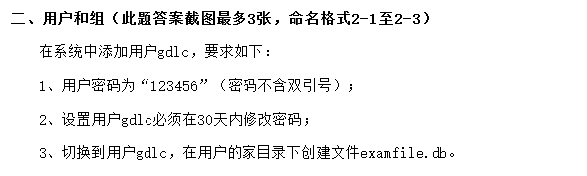

Useradd gdlc

Echo 123456 | passwd –stdin gdlc

Chage –M 30 gdlc

Su – gdlc

Touch ~/examfile.db

Ls ~/

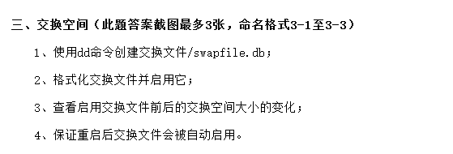

//路径/dev/hda

Sudo dd if=/dev/zero of=/swapfile.db bs=1024 count=10240000

Swapon -s

Mkswap /swapfile.db

Swapon /swapfile.db

Swapon -s

Vim /etc/fstab

/swapfile.db swap swap defaults 0 0

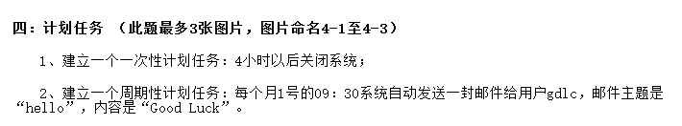

at now +4hours

at> shutdown -h now

at> <EOT>（baictrl+d）

crontab –e

30 9 1 * * echo Good Luck | mail –s ”hello” gdlc

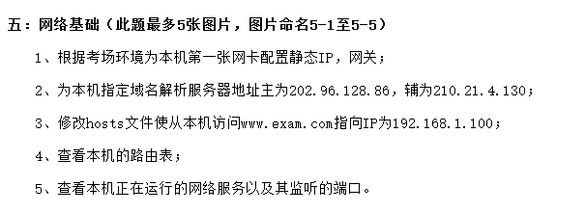

Vim /etc/sysconfig/network-scripts/ifcfg-eth0

BOOTPROTO=”static”

ONBOOT=yes

IPADDR=IP

NETMASK=

GETWAY=

Vim /etc/ resolv.conf

Nameserver 1ip为主

Nameserver 2ip为辅

Vim /etc/hosts

[www.exam.com](http://www.exam.com) ip

route

netstat -tuln

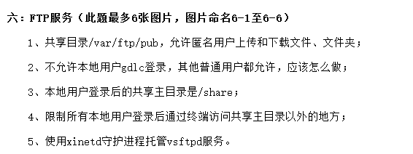

yum install -y vsftpd

vi /etc/vsftpd/vsftpd.conf

**anonymous_enable=YES**

**anon_root=/var/ftp/pub**

**write_enable=YES**

**ftp_username=ftp**

**anon_upload_enable=YES**

**anon_mkdir_write_enable=YES**

**wq**

**vim /etc/vsftpd/ftpusers**

**加入 用户gdlc**

vi /etc/vsftpd/vsftpd.conf

**local_enable=YES**

**local_root=/share**

**write_enable=YES**

chroot_list_enable=YES

chroot_list_file=/etc/vsftpd.chroot_list

allow_writeable_chroot=YES

service vsftpd stop

vi /etc/vsftpd/vsftpd.conf

Listen=ON

cd /etc/xinetd.d/

cp ./klogin ./vsftpd

vi vsftpd

service ftp

{

disable = no

socket_type = stream

wait = no

user = root

server = /usr/sbin/vsftpd

}

service xinetd restart

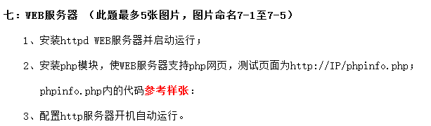

Yum install –y httpd

Service httpd start

yum -y install php

yum -y install php-fpm

yum -y install php-gd php-xml php-mbstring php-ldap php-pear php-xmlrpc php-devel

Vim /etc/httpd/httpd.conf

********

<VirtualHost ip:80>

DocumentRoot /data/htdocs *//第一个ip的网站的主页面目录*

ServerName [www.gdlc.com](http://www.gdlc.com)

<Directory /data/htdocs> *//要设置限制的目录*

Order allow,deny *//匹配了允许的就拒绝所有*

Allow from all

</VirtualHost>

AddType /文件位置/phpinfo.php

<IfModule dir_module>

DirectoryIndex index.html index.php

</IfModule>

Require all granted 改成这个

//Server httpd start

Apachectl 路径 start

在fox浏览器输入网址。

phpinfo.php内文件内容：照着打。

chkconfig --level 3 httpd on

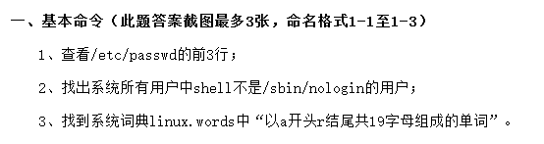

Head –n 3 /etc/passwd

Grep “/sbin/nologin” –v /etc/passwd | cut –d: -f1 –print

Grep “^a*{17}r$” /linux.words

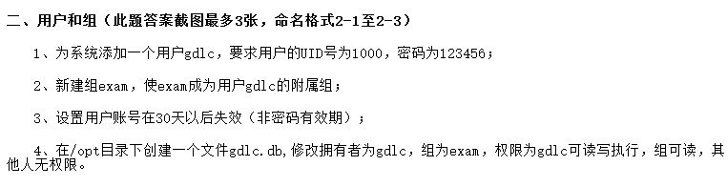

Useradd –u 1000 gdlc

Echo 123456 |passwd –stdin gdlc

Groupadd exam

Usermod –G exam gdlc

Usermod –E 30(日期) gdlc

>> /opt/gdlc.db

Chown gdlc:exam /opt/gdlc.db

Chmod 740 /opt/gdlc.db

ll

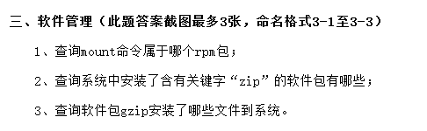

Rpm –qa |grep mount

Rpm –qa| grep “zip”

find / -type f -name "gz"

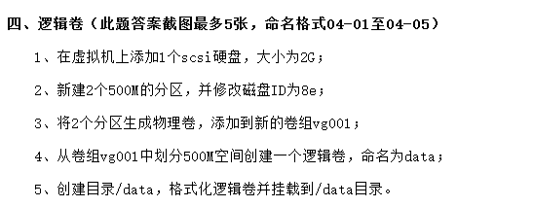

建一个2G scsi盘，重启

Fdisk /dev/sdb

n

1

+500M

n

2

+500M

t

1

8e

t

2

8e

pvcreate /dev/sdb{ 1,2}；

vgcreat vg001 /dev/sdb1 /dev/sdb2

lvcreat –L 500M –n data vg001

mkdir /data

mkfs.ext3 /dev/vg001/data

mount /dev/va001 /data

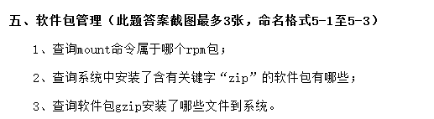

Rpm –qa |grep mount

Rpm –qa| grep “zip”

find / -type f -name "gz"

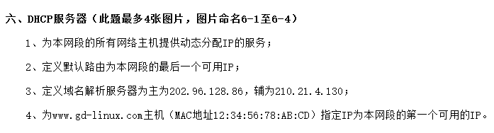

Yum install –y dhcp*

Cp /usr/share/doc/dhcp-n.n.n/dhcpd.conf.sample ./dhcpd.conf

Vim /etc/dhcp/dhcpd.conf

option domain-name "example.org"; //指定网域的域名

option domain-name-servers ns1.example.org, ns2.example.org; //指定域名解析服务器（DNS）的ip地址。

default-lease-time 600; //默认租约时间，单位为s

max-lease-time 7200; //最大租约时间，单位为s。过期续约，续约直接发送request包即可。

log-facility local7; //日志设备类型为local7.一般日志设备类型包括mail、crontab。通过此选项可以找到该服务的日志记录路径

subnet ip netmask 掩码{ //指定分配网段的ip地址以及子网掩码，括号内部为局部配置。

range 所有可用 ip-ip; //可使用的地址池范围

option domain-name-servers ns1.internal.example.org; //该网段的域名，可以省略

option domain-name "internal.example.org"; //网段DNS

option routers 10.5.5.1; //指定网关

option broadcast-address ip.255; //指定广播地址

default-lease-time 600; //租约时间

max-lease-time 7200; //最大租约时间。

}

Wq:截屏

Vim /etc/resolv.conf

加

nameserver ip1  
nameserver ip2

host www.gd-linux.com { //主机名称

hardware ethernet mac-adress; //主机的MAC地址

//filename "vmunix.passacaglia";

//server-name ""; //文件名和服务器名，不太需要。

fixed-address 第一个可用ip; //固定的ip地址

}

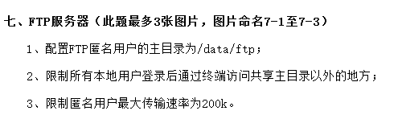

rpm -qa| grep vsftpd

yum  install vsftpd -y

vim  /etc/vsftpd/vsftpd.conf

anonymous_enable=YES

chroot_list_enable=YES

anon_root=/data/ftp

**\\ userlist_enable=YES**

***\* userlist_deny=NO**

**// /etc/vsftpd/user_list**

**//用户名：登陆方式**

**//Root:/ bin/bash**

//pasv_enable=NO

chroot_list_enable=YES //限制访问自身目录

chroot_list_file=/etc/vsftpd.chroot_list

anon_max_rate=200000

cut –d: -f1 /etc/passwd >>/etc/vsftpd.chroot_list

vim /etc/…//////////////////////上面

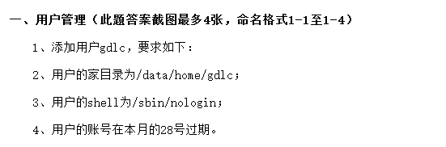

Useradd –d /data/home/gdlc –s /sbin/nologin –e //28 gdlc

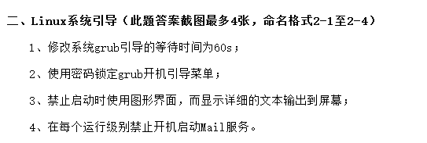

Vi /boot/grub/grub.conf

Time=5改为60

Vi /boot/grub/grub.conf

Passwd 123456

执行：prub-md5-crypt

Vi /etc/inittab

Id:5:initdefault 改为：id:3:initdefault

Chkconfig –level 0123456 sendmail off

Chkconfig –list sendmail

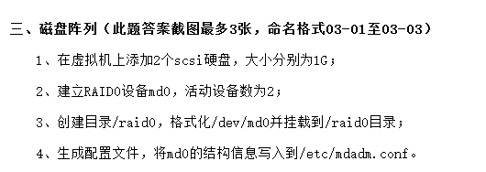

加两个scsi 的1G磁盘，重启

mdadm -Cv /dev/md0  -a yes -n 2 -l 0  /dev/sd[b-c]

mkdir /raid0

mkfs.xfs /dev/md0

mount /dev/md0 /raid0

mount –D /dev/md0 >>/etc/mdadm.conf

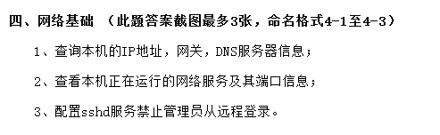

Ifconfig

Netstat

 vi /etc/ssh/sshd_config

PermitRootLogin no 去#

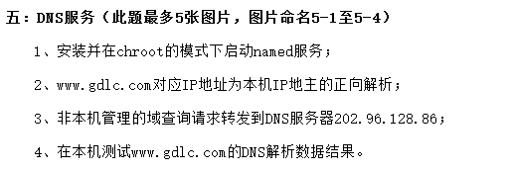

yum –y install bind

rpm -ql bind-chroot

vim /etc/named.conf或者/var/named/chroot/etc/named.conf

options{  
directory “/var/named/chroot/var/named”;  
};

zone “[www.gdlc.com](http://www.gdlc.com)” IN {  
type master;  
file “dnstest.zone”;

 forwarders { 202.96.128.86; }

};

zone “/本机ip反/.in-addr.arpa” IN { //192.168.0.2—>0.168.192.  
type master;  
file “reverse.zone”;  
};

vim /var/named/chroot/var/named/dnstest.zone

$TTL 86400

@ IN SOA dns.www.gdlc.com. root.www.gdlc.com. (

2015111701

3H

15M

1W

1D )

IN NS dns.www.gdlc.com.

dns IN A 本机ip

vim /var/named/chroot/var/named/reverse.zone

$TTL 86400

@ IN SOA dns. www.gdlc.com. root. www.gdlc.com. (

2015111701

3H

15M

1W

1D )

IN NS dns. www.gdlc.com.

本机ip IN PTR www.gdlc.com.

service named start

nslookup www.gdlc.com

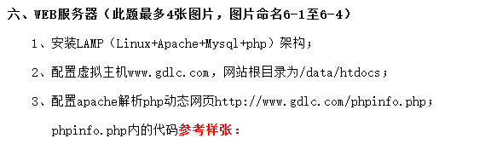

cat /etc/redhat-release

rpm -qa | grep httpd

service mysqld start

1. yum remove mysql
2. rm -f /etc/my.cnf

rpm –e httpd

yum -y install httpd

yum -y install php

yum -y install php-fpm

//yum -y install php-gd php-xml php-mbstring php-ldap php-pear php-xmlrpc ///php-devel

yum -y install mysql

//yum -y install mysql-server 7.2版本的Centos已经把mysql更名为mariadb

//  
//wget http://dev.mysql.com/get/mysql-community-release-el7-5.noarch.rpm

//rpm -ivh mysql-community-release-el7-5.noarch.rpm

//yum install mysql-community-server

yum -y install php-mysql

yum -y install httpd-manual mod_ssl mod_perl mod_auth_mysql

yum -y install php-gd php-xml php-mbstring php-ldap php-pear php-xmlrpc php-devel

yum -y install mysql-connector-odbc mysql-devel libdbi-dbd-mysql

mkdir /data/htdocs

vim /etc/httpd/conf/httpd.conf

<VirtualHost *:80>

DocumentRoot /data/htdocs *//第一个ip的网站的主页面目录*

ServerName [www.gdlc.com](http://www.gdlc.com)

1. <Directory /data/htdocs> *//要设置限制的目录*
2. Order allow,deny *//匹配了允许的就拒绝所有*
3. Allow from all

</VirtualHost>

AddType /文件位置/phpinfo.php

<IfModule dir_module>

DirectoryIndex index.html index.php

</IfModule>

Require all granted 改成这个

//Server httpd start

Apachectl 路径 start

在fox浏览器输入网址。

phpinfo.php内文件内容：照着打。

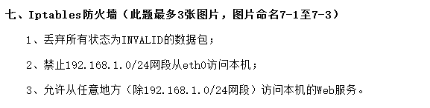

Iptables -A –state INVALID –p all DROP

Iptables –A INPUT –I etho0 -s 192.168.1.0/24 –j DROP

Iptables –I INPUT –p tcp –dport 80 –j ACCEPT

Iptables –A INPUT –s 192.168.1.0/24 –j DROP

1. <IfModule dir_module>
2. DirectoryIndex index.html //默认索引
3. </IfModule>