Topic: Students need to take breaks to do things other than just studying.

Good morning, everyone!

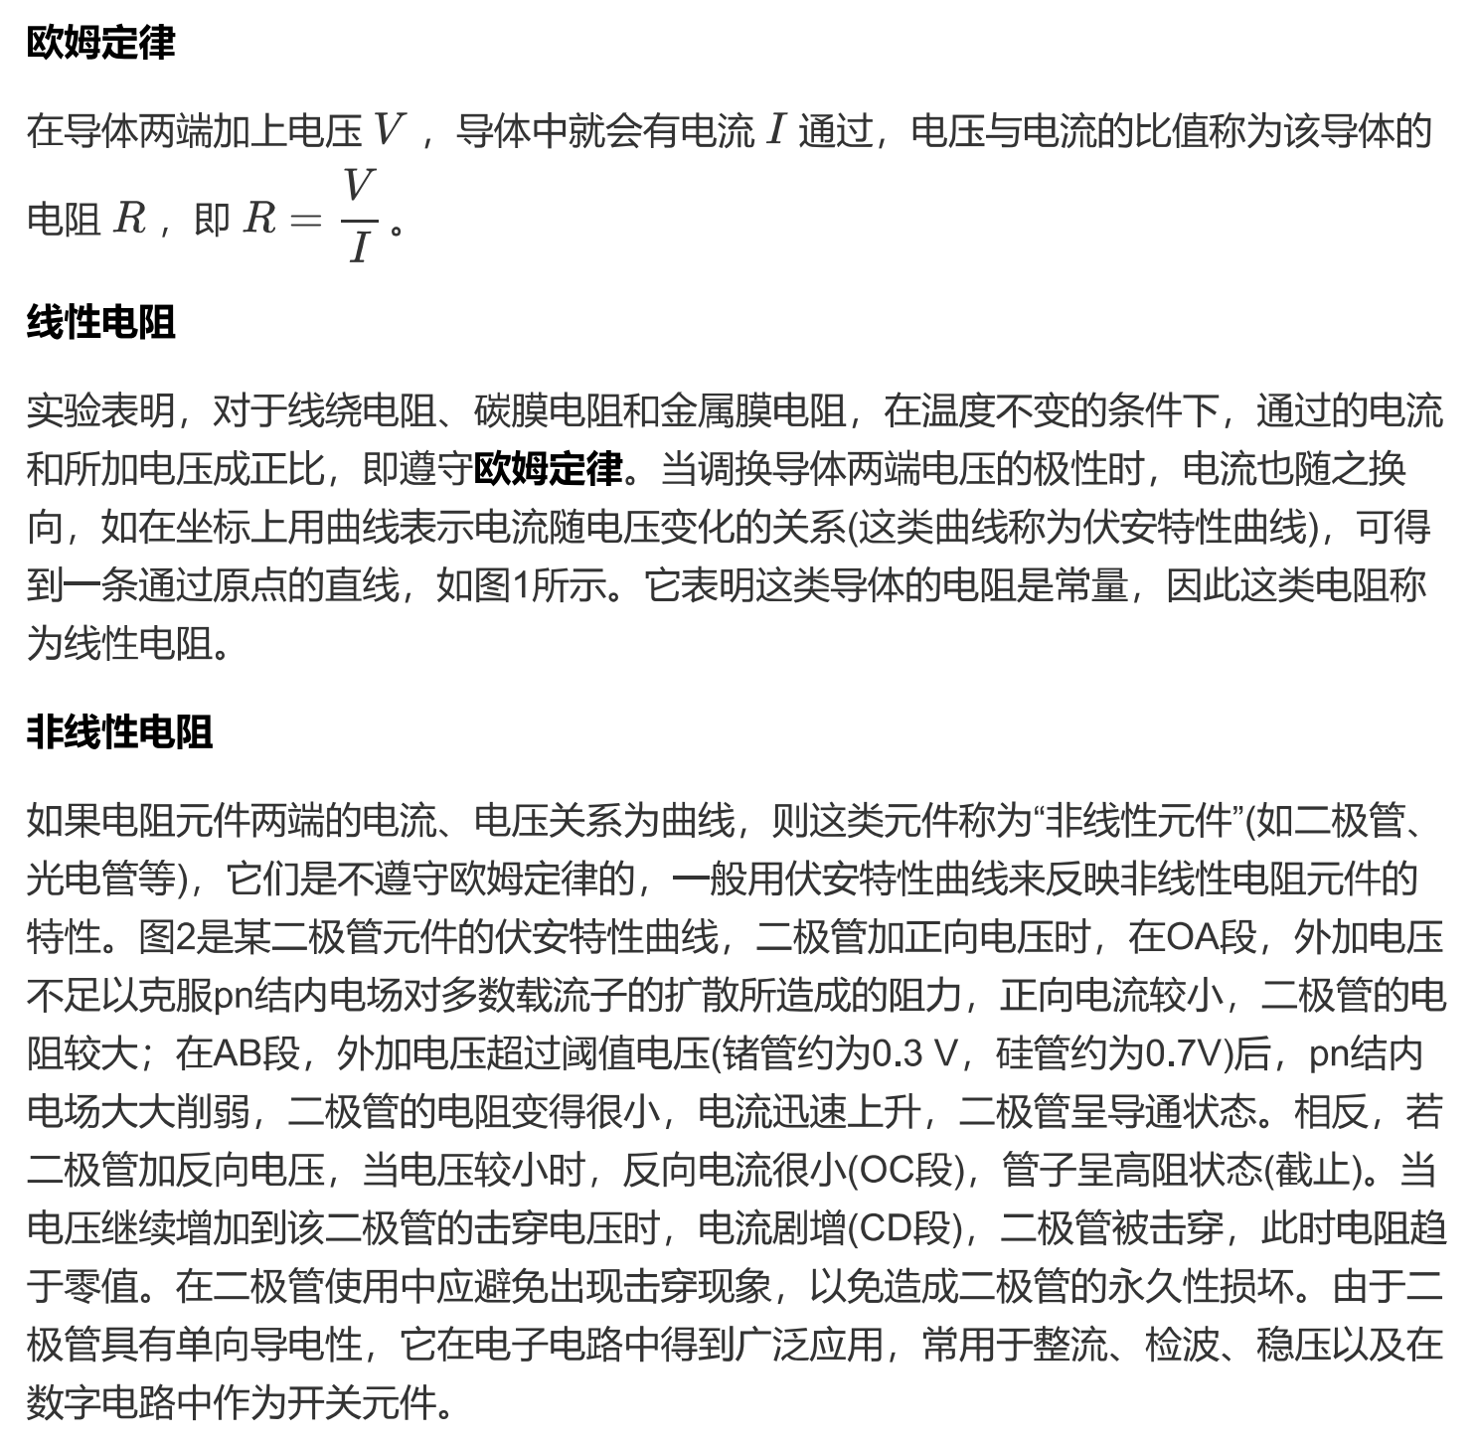

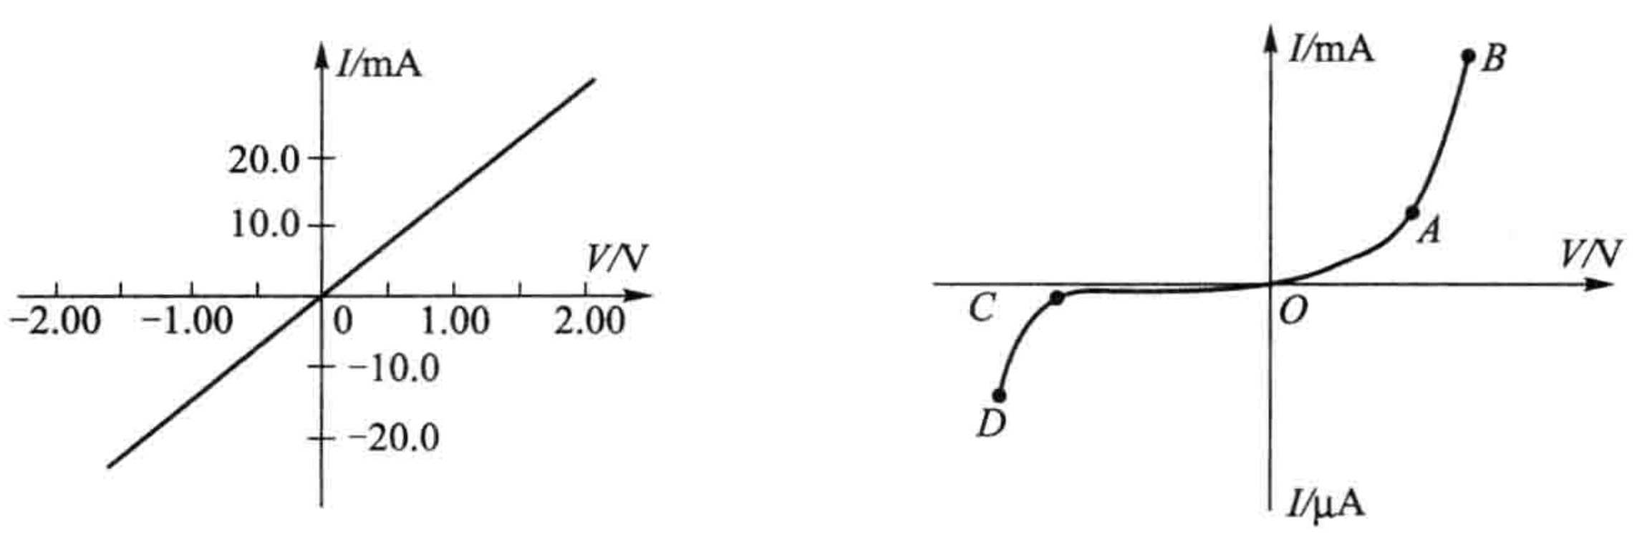

**图一 图二**