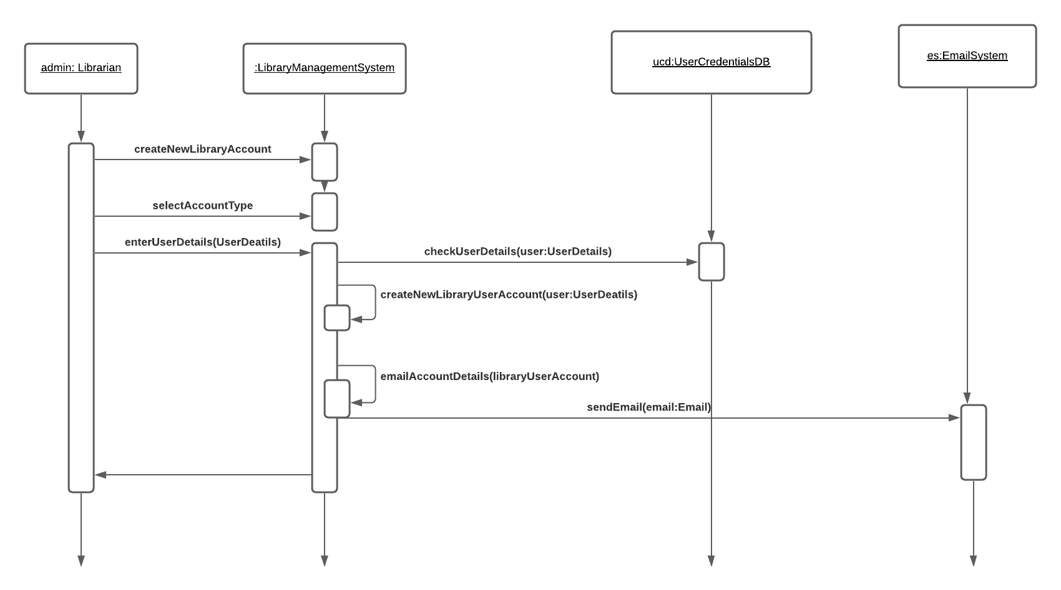

SEQUENCE DIAGRAM FOR NEW LIBRARY USER ACCOUNT

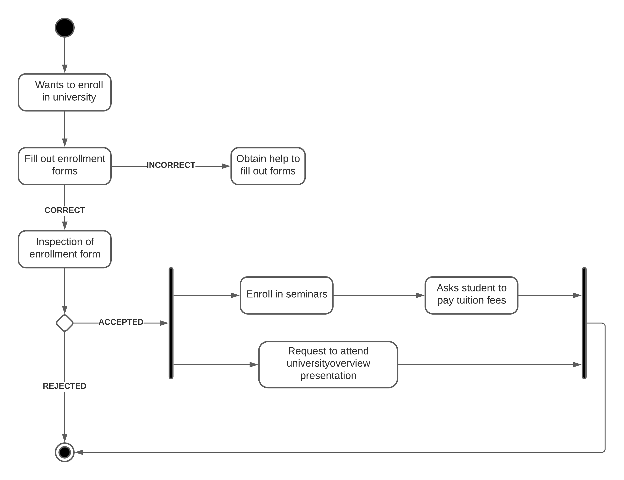

ACTIVITY DIAGRAM FOR STUDENT JOINING A COURSE

AIRLINE RESERVATION


UML CLASS DIAGRAM AIRLINE RESERVATION SYSTEM

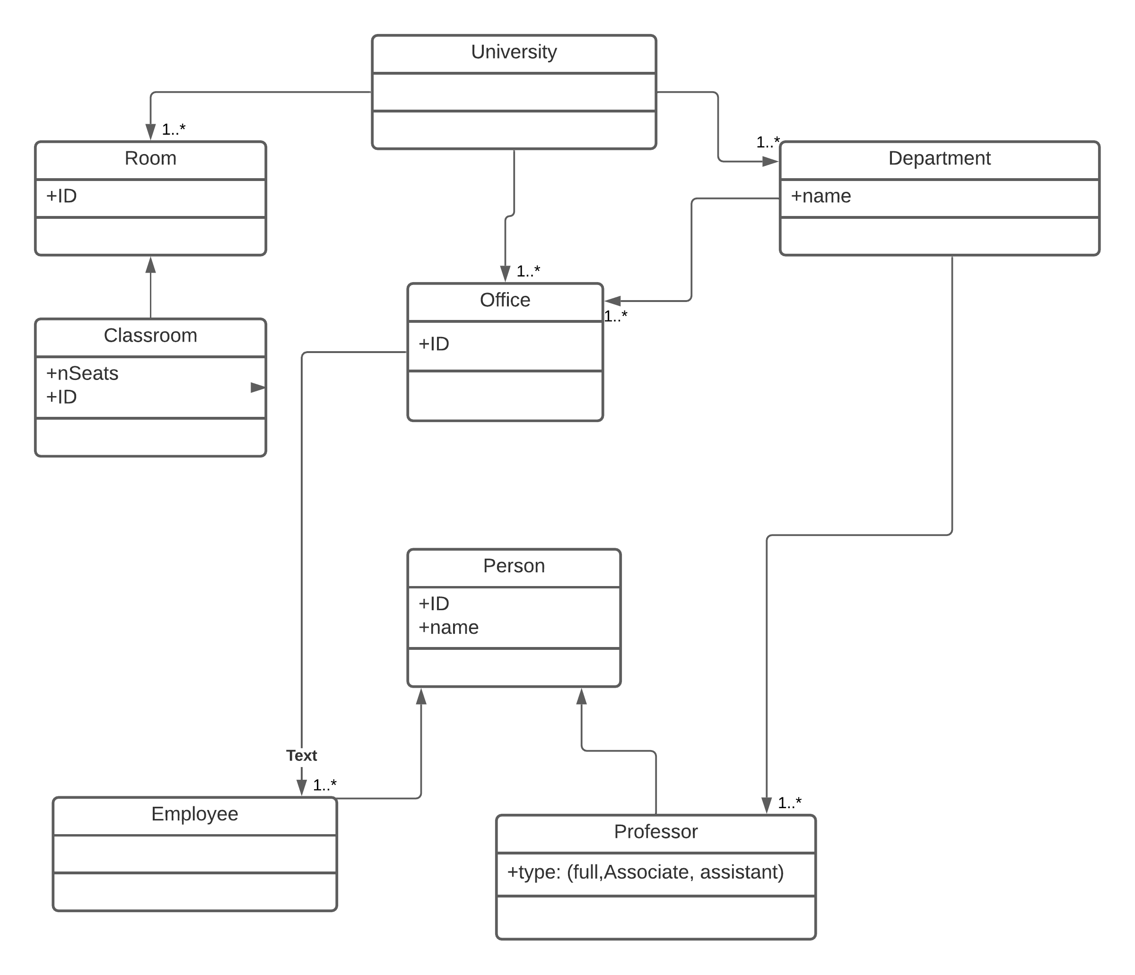

UML CLASS DIAGRAM FOR STUDENT ENROLLMENT