**Exercise**

**1.** (a) rate formula: $r=-\frac{1}{T}ln⁡P_{T}$

(b) forward rate formula: $r_{t,T}=-\frac{1}{T-t}ln⁡(\frac{P_{T}}{P_{t}})$

|  |  |  |  |  |
| --- | --- | --- | --- | --- |
| maturity(years) | maturity | bond price | interest rates(percent) | forward rates(percent) |
| 0.0027 | 1D | 99.9995 | 0.18250 | 0.33353 |
| 0.0192 | 1W | 99.9940 | 0.31201 | 0.35886 |
| 0.0833 | 1M | 99.9710 | 0.34805 | 0.42627 |
| 0.2500 | 3M | 99.9000 | 0.40020 | 1.00226 |
| 0.5000 | 6M | 99.6500 | 0.70123 | 1.20785 |
| 1.0000 | 1Y | 99.0500 | 0.95454 |  |

|  |  |  |  |
| --- | --- | --- | --- |
| **c) time-weighted average of forward rates:** | | | |
| 0.95454128 |  |  |  |

Time-weighted average of forward rates = $\sum{\frac{∆t}{T}FDT}=0.95454128$, the same as the 1Y zero rate.

**2.** (a) simple rates-discount factors formula: $P_{T}= {(1+r_{s}T)}^{-1}$

(b) simple rates-forward rates formula: 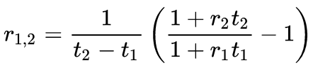

(c) monthly-compounding: $r_{m}=m(P_{T}^{-\frac{1}{mT}}-1)$

|  |  |  |  |  |
| --- | --- | --- | --- | --- |
| Time | Rate(percent) | discount factor | one-month forward rates (percent, simple interest) | interest rates (percent, monthly compounding) |
| o/n | 0.12800 | 1.00000 |  | 0.12801 |
| 1w | 0.16270 | 0.99997 |  | 0.16271 |
| 2w | 0.17170 | 0.99993 |  | 0.17171 |
| 1m | 0.19043 | 0.99984 | 0.25779 | 0.19043 |
| 2m | 0.22413 | 0.99963 | 0.31026 | 0.22411 |
| 3m | 0.25288 | 0.99937 | 0.41961 | 0.25283 |
| 4m | 0.29463 | 0.99902 | 0.57157 | 0.29452 |
| 5m | 0.35013 | 0.99854 | 0.66716 | 0.34993 |
| 6m | 0.40313 | 0.99799 | 0.79353 | 0.40279 |
| 7m | 0.45913 | 0.99733 | 0.88676 | 0.45860 |
| 8m | 0.51288 | 0.99659 | 0.97530 | 0.51211 |
| 9m | 0.56463 | 0.99578 | 1.10495 | 0.56357 |
| 10m | 0.61913 | 0.99487 | 1.18633 | 0.61770 |
| 11m | 0.67125 | 0.99388 | 1.36187 | 0.66938 |
| 12m | 0.72950 | 0.99276 |  | 0.72707 |

**3**

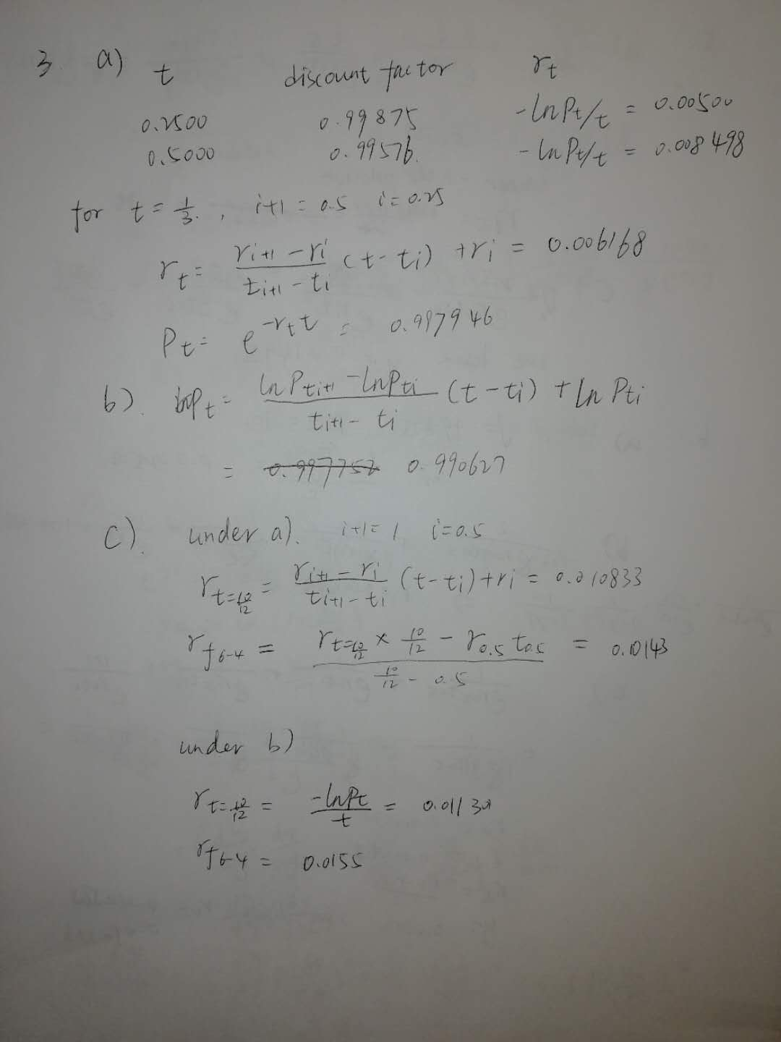

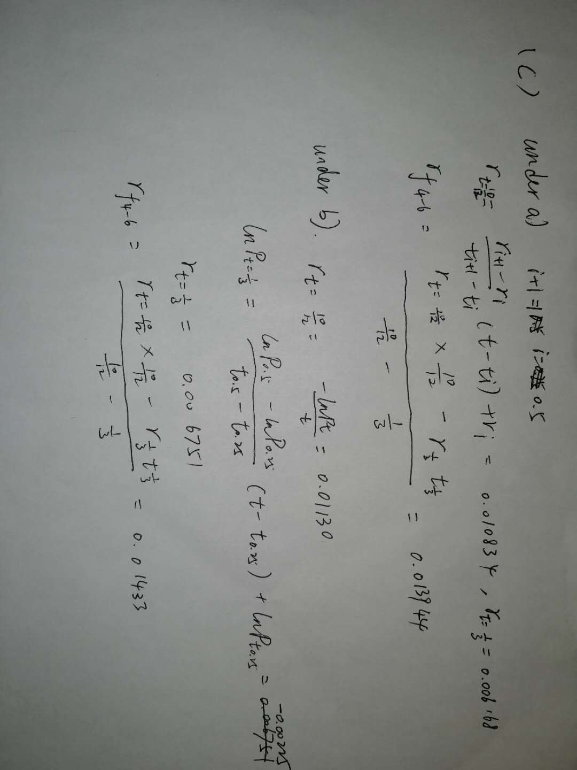

4.

(a) Given $P_{1}=e^{r_{1}{ t}_{1}}, P_{3}=e^{r_{3}t_{3}}$, we have

$$r_{1}^{*}=r_{3}^{*}=\frac{\log{P_{1}}-\log{P_{3}}}{t_{1}-t_{3}} = 1.775\%$$

(b) Since $r_{t}=at+b=0.175\%t+1.075\%$,

$$r_{t}^{*}=\frac{dr_{t}⋅t}{dt}=2at+b=0.35\%t+1.075\%$$

plugging in the values of $t_1$ and $t_3$, we have

$$r_{1}^{*}=1.425\%,r_{3}^{*}=2.215\%$$

(c) According to the assumption,

$$r_{t}^{*}=\frac{dr_{t}⋅t}{dt}=-4.555556\%×{10}^{-3}t^{3}+4.916667×{10}^{-3}t^{2}+0.02t+0.002$$

plugging the numbers, we get

$$r_{1}^{*}=2.24\%, r_{3}^{*}=-1.67\%$$

**5,6,7**

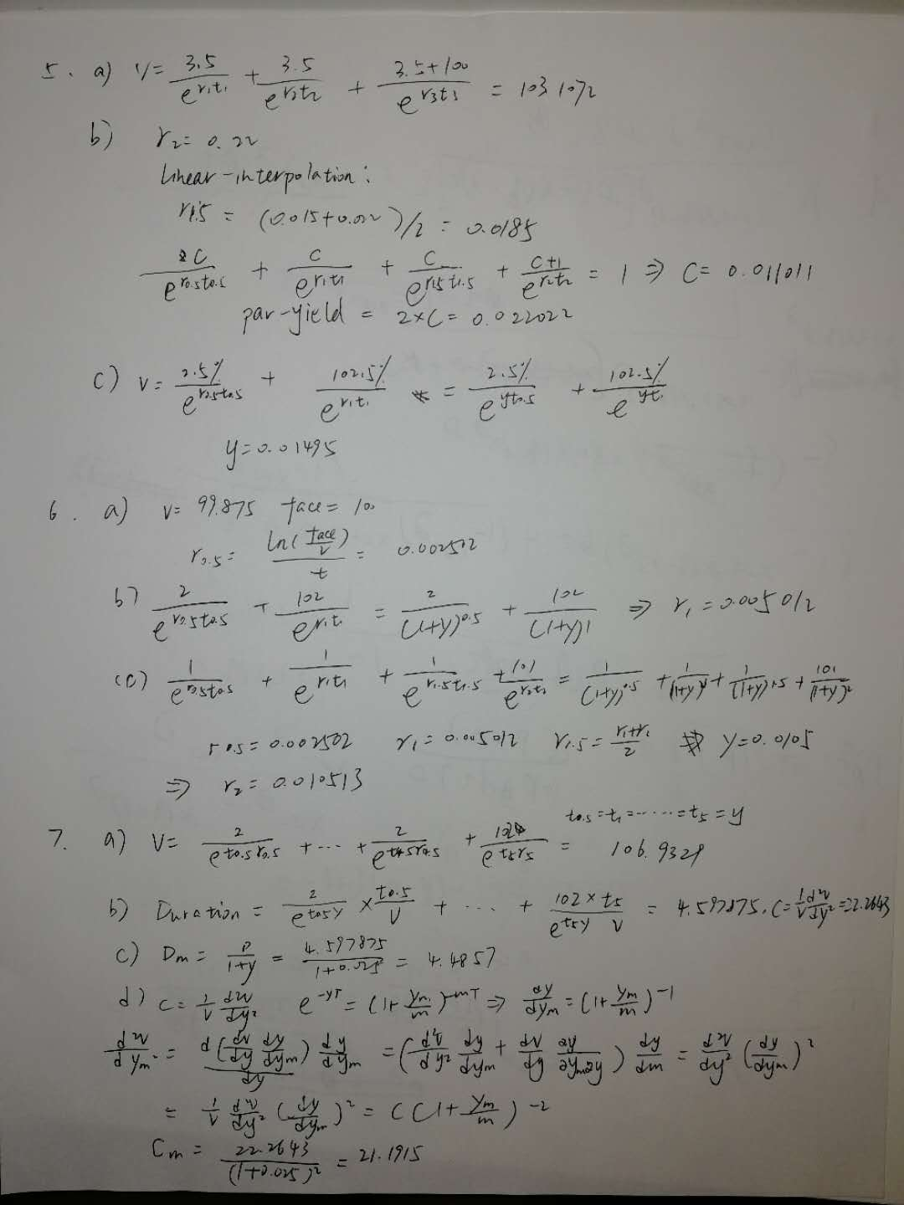

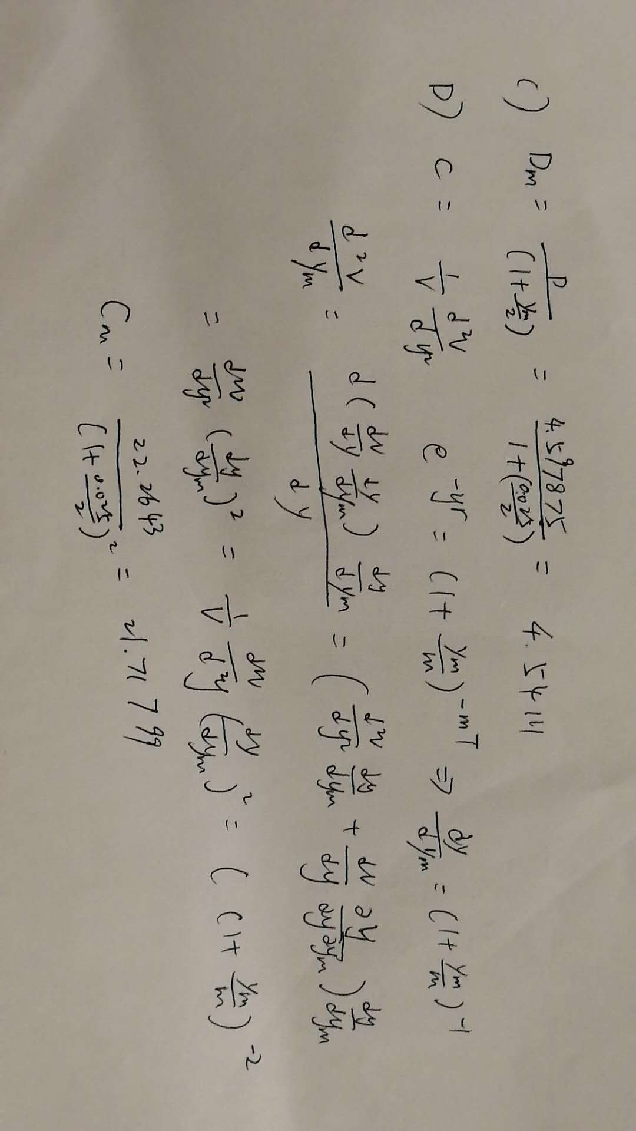

8.

By assuming piecewise constant forward rates, we can first solve for the 9-Month discount rate from the following equations,

$$\frac{r_{3}}{4}×\frac{3}{4}=\frac{r_{1}}{2}×\frac{1}{2}+c\left(\frac{3}{4}-\frac{1}{2}\right)$$

$$r_{1}=\frac{r_{1}}{2}×\frac{1}{2}+c(1-\frac{1}{2})$$

Solve these equations, we get $r_{\frac{3}{4}}=\frac{4}{3}(\frac{1}{4}×r_{\frac{1}{2}}+\frac{1}{2}r_{1})$, then according to the relationship between zero rate and discount factor, we get $P_{\frac{3}{4}}=e^{-\frac{3}{4}r_{\frac{3}{4}}}=e^{-(\frac{1}{4}×r_{\frac{1}{2}}+\frac{1}{2}r_{1})}$ = 0.98721.

Then, we move on to get the discount factors at other maturities, assume the constant forward rate between 1Y and 2Y is r, and the coupon rate is c, the price of the 2Y bond is $V_{2}$, then

$$V_{2}=\sum_{n=1}^{8}{c×\frac{100}{4}disc\left(\frac{n}{4}\right)+100×disc(\frac{8}{4})}$$

where disc(n/4) is the discount factor at n/4 years, for n = 5, 6, 7, 8,

$$disc\left(\frac{n}{4}\right)=e^{-r1+r\left(\frac{n}{4}-1\right)}=e^{-r_{1}}×e^{-\frac{r(n-4)}{4}}$$

where $r_{1}$ is the spot zero-rate, from the above equation, we can see that $e^{-\frac{2r}{4}}={{(e}^{-\frac{r}{4}})}^{2}$, $e^{-\frac{3r}{4}}={{(e}^{-\frac{r}{4}})}^{3}$, $e^{-\frac{4r}{4}}={{(e}^{-\frac{r}{4}})}^{4}$, then denote $e^{-\frac{r}{4}}$ as x, we have

$$V_{2}=\sum_{n=1}^{4}{c×\frac{100}{4}disc\left(\frac{n}{4}\right)+e^{-r_{1}}x+e^{-r_{1}}x^{2}+e^{-r_{1}}x^{3}+{(e}^{-r_{1}}+100)x^{4}}$$

which is a forth order polynomial, solve the equation, we get x = 0.976896.

Then, following similar procedure, we can solve for the rest discount factors at the rest maturities, the corresponding equations are list below (Note: In different equations, $e^{-\frac{r}{4}}$ represents different discount values)

$$V_{5}=\sum_{n=1}^{8}{c×\frac{100}{4}disc\left(\frac{n}{4}\right)+\sum_{n=1}^{12}{{{{(e}^{-\frac{r}{4}})}^{n}×e}^{-2r_{2}}}+100} {{{(e}^{-\frac{r}{4}})}^{12}×e}^{-2r_{2}}$$

$$V_{10}=\sum_{n=1}^{20}{c×\frac{100}{4}disc\left(\frac{n}{4}\right)+\sum_{n=1}^{20}{{{{(e}^{-\frac{r}{4}})}^{n}×e}^{-5r_{5}}}+100} {{{(e}^{-\frac{r}{4}})}^{20}×e}^{-5r_{5}}$$

$$V_{30}=\sum_{n=1}^{40}{c×\frac{100}{4}disc\left(\frac{n}{4}\right)+\sum_{n=1}^{80}{{{{(e}^{-\frac{r}{4}})}^{n}×e}^{-10r_{10}}}+100}{{{(e}^{-\frac{r}{4}})}^{80}×e}^{-10r_{10}}$$

Solve all the roots through a forward loop, then we can get the discount factors at 2Y, 5Y, 10Y and 30Y, are

Disc(2Y) = 0.965605,

Disc(5Y) = 0.902578,

Disc(10Y) = 0.790571,

Disc(30Y) = 0.392193,

and all the quarterly discount factors are shown in the following table.

**Quarterly Discount Factors in 30 years**

|  |  |  |  |  |
| --- | --- | --- | --- | --- |
|  | **1 Q** | **2 Q** | **3 Q** | **4 Q** |
| **0 Y** | 0.997254 | 0.993769 | 0.987208 | 0.980689 |
| **1 Y** | 0.976896 | 0.973118 | 0.969354 | **0.965605** |
| **2 Y** | 0.960189 | 0.954803 | 0.949448 | 0.944122 |
| **3 Y** | 0.938826 | 0.93356 | 0.928324 | 0.923116 |
| **4 Y** | 0.917938 | 0.912789 | 0.907669 | **0.902578** |
| **5 Y** | 0.896618 | 0.890698 | 0.884816 | 0.878974 |
| **6 Y** | 0.87317 | 0.867404 | 0.861677 | 0.855987 |
| **7 Y** | 0.850335 | 0.84472 | 0.839142 | 0.833601 |
| **8 Y** | 0.828097 | 0.822629 | 0.817197 | 0.811801 |
| **9 Y** | 0.806441 | 0.801116 | 0.795826 | **0.790571** |
| **10 Y** | 0.783674 | 0.776837 | 0.770059 | 0.763341 |
| **11 Y** | 0.756682 | 0.75008 | 0.743536 | 0.73705 |
| **12 Y** | 0.730619 | 0.724245 | 0.717927 | 0.711664 |
| **13 Y** | 0.705455 | 0.6993 | 0.693199 | 0.687152 |
| **14 Y** | 0.681157 | 0.675214 | 0.669324 | 0.663484 |
| **15 Y** | 0.657696 | 0.651958 | 0.64627 | 0.640632 |
| **16 Y** | 0.635043 | 0.629503 | 0.624011 | 0.618567 |
| **17 Y** | 0.61317 | 0.607821 | 0.602518 | 0.597262 |
| **18 Y** | 0.592051 | 0.586886 | 0.581766 | 0.57669 |
| **19 Y** | 0.571659 | 0.566672 | 0.561728 | 0.556827 |
| **20 Y** | 0.551969 | 0.547154 | 0.54238 | 0.537649 |
| **21 Y** | 0.532958 | 0.528308 | 0.523699 | 0.51913 |
| **22 Y** | 0.514601 | 0.510112 | 0.505662 | 0.50125 |
| **23 Y** | 0.496877 | 0.492542 | 0.488245 | 0.483986 |
| **24 Y** | 0.479763 | 0.475578 | 0.471429 | 0.467316 |
| **25 Y** | 0.463239 | 0.459197 | 0.455191 | 0.45122 |
| **26 Y** | 0.447284 | 0.443381 | 0.439513 | 0.435679 |
| **27 Y** | 0.431878 | 0.42811 | 0.424375 | 0.420673 |
| **28 Y** | 0.417003 | 0.413365 | 0.409758 | 0.406184 |
| **29 Y** | 0.40264 | 0.399127 | 0.395645 | **0.392193** |

**Application**

1. see xlsm document

2.

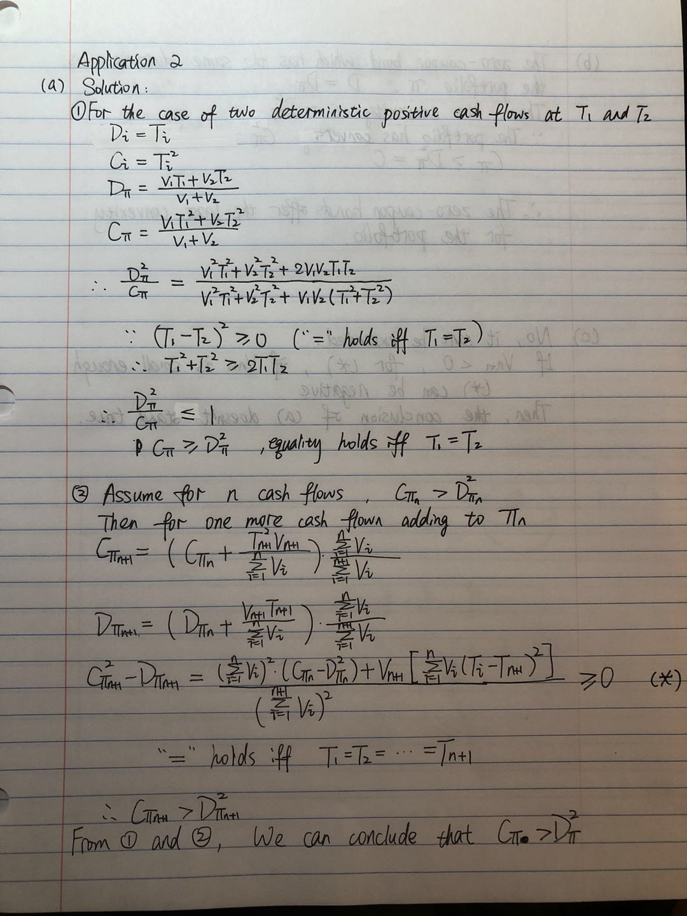

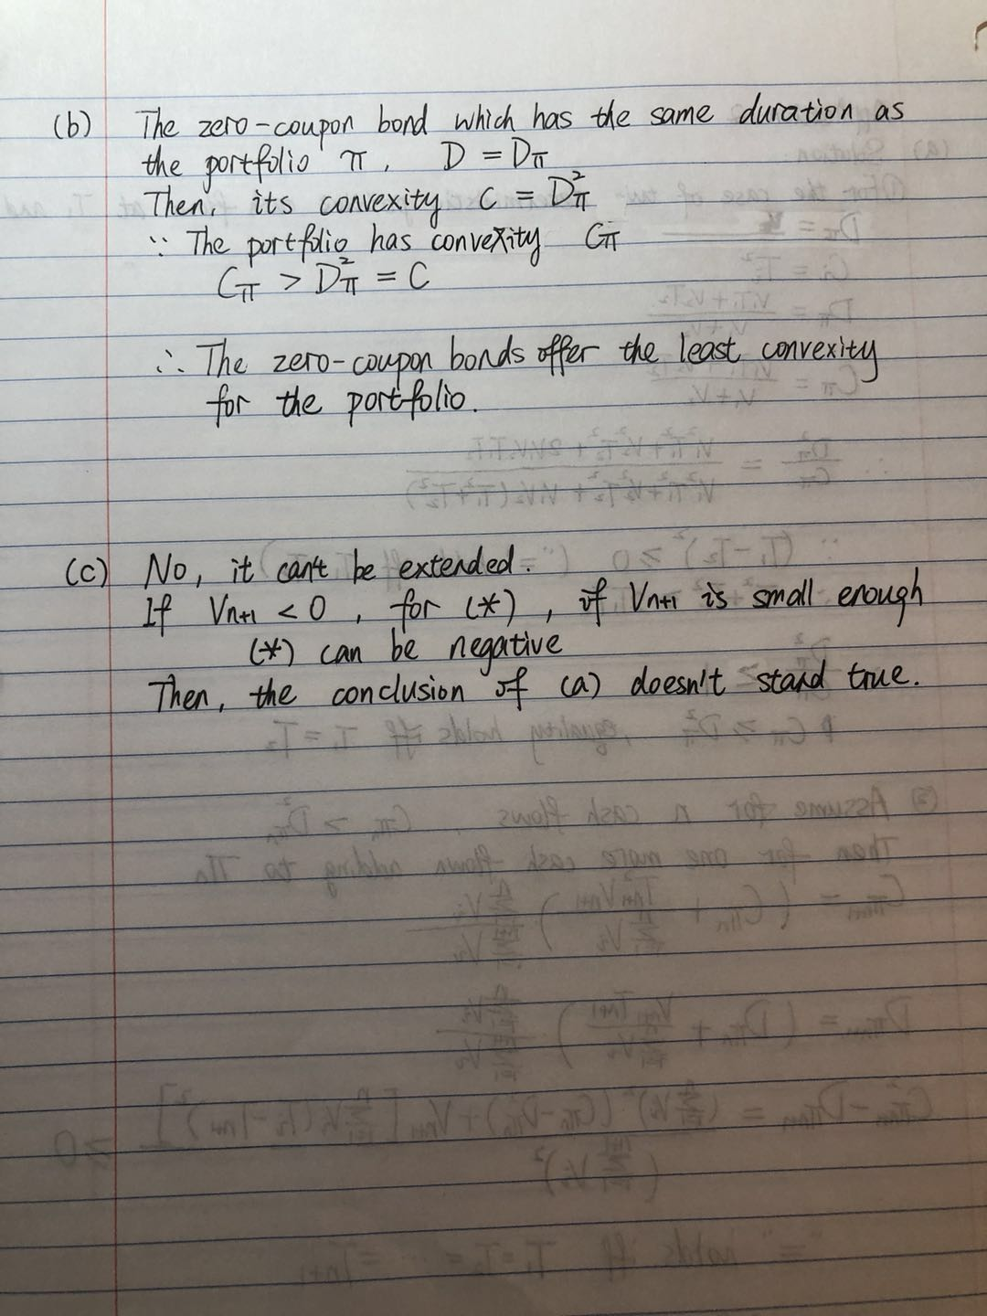

3. see xlsm document