Topic, Time, owner:

1. Logistics (lecture, 5min.)
2. Introduction to Openstack (lecture, 25) - Luis
3. lab environment (hands-on, 15) - Gopal
4. Admin tasks (implement a small design) (60), Luis
5. Tenant tasks (spin a VM and play) (hands-on, 30) – Gopal/Luis
6. Neutron intensive tasks (30), Gopal
7. Openstack review tasks (infra, neutron, nova focus) (15) – Gopal
8. Openstack orchestration, heat templates (30)
9. ~~Openstack API features??? (15)~~
10. Tenant tasks (hands-on, estimated time to complete: 30 min.)

Scenario: In this section, you would assume the role of a customer of a Openstack cloud. The goal is to launch a linux virtual machine and make some basic verifications. This exercise exposes typical Openstack tenant environment.

Customer name is Great-Customer. All the participants are Great-Customer’s engineers. Here, the project name is Great-Customer and you are one of the 24 users within the Great-Customer project.

Infrastructure needed to provide Internet access to your yet to be created virtual machine is pre-configured.

Here is the topology:

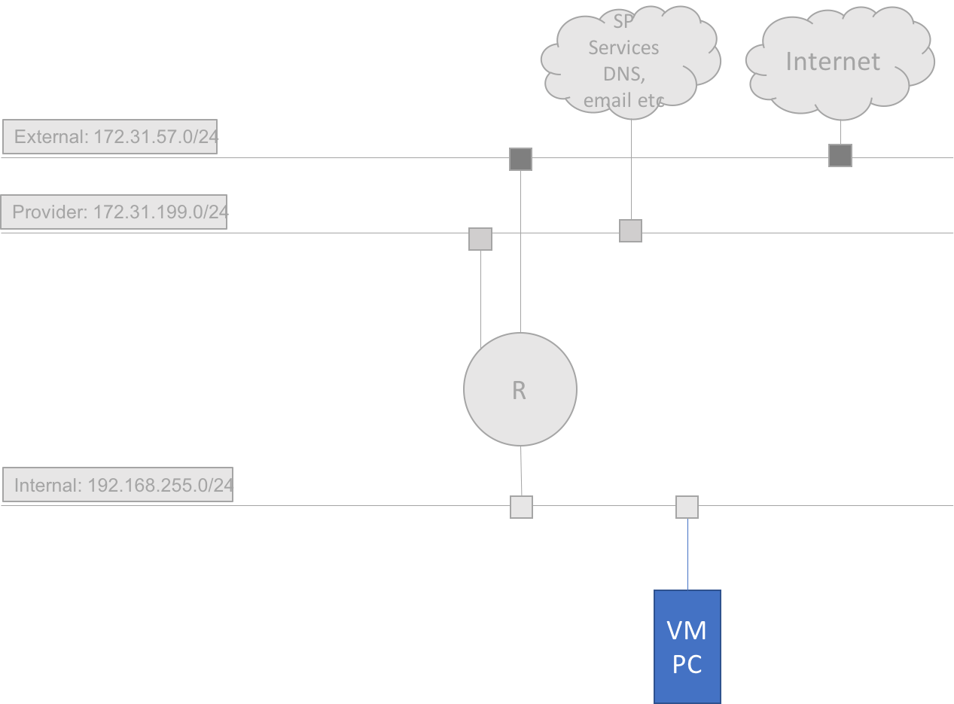

Perform the below tasks:

* 1. Login to Openstack dashboard
     1. URL: <http://172.31.56.216>
     2. Username: userXXX
     3. Password: cisco
  2. Find your project and user details
     1. On the left pane, click “Identity/Projects” and note your project name.
     2. On the left pane, click “Identity/Users” and go over your username and associated details.
  3. Find the available network names and subnets
     1. On the left pane, go to “Project/Network/Network Topology”
     2. On the left pane, go to “Project/Network/Networks”
  4. Find the available images
     1. On the left pane, go to “Project/Compute/Images” and go over the details
  5. Launch a linux virtual machine (VM)
     1. On the left pane, go to “Project/Compute/Instances” and click “Launch Instance”. In the Launch Instance pop-up, provide details as below
     2. Details:

Instance name: PCXXX

Source: Boot source: Image

Source: Create new volume: no (check it with Luis)

Source: mage name: cirros-0.4.0-x86_64 (Select this by clicking up-arrow symbol)

Flavor: m1.tiny (click UP-arrow symbol to select)

Networks: “tenant-net” (add provider-net)

* + 1. Click “Launch Instance”
  1. Verification
     1. On the left pane, go to “Project/Compute/Instances” and click “PCXXX”
     2. Go over details in “Overview” tab.
     3. Go over log in “Log” tab.
     4. Go to “Console” tab and click, “Click here to show only console”
     5. Login with username: cirros and password: gocubsgo
     6. From Linux $ prompt, ping google.com
  2. Kill the VM that you just created. This is to save resources.
     1. On the left pane, go to “Project/Compute/Instances” and check-mark/click in the little rectangular box, left of your VM, PCXXX. This selects your VM.

CAUTION: Since other users are within the same project as yours (Great-Customer), you will be able to see and select others VM. Ensure the VM selected is yours.

* + 1. Click “Delete Instances”
    2. Verify that your VM does not show up in the listed instances.
  1. Review the section and discuss if you have any questions or comments

1. Lab environment (Estimated time to complete: 15 min.)

Please note that a typical production NFV system or Openstack cloud includes components such as exclusive storage, DPDK network connectivity with PCIe or SR-IOv, OSS/BSS system, VNF management system, and Orchestration systems. In this lab, we have Openstack alone, which makes up ETSI model’s Virtual Infrastructure Manager (VIM).

The lab is built with 7 Cisco UCS C240 servers. The lab is behind a VPN server. To access the lab, you need to VPN into the VPN server. The VPN server and the lab are in US and the access to VPN server is over Internet.

### HW topology

Access to the lab is over VPN tunnel. When you create the tunnel, VPN server will advertise a few routes to your laptop.

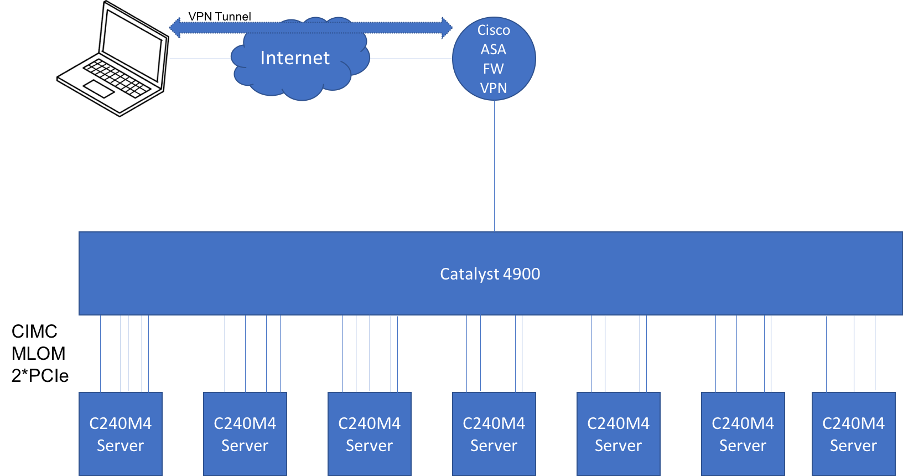

### Layer-3 topology

Openstack Controller has connectivity to external-VLAN but not any Computes. Your access to Openstack cloud, which include Computes is through Controller.

There are a few other VLANs such as management but their details are not shown here.

Provider data center services and customer’s hypothetical CPE connections are emulated from a dedicated server, marked in the below topology as “provider DC cloud”. Other than hosting some services, this server is not playing any other role in this session.

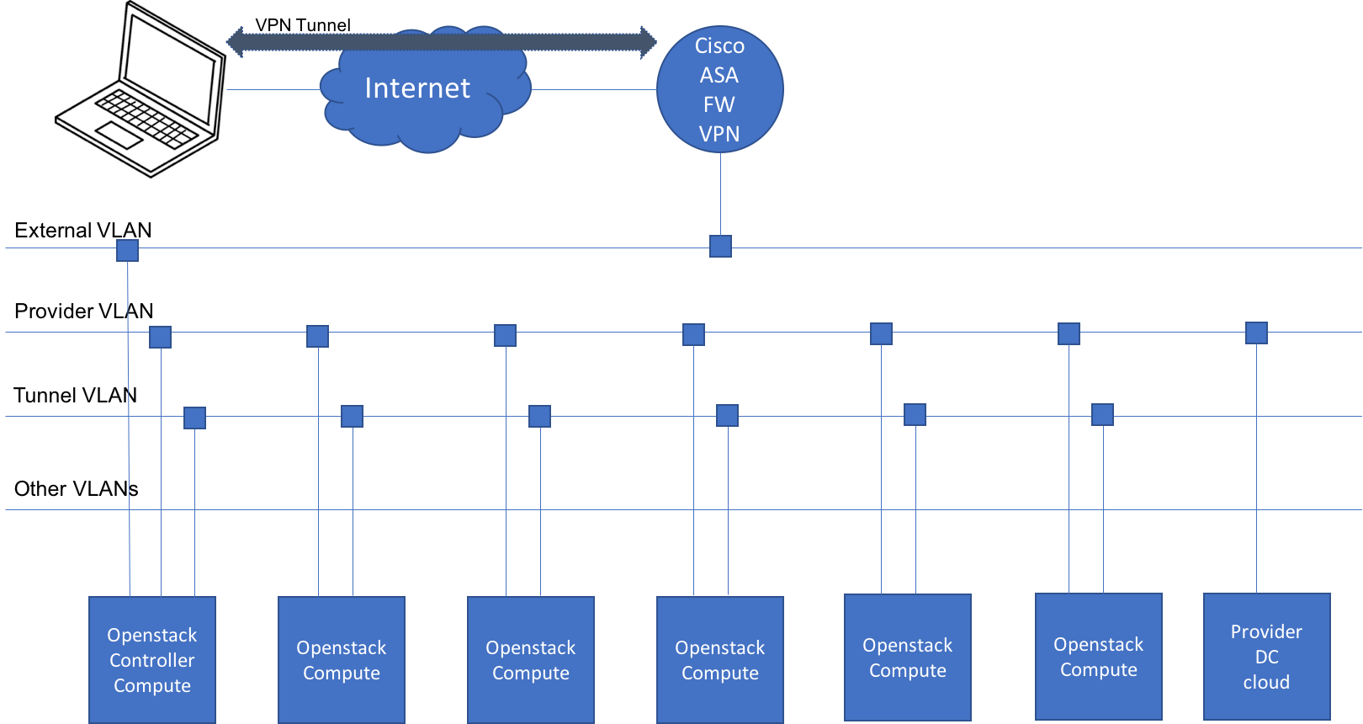

### Connectivity

Below is a representation of Openstack cloud connectivity to the external networks. You will access the Controller over Internet. And, this cloud uses provider-VLAN (just a name) to reach: 1. Service Provider services, and 2. Customers’ branch office sites.

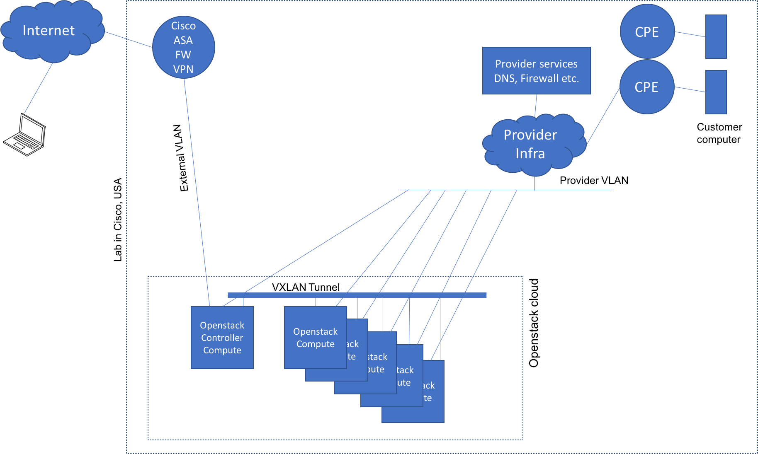

* 1. VPN into lab gateway

Using Cisco Any Connect VPN client app, VPN into the lab gateway. It will setup a VPN tunnel and will install a few routes in your workstation.

* + 1. Details:

IP: <consult your proctor>

Username: <consult your proctor>

Password: <consult your proctor>

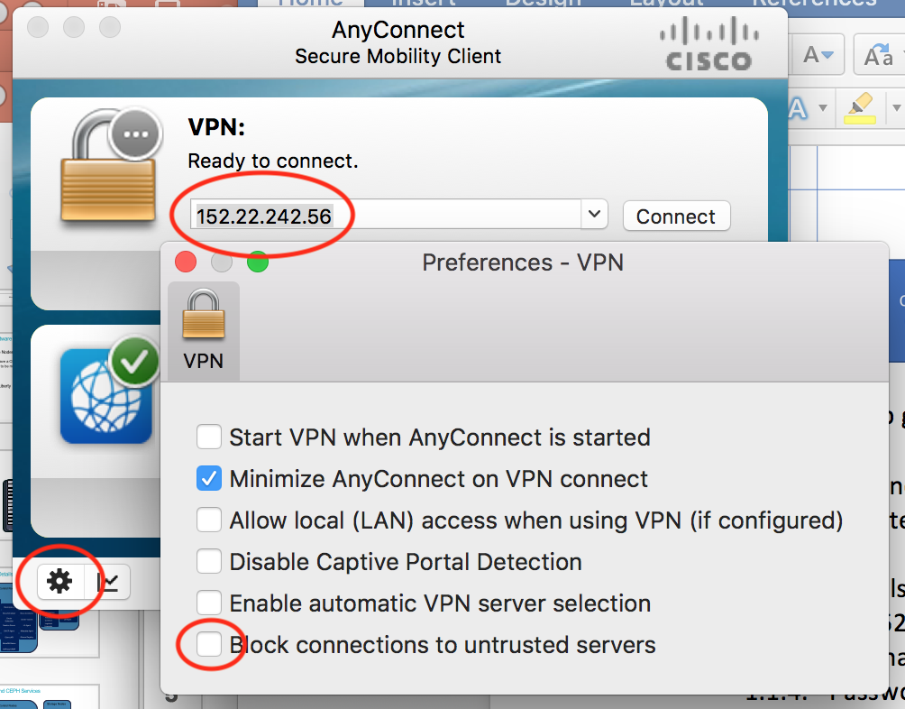

* 1. Verify routing on your desktop and check connectivity to Openstack controller
     1. $ ip route (or netstat -nr) //you should have route to 172.31.56.0/24
     2. ping 172.31.56.216
     3. from your browser, go to <http://172.31.56.216>
  2. Review the section and discuss if you have any questions or comments.

--------------Draft to be replaced with Luis content--------

1. Admin tasks

Scenario: In this section, you would assume the role of an Admin of an Openstack cloud. Your company is offering secure internet access services. Your goal in this section is to configure the cloud such that your customers can: 1. Use your secure internet DNS services 2. As a tenant, rent your cloud resources to create personal linux VMs 3. Launch public facing services.

1. Network design

<topology diagram, showing pre-configured and to-be configured components>

create network-1

create network-2

create router

add interface to the router

set default-gateway

test DNS server connectivity from branch site

configure server to point DNS to SP DNS

ping google.com

create an internal network

add network to router

launch an instance

configure DNS to SP DNS

ping google.com

1. Openstack review

In this concluding section, you will try to get an overall view of the Openstack cloud that you just worked on. Try to make sense of the output of each command. These some commonly used monitoring commands. Not every command and out may have a direct connection to the work that you did so far. The goal is to get an overall idea, not necessarily a detailed one.

Please note that a typical production NFV system or Openstack cloud includes components such as exclusive storage, high performance network connectivity with PCIe or SR-IOv, OSS/BSS system, VNF management system, and Orchestration systems. In this lab, we have Openstack alone, which makes up ETSI model’s Virtual Infrastructure Manager (VIM).

* 1. Acquire admin environment parameters (discuss with Luis)
     1. $ source /var/XXX/keystonerc_admin
     2. Try to avoid SUDO
  2. Cloud overview
     1. openstack-service list
     2. openstack-service status
     3. openstack-status
  3. Miscellaneous
     1. openstack command list
     2. openstack command list --group openstack.compute.v2
     3. openstack command list --group openstack.network.v2
     4. brctl show
     5. ovs-vsctl show
     6. ovs-vsctl list-br
     7. ip netns
  4. Compute
     1. Openstack compute service list
     2. openstack hypervisor list
     3. openstack hypervisor stats show
     4. openstack hypervisor show <hypervisor>
     5. openstack usage list
     6. openstack host list
     7. openstack host show <host name>
     8. Openstack flavor list
     9. Openstack server list --all-projects
     10. openstack quota show Great-Customer
  5. Network
     1. ovs-vsctl list-br
     2. openstack network list
     3. openstack network <net name or ID>
     4. openstack subnet list
     5. openstack subnet <subnet name or ID>
     6. openstack router list
     7. openstack network agent list
     8. openstack port list
  6. Identity
     1. openstack project list
     2. openstack role list
     3. openstack user list

1. Openstack networking (Estimated time to completion: 30 minutes)

The project code-name for Networking services is neutron. OpenStack Networking handles the creation and management of a virtual networking infrastructure, including networks, switches, subnets, and routers.

The goal of this section is to show networking in the cloud. The tasks in this section will help you navigate the path from virtual machine (VM) to External network.

Important:

* In this section, you need to execute the commands from the host that is hosting your CSR1Kv router-VM. So, the first step would be to find the right host(s) to execute the commands.
* Please note that we are using Openstack’s L3 agent router to route traffic to Internet. And, this router is hosted on the Network-node, which is 172.31.56.216 (this is also a Controller and a Compute node).

### Topology:

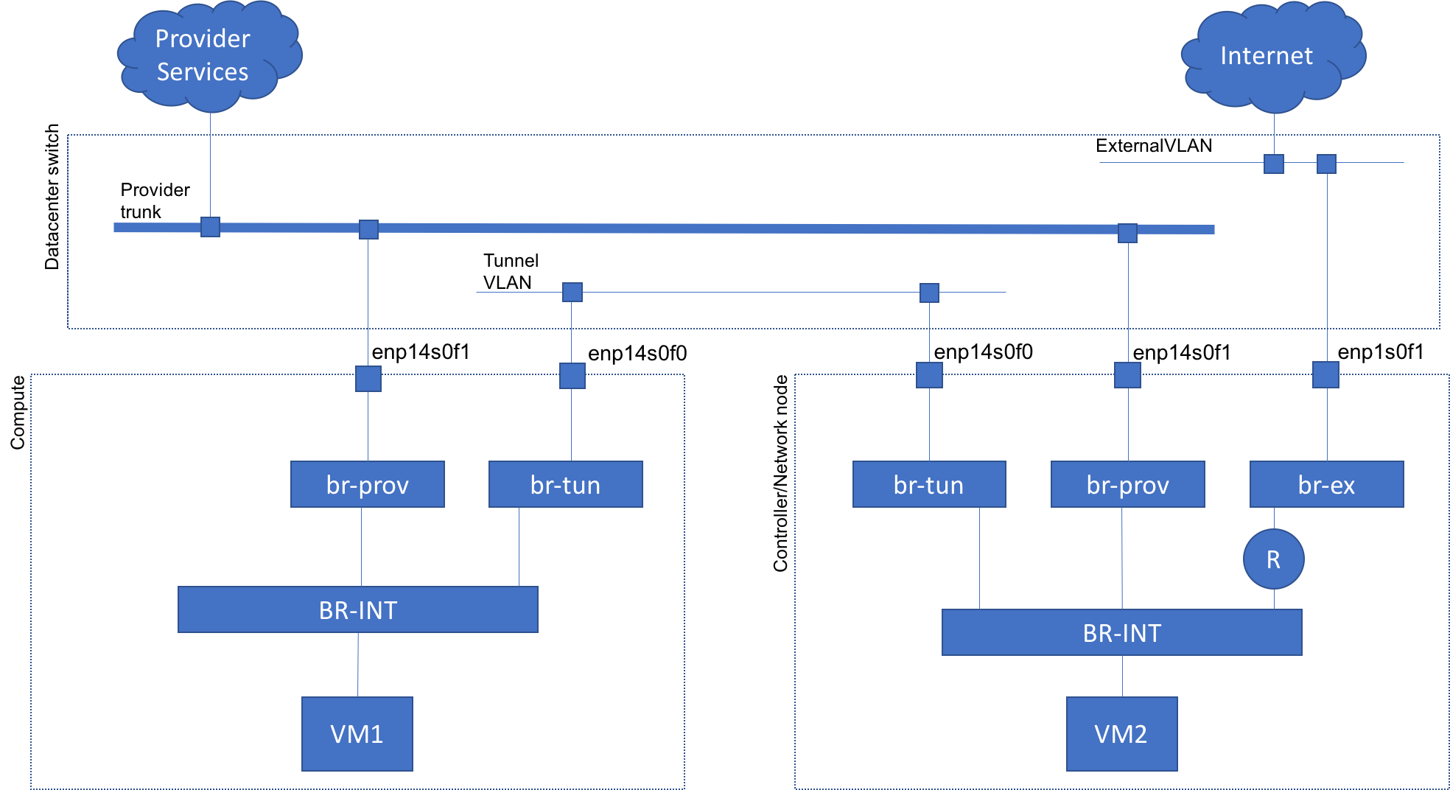

### Packet path:

In this below example diagram, our VM is hosted on compute node. Here the VM is CSR1Kv router.

Red dotted line represents path from CSR1Kv to Internet. If you notice, traffic goes to Controller node and reaches Internet via the router. Here, Controller node is functioning as Network node.

Including Network node, there are 6 nodes in our setup. br-tun bridge would have 5 VXLAN-tunnel interfaces to going to br-tun bridges on the other nodes.

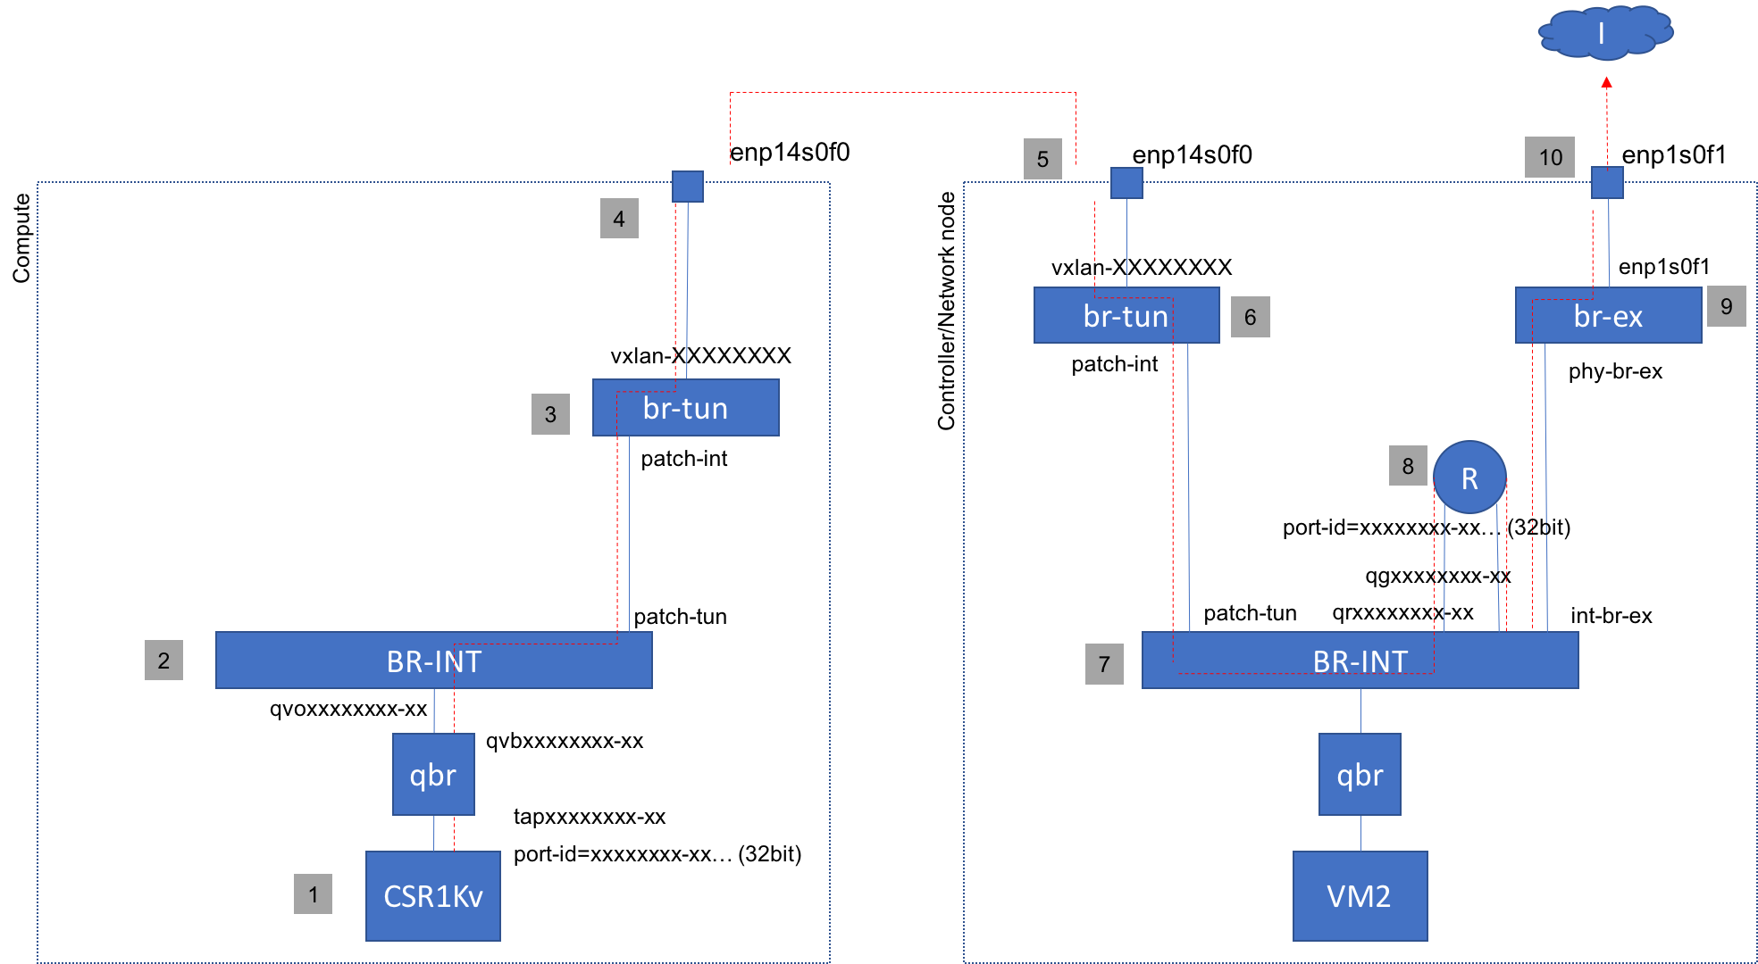

### Packet tracing tasks

* 1. Find the host which is hosting your CSR1Kv rotuer
     1. Login to Controller node: ssh [userXXX@172.31.56.216](mailto:userXXX@172.31.56.216)
     2. source <path/environment-file>
     3. Find your CSR1Kv VM name: openstack server list
     4. Find the host: openstack server show cirros-test
        1. Find the host from the “OS-EXT-SRV-ATTR:host”
     5. Login to the host that has your VM: ssh userXXX@<host>
        1. Ensure that you landed on the right server. Check the server hostname. $hostname
  2. Find the port-id of Internet-facing port (on compute node that hosted the VM)
     1. openstack server list //find Internet facing IP address
     2. openstack port list | grep <Internet facing IP address> //copy first 8 digits of port-id
  3. trace packets on linux bridge
     1. brctl show | grep -e bridge -e <first 8 digits of port-id> //find interface address (starts with tap, followed by first 10 digits of port-id)
     2. <install tcpdump on all servers
     3. copy rc files to all servers
     4. tcpdump -i <interface-id> icmp // do you see the packets?
        1. Example: tcpdump -i tap98e24fde-6d icmp
     5. Close tcpdump by control-c
  4. Trace packets on Open V switch.
     1. ovs-vsctl show | grep <first 8 digits of port-id> // note down interface id ((starts with qvo, followed by first 10 digits of port-id)
        1. Example: ovs-vsctl show | grep 98e24fde-6d
     2. tcpdump -i <interface-id> icmp // do you see the packets?
        1. tcpdump -i qvo98e24fde-6d icmp
     3. Close tcpdump by control-c
  5. trace packets on physical Ethernet port, enp14s0f0
     1. tcpdump -i enp14s0f0 icmp // do you see the packets?
     2. Close tcpdump by control-c
  6. Go to Controller node
     1. ssh user101@172.31.56.216
  7. trace packets on physical Ethernet port, enp14s0f0
     1. tcpdump -i enp14s0f0 icmp // do you see the packets?
     2. Close tcpdump by control-c
  8. Trace packets on router
     1. openstack router list //find your router id
     2. ip netns | grep <router-id>
        1. example: ip netns | grep 47ccc9d6-1544-4b13-a8c3-d7ce48eb1899
     3. ip netns exec <ip netns id of router> ip address
        1. example: ip netns exec qrouter-47ccc9d6-1544-4b13-a8c3-d7ce48eb1899 ip address //find interface name of Internet-facing IP
     4. ip netns exec qrouter-47ccc9d6-1544-4b13-a8c3-d7ce48eb1899 tcpdump -i <internet-facing port>
        1. example: ip netns exec qrouter-47ccc9d6-1544-4b13-a8c3-d7ce48eb1899 tcpdump -i qg-e77c253c-8b

VM on compute – internal-net—tunnel to controller—router—external net

* 1. Ping DNS IP
  2. Trace packet path
  3. Ping google.com
  4. Trace packet path
  5. agent high level topology view
  6. linux level topology
  7. executing commands on agents
  8. packet tracing across linux and ovs bridges
  9. networking across compute/controller nodes
  10. compute to external
  11. compute to provider

# Backup

Topology for Tenant tasks:

* gray items are preconfigured
* VM creation, connecting to network, select a flavor
* floating IP assignment(?). Ping from Internet
* ping DNS server
* ping google.com
* delete the VM at the end of this section

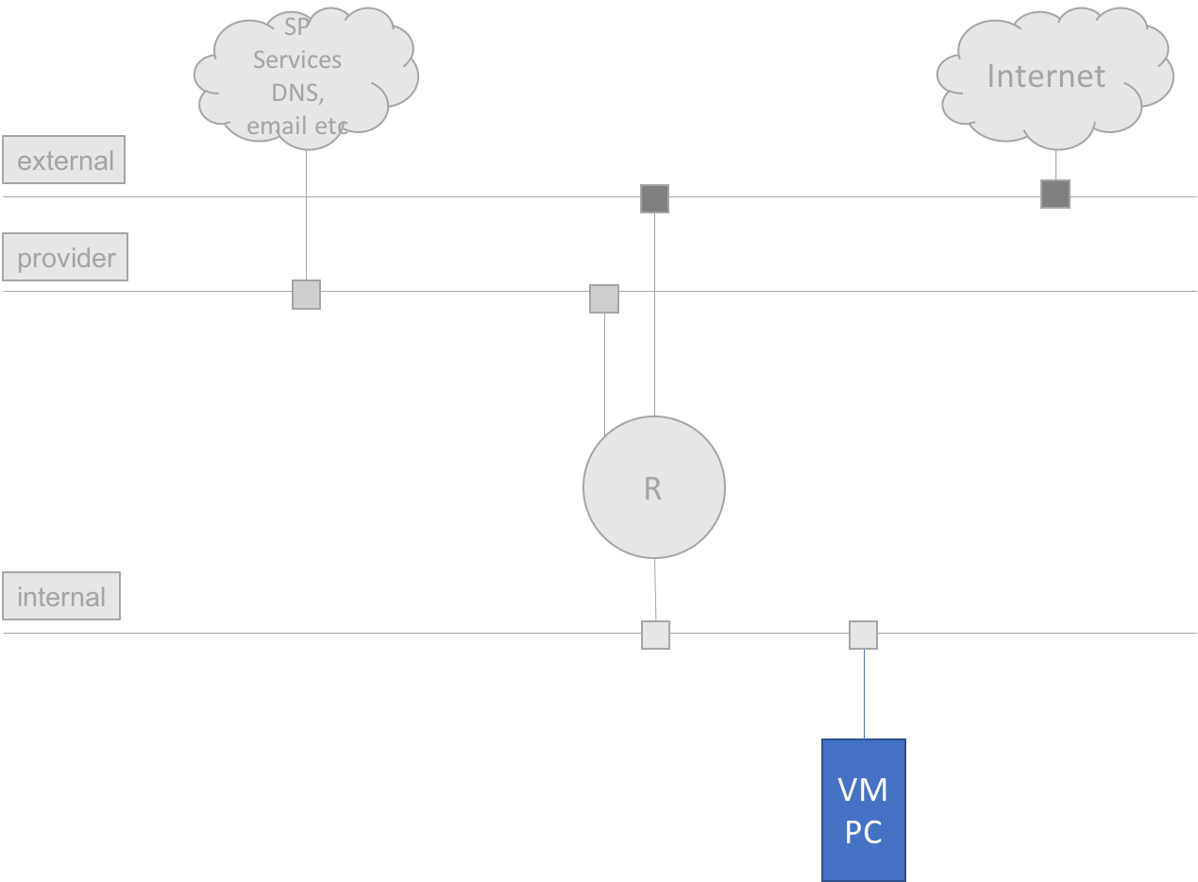

Provider tasks:

* setup provider infra to provide secure internet access to a sample customer
* CPE and customer PC are preconfigured
* create different networks, subnets
* create flavors
* create router
* test connectivity

Tenant tasks:

* from preconfigured PC, verify connectivity to DNS server and Internet
* launch a VM with a flavor and test connectivity

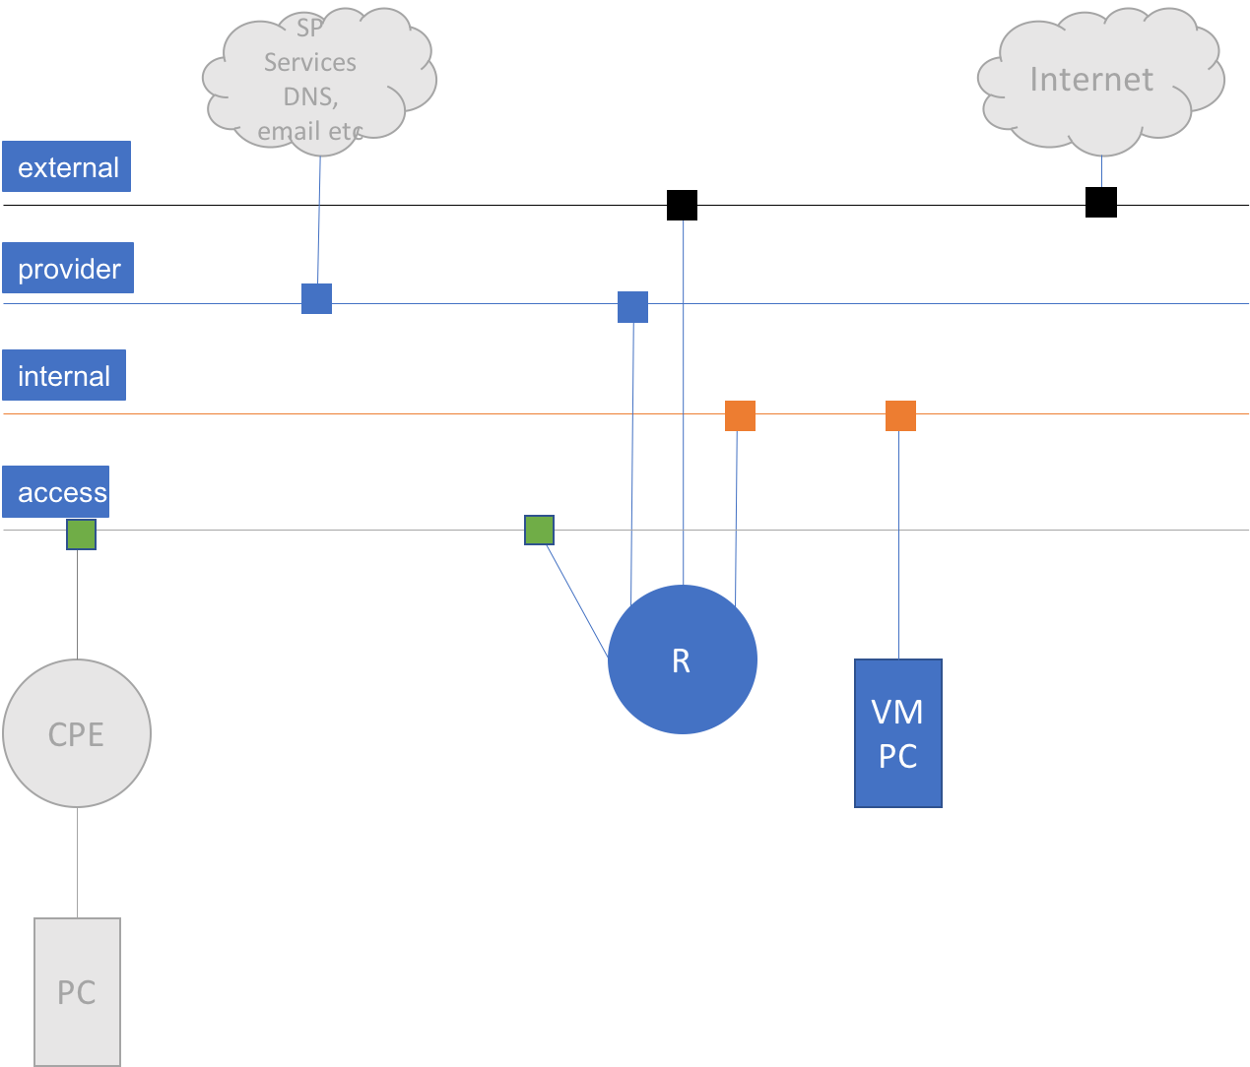

1. Logistics (lecture, 5min.)
2. Introduction to Openstack (lecture, 15)
   1. what is NFV
   2. NFV ETSO model
   3. What is Openstack
   4. Openstack architecture
   5. Openstack as ETSO model
   6. Relevance for Network Engineers
3. Openstack installation (lecture, 5)
   1. steps
   2. challenges
   3. best practices
   4. resources
4. lab environment (hands-on, 15)
   1. lab setup
   2. Lab cloud
   3. POD access
   4. Openstack overview commands (openstack-status, host list etc)
5. Tenant tasks (spin a VM and play) (hands-on, 30) - Gopal
   1. launch a server
   2. basic config
   3. access internet
   4. delete server VM
6. Admin tasks (implement a small design) (60)
   1. browse overall openstack cloud (some openstack CLI (host list etc), access computes etc)
   2. create flavor
   3. create network, subnet
   4. create image
   5. launch ASAv
   6. console access and verification tasks
   7. creating floating ip
   8. assign floating ip
   9. remote ssh access and verification tasks
   10. put some neutron heavy-tasks
7. Neutron intensive tasks (30)
   1. agent high level topology view
   2. linux level topology
   3. executing commands on agents
   4. packet tracing across linux and ovs bridges
   5. networking across compute/controller nodes
   6. compute to external
   7. compute to provider
8. Openstack review tasks (infra, neutron, nova focus) (15)
   1. openstack command list --group compute
   2. identity, volume, compute, image, network
   3. openstack-service list
   4. openstack-service status
   5. openstack-status
   6. openstack availability zone list
   7. openstack hypervisor stats show
   8. openstack host list
   9. openstack hypervisor list
   10. openstack hypervisor show <hypervisor>
   11. scale related
   12. health related
   13. identity based
       1. openstack role list
       2. project
       3. user
   14. nova based
       1. server list
       2. flavor list
   15. glance
       1. image list
   16. neutron based
       1. network list
       2. subnet list
       3. ovs-vsctl
       4. router
   17. ip netns
       1. exec
   18. openstack limits show --project Great-Customer –absolute
   19. openstack quota show Great-Customer
   20. openstack module list
9. Openstack API features (15)
10. Openstack orchestration (30)
    1. HEAT templates?
11. Reference