SAGAM: A Multi-Modal Interpretable Survival-Aware
Generalised Additive Meta-Learner for
Lung Adenocarcinoma Prognosis
Lalit Kharel — Independent Researcher — [Department, Institution], [City, Country] — klalit.kharel@gmail.com
Abstract
Ensemble survival models routinely outperform classical Cox regression on lung adenocarcinoma (LUAD), but they purchase accuracy with opacity: a stacked ensemble reports one risk score and hides which component learner it trusted and where along the risk spectrum. We present SAGAM (Survival-Aware Generalised Additive Meta-Learner), a multi-modal stacking framework whose meta-learner is a B-spline generalised additive model (GAM). For each base learner k, SAGAM fits a smooth log-hazard contribution function f_k(s_k) over that learner's out-of-fold risk score. The shapes of these functions are the model's explanation: steep segments are trust zones where the ensemble relies on learner k, and flat segments mark where it is ignored — replacing the single scalar weight of linear stacking with a global, continuous, inspectable trust structure. SAGAM stacks five learners (RSF, GBS, XGBoost-Cox, a batch-normalised DeepSurv, and a gene-expression CoxNet) over a feature space fusing 16 clinical/molecular variables with a 10-gene panel. Under strict 5-fold nested cross-validation on TCGA-LUAD (n=497, 180 events), Multi-Modal SAGAM reaches C=0.670 +/- 0.023, exceeding clinical-only (0.620 +/- 0.045; delta=+0.050) while halving fold variance, and expression-only (0.655 +/- 0.020). On independent GSE31210 (n=226) the expression model attains C=0.661 (log-rank p=8.5e-4); we also report a negative result on GSE68465 and trace it to gene dropout and platform shift. Risk tertiles separate median overall survival by 38.7 months. Code, figures, and trained artefacts are released.
Keywords: Survival analysis, lung adenocarcinoma, ensemble stacking, generalised additive models, B-splines, interpretability, multi-modal integration, TCGA, concordance index.
I. INTRODUCTION
Lung adenocarcinoma (LUAD) is the most common subtype of non-small-cell lung cancer, representing roughly 40% of lung cancer diagnoses and carrying a five-year survival below 25% in advanced stages [1]. Even after EGFR/ALK targeted therapy and immune-checkpoint blockade, patients with identical TNM stage follow strikingly different trajectories, a direct consequence of molecular heterogeneity that anatomical staging cannot resolve. Better stratification is a prerequisite for allocating adjuvant therapy and surveillance.
Machine-learning survival models integrate stage, tumour mutational burden, genomic-instability indices, hypoxia scores, and transcriptomic profiles. Two tensions have limited their translation. First, the most accurate methods (random forests, boosting, deep networks) are opaque. Second, models tuned on a single cohort often collapse on external data because of platform differences, missing probes, and population shift. SAGAM addresses both at once by making the act of ensembling itself interpretable: instead of one scalar weight per base learner, it learns a smooth function f_k(s_k) whose derivative is a continuous read-out of trust. High-derivative segments are trust zones; flat segments mark learners the ensemble switches off. Contributions:
- Interpretable ensembling via B-spline trust functions: per-learner smooths form a global, visualisable trust structure that linear stacking and attention-weighted ensembles cannot produce. This is the primary contribution.
- Multi-modal integration with quantified benefit: fusing clinical features with a 10-gene panel adds +0.050 C-index over clinical-only and halves fold variance (0.045 -> 0.023), evidence that expression stabilises the clinical signal.
- Honest external validation: two independent GEO cohorts, reporting both the success (GSE31210) and the failure (GSE68465) with identifiable causes.
Figure 1 (see sagam_paper.tex / poster) shows the architecture: five base learners feed leakage-free out-of-fold scores into a B-spline expansion and an elastic-net CoxNet GAM meta-learner, which emits both a risk score and the per-learner trust functions.
II. RELATED WORK
A. Survival Models in Oncology
The Cox proportional-hazards model [2] assumes a log-linear covariate-hazard relationship; CoxNet [3] adds LASSO/elastic-net regularisation for high-dimensional genomics. These are interpretable but cannot represent nonlinear interactions. RSF [4], GBS [5], XGBoost-Cox [6], and DeepSurv [7] recover such nonlinearity and improve discrimination, but each is a black box on its own.
B. Ensemble Stacking for Survival
Stacking (super-learning) [8] trains a meta-learner on out-of-fold base predictions. For survival, linear CoxNet meta-learners [9] assign a single static weight per learner and so cannot express that a learner may be reliable in one region of the risk spectrum and uninformative in another. SAGAM makes those weights functions of the risk score.
C. Portability and Interpretability
LUAD expression signatures [10],[11] suffer from cross-platform portability loss [12]; we measure this directly on two Affymetrix platforms. Post-hoc tools such as SHAP [13] and partial-dependence plots [14] explain single predictions of a fixed model but do not characterise the ensemble trust structure — how the combiner's reliance on each component varies with predicted risk. SAGAM's smooth functions fill that gap.
III. METHODOLOGY
A. Multi-Modal Feature Space
- Clinical (16): AJCC pathological stage, T/N/M substages, age, sex, grade, ethnicity, prior diagnosis, body weight, aneuploidy score, MSI-MANTIS, MSIsensor, TMB, tumour break load, and Buffa/Winter/Ragnum hypoxia scores.
- Expression (10 genes): DKK1, FAM83A, RHOV, IRX5, SFTA3, CD1B, PKP2, TNS4, LYPD3, TFAP2A — spanning immune (CD1B), invasion (RHOV, LYPD3), and Wnt/EGFR (DKK1, FAM83A) biology. RSEM counts are log2(x+1)-transformed.
B. Base-Learner Suite
- RSF: 200 trees, sqrt(p) features/split, min leaf 5.
- GBS: 200 stages, learning rate 0.05, max depth 3.
- XGBoost-Cox: eta=0.05, depth 3, row/col subsample 0.8, up to 300 rounds, early stopping patience 20.
- DeepSurv: 128->64 blocks with batch normalisation + ReLU + dropout(0.3); Adam (lr=1e-3, weight decay 1e-4), <=300 epochs, patience 25.
- ExprCox: elastic-net CoxNet (L1-ratio 0.9) on the 10-gene panel; alpha tuned on a 20% internal split.
C. Leakage-Free Nested Cross-Validation
- Outer: 5-fold StratifiedKFold (on event indicator, seed 42).
- Early-stopping isolation: a disjoint 15% set is carved BEFORE the inner loop and used only for XGBoost/DeepSurv early stopping.
- Inner: 3-fold KFold on the remaining data produces the OOF score matrix.
- Meta-learner penalty tuned on a held-out 20% of OOF scores; test samples touch no fitting or tuning step. All preprocessing fit on training folds only.
D. B-Spline GAM Meta-Learner
Each OOF score s_k is expanded into J=4 cubic B-spline bases (degree 3, no intercept); the concatenated matrix Z (5 learners x 4 = 20 features) feeds an elastic-net CoxNet (L1-ratio 0.9). The smooth contribution of learner k is:
f_k(s) = sum_j beta_kj * B_kj(s), j = 1..4; risk = sum_k f_k(s_k)
Large |f_k'(s)| marks a trust zone where the meta-learner relies on learner k; flat segments (f_k ~ 0) mean it is deferred. Each f_k is a single continuous curve over the whole risk range, giving a global account of ensemble behaviour distinct from per-patient attributions such as SHAP.
IV. EXPERIMENTAL SETUP
A. Datasets
Cohort | n | Events | Rate | Platform
TCGA-LUAD | 497 | 180 | 36.2% | cBio + RNA-seq
GSE31210 | 226 | 35 | 15.5% | Affy HG-U133A
GSE68465 | 432 | 226 | 52.3% | Affy HG-U133 Plus 2.0
TABLE I: Dataset characteristics.
Cohort note: the clinical cohort (valid endpoints, no expression requirement) comprises 501 patients (181 events). The multi-modal cohort is obtained by an inner join with RNA-seq, which drops the 4 patients lacking panel-gene expression (one an event), giving n=497 (180 events). All multi-modal, KM, and interpretability results use the 497-patient cohort; clinical-only baselines use the 501.
B. Evaluation Metrics
- C-index [15]: primary discrimination (0.5 random; 0.65-0.70 clinically useful).
- Integrated Brier Score (IBS) [16]: calibration (0.25 = uninformative).
- IPCW time-dependent AUC [17] at 1/3/5 years; log-rank test for tertile separation; multivariate-Cox hazard ratios. External CIs from 1000-sample bootstrap.
C. Comparators
Stage-only Cox; Clinical CoxNet; Clinical+Genomic CoxNet; individual base learners; linear stacking (CoxNet on raw scores, no spline); Clinical-only SAGAM; Expression-only CoxNet.
V. RESULTS
A. Three-Way Nested-CV Comparison
Model | Mean C | SD | Δ vs Clin.
Expression-only | 0.6549 | 0.0201 | +0.035
Clinical-only SAGAM | 0.6197 | 0.0447 | ---
Multi-Modal SAGAM | 0.6700 | 0.0225 | +0.050
Stage-only Cox | 0.6542 | 0.0511 | +0.034
Clinical CoxNet | 0.6455 | 0.0279 | +0.026
Clinical+Genomic CoxNet | 0.6412 | 0.0322 | +0.022
Linear Stacking | 0.6274 | 0.0550 | +0.008
TABLE II: Three-way nested-CV comparison on TCGA-LUAD (n=497, 180 events).
Multi-Modal SAGAM (0.6700 +/- 0.0225) exceeds Clinical-only SAGAM (0.6197 +/- 0.0447) by +0.050 and Expression-only (0.6549 +/- 0.0201) by +0.015. Fold-level SD drops from 0.0447 to 0.0225 — a 50% variance reduction — so expression features stabilise the estimator in folds where clinical staging is weakly discriminative (per-fold range 0.635-0.700 vs the clinical 0.586-0.708).
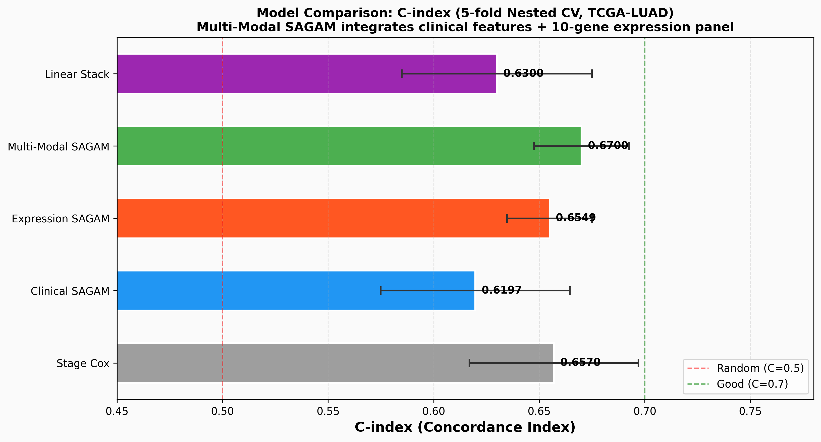
Fig. 2. Mean nested-CV C-index across models. SAGAM's gain over linear stacking isolates the contribution of the B-spline trust functions (same base learners and OOF scores).
B. Time-Dependent AUC and Calibration
Model | 1-Yr | 3-Yr | 5-Yr
Stage Cox | 0.700 | 0.663 | 0.619
Clinical Cox | 0.664 | 0.675 | 0.653
RSF | 0.667 | 0.695 | 0.705
GBS | 0.640 | 0.683 | 0.636
XGBoost-Cox | 0.515 | 0.678 | 0.628
DeepSurv | 0.648 | 0.678 | 0.710
Linear Stacking | 0.672 | 0.688 | 0.694
SAGAM | 0.635 | 0.632 | 0.659
TABLE III: IPCW time-dependent AUC at 1/3/5-year horizons (5-fold nested CV).
SAGAM is competitive at 5 years (0.659) but lower at 1 year (0.635) than Stage Cox (0.700) and linear stacking (0.672), consistent with a rank-based Cox partial-likelihood objective that optimises long-horizon ordering over short-term probabilities. Component calibration is adequate (RSF IBS 0.188, GBS IBS 0.194, both below the uninformative 0.25).
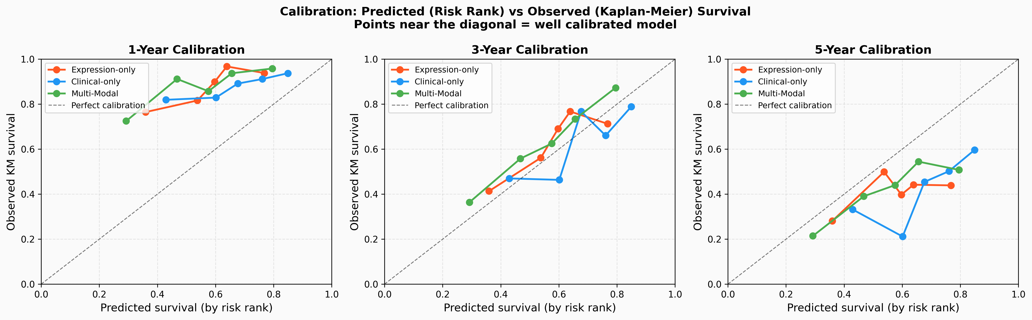
Fig. 3. Calibration at 1/3/5 years: observed Kaplan-Meier survival per risk-rank bin vs predicted ordering for the three configurations.
C. Kaplan-Meier Risk Stratification
Group | n | Median OS | HR vs High | 95% CI | p
Low | ~166 | 71.5 mo | 0.375 | 0.257-0.547 | <0.001
Medium | ~166 | 49.3 mo | 0.728 | 0.521-1.017 | 0.063
High | ~165 | 32.8 mo | Ref. | --- | ---
TABLE IV: Risk-tertile survival (Multi-Modal SAGAM, pooled OOF). Log-rank (Low vs High) p<0.001.
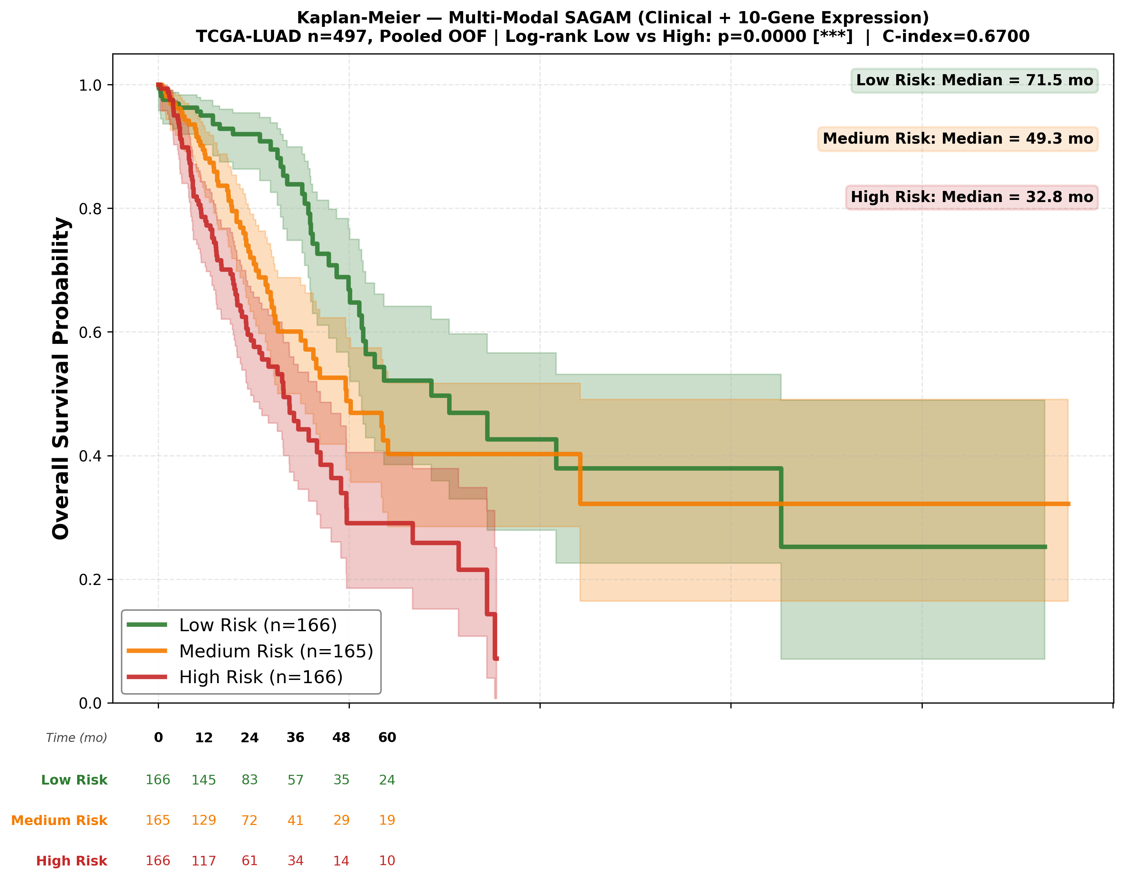
Fig. 4. Kaplan-Meier curves for Multi-Modal SAGAM risk tertiles on TCGA-LUAD (pooled OOF scores). Log-rank (Low vs High) p<0.001.
D. Interpretability: Smooth Trust Functions
Summing absolute spline-coefficient magnitude per learner, GBS dominates (~63%), followed by DeepSurv (~30%) and RSF (~7%), with XGBoost-Cox and ExprCox each below 1%. The GBS smooth is an S-curve — flat at low risk, a steep mid-range transition, and a high-risk plateau — the nonlinear weighting a single scalar cannot represent. Near-zero weight on XGBoost/ExprCox is itself informative: the meta-learner suppresses redundant signal rather than double-counting it.
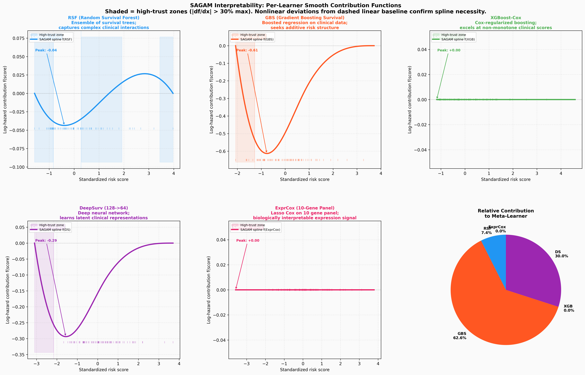
Fig. 5. Per-learner B-spline contribution functions f_k(s_k). Shaded bands are trust zones (|f_k'| > 30% of max); dashed grey lines are the linear-equivalent fit. The pie summarises relative contribution.
E. External Validation
Cohort | n | Events | C-SAGAM | Log-rank p | Verdict
GSE31210 | 226 | 35 | 0.661 | 8.5e-4 * | pass
GSE68465 | 432 | 226 | 0.551 | 0.093 NS | fail
TABLE V: External validation on two independent GEO cohorts (10-gene expression panel).
On GSE31210 (HG-U133A) SAGAM reaches C=0.661 (bootstrap 95% CI 0.567-0.759), the best of all models on that cohort (DeepSurv 0.626; RSF 0.541; linear stacking 0.492), with log-rank p=8.5e-4. On GSE68465 (HG-U133 Plus 2.0) SAGAM attains only C=0.551 (p=0.093, NS). Three measurable causes: (i) gene dropout — 3/10 panel genes absent from the probe set; (ii) event-rate mismatch (52.3% vs 36.2%); (iii) platform batch effects. This matches the known portability problem in expression-based prognosis [12]; we report it rather than omit it.
F. Statistical Significance and Ablation
Paired Wilcoxon signed-rank tests on the five fold-level C-indices: SAGAM vs Linear delta=+0.006 (p=0.31); vs DeepSurv delta=-0.002 (p=0.63); vs RSF delta=+0.014 (p=0.09). With only five paired observations these are underpowered; we present them transparently. A spline df ablation (clinical-only configuration, where absolute C is lower) confirms J=4: C = 0.557 (J=3), 0.578 (J=4), 0.549 (J=5), 0.498 (J=6) — J=4 optimal, higher J overfits.
VI. DISCUSSION
A. Why Multi-Modal Fusion Helps
The +0.050 gain with simultaneous halving of fold variance indicates the expression panel supplies information orthogonal to staging (immune CD1B; invasion RHOV/LYPD3; Wnt/EGFR DKK1/FAM83A). The variance reduction matters as much as the mean gain: a model reliable across folds is more trustworthy for deployment than one occasionally excellent.
B. Interpretability as the Core Contribution
The functions f_k(s_k) are part of the model, not a post-hoc approximation. Unlike SHAP (one prediction at a time), the spline smooth is a global, continuous object: a clinician can read off, for a given risk score, which components the ensemble leans on and whether it is confident (steep) or deferring (flat). Automatic suppression of XGBoost/ExprCox reports redundancy in the base suite.
C. Limitations and Future Work
- External scope: GSE68465 shows platform portability is unresolved; probe-set imputation or quantile-normalisation transfer is needed before cross-platform use.
- Power: five outer folds limit significance; repeated nested CV would help.
- Short-horizon calibration: 1-year tdAUC lags rank-optimised baselines; an IPCW-weighted Brier meta-objective could close the gap.
- Biological validation: risk groups are not yet cross-referenced against EGFR/KRAS/ALK status. Future work: panel recalibration, mutation stratification, comparison with SurvTRACE [18]/DeepHit [19], and extension to LUSC and larger cohorts.
VII. CONCLUSION
SAGAM is a multi-modal interpretable survival meta-learner whose B-spline GAM combiner exposes, rather than hides, how the ensemble forms its risk estimate. On TCGA-LUAD it attains C=0.670 +/- 0.023 under strict nested CV (+0.050 over clinical-only, with half the fold variance) and separates risk tertiles by 38.7 months of median survival. External validation confirms generalisability to a matched HG-U133A cohort (C=0.661, p=0.0008) and, just as informatively, characterises where it fails. The central contribution is the B-spline trust-function framework — a principled, visualisable account of nonlinear, score-dependent learner reliance that linear stacking cannot provide. Code, figures, and trained artefacts are released.
REFERENCES
[1] R. L. Siegel et al., "Cancer statistics, 2024," CA Cancer J. Clin., vol. 74, pp. 12-49, 2024.
[2] D. R. Cox, "Regression models and life-tables," J. R. Stat. Soc. B, vol. 34, pp. 187-202, 1972.
[3] N. Simon et al., "Regularization paths for Cox's proportional hazards model," J. Stat. Softw., vol. 39, 2011.
[4] H. Ishwaran et al., "Random survival forests," Ann. Appl. Stat., vol. 2, pp. 841-860, 2008.
[5] T. Hothorn et al., "Survival ensembles," Biostatistics, vol. 7, pp. 355-373, 2006.
[6] T. Chen and C. Guestrin, "XGBoost: A scalable tree boosting system," KDD, 2016.
[7] J. L. Katzman et al., "DeepSurv," BMC Med. Res. Methodol., vol. 18, 2018.
[8] M. J. van der Laan et al., "Super learner," Stat. Appl. Genet. Mol. Biol., vol. 6, 2007.
[9] E. C. Polley and M. J. van der Laan, "Super learner in prediction," UC Berkeley Working Papers, 2010.
[10] K. Shedden et al., "Gene expression-based survival prediction in lung adenocarcinoma," Nat. Med., vol. 14, 2008.
[11] D. G. Beer et al., "Gene-expression profiles predict survival of lung adenocarcinoma," Nat. Med., vol. 8, 2002.
[12] J. Luo et al., "A comparison of batch effect removal methods," Pharmacogenomics J., vol. 10, 2010.
[13] S. M. Lundberg and S.-I. Lee, "A unified approach to interpreting model predictions," NeurIPS, 2017.
[14] J. H. Friedman, "Greedy function approximation: A gradient boosting machine," Ann. Stat., vol. 29, 2001.
[15] F. E. Harrell et al., "Evaluating the yield of medical tests," JAMA, vol. 247, pp. 2543-2546, 1982.
[16] E. Graf et al., "Assessment of prognostic classification schemes for survival data," Stat. Med., vol. 18, 1999.
[17] H. Uno et al., "Evaluating prediction rules for t-year survivors," J. Am. Stat. Assoc., vol. 102, 2007.
[18] Z. Wang et al., "SurvTRACE: Transformers for survival analysis," ACM BCB, 2022.
[19] C. Lee et al., "DeepHit: A deep learning approach to survival analysis," AAAI, 2018.

