# VISVESVARAYA TECHNOLOGICAL UNIVERSITY

## BELAGAVI – 590018, Karnataka INTERNSHIP REPORT

#### ON

“Template Photography Website”

***Submitted in partial fulfillment for the award of degree(18CSI85)***

## BACHELOR OF ENGINEERING IN

## CSE

***Submitted by:***

**Name : Almas Sadaf Farooqi (1GC20CS002)**

**Name : Fazeelath Mehdi (1GC20CS014)**

**Name : Harshita Sindhe N (1GC20CS016)**

**Name : S Khushi Prasad (1GC20CS046)**

LOGO Ex:

Conducted at

**Varcons Technologies Pvt Ltd**



# Ghouisa College of Engineering

**Department of CSE**

**Accredited by NBA, Karnataka**

# Ramanagara 562159

# Ghouisa College of Engineering

**Department of CSE**

**Accredited by NBA, Karnataka**

# Ramanagara 562159



**CERTIFICATE**

This is to certify that the Internship titled **“Template Photography Website”** carried out by **Mrs. Almas Sadaf Farooqi, Mrs Fazeelath Mehdi, Mrs Harshita Sindhe N , Mrs S Khushi Prasad a** bonafide student of Ghouisa college of Engineering, in partial fulfillment for the award of **Bachelor of Engineering**, in **CSE** under Visvesvaraya Technological University, Belagavi, during the year 2022-2023. It is certified that all corrections/suggestions indicated have been incorporated in the report.

The project report has been approved as it satisfies the academic requirements in respect of Internship prescribed for the course Internship / Professional Practice (18CSI85)

#### Signature of Guide Signature of HOD Signature of Principal

**External Viva:**

Name of the Examiner Signature with Date

1)

2)

# D E C L A R A T I O N

I, **Almas Sadaf Farooqi, Fazeelath Mehdi, Harshita Sindhe N, S Khushi Prasad** Third year student of CSE, Ghouisa College of Engineering, declare that the Internship has been successfully completed, in **Varcons Technologies Pvt Ltd** . This report is submitted in partial fulfillment of the requirements for award of Bachelor Degree in CSE, during the academic year 2022-2023.

Date : 13-11-2022 :

Place : Ramanagara

USN : 1GC20CS002

NAME : Almas Sadaf Farooqi

USN : 1GC20CS014

NAME : Fazeelath Mehdi

USN : 1GC20CS016

NAME : Harshita Sindhe N

USN : 1GC20CS046

NAME : S Khushi Prasad

**OFFER LETTER PROVIDED BY THE COMPANY**

# A C K N O W L E D G E M E N T

This Internship is a result of accumulated guidance, direction and support of several important persons. We take this opportunity to express our gratitude to all who have helped us to complete the Internship.

We express our sincere thanks to our Principal, for providing us adequate facilities to undertake this Internship.

We would like to thank our Head of Dept – CSE, for providing us an opportunity to carry out Internship and for his valuable guidance and support.

We would like to thank our mentors for guiding us during the period of internship.

We would like to thank all the faculty members of our department for the support extended during the course of Internship.

We would like to thank the non-teaching members of our dept, forhelping us during the Internship.

Last but not the least, we would like to thank our parents and friends without whose constant help, the completion of Internship would have not been possible.

**ABSTRACT**

With the development of tourism and the improvement of people's life, photography is becoming more and more popular. Photography has also become a major branch of entertainment and hobbies. At present, there are a lot of photography enthusiasts in the world. They desire to have a good and easy-to-use platform to share hight quality photos and to participate in photography competitions on the Internet.

In order to meet the demands of students and mentors/professors in GIT/GCE, this project was setup, whose aim was to design and develop such a system for photo sharing and photography competition management.

This paper describes in detail the design and implementation of the system, which is a web-based photo sharing and website display.

Firstly, we made investigation of requirements and finished requirement analysis. Secondly, we designed the architecture of the system. Thirdly, we designed the processing logic and steps for each module. Finally, we implemented the whole system by writing HTML, CSS, JS and testing and put the system into trial operation.

Screen shots of the user interfaces of the system, the code lines and the test results are given in this paper.

# Table of Contents

|  |  |  |
| --- | --- | --- |
| **Sl no** | **Description** |  |
| 1 | Company Profile |  |
| 2 | About the Company |  |
| [3](https://1.bp.blogspot.com/-dODuK8N5h1Q/Wlnyb3V9HFI/AAAAAAAACL4/WxQtCJ1pM5wccDABg4wIrTBUB0vlikXQQCLcBGAs/s1600/poly1.jpg) | Introduction |  |
| [4](https://1.bp.blogspot.com/-dODuK8N5h1Q/Wlnyb3V9HFI/AAAAAAAACL4/WxQtCJ1pM5wccDABg4wIrTBUB0vlikXQQCLcBGAs/s1600/poly1.jpg) | System Analysis |  |
| [5](https://1.bp.blogspot.com/-dODuK8N5h1Q/Wlnyb3V9HFI/AAAAAAAACL4/WxQtCJ1pM5wccDABg4wIrTBUB0vlikXQQCLcBGAs/s1600/poly1.jpg) | Requirement Analysis |  |
| 6 | [Implementation](https://4.bp.blogspot.com/-IOOxgPaXMVc/Wlj3LWvcnjI/AAAAAAAACKE/UeTFYvAxDmUDel5UBjdifeWaApB3-dXVgCLcBGAs/s1600/img1.jpg) |  |
| 7 | Snapshots |  |
| 8 | Conclusion |  |
| 9 | References |  |

**[CHAPTER](https://1.bp.blogspot.com/-dODuK8N5h1Q/Wlnyb3V9HFI/AAAAAAAACL4/WxQtCJ1pM5wccDABg4wIrTBUB0vlikXQQCLcBGAs/s1600/poly1.jpg) 1** **COMPANY PROFILE**

# COMPANY PROFILE

**Varcons Technologies Pvt Ltd**

Varcons Technologies is a leading provider of cutting-edge technologies and services, offering scalable solutions for businesses of all sizes. Founded by a group of friends who started by scribbling their ideas on a piece of paper, today we offer smart, innovative services to dozens of clients. We develop SaaS products, provide Corporate Seminars, Industrial trainings and much more.

Smart solutions are at the core of all that we do at VCT. Our main goal is to find smart ways of using technology that will help build a better tomorrow for everyone, everywhere. SaaS offers a variety of advantages over traditional software licensing models and We here at VCT tend to include the key features of SaaS in everything we build.

# [CHAPTER](https://1.bp.blogspot.com/-dODuK8N5h1Q/Wlnyb3V9HFI/AAAAAAAACL4/WxQtCJ1pM5wccDABg4wIrTBUB0vlikXQQCLcBGAs/s1600/poly1.jpg) 2 ABOUT THE COMPANY

1. **ABOUT THE COMPANY**



At VCT, We make sure every product/service that we offer is built keeping in mind the practical usability of the product/Service, We're a startup focused on Creativity and Customizability, and We also provide subscription models for Software that we have already built, Since the application is already configured, the user has a ready-to-use application. This not only reduces installation and configuration time but also cuts down the time wasted on potential glitches linked to software deployment.

Varcons Technologies is a leading provider of cutting-edge technologies and services, offering scalable solutions for businesses of all sizes. Founded by a group of friends who started by scribbling their ideas on a piece of paper, today we offer smart, innovative services to dozens of clients. We develop SaaS products, provide Corporate Seminars, Industrial trainings and much more.

Smart solutions are at the core of all that we do at VCT. Our main goal is to find smart ways of using technology that will help build a better tomorrow for everyone, everywhere. SaaS offers a variety of advantages over traditional software licensing models and We here at VCT tend to include the key features of SaaS in everything we build.

## OD services Varcons provide :

Website as Software :

We develop websites that behave and interact similar to Sophisticated software. Information+Functionality=WaaS

Analytics and Research :

Let us analyse the way your users/customers interact with you/your business by gathering, studying, and understanding the consumer voice and their perception of the product/service to generate a report to help you make better market decisions

Comprehensive Customer Support :

With a comprehensive range of services, We can guarantee your technology needs are not just met, but exceeded. We shall work with your Customers/users closely to understand the way your users/customers use/make use of Products/Services.

### Smart Automation Tools :

We create API's and tools that help you automate any process with a host of features pertaining to the Device.

# [CHAPTER](https://1.bp.blogspot.com/-dODuK8N5h1Q/Wlnyb3V9HFI/AAAAAAAACL4/WxQtCJ1pM5wccDABg4wIrTBUB0vlikXQQCLcBGAs/s1600/poly1.jpg) 3 INTRODUCTION

1. **INTRODUCTION**

## Introduction to Web Apps

Web applications are similar to the traditional applications you’d install on your Information, such as Microsoft Office. They are able to perform the same kinds of tasks, they look the same and they feel the same but there is one key difference - the application itself is not installed on your phone or Information, but lives in the cloud. Web apps are not new, but it used to be that they were often unable to compete with more traditional applications for business critical functions or where rich user interaction was required. This is no longer the case. With the power of modern web technologies, we are able to design and build performing, secure, and feature rich applications that live in the cloud and bring with them a huge number of benefits.

#### They can be accessed from anywhere.

* Because web applications are built with web technologies and they run in a web browser Internet Explorer, Google Chrome, Mozilla Firefox – this allows them to be accessed from every web enabled tool. As long as you have an internet connection you can use them.
* It allows for remote working, it allows for rapid publishing of content, it allows for real time collaboration between teams. If you have web access, you have the ability to access your business tools.

#### They are cost effective.

* Web applications are cheaper to produce and maintain than traditional applications. No matter how many platforms your business uses (Mac, Linux, Windows) web application build can be used across them all.

#### They benefit from more rapid update cycles.

* A huge benefit of web applications is that when an update is released, all of your users are immediately using that version. This doesn’t happen with installed applications, especially in large organizations with IT policies that restrict administrator access.

#### They are secure.

* Web developers have had to become experts in security – the web is a platform designed to share everything with everyone! As such, the types and levels of security included in web applications are often far greater than those seen in traditional applications.
* They also benefit from the ability to launch updates in real-time – the application on the servers is the application people are using. The applications on people’s laptops however is the version last installed. And when those laptops get left on a train it’s not a concern, as nothing is stored locally.

#### They enable more computing with fewer Information.

* Web applications push all of the hard work to the servers, and act as intermediaries between the user interface and the calculations happening behind the scenes. This means you can accomplish terrifyingly complex work on a tablet, or your phone.
* We’ve built web applications that allow people to understand the complex relationships between 250,000 pieces of art on their phones, and applications that run the business systems of one of the largest solar energy providers in the world. Often these products are not financially viable to build using traditional application processes.

## Problem Statement

Develop an application which facilitates creation of web pages having a need to install any HTML editor based software and also which can be used by any novice user (no HTML knowledge needed) that is developing web pages on the online. This module is designed to reduce the process involved in managing the activity of customers and business where the business can sell their services and the customers can buy those.

## Introduction to B2C Ecommerce Website Development with Admin Panel

B2C E-commerce website content providers to focus on creating effective assessment questions and focusing on providing a platform for easy access between Buyer and Consumer.

Here we present techniques that are pertinent to the elements of assessment process: answers submission, Informationized grading, and feedback after submission. As the modern organizations are automated and Informations are working as per the instructions, it becomes essential for the coordination of human beings, commodity and Informations in a modern

organization.

# [CHAPTER](https://1.bp.blogspot.com/-dODuK8N5h1Q/Wlnyb3V9HFI/AAAAAAAACL4/WxQtCJ1pM5wccDABg4wIrTBUB0vlikXQQCLcBGAs/s1600/poly1.jpg) 4 SYSTEM ANALYSIS

**4. SYSTEM ANALYSIS**

## Existing System

Offline system

## Proposed System

Online system

## Objective of the System

Filling the gap of fast moving world

# [CHAPTER](https://1.bp.blogspot.com/-dODuK8N5h1Q/Wlnyb3V9HFI/AAAAAAAACL4/WxQtCJ1pM5wccDABg4wIrTBUB0vlikXQQCLcBGAs/s1600/poly1.jpg) 5 REQUIREMENT ANALYSIS

**5. REQUIREMENT ANALYSIS**

## Hardware Requirement Specification

* Processor: Intel core i3 processer
* Memory: 15.6 GB
* RAM : 128 MB
* Hard Disk: 40 GB

## Software Requirement Specification

* Linux 7.1 or windows xp/7/8/10 r any operating system
* VSCode Editor
* VSCode Liveserver
* Web Browser (updated)

# [CHAPTER](https://1.bp.blogspot.com/-dODuK8N5h1Q/Wlnyb3V9HFI/AAAAAAAACL4/WxQtCJ1pM5wccDABg4wIrTBUB0vlikXQQCLcBGAs/s1600/poly1.jpg) 6 Implimentation

1. **IMPLIMENTATION**

Implementation is the stage where the theoretical design is turned into a working system. The most crucial stage in achieving a new successful system and in giving confidence on the new system for the users that it will work efficiently and effectively.

The system can be implemented only after thorough testing is done and if it is found to work according to the specification. It involves careful planning, investigation of the current system and it constraints on implementation, design of methods to achieve the change over and an evaluation of change over methods a part from planning.

Two major tasks of preparing the implementation are education and training of the users and testing of the system. The more complex the system being implemented, the more involved will be the system analysis and design effort required just for implementation.

The implementation phase comprises of several activities. The required hardware and software acquisition is carried out. The system may require some software to be developed. For this, programs are written and tested. The user then changes over to his new fully tested system and the old system is discontinued.

TO implement this project we require nothing but VSCode editor and some knowledge about the HTML, CSS, JS, Bootstrap, attaching the source code as shown below

**Source code:**

<!DOCTYPE html>

<html lang="en">

<head>

<meta charset="UTF-8">

<meta name="viewport" content="width=device-width, initial-scale=1.0">

<meta http-equiv="X-UA-Compatible" content="ie=edge">

<title>Photography</title>

<link rel="stylesheet" href="css/style.css">

<link rel="stylesheet" href="css/lightbox.min.css">

<link href="css/animate.css" rel="stylesheet" />

<link href="css/waypoints.css" rel="stylesheet" />

<link rel="stylesheet" href="css/aos.scss">

<link rel="stylesheet" href="https://cdnjs.cloudflare.com/ajax/libs/font-awesome/4.7.8/css/font-awesome.min.css">

<link href="https://fonts.googleapis.com/css?family=Poppins&display=swap" rel="stylesheet">

<link rel="stylesheet" href="https://stackpath.bootstrapcdn.com/bootstrap/4.1.3/css/bootstrap.min.css">

<link rel="stylesheet" href="https://stackpath.bootstrapcdn.com/font-awesome/4.7.0/css/font-awesome.min.css">

<link href="https://unpkg.com/aos@2.3.1/dist/aos.css" rel="stylesheet">

<script>

function ImagetoPrint(source) {

return "<html><head><script>function step1(){\n" +

"setTimeout('step2()', 10);}\n" +

"function step2(){window.print();window.close()}\n" +

"</scri" + "pt></head><body onload='step1()'>\n" +

"<img src='" + source + "' /></body></html>";

}

function PrintImage(source) {

Pagelink = "about:blank";

var pwa = window.open(Pagelink, "_new");

pwa.document.open();

pwa.document.write(ImagetoPrint(source));

pwa.document.close();

}

</script>

<style type="text/css">

button {

background-color: DodgerBlue;

color: white;

padding: 0.5rem 0.5rem;

font-size: 1rem;

text-decoration: none;

border-radius:2px;

}

/* img { width: 200px;} */

</style>

</head>

<body>

<!-- navigation -->

<section id="navigation">

<nav class="navbar navbar-expand-lg navbar-light bg-light fixed-top">

<a class="navbar-brand" href="#">Rookie Pionners</a>

<button class="navbar-toggler" type="button" data-toggle="collapse" data-target="#navbarNav"

aria-controls="navbarNav" aria-expanded="false" aria-label="Toggle navigation">

<span class="navbar-toggler-icon"></span>

</button>

<div class="collapse navbar-collapse" id="navbarNav">

<ul class="navbar-nav mr-auto w-100 justify-content-center text-uppercase">

<li class="nav-item">

<a class="nav-link" href="#home">home</a>

</li>

<li class="nav-item">

<a class="nav-link" href="#gallery">gallery</a>

</li>

<li class="nav-item">

<a class="nav-link" href="#services">services</a>

</li>

<li class="nav-item">

<a class="nav-link" href="#about">about</a>

</li>

<li class="nav-item">

<a class="nav-link" href="#footer">contact</a>

</li>

</ul>

</div>

</nav>

</section>

<!-- home -->

<section id="home">

<div class="container">

<div class="intro-text" data-aos="fade-right">

<h3 class="intro-lead-in font-weight-bold">Template<span> Photography</span></h3>

<p class="intro-heading text-capitalize">A Customized website where you can view photos from around the world🤳, also you can print them or just download it ✌</p>

<div class="social">

<a href="#"><i class="fa fa-facebook"></i></a>

<a href=""><i class="fa fa-twitter"></i></a>

<a href=""><i class="fa fa-instagram"></i></a>

</div>

</div>

</div>

</section>

<!-- gallery -->

<section id="gallery">

<div class="container">

<div class="img-gallery row text-center">

<div class="col-lg-3 col-md-4 col-sm-6" data-aos="fade-up">

<div class="img-item">

<img src="img/gallery-5.jpg" alt="">

<div class="hover">

<a href="#">

<h4>Our work samples</h4>

</a>

<a href="img/gallery-5.jpg" download='Pic' class="download-btn">Download

<i class="fa fa-download"></i>

</a>

<a href="#" onclick="PrintImage('img/gallery-5.jpg'); return false;" ><button id="printImage">Print</button></a>

<a class="light" href="img/gallery-5.jpg" data-lightbox="mygallary"><i

class="fa fa-expand"></i></a>

</div>

</div>

</div>

<div class="col-lg-3 col-md-4 col-sm-6" data-aos="fade-up">

<div class="img-item">

<img src="img/gallery-2.jpg" alt="">

<div class="hover">

<a href="#">

<h4>Our work samples</h4>

</a>

<a href="img/gallery-2.jpg" download='Pic' class="download-btn">Download

<i class="fa fa-download"></i>

</a>

<a href="#" onclick="PrintImage('img/gallery-2.jpg'); return false;" ><button id="printImage">Print</button></a>

<a class="light" href="img/gallery-2.jpg" data-lightbox="mygallary"><i

class="fa fa-expand"></i></a>

</div>

</div>

</div>

<div class="col-lg-3 col-md-4 col-sm-6" data-aos="fade-up">

<div class="img-item">

<img src="img/gallery-3.jpg" alt="">

<div class="hover">

<a href="#">

<h4>Our work samples</h4>

</a>

<a href="img/gallery-3.jpg" download="Pic" class="download-btn">Download

<i class="fa fa-download"></i>

</a>

<a href="#" onclick="PrintImage('img/gallery-3.jpg'); return false;" ><button id="printImage">Print</button></a>

<a class="light" href="img/gallery-3.jpg" data-lightbox="mygallary"><i

class="fa fa-expand"></i></a>

</div>

</div>

</div>

<div class="col-lg-3 col-md-4 col-sm-6" data-aos="fade-up">

<div class="img-item">

<img src="img/gallery-8.jpg" alt="">

<div class="hover">

<a href="#">

<h4>Our work samples</h4>

</a>

<a href="img/gallery-8.jpg" download="Pic" class="download-btn">Download

<i class="fa fa-download"></i>

</a>

<a href="#" onclick="PrintImage('img/gallery-8.jpg'); return false;" ><button id="printImage">Print</button></a>

<a class="light" href="img/gallery-8.jpg" data-lightbox="mygallary"><i

class="fa fa-expand"></i></a>

</div>

</div>

</div>

<div class="col-lg-3 col-md-4 col-sm-6" data-aos="fade-up">

<div class="img-item">

<img src="img/gallery-1.jpeg" alt="">

<div class="hover">

<a href="#">

<h4>Our work samples</h4>

</a>

<a href="img/gallery-1.jpeg" download="Pic" class="download-btn">Download

<i class="fa fa-download"></i>

</a>

<a href="#" onclick="PrintImage('img/gallery-1.jpeg'); return false;" ><button id="printImage">Print</button></a>

<a class="light" href="img/gallery-1.jpeg" data-lightbox="mygallary"><i

class="fa fa-expand"></i></a>

</div>

</div>

</div>

<div class="col-lg-3 col-md-4 col-sm-6" data-aos="fade-up">

<div class="img-item">

<img src="img/gallery-6.jpeg" alt="">

<div class="hover">

<a href="#">

<h4>Our work samples</h4>

</a>

<a href="img/gallery-6.jpeg" download="Pic" class="download-btn">Download

<i class="fa fa-download"></i>

</a>

<a href="#" onclick="PrintImage('img/gallery-6.jpeg'); return false;" ><button id="printImage">Print</button></a>

<a class="light" href="img/gallery-6.jpeg" data-lightbox="mygallary"><i

class="fa fa-expand"></i></a>

</div>

</div>

</div>

<div class="col-lg-3 col-md-4 col-sm-6" data-aos="fade-up">

<div class="img-item">

<img src="img/gallery-7.jpeg" alt="">

<div class="hover">

<a href="#">

<h4>Our work samples</h4>

</a>

<a href="img/gallery-7.jpeg" download="Pic" class="download-btn">Download

<i class="fa fa-download"></i>

</a>

<a href="#" onclick="PrintImage('img/gallery-7.jpeg'); return false;" ><button id="printImage">Print</button></a>

<a class="light" href="img/gallery-7.jpeg" data-lightbox="mygallary"><i

class="fa fa-expand"></i></a>

</div>

</div>

</div>

<div class="col-lg-3 col-md-4 col-sm-6" data-aos="fade-up">

<div class="img-item">

<img src="img/gallery-4.jpeg" alt="">

<div class="hover">

<a href="#">

<h4>Our work samples</h4>

</a>

<a href="img/gallery-4.jpeg" download="Pic" class="download-btn">Download

<i class="fa fa-download"></i>

</a>

<a href="#" onclick="PrintImage('img/gallery-4.jpeg'); return false;" ><button id="printImage">Print</button></a>

<a class="light" href="img/gallery-4.jpeg" data-lightbox="mygallary"><i

class="fa fa-expand"></i></a>

</div>

</div>

</div>

</div>

</div>

</section>

<!-- about -->

<section id="about">

<div class="container">

<div class="about-box">

<img class="img-fluid" src="img/about.jpeg" alt="" data-aos="fade-up">

<div class="about-text" data-aos="flip-right">

<div class="about-text-inner">

<h4>Hi world we are the ROOKIE PIONERS interns from Varcons Technologies pvt tld/TIE</h4>

<p>This is a place where you can find photos from the world around you, Here you can download the photos or else you can print them and ofcourse view them as well😊, we also provide photography service 😉 Just a mail away is our service for you❤</p>

</div>

</div>

</div>

</div>

</section>

<!-- client -->

<section id="client">

<div class="container">

<div class="row">

<div class="col-md-6" data-aos="fade-right">

<div class="left-box">

<h1>Client’s Feedback</h1>

<p>“Your willingness and ability to collaborate with other teams is something we can all learn from. Thank you for offering up your time to help others do their role better through sharing your knowledge, like sharing your insights with the sales team so they could better understand customer needs and why they love working with us.”</p>

</div>

</div>

<div class="col-md-6" data-aos="fade-left">

<div class="right-box">

<span><img src="img/client.jpeg" alt=""></span>

<div class="client-inner">

<h5 class="text-capitalize">mark wilsome</h5>

<p>CEO at XYZ</p>

</div>

</div>

</div>

</div>

</div>

</section>

<!-- services -->

<section id="services">

<div class="container">

<div class="row">

<div class="col-lg-12 text-center" data-aos="fade-left">

<div class="heading">

<h2 class="services-heading text-uppercase font-weight-bold">Why we are the best</h2>

<p class="services-subheading text-capitalize text-muted font-italic">Who are in extremely love

with eco friendly system.</p>

</div>

</div>

<div class="col-md-4 text-center" data-aos="zoom-in-up">

<div class="box">

<h4 class="service-heading text-capitalize">expert technicians</h4>

<p>WE have a team of expert photographers with us to provide you</p>

</div>

</div>

<div class="col-md-4 col-sm-6 text-center" data-aos="zoom-in-up">

<div class="box">

<h4 class="service-heading text-capitalize">professional service</h4>

<p>Aim to provide a fuly professional service for you to enjoy your moments</p>

</div>

</div>

<div class="col-md-4 col-sm-6 text-center" data-aos="zoom-in-up">

<div class="box">

<h4 class="service-heading text-capitalize">great support</h4>

<p>provide a great support in your profession by our service</p>

</div>

</div>

<div class="col-md-4 col-sm-6 text-center" data-aos="zoom-in-up">

<div class="box">

<h4 class="service-heading text-capitalize">technical skills</h4>

<p>with experts in our team we have a load of technical skills with us</p>

</div>

</div>

<div class="col-md-4 col-sm-6 text-center" data-aos="zoom-in-up">

<div class="box">

<h4 class="service-heading text-capitalize">highly recommended</h4>

<p>clients recommend us due to our overall professional and expert team </p>

</div>

</div>

<div class="col-md-4 col-sm-6 text-center" data-aos="zoom-in-up">

<div class="box">

<h4 class="service-heading text-capitalize">positive reviews</h4>

<p>We strive to get positive reviews from our clients and we are successfull in it as expected.</p>

</div>

</div>

</div>

</div>

</section>

<!-- social -->

<section id="social">

<div class="container">

<div class="social-btn" data-aos="flip-down">

<a class="btn" href="#">Follow us on instagram</a>

</div>

<div class="social-image row ">

<a href="#"><img src="img/ins-1.jpeg" alt=""></a>

<a href="#"><img src="img/ins-2.jpeg" alt=""></a>

<a href="#"><img src="img/ins-3.jpeg" alt=""></a>

<a href="#"><img src="img/ins-4.jpeg" alt=""></a>

<a href="#"><img src="img/ins-5.jpeg" alt=""></a>

<a href="#"><img src="img/ins-6.jpeg" alt=""></a>

</div>

</div>

</section>

<!-- footer -->

<div id="footer">

<div class="container-fluid">

<div class="row">

<div class="col-lg-5 col-sm-6" data-aos="fade-up">

<h3 class="mb-4">About Us</h3>

<p>ROOKIE PIONERS Interns @ Varcons Technologies Pvt Ltd students from Ghousia College of Engineering Ramanagara</p>

<p>Made With <i class="fa fa-heart-o"></i> by Rookie Pioners</p>

</div>

<div class="col-lg-5 col-sm-6" data-aos="fade-up">

<h3 class="mb-4">Newsletter</h3>

<p>Submit down your email to get latest updates</p>

<div class="news-widget">

<form target="_blank" action="" method="get" class="subscribe-form relative">

<div class="input-group d-flex flex-row">

<input name="EMAIL" placeholder="Enter email address" onfocus="this.placeholder = ''"

onblur="this.placeholder = 'Email Address '" required="" type="email">

<button class="btn sub-btn"><span class="fa fa-arrow-right"></span></button>

</div>

</form>

</div>

</div>

<div class="col-lg-2" data-aos="fade-up">

<h3 class="mb-4">Follow US</h3>

<p>let us be on social</p>

<div class="social-widget">

<a href="#"><i class="fa fa-facebook"></i></a>

<a href="#"><i class="fa fa-snapchat"></i></a>

<a href="#"><i class="fa fa-twitter"></i></a>

<a href="#"><i class="fa fa-pinterest"></i></a>

</div>

</div>

</div>

</div>

</div>

<script src="https://code.jquery.com/jquery-3.3.1.slim.min.js"></script>

<script src="https://cdnjs.cloudflare.com/ajax/libs/popper.js/1.14.3/umd/popper.min.js"></script>

<script src="https://stackpath.bootstrapcdn.com/bootstrap/4.1.3/js/bootstrap.min.js"></script>

<script src="https://cdnjs.cloudflare.com/ajax/libs/jquery/3.3.1/jquery.min.js"></script>

<script src="https://cdnjs.cloudflare.com/ajax/libs/jquery-scrollTo/2.1.2/jquery.scrollTo.min.js"></script>

<script src="https://cdnjs.cloudflare.com/ajax/libs/jquery-localScroll/2.0.0/jquery.localScroll.min.js"></script>

<script src="js/jquery.waypoints.min.js" type="text/javascript"></script>

<script src="js/waypoints.js" type="text/javascript"></script>

<script src="js/lightbox-plus-jquery.min.js"></script>

<script src="js/aos.js"></script>

<script src="https://unpkg.com/aos@2.3.1/dist/aos.js"></script>

<script>

AOS.init({

duration: 1000,

});

$('.nav-item').localScroll();

</script>

</body>

</html>

# [CHAPTE](https://1.bp.blogspot.com/-dODuK8N5h1Q/Wlnyb3V9HFI/AAAAAAAACL4/WxQtCJ1pM5wccDABg4wIrTBUB0vlikXQQCLcBGAs/s1600/poly1.jpg)R 7 SNAPSHOTS

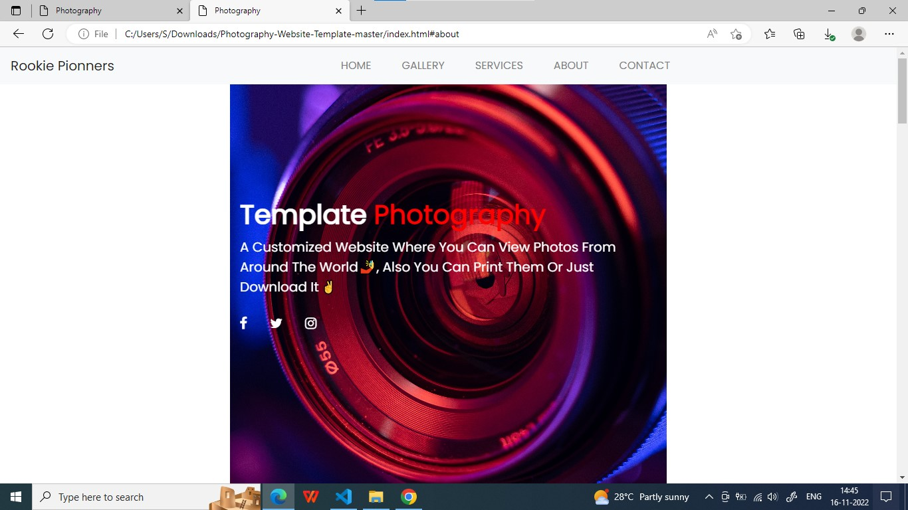

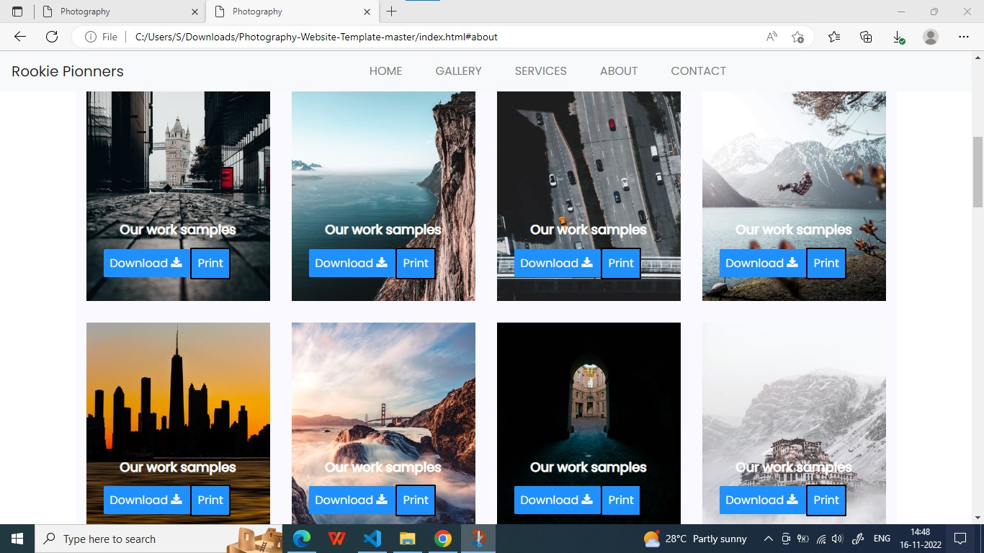

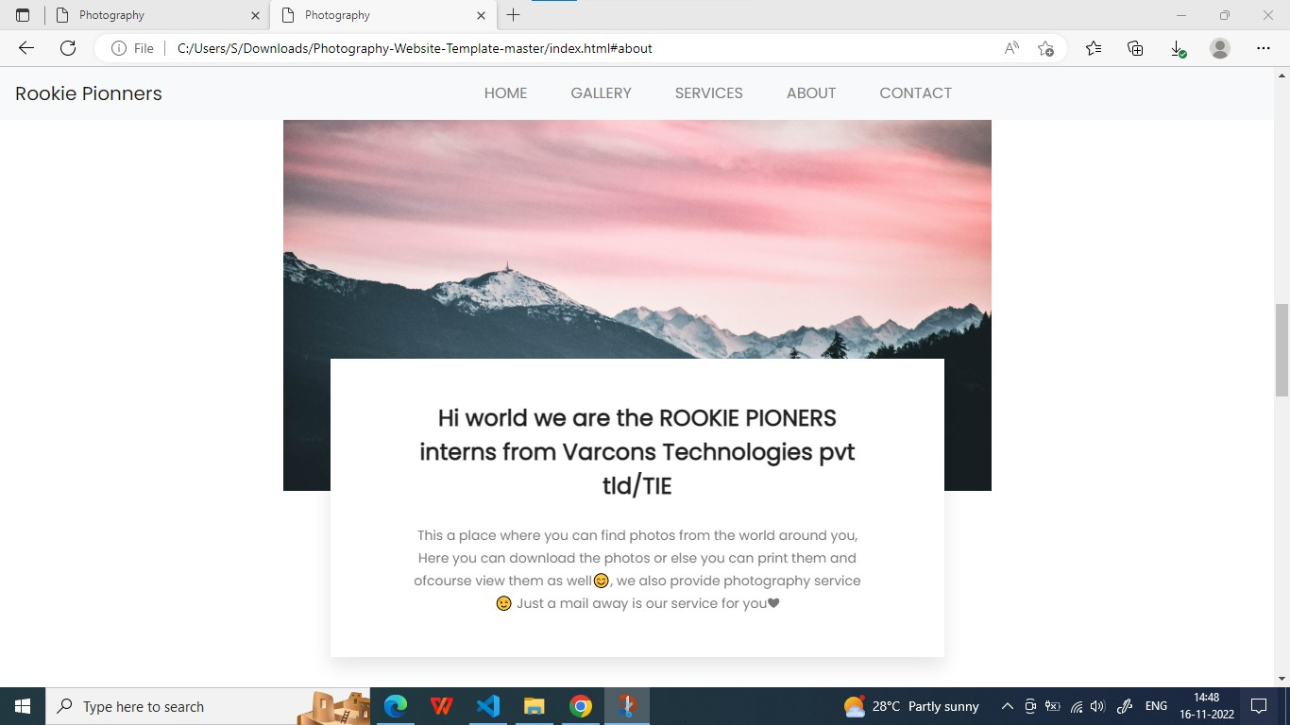

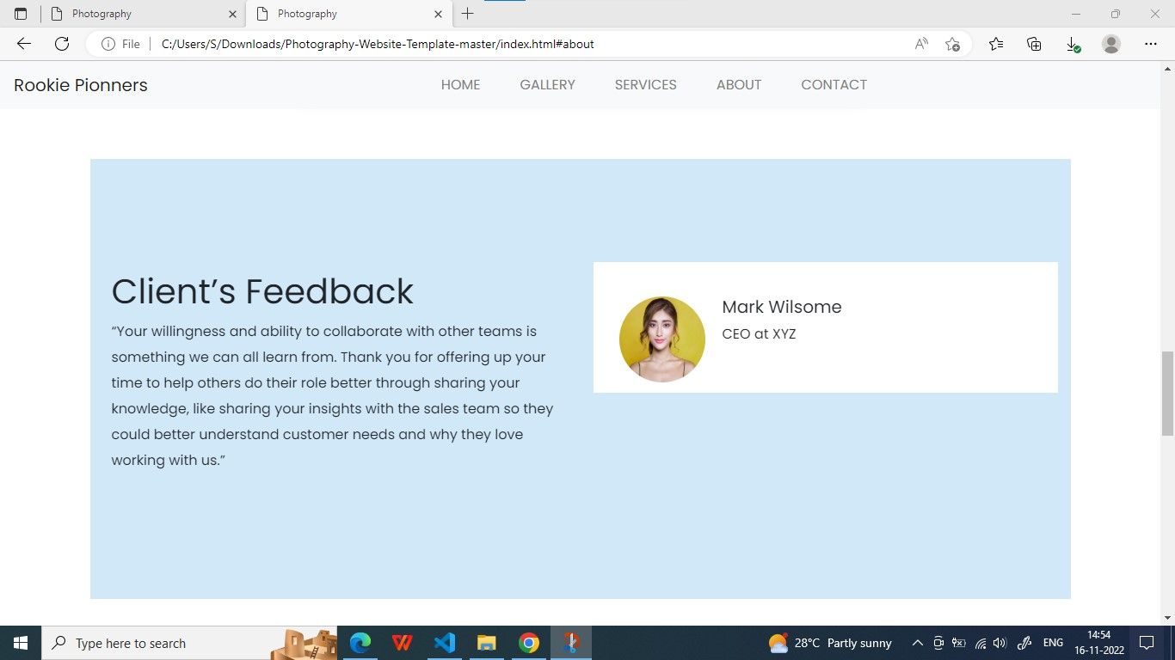

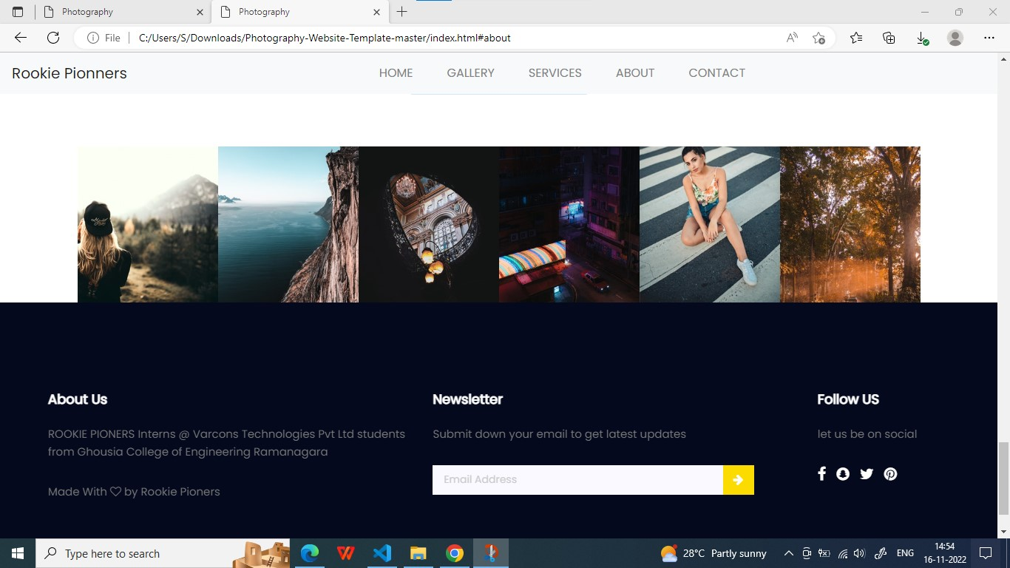

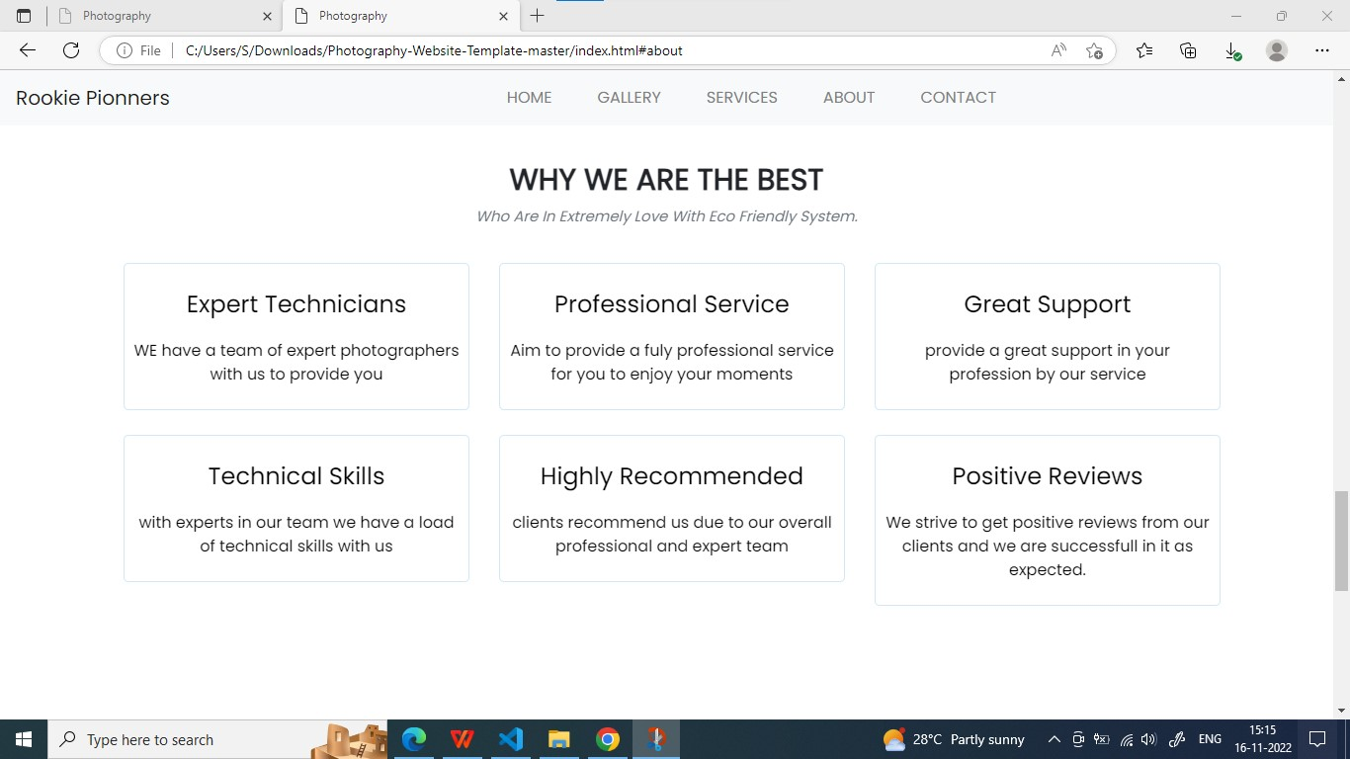

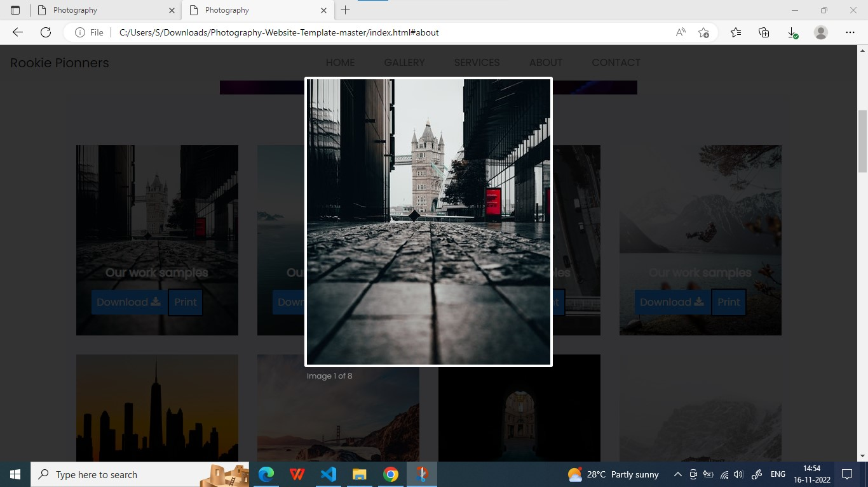

# [CHAPTE](https://1.bp.blogspot.com/-dODuK8N5h1Q/Wlnyb3V9HFI/AAAAAAAACL4/WxQtCJ1pM5wccDABg4wIrTBUB0vlikXQQCLcBGAs/s1600/poly1.jpg)R 8 CONCLUSION

* 1. **CONCLUSION**

The package was designed in such a way that future modifications can be done easily. The following conclusions can be deduced from the development of the project:

* Automation of the entire system improves the efficiency
* It provides a friendly graphical user interface which proves to be better when compared to the existing system.
* It effectively overcomes the delay in communications.
* Updating of information becomes so easier
* System security, data security and reliability are the striking features.
* The System has adequate scope for modification in future if it is necessary.

# [CHAPTE](https://1.bp.blogspot.com/-dODuK8N5h1Q/Wlnyb3V9HFI/AAAAAAAACL4/WxQtCJ1pM5wccDABg4wIrTBUB0vlikXQQCLcBGAs/s1600/poly1.jpg)R 9 REFERENCES

* 1. **REFERENCES**

1. W3 schools : <https://www.w3schools.com/>
2. Wiki how : <https://www.wikihow.com/>
3. Stackoverflow : <https://stackoverflow.com/>