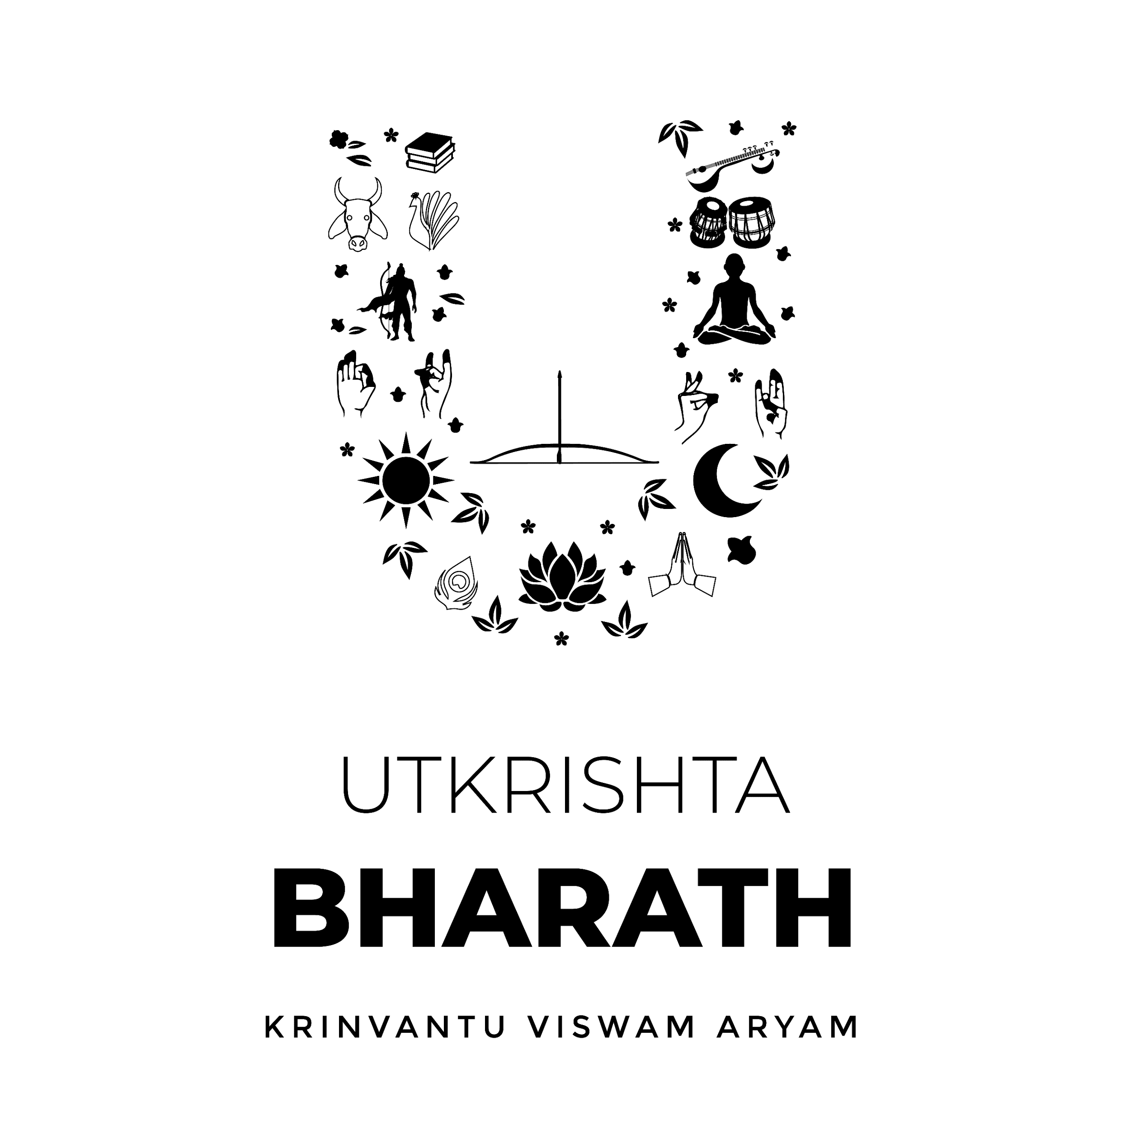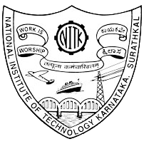

UTKRISHTA BHARATH CLUB, NITK SURATHKAL

**NATIONAL INSTITUTE OF TECHNOLOGY KARNATAKA**

**SURATHKAL, MANGALORE-575025**

To,

Dean of Student Welfare,

NITK Surathkal,

Date : 6th October 2023

Subject : Permission to organize a guest lecture by **Dr. Nambi Narayanan**

Sir,

I write this letter to you as a request for permission to conduct a **guest lecture** by **Dr. Nambi Narayanan** a visionary scientist and **ISRO** luminary, etched his name in the annals of history, not just for his groundbreaking contributions to **India's space program** but also for his indomitable spirit in the face of adversity. His unwavering dedication to the development of **liquid propulsion technology** and the successful launch of India's first satellite, **Aryabhata**, stands as a testament to his profound achievements in the realm of space science.

Dr. Nambi Narayanan's guest lecture in college will be a beacon of inspiration, igniting the flames of curiosity and ambition within students, guiding them towards a path of scientific excellence. His invaluable insights and experiences will serve as a compass, steering them through the challenges of their educational journey and beyond.

We believe that this event would not only be entertaining but also educational, contributing to the cultural awareness and engagement of our student body. Thank you for considering our request.

Yours sincerely,

Nitin Kumar,

Convenor,

Utkrishta Bharath NITK

Dr. A. C. Hegde,

Dean Student Welfare,

NITK Surathkal