|  |
| --- |
| DT228/2 |
| Web Development II |
| Assignment 2015 - 2016 |

|  |
| --- |
| Vlad Zat |

Contents

PHP Pages 3

Source Code 4

Login.php 4

Register.php 4

Books.php 4

Search.php 4

Reservations.php 4

Functions.php 4

db.php 4

Logout.php 4

Username.php 4

ReserveBook.php 4

Return.php 4

Header.html 4

Footer.html 4

AccessDenied.html 4

mystyle.css 4

script.js 4

Screen Samples 5

Login Page 5

Register 5

Login and Register 6

Books 6

Search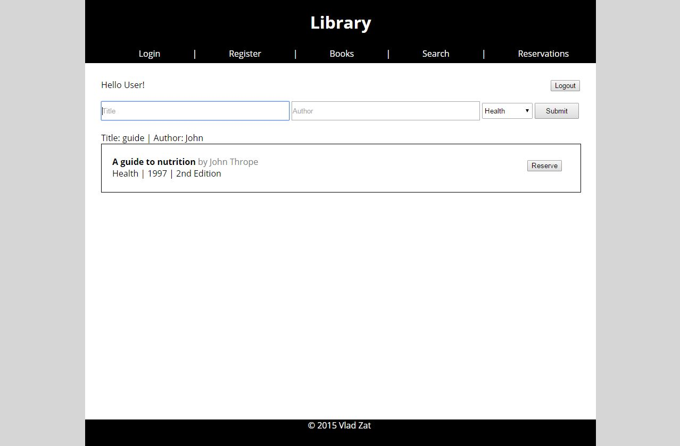 7

Reservations 7

Books, Search and Reservations 8

Design 9

# PHP Pages

* **Login.php** – This is the first page of the application. This is where the user can login. This is an independent page but it assigns the username that is used throughout the application.
* **Register.php** – This is the page where a guest can create an account. It also verifies the information entered in the form.
* **Books.php** – In this page all the books can be viewed. There are 5 books displayed per page. It shows the book title, author, category, publication date and edition. In addition it also contains a button on the right where the user can reserve the book.
* **Search.php** – This page works similarly to the Books page with the addition that the user can choose which books to display. It can search by book title and/or author and it can also search by book category.
* **Reservations.php** – In this page the reserved books of the currently logged in user are displayed in a similar fashion as in the Books page.
* **Functions.php** – This file is used to store functions that are used throughout the pages. It contains a function to read the books that adhere to some condition, a function to display the books read and a function to return the page number.
* **db.php** – This file is used to open the database. It is used in all the pages of the application.
* **Logout.php** – This php page destroys the session and redirects the user to the Login page.
* **Username.php** – This page is included in the 3 pages that display data to show the username and a logout button just under the header.
* **ReserveBook.php** – This page is accessed when a book is reserved in either the Books page or in the Search page. It adds the book that the user wants to reserve to the Reservation table and it also sets the Reserved column of the book in the Books table to Y.
* **Return.php** – This page is accessed when a book is returned from the Reservations Page. It removes the book from the Reservations table and it also sets the Reserved column of the book in the Books table to N.

# Source Code

## Login.php

## Register.php

## Books.php

## Search.php

## Reservations.php

## Functions.php

## db.php

## Logout.php

## Username.php

## ReserveBook.php

## Return.php

## Header.html

## Footer.html

## AccessDenied.html

## mystyle.css

## script.js

# Screen Samples

## Login Page

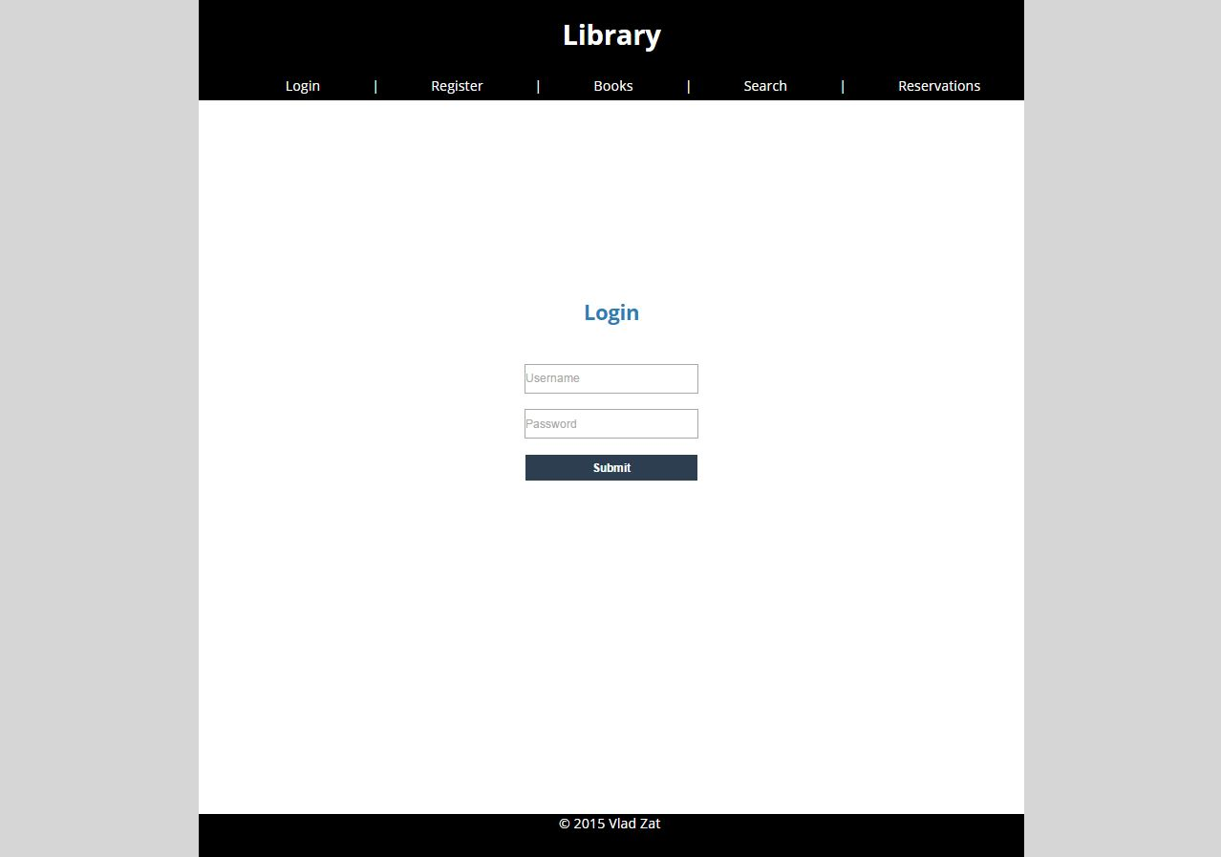

Login page when no user is logged in

## Register

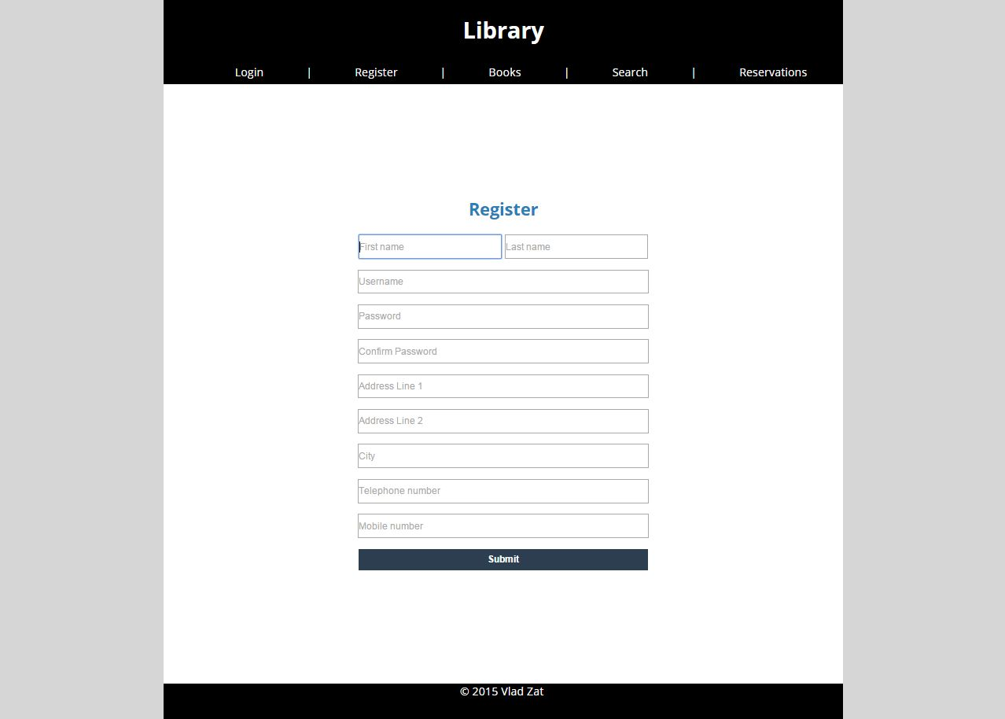

Register page when no user is logged in

## Login and Register

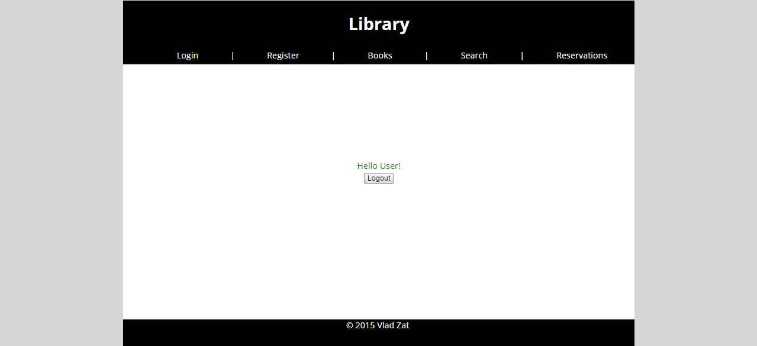

Login and Register page when a user is logged in

## Books

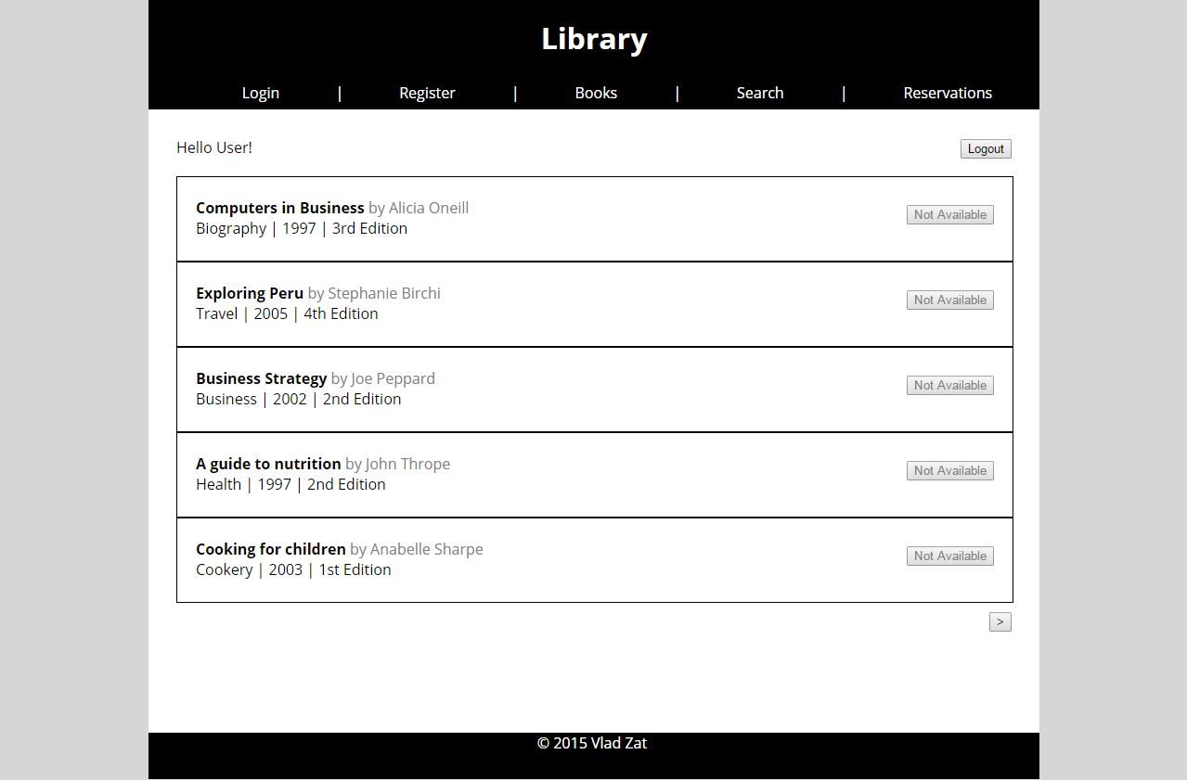

Books page when a user is logged in

## SearchC:\Users\Jean-Luc Picard\Desktop\Search.JPG

Search page when a user is logged in

## Reservations

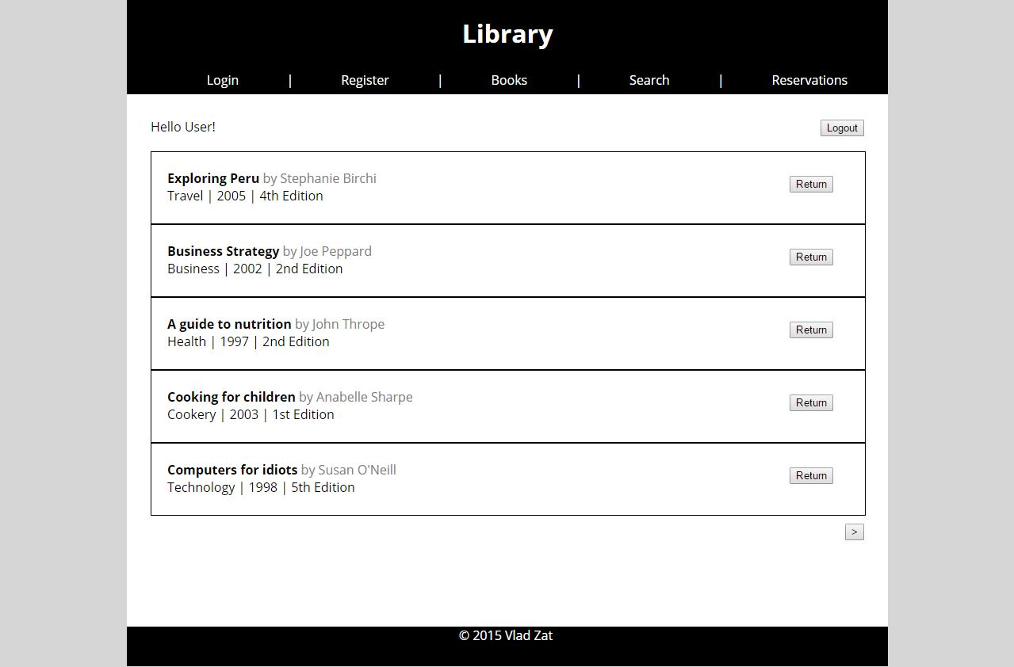

Reservations page when a user is logged in

## Books, Search and Reservations

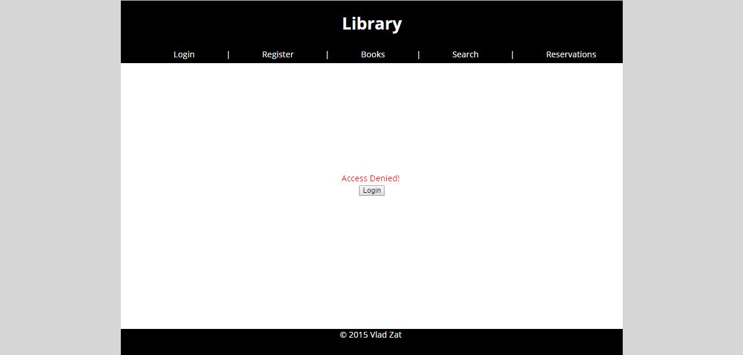

Books, Search and Reservations pages when no user is logged in

# Design

