Exam Wireframes

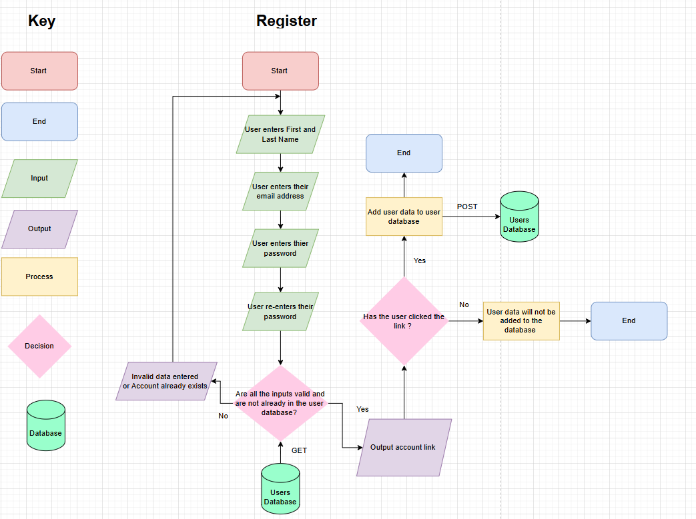The user enters their first and last name, email address, phone number and a password so their account is unique to them. A validation check will occur to make sure the data provided is valid and if it is invalid the user must provide valid data again. If the account is already in our database they must log in .If the data is valid and the account doesn’t exist in the user database the user will be sent an account confirmation link if the user clicks the link their account will be added to the database but If the user doesn’t then their data won’t be added to the user database.
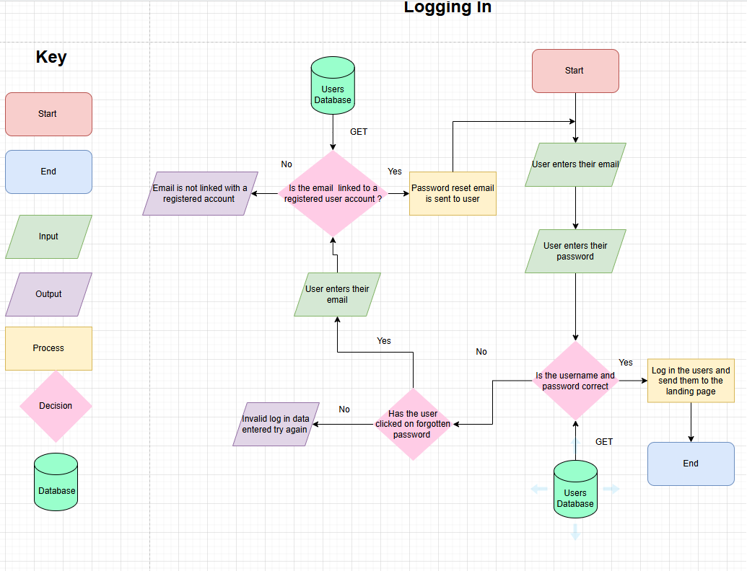The user enters the email address they registered an account with, then they enter their password after they have entered their password a validation check which involves the user database. If the email and password are correct then they will be logged into the solution and will be taken to the landing page . However, If either the email or password are not found in the database the solution will flag the error message . If the user has forgotten their password they can click the password reset link .The user has to enter the email of the account they registered with if it isn’t found in the user data base the user an error message will show up telling the user about it .If the email is found then the user will be sent a reset link .
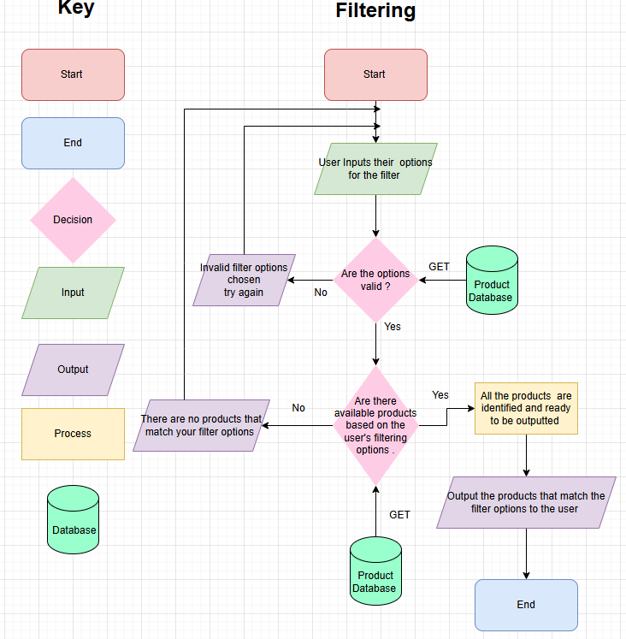The user enters their filtering options then options go through a validation check using the product database to make sure the options are actually in the database . If the options are invalid an error message will be displayed and the user will have to try again . After the options are flagged as valid the products match the filtering options will be searched using the product the database . Products that match the user’s filtering options will be displayed .If no products have been found an error message will be outputted to the user .
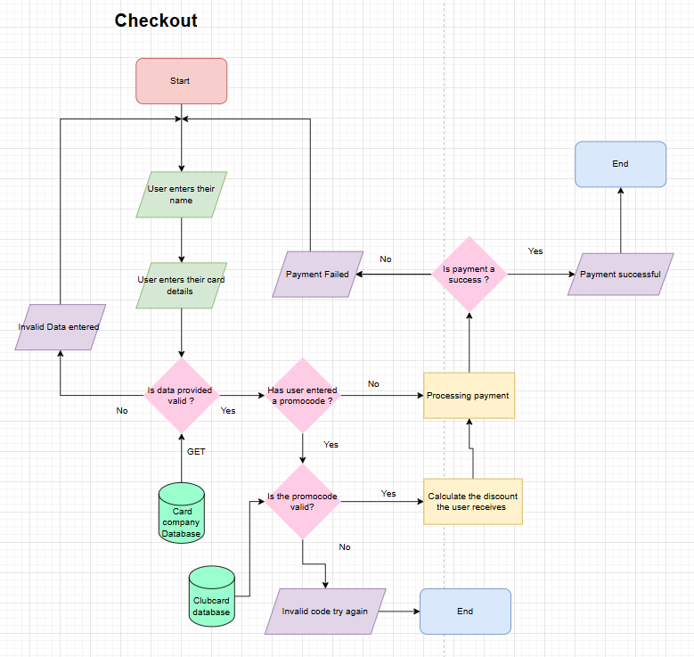
Firstly, the user will enter their name as it will be used to as a form of identification in the confirmation message. Secondly, their card details will be checked with the help of card provider databases. If the data is valid the payment will start processing if it isn’t the user will be sent an error message. If the payment turns out to be a success the user will later be sent a booking success message. The user will get an error message if the payment fails. If the user has entered a promo code from a loyalty scheme there will be a valid check using the club card database if the promo code is valid they will receive a discount on their payment .If the promo code is invalid an error message will be shown .

