EXPERIMENT – 1
BASIC FUNCTIONS OF IMAGE PROCESSING WITH OpenCV

OBJECTIVE:
To understand and implement basic OpenCV functions for image processing

THEORY:
OpenCV, arguably the most widely used computer vision library, includes hundreds of ready-to-use imaging and vision functions and is used in both academia and industry. As cameras get cheaper and imaging features grow in demand, the range of applications using OpenCV increases significantly, both for desktop and mobile platforms. Initially developed by Intel, OpenCV (Open Source Computer Vision) is a free cross-platform library for real-time image processing.
The applications for OpenCV cover areas such as segmentation and recognition, 2D and3D feature toolkits, object identification, facial recognition, motion tracking, gesture recognition, image stitching, high dynamic range (HDR) imaging, augmented reality, and so on. Moreover, to support some of the previous application areas, a module with statistical machine learning functions is included.
OpenCV-Python:
Python is a general purpose programming language started by Guido van Rossum, which became very popular in short time mainly because of its simplicity and code readability. It enables the programmer to express his ideas in fewer lines of code without reducing any readability.
And the support of Numpy makes the task easier. Numpy is a highly optimized library for numerical operations. It gives MATLAB/Scilab-style syntax. All the OpenCV array structures are converted toand-from Numpy arrays. So whatever operations you can do in Numpy, you can combine it with OpenCV, which increases number of weapons in your arsenal. Besides that, several other libraries like SciPy, Matplotlib which supports Numpy can be used with this. So OpenCV-Python is an appropriate tool for fast prototyping of computer vision problems.
SAMPLE PROGRAM: (1) Read, Write and Displaying an image
import cv2
imgpath = r"C:\MEET\VS CODE\image_processing\ip.png"
img = cv2.imread(imgpath,0)
cv2.imshow("dispaly",img)
cv2.waitKey(0)
cv2.destroyAllWindows()

OUTPUT:

Fig 1.1 Gray scale image

(2) Display image properties
import cv2
imgpath = r"C:\MEET\VS CODE\image_processing\ip.png"
img = cv2.imread(imgpath, 0)
print(img.dtype)
print(img.shape)
print(img.size)
print(img.ndim)
print(type(img))
(nr, nc) = img.shape
print(nr,nc)

RESULT:
uint8
(596, 445)
265220
2
<class 'numpy.ndarray'>
596 445

(3) Color image to Gray Scale Conversion
import cv2
imgpath = r"C:\MEET\VS CODE\image_processing\ip.png"
img = cv2.imread(imgpath, 1)
cv2.imshow('color', img)
cv2.waitKey(0)
gray = cv2.cvtColor(img, cv2.COLOR_RGB2GRAY)
cv2.imshow('gray', gray)
cv2.waitKey(0)
cv2.destroyAllWindows()



OUTPUT:

Fig 1.2 Color to Gray image

(4) Display multiple images
import cv2
import matplotlib.pyplot as plt
imgpath1 = r"C:\MEET\VS CODE\image_processing\ip.png"
imgpath2 = r"C:\MEET\VS CODE\image_processing\meet.png"

img1 = cv2.imread(imgpath1,0)
img2 = cv2.imread(imgpath2,0)

title = ['img1','img2']
img = [img1,img2]

for i in range(2):
plt.subplot(1,2,i+1)
plt.imshow(img[i],cmap='gray')
plt.title(title[i])
plt.xticks([])
plt.yticks([])
plt.show()

OUTPUT:
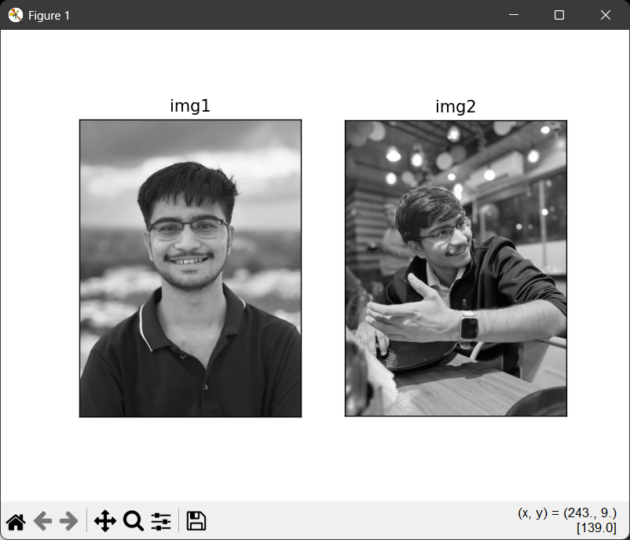
Fig 1.3 Multiple images

(5) Pixel value accessing and editing
import cv2
imgpath = r"C:\MEET\VS CODE\image_processing\ip.png"
img = cv2.imread(imgpath, 1)
x = img.item(10,10,0)
print("x: ", x)
img[10,10,0] = 255 # if older version then use img.itemset((10,10,0),newpixelvalue)
y = img.item(10,10,0)
print("y: ", y)
RESULT:
x: 163
y: 255

(6) Image resize
import cv2
import matplotlib.pyplot as plt
imgpath = r"C:\MEET\VS CODE\image_processing\ip.png"
img = cv2.imread(imgpath, 1)
img = cv2.imread(imgpath,1)
cv2.imshow("original",img)
cv2.waitKey(0)
(nr,nc,nch) = img.shape
r = 300
c = 400

img2 = cv2.resize(img,(r,c),interpolation=cv2.INTER_AREA)
cv2.imshow("resize",img2)
cv2.waitKey(0)
print('original',img.shape)
print('resized', img2.shape)
cv2.destroyAllWindows()

OUTPUT:


Fig 1.4 Original and Resized image

(7) Rotate an image
import cv2
imgpath = r"C:\MEET\VS CODE\image_processing\ip.png"
img = cv2.imread(imgpath, 0)
(h, w) = img.shape[:2]
center = (w // 2, h // 2)

M = cv2.getRotationMatrix2D(center, 45, 1.0) # Rotate 45 degrees
rotated = cv2.warpAffine(img, M, (w, h))
cv2.imshow("Rotated", rotated)
cv2.waitKey(0)
cv2.destroyAllWindows()

OUTPUT:
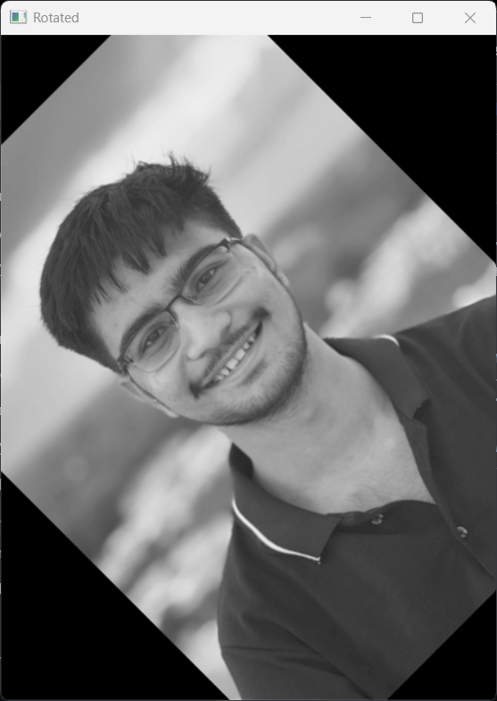
Fig 1.5 Rotated picture

(8) Flip an image
import cv2
import matplotlib.pyplot as plt
imgpath = r"C:\MEET\VS CODE\image_processing\ip.png"
img = cv2.imread(imgpath, 0)
flip_horizontal = cv2.flip(img, 1) # Horizontal flip
flip_vertical = cv2.flip(img, 0) # Vertical flip
flip_both = cv2.flip(img, -1) # Both axes

title = ['horizontal','vertical', 'both']
img = [flip_horizontal,flip_vertical, flip_both]

for i in range(3):
plt.subplot(1,3,i+1)
plt.imshow(img[i],cmap='gray')
plt.title(title[i])
plt.xticks([])
plt.yticks([])
plt.show()

OUTPUT:
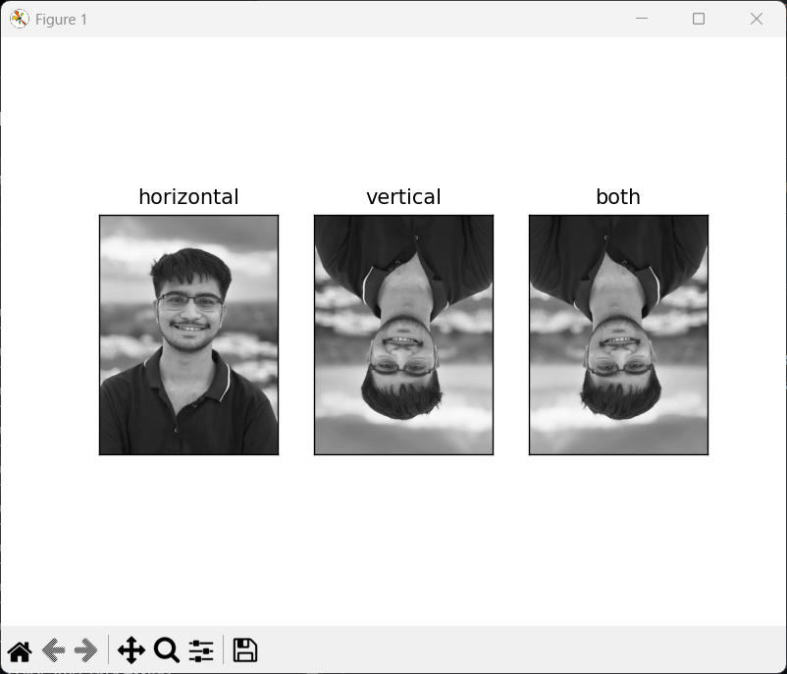
Fig 1.6 Flipped image

(9) Crop an image
import cv2
img = cv2.imread(r"C:\MEET\VS CODE\image_processing\ip.png", 0)
crop = img[0:300,100:900]
cv2.imshow("cropped",crop)
cv2.waitKey(0)
cv2.destroyAllWindows()

OUTPUT:

Fig 1.7 Cropped image
(10) Blurred image
import cv2
imgpath = r"C:\MEET\VS CODE\image_processing\ip.png"
img = cv2.imread(imgpath, 0)
blur = cv2.GaussianBlur(img, (5, 5), 0)
cv2.imshow("Blurred", blur)
cv2.waitKey(0)
cv2.destroyAllWindows()

OUTPUT:

Fig 1.8 Blurred image

Conclusion:

EXPERIMENT – 2
FUNDAMENTAL IMAGE PROCESSING

OBJECTIVE:
(!) Find out average intensity of grayscale image
(2) Apply negative intensity transformation on any grayscale image

SAMPLE PROGRAM:
(1) Find average intensity of grayscale image
import cv2
import numpy as np
import matplotlib.pyplot as plt
imgpath = r"C:\MEET\VS CODE\image_processing\ip.png"
img = cv2.imread(imgpath,0)
(nr,nc) = img.shape
print(nr,nc)
cv2.imshow("cv", img)
cv2.waitKey(0)
cv2.destroyAllWindows()
temp = 0
for i in range(nr):
for j in range(nc):
temp = temp + int(img[i][j])
avgintensity = temp / (nr*nc)
print(avgintensity)

OUTPUT:

Fig 2.1 Output
596 445
126.88213935600633

(2) Apply negative intensity transformation on a grayscale image
import cv2
import matplotlib.pyplot as plt
imgpath = r"C:\MEET\VS CODE\image_processing\meet.png"
img1 = cv2.imread(imgpath,0)
img2 = abs(255-img1)
titles = ['original','negative']
images = [img1, img2]
for i in range(2):
plt.subplot(1,2,i+1)
plt.imshow(images[i], cmap='gray')
plt.title(titles[i])
plt.show()

OUTPUT:
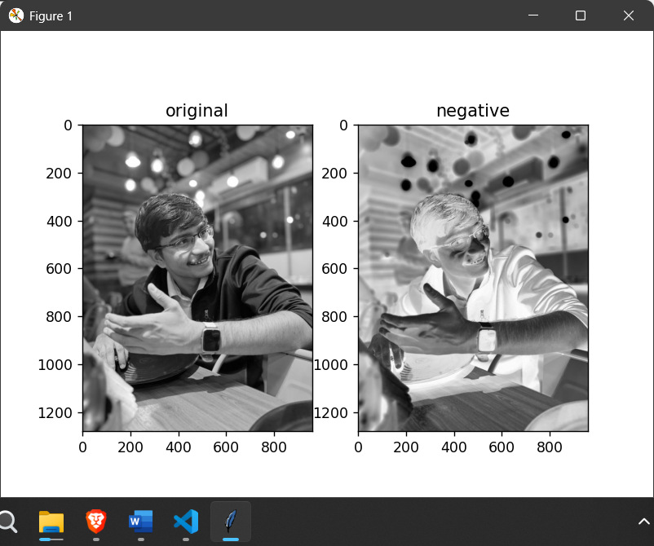
Fig 2.2 Original vs negative picture

ASSIGNMENT
(1) Read images having following characteristics and calculate average intensity of the same.
- Darker Image
- Brighter Image.
Justify your answer.
import cv2
import numpy as np
import matplotlib.pyplot as plt
imgpath = r"C:\MEET\VS CODE\image_processing\meet.png"
img1 = cv2.imread(imgpath,0)
img2 = abs(255-img1)
titles = ['original','negative']
images = [img1, img2]
for i in range(2):
plt.subplot(1,2,i+1)
plt.imshow(images[i], cmap='gray')
plt.title(titles[i])
plt.show()

(nr,nc) = img1.shape
temp = 0
for i in range(nr):
for j in range(nc):
temp = temp + int(img1[i][j])

avgintensity = temp / (nr*nc)
print("average intensity of darker image",avgintensity)

(nr,nc) = img2.shape
temp = 0
for i in range(nr):
for j in range(nc):
temp = temp + int(img2[i][j])

avgintensity = temp / (nr*nc)
print("average intensity of lighter image",avgintensity)

OUTPUT:

Fig 2.3 Outputs

average intensity of darker image 106.96275309244791
average intensity of lighter image 148.0372469075521

The average intensity of the original is lower because dark areas dominate. When inverted, those dark areas become bright, shifting the balance and raising the average. The two averages always sum to 255 (for 8-bit images), which is why your results (106.96 and 148.03) are consistent and correct.

(2) W.A.P to perform Image Flipping operation on digital image.
import cv2
import matplotlib.pyplot as plt
imgpath = r"C:\MEET\VS CODE\image_processing\ip.png"
img = cv2.imread(imgpath, 0)
flip_horizontal = cv2.flip(img, 1) # Horizontal flip
flip_vertical = cv2.flip(img, 0) # Vertical flip
flip_both = cv2.flip(img, -1) # Both axes

title = ['horizontal','vertical', 'both']
img = [flip_horizontal,flip_vertical, flip_both]

for i in range(3):
plt.subplot(1,3,i+1)
plt.imshow(img[i],cmap='gray')
plt.title(title[i])
plt.xticks([])
plt.yticks([])
plt.show()

OUTPUT:

Fig 2.4 Flipped outputs

(3) W.A.P to perform to apply log transform on grayscale image.
import cv2
import numpy as np
import matplotlib.pyplot as plt
imgpath = r"C:\MEET\VS CODE\image_processing\ip.png"
img = cv2.imread(imgpath,0)
img_float = img.astype(float)
c = 255 / np.log(1 + np.max(img_float))
log_img = c * np.log(1 + img_float)
log_img = np.uint8(log_img)

plt.subplot(1,2,1)
plt.imshow(img, cmap='gray')
plt.xticks([])
plt.yticks([])
plt.subplot(1,2,2)
plt.imshow(log_img, cmap='gray')
plt.xticks([])
plt.yticks([])
plt.show()

OUTPUT:
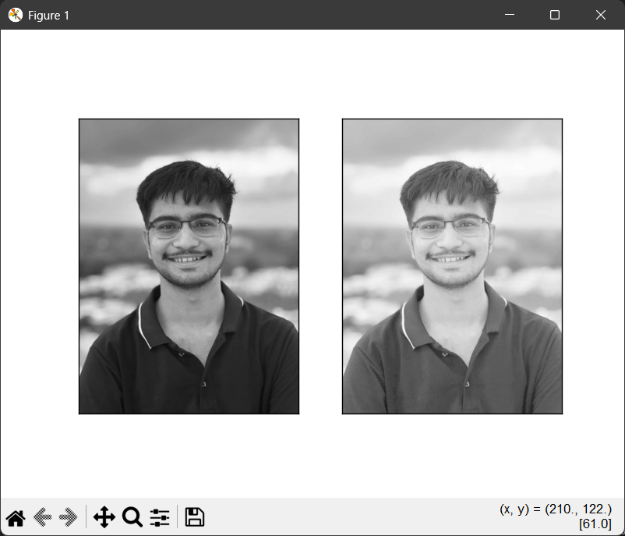
Fig 2.5 Log transform output

(4) W.A.P to perform gamma transform on grayscale image.
import cv2
import numpy as np
import matplotlib.pyplot as plt
imgpath = r"C:\MEET\VS CODE\image_processing\ip.png"
img = cv2.imread(imgpath, 0)
norm_img = img / 255.0
gamma = 2.2
new_gamma = np.power(norm_img, gamma)
new_gamma = new_gamma * 255
new_gamma = np.uint8(new_gamma)
plt.subplot(121)
plt.imshow(img, cmap='gray')
plt.subplot(122)
plt.imshow(new_gamma, cmap='gray')
plt.show()

OUTPUT:
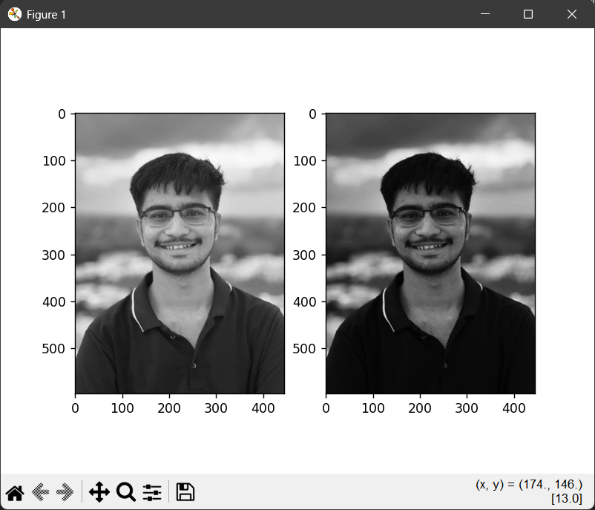
Fig 2.6 Gamma Transform Output

CONCLUSION:

EXPERIMENT – 3
CONTRAST ENHANCEMENT ALGORITHMS

OBJECTIVE:
- To observe histogram of grayscale image
- II. To apply contrast stretching intensity transformation on grayscale image
- III. To observe bit-plane slicing of any grayscale image

SAMPLE PROGRAM:
(1) Observe histogram of grayscale image
import cv2
from matplotlib import pyplot as plt
img = cv2.imread(r"C:\MEET\VS CODE\image_processing\ip.png",0)
# find frequency of pixels in range 0-255
histr = cv2.calcHist([img],[0],None,[256],[0,256])
plt.subplot(121)
plt.imshow(img, cmap='gray')
plt.xticks([])
plt.yticks([])
plt.subplot(122)
plt.plot(histr)
plt.show()

OUTPUT:
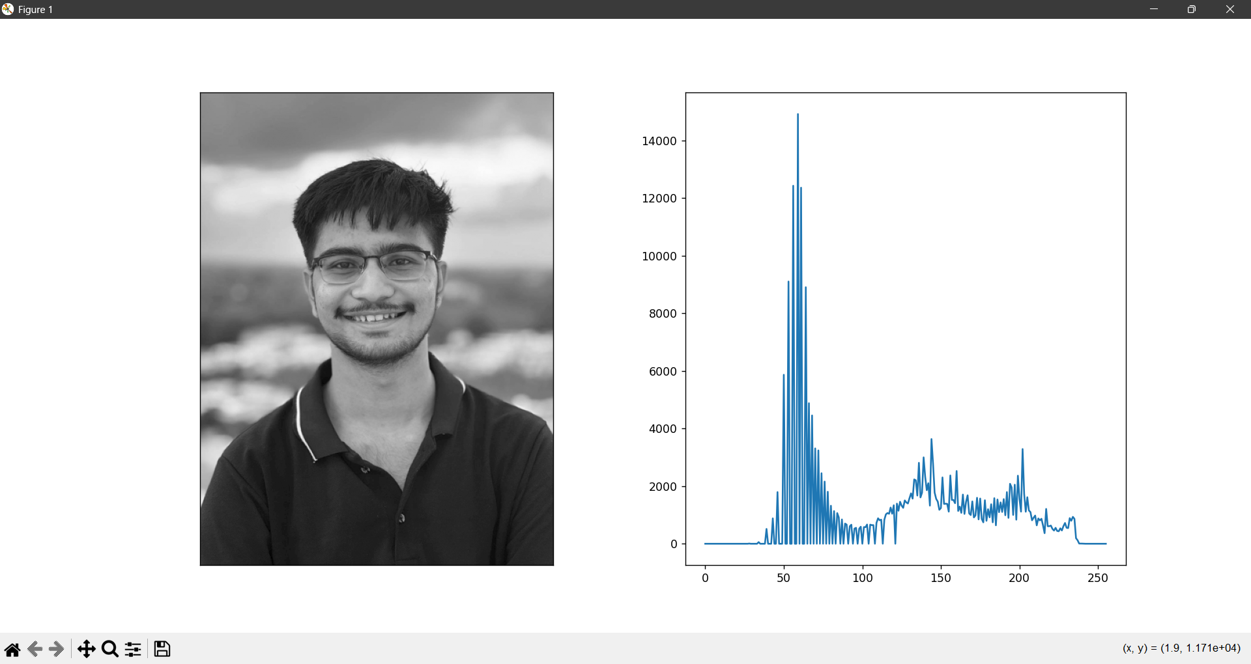
Fig 3.1 Histogram of grayscale image

(2) Without inbuilt function
import cv2
import numpy as np
from matplotlib import pyplot as plt
img = cv2.imread(r"C:\MEET\VS CODE\image_processing\ip.png", 0)
histr = np.zeros(256, dtype=int)
height, width = img.shape
for i in range(height):
for j in range(width):
intensity = img[i, j]
histr[intensity] += 1
plt.plot(histr)
plt.title('Histogram without cv2.calcHist')
plt.xlabel('Pixel Intensity')
plt.ylabel('Frequency')
plt.show()

OUTPUT:
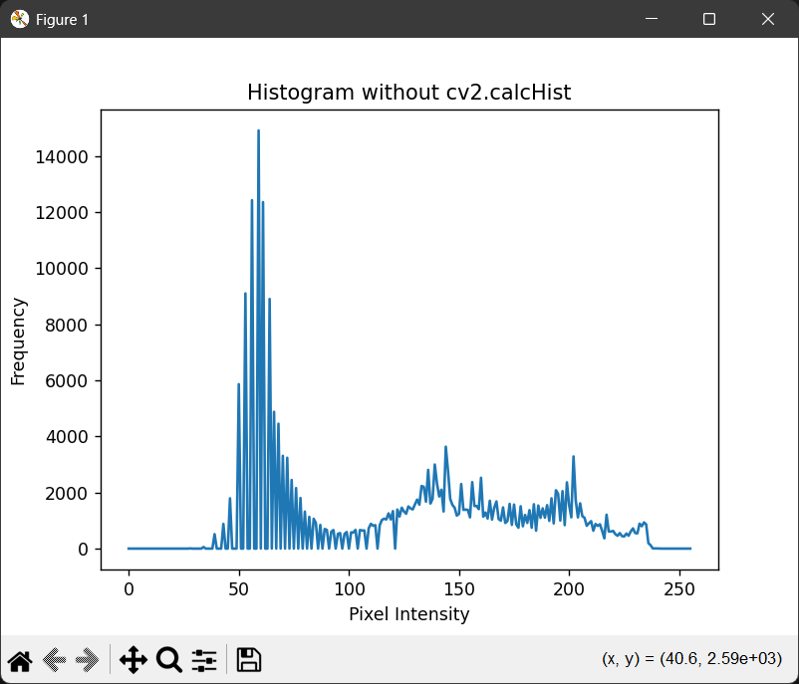
Fig 3.2 Histogram without inbuilt function

(3) To observe bit-plane slicing of grayscale image
import cv2
import numpy as np
import matplotlib.pyplot as plt
image_path = r"C:\MEET\B-Tech\sem_7\image_processing\bit_plane_slicing.jpg"
grayscale_image = cv2.imread(image_path, 0)
height, width = grayscale_image.shape
plt.figure(figsize=(12, 8))
for bit_position in range(8):
mask = 1 << bit_position
sliced_plane = np.bitwise_and(grayscale_image, mask)
visible_plane = np.where(sliced_plane > 0, 255, 0).astype(np.uint8)
plt.subplot(2, 4, bit_position + 1)
plt.imshow(visible_plane, cmap='gray')
plt.title(f'Bit Plane {bit_position}')
plt.axis('off')
plt.show()

OUTPUT:
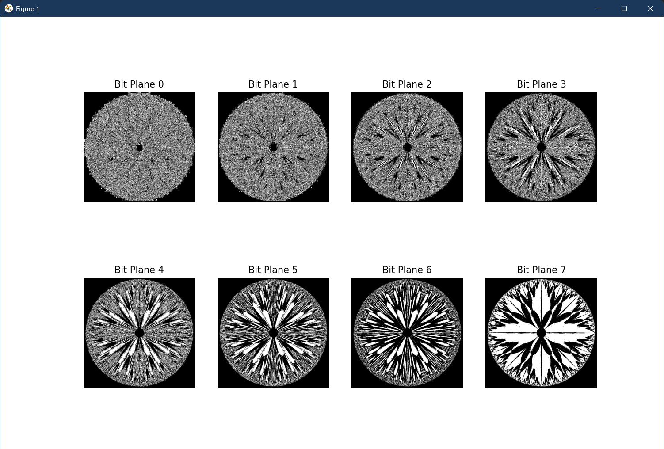
Fig 3.3 Bit plane slicing of a grayscale image

ASSIGNMENT:
1) W.A.P. to perform histogram equalization on digital image.
Ans.
CODE
import cv2
import numpy as np
from matplotlib import pyplot as plt
img = cv2.imread(r"C:\MEET\B-Tech\sem_7\image_processing\cv.jpg", 0)
final = np.zeros_like(img, dtype='float16')
r1, r2 = 40, 180 # input intensity range (from histogram)
s1, s2 = 0, 255 # output intensity range (full contrast)
m1 = s1 / r1
m2 = (s2 - s1) / (r2 - r1)
m3 = (256 - s2) / (256 - r2)
for i in range(img.shape[0]):
for j in range(img.shape[1]):
pixel = img[i, j]
if pixel <= r1:
final[i, j] = m1 * pixel
elif pixel <= r2:
final[i, j] = m2 * (pixel - r1) + s1
else:
final[i, j] = m3 * (pixel - r2) + s2
im1 = np.clip(final, 0, 255).astype(np.uint8)
cv2.imshow("Original Image", img)
cv2.imshow("Contrast Stretched Image", im1)
cv2.waitKey(0)
cv2.destroyAllWindows()
titles = ['Original Image', 'Contrast Stretched Image']
images = [img, im1]

plt.figure(figsize=(10, 5))
for k in range(2):
plt.subplot(1, 2, k + 1)
plt.imshow(images[k], cmap='gray')
plt.title(titles[k])
plt.axis('off')
plt.tight_layout()
plt.show()

plt.figure(figsize=(10, 4))
plt.subplot(1, 2, 1)
plt.hist(img.ravel(), bins=256, range=[0, 256])
plt.title('Original Histogram')
plt.xlabel('Pixel Intensity')
plt.ylabel('Frequency')

plt.subplot(1, 2, 2)
plt.hist(im1.ravel(), bins=256, range=[0, 256])
plt.title('Stretched Histogram')
plt.xlabel('Pixel Intensity')
plt.ylabel('Frequency')
plt.tight_layout()
plt.show()
OUTPUT:
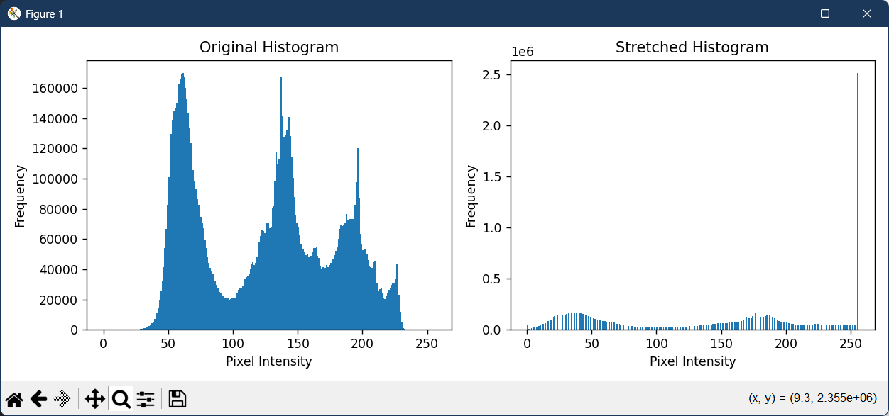
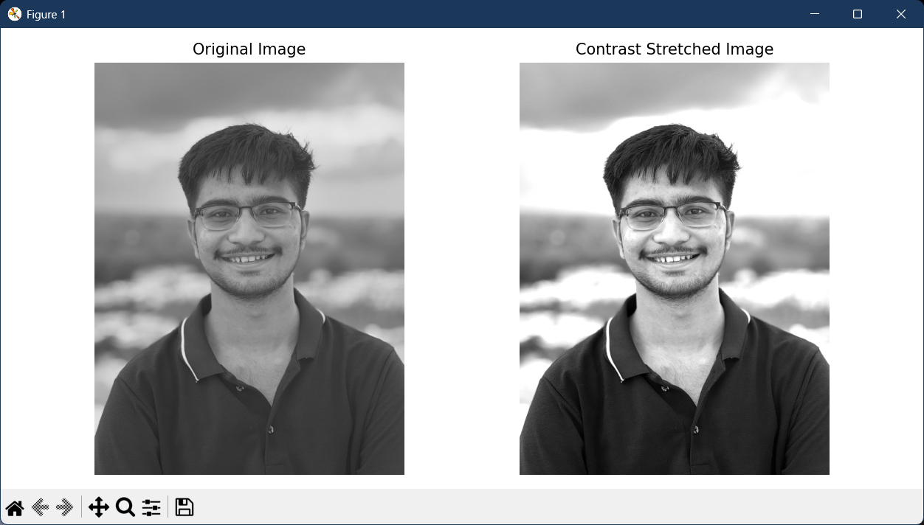
Fig 3.4 Equalised histogram and contrast stretched image

CONCLUSION:
EXPERIMENT – 4
EFFECT OF SAMPLING AND QUANTIZATION OF AN IMAGE

OBJECTIVE:
- To observe checker-board effect due to different sampling rate
- II To observe false contouring effect due to number of gray level

SAMPLE PROGRAM:
(1) To observe checker-board effect due to different sampling rate
import cv2
import numpy as np
import matplotlib.pyplot as plt
path = r"C:\MEET\B-Tech\sem_7\image_processing\cv.jpg"
img = cv2.imread(path, 0)
samples = 8
sampled = img[::samples, ::samples]
titles = ['Original Image', 'Sampled Image']
images = [img, sampled]
plt.figure(figsize=(10, 5))
for i in range(2):
plt.subplot(1, 2, i + 1)
plt.imshow(images[i], cmap='gray')
plt.title(titles[i])
plt.axis('off')
plt.tight_layout()
plt.show()

OUTPUT:
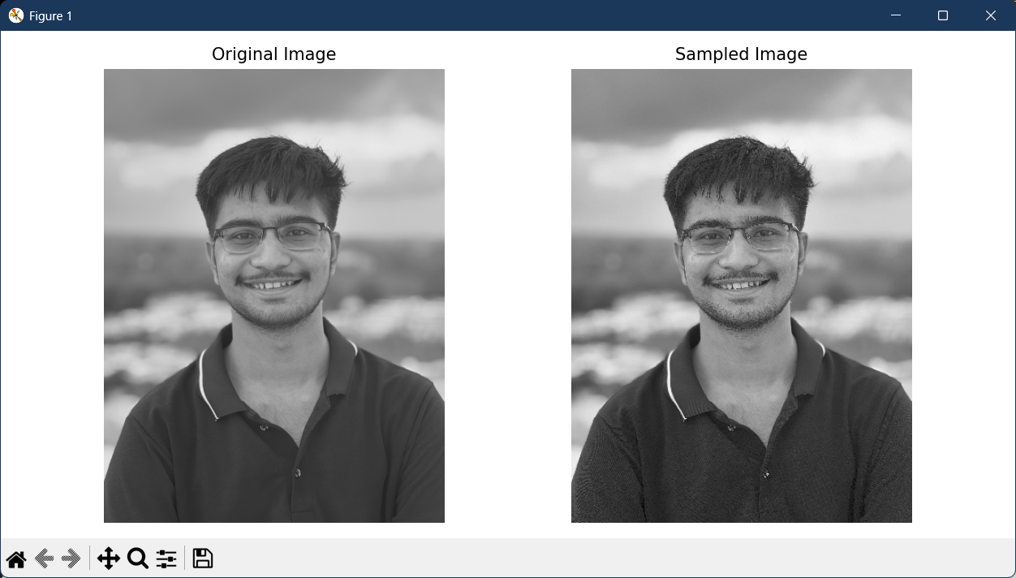
Fig 4.1 Sampled image

(2) To observe false contouring effect due to number of gray level
import cv2
import numpy as np
import matplotlib.pyplot as plt
img = cv2.imread(r"C:\MEET\B-Tech\sem_7\image_processing\cv.jpg",0)
# Create zeros array to store the stretched image
final1 = np.zeros((img.shape[0],img.shape[1]),dtype = 'uint8')
for i in range(img.shape[0]):
for j in range(img.shape[1]):
if (img[i][j]>=0 and img[i][j]<=25) :
final1[i,j] = 13
elif(img[i][j]>25 and img[i][j]<=50) :
final1[i,j] = 38
elif(img[i][j]>50 and img[i][j]<=75) :
final1[i,j] = 63
elif(img[i][j]>75 and img[i][j]<=100) :
final1[i,j] = 88
elif(img[i][j]>100 and img[i][j]<=125) :
final1[i,j] = 113
elif(img[i][j]>125 and img[i][j]<=150) :
final1[i,j] = 138
elif(img[i][j]>150 and img[i][j]<=175) :
final1[i,j] = 163
elif(img[i][j]>175 and img[i][j]<=200) :
final1[i,j] = 188
elif(img[i][j]>200 and img[i][j]<=225) :
final1[i,j] = 213
elif(img[i][j]>225 and img[i][j]<=255) :
final1[i,j] = 238
titles = ['Original Image', 'False Contouring With 10 Intensity Level ']
images = [img,final1]
no=2
for k in range(no):
plt.subplot(1, no, k+1)
plt.imshow(images[k],cmap='gray')
plt.title(titles[k])
plt.xticks([])
plt.yticks([])
plt.show()

OUTPUT:
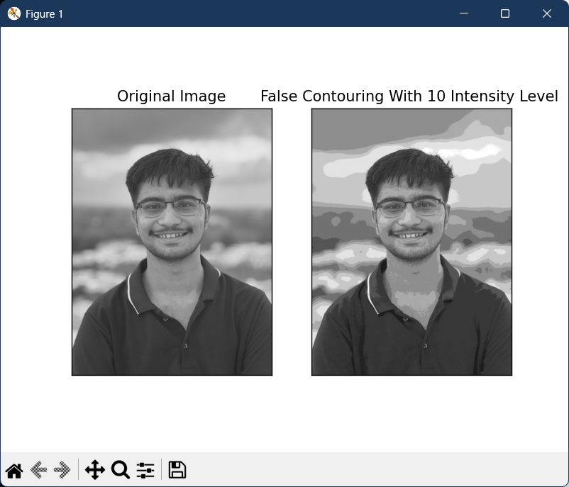
Fig 4.2 False contouring effect

ASSIGNMENT:
(1) W.A.P. to observe False contouring effect due to no. of gray level. Keep only 4 gray
levels for observation.
CODE:
import cv2
import numpy as np
import matplotlib.pyplot as plt
img = cv2.imread(r"C:\MEET\B-Tech\sem_7\image_processing\cv.jpg",0)
# Create zeros array to store the stretched image
final1 = np.zeros((img.shape[0],img.shape[1]),dtype = 'uint8')
for i in range(img.shape[0]):
for j in range(img.shape[1]):
if (img[i][j]>=0 and img[i][j]<=63) :
final1[i,j] = 32
elif(img[i][j]>63 and img[i][j]<=126) :
final1[i,j] = 95
elif(img[i][j]>126 and img[i][j]<=189) :
final1[i,j] = 158
elif(img[i][j]>189 and img[i][j]<=255) :
final1[i,j] = 221
titles = ['Original Image', 'False Contouring With 10 Intensity Level ']
images = [img,final1]
no=2
for k in range(no):
plt.subplot(1, no, k+1)
plt.imshow(images[k],cmap='gray')
plt.title(titles[k])
plt.xticks([])
plt.yticks([])
plt.show()

OUTPUT:
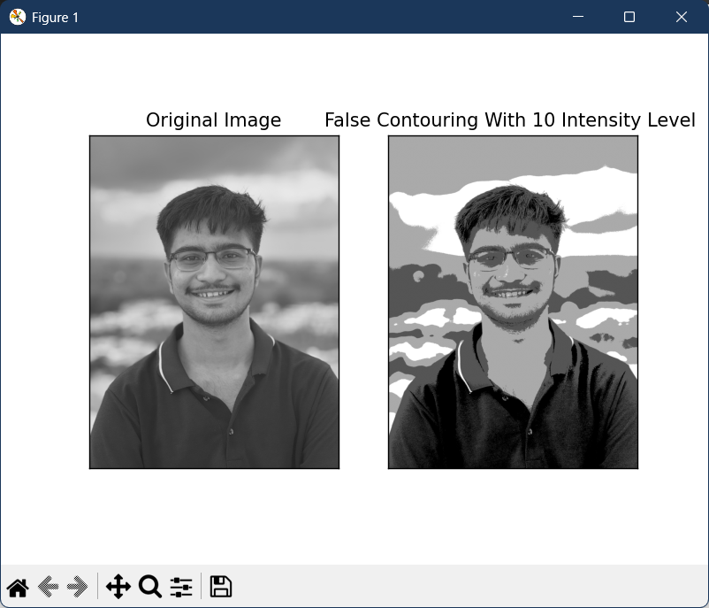
Fig 4.3 False contouring effect coz of 4 gray levels

(2) W.A.P. to observe checkerboard effect for different sampling rates
CODE:
import cv2
import numpy as np
import matplotlib.pyplot as plt
path = r"C:\MEET\B-Tech\sem_7\image_processing\cv.jpg"
img = cv2.imread(path, 0)
samples = 4
sampled = img[::samples, ::samples]
titles = ['Original Image', 'Sampled Image']
images = [img, sampled]
plt.figure(figsize=(10, 5))
for i in range(2):
plt.subplot(1, 2, i + 1)
plt.imshow(images[i], cmap='gray')
plt.title(titles[i])
plt.axis('off')
plt.tight_layout()
plt.show()

OUTPUT:
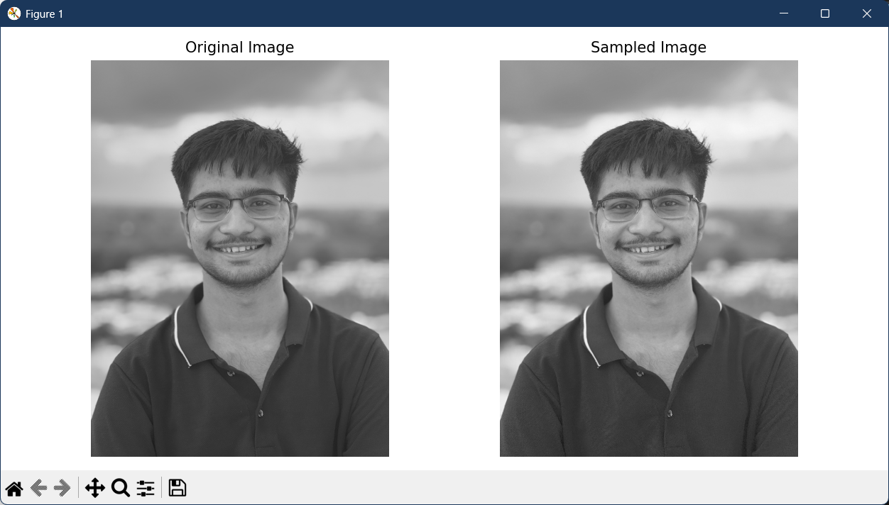
Fig 4.4 Output with sampling rate = 4

(3) Observe sampling and quantization on an image
CODE:
import cv2
import numpy as np
import matplotlib.pyplot as plt

def sam_and_qua(imgpath, sample, quant):
pth = imgpath
im = cv2.imread(pth, 0)
a1, a2 = im.shape[0], im.shape[1]
s = []
for i in range(0, a1, sample):
for j in range(0, a2, sample):
s.append(im[i][j])
b1 = int(a1 / sample)
b2 = int(a2 / sample)
sampled = np.reshape(s, (b1, b2))
qimg = np.zeros((a1, a2), dtype='uint8')
z = 256 / quant
for x in range(a1):
for y in range(a2):
level = int(im[x][y] // z)
if level == quant:
level -= 1
qimg[x][y] = int((level + 0.5) * z)

return im, sampled, qimg

path = r"C:\MEET\B-Tech\sem_7\image_processing\cv.jpg"
original, sampled, quantized = sam_and_qua(path, sample=3, quant=8)

sr = 3
for i, h in enumerate([original, sampled, quantized]):
plt.subplot(1, sr, i+1)
plt.imshow(h, cmap='gray')
plt.axis('off')
plt.tight_layout()
plt.show()

OUTPUT:
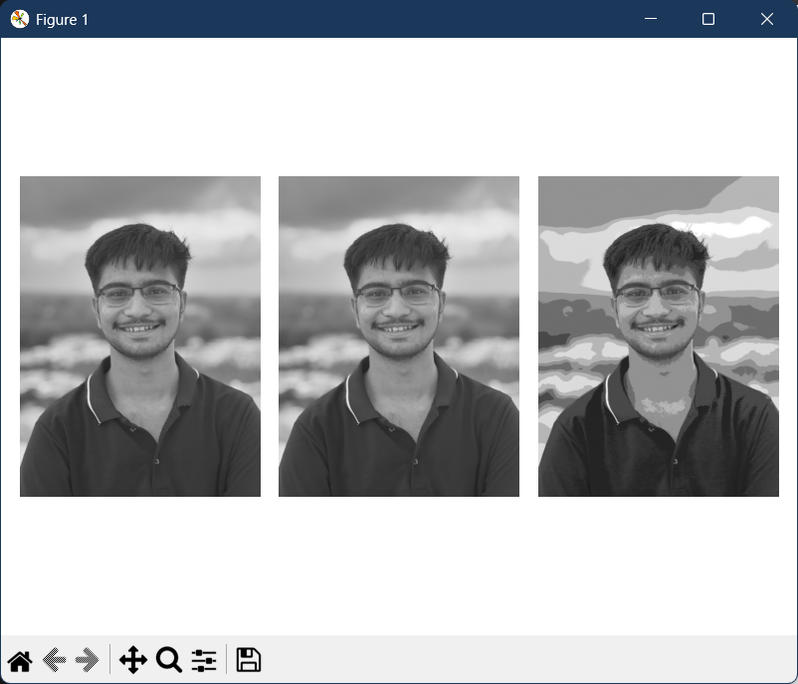
Fig 4.5 Sampled and quantized image
CONCLUSION:

EXPERIMENT – 5
SPATIAL FILTERS (SMOOTHING & SHARPENING)

OBJECTIVES:
I. To observe effect of various order of averaging filter (Linear Filter) on grayscale image.
II. W.A.P. to perform median filtering operation on a given noisy image.
II. Comparison performance of median and averaging filters to remove salt & pepper noise.
III. To observe effect of various type of filtering mask on grayscale image.

THEORY:
Filtering is a technique for modifying or enhancing an image. Spatial domain operation or filtering (the processed value for the current pixel processed value for the current pixel depends on both itself and surrounding pixels). Hence, filtering is a neighborhood operation, in which the value of any given pixel in the output image is determined by applying some algorithm to the values of the pixels in the neighborhood of the corresponding input pixel. A pixel's neighborhood is some set of pixels, defined by their locations relative to that pixel. Filters are used for noise removal also.

Spatial filtering is of two types: (1) linear filtering in which response is decided by a mask is convolved with respective image pixel values. E.g. smoothing filters, sharpening filters, (2) Non-linear filtering where response is decided by arranging pixels values of neighborhood in order and selecting pixel as per requirement. E.g. median filters, min or max filters.

SAMPLE PROGRAM:
I. Observing the effect of smoothing filters
import cv2
import matplotlib.pyplot as plt
import numpy as np

imgpath = r"C:\MEET\B-Tech\sem_7\image_processing\cv.jpg"
img = cv2.imread(imgpath, 0)
k1 = np.ones((11, 11), np.float32) / 121
print(k1)
output = cv2.filter2D(img, -1, k1)
plt.subplot(1, 2, 1)
plt.imshow(img, cmap='gray')
plt.title('Original Image')

plt.subplot(1, 2, 2)
plt.imshow(output, cmap='gray')
plt.title('Filtered Image')
plt.show()
OUTPUT:
[[0.00826446 0.00826446 0.00826446 0.00826446 0.00826446 0.00826446
0.00826446 0.00826446 0.00826446 0.00826446 0.00826446]
[0.00826446 0.00826446 0.00826446 0.00826446 0.00826446 0.00826446
0.00826446 0.00826446 0.00826446 0.00826446 0.00826446]
[0.00826446 0.00826446 0.00826446 0.00826446 0.00826446 0.00826446
0.00826446 0.00826446 0.00826446 0.00826446 0.00826446]
[0.00826446 0.00826446 0.00826446 0.00826446 0.00826446 0.00826446
0.00826446 0.00826446 0.00826446 0.00826446 0.00826446]
[0.00826446 0.00826446 0.00826446 0.00826446 0.00826446 0.00826446
0.00826446 0.00826446 0.00826446 0.00826446 0.00826446]
[0.00826446 0.00826446 0.00826446 0.00826446 0.00826446 0.00826446
0.00826446 0.00826446 0.00826446 0.00826446 0.00826446]
[0.00826446 0.00826446 0.00826446 0.00826446 0.00826446 0.00826446
0.00826446 0.00826446 0.00826446 0.00826446 0.00826446]
[0.00826446 0.00826446 0.00826446 0.00826446 0.00826446 0.00826446
0.00826446 0.00826446 0.00826446 0.00826446 0.00826446]
[0.00826446 0.00826446 0.00826446 0.00826446 0.00826446 0.00826446
0.00826446 0.00826446 0.00826446 0.00826446 0.00826446]
[0.00826446 0.00826446 0.00826446 0.00826446 0.00826446 0.00826446
0.00826446 0.00826446 0.00826446 0.00826446 0.00826446]
[0.00826446 0.00826446 0.00826446 0.00826446 0.00826446 0.00826446
0.00826446 0.00826446 0.00826446 0.00826446 0.00826446]]

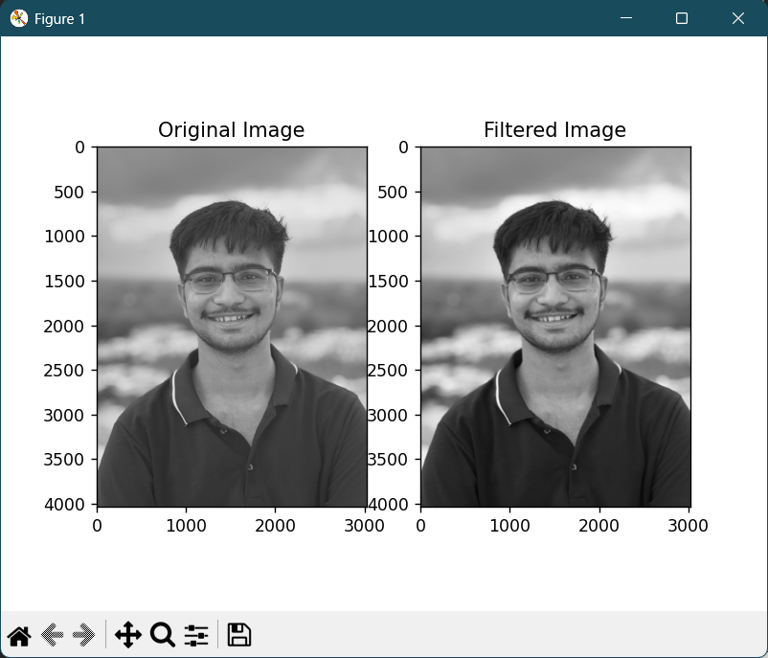
Fig 5.1 Sample Program output
MODIFICATIONS:
1. Compare the sharpening filter results with mask [-1, -1, -1], [-1, 9, -1], [-1, -1, -1]
import cv2
import matplotlib.pyplot as plt
import numpy as np

imgpath = r"C:\MEET\B-Tech\sem_7\image_processing\cv.jpg"
img = cv2.imread(imgpath, 0)
k1 = np.array([[-1, -1, -1],
[-1, 9, -1],
[-1, -1, -1]])
print(k1)
output = cv2.filter2D(img, -1, k1)
plt.subplot(1, 2, 1)
plt.imshow(img, cmap='gray')
plt.title('Original Image')
plt.subplot(1, 2, 2)
plt.imshow(output, cmap='gray')
plt.title('Sharpened Image')
plt.show()

OUTPUT:
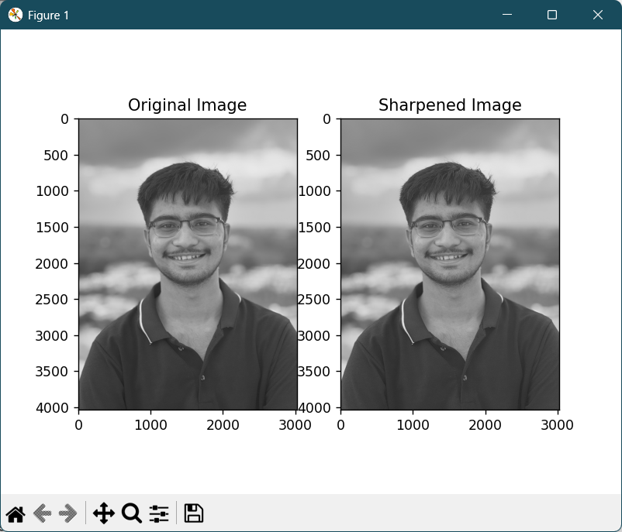
Fig 5.2 Sharpened filter output
2. Vary the mask size of average filter and see effect on an image.
Mask size | Effect | Explanation
3x3 | Slight smoothing | Averages over a small area → noise is reduced a bit but fine details are preserved.
5x5 | Noticeable smoothing | Edges begin to blur slightly; small texture details fade.
11x11 | Strong smoothing | Image looks blurry; edges and fine features are softened significantly.
21x21 | Very heavy blur | The image loses almost all detail appearing “washed out”

II. Median filters
import cv2
import matplotlib.pyplot as plt
import numpy as np
import random
imgpath = r"C:\MEET\B-Tech\sem_7\image_processing\cv.jpg"
img = cv2.imread(imgpath, 1)
img = cv2.cvtColor(img, cv2.COLOR_BGR2GRAY)
noisy = np.zeros(img.shape, np.uint8)
p = 0.2
for i in range(img.shape[0]):
for j in range(img.shape[1]):
r = random.random()
if r < p/2:
noisy[i][j] = 0
elif r < p:
noisy[i][j] = 255
else:
noisy[i][j] = img[i][j]
denoised_median = cv2.medianBlur(noisy, 5)
#For Average Filtering
k1 = np.array(np.ones((11, 11), np.float32))/121 #average filter
print(k1) #printing mask
Averaged = cv2.filter2D(noisy, -1, k1) #here change mask variable
output = [img, noisy, denoised_median]
titles = ['Original', 'Noisy', 'Denoised_Median']
for i in range(3):
plt.subplot(1, 3, i+1)
plt.imshow(output[i],'gray')
plt.title(titles[i])
plt.xticks([])
plt.yticks([])
plt.show()

OUTPUT:
[[0.00826446 0.00826446 0.00826446 0.00826446 0.00826446 0.00826446
0.00826446 0.00826446 0.00826446 0.00826446 0.00826446]
[0.00826446 0.00826446 0.00826446 0.00826446 0.00826446 0.00826446
0.00826446 0.00826446 0.00826446 0.00826446 0.00826446]
[0.00826446 0.00826446 0.00826446 0.00826446 0.00826446 0.00826446
0.00826446 0.00826446 0.00826446 0.00826446 0.00826446]
[0.00826446 0.00826446 0.00826446 0.00826446 0.00826446 0.00826446
0.00826446 0.00826446 0.00826446 0.00826446 0.00826446]
[0.00826446 0.00826446 0.00826446 0.00826446 0.00826446 0.00826446
0.00826446 0.00826446 0.00826446 0.00826446 0.00826446]
[0.00826446 0.00826446 0.00826446 0.00826446 0.00826446 0.00826446
0.00826446 0.00826446 0.00826446 0.00826446 0.00826446]
[0.00826446 0.00826446 0.00826446 0.00826446 0.00826446 0.00826446
0.00826446 0.00826446 0.00826446 0.00826446 0.00826446]
[0.00826446 0.00826446 0.00826446 0.00826446 0.00826446 0.00826446
0.00826446 0.00826446 0.00826446 0.00826446 0.00826446]
[0.00826446 0.00826446 0.00826446 0.00826446 0.00826446 0.00826446
0.00826446 0.00826446 0.00826446 0.00826446 0.00826446]
[0.00826446 0.00826446 0.00826446 0.00826446 0.00826446 0.00826446
0.00826446 0.00826446 0.00826446 0.00826446 0.00826446]
[0.00826446 0.00826446 0.00826446 0.00826446 0.00826446 0.00826446
0.00826446 0.00826446 0.00826446 0.00826446 0.00826446]]

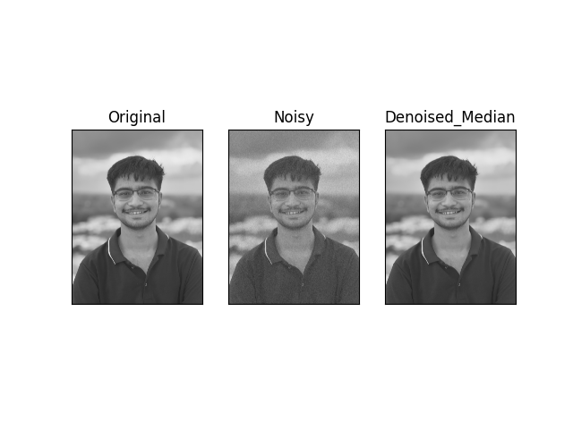
Fig 5.3 Median filter output
III. Comparison of averaging and median filters.
import cv2
import matplotlib.pyplot as plt
import numpy as np
import random

path = r"C:\MEET\B-Tech\sem_7\image_processing\cv.jpg"
imgpath = path
img = cv2.imread(imgpath, 0)
noisy = np.zeros(img.shape, np.uint8)
p = 0.2

for i in range(img.shape[0]):
for j in range(img.shape[1]):
r = random.random()
if r < p/2:
noisy[i][j] = 0
elif r < p:
noisy[i][j] = 255
else:
noisy[i][j] = img[i][j]
denoised_median = cv2.medianBlur(noisy, 5)

k1 = np.array(np.ones((11, 11), np.float32))/121
print(k1)
Averaged = cv2.filter2D(noisy, -1, k1)
output = [img, noisy, denoised_median, Averaged]
titles = ['Original', 'Noisy', 'Denoised_Median' , 'Averaged']
for i in range(4):
plt.subplot(2, 2, i+1)
plt.imshow(output[i],'gray')
plt.title(titles[i])
plt.xticks([])
plt.yticks([])
plt.show()

OUTPUT:
[[0.00826446 0.00826446 0.00826446 0.00826446 0.00826446 0.00826446
0.00826446 0.00826446 0.00826446 0.00826446 0.00826446]
[0.00826446 0.00826446 0.00826446 0.00826446 0.00826446 0.00826446
0.00826446 0.00826446 0.00826446 0.00826446 0.00826446]
[0.00826446 0.00826446 0.00826446 0.00826446 0.00826446 0.00826446
0.00826446 0.00826446 0.00826446 0.00826446 0.00826446]
[0.00826446 0.00826446 0.00826446 0.00826446 0.00826446 0.00826446
0.00826446 0.00826446 0.00826446 0.00826446 0.00826446]
[0.00826446 0.00826446 0.00826446 0.00826446 0.00826446 0.00826446
0.00826446 0.00826446 0.00826446 0.00826446 0.00826446]
[0.00826446 0.00826446 0.00826446 0.00826446 0.00826446 0.00826446
0.00826446 0.00826446 0.00826446 0.00826446 0.00826446]
[0.00826446 0.00826446 0.00826446 0.00826446 0.00826446 0.00826446
0.00826446 0.00826446 0.00826446 0.00826446 0.00826446]
[0.00826446 0.00826446 0.00826446 0.00826446 0.00826446 0.00826446
0.00826446 0.00826446 0.00826446 0.00826446 0.00826446]
[0.00826446 0.00826446 0.00826446 0.00826446 0.00826446 0.00826446
0.00826446 0.00826446 0.00826446 0.00826446 0.00826446]
[0.00826446 0.00826446 0.00826446 0.00826446 0.00826446 0.00826446
0.00826446 0.00826446 0.00826446 0.00826446 0.00826446]
[0.00826446 0.00826446 0.00826446 0.00826446 0.00826446 0.00826446
0.00826446 0.00826446 0.00826446 0.00826446 0.00826446]]

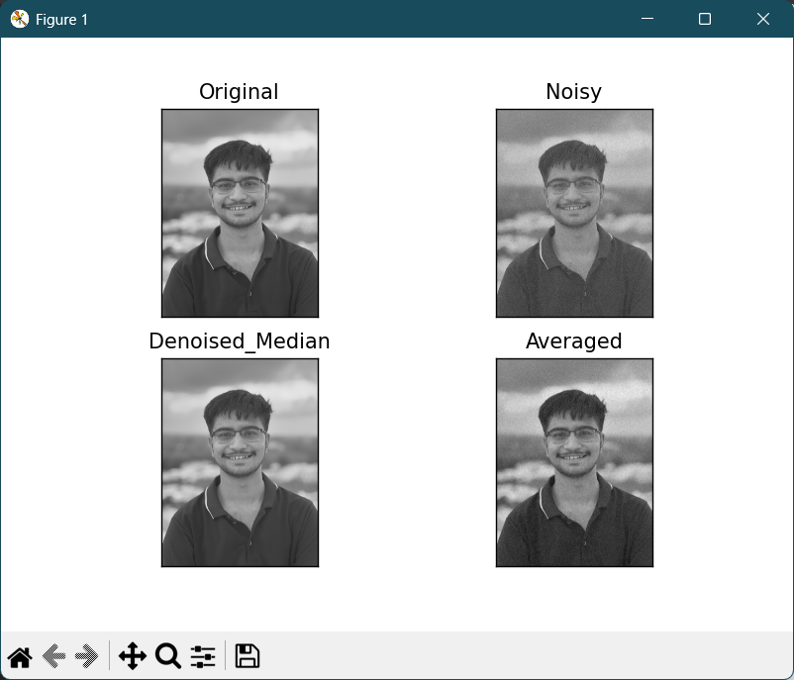
Fig 5.4 Comparison between average and median filters

MODIFICATIONS:
1. Compare median and average filter with size of mask.
import cv2
import matplotlib.pyplot as plt
import numpy as np
import random
path = r"C:\MEET\B-Tech\sem_7\image_processing\cv.jpg"
img = cv2.imread(path, 0)
noisy = np.zeros(img.shape, np.uint8)
p = 0.2
for i in range(img.shape[0]):
for j in range(img.shape[1]):
r = random.random()
if r < p / 2:
noisy[i, j] = 0
elif r < p:
noisy[i, j] = 255
else:
noisy[i, j] = img[i, j]

mask_sizes = [3, 5, 7]
median_results = [cv2.medianBlur(noisy, k) for k in mask_sizes]
average_results = [cv2.filter2D(noisy, -1, np.ones((k, k), np.float32)/(k*k)) for k in mask_sizes]
plt.figure(figsize=(20, 10))
# Top row: Original, Noisy, Median 3x3, Median 5x5
plt.subplot(2, 4, 1)
plt.imshow(img, cmap='gray')
plt.title("Original")
plt.axis('off')

plt.subplot(2, 4, 2)
plt.imshow(noisy, cmap='gray')
plt.title("Noisy")
plt.axis('off')

for i in range(2):
plt.subplot(2, 4, i + 3)
plt.imshow(median_results[i], cmap='gray')
plt.title(f"Median k={mask_sizes[i]}")
plt.axis('off')

# Bottom row: Median 7x7, Average 3x3, Average 5x5, Average 7x7
plt.subplot(2, 4, 5)
plt.imshow(median_results[2], cmap='gray')
plt.title(f"Median k={mask_sizes[2]}")
plt.axis('off')

for i in range(3):
plt.subplot(2, 4, 6 + i)
plt.imshow(average_results[i], cmap='gray')
plt.title(f"Average k={mask_sizes[i]}")
plt.axis('off')

plt.tight_layout()
plt.show()

OUTPUT:
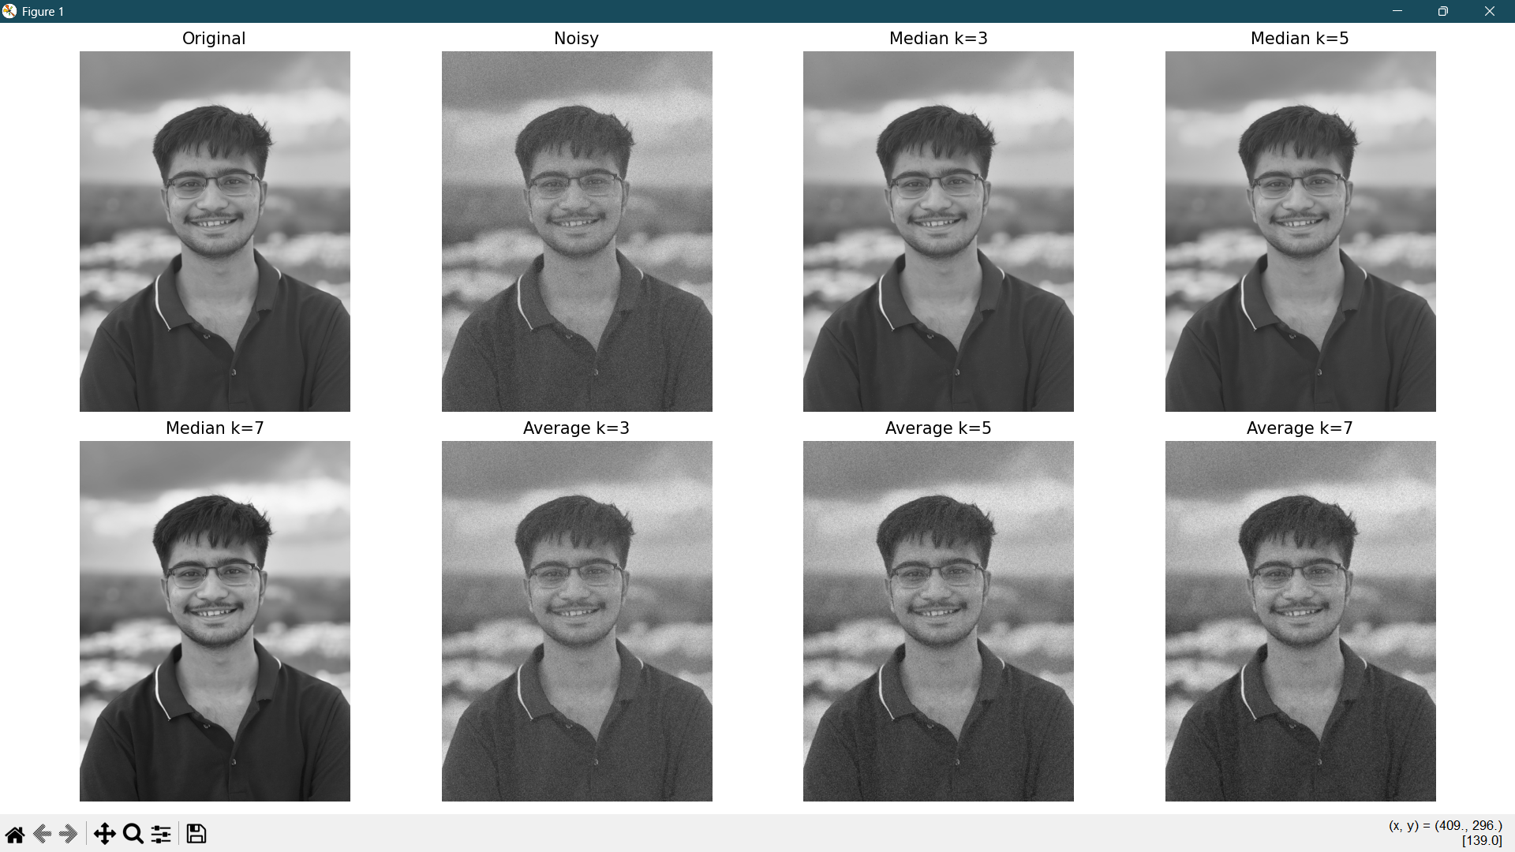
Fig 5.5 Comparison between average and median filters for different mask sizes

2. Vary amount of noise and compare output of both filters.
import cv2
import matplotlib.pyplot as plt
import numpy as np
import random

path = r"C:\MEET\B-Tech\sem_7\image_processing\cv.jpg"
img = cv2.imread(path, 0)

mask_sizes = [3, 5, 7] # example median/average mask sizes
noise_levels = [0.05, 0.1, 0.2] # different noise probabilities

for p in noise_levels:
noisy = np.zeros(img.shape, np.uint8)

# Add salt-and-pepper noise
for i in range(img.shape[0]):
for j in range(img.shape[1]):
r = random.random()
if r < p / 2:
noisy[i, j] = 0
elif r < p:
noisy[i, j] = 255
else:
noisy[i, j] = img[i, j]

median_results = [cv2.medianBlur(noisy, k) for k in mask_sizes]
average_results = [cv2.filter2D(noisy, -1, np.ones((k, k), np.float32)/(k*k)) for k in mask_sizes]
plt.figure(figsize=(20, 10))
plt.suptitle(f"Noise Level = {int(p*100)}%", fontsize=16)

# Top row: Original, Noisy, Median 3x3, Median 5x5
plt.subplot(2, 4, 1)
plt.imshow(img, cmap='gray')
plt.title("Original")
plt.axis('off')

plt.subplot(2, 4, 2)
plt.imshow(noisy, cmap='gray')
plt.title("Noisy")
plt.axis('off')
for i in range(2):
plt.subplot(2, 4, i + 3)
plt.imshow(median_results[i], cmap='gray')
plt.title(f"Median k={mask_sizes[i]}")
plt.axis('off')
# Bottom row: Median 7x7, Average 3x3, Average 5x5, Average 7x7
plt.subplot(2, 4, 5)
plt.imshow(median_results[2], cmap='gray')
plt.title(f"Median k={mask_sizes[2]}")
plt.axis('off')
for i in range(3):
plt.subplot(2, 4, 6 + i)
plt.imshow(average_results[i], cmap='gray')
plt.title(f"Average k={mask_sizes[i]}")
plt.axis('off')
plt.tight_layout()
plt.show()

OUTPUT:
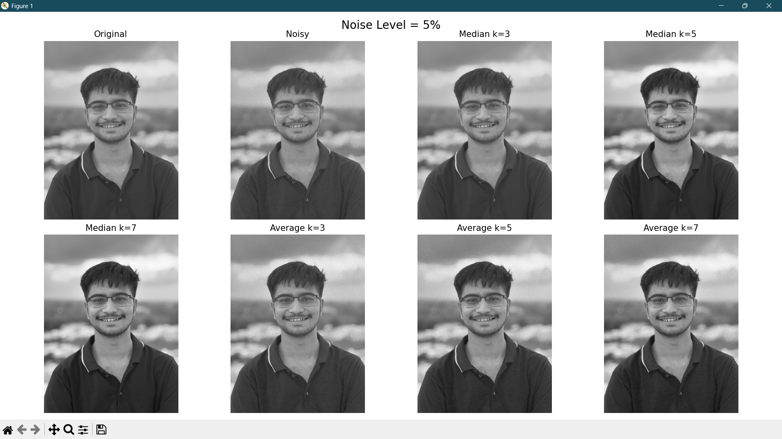
Fig 5.6 Comparison for noise level = 5%

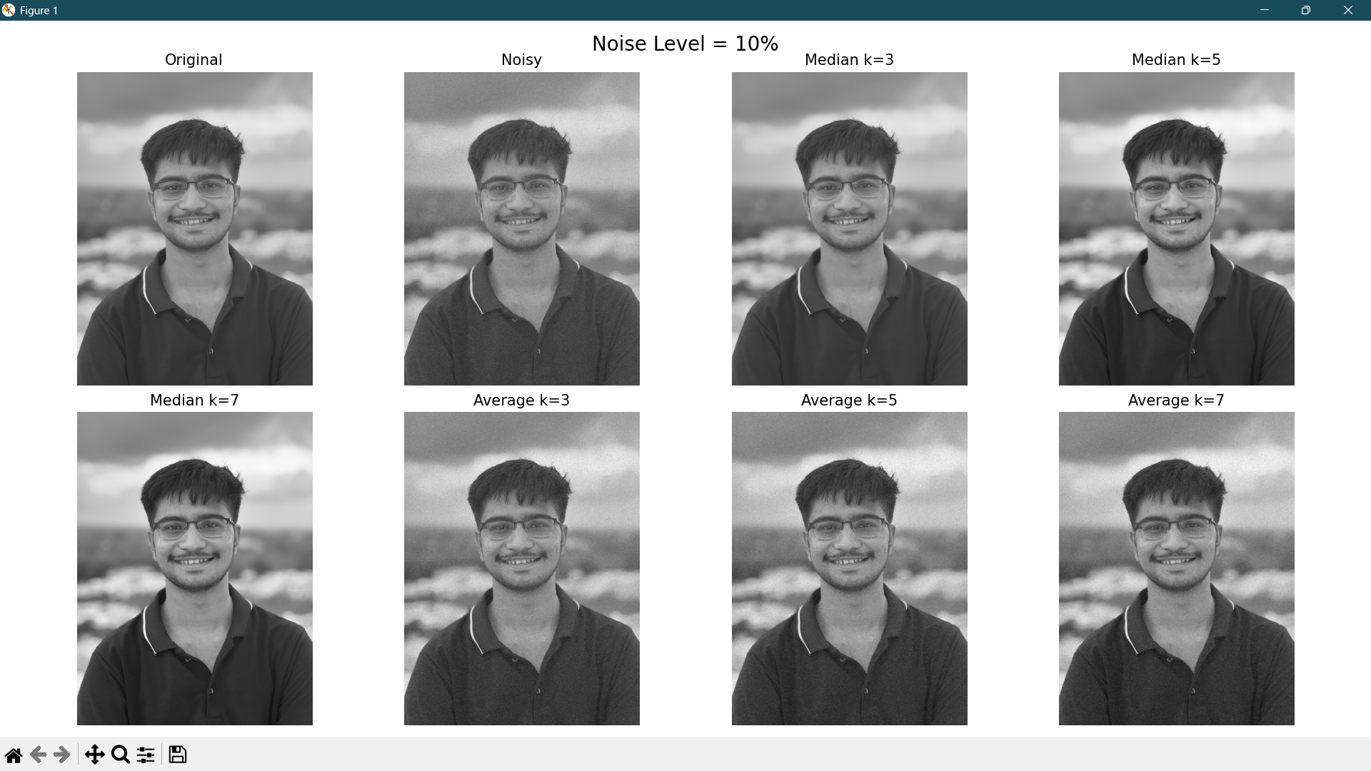
Fig 5.7 Comparison for noise level = 10%
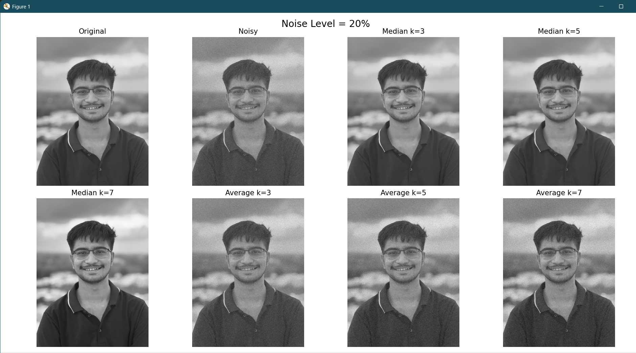
Fig 5.8 Comparison for noise level = 20%

3. To observe the effect of laplacian sharpening filter on grayscale image.
import cv2
import matplotlib.pyplot as plt
import numpy as np

path = r"C:\MEET\B-Tech\sem_7\image_processing\cv.jpg"
img = cv2.imread(path, 0)

title = ['3x3', '7x7', '11x11', 'sharpen', 'laplacian']
for i in range(3):
j = i
k = np.array(np.ones((3 + j, 3 + j), np.float32)) / (3 + j) ** 2
j = j + 4
output = cv2.filter2D(img, -1, k)
plt.subplot(2, 3, i + 1)
plt.imshow(output, cmap='gray')
plt.title(title[i])
plt.xticks([])
plt.yticks([])

shar = np.array([[0, -1, 0], [-1, 5,-1], [0, -1, 0]], dtype=np.float32)
oshar = cv2.filter2D(img, -1, shar)
plt.subplot(2,3, 4)
plt.imshow(oshar, cmap='gray')
plt.title(title[3])
plt.xticks([])
plt.yticks([])
lap = np.array(np.ones((3 , 3 ), np.float32)) * (-1)
lap[1][1] = 9
olap = cv2.filter2D(img, -1, lap)
plt.subplot(2, 3, 5)
plt.imshow(olap, cmap='gray')
plt.title(title[4])
plt.xticks([])
plt.yticks([])
plt.show()

OUTPUT:
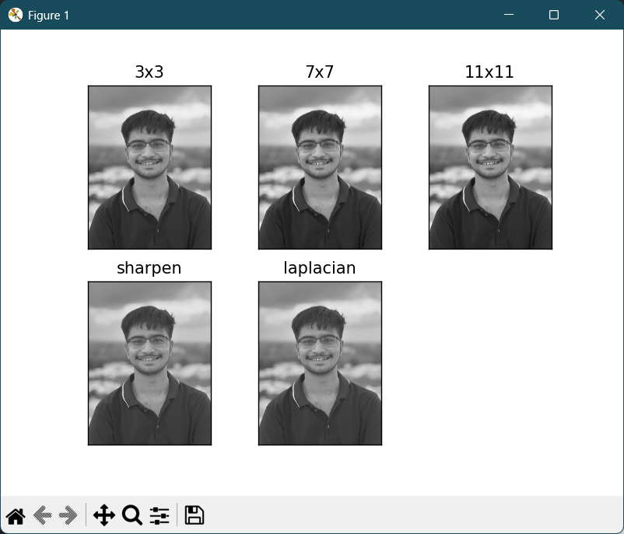
Fig 5.9 Laplacian filter output

4. Apply sobel and prewait mask on digital image to detect edges.
import cv2
import numpy as np
import matplotlib.pyplot as plt

path = r"C:\MEET\B-Tech\sem_7\image_processing\meet.png"
image = cv2.imread(path, 0)

sobel_x_kernel = np.array([[-1, 0, 1],
[-2, 0, 2],
[-1, 0, 1]], dtype=np.float32)
sobel_y_kernel = np.array([[-1, -2, -1],
[ 0, 0, 0],
[ 1, 2, 1]], dtype=np.float32)

sobel_x = cv2.filter2D(image, -1, sobel_x_kernel)
sobel_y = cv2.filter2D(image, -1, sobel_y_kernel)
sobel = np.sqrt(sobel_x.astype(np.float32)**2 + sobel_y.astype(np.float32)**2)
sobel = cv2.convertScaleAbs(sobel)

prewitt_x_kernel = np.array([[-1, 0, 1],
[-1, 0, 1],
[-1, 0, 1]], dtype=np.float32)
prewitt_y_kernel = np.array([[ 1, 1, 1],
[ 0, 0, 0],
[-1, -1, -1]], dtype=np.float32)

prewitt_x = cv2.filter2D(image, -1, prewitt_x_kernel)
prewitt_y = cv2.filter2D(image, -1, prewitt_y_kernel)
prewitt = np.sqrt(prewitt_x.astype(np.float32)**2 + prewitt_y.astype(np.float32)**2)
prewitt = cv2.convertScaleAbs(prewitt)

plt.figure(figsize=(15, 5))

plt.subplot(1, 3, 1)
plt.imshow(image, cmap='gray')
plt.title("Original")
plt.axis('off')

plt.subplot(1, 3, 2)
plt.imshow(sobel, cmap='gray')
plt.title("Sobel Edge")
plt.axis('off')

plt.subplot(1, 3, 3)
plt.imshow(prewitt, cmap='gray')
plt.title("Prewitt Edge")
plt.axis('off')
plt.tight_layout()
plt.show()

OUTPUT:
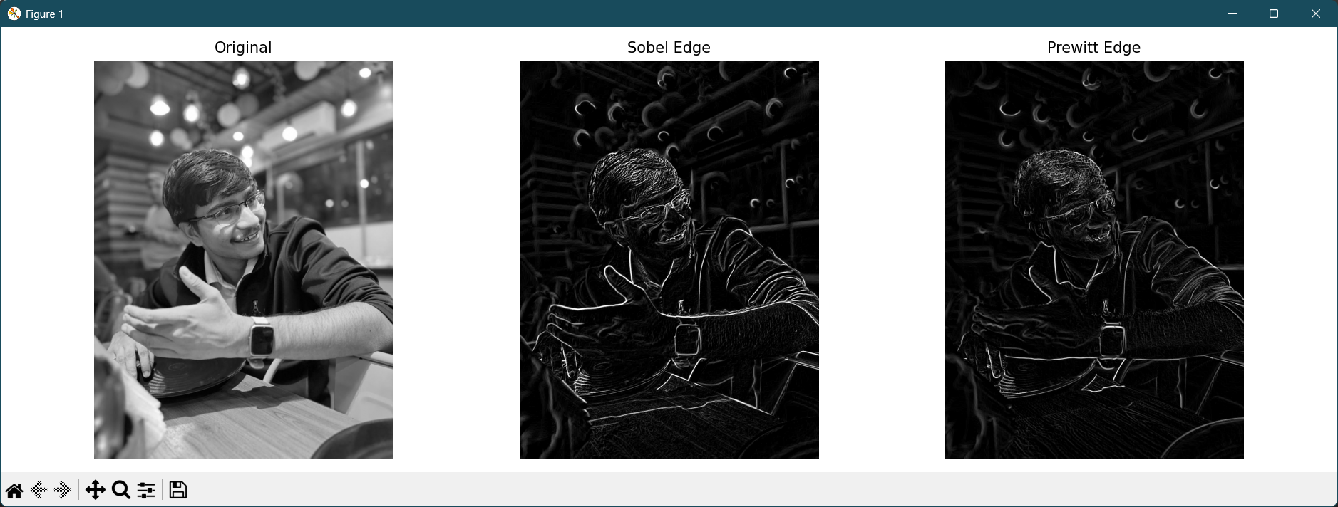
Fig 5.10 Sobel and prewitt filter output

CONCLUSION:

EXPERIMENT – 6
IMAGE RESTORATION

OBJECTIVE:
I. Implement the Alpha trimmed Order Statistic Restoration filter.
II. Implement the Following Mean Restoration filters: Arithmetic, Contra Harmonic.

SAMPLE PROGRAM:
1. To implement the Alpha- trimmed Order Statistic Restoration filter.
import cv2
import numpy as np
import matplotlib.pyplot as plt
from scipy import stats
from numpy import mean
def trimmeanval(arr, d):
n = len(arr)
k = int(d/2)
return mean(arr[k:n-k])
# Reading the input image
imgpath = "D:\LAB SOURCE new\DIP_IMAGES\DIP3E_CH05_Original_Images\Fig0503 (original_pattern).tif"
img1 = cv2.imread(imgpath, 0)
##### Gaussian Filter
max_val=np.max(img1);
print(max_val);
img2=(img1/max_val); # Normalization
a=0;
b=0.01;
(nr,nc) = img1.shape

x = a+(b*np.random.normal(a,b,(nr,nc))); # Gaussian Distribution with mean (a) and variance (b)
y = a+((b-a)*np.random.rand(nr,nc)); # Uniform Distribution
img_guassian=(img2+x)*max_val;
##########Salt & Pepper Noise
max_val=np.max(img_guassian);
print(max_val);
img3=(img_guassian/max_val); # Normalization
pa=0.05;
pb=0.05;
(nr,nc) = img_guassian.shape
R = np.uint8(np.zeros((nr,nc),dtype = 'uint8')+0.11);
x=np.random.rand(nr,nc);
[r,c]=np.where(x<=pa);
for i in range(len(r)):
R[r[i]][c[i]]=np.uint8(0);
u=pa+pb;
[r,c]=np.where(x<=u);
for i in range(len(r)):
R[r[i]][c[i]]=np.uint8(255);

img_noise = img_guassian+R;

###### Alpha Trimmed Filter
img = img_noise;
(nr,nc) = img_noise.shape # to access row and column of image
print('No. of Row: ',nr)
print('No. of Column: ', nc)
output=np.zeros((nr,nc),dtype='uint8');
ary=np.zeros(9,dtype='uint8');
ary1=np.zeros(9,dtype='uint8');
output = np.zeros((nr, nc), dtype='uint8')

for i in range(1, nr-1):
for j in range(1, nc-1):
temp = 0
for x in range(i-1, i+2):
for y in range(j-1, j+2):
ary[temp] = img_noise[x, y]
temp += 1

ary.sort()
ary1 = ary
output[i][j] = np.uint8(np.clip(np.median(ary1), 0, 255))

# Displaying images
plt.subplot(1, 4, 1)
plt.imshow(img1, cmap='gray')
plt.title('Original')
plt.xticks([]), plt.yticks([])
plt.subplot(1, 4, 2)
plt.imshow(img_guassian, cmap='gray')
plt.title('Gaussian')
plt.xticks([]), plt.yticks([])
plt.subplot(1, 4, 3)
plt.imshow(img_noise, cmap='gray')
plt.title('Gaussian + S&P')
plt.xticks([]), plt.yticks([])
plt.subplot(1, 4, 4)
plt.imshow(output, cmap='gray')
plt.title('Filtered')
plt.xticks([]), plt.yticks([])
plt.show()

OUTPUT:
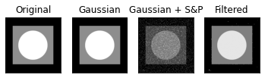
Fig 6.1 Output for Alpha- trimmed Order Statistic Restoration filter

ASSIGNMENT:
1. Implement the Following Order Statistic Restoration filters: Median, Max, Min, Mid- Point.
import cv2
import numpy as np
import matplotlib.pyplot as plt
from numpy import mean
from scipy import stats

imgpath = r"C:\Users\djain\Downloads\Screenshot 2025-10-14 124950.png"
img1 = cv2.imread(imgpath, 0)

max_val = np.max(img1)
print(max_val)
img2 = (img1 / max_val) # Normalization
a = 0
b = 0.01
(nr, nc) = img1.shape

x = a + (b * np.random.normal(a, b, (nr, nc)))
y = a + ((b - a) * np.random.rand(nr, nc))
img_guassian = (img2 + x) * max_val

# s and p Noise
max_val = np.max(img_guassian)
print(max_val)
img3 = (img_guassian / max_val) # Normalization
pa = 0.05
pb = 0.05
(nr, nc) = img_guassian.shape
R = np.uint8(np.zeros((nr, nc), dtype='uint8') + 0.11)
x = np.random.rand(nr, nc)
[r, c] = np.where(x <= pa)
for i in range(len(r)):
R[r[i]][c[i]] = np.uint8(0)
u = pa + pb
[r, c] = np.where(x <= u)
for i in range(len(r)):
R[r[i]][c[i]] = np.uint8(255)

img_noise = img_guassian + R

def median(img):
nr, nc = img.shape
output = np.zeros((nr, nc), dtype='uint8')
for i in range(1, nr-1):
for j in range(1, nc-1):
neighborhood = img[i-1:i+2, j-1:j+2]
sortedf = np.sort(neighborhood.flatten())
output[i, j] = sortedf[4]
return output

def maxi(img):
nr, nc = img.shape
output = np.zeros((nr, nc), dtype='uint8')
for i in range(1, nr-1):
for j in range(1, nc-1):
n = img[i-1:i+2, j-1:j+2]
output[i, j] = np.max(n)
return output

def mini(img):
nr, nc = img.shape
output = np.zeros((nr, nc), dtype='uint8')
for i in range(1, nr-1):
for j in range(1, nc-1):
n = img[i-1:i+2, j-1:j+2]
output[i, j] = np.min(n)
return output

def midpoint(img):
nr, nc = img.shape
output = np.zeros((nr, nc), dtype='uint8')
for i in range(1, nr-1):
for j in range(1, nc-1):
n = img[i-1:i+2, j-1:j+2]
mini = np.min(n)
maxi = np.max(n)
output[i, j] = (mini + maxi) // 2
return output
median = median(img_noise)
maxi = maxi(img_noise)
mini = mini(img_noise)
midpoint = midpoint(img_noise)

plt.subplot(231)
plt.imshow(img1, cmap = 'gray')
plt.title('original')
plt.xticks([]), plt.yticks([])
plt.subplot(232)
plt.imshow(img_noise, cmap = 'gray')
plt.title('noisy')
plt.xticks([]), plt.yticks([])
plt.subplot(2, 3, 3)
plt.imshow(median, cmap='gray')
plt.title('median')
plt.xticks([]), plt.yticks([])

plt.subplot(2, 3, 4)
plt.imshow(maxi, cmap='gray')
plt.title('max')
plt.xticks([]), plt.yticks([])

plt.subplot(2, 3, 5)
plt.imshow(mini, cmap='gray')
plt.title('min')
plt.xticks([]), plt.yticks([])

plt.xticks([]), plt.yticks([])
plt.subplot(2, 3, 6)
plt.imshow(midpoint, cmap='gray')
plt.title('midpoint')
plt.xticks([]), plt.yticks([])
plt.show()
OUTPUT:
255
255.0780715891069
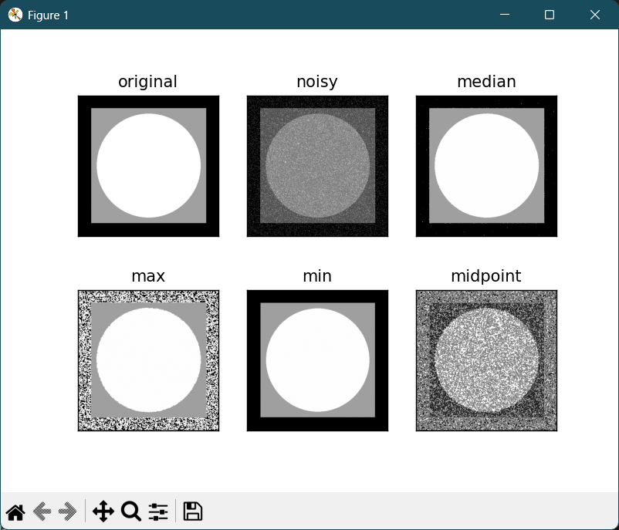
Fig 6.2 Output of Statistic Restoration filters

II. Implement the Following Mean Restoration filters: Arithmetic, Contra-Harmonic.
import cv2
import numpy as np
import matplotlib.pyplot as plt
# Reading the input image
imgpath = r"C:\Users\djain\Downloads\Screenshot 2025-10-14 124950.png"
img1 = cv2.imread(imgpath, 0)
##### Gaussian Filter
max_val=np.max(img1);
print(max_val);
img2=(img1/max_val); # Normalization
a=0;
b=0.2;
(nr,nc) = img1.shape

x=a+(b*np.random.normal(a,b,(nr,nc))); # Gaussian Distribution with mean (a) and variance (b)
y=a+((b-a)*np.random.rand(nr,nc)); # Uniform Distribution
img_guassian=(img2+x)*max_val;
###### Arithmetic Mean Filter
filterSize = 3
k1 = np.array(np.ones((filterSize, filterSize), np.float32))/(filterSize * filterSize) #average filter
print(k1) #printing mask
output = cv2.filter2D(img_guassian, -1, k1) #here change mask variable
plt.subplot(1, 3, 1)
plt.imshow(img1,cmap='gray')
plt.title('Original Image')
plt.xticks([])
plt.yticks([])
plt.subplot(1, 3, 2)
plt.imshow(img_guassian,cmap='gray')
plt.title('Noisy Image')
plt.xticks([])
plt.yticks([])
plt.subplot(1, 3, 3)
plt.imshow(output,cmap='gray')
plt.title('Filtered Image')
plt.xticks([])
plt.yticks([])
plt.show()
cv2.waitKey(0) #Wait until key strike from keyboard
cv2.destroyAllWindows()#Close all windows

OUTPUT:
255
[[0.11111111 0.11111111 0.11111111]
[0.11111111 0.11111111 0.11111111]
[0.11111111 0.11111111 0.11111111]]
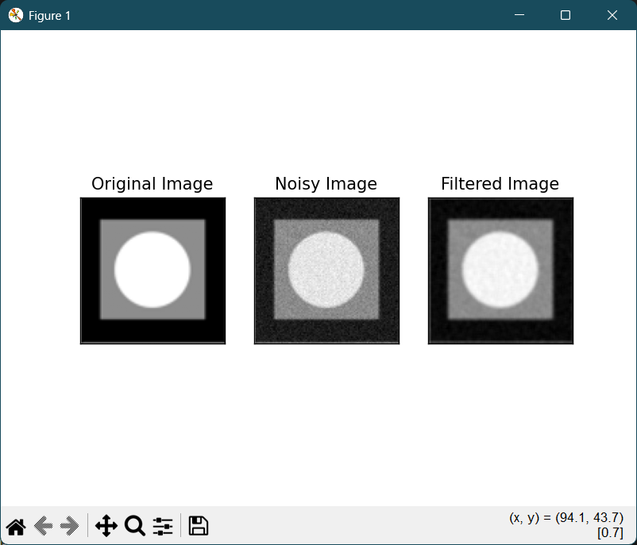
Fig 6.3 Artihmetic and Contraharmonic filter

III. Contra-Harmonic Filter:
import cv2
import numpy as np
import matplotlib.pyplot as plt
# Reading the input image
imgpath = r"C:\MEET\B-Tech\sem_7\image_processing\CVML-main\circle_in_square_512.png"
img1 = cv2.imread(imgpath, 0)
##########Salt & Pepper Noise
max_val=np.max(img1);
print(max_val);
img3 = (img1/max_val); # Normalization
pa=0.05;
pb=0.05;
(nr,nc) = img1.shape
R = np.float32(np.zeros((nr,nc),dtype = 'float32')+0.11);
x=np.random.rand(nr,nc);
[r,c]=np.where(x<=pa);
for i in range(len(r)):
R[r[i]][c[i]]=np.uint8(0);
u=pa+pb
[r,c]=np.where(x<=u);
for i in range(len(r)):
R[r[i]][c[i]]=np.uint8(255);
img_noise=img1+R;
###### Contra-Harmonic Filter
(nr,nc) = img_noise.shape # to access row and column of image
print('No. of Row: ',nr)
print('No. of Column: ', nc)
output=np.zeros((nr,nc),dtype='uint8');
Q=-5
for i in range(1,nr-1,1):
for j in range(1,nc-1,1):
num=0;denom=0;
for x in range(i-1,i+2):
for y in range(j-1,j+2):
num = num + (pow(img_noise[x][y],(Q+1)))
denom = denom + (pow(img_noise[x][y],Q))
if denom != 0:
output[i][j]= num / denom;

plt.subplot(1, 3, 1)
plt.imshow(img1,cmap='gray')
plt.title('Original Image')
plt.xticks([])
plt.yticks([])
plt.subplot(1, 3, 2)
plt.imshow(img_noise,cmap='gray')
plt.title('Img with S&P Noise')
plt.xticks([])
plt.yticks([])
plt.subplot(1, 3, 3)
plt.imshow(output,cmap='gray')
plt.title('Filtered Output')
plt.xticks([])
plt.yticks([])
plt.show()
cv2.waitKey(0) #Wait until key strike from keyboard
cv2.destroyAllWindows()#Close all windows

OUTPUT:
255
No. of Row: 512
No. of Column: 512
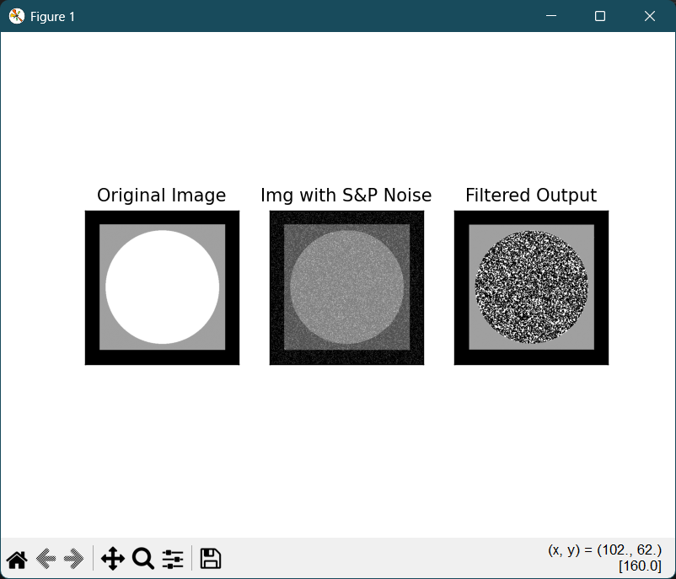
Fig 6.4 Contra-harmonic filter

ASSIGNEMNT:
1. Implement the Following Mean Restoration filters: Geometric, Harmonic.
import cv2
import numpy as np
import matplotlib.pyplot as plt
imgpath=r"C:\MEET\BTech\sem_7\image_processing\CVMLmain\circle_in_square.png"
img1 = cv2.imread(imgpath, 0) # grayscale

# Salt & Pepper Noise
pa = 0.05 # probability of salt
pb = 0.05 # probability of pepper
nr, nc = img1.shape
img_noise = img1.copy()
x = np.random.rand(nr, nc)

# pepper noise (black)
img_noise[x < pa] = 0
# salt noise (white)
img_noise[x > 1 - pb] = 255

# Contra-Harmonic Filter
op = np.zeros((nr, nc), dtype='float32')
Q = -5
for i in range(1, nr - 1):
for j in range(1, nc - 1):
window = img_noise[i-1:i+2, j-1:j+2].astype(np.float32)
num = np.sum(np.power(window, Q + 1))
denom = np.sum(np.power(window, Q))
if denom != 0:
op[i, j] = num / denom
op = np.clip(op, 0, 255).astype('uint8')

# Geometric Mean Filter
gm = np.zeros((nr, nc), dtype='float32')
for i in range(1, nr - 1):
for j in range(1, nc - 1):
window = img_noise[i-1:i+2, j-1:j+2].astype(np.float32) + 1e-5
prod = np.prod(window)
gm[i, j] = pow(prod, 1/9)
gm = np.clip(gm, 0, 255).astype('uint8')

# Harmonic Mean Filter
hm = np.zeros((nr, nc), dtype='float32')
for i in range(1, nr - 1):
for j in range(1, nc - 1):
window = img_noise[i-1:i+2, j-1:j+2].astype(np.float32) + 1e-5
hm[i, j] = 9 / np.sum(1.0 / window)
hm = np.clip(hm, 0, 255).astype('uint8')

plt.figure(figsize=(15, 5))
plt.subplot(1, 5, 1)
plt.imshow(img1, cmap='gray')
plt.title('Original')
plt.axis('off')
plt.subplot(1, 5, 2)
plt.imshow(img_noise, cmap='gray')
plt.title('Salt & Pepper')
plt.axis('off')
plt.subplot(1, 5, 3)
plt.imshow(op, cmap='gray')
plt.title('Contra-Harmonic')
plt.axis('off')
plt.subplot(1, 5, 4)
plt.imshow(gm, cmap='gray')
plt.title('Geometric Mean')
plt.axis('off')

plt.subplot(1, 5, 5)
plt.imshow(hm, cmap='gray')
plt.title('Harmonic Mean')
plt.axis('off')

plt.tight_layout()
plt.show()

cv2.waitKey(0)
cv2.destroyAllWindows()

OUTPUT:
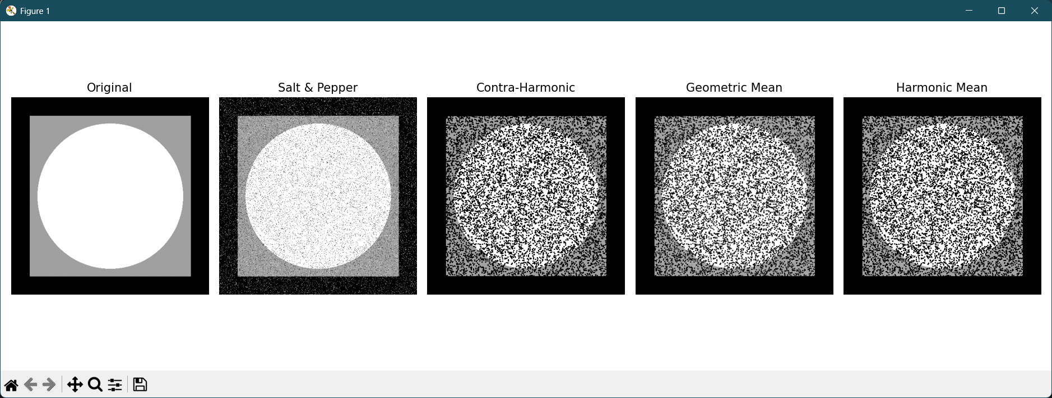
Fig 6.5 Geometric and Harmonic filter

CONCLUSION:

EXPERIMENT – 7
COLOR IMAGE PROCESSING

OBJECTIVE:
I. Split and merge the R, G, B component from the color image.
II. Observe effect saturation of red, green and blue color component in the blank image.

SAMPLE PROGRAM:
I. Split and merge the R, G, B component from the color image
import cv2
import matplotlib.pyplot as plt
path = r"C:\MEET\B-Tech\sem_7\image_processing\ip.png"
img = cv2.imread(path)
rgb_img = cv2.cvtColor(img, cv2.COLOR_BGR2RGB)
r, g, b = cv2.split(rgb_img)

titles = ['Original (RGB)', 'Red Channel', 'Green Channel', 'Blue Channel', 'Merged RGB']
images = [rgb_img, r, g, b, cv2.merge([r, g, b])]
plt.figure(figsize=(15, 5))
for i in range(len(images)):
plt.subplot(1, len(images), i + 1)
if len(images[i].shape) == 2:
plt.imshow(images[i], cmap='gray')
else:
plt.imshow(images[i])
plt.title(titles[i])
plt.axis('off')
plt.tight_layout()
plt.show()

OUTPUT:
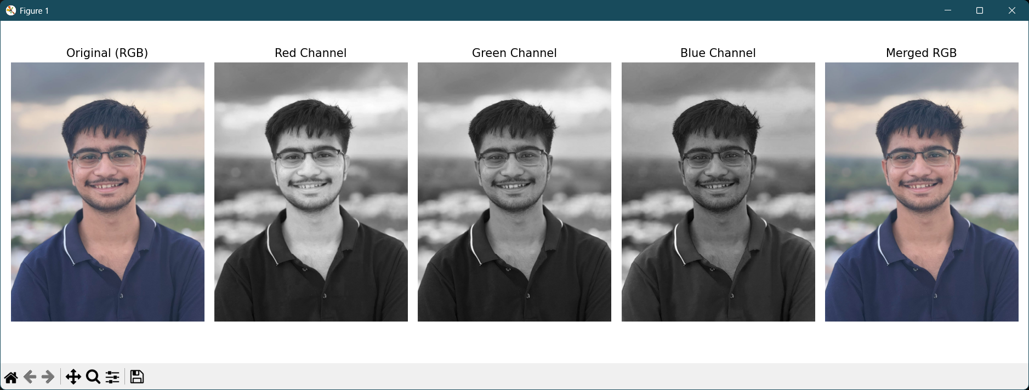
Fig 7.1 Merge and Split of an image
II. Observe effect saturation of red, green and blue color component in the blank image
import cv2
import numpy as np
def emptyFunction():
pass

def main():
img1 = np.zeros((512, 512, 3), np.uint8)
windowName = 'OpenCV BGR Color Palette'
cv2.namedWindow(windowName)
cv2.createTrackbar('B', windowName, 0, 255, emptyFunction)
cv2.createTrackbar('G', windowName, 0, 255, emptyFunction)
cv2.createTrackbar('R', windowName, 0, 255, emptyFunction)
while(True):
cv2.imshow(windowName, img1)
# cv2.waitKey(0)
if cv2.waitKey(1) == 27: # ASCII Code for the ESC key
break
blue = cv2.getTrackbarPos('B', windowName)
green = cv2.getTrackbarPos('G', windowName)
red = cv2.getTrackbarPos('R', windowName)
img1[:] = [blue, green, red]
print (blue, green, red)
cv2.destroyAllWindows()

if __name__ == "__main__":
main()

OUTPUT:
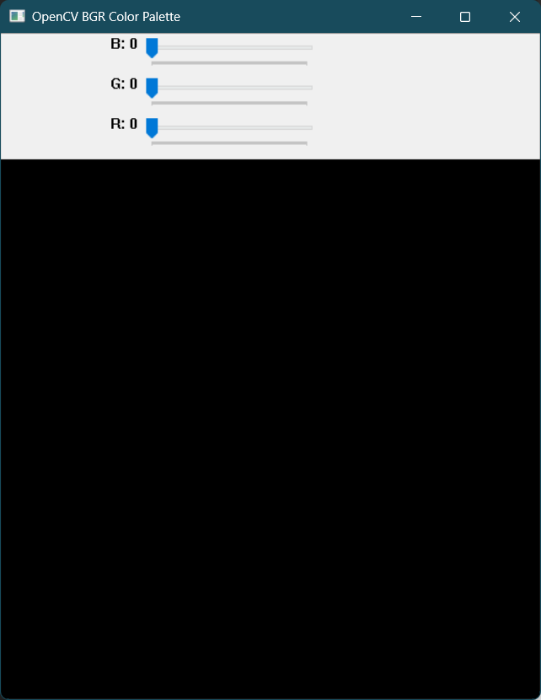
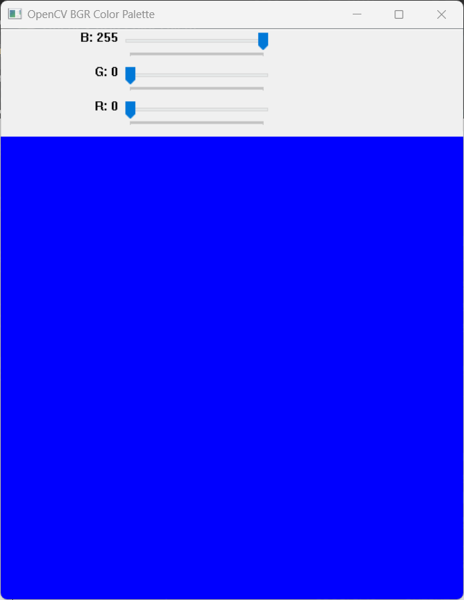
Fig 7.2 Red, green and blue component from a color palette
III. Write a program to convert RGB to HSI
import cv2
import numpy as np
import matplotlib.pyplot as plt

def hsi(img):
img = img.astype(np.float32) / 255
B, G, R = cv2.split(img)
I = (R + G + B) / 3

min_val = np.minimum(np.minimum(R, G), B)
S = 1 - (3 / (R + G + B + 1e-6)) * min_val

num = 0.5 * ((R - G) + (R - B))
den = np.sqrt((R - G)**2 + (R - B)*(G - B)) + 1e-6
theta = np.arccos(np.clip(num / den, -1, 1))

H = np.where(B <= G, theta, 2 * np.pi - theta)
H = H / (2 * np.pi) # Normalize Hue to 0–1 for display
return H, S, I

def main():
img = cv2.imread(r"C:\MEET\B-Tech\sem_7\image_processing\ip.png", 1)
img_rgb = cv2.cvtColor(img, cv2.COLOR_BGR2RGB) # Convert to RGB for matplotlib

H, S, I = hsi(img)

# Create combined HSI image for visualization
hsi_combined = np.stack((H, S, I), axis=-1)

plt.figure(figsize=(15, 8))

# Original Image
plt.subplot(2, 3, 1)
plt.imshow(img_rgb)
plt.title("Original Image")
plt.axis('off')

# Hue
plt.subplot(2, 3, 2)
plt.imshow(H, cmap='gray')
plt.title("Hue")
plt.axis('off')

# Saturation
plt.subplot(2, 3, 3)
plt.imshow(S, cmap='gray')
plt.title("Saturation")
plt.axis('off')

# Intensity
plt.subplot(2, 3, 4)
plt.imshow(I, cmap='gray')
plt.title("Intensity")
plt.axis('off')

# Combined HSI
plt.subplot(2, 3, 5)
plt.imshow(hsi_combined)
plt.title("Combined HSI")
plt.axis('off')

plt.tight_layout()
plt.show()

if __name__ == "__main__":
main()

OUTPUT:
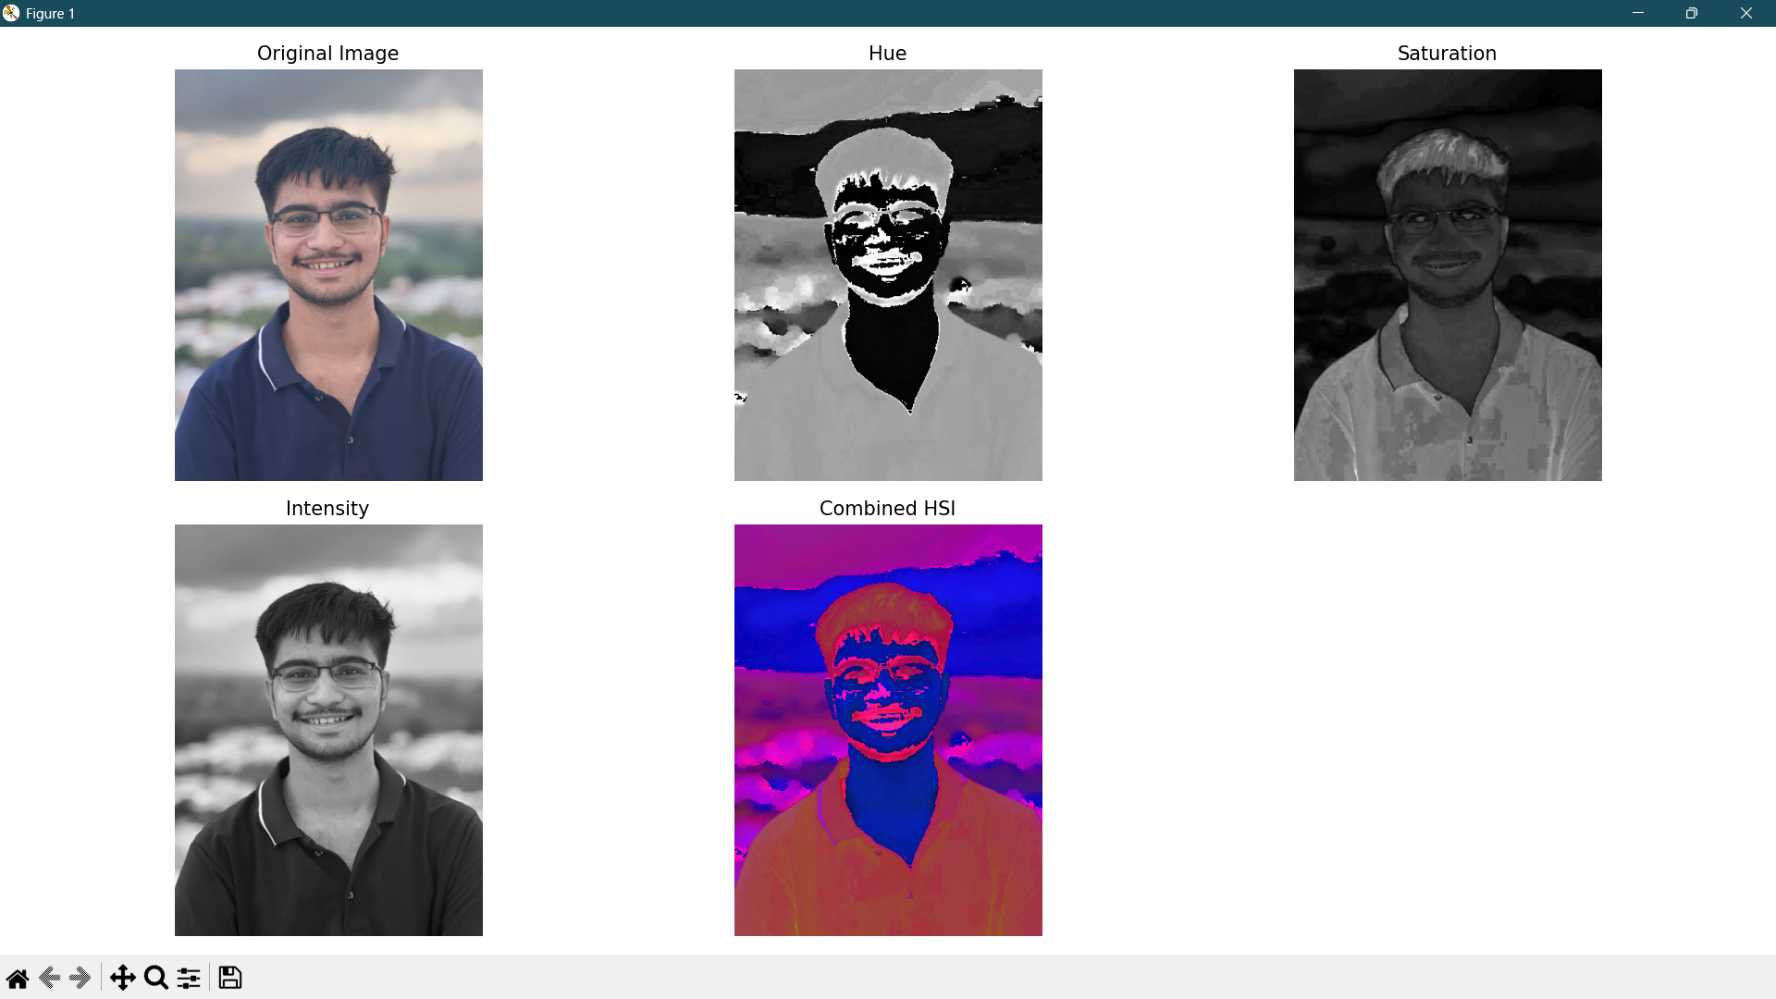
Fig 7.3 RGB to HSI

CONCLUSION:

EXPERIMENT –08
IMAGE SEGMENTATION & MORPHOLOGICAL OPERATION

OBJECTIVE:
I. To find optimum threshold value by maximizing between class variance.
II. Perform erosion operation on binary image with various structuring elements.
III. Perform dilation operation on binary image with various structuring elements.
IV. Illustrating morphological open by erosion followed by dilation.
V. Illustrating morphological close by dilation followed by erosion.

IMAGE SEGMENTATION
SAMPLE PROGRAM:
I. To find optimum threshold value by maximizing between class variance.
import cv2
import numpy as np
import matplotlib.pyplot as plt

# Load the image in grayscale
imgpath = r"C:\MEET\B-Tech\sem_7\image_processing\ip.png"
img = cv2.imread(imgpath, 0)

# Calculate histogram
hist_values, bin_edges = np.histogram(img.ravel(), bins=256, range=(0,256))
total_pixels = np.sum(hist_values)

# Initialize variables
w_0 = 0.0
w_1 = 1.0 # Initially all pixels are in the right class
weighted_sum_0 = 0.0
weighted_sum_1 = np.dot(hist_values, np.arange(256)) # Total sum for the right class

def recursive_otsu(hist_values, weighted_sum_0=0, weighted_sum_1=None, w_0=0, w_1=1, threshold=0, max_var=-np.inf, opt_thresh=0):
if weighted_sum_1 is None:
weighted_sum_1 = np.dot(hist_values, np.arange(256))

if threshold > 255:
return max_var, opt_thresh

if np.sum(hist_values[:threshold+1]) != 0 and np.sum(hist_values[threshold+1:]) != 0:
# Update weights
w_0 += hist_values[threshold] / total_pixels
w_1 -= hist_values[threshold] / total_pixels

# Update means
weighted_sum_0 += hist_values[threshold] * threshold
mean_0 = weighted_sum_0 / np.sum(hist_values[:threshold+1])
weighted_sum_1 -= hist_values[threshold] * threshold
mean_1 = weighted_sum_1 / np.sum(hist_values[threshold+1:])

# Between-class variance
var_between = w_0 * w_1 * ((mean_0 - mean_1) ** 2)

if var_between > max_var:
max_var = var_between
opt_thresh = threshold

return recursive_otsu(hist_values, weighted_sum_0, weighted_sum_1, w_0, w_1, threshold+1, max_var, opt_thresh)

# Find optimal threshold
max_variance, threshold_value = recursive_otsu(hist_values)
print("Maximum Between-class Variance:", max_variance)
print("Optimal Threshold Value:", threshold_value)

# Threshold the image manually
_, thresh_manual = cv2.threshold(img, threshold_value, 255, cv2.THRESH_BINARY)

# Threshold the image using OpenCV built-in Otsu
retval, thresh_otsu = cv2.threshold(img, 0, 255, cv2.THRESH_BINARY + cv2.THRESH_OTSU)
print("OpenCV Otsu Threshold Value:", retval)

# Display images using matplotlib subplots
plt.figure(figsize=(15,5))

plt.subplot(1,3,1)
plt.imshow(img, cmap='gray')
plt.title("Original Image")
plt.axis('off')

plt.subplot(1,3,2)
plt.imshow(thresh_manual, cmap='gray')
plt.title(f"Manual Otsu Threshold: {threshold_value}")
plt.axis('off')
plt.subplot(1,3,3)
plt.imshow(thresh_otsu, cmap='gray')
plt.title(f"OpenCV Otsu Threshold: {retval}")
plt.axis('off')
plt.show()

OUTPUT:
Maximum Between-class Variance: 2465.259613881298
Optimal Threshold Value: 119
OpenCV Otsu Threshold Value: 119.0
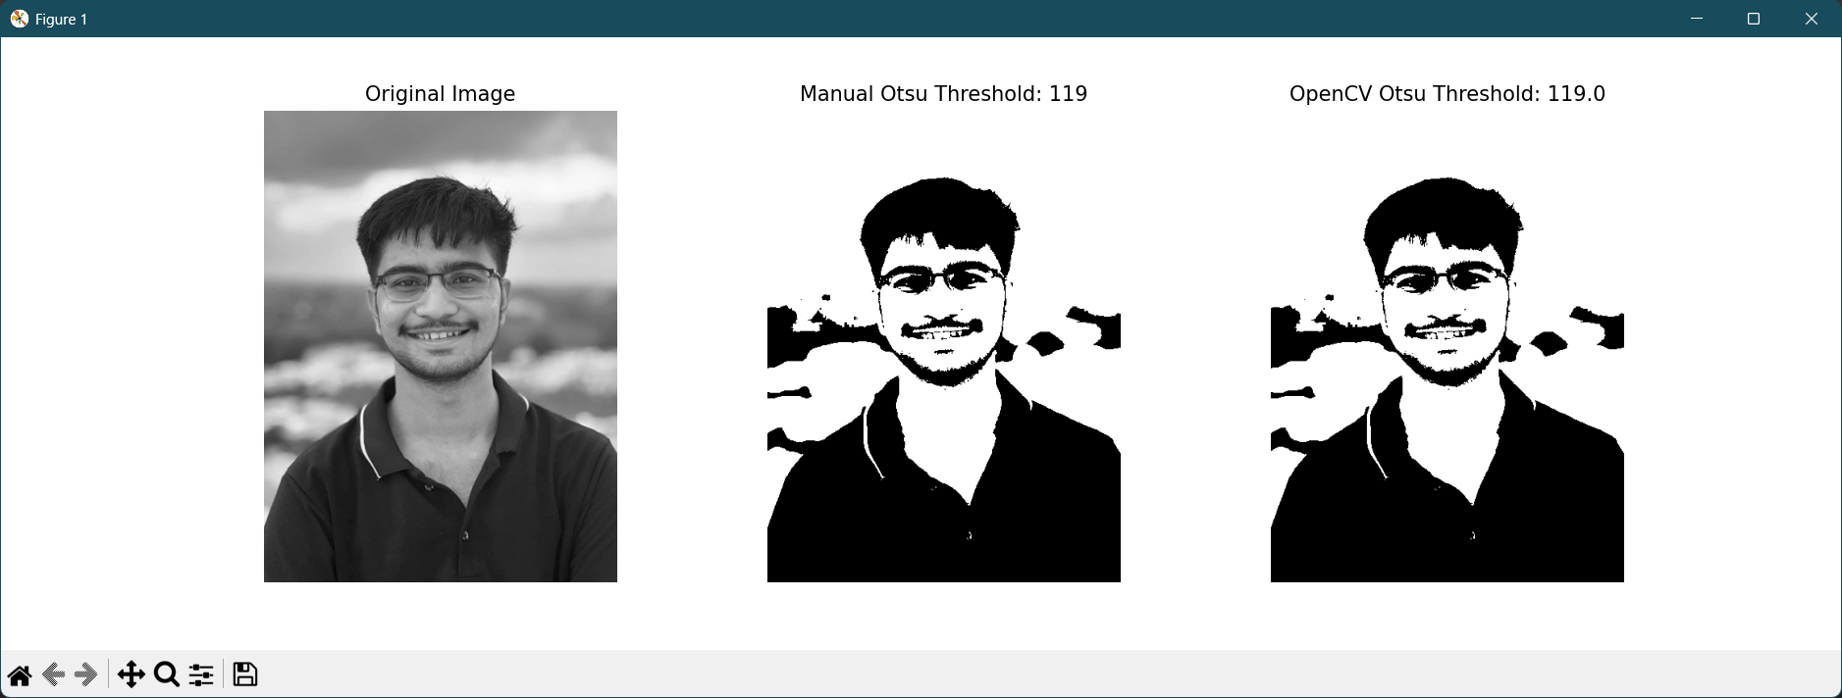
Fig 8.1 Maximizing between class variance

MORPHOLOGICAL OPERATION
THEORY:
Morphology word commonly denotes a branch of biology that deals with the form and structure of animals and plants. Using the same word in context of image processing, mathematical morphology is a tool for extracting image components that are useful in the representation and description of region shape, such as boundaries, skeletons, and the convex hull. The language of mathematical morphology is set theory. It was originally defined or binary images, later being extended to grayscale images. The basic idea in binary morphology is to probe an image with a simple, pre-defined shape, drawing conclusions on how this shape fits or misses the shapes in the image. This simple "probe" is called structuring element, and is itself a binary image (i.e., a subset of the space or grid).
The basic morphological operators are erosion, dilation, opening and closing.

1. Erosion:
Erosion of set A by structuring element B is denoted as A Ө B, and is defined as,
A⊖B={z∣Bz​⊆A}
Erosion shrinks or thins objects in a binary image.

2. Dilation:
Dilation of set A by structuring element B is defined by the following equation.
A ⊕ B = {z ∣ (B)_{z} ​∩ A = ∅ }
Unlike erosion, dilation grows. Dilation is used for expanding an element A by using structuring element B.

3. Opening:
Theopening of setA by structuring element B, denoted A ° B, is defined as,
A ° B = (A Ө B)  B
The opening A by B is the erosion of A by B, followed by a dilation of the result by B. Opening
generally smoothes the contour of an object, breaks narrow isthmuses, and eliminates thin protrusions.

4. Closing:
Closing of set A by structuring element B is defined as,
A • B = (A  B) Ө B
The closing A by B is the dilation of A by B, followed by an erosion of the result by B. Closingalso tends to smooth sections of contours but, as opposed to opening, it generally fuses narrow breaks and long thin gulfs, eliminates small holes, and fills gaps in the contour.

SAMPLE PROGRAM:
I. Perform erosion operation on binary image with various structuring elements
import cv2
import numpy as np
import matplotlib.pyplot as plt

# Read the binary image
imgpath = r"C:\MEET\B-Tech\sem_7\image_processing\CVML-main\eroded_example.tif"
img = cv2.imread(imgpath, 0)

# Otsu thresholding to ensure binary image
_, binary_img = cv2.threshold(img, 0, 255, cv2.THRESH_OTSU)

# Define various structuring elements
kernel_square = np.ones((5,5), np.uint8)
kernel_cross = np.array([[0, 0, 1, 0, 0],
[0, 0, 1, 0, 0],
[1, 1, 1, 1, 1],
[0, 0, 1, 0, 0],
[0, 0, 1, 0, 0]], dtype=np.uint8)
kernel_vertical = np.array([[0, 0, 1, 0, 0],
[0, 0, 1, 0, 0],
[0, 0, 1, 0, 0],
[0, 0, 1, 0, 0],
[0, 0, 1, 0, 0]], dtype=np.uint8)

# Perform erosion with different kernels
erosion_square = cv2.erode(binary_img, kernel_square, iterations=1)
erosion_cross = cv2.erode(binary_img, kernel_cross, iterations=1)
erosion_vertical = cv2.erode(binary_img, kernel_vertical, iterations=1)

# Display results
plt.figure(figsize=(16, 8))

images = [binary_img, erosion_square, erosion_cross, erosion_vertical]
titles = ['Original Image', 'Erosion - Square Kernel', 'Erosion - Cross Kernel', 'Erosion - Vertical Kernel']

for i in range(4):
plt.subplot(2, 2, i+1)
plt.imshow(images[i], cmap='gray')
plt.title(titles[i], fontsize=14)
plt.axis('off')

plt.tight_layout()
plt.show()

OUTPUT:
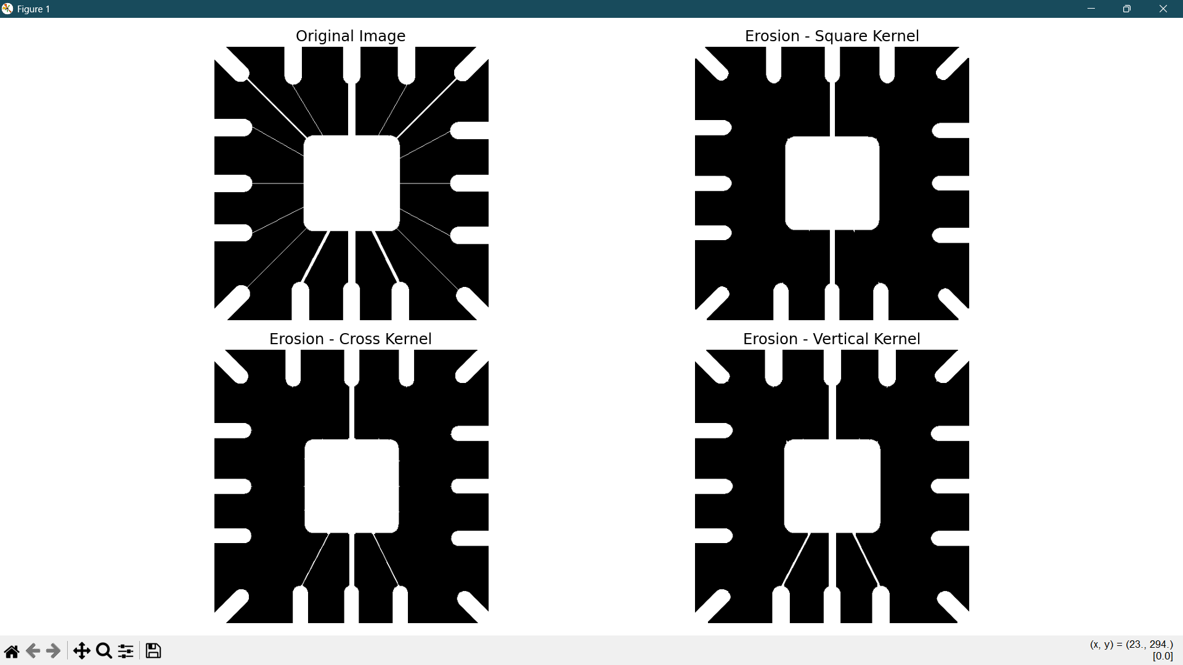
Fig 8.2 Eroded image

MODIFICATIONS:
Perform and analyze the effect of all basic morphological operations on a binary image using different structuring elements.
Specifically:
- Perform erosion and dilation using various structuring elements.
- Illustrate opening (erosion followed by dilation) and closing (dilation followed by erosion) operations.
- Optionally, explore gradient, top-hat, and black-hat operations to observe boundary extraction and small region enhancement.

import cv2
import numpy as np
import matplotlib.pyplot as plt

# Read the input image
imgpath = r"C:\MEET\B-Tech\sem_7\image_processing\CVML-main\eroded_example.tif"
img = cv2.imread(imgpath, 0)

# Otsu thresholding to ensure binary image
_, binary_img = cv2.threshold(img, 0, 255, cv2.THRESH_OTSU)

# Define different structuring elements
kernels = {
"Square 5x5": np.ones((5,5), np.uint8),
"Cross 5x5": np.array([[0, 0, 1, 0, 0],
[0, 0, 1, 0, 0],
[1, 1, 1, 1, 1],
[0, 0, 1, 0, 0],
[0, 0, 1, 0, 0]], dtype=np.uint8),
"Vertical Line 5x5": np.array([[0, 0, 1, 0, 0],
[0, 0, 1, 0, 0],
[0, 0, 1, 0, 0],
[0, 0, 1, 0, 0],
[0, 0, 1, 0, 0]], dtype=np.uint8)
}

# Perform morphological operations for each kernel
results = {}
for name, kernel in kernels.items():
results[f"Erosion - {name}"] = cv2.erode(binary_img, kernel, iterations=1)
results[f"Dilation - {name}"] = cv2.dilate(binary_img, kernel, iterations=1)
results[f"Opening - {name}"] = cv2.morphologyEx(binary_img, cv2.MORPH_OPEN, kernel)
results[f"Closing - {name}"] = cv2.morphologyEx(binary_img, cv2.MORPH_CLOSE, kernel)

# Visualization
plt.figure(figsize=(18, 16))
plt.subplot(5, 3, 1)
plt.imshow(binary_img, cmap='gray')
plt.title("Original Image", fontsize=14)
plt.axis('off')

i = 2
for title, image in results.items():
plt.subplot(5, 3, i)
plt.imshow(image, cmap='gray')
plt.title(title, fontsize=12)
plt.axis('off')
i += 1

plt.tight_layout()
plt.show()
plt.show()

OUTPUT:
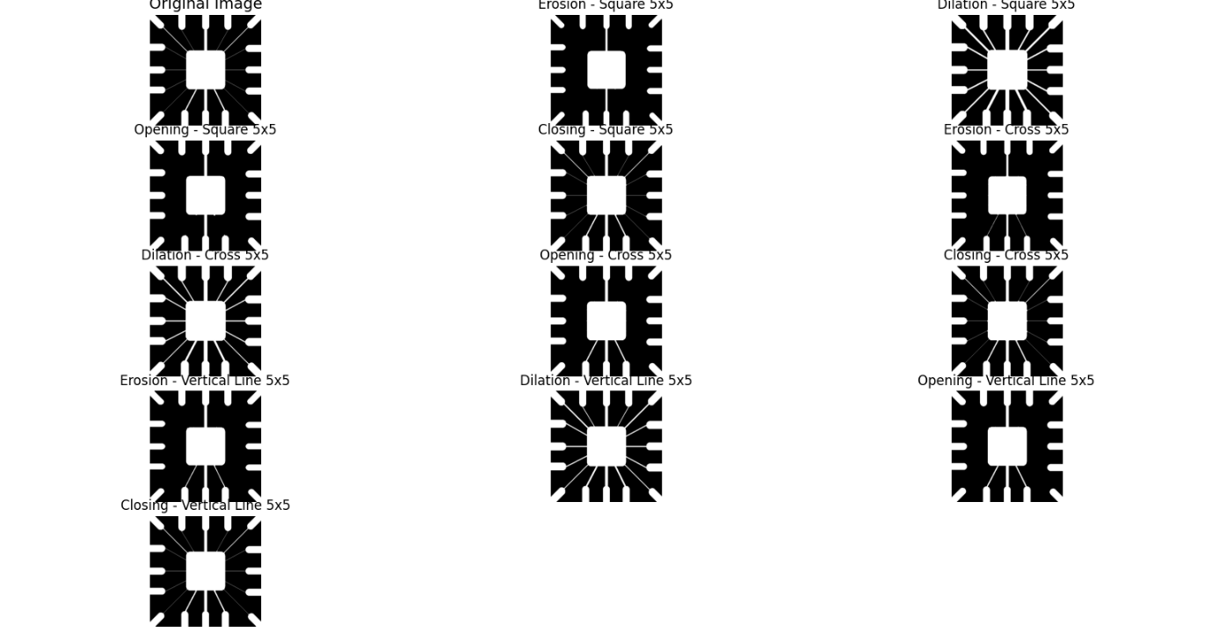
Fig 8.3 Output of basic morphological operations

ASSIGNMENTS:
1. Apply (i) different structuring elements, (ii) different iterations, and write your
observations.
1. Different Structuring Elements
- Square kernel (e.g., 3×3 or 5×5):
  - Erosion: Shrinks objects uniformly in all directions. Small objects may disappear completely.
  - Dilation: Expands objects uniformly; gaps between close objects may close.
  - Opening: Smoothens edges, removes small noise blobs.
  - Closing: Fills small holes and gaps evenly.
- Cross-shaped kernel:
  - Erosion: Shrinks objects more along vertical and horizontal axes; corners are less affected.
  - Dilation: Expands objects along vertical and horizontal directions; thin gaps along diagonals may remain.
  - Opening: Removes small noise more along axes than diagonals.
  - Closing: Fills gaps along axes better than diagonals.
- Vertical or horizontal line kernel:
  - Erosion: Thins objects along the line direction; parts perpendicular to the line remain more intact.
  - Dilation: Extends objects along the line direction only.
  - Opening/Closing: Has directional effect; noise or gaps along the line direction are removed or filled, but perpendicular features may remain.

2. Different Iterations
- Increasing the number of iterations amplifies the effect:
  - Erosion: Objects shrink more; small objects disappear faster.
  - Dilation: Objects expand more; gaps close faster.
  - Opening: More iterations remove larger noise blobs and thin protrusions.
  - Closing: More iterations fill larger holes or gaps.

3. General Observations
- Erosion is shrinking, dilation is growing.
- Opening is good for removing small noise.
- Closing is good for filling holes.
- Kernel size and shape affects the magnitude and direction of changes.
- Iteration count controls strength of the operation.

2. Modify the program without using in-built erode and dilate functions.
import cv2
import numpy as np
import matplotlib.pyplot as plt
imgpath = r"C:\MEET\B-Tech\sem_7\image_processing\CVML-main\eroded_example.tif"
img = cv2.imread(imgpath, 0)
_, binary_img = cv2.threshold(img, 0, 255, cv2.THRESH_OTSU)
kernel = np.ones((3, 3), np.uint8) # square 3x3 kernel
k_h, k_w = kernel.shape
pad_h, pad_w = k_h // 2, k_w // 2

padded_img = np.pad(binary_img, ((pad_h, pad_h), (pad_w, pad_w)), mode='constant', constant_values=0)

erosion_img = np.zeros_like(binary_img)
for i in range(pad_h, padded_img.shape[0]-pad_h):
for j in range(pad_w, padded_img.shape[1]-pad_w):
region = padded_img[i-pad_h:i+pad_h+1, j-pad_w:j+pad_w+1]
# Erosion: if all pixels under kernel are 255, keep 255; else 0
if np.all(region[kernel==1] == 255):
erosion_img[i-pad_h, j-pad_w] = 255
else:
erosion_img[i-pad_h, j-pad_w] = 0

dilation_img = np.zeros_like(binary_img)
for i in range(pad_h, padded_img.shape[0]-pad_h):
for j in range(pad_w, padded_img.shape[1]-pad_w):
region = padded_img[i-pad_h:i+pad_h+1, j-pad_w:j+pad_w+1]
if np.any(region[kernel==1] == 255):
dilation_img[i-pad_h, j-pad_w] = 255
else:
dilation_img[i-pad_h, j-pad_w] = 0
plt.figure(figsize=(12,6))
plt.subplot(1,3,1)
plt.imshow(binary_img, cmap='gray')
plt.title("Original Image")
plt.axis('off')

plt.subplot(1,3,2)
plt.imshow(erosion_img, cmap='gray')
plt.title("Manual Erosion")
plt.axis('off')

plt.subplot(1,3,3)
plt.imshow(dilation_img, cmap='gray')
plt.title("Manual Dilation")
plt.axis('off')

plt.tight_layout()
plt.show()

OUTPUT:
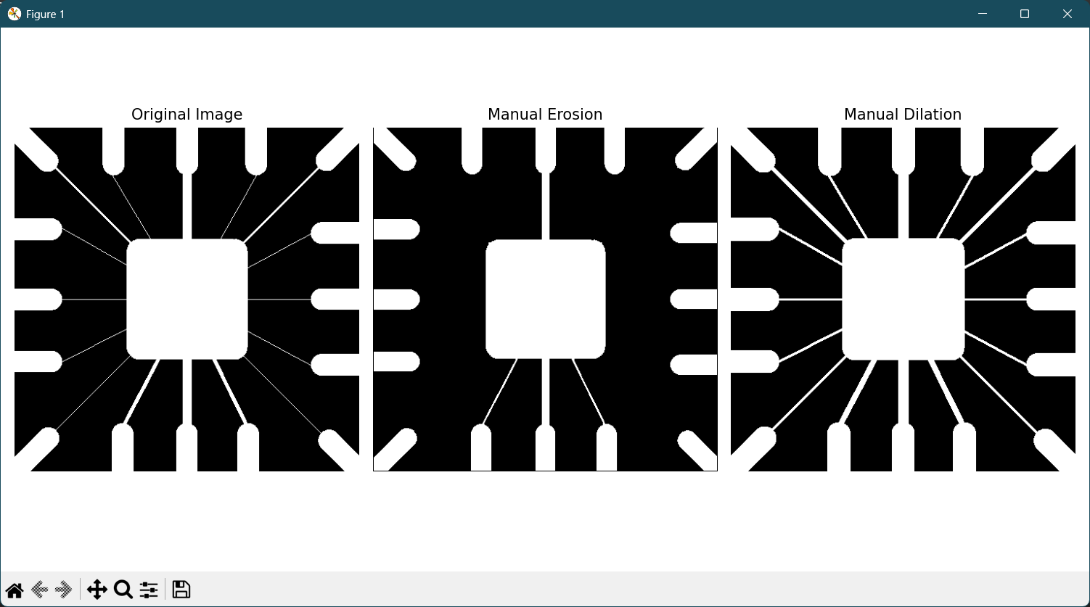
Fig 8.4 Manual erosion and dilation of a binary image

3. Modify the open and close programs using erosion and dilation functions.
import cv2
import numpy as np
import matplotlib.pyplot as plt

imgpath = r"C:\MEET\B-Tech\sem_7\image_processing\CVML-main\eroded_example.tif"
img = cv2.imread(imgpath, 0)

kernel = np.ones((3, 3), np.uint8)
k_h, k_w = kernel.shape
pad_h, pad_w = k_h // 2, k_w // 2

def pad_image(image, pad_h, pad_w):
return np.pad(image, ((pad_h, pad_h), (pad_w, pad_w)), mode='constant', constant_values=0)

def manual_erosion(img, kernel):
k_h, k_w = kernel.shape
pad_h, pad_w = k_h // 2, k_w // 2
padded = pad_image(img, pad_h, pad_w)
out = np.zeros_like(img)
for i in range(pad_h, padded.shape[0]-pad_h):
for j in range(pad_w, padded.shape[1]-pad_w):
region = padded[i-pad_h:i+pad_h+1, j-pad_w:j+pad_w+1]
if np.all(region[kernel==1] == 255):
out[i-pad_h, j-pad_w] = 255
else:
out[i-pad_h, j-pad_w] = 0
return out

def manual_dilation(img, kernel):
k_h, k_w = kernel.shape
pad_h, pad_w = k_h // 2, k_w // 2
padded = pad_image(img, pad_h, pad_w)
out = np.zeros_like(img)
for i in range(pad_h, padded.shape[0]-pad_h):
for j in range(pad_w, padded.shape[1]-pad_w):
region = padded[i-pad_h:i+pad_h+1, j-pad_w:j+pad_w+1]
if np.any(region[kernel==1] == 255):
out[i-pad_h, j-pad_w] = 255
else:
out[i-pad_h, j-pad_w] = 0
return out

opened_img = manual_dilation(manual_erosion(img, kernel), kernel)
closed_img = manual_erosion(manual_dilation(img, kernel), kernel)

plt.figure(figsize=(12,6))
plt.subplot(1,3,1)
plt.imshow(img, cmap='gray')
plt.title("Original Image")
plt.axis('off')

plt.subplot(1,3,2)
plt.imshow(opened_img, cmap='gray')
plt.title("Manual Opening")
plt.axis('off')

plt.subplot(1,3,3)
plt.imshow(closed_img, cmap='gray')
plt.title("Manual Closing")
plt.axis('off')

plt.tight_layout()
plt.show()

OUTPUT:
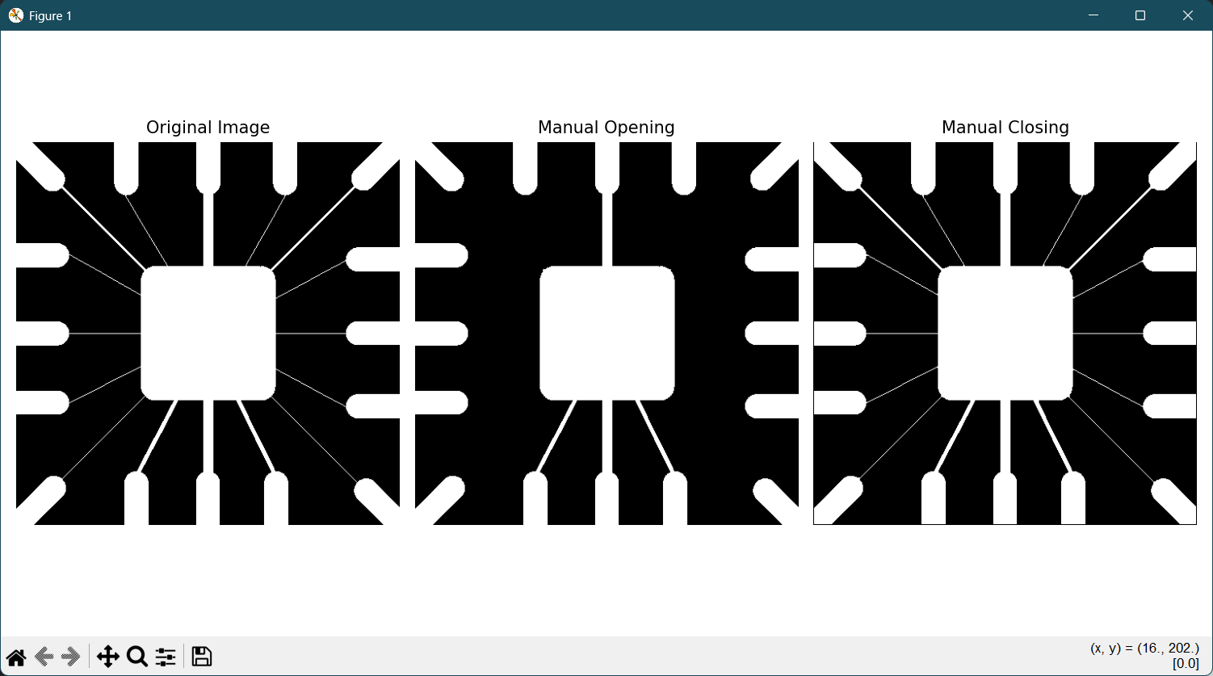
Fig 8.5 Manual closing and opening

CONCLUSION:

EXPERIMENT – 09
IMAGE CLASSIFICATION USING K-MEANS CLUSTERING ALGORITHM

OBJECTIVE:
To implement image classification using the K-Means clustering algorithm, which is an
unsupervised learning technique.

THEORY:
K-Means Clustering: K-Means is a popular unsupervised learning algorithm used for clustering data into K distinct groups based on their features. The algorithm aims to partition the dataset into K clusters, where each data point belongs to the cluster with the nearest mean. The K-Means algorithm minimizes the within-cluster variance, i.e., the sum of the squared distances between data points and their corresponding cluster centroids.

Steps in K-Means Clustering:
1. Initialization: Choose K initial cluster centroids randomly.
2. Assignment : Assign each data point to the cluster whose centroid is closest to it.
3. Update Step: Recalculate the centroids by taking the mean of all data points
assigned to each cluster.
4. Repeat: Continue the assignment and update steps until the centroids no longer
change or a maximum number of iterations is reached.
5. Labeling Clusters: Assign labels to the clusters based on the majority class of data
points within each cluster.

Advantages of K-Means:
• Simple and easy to implement.
• Efficient for large datasets.
• Works well when the clusters are well-separated.

Disadvantages of K-Means:
• Requires the number of clusters K to be specified in advance.
• Sensitive to the initial placement of centroids.
• May converge to a local minimum rather than a global minimum.

SAMPLE PROGRAM:
(i) K-Means clustering applied on randomly generated data.
import numpy as np
import matplotlib.pyplot as plt
from sklearn.cluster import KMeans
np.random.seed(7) #generate 2D random data for three clusters and represent them

def generate_data():
np.random.seed(7)
x1 = np.random.standard_normal((100,2))*0.6+np.ones((100,2))
x2 = np.random.standard_normal((100,2))*0.5-np.ones((100,2))
x3 = np.random.standard_normal((100,2))*0.4-2*np.ones((100,2))+5
X = np.concatenate((x1,x2,x3),axis=0)
return X
n = 3 #generate the k=3 initial centroids with the function
X = generate_data()
plt.plot(X[:,0],X[:,1],'k.')
k_means = KMeans(n_clusters=n)
model = k_means.fit(X)
centroids = k_means.cluster_centers_
labels= k_means.labels_
plt.figure()
plt.plot(X[labels==0,0],X[labels==0,1],'r.', label='cluster 1')
plt.plot(X[labels==1,0],X[labels==1,1],'b.', label='cluster 2')
plt.plot(X[labels==2,0],X[labels==2,1],'g.', label='cluster 3')
plt.show()

OUTPUT:
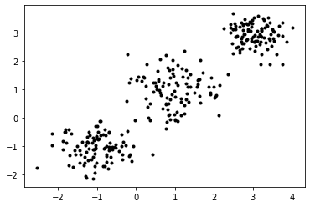
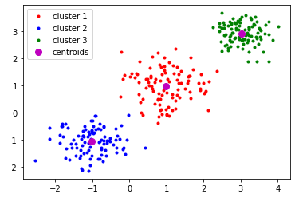
Fig 9.1 Raw data points and clustered data in three groups

MODIFICATIONS:
I. Generate different number of clusters and try with different number of centroids. Write your observations.
import numpy as np
import matplotlib.pyplot as plt
from sklearn.cluster import KMeans
np.random.seed(7)
#generate 2D random data for three clusters and represent them
def generate_data():
np.random.seed(7)
x1 = np.random.standard_normal((100,2))*0.6+np.ones((100,2))
x2 = np.random.standard_normal((100,2))*0.5-np.ones((100,2))
x3 = np.random.standard_normal((100,2))*0.4-2*np.ones((100,2))+5
x4 = np.random.standard_normal((100,2))*0.8-np.ones((100,2))+10
X = np.concatenate((x1,x2,x3,x4),axis=0)
return X
#generate the k=3 initial centroids with the function
n = 4
X = generate_data()
plt.plot(X[:,0],X[:,1],'k.')
plt.show()
k_means = KMeans(n_clusters=n)
model = k_means.fit(X)
centroids = k_means.cluster_centers_
labels= k_means.labels_
plt.figure()
plt.plot(X[labels==0,0],X[labels==0,1],'r.', label='cluster 1')
plt.plot(X[labels==1,0],X[labels==1,1],'b.', label='cluster 2')
plt.plot(X[labels==2,0],X[labels==2,1],'g.', label='cluster 3')
plt.plot(X[labels==3,0],X[labels==3,1],'b.', label='cluster 4')
plt.plot(centroids[:,0],centroids[:,1],'mo',markersize=8, label='centroids')
plt.legend(loc='best')
plt.show()

OUTPUT:
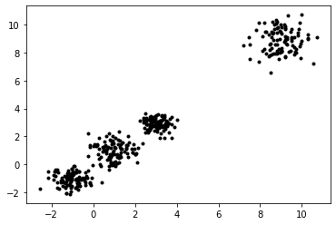
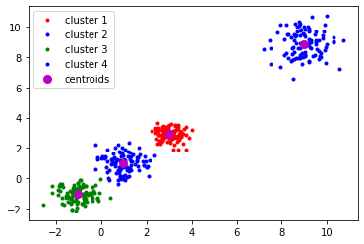
Fig 9.2 Raw data points and clustered data

• Effect of Number of Clusters (n_clusters):
- When n_clusters is less than the true number of natural clusters in the data:
  - Some distinct clusters get merged.
  - The model tries to fit fewer centroids, resulting in higher intra-cluster variance.
- When n_clusters is equal to the true number of clusters:
  - Each centroid aligns closely with one natural cluster.
  - Clusters are well-separated, and centroids represent cluster centers accurately.
- When n_clusters is more than the natural clusters:
  - Some clusters may be split into sub-clusters.
  - Extra centroids may lie in empty space or very close to existing clusters.
  - Can create small “artificial” clusters that don’t correspond to the data distribution.
• Effect of Initial Centroids (Random Initialization):
- K-Means uses random initialization (k-means++ by default).
- Different initial centroids can lead to different clustering results if clusters are close or overlap.
- Sometimes the algorithm converges to a local minimum, so centroids may not perfectly match the actual cluster centers.
- Using k-means++ initialization usually gives better and more consistent results.

II. Kmeans clustering in MNIST dataset classification.
import numpy as np
import matplotlib.pyplot as plt
from sklearn.cluster import KMeans
from sklearn.datasets import load_digits
digits = load_digits()
data = digits.data
print(data.shape)
#To improve the visualization, we invert the colors
data = 255-data
np.random.seed(1)
n=10
kmeans = KMeans(n_clusters=n,init='random')
kmeans.fit(data)
Z = kmeans.predict(data)
for i in range(0,n):
row = np.where(Z==i)[0] # row in Z for elements of cluster i
num = row.shape[0] # number of elements for each cluster
r = int(np.floor(num/10.)) # number of rows in the figure of the cluster
print("cluster "+str(i))
print(str(num)+" elements")
plt.figure(figsize=(10,10))
for k in range(0, num):
plt.subplot(r+1, 10, k+1)
image = data[row[k], ]
image = image.reshape(8, 8)
plt.imshow(image, cmap='gray')
plt.axis('off')
plt.show()

OUTPUT:
cluster 0
182 elements
cluster 1
156 elements
cluster 2
197 elements
cluster 3
179 elements
cluster 4
180 elements
cluster 5
176 elements
cluster 6
166 elements
cluster 7
242 elements
cluster 8
93 elements
cluster 9
226 elements
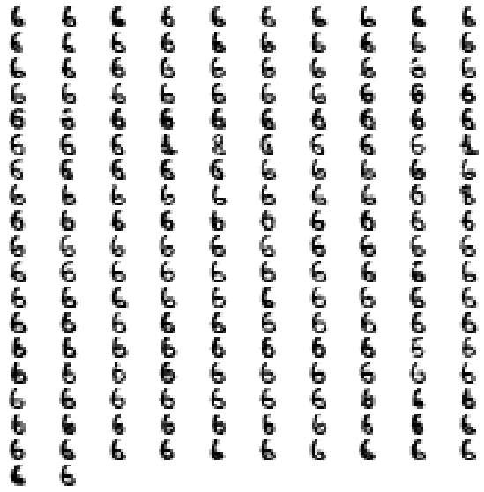
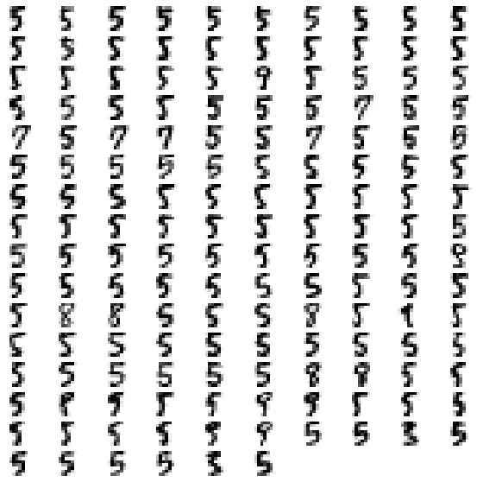
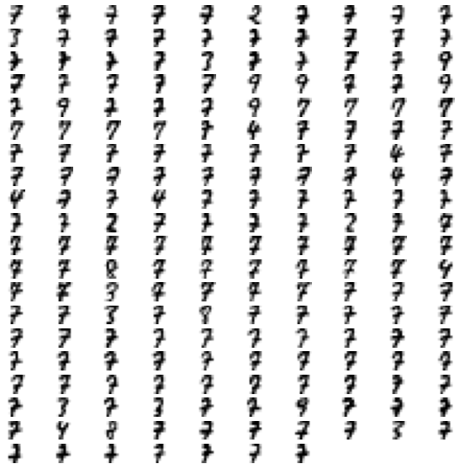
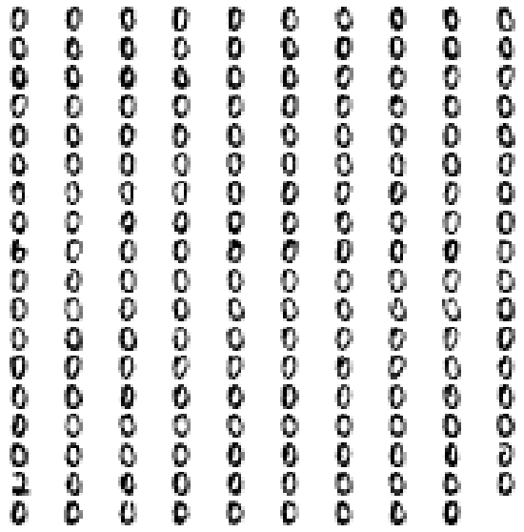
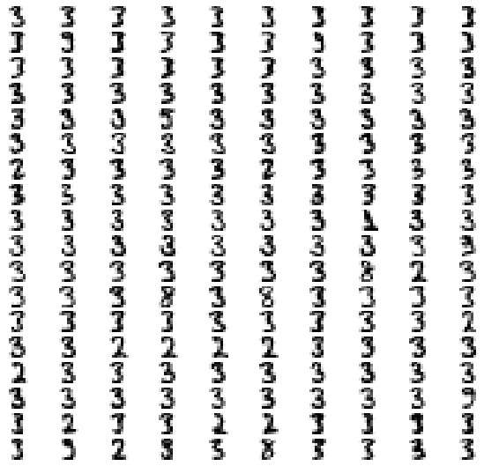
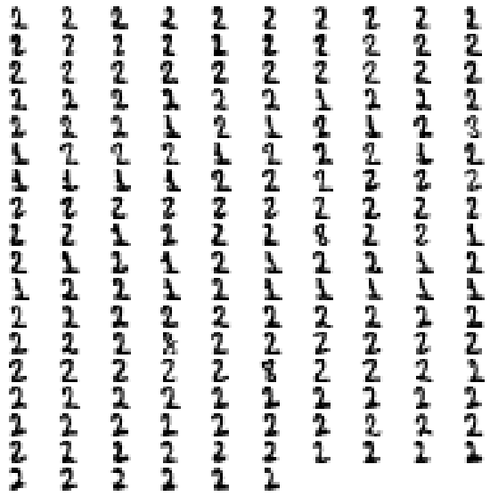
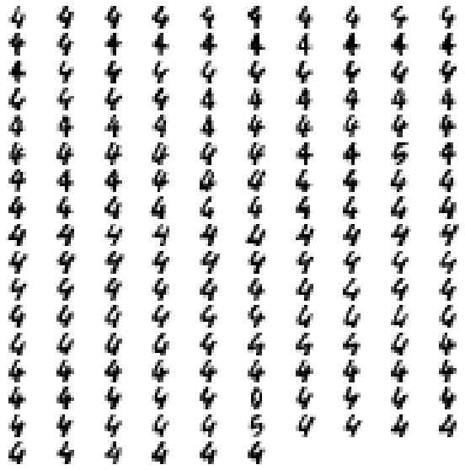
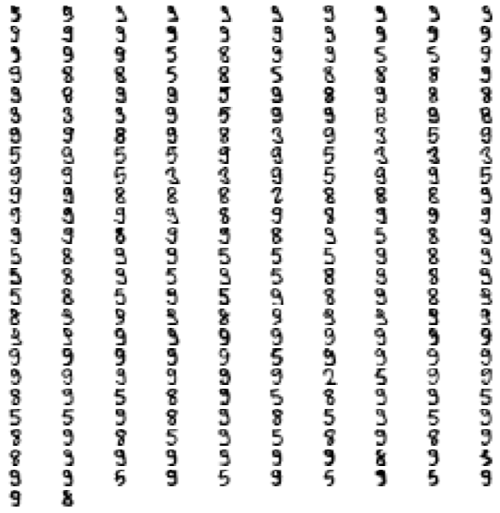
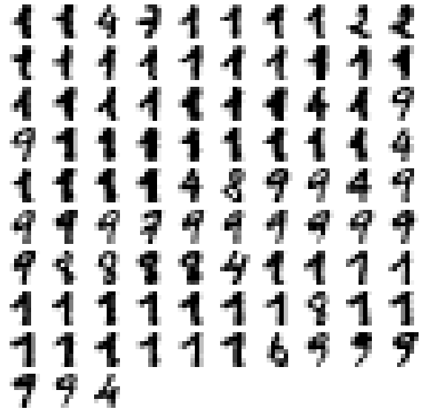
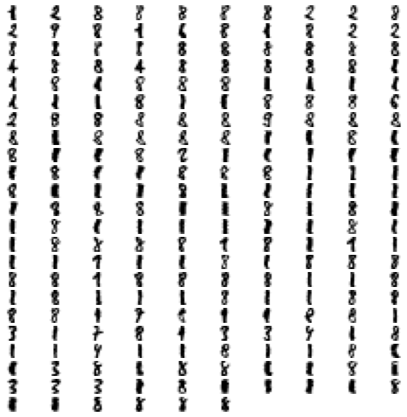
Fig 9.3 Numbers generated through MNIST classification

CONCLUSION:

EXPERIMENT – 10
PERCEPTRON AND GRADIENT DECENT ALGORITHMS

OBJECTIVE:
I. To evaluate weight for different logic gates using perceptron algorithm.
II. To apply gradient decent algorithm.

PERCEPTRON ALGORITHM
THEORY:
In machine learning, the perceptron is an algorithm for supervised learning of binary classifiers. A binary classifier is a function which can decide whether or not an input, represented by a vector of numbers, belongs to some specific class. Single-layer perceptrons are only capable of learning linearly separable patterns.

SAMPLE PROGRAM:
I. To evaluate weight for OR logic gate using perceptron algorithm.
import numpy as np
atributes = np.array([ [0, 0], [0, 1], [1, 0], [1, 1]])
labels = np.array([0, 1, 1, 1])
w = [1, 1]
threshold = 0.5
bias = 0
alpha = 0.2
epoch = 50
print("learning rate: ", alpha,", threshold: ", threshold)
for i in range(0, epoch):
print("epoch ", i+1)
global_delta = 0
for j in range(len(atributes)):
actual = labels[j]
sum = atributes[j][0]*w[0] + atributes[j][1]*w[1] + bias
if sum > threshold:
predicted = 1
else:
predicted = 0
delta = actual - predicted
global_delta = global_delta + abs(delta)
for k in range(0, 2):
w[k] = w[k] + delta * alpha
print(atributes[j][0]," ", labels, " ", atributes[j][1], " -> actual: ", actual, ", predicted: ",predicted, " (w: ",w[0],")")
if global_delta == 0:
break
print("------------------------------")

OUTPUT:
earning rate: 0.2 , threshold: 0.5
epoch 1
0 [0 1 1 1] 0 -> actual: 0 , predicted: 0 (w: 1.0 )
0 [0 1 1 1] 1 -> actual: 1 , predicted: 1 (w: 1.0 )
1 [0 1 1 1] 0 -> actual: 1 , predicted: 1 (w: 1.0 )
1 [0 1 1 1] 1 -> actual: 1 , predicted: 1 (w: 1.0 )
epoch 2
0 [0 1 1 1] 0 -> actual: 0 , predicted: 0 (w: 1.0 )
0 [0 1 1 1] 1 -> actual: 1 , predicted: 1 (w: 1.0 )
1 [0 1 1 1] 0 -> actual: 1 , predicted: 1 (w: 1.0 )
1 [0 1 1 1] 1 -> actual: 1 , predicted: 1 (w: 1.0 )
epoch 3
0 [0 1 1 1] 0 -> actual: 0 , predicted: 0 (w: 1.0 )
0 [0 1 1 1] 1 -> actual: 1 , predicted: 1 (w: 1.0 )
1 [0 1 1 1] 0 -> actual: 1 , predicted: 1 (w: 1.0 )
1 [0 1 1 1] 1 -> actual: 1 , predicted: 1 (w: 1.0 )
epoch 4
0 [0 1 1 1] 0 -> actual: 0 , predicted: 0 (w: 1.0 )
0 [0 1 1 1] 1 -> actual: 1 , predicted: 1 (w: 1.0 )
1 [0 1 1 1] 0 -> actual: 1 , predicted: 1 (w: 1.0 )
1 [0 1 1 1] 1 -> actual: 1 , predicted: 1 (w: 1.0 )
epoch 5
0 [0 1 1 1] 0 -> actual: 0 , predicted: 0 (w: 1.0 )
0 [0 1 1 1] 1 -> actual: 1 , predicted: 1 (w: 1.0 )
1 [0 1 1 1] 0 -> actual: 1 , predicted: 1 (w: 1.0 )
1 [0 1 1 1] 1 -> actual: 1 , predicted: 1 (w: 1.0 )
….. 50 total epochs

MODIFICATIONS:
1. To evaluate weight for AND logic gate using perceptron algorithm.
import numpy as np
atributes = np.array([ [0, 0], [0, 1], [1, 0], [1, 1]])
labels = np.array([0,0,0,1])
w = [1, 1]
threshold = 0.5
bias = 0
alpha = 0.2
epoch = 50
print("learning rate: ", alpha,", threshold: ", threshold)
for i in range(0, epoch):
print("epoch ", i+1)
global_delta = 0
for j in range(len(atributes)):
actual = labels[j]
sum = atributes[j][0]*w[0] + atributes[j][1]*w[1] + bias
if sum > threshold:
predicted = 1
else:
predicted = 0
delta = actual - predicted
global_delta = global_delta + abs(delta)
for k in range(0, 2):
w[k] = w[k] + delta * alpha
print(atributes[j][0]," ", labels, " ", atributes[j][1], " -> actual: ", actual, ", predicted: ",predicted, " (w: ",w[0],")")
if global_delta == 0:
break
print("------------------------------")

OUTPUT:
learning rate: 0.2 , threshold: 0.5
epoch 1
0 [0 0 0 1] 0 -> actual: 0 , predicted: 0 (w: 1.0 )
0 [0 0 0 1] 1 -> actual: 0 , predicted: 1 (w: 0.8 )
------------------------------
0 [0 0 0 1] 1 -> actual: 0 , predicted: 1 (w: 0.8 )
------------------------------
1 [0 0 0 1] 0 -> actual: 0 , predicted: 1 (w: 0.6000000000000001 )
------------------------------
1 [0 0 0 1] 0 -> actual: 0 , predicted: 1 (w: 0.6000000000000001 )
------------------------------
1 [0 0 0 1] 1 -> actual: 1 , predicted: 1 (w: 0.6000000000000001 )
------------------------------
1 [0 0 0 1] 1 -> actual: 1 , predicted: 1 (w: 0.6000000000000001 )
------------------------------
epoch 2
0 [0 0 0 1] 0 -> actual: 0 , predicted: 0 (w: 0.6000000000000001 )
0 [0 0 0 1] 1 -> actual: 0 , predicted: 1 (w: 0.4000000000000001 )
------------------------------
0 [0 0 0 1] 1 -> actual: 0 , predicted: 1 (w: 0.4000000000000001 )
------------------------------
1 [0 0 0 1] 0 -> actual: 0 , predicted: 0 (w: 0.4000000000000001 )
------------------------------
1 [0 0 0 1] 0 -> actual: 0 , predicted: 0 (w: 0.4000000000000001 )
------------------------------
1 [0 0 0 1] 1 -> actual: 1 , predicted: 1 (w: 0.4000000000000001 )
------------------------------
1 [0 0 0 1] 1 -> actual: 1 , predicted: 1 (w: 0.4000000000000001 )
------------------------------
epoch 3
0 [0 0 0 1] 0 -> actual: 0 , predicted: 0 (w: 0.4000000000000001 )
0 [0 0 0 1] 1 -> actual: 0 , predicted: 0 (w: 0.4000000000000001 )
1 [0 0 0 1] 0 -> actual: 0 , predicted: 0 (w: 0.4000000000000001 )
1 [0 0 0 1] 1 -> actual: 1 , predicted: 1 (w: 0.4000000000000001 )
epoch 4
0 [0 0 0 1] 0 -> actual: 0 , predicted: 0 (w: 0.4000000000000001 )
0 [0 0 0 1] 1 -> actual: 0 , predicted: 0 (w: 0.4000000000000001 )
1 [0 0 0 1] 0 -> actual: 0 , predicted: 0 (w: 0.4000000000000001 )
1 [0 0 0 1] 1 -> actual: 1 , predicted: 1 (w: 0.4000000000000001 )
epoch 5
0 [0 0 0 1] 0 -> actual: 0 , predicted: 0 (w: 0.4000000000000001 )
0 [0 0 0 1] 1 -> actual: 0 , predicted: 0 (w: 0.4000000000000001 )
1 [0 0 0 1] 0 -> actual: 0 , predicted: 0 (w: 0.4000000000000001 )
1 [0 0 0 1] 1 -> actual: 1 , predicted: 1 (w: 0.4000000000000001 )
….. 50 total epochs

2. To evaluate weight for XOR logic gate using perceptron algorithm and write your
observations.
import numpy as np
atributes = np.array([ [0, 0], [0, 1], [1, 0], [1, 1]])
labels = np.array([0,1,1,0])
w = [1, 1]
threshold = 0.5
bias = 0
alpha = 0.2
epoch = 50
print("learning rate: ", alpha,", threshold: ", threshold)
for i in range(0, epoch):
print("epoch ", i+1)
global_delta = 0
for j in range(len(atributes)):
actual = labels[j]
sum = atributes[j][0]*w[0] + atributes[j][1]*w[1] + bias
if sum > threshold:
predicted = 1
else:
predicted = 0
delta = actual - predicted
global_delta = global_delta + abs(delta)
for k in range(0, 2):
w[k] = w[k] + delta * alpha
print(atributes[j][0]," ", labels, " ", atributes[j][1], " -> actual: ", actual, ", predicted: ",predicted, " (w: ",w[0],")")
if global_delta == 0:
break
print("------------------------------")

OUTPUT:
learning rate: 0.2 , threshold: 0.5
epoch 1
0 [0 1 1 0] 0 -> actual: 0 , predicted: 0 (w: 1.0 )
0 [0 1 1 0] 1 -> actual: 1 , predicted: 1 (w: 1.0 )
1 [0 1 1 0] 0 -> actual: 1 , predicted: 1 (w: 1.0 )
1 [0 1 1 0] 1 -> actual: 0 , predicted: 1 (w: 0.8 )
------------------------------
1 [0 1 1 0] 1 -> actual: 0 , predicted: 1 (w: 0.8 )
------------------------------
epoch 2
0 [0 1 1 0] 0 -> actual: 0 , predicted: 0 (w: 0.8 )
0 [0 1 1 0] 1 -> actual: 1 , predicted: 1 (w: 0.8 )
1 [0 1 1 0] 0 -> actual: 1 , predicted: 1 (w: 0.8 )
1 [0 1 1 0] 1 -> actual: 0 , predicted: 1 (w: 0.6000000000000001 )
------------------------------
1 [0 1 1 0] 1 -> actual: 0 , predicted: 1 (w: 0.6000000000000001 )
------------------------------
epoch 3
0 [0 1 1 0] 0 -> actual: 0 , predicted: 0 (w: 0.6000000000000001 )
0 [0 1 1 0] 1 -> actual: 1 , predicted: 1 (w: 0.6000000000000001 )
1 [0 1 1 0] 0 -> actual: 1 , predicted: 1 (w: 0.6000000000000001 )
1 [0 1 1 0] 1 -> actual: 0 , predicted: 1 (w: 0.4000000000000001 )
------------------------------
1 [0 1 1 0] 1 -> actual: 0 , predicted: 1 (w: 0.4000000000000001 )
------------------------------
epoch 4
0 [0 1 1 0] 0 -> actual: 0 , predicted: 0 (w: 0.4000000000000001 )
0 [0 1 1 0] 1 -> actual: 1 , predicted: 0 (w: 0.6000000000000001 )
------------------------------
0 [0 1 1 0] 1 -> actual: 1 , predicted: 0 (w: 0.6000000000000001 )
------------------------------
1 [0 1 1 0] 0 -> actual: 1 , predicted: 1 (w: 0.6000000000000001 )
------------------------------
1 [0 1 1 0] 0 -> actual: 1 , predicted: 1 (w: 0.6000000000000001 )
------------------------------
1 [0 1 1 0] 1 -> actual: 0 , predicted: 1 (w: 0.4000000000000001 )
------------------------------
1 [0 1 1 0] 1 -> actual: 0 , predicted: 1 (w: 0.4000000000000001 )
------------------------------
epoch 5
0 [0 1 1 0] 0 -> actual: 0 , predicted: 0 (w: 0.4000000000000001 )
0 [0 1 1 0] 1 -> actual: 1 , predicted: 0 (w: 0.6000000000000001 )
------------------------------
0 [0 1 1 0] 1 -> actual: 1 , predicted: 0 (w: 0.6000000000000001 )
------------------------------
1 [0 1 1 0] 0 -> actual: 1 , predicted: 1 (w: 0.6000000000000001 )
------------------------------
1 [0 1 1 0] 0 -> actual: 1 , predicted: 1 (w: 0.6000000000000001 )
------------------------------
1 [0 1 1 0] 1 -> actual: 0 , predicted: 1 (w: 0.4000000000000001 )
------------------------------
1 [0 1 1 0] 1 -> actual: 0 , predicted: 1 (w: 0.4000000000000001 )
…… 50 total epochs

ASSIGNMENTS:
I. Apply different initial weight and bias values and write your observations.
Initial Weights | Bias | Observation
[1, 1] | 0 | Model converges after a few epochs; already close to ideal for AND gate.
[0, 0] | 0 | Takes more epochs to reach correct classification; starts far from decision boundary.
[-1, -1] | 0 | Initially predicts all outputs as 0; requires more updates to reach correct weights.
[0.5, -0.5] | 0.2 | Slower convergence; bias helps slightly in moving the threshold.
[2, 2] | 1 | Starts above the threshold; might misclassify initially, but still converges after several updates.
Different initial weights and bias values change the speed of convergence, but the final result remains the same (correct classification) if the learning rate and epochs are sufficient.
If weights start too large or too small, learning can be unstable or slow.

II. Apply different learning rate and write your observations.
Learning Rate (α) | Observation
0.1 | Model converges slowly, takes more epochs to stabilize.
0.2 | Balanced learning — converges efficiently without oscillation.
0.5 | Faster convergence but slight instability (weights fluctuate more).
0.8 | Often overshoots — weights may jump past the optimal value; unstable.
0.01 | Extremely slow learning, may not converge within 50 epochs.
A moderate learning rate (0.1–0.3) gives the best results — faster convergence with stable weight updates.
Too low → slow learning; too high → unstable or divergent.

GRADIENT DECENT ALGORITHM
THEORY:
Gradient descent is an optimization algorithm which is commonly-used to train machine learning models and neural networks. It trains machine learning models by minimizing errors between predicted and actual results. Training data helps these models learn over time.

SAMPLE PROGRAM:
I. To apply gradient decent algorithm for y = x^2
from numpy import asarray
from numpy import arange
from numpy.random import rand
from matplotlib import pyplot
def objective(x):
return x**2.0
def derivative(x):
return x * 2.0
def gradient_descent(objective, derivative, bounds, n_iter, step_size):
solutions, scores = list(), list()
solution = bounds[:, 0] + rand(len(bounds)) * (bounds[:, 1] - bounds[:, 0])
for i in range(n_iter):
gradient = derivative(solution)
solution = solution - step_size * gradient
solution_eval = objective(solution)
solutions.append(solution)
scores.append(solution_eval)
print('>%d f(%s) = %.5f' % (i, solution, solution_eval))
return [solutions, scores]
bounds = asarray([[-1.0, 1.0]])
n_iter = 5
step_size = 0.0001
solutions, scores = gradient_descent(objective, derivative, bounds, n_iter, step_size)
inputs = arange(bounds[0,0], bounds[0,1]+0.1, 0.1)
results = objective(inputs)
pyplot.plot(inputs, results)
pyplot.plot(solutions, scores, '.-', color='red')
pyplot.show()

OUTPUT:
>0 f([0.3204227]) = 0.10267
>1 f([0.32035862]) = 0.10263
>2 f([0.32029454]) = 0.10259
>3 f([0.32023049]) = 0.10255
>4 f([0.32016644]) = 0.10251
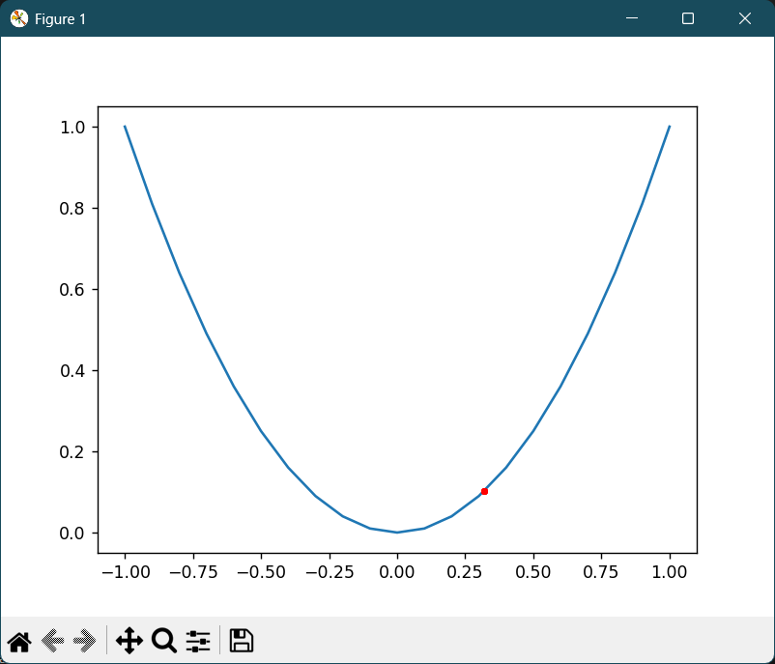
Fig 10.1 Gradient descent algorithm for y = x^2

MODIFICATIONS:
I. Change the number of iteration and write your observations.
n_iter = 10
step_size = 0.0001

OUTPUT:
>0 f([0.26587759]) = 0.07069
>1 f([0.26582441]) = 0.07066
>2 f([0.26577125]) = 0.07063
>3 f([0.26571809]) = 0.07061
>4 f([0.26566495]) = 0.07058
>5 f([0.26561181]) = 0.07055
>6 f([0.26555869]) = 0.07052
>7 f([0.26550558]) = 0.07049
>8 f([0.26545248]) = 0.07047
>9 f([0.26539939]) = 0.07044
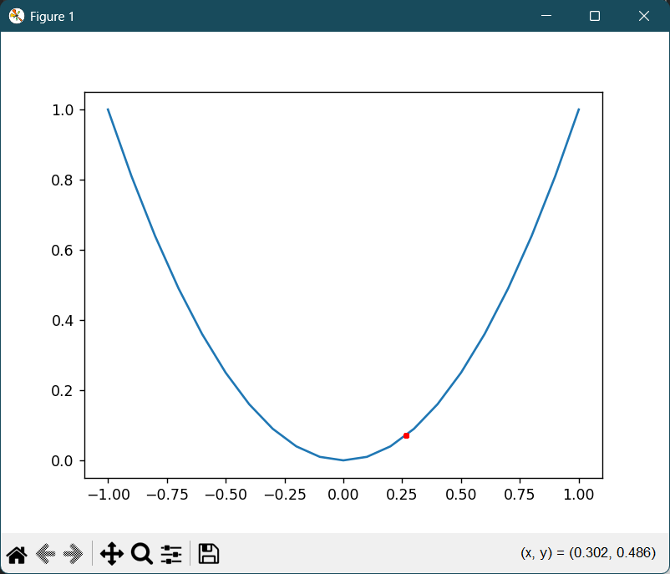
Fig 10.2 Gradient descent algo for iterations = 10

Iterations | Observation
5 iterations | The solution only moves slightly toward the minimum. Gradient descent starts reducing the function value, but it hasn’t yet reached near 0. The path (red points) is sparse and far apart.
10 iterations | The solution gets much closer to the minimum (x ≈ 0). The objective value f(x) reduces significantly, and the red line shows a smoother descent toward the parabola’s bottom.
50 iterations | The solution converges almost fully to 0. The function value f(x) becomes nearly constant, showing that gradient descent has reached or is oscillating around the minimum.
100 iterations | There’s almost no visible change after ~50 iterations. The algorithm has fully converged — further iterations make negligible difference.
Too many iterations (e.g., 500+) | The cost doesn’t reduce further; convergence plateau is reached. Additional iterations only repeat the same small updates without improvement.
II. Apply different step size and write your observations.
n_iter = 5
step_size = 0.01

OUTPUT:
>0 f([-0.88764399]) = 0.78791
>1 f([-0.86989111]) = 0.75671
>2 f([-0.85249329]) = 0.72674
>3 f([-0.83544342]) = 0.69797
>4 f([-0.81873455]) = 0.67033
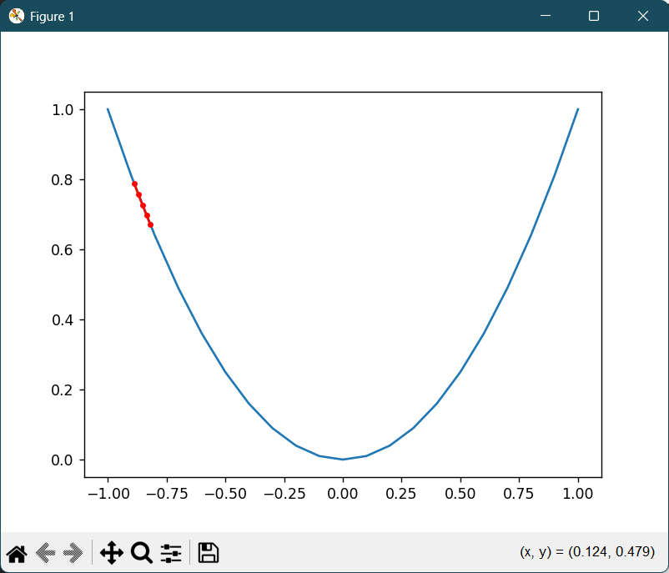
Fig 10.3 Gradient descent algorithm for step size = 0.01

Step Size (α) | Observation
Very small (e.g., 0.0001) | The update per iteration is tiny. The solution moves very slowly toward the minimum. After 5 iterations, it’s still far from x = 0 — convergence is very slow.
Moderate (e.g., 0.01) | The descent is smooth and efficient. The solution moves closer to x = 0 in just 5 iterations. Convergence is noticeable but not too aggressive.
Large (e.g., 0.1) | The steps are big. The solution may reach near 0 faster but might overshoot the minimum slightly. The oscillations around x = 0 start to appear.
Too large (e.g., 0.5 or 1) | The updates are huge. The solution jumps back and forth across the minimum without settling. Gradient descent becomes unstable or diverges — f(x) increases instead of decreasing.
The step size controls the speed and stability of learning —
too small → slow progress,
too large → unstable or diverging updates.

ASSIGNMENTS:
I. To apply gradient decent algorithm for y = 2(x^2)
from numpy import asarray
from numpy import arange
from numpy.random import rand
from matplotlib import pyplot
def objective(x):
return 2*x**2.0
def derivative(x):
return x * 4.0
def gradient_descent(objective, derivative, bounds, n_iter, step_size):
solutions, scores = list(), list()
solution = bounds[:, 0] + rand(len(bounds)) * (bounds[:, 1] - bounds[:, 0])
for i in range(n_iter):
gradient = derivative(solution)
solution = solution - step_size * gradient
solution_eval = objective(solution)
solutions.append(solution)
scores.append(solution_eval)
print('>%d f(%s) = %.5f' % (i, solution, solution_eval))
return [solutions, scores]

bounds = asarray([[-1.0, 1.0]])
n_iter = 5
step_size = 0.0001
solutions, scores = gradient_descent(objective, derivative, bounds, n_iter, step_size)
inputs = arange(bounds[0,0], bounds[0,1]+0.1, 0.1)
results = objective(inputs)
pyplot.plot(inputs, results)
pyplot.plot(solutions, scores, '.-', color='red')
pyplot.show()

OUTPUT:
>0 f([-0.44653318]) = 0.39878
>1 f([-0.44635457]) = 0.39846
>2 f([-0.44617602]) = 0.39815
>3 f([-0.44599755]) = 0.39783
>4 f([-0.44581915]) = 0.39751
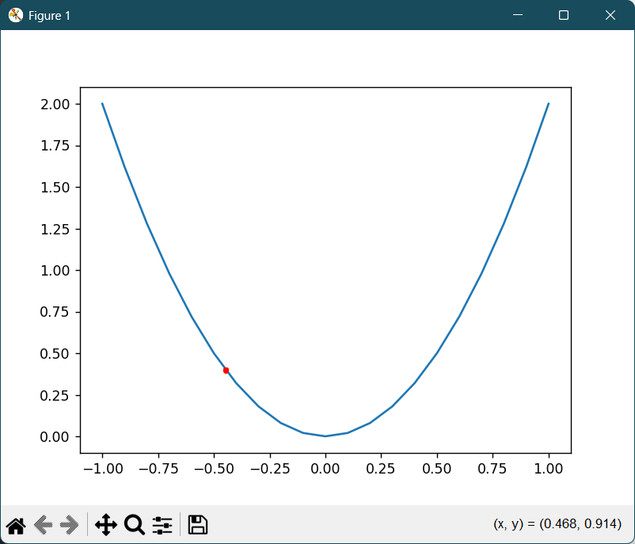
Fig 10.4 Gradient descent algorithm for y = 2*x^2

CONCLUSION:

