_{LATEX PROGRAM}

7) Develop a LaTeX script to create a document that consists of the following two mathematical equations
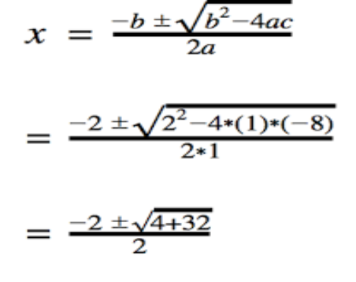
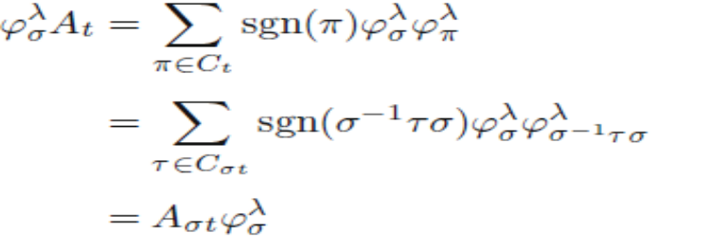
\documentclass{article}
\usepackage{amsmath}

\begin{document}

\begin{equation}
x = \frac{-b \pm \sqrt{b^2 - 4ac}}{2a}
= \frac{-2 \pm \sqrt{2^2 - 4 \cdot 1 \cdot (-8)}}{2 \cdot 1}
\end{equation}

\begin{equation}
= \frac{-2 \pm \sqrt{2^2 - 4 \cdot 1 \cdot (-8)}}{2 \cdot 1}
\end{equation}

\begin{equation}
= \frac{-2 \pm \sqrt{4 + 32}}{2}
\end{equation}

\begin{equation}
\varphi^\lambda_\sigma A_t = \sum_{\pi \in C_t} \text{sgn}(\pi) \varphi^\lambda_\sigma \varphi^\lambda_\pi
\end{equation}

\begin{equation}
= \sum_{\tau \in C_t} \text{sgn}(\sigma^{-1} \tau) \varphi^\lambda_\sigma \varphi^\lambda_{\sigma^{-1} \tau \sigma}
\end{equation}

\begin{equation}
= A_{\sigma t} \varphi^\lambda_\sigma
\end{equation}

\end{document}
8. Develop a LaTeX script to demonstrate the presentation of Numbered theorems, definitions, corollaries, and lemmas in the document

\documentclass{article}
\usepackage{amsthm}
\newtheorem{theorem}{Theorem}[section]
\newtheorem{definition}[theorem]{Definition}
\newtheorem{corollary}[theorem]{Corollary
\newtheorem{lemma}[theorem]{Lemma}
\begin{document}
\section{Mathematical Results}

\begin{theorem}
This is a theorem statement.
\end{theorem}
\begin{definition}
A prime number is a natural number greater than 1 that has no positive divisors other than 1 and itself.
\end{definition}
\begin{corollary}
Every even integer greater than 2 can be expressed as the sum of two prime numbers.
\end{corollary}
\begin{lemma}
The square of any odd integer is also odd.
\end{lemma}
\begin{theorem}[Fundamental Theorem of Arithmetic]
Every positive integer greater than 1 can be uniquely factorized into prime factors.
\end{theorem}
\label{thm:fundamental}
As stated in Theorem \ref{thm:fundamental}, every positive integer greater than 1 can be uniquely factorized into prime factors.
\end{document}

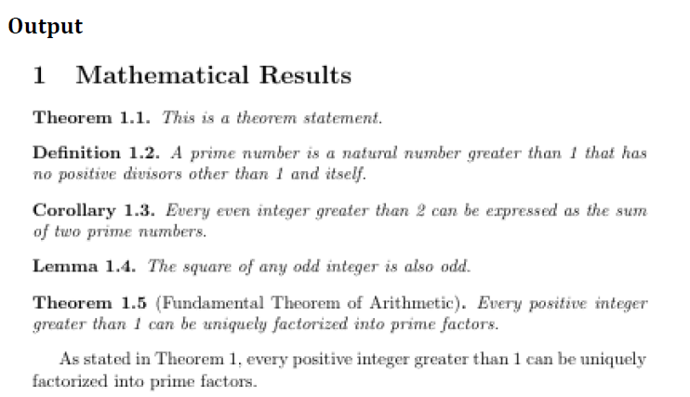

9. Develop a LaTeX script to create a document that consists of two paragraphs with a minimum of 10 citations in it and display the reference in the section
\documentclass[]{article}
\title{Research document}
\author{JBN}
\begin{document}
\maketitle
\section{Introduction}
\paragraph{}
introduction to machine learning \cite{ML}
\section{Deep learning}
\paragraph{Deeplearning}
Introduction to deep learning \cite{DL}
\bibliographystyle{plain} %alpha unsrt acm
\bibliography{bibilo.bib}
\end{document}
Bibilio.bib
@article{ML,
title={Machine learning for microbiologists},
author={Asnicar, Francesco and Thomas, Andrew Maltez and Passerini, Andrea and Waldron, Levi and Segata, Nicola},
journal={Nature Reviews Microbiology},
volume={22},
number={4},
pages={191--205},
year={2024},
publisher={Nature Publishing Group UK London}
}
@article{st,
title={Research in software engineering: an analysis of the literature},
author={Glass, Robert L. and Vessey, Iris and Ramesh, Venkataraman},
journal={Information and Software technology},
volume={44},
number={8},
pages={491--506},
year={2002},
publisher={Elsevier}
}
@book{DL,
title={Applied machine learning using mlr3 in R},
author={Bischl, Bernd and Sonabend, Raphael and Kotthoff, Lars and Lang, Michel},
year={2024},
publisher={CRC Press}
}

@article{cloud,
title={Cloud Computing for Large-Scale Resource Computation and Storage in Machine Learning},
author={Wang, Yufu and Bao, Qiaozhi and Wang, Jiufan and Su, Guangze and Xu, Xiaonan},
journal={Journal of Theory and Practice of Engineering Science},
volume={4},
number={03},
pages={163--171},
year={2024}
}
@misc{wiki,
title={Wikipedia},
howpublished="\url{https://en.wikipedia.org/wiki/Home_page}"
}
Output:
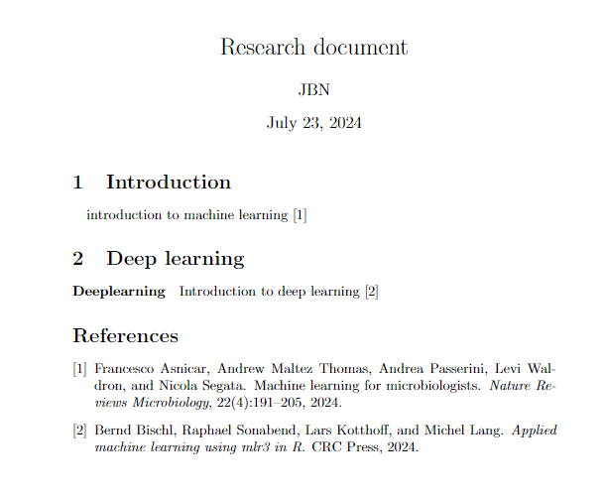

10. Develop a LaTeX script to design a simple tree diagram or hierarchical structure in the document with appropriate labels using the Tikz library
\documentclass{article}
\usepackage{tikz}
\begin{document}

\tikzstyle{level 1}=[level distance=1.5cm, sibling distance=3cm]
\tikzstyle{level 2}=[level distance=1.5cm, sibling distance=2cm]
\tikzstyle{level 3}=[level distance=1.5cm, sibling distance=1.5cm]

\begin{tikzpicture}[
level 1/.style={level distance=1.5cm, sibling distance=4cm},
level 2/.style={level distance=1.5cm, sibling distance=2cm},
level 3/.style={level distance=1.5cm, sibling distance=1.5cm}
]
\node {Root}
child
{
node {Child 1}
child { node {Grandchild 1} }
child { node {Grandchild 2} }
}
child
{
node {Child 2}
child { node {Grandchild 3} }
child { node {Grandchild 4} }
}
child
{
node {Child 3}
child { node {Grandchild 5} }
child { node {Grandchild 6} }
};
\end{tikzpicture}
\end{document}

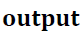
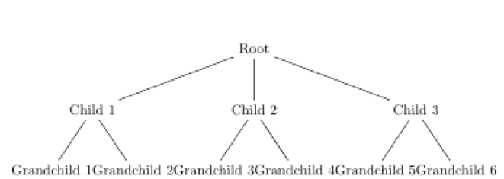

11. Develop a LaTeX script to present an algorithm in the document using algorithm/algorithmic/algorithm2e Library
\documentclass[12pt]{article}
\usepackage{amsmath}
\usepackage{graphicx}
\usepackage{hyperref}
\usepackage{geometry}
\usepackage[linesnumbered,ruled,vlined]{algorithm2e}

\geometry{a4paper, margin=1in}

\title{A Simple LaTeX Report with Algorithms}
\author{JBN}
\date{\today}

\begin{document}
​\section*{Algorithm Example}
​\begin{algorithm}[H]
​​\DontPrintSemicolon
​​\KwIn{Array $A$ of $n$ elements}
​​\KwOut{Maximum element in $A$}
​​\SetKwFunction{FindMax}{FindMax}
​​\SetKwProg{Fn}{Function}{:}{}
​​\Fn{\FindMax{$A, n$}}{
​​​$max \leftarrow A[0]$\;
​​​\For{$i \leftarrow 1$ \KwTo $n-1$}{
​​​​\If{$A[i] > max$}{
​​​​​$max \leftarrow A[i]$\;
​​​​}
​​​}
​​​\KwRet $max$\;
​​}
​\end{algorithm}
​​\end{document}

Output:
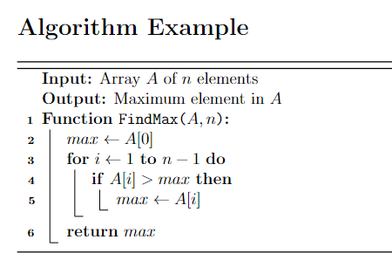

12. Develop a LaTeX script to create a simple report and article by using suitable commands and formats of user Choice

\documentclass{article}
\title{Sample Report}
\author{Author Name}
\date{\today}
\begin{document}
\maketitle
\section{Introduction}
This is the introduction section of the report.
\section{Methodology}
Here we explain the methodology used.
\section{Results}
The results of our study are presented here.
\section{Conclusion}
In conclusion, we summarize our findings.
\end{document}

