CCMS — Court Case Management System

Field | Details
**Frontend** | Angular 21
**Backend** | .NET 10 (ASP.NET Core Web API)
**Database** | Microsoft SQL Server 2022
**Deployment** | Microsoft Azure — Azure Kubernetes Service (AKS)

What You Are Building

A web portal that digitises the process of courts issuing legal orders to banks. Today this is done via physical paperwork. Your system replaces that with a digital workflow:

- A **Court Officer** raises a case online, attaches legal documents, and issues an order to a bank — either to freeze a defendant's account or to enquire the account balance.
- A **scheduled Batch Job** automatically validates whether the defendant's account exists in the bank's records(This job lives in Bank’s side) .
- A **Bank Officer** reviews validated cases and submits a formal response.

There are two roles. Each role sees a different interface. Both share the same login page.

Technology Stack

Layer | Technology
Frontend | Angular 21 (standalone components, Angular Material, Reactive Forms)
Backend | .NET 10 — ASP.NET Core Web API, Clean Architecture
ORM | Entity Framework Core 10
Database | Microsoft SQL Server 2022
Auth | JWT Bearer tokens
Background Job | .NET BackgroundService (hosted service)
Logging | Serilog
API Docs | Swagger / OpenAPI
Containers | Docker (multi-stage builds)
Orchestration | Azure Kubernetes Service (AKS)
Registry | Azure Container Registry (ACR)
CI/CD | Azure Devops

Authentication — JWT

The entire application is protected by JWT (JSON Web Token) based authentication. There is no session state on the server — the token itself carries all the identity information the API needs.

Security note

The JWT signing secret must be a strong random string (minimum 32 characters). In development store it in appsettings.json; in production it must come from a Kubernetes Secret / Azure Key Vault — never hardcoded in source code.

Module 1 — Court Portal

Login
A single login page serves both roles. After login the system detects the user's role and redirects them to the appropriate dashboard.

Court Dashboard
Shows the Court Officer a summary of all cases they have raised, grouped by their current status. The officer can navigate to create a new case or view an existing one.

Create Case
The Court Officer fills in details about the complainant and the defendant (name, identity numbers, bank account number, which bank). They choose an order type — either Freeze Account or Balance Enquiry. If freezing, they enter the amount to freeze. They must also upload three supporting documents: the signed court order, an Aadhaar copy, and a PAN copy. Once submitted the case is registered and awaits batch validation.

Case Number: The backend must auto-generate a unique case number at the moment of submission. Use the format CCMS-YYYYMMDD-XXXX where YYYYMMDD is today's date and XXXX is a zero-padded sequential counter (e.g. CCMS-20260610-0001). The Court Officer never types this — it is system-assigned and displayed after creation.

File Uploads: Accept PDF and common image formats (JPG, PNG) only. Maximum file size per attachment is 5 MB. All three files are mandatory — the form must not submit if any one is missing.

Case Detail (Court View)
A read-only view of a case. Sensitive defendant information (Aadhaar, PAN, account number) must be partially masked on screen. The page also shows whether the bank has responded yet, and if so, what the response was.

Module 2 — Batch Account Validation

A background service runs on a schedule (every 15 minutes) and processes all newly created cases. For each case it attempts to find the defendant's account in the bank's customer records using up to three match criteria — account number first, then Aadhaar, then PAN — trying each only if the previous one finds no match.

- If a match is found: the case is marked as validated and the matched account details are stored against the case.
- If no match is found: the case is automatically closed with a "no account found" response — no bank officer action is needed.

Important — scope of each run: The batch job must only process cases that are currently in the Pending state. Cases that are already in Account Validated, Account Not Found, Freeze Applied, or Balance Provided state must be left completely untouched. Do not re-evaluate or overwrite any case that has already been validated or resolved — even if the batch runs again while that case is still awaiting a bank officer's response.

A Bank Officer can also trigger this job manually from the Bank Dashboard without waiting for the next scheduled run.

Every run (scheduled or manual) is logged with its outcome statistics and duration.

Module 3 — Bank Portal

Bank Dashboard
Shows the Bank Officer a summary of cases relevant to their bank, grouped by status. They can see how many cases need their attention, how many are pending batch validation, and how many are already resolved. A batch control panel shows the last run time and lets the officer trigger a manual run.

Case Inbox
A tabbed view of all cases:
- Cases awaiting the officer's action (account has been validated by the batch job)
- Cases the officer has already completed
- Cases that were automatically closed (no account found)
- Cases still waiting for batch validation to run

Case Detail (Bank View)
The Bank Officer sees the full court order details, the batch validation result (matched account, balance, account status), and the uploaded documents. For cases awaiting action they see a response form:

- **Balance Enquiry**: The account balance from the batch result is pre-filled. The officer can adjust it and add remarks before submitting.
- **Freeze Account**: The officer must download and read the court order PDF to determine the freeze amount, then enter it manually along with remarks before submitting.

Once submitted, the case is closed and the Court Officer can see the bank's response on their end.

Case Lifecycle & Bank Handling Scenarios

This section describes every state a case can be in and what must happen at each stage. Design your database, API, and UI around these rules.

Case States

A case moves through the following states in order. Some transitions are done by the system automatically; others require a bank officer's action.

State | Who Sets It | What It Means
**Pending** | System on case creation | Case created by court, batch has not run yet
**Account Validated** | Batch job | Defendant's account was found; bank officer must now act
**Account Not Found** | Batch job (automatic) | No account matched; case is auto-closed with a system response
**Freeze Applied** | Bank Officer | Officer confirmed the account is frozen for the requested amount
**Balance Provided** | Bank Officer | Officer submitted the account balance in response to the enquiry

The final three states are **terminal** — a case in these states cannot be modified further.
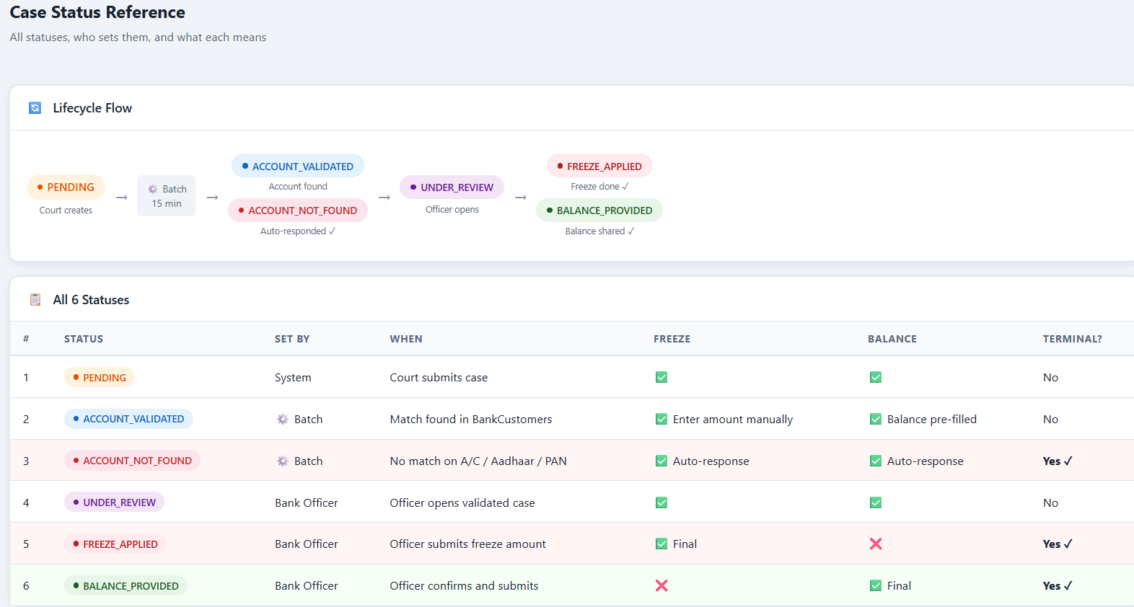

Scenario 1 — Account Found, Freeze Order

- Court Officer creates a case with order type **Freeze Account** and uploads documents. Case state: **Pending**.
- Batch job runs. It finds the defendant's account in the bank's records. Case state: **Account Validated**. The matched account number, current balance, and account status are stored against the case.
- Bank Officer opens the **Awaiting Action** tab in the Case Inbox and sees this case.
- Bank Officer opens the case detail. They see:
  - - The court order details (who the defendant is, how much to freeze)
  - - The batch validation result (which account was matched, its current balance and status)
  - - A download link for the Court Order PDF — the officer must read it to confirm the freeze amount
- Bank Officer enters the freeze amount (read from the PDF), adds remarks, and submits.
- Case state changes to **Freeze Applied**. The case moves out of Awaiting Action and into Completed.
- Court Officer refreshes their case detail and now sees the bank's response — freeze amount applied, remarks, and timestamp.

Scenario 2 — Account Found, Balance Enquiry

- Court Officer creates a case with order type **Balance Enquiry**. Case state: **Pending**.
- Batch job runs. Account is found. Case state: **Account Validated**. Balance stored from bank records.
- Bank Officer sees the case in the **Awaiting Action** tab.
- Bank Officer opens the case. The response form shows the account balance pre-filled from the batch result. The officer can adjust this value if needed (e.g., balance has changed since batch ran) and adds remarks.
- Bank Officer submits.
- Case state changes to **Balance Provided**.
- Court Officer sees the reported balance, remarks, and timestamp on their case detail.

Scenario 3 — Account Not Found (Fully Automatic)

- Court Officer creates a case. Case state: **Pending**.
- Batch job runs. All three match attempts (account number, Aadhaar, PAN) return no result.
- The system automatically:
- - Changes the case state to **Account Not Found**
- - Creates a system-generated response: *"No matching account found in bank records."* (no bank officer involved)
- No action is required from the Bank Officer. The case appears in the **Auto-Resolved** tab for reference only.
- Court Officer sees the auto-response on their case detail with a clear indication that no account was found.

Scenario 4 — Preventing Duplicate Responses

A case may only receive one response. Once a bank officer submits a response:
- The response form must no longer be shown for that case
- The API must reject a second response submission for the same case
- The case detail page for a completed case should show the submitted response in read-only view

Scenario 5 — Cases Pending Batch (No Officer Action Yet)

Some cases will be in the Pending state because the batch job has not run since they were created. The Bank Officer can see these in the Pending Batch tab. There is nothing for the officer to act on yet — these cases are informational. The officer may choose to trigger the batch job manually from the dashboard to process them immediately.

Summary of Bank Officer Actions

What the officer can do | When
View case details and download attachments | Any time a case is visible to them
Trigger the batch job manually | Any time, from the dashboard
Submit a Freeze response | Only when case is in **Account Validated** state
Submit a Balance response | Only when case is in **Account Validated** state
View completed cases | Read-only, no further action possible

Data Sensitivity Requirements

Certain defendant details must never be displayed in full on any screen — they must be partially hidden (masked). Design your masking so that only the last few characters are visible. This applies to Aadhaar numbers, PAN numbers, and bank account numbers.

The raw values are stored in the database and used for batch matching. Masking is applied in the API response layer before data reaches the frontend.

Deployment Requirements

Both the Angular frontend and the .NET backend must be containerised using Docker. The system must run on Azure Kubernetes Service with:
- Separate deployments for the frontend and backend, each with multiple replicas
- An NGINX ingress controller routing traffic to the correct kubernetes service
- Database connection strings and JWT secrets managed as Kubernetes Secrets (not hardcoded).Any non-sensitive information can be managed within appsettings and it needs to be set using Kubernetes ConfigMap
- Azure Devops pipeline that builds images and deploys to AKS on every push to `main`

Additional points

- No user self-registration — seed two users (one Court, one Bank) directly in the database
- Files stored on the local filesystem during development; Azure Blob Storage in production
- Account matching is done by simple string comparison against a seeded bank customer table
- Create Sample PDF files for testing the upload limits of 5 MB size.

Glossary

Term | Meaning
**Court Officer** | User with the Court role who raises and tracks cases
**Bank Officer** | User with the Bank role who processes and responds to cases
**Batch Job** | Scheduled background process that validates defendant accounts
**Freeze Order** | Court instruction to freeze a specified amount in a defendant's account
**Balance Enquiry** | Court instruction to the bank to report the defendant's account balance
**Masking** | Displaying only partial sensitive data on screen, e.g. `****1234`
**Clean Architecture** | Layered project design: Domain → Application → Infrastructure → API
**AKS** | Azure Kubernetes Service — managed container orchestration
**Ingress** | Kubernetes component that routes external HTTP traffic into the cluster
**JWT** | JSON Web Token — used to authenticate and identify users in API calls

