C++ Asynchronous Concurrency
Quick Reference & Refresher Guide
C++11 / C++14 / C++17 / C++20
Headers: <thread> <mutex> <condition_variable> <atomic> <future> <semaphore> <latch> <barrier> <coroutine>

1. std::thread
Represents an OS thread. Must be joined or detached before destruction, or std::terminate() is called.
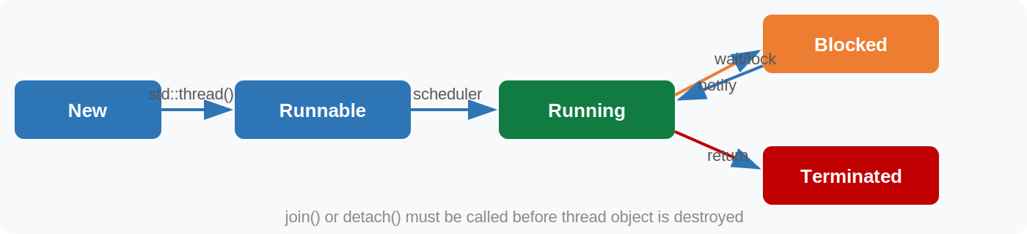
Fig 1 — Thread lifecycle states

Construction & Basic Usage
#include <thread>
#include <iostream>

void task(int id) { std::cout << "thread " << id << "\n"; }

int main() {
std::thread t1(task, 1); // spawn with args
std::thread t2([]{ task(2); }); // lambda
t1.join(); // wait for t1
t2.detach(); // release t2 (runs freely)
}

Useful Queries
std::thread::id id = t.get_id(); // thread ID
unsigned hw = std::thread::hardware_concurrency(); // logical CPU count (hint)
bool joinable = t.joinable(); // false after join/detach

std::this_thread Utilities
#include <chrono>
using namespace std::chrono_literals;

std::this_thread::sleep_for(100ms); // sleep relative
std::this_thread::sleep_until(tp); // sleep until time_point
std::this_thread::yield(); // hint scheduler to switch
auto tid = std::this_thread::get_id();
⚑ Never copy a thread object — move it: std::thread t2 = std::move(t1);

2. Mutual Exclusion — Mutexes & Locks
Mutexes guard shared data. Always use RAII wrappers (lock_guard / unique_lock) — never call lock()/unlock() manually.
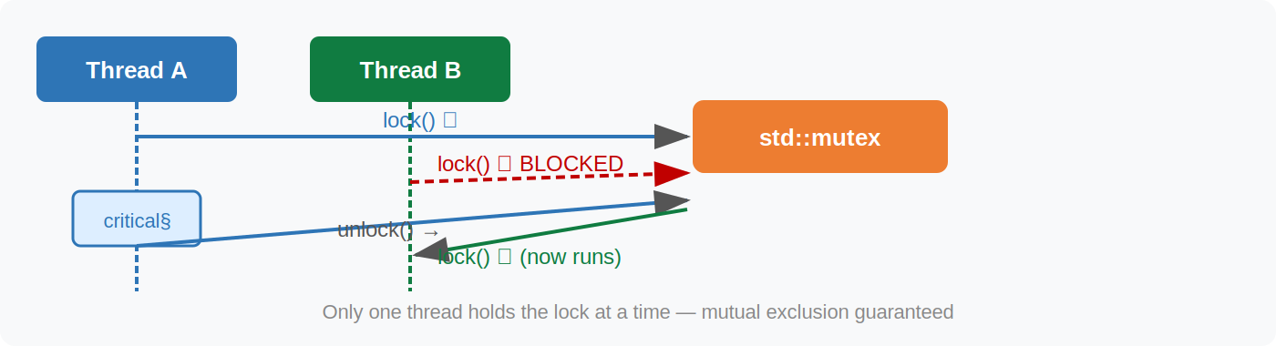
Fig 2 — Mutex contention: Thread B blocks until A releases

2.1 std::mutex
#include <mutex>

std::mutex mtx;
int shared = 0;

void increment() {
std::lock_guard<std::mutex> lk(mtx); // RAII — unlocks on scope exit
++shared;
} // lk destructs → unlock

2.2 std::lock_guard (C++11)
Minimal RAII wrapper: locks on construction, unlocks on destruction. No manual control.
{
std::lock_guard<std::mutex> guard(mtx); // locked
// ... critical section ...
} // automatically unlocked

2.3 std::unique_lock (C++11)
Flexible RAII wrapper: deferred locking, timed tries, manual lock/unlock, and transferable ownership. Required by condition_variable.
std::unique_lock<std::mutex> ul(mtx); // locks immediately
ul.unlock(); // manual unlock
ul.lock(); // re-lock

// Deferred lock
std::unique_lock<std::mutex> ul2(mtx, std::defer_lock);
ul2.try_lock(); // non-blocking attempt

// Timed lock
if (ul2.try_lock_for(50ms)) { /* got it */ } // requires timed_mutex

2.4 std::scoped_lock (C++17)
Locks multiple mutexes simultaneously using deadlock-avoidance algorithm. Prefer over std::lock() + adopt_lock.
std::mutex m1, m2;

void safe_transfer() {
std::scoped_lock lk(m1, m2); // acquires both, deadlock-safe
// ...
}

2.5 std::shared_mutex / std::shared_lock (C++17)
Reader-Writer lock: multiple readers OR one writer at a time. Ideal for read-heavy data structures.
#include <shared_mutex>

std::shared_mutex rw;
int data = 0;

void read() {
std::shared_lock lk(rw); // shared (multiple readers OK)
std::cout << data;
}
void write(int v) {
std::unique_lock lk(rw); // exclusive (blocks all)
data = v;
}

2.6 std::recursive_mutex / std::timed_mutex
// recursive_mutex — same thread can lock multiple times (must unlock equally)
std::recursive_mutex rmtx;
void recurse(int n) {
std::lock_guard lk(rmtx);
if (n > 0) recurse(n - 1); // safe with recursive_mutex
}

// timed_mutex — non-blocking attempts with timeout
std::timed_mutex tmtx;
if (tmtx.try_lock_for(10ms)) {
// got the lock
tmtx.unlock();
}

Quick Reference — Lock Types
Type / Class | Key Method / Usage | Notes
lock_guard | ctor lock / dtor unlock | C++11, non-moveable, minimal overhead
unique_lock | manual lock/unlock/try | C++11, needed for condition_variable
scoped_lock | multi-mutex deadlock-safe ctor | C++17, preferred for 2+ mutexes
shared_lock | shared (read) ownership | C++14, pairs with shared_mutex
shared_mutex | shared_lock / unique_lock | C++17 reader-writer pattern
recursive_mutex | same-thread re-entrant locking | C++11, heavier than plain mutex
timed_mutex | try_lock_for / try_lock_until | C++11, bounded wait

3. std::condition_variable
Allows a thread to sleep until a condition becomes true. Always used with a unique_lock. Protects against spurious wakeups via a predicate overload.
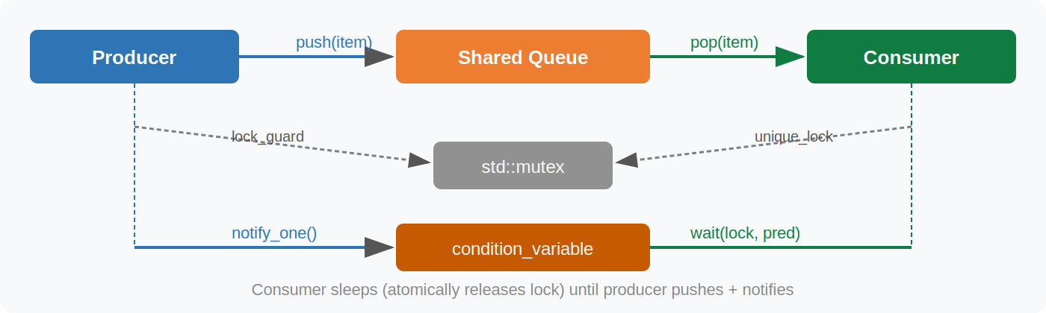
Fig 3 — condition_variable producer-consumer pattern

Core Pattern
#include <condition_variable>
#include <mutex>
#include <queue>

std::mutex mtx;
std::condition_variable cv;
std::queue<int> q;

// Producer thread
void produce(int v) {
{
std::lock_guard lk(mtx);
q.push(v);
}
cv.notify_one(); // wake one waiting consumer
}

// Consumer thread
int consume() {
std::unique_lock lk(mtx);
cv.wait(lk, []{ return !q.empty(); }); // spurious-wakeup safe
int v = q.front(); q.pop();
return v;
}

wait with timeout
cv.wait_for(lk, 100ms, pred); // returns false on timeout
cv.wait_until(lk, deadline, pred); // absolute time_point variant

notify_one vs notify_all
cv.notify_one(); // wake one waiter (use when any one consumer suffices)
cv.notify_all(); // wake every waiter (use when condition affects all)
✓ Always check the predicate: condition_variable.wait(lock, predicate) is equivalent to: while (!predicate()) cv.wait(lock);
⚑ std::condition_variable_any works with any Lockable, not just unique_lock (slightly heavier).

4. std::atomic & Memory Ordering
Lock-free, race-condition-free operations on scalar types. The compiler emits appropriate hardware instructions (CAS, fence, etc.).

4.1 Basic Atomic Operations
#include <atomic>

std::atomic<int> counter{0};
std::atomic<bool> ready{false};

counter.fetch_add(1); // atomic ++
counter.fetch_sub(1); // atomic --
int old = counter.exchange(10); // swap and return old
counter.store(42); // write
int v = counter.load(); // read
int expected = 5;
counter.compare_exchange_strong(expected, 99); // CAS

4.2 Atomic Flags (lock-free spinlock)
std::atomic_flag flag = ATOMIC_FLAG_INIT;

// Spinlock
void lock() { while (flag.test_and_set(std::memory_order_acquire)) {} }
void unlock() { flag.clear(std::memory_order_release); }

// C++20: test() without setting
bool b = flag.test();

4.3 Memory Ordering
Controls visibility and reordering of memory operations around atomics. Weakest-to-strongest:
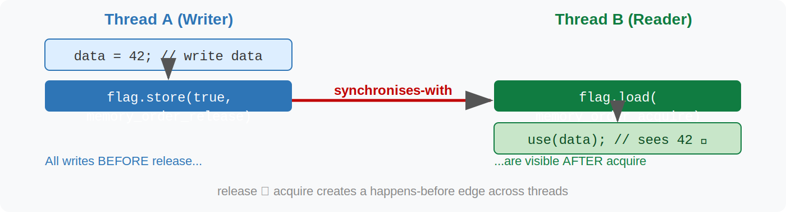
Fig 4 — acquire/release establishes a happens-before edge across threads

// relaxed — only atomicity; no ordering guarantees
counter.fetch_add(1, std::memory_order_relaxed); // stats counters

// acquire/release — synchronises-with relationship
flag.store(true, std::memory_order_release); // writer
flag.load(std::memory_order_acquire); // reader (sees all writes before release)

// acq_rel — read-modify-write: acquire + release in one
flag.fetch_add(1, std::memory_order_acq_rel);

// seq_cst — default; total global order (expensive on ARM/POWER)
flag.store(true); // same as memory_order_seq_cst

Memory Ordering Quick Reference
Type / Class | Key Method / Usage | Notes
relaxed | No ordering; only atomicity | Counters, stats
acquire | No loads move before this load | Paired with release on write side
release | No stores move after this store | Paired with acquire on read side
acq_rel | Both acquire + release on RMW | fetch_add on shared flag
seq_cst | Total order across all threads | Default; safest; most expensive

5. std::future & std::promise
One-shot asynchronous channel: the promise holds the write end and the future holds the read end. Calling get() blocks until the value (or exception) is ready.
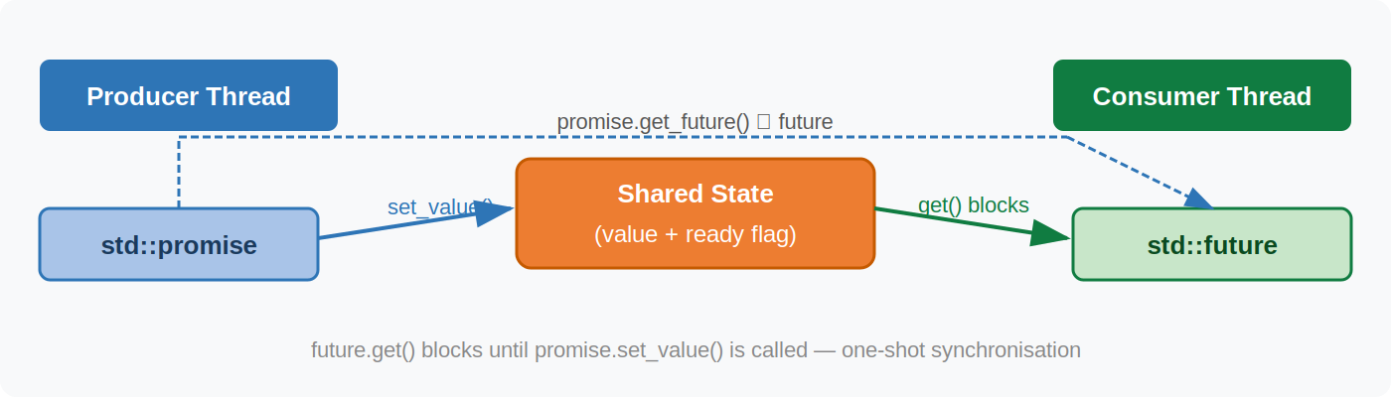
Fig 5 — promise / future shared state

5.1 std::promise / std::future
#include <future>
#include <thread>

std::promise<int> prom;
std::future<int> fut = prom.get_future(); // one future per promise

std::thread worker([&prom]{
int result = 42;
prom.set_value(result); // unblocks fut.get()
});

int val = fut.get(); // blocks until set_value
worker.join();

Propagating Exceptions
std::thread worker([&prom]{
try { /* work */ }
catch (...) {
prom.set_exception(std::current_exception()); // passes exception to fut
}
});
try { fut.get(); }
catch (const std::exception& e) { /* rethrown here */ }

5.2 std::shared_future
Multiple threads can wait on the same result. Created by calling future.share().
std::shared_future<int> sf = fut.share(); // fut is now invalid
auto sf2 = sf; // copy — both wait on same result

std::thread([sf]{ int v = sf.get(); }).detach(); // each thread calls .get()
✓ Use shared_future when broadcasting a single result to N consumers.
⚑ future::get() may only be called once; shared_future::get() is repeatable and thread-safe.

6. std::async
Simplest way to run a callable asynchronously and retrieve its result via a future. Launch policy controls whether a new thread is used.
#include <future>

// async::launch::async — guaranteed new thread
auto fut = std::async(std::launch::async, []{
return heavy_computation();
});

// async::launch::deferred — runs lazily on fut.get() (same thread)
auto lazy = std::async(std::launch::deferred, []{ return 1; });
lazy.get(); // runs NOW, synchronously

// default (async | deferred) — implementation decides
auto f = std::async([]{ return 99; });
int result = f.get();
⚑ The destructor of the future returned by std::async blocks if the task is still running (with launch::async). Store the future explicitly to control lifetime.
✓ Prefer std::launch::async explicitly when you need guaranteed concurrency.

7. std::packaged_task
Wraps a callable and connects it to a future. Unlike async, you control when and where the task runs. Useful for task queues and thread pools.
#include <future>
#include <thread>

std::packaged_task<int(int, int)> task([](int a, int b){ return a + b; });
std::future<int> result = task.get_future();

std::thread t(std::move(task), 3, 4); // runs task on new thread
int sum = result.get(); // = 7
t.join();

Thread Pool Pattern
// Submit work to a queue of packaged_tasks
std::queue<std::packaged_task<void()>> work_queue;

auto enqueue = [&](auto fn) {
std::packaged_task<void()> pt(fn);
auto fut = pt.get_future();
work_queue.push(std::move(pt));
return fut;
};

auto fut = enqueue([]{ /* work */ });
work_queue.front()(); // execute (worker thread would do this)
fut.get();

8. std::latch (C++20)
Single-use countdown counter. N threads decrement it; one or more threads wait at zero. Cannot be reset — use barrier for repeating phases.
#include <latch>
#include <thread>
#include <vector>

const int N = 4;
std::latch done(N); // countdown from 4

std::vector<std::thread> threads;
for (int i = 0; i < N; ++i)
threads.emplace_back([&, i]{
/* do work */
done.count_down(); // each thread decrements once
});

done.wait(); // main blocks until count == 0
// All 4 workers are done here

// arrive_and_wait() — count down AND wait in one call
std::latch start_gate(N + 1);
// workers call start_gate.arrive_and_wait();
// coordinator calls start_gate.arrive_and_wait(); — everyone unblocks together
✓ Latch is perfect for: wait-for-all-setup, one-shot rendezvous, or counting down work items.

9. std::barrier (C++20)
Reusable synchronisation point for a fixed number of threads. All threads arrive, an optional completion function runs, then all are released to the next phase.
#include <barrier>

std::barrier sync(4, []{
// completion function — runs once per phase in one thread
std::cout << "phase done\n";
});

// Each of 4 worker threads:
for (int phase = 0; phase < 3; ++phase) {
/* do phase work */
sync.arrive_and_wait(); // block until all 4 arrive → then proceed
}

// A thread that leaves the barrier group permanently:
sync.arrive_and_drop(); // counts down but won't wait or participate next phase
✓ Use barrier for iterative parallel algorithms where threads work in lockstep phases.

10. std::counting_semaphore / std::binary_semaphore (C++20)
Controls access to a resource with a maximum concurrency count. Unlike mutexes, acquire and release can be called from different threads.
#include <semaphore>

// counting_semaphore<N>: at most N concurrent acquires
std::counting_semaphore<3> pool(3); // 3 slots available

// Worker: acquire before using resource, release after
void use_resource() {
pool.acquire(); // decrements; blocks if count == 0
/* use limited resource */
pool.release(); // increments; unblocks a waiter
}

// Non-blocking try
if (pool.try_acquire()) { /* got it */ pool.release(); }
// Timed try
if (pool.try_acquire_for(50ms)) { /* ... */ pool.release(); }

// Binary semaphore — specialisation with max == 1 (fastest)
std::binary_semaphore signal(0); // starts at 0 (locked)
// Producer:
signal.release(); // post (unlocks)
// Consumer:
signal.acquire(); // wait (blocks until released)
⚑ binary_semaphore is lighter than mutex because release() can be called from a different thread than acquire().

11. std::jthread & std::stop_token (C++20)
std::jthread is a cooperative-cancellation, auto-joining thread. It automatically joins on destruction (no std::terminate risk) and supports stop requests via stop_token.
#include <thread>

// jthread auto-joins on destruction — no need to call join()
{
std::jthread t([](std::stop_token st){
while (!st.stop_requested()) {
/* do work */
}
});
// ... somewhere else ...
t.request_stop(); // signals the token (non-blocking)
} // dtor calls request_stop() + join() automatically

// stop_callback — register cleanup on stop request
std::jthread t([](std::stop_token st){
std::stop_callback cb(st, []{ /* cleanup on stop */ });
while (!st.stop_requested()) { /* ... */ }
});
✓ jthread is the modern default — prefer it over std::thread for cancellable tasks.
⚑ stop_source can be shared to coordinate stopping from outside the thread.
std::stop_source src;
std::jthread t1([](std::stop_token st){ while(!st.stop_requested()){/*...*/} },
src.get_token());
std::jthread t2([](std::stop_token st){ while(!st.stop_requested()){/*...*/} },
src.get_token());
src.request_stop(); // stops both t1 and t2 via the shared source

12. C++20 Coroutines
Functions that can suspend and resume execution. The compiler transforms the body into a state machine allocated on the heap. Three keywords: co_await, co_yield, co_return.
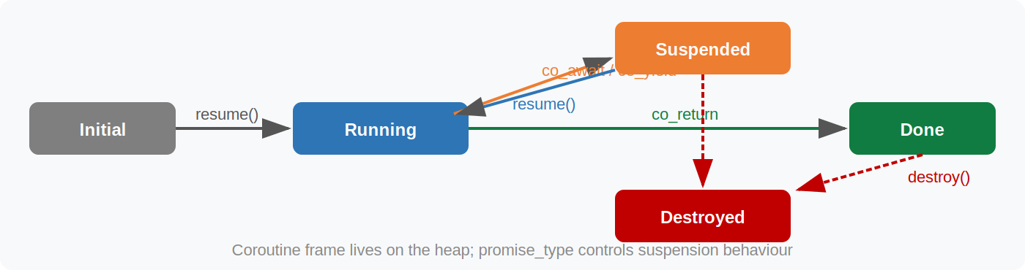
Fig 6 — Coroutine state machine

12.1 Key Keywords
co_await expr; // suspend until expr's awaitable is ready
co_yield value; // suspend and yield value to caller
co_return value; // final return, destroys coroutine frame

12.2 Generator Pattern (co_yield)
// Minimal generator using std::generator (C++23) or custom promise
#include <generator> // C++23 std::generator
// (libcoro / cppcoro for C++20 polyfill)

std::generator<int> fibonacci() {
int a = 0, b = 1;
while (true) {
co_yield a; // suspend and return a to caller
std::tie(a, b) = std::make_tuple(b, a + b);
}
}

for (int x : fibonacci() | std::views::take(10))
std::cout << x << " "; // 0 1 1 2 3 5 8 13 21 34

12.3 Awaitable / Awaiter Protocol
// Custom awaitable — the three required methods
struct MyAwaitable {
bool await_ready() { return false; } // false = always suspend
void await_suspend(std::coroutine_handle<> h) {
// store h somewhere; resume h later from another thread
scheduler.post(h);
}
int await_return() { return 42; } // value of co_await expr
};

// Usage
Task<int> my_coro() {
int v = co_await MyAwaitable{};
co_return v + 1;
}

12.4 Task (fire-and-forget / async task)
// Task<T> is a common coroutine return type (from cppcoro / custom)
Task<int> fetch_data() {
auto conn = co_await connect("db://...");
auto rows = co_await conn.query("SELECT ...");
co_return rows.size();
}

// Composing coroutines
Task<void> run() {
int n = co_await fetch_data(); // suspends here until fetch_data completes
std::cout << n;
}

12.5 promise_type Skeleton
template<typename T>
struct Task {
struct promise_type {
Task get_return_object() { return {std::coroutine_handle<promise_type>::from_promise(*this)}; }
std::suspend_never initial_suspend() { return {}; } // start immediately
std::suspend_always final_suspend() noexcept { return {}; } // suspend at end
void return_value(T v) { value = v; }
void unhandled_exception() { std::rethrow_exception(std::current_exception()); }
T value;
};
std::coroutine_handle<promise_type> handle;
T get() { return handle.promise().value; }
~Task() { if (handle) handle.destroy(); }
};
⚑ suspend_never means 'don't suspend here'; suspend_always means 'always suspend here'. initial_suspend controls eager vs lazy start.

13. At-a-Glance Summary

Type / Class | Key Method / Usage | Notes
std::thread | join() / detach() | C++11 OS thread, MUST join/detach
std::jthread | request_stop() / auto-join | C++20 preferred thread
std::mutex | lock() / unlock() | Basic mutual exclusion
std::lock_guard | RAII, ctor lock / dtor unlock | C++11, non-moveable
std::unique_lock | deferred, timed, manual | Required for cond_var
std::scoped_lock | multi-mutex safe | C++17 deadlock-free
std::shared_mutex | shared_lock / unique_lock | C++17 reader-writer
std::condition_variable | wait(lk, pred) / notify_one() | Always use predicate
std::atomic<T> | load/store/fetch_add/CAS | Lock-free primitives
std::promise<T> | set_value() / set_exception() | Write end of channel
std::future<T> | get() / wait() / wait_for() | Read end, one-shot
std::shared_future<T> | get() multi-thread safe | Broadcast result
std::async | launch::async / deferred | Easiest async
std::packaged_task<F> | get_future() + operator() | Deferred callable
std::latch | count_down() / wait() | C++20 one-shot gate
std::barrier | arrive_and_wait() | C++20 reusable phase
counting_semaphore<N> | acquire() / release() | C++20 throttle N
binary_semaphore | acquire() / release() | C++20 signal/notify

14. Common Pitfalls

Data Race
Accessing a non-atomic variable from multiple threads without synchronisation is undefined behaviour. Use mutex or atomic.
Deadlock
Occurs when thread A holds mutex 1 and waits for mutex 2, while thread B holds mutex 2 and waits for mutex 1. Fix: always acquire mutexes in the same order, or use std::scoped_lock.
// Deadlock risk:
lock(m1); lock(m2); // thread A
lock(m2); lock(m1); // thread B ← DEADLOCK if interleaved
// Safe:
std::scoped_lock lk(m1, m2); // deadlock-avoidance algorithm
Spurious Wakeup
condition_variable::wait() can return without notify(). Always use the predicate overload:
// BAD
cv.wait(lk); // may wake spuriously
// GOOD
cv.wait(lk, []{ return ready; }); // loops internally until predicate is true
Future Abandoned / std::terminate on Thread Destruction
// DANGER: thread destroyed without join/detach
{
std::thread t([]{ /* ... */ });
} // ← std::terminate() called!

// Fix: use jthread (auto-joins) or ensure join/detach
{
std::jthread t([]{ /* ... */ });
} // ← safe: dtor joins automatically
memory_order_relaxed Misuse
Relaxed ordering provides no synchronisation. Only use it when you need atomicity but not ordering (e.g., counters where the exact value is not a signal to another thread).

15. thread_local Storage
The thread_local keyword gives each thread its own independent copy of a variable. Useful for per-thread caches, random seeds, or error states — without any locking.

Basic Usage
thread_local int tls_counter = 0; // each thread has its own counter

void increment() {
++tls_counter; // no mutex needed — purely per-thread
}

void print_id() {
thread_local std::string id = generate_id(); // initialized once per thread
std::cout << id;
}

Class Static + thread_local
struct Logger {
// Each thread gets its own Logger instance
static thread_local Logger instance;
std::vector<std::string> log;
void write(const std::string& msg) { log.push_back(msg); }
};
thread_local Logger Logger::instance;

Lifetime & Initialization
// Initialized the first time the thread reaches the declaration
// Destroyed when the thread exits

thread_local std::mt19937 rng(std::random_device{}()); // per-thread RNG
// rng is initialized once per thread — no shared state, no locking needed
⚑ thread_local works on global, function-static, and non-static class members. It implies static storage duration within the thread.
✓ Per-thread caches, per-thread RNG engines, and per-thread arena allocators are the canonical use cases.

16. std::call_once & std::once_flag
Guarantees a callable is executed exactly once, even when called concurrently from multiple threads. The canonical tool for thread-safe lazy initialization.
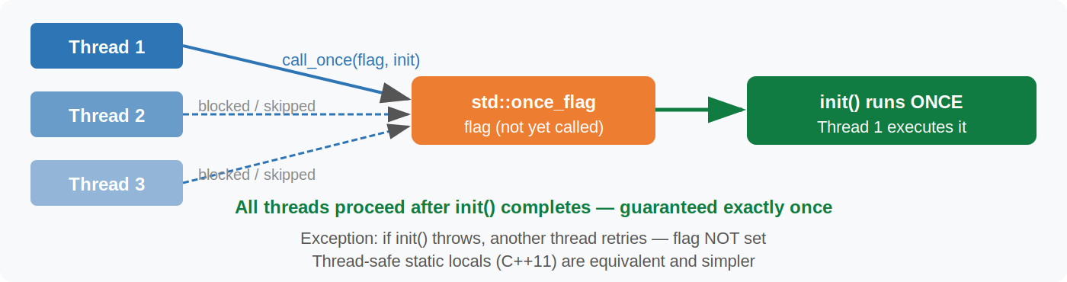
Fig 7 — call_once: only one thread runs init(); others wait then proceed

Core Pattern
#include <mutex>

std::once_flag init_flag;

void initialize() { /* expensive one-time setup */ }

void use_resource() {
std::call_once(init_flag, initialize); // safe across threads
// after this line, initialize() has run exactly once
}

Lazy Singleton (thread-safe)
class Database {
static Database* instance_;
static std::once_flag flag_;
public:
static Database& get() {
std::call_once(flag_, []{ instance_ = new Database(); });
return *instance_;
}
};

// Simpler C++11 equivalent using function-static (preferred):
Database& get_db() {
static Database db; // guaranteed initialized exactly once (C++11)
return db;
}

Exception Handling
std::once_flag flag;
std::call_once(flag, []{
throw std::runtime_error("init failed"); // flag NOT marked as done
});
// another thread (or retry) will attempt call_once again
// once init succeeds without throwing, flag is set permanently
✓ C++11 guarantees that function-local statics are initialized exactly once in a thread-safe manner. Prefer static MyType x; over call_once for singleton-style init.

17. volatile vs std::atomic
A common and dangerous misconception: volatile does NOT provide thread safety or atomic access. They solve completely different problems.
// volatile — tells the compiler: "don't cache in a register; re-read from memory every time"
// Use for: memory-mapped I/O, hardware registers, setjmp/longjmp
volatile int hw_register = 0; // compiler won't optimize away reads

// std::atomic — thread-safe read/modify/write with ordering guarantees
// Use for: shared data between threads
std::atomic<int> shared_val{0}; // safe across threads

volatile vs atomic comparison
Type / Class | Key Method / Usage | Notes
volatile | Suppress register caching | HW registers, signal handlers only
atomic<T> | Thread-safe R/M/W + ordering | ALL shared-state concurrency
volatile atomic<T> | Both semantics combined | Memory-mapped atomic registers (rare)

// ❌ WRONG — volatile does NOT prevent data races
volatile bool done = false; // race condition!
// Thread A: done = true;
// Thread B: while(!done) {} // UB: compiler may hoist the read

// ✅ CORRECT — atomic provides ordering guarantee
std::atomic<bool> done{false};
// Thread A: done.store(true, std::memory_order_release);
// Thread B: while(!done.load(std::memory_order_acquire)) {}
⚑ On x86, volatile reads/writes happen to be atomic for aligned int-sized types, but this is an implementation detail — not guaranteed by the standard. Never rely on it.

18. False Sharing & Cache-Line Padding
False sharing occurs when two threads write to different variables that happen to share the same CPU cache line (~64 bytes). Each write forces the other core to reload the entire cache line, causing a severe performance penalty despite no logical sharing.
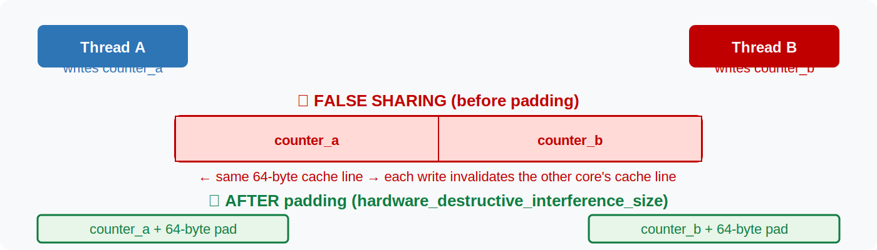
Fig 8 — False sharing: independent variables on the same cache line cause cross-core invalidation

Diagnosis & Fix
#include <new> // std::hardware_destructive_interference_size (C++17)

// ❌ FALSE SHARING — both counters likely on the same cache line
struct Counters {
std::atomic<int> a{0};
std::atomic<int> b{0};
};

// ✅ PADDED — force each counter to its own cache line
struct alignas(std::hardware_destructive_interference_size) PaddedCounter {
std::atomic<int> value{0};
// implicit padding to fill the cache line
};

PaddedCounter counter_a; // thread A writes this
PaddedCounter counter_b; // thread B writes this — different cache lines

Manual Padding Fallback
// If hardware_destructive_interference_size is unavailable (pre-C++17):
constexpr std::size_t CACHE_LINE = 64;

struct alignas(CACHE_LINE) Counter {
std::atomic<long> value{0};
char padding[CACHE_LINE - sizeof(std::atomic<long>)];
};

True Sharing vs False Sharing
// hardware_constructive_interference_size — minimum size to keep data
// that IS shared between threads on the SAME cache line (good for read-only)
struct SharedReadOnly {
alignas(std::hardware_constructive_interference_size)
int x, y, z; // keep together — one cache-line fetch
};
✓ Profile before padding. False sharing is only measurable at high thread counts or very tight loops. Over-padding wastes memory.

19. Common Concurrency Patterns

19.1 Double-Checked Locking (DCLP) — correct C++11 version
Use atomics to avoid taking the mutex on every call, while still being safe.
std::atomic<Resource*> resource{nullptr};
std::mutex init_mtx;

Resource* get_resource() {
Resource* p = resource.load(std::memory_order_acquire);
if (!p) {
std::lock_guard lk(init_mtx);
p = resource.load(std::memory_order_relaxed);
if (!p) {
p = new Resource();
resource.store(p, std::memory_order_release);
}
}
return p;
}
✓ In modern C++, prefer the static-local idiom — it is simpler and equally correct.

19.2 Single-Producer / Single-Consumer Lock-Free Queue
When producer and consumer are exactly one thread each, a ring buffer can be implemented without any mutex.
template<typename T, std::size_t N>
class SPSCQueue {
std::array<T, N> buf;
std::atomic<std::size_t> head{0}, tail{0};
public:
bool push(const T& v) {
auto t = tail.load(std::memory_order_relaxed);
if ((t + 1) % N == head.load(std::memory_order_acquire)) return false; // full
buf[t] = v;
tail.store((t + 1) % N, std::memory_order_release);
return true;
}
bool pop(T& out) {
auto h = head.load(std::memory_order_relaxed);
if (h == tail.load(std::memory_order_acquire)) return false; // empty
out = buf[h];
head.store((h + 1) % N, std::memory_order_release);
return true;
}
};

19.3 Thread Pool (minimal)
class ThreadPool {
std::vector<std::thread> workers;
std::queue<std::function<void()>> tasks;
std::mutex mtx;
std::condition_variable cv;
bool stop = false;
public:
ThreadPool(std::size_t n) {
for (std::size_t i = 0; i < n; ++i)
workers.emplace_back([this]{
for (;;) {
std::function<void()> task;
{
std::unique_lock lk(mtx);
cv.wait(lk, [this]{ return stop || !tasks.empty(); });
if (stop && tasks.empty()) return;
task = std::move(tasks.front()); tasks.pop();
}
task();
}
});
}
template<typename F>
auto submit(F&& f) {
auto pt = std::make_shared<std::packaged_task<decltype(f())()>>(std::forward<F>(f));
auto fut = pt->get_future();
{ std::lock_guard lk(mtx); tasks.emplace([pt]{ (*pt)(); }); }
cv.notify_one();
return fut;
}
~ThreadPool() {
{ std::lock_guard lk(mtx); stop = true; }
cv.notify_all();
for (auto& w : workers) w.join();
}
};

// Usage:
ThreadPool pool(4);
auto f1 = pool.submit([]{ return compute_a(); });
auto f2 = pool.submit([]{ return compute_b(); });
auto result = f1.get() + f2.get();

19.4 Reader-Writer Cache (shared_mutex)
std::shared_mutex rw;
std::unordered_map<int, std::string> cache;

// Many threads can read simultaneously
std::string lookup(int key) {
std::shared_lock lk(rw); // shared (read) lock
auto it = cache.find(key);
return (it != cache.end()) ? it->second : "";
}

// Only one thread can write at a time
void insert(int key, std::string val) {
std::unique_lock lk(rw); // exclusive (write) lock
cache[key] = std::move(val);
}

19.5 Async Pipeline with Futures
// Stage chaining with std::async
auto stage1 = std::async(std::launch::async, []{ return fetch_data(); });
auto stage2 = std::async(std::launch::async, [&]{ return parse(stage1.get()); });
auto stage3 = std::async(std::launch::async, [&]{ return compute(stage2.get()); });
auto result = stage3.get();

20. C++23 / C++26 Preview

20.1 std::generator (C++23)
Standard coroutine-based lazy range generator. Replaces hand-rolled promise_type for yielding sequences.
#include <generator> // C++23

std::generator<int> iota(int start = 0) {
for (int i = start; ; ++i)
co_yield i;
}

std::generator<std::string> read_lines(std::istream& is) {
for (std::string line; std::getline(is, line);)
co_yield line;
}

// Works with ranges
for (int x : iota(1) | std::views::take(5))
std::cout << x << " "; // 1 2 3 4 5

20.2 std::execution / Senders & Receivers (C++26 / stdexec today)
A composable, structured approach to async work. A sender describes work; a receiver handles the result. Scheduled on an executor (thread pool, GPU, coroutine handle, etc.).
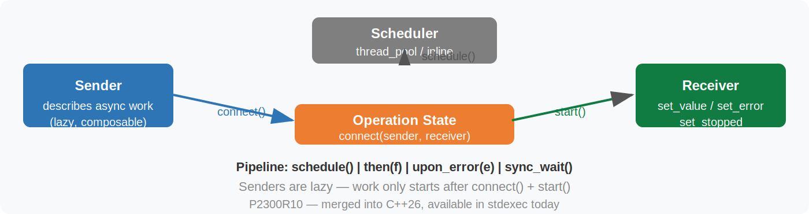
Fig 9 — Sender/Receiver model: lazy composition, then start() kicks off work

// Using stdexec (reference implementation, ships with C++26)
#include <exec/static_thread_pool.hpp>
#include <stdexec/execution.hpp>
namespace ex = stdexec;

exec::static_thread_pool pool(4);
auto sched = pool.get_scheduler();

// Build a pipeline of async work (nothing runs yet)
auto work =
ex::schedule(sched) // start on thread pool
| ex::then([]{ return fetch(); })
| ex::then([](auto data){ return parse(data); })
| ex::upon_error([](auto e){ return fallback(); });

// Start and wait (blocking)
auto result = ex::sync_wait(std::move(work)).value();

20.3 std::atomic_ref (C++20)
Provides atomic access to an existing non-atomic object. Useful for arrays or third-party types you cannot change.
#include <atomic>

int plain_array[100] = {};

void safe_increment(int index) {
std::atomic_ref<int> ref(plain_array[index]);
ref.fetch_add(1, std::memory_order_relaxed);
}
// The same plain_array can be used non-atomically when exclusive access is guaranteed

20.4 std::hazard_pointer / std::rcu (C++26)
Standard library support for two advanced lock-free memory reclamation schemes. Hazard pointers protect individual objects; RCU (Read-Copy-Update) protects entire data structure snapshots.
// Hazard pointer (C++26 preview — API may still change)
#include <hazard_pointer>

std::hazard_pointer hp = std::make_hazard_pointer();
Node* p = head.load(std::memory_order_acquire);
hp.protect(p, head); // publish hazard: don't reclaim p
// ... safe to read *p even if another thread concurrently retires it ...
hp.reset_protection(); // done with p
⚑ hazard_pointer and rcu are primarily for lock-free data structure authors; most application code should prefer higher-level primitives.

C++23/26 Feature Overview
Type / Class | Key Method / Usage | Notes
std::generator<T> | co_yield range generator | C++23, works with std::ranges
std::execution | sender/receiver async framework | C++26 (stdexec available now)
std::atomic_ref<T> | atomic access to non-atomic object | C++20, array/legacy support
std::hazard_pointer | lock-free memory reclamation | C++26 (advanced)
std::rcu_obj_base<T> | read-copy-update reclamation | C++26 (advanced)

21. Decision Guide — Which Primitive to Use?

Type / Class | Key Method / Usage | Notes
Run code on another thread | std::jthread (C++20) or std::thread | Prefer jthread for auto-join + stop
Protect shared mutable data | std::mutex + std::lock_guard | Use scoped_lock for 2+ mutexes
Many readers, rare writes | std::shared_mutex + shared_lock | C++17
Wait for a condition | std::condition_variable + unique_lock | Always use predicate overload
Return a result from a thread | std::async or std::packaged_task | async is simplest; task = more control
One-shot signal between threads | std::promise / std::future | Or binary_semaphore (lighter)
Throttle N concurrent accesses | std::counting_semaphore | C++20
Run something exactly once | std::call_once or static local | Prefer static local (simpler)
Lock-free shared scalar | std::atomic<T> | Pick weakest sufficient memory_order
Atomic access to existing object | std::atomic_ref<T> | C++20
Wait for N tasks to finish | std::latch | C++20, single-use
N threads, repeating phases | std::barrier | C++20, reusable
Per-thread state without locks | thread_local | No contention
Avoid false sharing in hot loop | alignas(cache_line_size) | Measure first
Lazy producer / lazy sequence | C++20 coroutine + co_yield | C++23 std::generator
Composable async pipeline | stdexec senders/receivers | C++26 / stdexec library

C++ Asynchronous Concurrency Reference • C++11–C++26

