The DDS Handbook
Concepts, Analogies and a Quick Reference for the Data Distribution Service
DDS Knowledge Map (expanded edition)
2026-11-07

About This Book
This handbook has two jobs.
First, it teaches. Every chapter opens with a one-sentence summary and a plain-language analogy, then explains the idea properly, with the code, configuration and protocol details a working engineer needs.
Second, it is a reference you can come back to. Every chapter ends with a short list of things to remember, and the appendices collect the facts you look up most often: compatibility rules, port formulas, a troubleshooting checklist, a networking primer and a glossary.

How the chapters are built
Each chapter follows the same pattern, so you always know where to look.
In one sentence. The whole chapter, compressed to a line you can reread in five seconds.
Analogy. A familiar picture (a post office, a dead-man’s switch, a spreadsheet) that carries the core idea. Analogies are teaching aids. Where they stop being accurate, the main text takes over.
Then come the detailed sections, a Summary, and Things to Remember, which is the part to reread when you need a fast refresh.

Three ways to read it
Learning from scratch. Read Parts I and II in order (chapters 1 to 15). Skim Part III (the wire protocol) on the first pass and return to it when you start debugging. Chapter 43 is a good companion to chapter 24.
Brushing up before a design review or interview. Read the In one sentence and Analogy boxes of every chapter, then use Appendix A, The Refresher, which collects every chapter’s Things to Remember in one place.
Debugging right now. Go to Appendix C (Troubleshooting), then chapters 15, 36 and 18, in that order.

Conventions
- Chapter references such as topic 24 are links. Tap them to jump.
- Code is C++-style pseudocode unless stated otherwise. Long lines are wrapped and the continuation is indented, so a wrapped line is still one statement.
- QoS names are shown the way the specification writes them (RELIABLE, KEEP_LAST). Exact API spellings differ between vendors.
- Behaviour that depends on the vendor is marked as such. Your vendor’s documentation always wins over this book for defaults and config syntax.
- Diagrams are images so that they stay readable on an e-reader. Tap an image to enlarge it.

A word on versions and accuracy
The text follows the OMG DDS specification (version 1.4), the DDSI-RTPS wire protocol and the DDS Security and XTypes specifications. Vendors cover these to different degrees, and defaults change between releases. When a number matters (a default, a port, a timeout), verify it against the version you are running.

The Big Picture in One Page
Before the details, here is the whole of DDS as one story. Come back to this page whenever the details start to blur.

The trade-fair story
Imagine a large trade fair.
- The fair has numbered halls. People in Hall 3 cannot hear anything said in Hall 5. That is a Domain, identified by a Domain ID.
- Each company sends a delegate with a badge. The badge proves who they are, and everything the company sets up is registered under it. That is a DomainParticipant.
- In the hall there are bulletin boards. Each board has a name and a printed form with fixed fields. That is a Topic, which is a name plus a data type.
- A form with a key field, such as vehicle_id, effectively has one row per vehicle. Each row is an Instance. A new note pinned on a row is a Sample.
- Staff who pin notes are DataWriters. Staff who copy notes are DataReaders. Their department managers are Publishers and Subscribers.
- Every staff member carries a contract card (QoS): how reliably they deliver, whether they keep copies for latecomers, how often they update, how long a note stays valid. Two staff members cooperate only if the writer’s offer meets the reader’s requirement.
- There is no reception desk. When people enter, they announce themselves (SPDP) and then swap manifests of what they carry (SEDP). That is Discovery.
- Everyone follows the same fair rulebook, no matter which vendor’s pens they use. That is the RTPS wire protocol.

The same story as a table
Fair | DDS
Hall number | Domain ID
Delegate badge | DomainParticipant
Board with a form | Topic (name + type + QoS)
One row on the form | Instance (identified by key)
A note pinned on a row | Sample
Staff who pin / copy | DataWriter / DataReader
Department managers | Publisher / Subscriber
Contract card | QoS policies
Wristband colour | Partition
Shout of name at the door | SPDP
Exchange of manifests | SEDP
Fair rulebook | RTPS

The picture
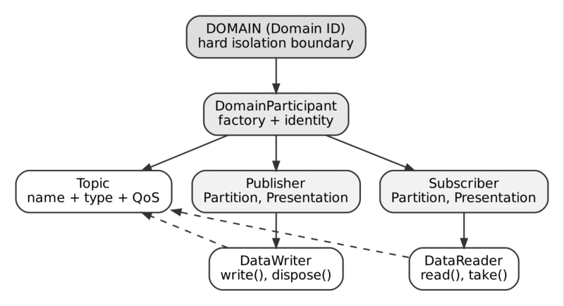
The DDS entity hierarchy

The five sentences to remember
- DDS shares typed, live data in a global data space; it does not pass opaque messages.
- There is no broker: endpoints discover each other and talk directly.
- QoS contracts are chosen per data flow, and a writer and reader connect only if the contracts are compatible.
- Keys and instances let DDS track many independent things inside one topic.
- RTPS is the standard wire protocol that makes different vendors interoperate.

Contents
Tap an entry to jump to it. In Word, the Navigation Pane (View, Navigation Pane) shows every chapter and section.
- About This Book
- The Big Picture in One Page
Part I: Foundations
- 01. What is DDS
- 02. Domain and DomainParticipant
- 03. Topics and Data Types
- 04. Publishers and Subscribers
- 05. DataWriters and DataReaders
Part II: Quality of Service
- 06. QoS Framework Overview
- 07. Reliability QoS
- 08. Durability QoS
- 09. History and Resource Limits QoS
- 10. Deadline QoS
- 11. Liveliness QoS
- 12. Ownership and Ownership Strength QoS
- 13. Partition QoS
- 14. Lifespan and Time-Based Filter QoS
- 15. QoS Compatibility and Matching Rules
Part III: The RTPS Wire Protocol
- 16. RTPS Protocol Overview
- 17. RTPS Message and Submessage Structure
- 18. Sequence Numbers, Heartbeats and ACKNACK
- 19. Entity IDs and GUIDs
Part IV: Discovery
- 20. Simple Participant Discovery Protocol (SPDP)
- 21. Simple Endpoint Discovery Protocol (SEDP)
- 22. Discovery Scalability and Tuning
Part V: Data Modelling and the Type System
- 23. IDL and Data Type Definition
- 24. Keys and Instances
- 25. Serialization (CDR)
- 26. Extensible Types (XTypes)
Part VI: Transport and Performance
- 27. Transport Configuration
- 28. Multicast vs Unicast Delivery
- 29. Performance Tuning and Batching
- 30. WAN and Routing (Routing/Gateway Services)
Part VII: Security
- 31. DDS Security Overview
- 32. Authentication and Access Control
- 33. Data Encryption and Signing
Part VIII: Ecosystem, Interoperability and Operations
- 34. Vendor Interoperability
- 35. Content-Filtered and Multi-Topics
- 36. Monitoring, Debugging and Tooling
- 37. DDS in ROS 2
- 38. Failover, Redundancy and Fault Tolerance Patterns
Part IX: Illustrated Deep Dives
- 39. DDS Use Cases: A Visual Atlas
- 40. Internal Communication Flow, Step by Step
- 41. DDS Configuration and QoS Profiles
- 42. The DDS Entity Hierarchy Illustrated
- 43. Instances in DDS, Clarified
- Appendix A: The Refresher
- Appendix B: Cheat Sheets
- Appendix C: Troubleshooting Checklist
- Appendix D: Networking Primer: Unicast and Multicast
- Appendix E: Tools for Tracing, Decoding and Debugging
- Appendix F: Glossary of DDS Terms

Part I: Foundations
What DDS is and the five entities you meet in every program: Domain, DomainParticipant, Topic, Publisher/Subscriber and DataWriter/DataReader.
Imagine DDS as a trade fair. The Domain is the hall, the DomainParticipant is your company’s delegate badge, a Topic is a bulletin board with a printed form, and DataWriters and DataReaders are the staff who pin notes to boards and copy notes from them. Chapters 1 to 5 introduce these roles one at a time.

01. What is DDS
In one sentence. DDS is a brokerless, data-centric publish-subscribe standard: applications share a live, typed data space instead of passing sealed messages through a middleman.
Analogy. A message broker is a post office: everybody hands sealed envelopes to the counter, and the clerk (the broker) forwards them without ever opening them. DDS is a shared whiteboard in a control room: each engineer writes the current value of their own box on the board, and everyone who cares about a box simply looks at it. Nobody has to know who is looking, and the board itself knows what each box means (a speed, a position) and can tell you when a value has gone stale. Three-way decoupling in this picture: engineers do not need to know where the others sit (space), a newcomer can read what was written before they arrived (time), and a slow reader never makes a fast writer wait (flow).

Overview
DDS (Data Distribution Service) is an Object Management Group (OMG) standard for data-centric publish-subscribe (DCPS) communication, originally published in 2004 and still actively maintained (latest formal revision: DDS 1.4, alongside the companion DDS-RTPS wire protocol standard that guarantees interoperability between vendor implementations).
DDS was designed for systems that need:
- Low latency and high throughput (microseconds to low milliseconds)
- Deterministic, real-time behavior
- No single point of failure (no broker/server in the data path)
- Fine-grained control over delivery guarantees, per data flow
It is the dominant middleware in domains such as defense, aerospace, autonomous vehicles, industrial automation, robotics (ROS 2), medical devices, and financial trading systems — anywhere a broker-based queue would introduce unacceptable latency or a single point of failure.
DDS is not a product — it’s a specification. Multiple independent, interoperable implementations exist: RTI Connext, eProsima Fast DDS, Eclipse Cyclone DDS, OpenDDS, GurumDDS, and others. They interoperate at the wire level via RTPS (Real-Time Publish-Subscribe protocol), covered in topic 16.

The Data-Centric Publish-Subscribe Paradigm
Traditional publish-subscribe systems (message queues, brokers) are message-centric: they move opaque payloads (bytes) from a producer to a consumer through an intermediary. The middleware has no idea what’s inside the message.
DDS is data-centric: the middleware understands the structure and semantics of the data itself.
Key implications:
- Every piece of data is published under a Topic, which binds a name to a strongly-typed data structure (defined in IDL — see topic 23).
- DDS maintains a global data space, conceptually a distributed, virtual database of the current (and optionally historical) state of every topic instance in the domain.
- Readers don’t just receive “a message” — they receive samples of an instance’s state, and DDS tracks instance identity via key fields (topic 24), instance lifecycle (ALIVE / DISPOSED / NO_WRITERS), and staleness.
- Because the middleware understands the data, it can do things a message broker cannot: filter by content (topic 35), merge/query data (MultiTopic), detect missed updates (Deadline QoS), and manage per-instance ownership (Ownership QoS).
Analogy: a message-centric system is like a postal courier — it delivers sealed envelopes and doesn’t care what’s inside. A data-centric system is like a shared, continuously-updated whiteboard — every participant sees the current values of the fields they care about, automatically kept in sync.

Minimal conceptual example
// IDL: defines the *shape* of the data DDS understands and manages
struct VehiclePosition {
@key long vehicle_id; // key field -> defines instance identity
double latitude;
double longitude;
double speed_kmh;
long long timestamp;
};
// Publisher side (pseudo-code, C++ DDS API)
DomainParticipant* participant = factory->create_participant(DOMAIN_ID);
Topic* topic = participant->create_topic("VehiclePosition", "VehiclePosition::Type");
Publisher* pub = participant->create_publisher();
DataWriter* writer = pub->create_datawriter(topic, qos);
VehiclePosition sample{.vehicle_id = 42, .latitude = 48.1, .longitude = 8.4,
.speed_kmh = 63.5, .timestamp = now()};
writer->write(sample);
// Subscriber side - anywhere on the network, no broker involved
DataReader* reader = sub->create_datareader(topic, qos);
reader->set_listener(new MyListener()); // on_data_available callback fires
The publisher never knows (or cares) who is subscribed, how many subscribers exist, or where they are. DDS handles discovery, matching, and delivery transparently.

Decoupling in Time, Space, and Flow
DDS’s core value proposition is often summarized as three-way decoupling:

1. Decoupling in Space
Publishers and subscribers do not need to know each other’s network location, process, or host. There is no broker address to configure — DDS entities discover each other automatically via a peer-to-peer discovery protocol (topics 20–22). A publisher just declares “I write Topic X”; any matching subscriber anywhere on the domain connects automatically.

2. Decoupling in Time
Thanks to Durability QoS (topic 08), a subscriber that joins after data was published can still receive relevant historical samples (TRANSIENT_LOCAL, TRANSIENT, PERSISTENT). Publishers and subscribers do not need to be online simultaneously — within the bounds of the configured durability/history policy.

3. Decoupling in Flow
Publishers and subscribers do not block each other. A slow subscriber does not slow down a fast publisher (bounded by RESOURCE_LIMITS and HISTORY QoS, topic 09); each subscriber can consume data at its own rate. There is no shared queue that couples producer and consumer throughput together, unlike many broker-based systems.
Together, these three decouplings let DDS support highly dynamic topologies: nodes can join, leave, restart, or fail independently, and the system self-heals without reconfiguration.

DDS vs. Broker-Based Messaging (Kafka, MQTT, AMQP)
This is one of the most common points of confusion for engineers coming from enterprise messaging backgrounds. The fundamental architectural difference is DDS has no broker — it is peer-to-peer. Kafka, MQTT, and AMQP all rely on a central (or clustered) intermediary that sits in the data path.
Architecture
- DDS: Peer-to-peer, brokerless
- Kafka: Broker cluster (log-based)
- MQTT: Broker (central)
- AMQP (e.g. RabbitMQ): Broker (central/clustered)
Data model
- DDS: Data-centric, typed, key-based instances
- Kafka: Byte payload + offset log
- MQTT: Opaque byte payload
- AMQP (e.g. RabbitMQ): Opaque byte payload
Discovery
- DDS: Automatic (dynamic, decentralized)
- Kafka: Manual broker/topic config
- MQTT: Manual broker config
- AMQP (e.g. RabbitMQ): Manual broker/exchange config
Latency
- DDS: Microseconds–low ms (real-time capable)
- Kafka: Low ms–tens of ms (throughput optimized)
- MQTT: Low ms (lightweight)
- AMQP (e.g. RabbitMQ): Low–moderate ms
Delivery guarantees
- DDS: Per-flow QoS (20+ policies: reliability, deadline, ownership, liveliness…)
- Kafka: At-least-once / exactly-once (config’d)
- MQTT: QoS 0/1/2 (3 levels)
- AMQP (e.g. RabbitMQ): At-most/least/exactly-once via acks
Persistence model
- DDS: Optional, per-topic (Transient/Persistent QoS)
- Kafka: Durable log, replay by offset
- MQTT: Optional retained messages
- AMQP (e.g. RabbitMQ): Optional durable queues
Typical use case
- DDS: Real-time control systems, avionics, robotics, SCADA
- Kafka: Event streaming, log aggregation, analytics pipelines
- MQTT: IoT telemetry, constrained devices
- AMQP (e.g. RabbitMQ): Enterprise integration, task queues
Single point of failure
- DDS: None (no broker)
- Kafka: Broker cluster (mitigated by replication)
- MQTT: Broker
- AMQP (e.g. RabbitMQ): Broker (mitigated by clustering)
Scalability pattern
- DDS: Scales via multicast + direct peer connections
- Kafka: Scales via partitions across brokers
- MQTT: Scales via broker clustering/bridging
- AMQP (e.g. RabbitMQ): Scales via broker clustering/federation
Wire protocol standard
- DDS: RTPS (OMG standard, cross-vendor interoperable)
- Kafka: Kafka wire protocol (proprietary-ish, single ecosystem)
- MQTT: MQTT (OASIS standard)
- AMQP (e.g. RabbitMQ): AMQP 0-9-1 / 1.0 (standard)

When DDS wins
- Hard real-time or safety-critical control loops (e.g., flight control, autonomous driving perception/planning, industrial robot arms).
- Environments where a broker is an unacceptable single point of failure or added hop of latency.
- Systems needing rich, declarative QoS per data flow rather than per-broker/queue (e.g., one topic reliable + durable, another best-effort + volatile, in the same app).
- Embedded/edge systems needing to avoid the operational overhead of running and scaling a broker cluster.

When Kafka/MQTT/AMQP win
- Large-scale event streaming, analytics, and log aggregation where durable replay by offset (Kafka) is the primary need.
- Massive numbers of intermittently-connected, resource-constrained devices (MQTT is purpose-built for this — e.g., battery-powered IoT sensors over cellular).
- Enterprise integration patterns: routing, transformation, work queues, RPC-style request/reply across heterogeneous systems (AMQP’s strength).
- Teams that want the simpler, well-understood operational model of a managed broker service (many hosted Kafka/MQTT offerings exist; hosted DDS is rarer).

A concrete mental model
- Kafka = a durable, ordered, replayable commit log you write to and read from.
- MQTT = a lightweight “fire it at the broker, broker fans it out” pattern for simple telemetry.
- AMQP = a flexible message-routing broker with exchanges, queues, and bindings.
- DDS = a shared, live, strongly-typed data space where the network itself handles matching, delivery guarantees, and instance lifecycle — no middleman process.

Summary
DDS is fundamentally different from broker-based messaging because it is data-centric (the middleware understands and manages the data’s structure, identity, and lifecycle, not just opaque bytes) and brokerless/peer-to-peer (publishers and subscribers discover and talk to each other directly). This gives it three-way decoupling — in space (no need to know peer locations), time (late joiners can get historical data via Durability), and flow (producers and consumers are not rate-coupled) — while offering fine-grained, per-topic Quality of Service control that lets a single application mix hard-real-time flows with best-effort ones. This makes DDS the middleware of choice for real-time, safety-critical, and highly dynamic distributed systems, whereas Kafka/MQTT/AMQP remain better suited to event streaming, IoT telemetry at scale, and enterprise integration where a central broker’s operational simplicity and durable replay semantics outweigh the need for brokerless, microsecond-latency delivery.

Things to Remember
- DDS is a specification, not a product — many interoperable vendor implementations exist.
- Data-centric: DDS understands the data’s type, key, and instance lifecycle — not just bytes.
- Brokerless / peer-to-peer: no intermediary sits in the data path → no single point of failure, lower latency.
- Three-way decoupling: space (auto-discovery), time (durability for late joiners), flow (independent producer/consumer rates).
- QoS is per-topic/per-entity, not global — a single app can mix reliable+durable and best-effort+volatile flows.
- Interoperability guaranteed by RTPS, the companion OMG wire-protocol standard.
- Best fit: real-time, safety-critical, low-latency, highly dynamic systems (robotics, avionics, industrial control).
- Not the best fit for durable event-log replay at massive scale (that’s Kafka’s specialty) or huge fleets of constrained/intermittent devices (that’s MQTT’s specialty).

02. Domain and DomainParticipant
In one sentence. A Domain is a hard isolation boundary identified by a number; a DomainParticipant is an application’s membership card for that domain and the factory for everything else.
Analogy. Picture a conference centre with numbered halls. People in Hall 3 cannot hear a thing said in Hall 5, even though the halls share one building (the physical network). The DomainParticipant is your delegate badge: you get one per company (process), it carries your identity, and every booth, board and clerk your company sets up is registered under it. Hand the badge back and everything registered under it is dismantled. Most “my nodes cannot see each other” problems are simply two delegates standing in different halls.

Overview
Before any publisher or subscriber can exchange data in DDS, it must join a Domain — the top-level isolation boundary of a DDS deployment — through a DomainParticipant, the entry-point entity of the DDS entity model. Understanding these two concepts correctly is foundational: nearly every bug related to “why can’t my nodes see each other?” traces back to a domain or participant misconfiguration.

The Domain
A Domain is a logical network of DDS applications that can discover and communicate with one another. It is identified by a Domain ID — a small non-negative integer (commonly 0–232, though the practical/portable range is vendor- and deployment-dependent).
Key properties:
- Isolation, not physical separation. Two applications on the same physical network (same subnet, same multicast group) but configured with different Domain IDs will never discover each other — DDS enforces isolation logically, at the protocol level, not just via network topology.
- The Domain ID maps to network ports. In the standard RTPS discovery scheme (topic 20), the Domain ID is used to compute the UDP ports used for multicast discovery traffic, via a formula roughly of the form:
- ``` PB = 7400 # Port Base DG = 250 # Domain Gain spdp_multicast_port = PB + DG * domain_id
This is *why* changing the Domain ID is often the fastest way to run multiple,
fully-isolated DDS test environments on the same LAN without them interfering with
each other.
- **One domain = one "universe" of Topics.** A Topic named `"VehiclePosition"` in Domain 0
is a completely distinct entity from a Topic of the same name in Domain 1 — no data
ever crosses domain boundaries unless explicitly bridged (e.g., via a Routing Service,
topic 30).
- **Practical use of multiple domains:**
- Separate **environments**: dev = domain 0, staging = domain 1, prod = domain 2.
- Separate **subsystems** that must never accidentally cross-talk (e.g., a simulation
domain vs. a live-vehicle domain).
- **Multi-tenancy** on shared infrastructure.
### Example: two isolated domains on the same host
```cpp
// Application A - Domain 0
DomainParticipant* participantA = factory->create_participant(0 /* domain_id */,
PARTICIPANT_QOS_DEFAULT);
// Application B - Domain 1, same machine, same topic name/type
DomainParticipant* participantB = factory->create_participant(1 /* domain_id */,
PARTICIPANT_QOS_DEFAULT);
Even though A and B run on the same host and could define an identical "VehiclePosition" topic, they will never discover each other — they are on different domains. This is a deliberate, commonly-used isolation mechanism, not a bug.

The DomainParticipant
A DomainParticipant is the DDS entity that represents an application’s membership in a Domain. It is the factory for every other entity:
DomainParticipant
+-- creates -> Topic
+-- creates -> Publisher -> creates -> DataWriter
+-- creates -> Subscriber -> creates -> DataReader
Responsibilities of the DomainParticipant:
- Joining the domain — starting participant discovery (SPDP, topic 20) so it becomes visible to (and can discover) other participants on the same Domain ID.
- Resource ownership — it owns and manages the lifecycle of every Topic, Publisher, Subscriber, DataWriter, and DataReader created under it. Deleting a participant cascades and deletes all of its child entities.
- Default QoS scope — it holds default QoS profiles that child entities inherit unless overridden.
- Domain-wide configuration — network interfaces, discovery peers, transport settings, and (if used) security settings are typically configured at the participant level via QoS or vendor-specific XML configuration.

Typical lifecycle
// 1. Get the singleton factory
DomainParticipantFactory* factory = DomainParticipantFactory::get_instance();
// 2. Create a participant on a given domain
DomainParticipant* participant = factory->create_participant(
42, // Domain ID
PARTICIPANT_QOS_DEFAULT, // QoS
nullptr, // listener
STATUS_MASK_NONE);
// 3. Use the participant as a factory for Topics, Publishers, Subscribers...
Topic* topic = participant->create_topic("VehiclePosition", "VehiclePosition::Type",
TOPIC_QOS_DEFAULT);
Publisher* publisher = participant->create_publisher(PUBLISHER_QOS_DEFAULT);
Subscriber* subscriber = participant->create_subscriber(SUBSCRIBER_QOS_DEFAULT);
// ... application runs, entities exchange data ...
// 4. Clean shutdown: delete contained entities, then the participant, then finalize
// factory
participant->delete_contained_entities();
factory->delete_participant(participant);
factory->finalize_instance();

One participant vs. many per process
A common design question: should a process create one DomainParticipant (shared by all its topics) or several (e.g., one per subsystem)?
Approach | Pros | Cons
Single participant per process | Lower discovery overhead (one set of discovery announcements); simpler resource management; recommended default | All entities share one identity/lifecycle; a participant-level QoS change affects everything
Multiple participants per process | Logical isolation within a process (e.g., different partitions, different security identities, different transport configs); can join different domains from one process | More discovery traffic (each participant announces itself separately, O(n²) scaling concerns — see topic 22); more resource overhead
Rule of thumb: default to one participant per process per domain, and only create additional participants when you have a concrete reason (different domain, different security identity, or isolating discovery/QoS scope).

How Domain and DomainParticipant Interact With Discovery
When a DomainParticipant is created:
- It begins sending/listening for SPDP (Simple Participant Discovery Protocol) announcements on the multicast (and/or unicast) address/port derived from its Domain ID (topic 20).
- When it discovers another participant announcing the same Domain ID, the two participants exchange metadata and proceed to SEDP (Simple Endpoint Discovery Protocol, topic 21) to match compatible DataWriters/DataReaders.
- Participants on different Domain IDs simply never engage in this handshake — from each other’s perspective, they don’t exist.
This is why Domain ID mismatches (e.g., one node misconfigured with domain 0 instead of domain 5) are one of the most common “why won’t my publisher and subscriber connect?” troubleshooting scenarios in real deployments.

Summary
The Domain is DDS’s top-level, logical isolation boundary — identified by a small integer Domain ID that (via a well-known formula) also determines the discovery network ports, meaning two applications on different Domain IDs are completely invisible to each other even on the same physical network. The DomainParticipant is the entry-point entity an application uses to join a Domain and acts as the factory for every other DDS entity (Topics, Publishers, Subscribers, DataWriters, DataReaders), owning their lifecycle and providing default QoS scope. Getting the Domain ID right — and choosing a sensible participant-per-process strategy — is the first and most common troubleshooting checkpoint in any DDS deployment.

Things to Remember
- Domain ID isolates communication logically, not just physically — different domain IDs never see each other, even on the same LAN/host.
- Domain ID determines discovery ports via a standard formula (PB + DG × domain_id in default RTPS discovery) — useful for running isolated test environments side by side.
- DomainParticipant is the factory for Topics, Publishers, Subscribers, DataWriters, and DataReaders — deleting it cascades to all children.
- Default to one participant per process per domain unless you have a specific reason (multiple domains, isolated QoS/security scope) for more — extra participants increase discovery overhead.
- Domain ID mismatch is the #1 “nodes can’t see each other” bug — always check this first when troubleshooting connectivity.
- Domains ≠ Partitions — Partitions (topic 13) are a finer-grained, in-domain filtering mechanism; Domains are a hard, protocol-level isolation boundary.

03. Topics and Data Types
In one sentence. A Topic binds a name, a data type and QoS together; writers and readers only meet if they agree on the Topic.
Analogy. A Topic is a bulletin board with a printed form on it. The board has a name (“VehiclePosition”), and the form has fixed fields (id, latitude, longitude, speed). You cannot pin a lunch menu on a board that expects a vehicle form; DDS checks that at discovery time and refuses to match, instead of letting garbage in. The board’s name and form layout are a public contract: renaming the board or reordering the fields breaks every visitor who learned the old layout.

Overview
The Topic is the central organizing concept of DDS’s data-centric model. It is the “noun” that everything else revolves around: DataWriters write to a Topic, DataReaders read from a Topic, and DDS’s discovery and matching logic is fundamentally about finding compatible writers and readers of the same Topic.
A Topic binds together three things:
- A unique name (a string, e.g. "VehiclePosition") — scoped to the Domain (topic 02).
- A data type — a strongly-typed structure, normally defined in IDL (topic 23).
- A set of QoS policies that apply as defaults/constraints for entities using it.
Topic = Name + Type + QoS
Two applications only interoperate on a given Topic if they agree on all three — mismatched names, incompatible types, or incompatible QoS all prevent matching.

Why the Topic Matters: It’s Not Just a Channel Name
In broker-based systems, a “topic” or “queue name” is usually just a routing key — an opaque string the broker uses to fan messages out. In DDS, the Topic is a first-class, typed entity that the middleware itself understands and enforces:
- Type safety is structural, not just nominal. DDS implementations perform (or can perform, depending on XTypes configuration — topic 26) type compatibility checks at discovery time. A writer and reader with the same topic name but incompatible types simply won’t match — you get a protected failure mode, not silent data corruption.
- The Topic carries semantic meaning for keyed instances. Because the data type can declare @key fields (topic 24), the Topic isn’t just “a stream of messages” — it’s a managed space of instances, each with independent lifecycle, history, and QoS application.
- QoS is topic-scoped. You can — and often should — give different topics wildly different QoS: a high-frequency sensor topic might be BEST_EFFORT + VOLATILE, while a configuration topic is RELIABLE + TRANSIENT_LOCAL.

Defining a Topic’s Data Type (IDL)
Data types are conventionally defined in IDL (Interface Definition Language) and compiled by a vendor-specific code generator (rtiddsgen, fastddsgen, idlc, etc.) into language bindings (C++, Java, Python, C, Rust…).
module Fleet {
struct VehiclePosition {
@key long vehicle_id;
double latitude;
double longitude;
double speed_kmh;
long long timestamp_ms;
};
};
This generates, e.g. in C++, a Fleet::VehiclePosition class with accessors, plus the type-support code DDS needs to (de)serialize it (CDR — topic 25) and register it with a participant.

Registering and creating a Topic
// 1. Register the type with the participant (ties the IDL-generated type to a name
// DDS uses internally)
Fleet::VehiclePositionTypeSupport::register_type(participant,
"Fleet::VehiclePosition");
// 2. Create the Topic: binds a Topic *name* to the registered *type name*, plus QoS
Topic* topic = participant->create_topic(
"VehiclePosition", // Topic name (used for discovery/matching)
"Fleet::VehiclePosition", // Registered type name
TOPIC_QOS_DEFAULT);
Note the two distinct strings: the Topic name (what applications match on) and the type name (what defines the data’s shape). It’s entirely possible — and sometimes useful — to have multiple Topics share the same type, or the same-named Topic evolve its type over time via XTypes-compatible extensions.

Kinds of Topics
DDS defines more than one topic-like entity, though the plain Topic is by far the most common:
Kind | Purpose
Topic | The standard case: a named, typed data stream.
ContentFilteredTopic | A “view” over a Topic that only delivers samples matching a filter expression (SQL-like syntax), evaluated before transmission where supported — see topic 35.
MultiTopic | Combines/joins data from multiple related Topics into a single derived stream (less commonly used; support varies by vendor).

Example: ContentFilteredTopic
ContentFilteredTopic* fastVehicles = participant->create_contentfilteredtopic(
"FastVehicles",
topic, // base Topic
"speed_kmh > %0", // filter expression
{"80"}); // parameter
DataReader* reader = subscriber->create_datareader(fastVehicles,
DATAREADER_QOS_DEFAULT);
// This reader only receives samples where speed_kmh > 80 - filtering can happen
// writer-side (if supported) to save bandwidth, not just reader-side.

Built-in Topics
DDS implementations expose a set of built-in Topics that describe the domain’s own state — participants, publications, and subscriptions currently discovered. These are ordinary Topics (readable via ordinary DataReaders) that provide introspection:
- DCPSParticipant — discovered DomainParticipants
- DCPSPublication — discovered DataWriters and their QoS
- DCPSSubscription — discovered DataReaders and their QoS
- DCPSTopic — discovered Topics (in some implementations)
These are invaluable for building monitoring/diagnostic tooling (topic 36) — e.g., a dashboard that lists every writer/reader currently active in the domain, without any custom instrumentation.
DataReader* builtinPubReader = participant->get_builtin_subscriber()
->lookup_datareader("DCPSPublication");
// Read this to see every DataWriter currently discovered in the domain, with its QoS.

Topic Naming and Design Practices
- Use clear, hierarchical, stable names. Since renaming a Topic is a breaking change for every participant, treat Topic names like a public API contract (e.g., "Fleet::VehiclePosition" or "/fleet/vehicle_position" depending on vendor convention — ROS 2 uses a path-like convention under the hood, topic 37).
- One Topic = one semantic concept, not a dumping ground for unrelated fields. Split data with very different QoS needs (e.g., high-rate telemetry vs. rare config) into separate Topics even if conceptually related.
- Design the key fields deliberately (topic 24) — the key defines what “an instance” means, and that decision is hard to change later without breaking compatibility.
- Plan for evolution up front. Decide whether the type is final, appendable, or mutable under XTypes (topic 26) — this determines whether you can add optional fields later without breaking older readers/writers.

Summary
The Topic is DDS’s core organizing abstraction: a named, strongly-typed, QoS-scoped channel that DataWriters and DataReaders must agree on (name, type, and compatible QoS) in order to match and exchange data. Unlike a broker’s opaque routing key, a DDS Topic is understood by the middleware itself, enabling type-safe matching, per-instance lifecycle management via key fields, content-based filtering (ContentFilteredTopic), and rich introspection via built-in Topics. Careful, deliberate Topic and type design — names, key fields, and extensibility strategy — pays off enormously over an application’s lifetime, since Topics function as a durable public contract between independently evolving publishers and subscribers.

Things to Remember
- Topic = Name + Type + QoS — all three must be compatible for a writer and reader to match.
- Data types are normally defined in IDL and compiled into language bindings by a vendor code generator.
- Topic name ≠ type name — a Topic name is the matching key; the type name defines the data shape; they’re registered separately.
- ContentFilteredTopic lets readers subscribe to a filtered subset of a Topic, sometimes with writer-side filtering to save bandwidth.
- Built-in Topics (DCPSParticipant, DCPSPublication, DCPSSubscription) give free, standardized introspection into the domain’s live state.
- Treat Topic names and key-field design as a public API contract — changing them later breaks compatibility across independently deployed applications.
- Split by QoS needs, not just by “relatedness” — don’t force high-rate and low-rate data into the same Topic.

04. Publishers and Subscribers
In one sentence. Publishers and Subscribers are container entities that own DataWriters/DataReaders and apply group-level settings such as Partition and Presentation.
Analogy. Think of a department manager who supervises several clerks. The manager does not write on the boards personally; they hand out the house rules (which room the department works in = Partition) and can say “hold everything until all clerks have finished their entries, then release them together” (coherent updates). Most small companies have exactly one such manager for outgoing notes and one for incoming notes, and that is fine.

Overview
Between the DomainParticipant (topic 02) and the actual data-moving entities — DataWriters and DataReaders (topic 05) — DDS interposes two container entities: Publisher and Subscriber. They are frequently under-appreciated, because a huge number of applications never need more than the default one-of-each, but understanding what they actually do (and don’t do) matters for anyone tuning performance, coordinating multi-writer consistency, or organizing large applications.
DomainParticipant
+-- Publisher -> creates/owns -> DataWriter(s)
+-- Subscriber -> creates/owns -> DataReader(s)
A Publisher owns and manages one or more DataWriters; a Subscriber owns and manages one or more DataReaders. Neither is tied to a single Topic — a single Publisher can have DataWriters for many different Topics, and likewise for a Subscriber.

What a Publisher Actually Does
The Publisher is not just a “bag of DataWriters” — it has real responsibilities:
- Factory and lifecycle owner for its DataWriters — deleting a Publisher deletes all DataWriters it created.
- Default QoS scope — DataWriters inherit DATAWRITER_QOS_DEFAULT values that ultimately trace back through the Publisher’s default QoS.
- Coordinated (grouped) sample publication, via suspend_publications() / resume_publications(). This lets you group writes from multiple DataWriters under the same Publisher so that they are released to the transport together, which is important when a subscriber needs to see a consistent, atomic snapshot across several related Topics (e.g., updating Position and Velocity for the same object “at once”).
- PARTITION QoS application point — Partition (topic 13) is set at the Publisher/Subscriber level, not per-DataWriter/DataReader, meaning every DataWriter under a Publisher shares the same partition membership by default.
- Presentation QoS — controls whether changes across multiple instances/topics under this Publisher are delivered to matching Subscribers in a coordinated (grouped) or independent (instance-by-instance) way. PRESENTATION QoS has an access_scope (INSTANCE, TOPIC, or GROUP) that determines the granularity of this coordination.

Example: coordinated multi-writer update
Publisher* pub = participant->create_publisher(PUBLISHER_QOS_DEFAULT);
DataWriter* positionWriter = pub->create_datawriter(positionTopic,
DATAWRITER_QOS_DEFAULT);
DataWriter* velocityWriter = pub->create_datawriter(velocityTopic,
DATAWRITER_QOS_DEFAULT);
pub->suspend_publications();
positionWriter->write(newPosition);
velocityWriter->write(newVelocity);
pub->resume_publications();
// With PRESENTATION access_scope = GROUP and coherent_access = true,
// subscribers see position and velocity updates as one atomic, coherent change set.

What a Subscriber Actually Does
Symmetrically, the Subscriber:
- Factory and lifecycle owner for its DataReaders.
- Default QoS scope for DataReaders it creates.
- PARTITION QoS application point — shared partition membership across all DataReaders it owns.
- Coordinated access to multiple DataReaders’ data, via begin_access() / end_access(), paired with PRESENTATION QoS on the Subscriber side — enabling an application to read a consistent set of changes across multiple related DataReaders (mirroring the Publisher’s coherent grouping).
- Aggregated status/data-available notification — a Subscriber-level listener can be notified when any of its DataReaders has new data, useful for building generic dispatch loops without registering a listener per DataReader.

Example: coherent read across two DataReaders
Subscriber* sub = participant->create_subscriber(SUBSCRIBER_QOS_DEFAULT);
DataReader* positionReader = sub->create_datareader(positionTopic,
DATAREADER_QOS_DEFAULT);
DataReader* velocityReader = sub->create_datareader(velocityTopic,
DATAREADER_QOS_DEFAULT);
sub->begin_access();
positionReader->take(positionSamples, positionInfos);
velocityReader->take(velocitySamples, velocityInfos);
sub->end_access();
// With matching PRESENTATION QoS, the samples taken here reflect one coherent
// publisher-side update, not a torn read across two independent writes.

Why Not Just Use One Publisher/Subscriber for Everything?
Most applications do just use one default Publisher and one default Subscriber per participant — that’s a perfectly reasonable default. You reach for multiple Publishers/Subscribers within a participant when you need:
Reason | Explanation
Different Partition sets | e.g., one Publisher writes to partition "SimA", another to "SimB", from the same process.
Different default QoS profiles | e.g., one Publisher default-configured for reliable/durable writers, another for best-effort/volatile ones, to avoid repeating QoS on every DataWriter.
Independent coherent groups | Two logically unrelated sets of writers that each need their own atomic-update grouping, without interfering with each other.
Organizational clarity | Large systems sometimes split Publishers/Subscribers by subsystem for readability and independent lifecycle management (e.g., shutting down one subsystem’s writers without touching another’s).

Publisher/Subscriber vs. DataWriter/DataReader — Don’t Confuse the Layers
A common point of confusion for engineers new to DDS: Partition and Presentation QoS live on the Publisher/Subscriber, while Reliability, Durability, History, Deadline, Ownership, Lifespan, etc. live on the DataWriter/DataReader (or Topic, as defaults). If two DataWriters under the same Publisher need genuinely different delivery guarantees (one reliable, one best-effort), that’s fine — those policies are set per-DataWriter, not inherited rigidly from the Publisher, aside from default QoS inheritance which can always be overridden per entity.
Sets: Sets:
Publisher -> Partition, Presentation | DataWriter -> Reliability, Durability,
Subscriber -> Partition, Presentation | DataReader -> History, Deadline,
Ownership,
| Lifespan, Liveliness, etc.

Summary
Publisher and Subscriber are the container/factory entities that sit between the DomainParticipant and the actual DataWriters/DataReaders that move data. Beyond simple lifecycle ownership, they are the application point for Partition QoS (shared partition membership across everything they own) and Presentation QoS (coordinated, atomic delivery of related changes across multiple writers or readers via suspend/resume and begin/end access). Most applications need only one default Publisher and Subscriber per participant; reach for additional ones when you need distinct partition sets, distinct default QoS profiles, or independent coherent-update groups.

Things to Remember
- Publisher owns DataWriters; Subscriber owns DataReaders — deleting the container cascades to its children.
- Partition and Presentation QoS are set on Publisher/Subscriber, not on individual DataWriters/DataReaders.
- suspend_publications()/resume_publications() (Publisher) and begin_access()/end_access() (Subscriber), paired with PRESENTATION QoS, enable atomic/coherent multi-writer or multi-reader updates.
- One default Publisher + one default Subscriber per participant is the common case — add more only for distinct partitions, distinct default QoS, or independent coherent groups.
- Reliability/Durability/History/Deadline/Ownership/etc. live at the DataWriter/DataReader (or Topic) level, not the Publisher/Subscriber level — don’t confuse the two layers of QoS.

05. DataWriters and DataReaders
In one sentence. DataWriters and DataReaders are the endpoints your code actually calls; they match only when topic, type, QoS, partition and security all agree.
Analogy. The DataWriter is the clerk with a pen who pins notes to one particular board. The DataReader is the clerk with a notepad who watches that same board. read() is copying a note and leaving it on the board; take() is peeling it off the board. dispose() is the clerk writing “this row no longer exists”. Simply putting the pen down is not the same thing: the old note stays up and looks perfectly valid. Writers and readers only start exchanging notes once their contract cards (QoS) are compatible.

Overview
DataWriters and DataReaders are where DDS’s data-centric model actually touches application code — they are the entities you call write() and take()/read() on. Everything discussed so far (Domain, DomainParticipant, Topic, Publisher, Subscriber) exists to set up the context in which a DataWriter and a matching DataReader can find each other and exchange samples according to an agreed-upon contract of QoS.
Publisher -> creates -> DataWriter (bound to one Topic)
Subscriber -> creates -> DataReader (bound to one Topic)
Each DataWriter/DataReader is bound to exactly one Topic for its lifetime. Most of the fine-grained QoS policies that define how data is delivered (Reliability, Durability, History, Deadline, Ownership, Lifespan, Liveliness, Resource Limits, Time- Based Filter — topics 07–14) are set at this level (or inherited as defaults from the Topic/Publisher/Subscriber).

DataWriter: Writing Data
The DataWriter’s core API surface centers on write(), plus explicit instance-lifecycle operations:
DataWriter* writer = publisher->create_datawriter(topic, qos, listener, mask);
VehiclePosition sample{.vehicle_id = 42, .latitude = 48.1, .longitude = 8.4,
.speed_kmh = 63.5, .timestamp_ms = now_ms()};
// optional, optimizes repeated writes
InstanceHandle_t handle = writer->register_instance(sample);
writer->write(sample, handle);
// ... later, when this instance no longer exists (e.g., vehicle went offline) ...
// marks instance as DISPOSED for all readers
writer->dispose(sample, handle);
// writer relinquishes ownership of the instance
writer->unregister_instance(sample, handle);
Key DataWriter operations:
Operation | Purpose
register_instance() | Pre-computes/caches the instance handle for a given key value, avoiding repeated key-hashing on every write() — an optimization, not strictly required.
write() | Publishes a new sample/state for an instance.
dispose() | Explicitly marks an instance as no longer existing — propagates DISPOSED instance state to all matching readers (distinct from simply stopping writes).
unregister_instance() | Signals this writer is done writing this instance (relevant for NO_WRITERS instance state and Ownership QoS handoff).
get_matched_subscriptions() | Introspects which DataReaders currently match this writer.
assert_liveliness() | Manually asserts liveliness when using MANUAL_BY_TOPIC/MANUAL_BY_PARTICIPANT liveliness QoS (topic 11).

write() vs. dispose() — a frequent point of confusion
Simply not calling write() anymore does not tell subscribers the instance is gone — it just means no new data arrives (readers may eventually infer staleness via Deadline QoS, but that’s a missed-update signal, not an existence signal). To explicitly communicate “this instance no longer exists” (e.g., a vehicle was decommissioned, an order was cancelled), the writer must call dispose(). This is one of the most common correctness bugs in real DDS applications: forgetting to dispose() leaves subscribers with stale-but-technically-still-ALIVE instances forever.

DataReader: Reading Data
DataReaders expose two fundamentally different retrieval semantics: read() (non- destructive) and take() (destructive/removing).
DataReader* reader = subscriber->create_datareader(topic, qos, listener, mask);
VehiclePositionSeq samples;
SampleInfoSeq infos;
reader->take(samples, infos, LENGTH_UNLIMITED,
ANY_SAMPLE_STATE, ANY_VIEW_STATE, ANY_INSTANCE_STATE);
for (size_t i = 0; i < samples.length(); i++) {
if (infos[i].valid_data) {
std::cout << "vehicle " << samples[i].vehicle_id
<< " at " << samples[i].latitude << "," << samples[i].longitude <<
"\n";
}
}
reader->return_loan(samples, infos); // return middleware-owned buffers
Operation | Behavior
read() | Returns matching samples but leaves them in the reader’s cache (marked as READ) — a subsequent read() can see them again.
take() | Returns matching samples and removes them from the reader’s cache — they will not be returned again.
read_next_sample() / take_next_sample() | Single-sample convenience variants.
get_key_value() | Recovers the key fields for a given instance handle (useful when you only stored the handle, e.g., from a DISPOSED notification with no data payload).

Sample, View, and Instance State — the three filtering dimensions
Every retrieved sample carries a SampleInfo with three independent state flags that let you filter precisely what you get back:
State | Values | Meaning
Sample State | READ / NOT_READ | Has this sample been read()/take()n before?
View State | NEW / NOT_NEW | Is this the first sample ever seen for this instance by this reader?
Instance State | ALIVE / NOT_ALIVE_DISPOSED / NOT_ALIVE_NO_WRITERS | Is the instance currently alive, explicitly disposed, or has it lost all its writers (topic 24)?
// Only get samples for instances that just became newly visible to this reader
reader->take(samples, infos, LENGTH_UNLIMITED,
ANY_SAMPLE_STATE, NEW_VIEW_STATE, ANY_INSTANCE_STATE);
This three-axis filtering is a direct consequence of the data-centric model (topic 01): DDS isn’t just “did a message arrive?” — it’s “what is the current state of this instance, and have I already processed it?”

Listeners vs. WaitSets vs. Polling
DDS supports three complementary ways to consume data and react to status changes — choosing the right one matters for both responsiveness and thread-model cleanliness.
****Listener****
- Model: Callback invoked by a middleware thread when an event occurs (on_data_available, on_liveliness_changed, on_requested_deadline_missed, etc.)
- Typical use: Simple, event-driven apps; be careful — callbacks run on middleware threads, so keep them fast and non-blocking.
****WaitSet + Condition****
- Model: Application thread blocks on wait() until one or more registered Conditions (e.g., a DataReader’s StatusCondition or a ReadCondition) become true
- Typical use: Apps that want a single, controlled thread pumping multiple entities without per-entity callback threads.
****Polling****
- Model: Application periodically calls read()/take() on its own schedule
- Typical use: Simple periodic/cyclic real-time tasks (e.g., a 100 Hz control loop that reads the latest sample each cycle, regardless of whether new data arrived).

Example: WaitSet across multiple readers
WaitSet waitSet;
StatusCondition* cond1 = positionReader->get_statuscondition();
cond1->set_enabled_statuses(DATA_AVAILABLE_STATUS);
waitSet.attach_condition(cond1);
StatusCondition* cond2 = velocityReader->get_statuscondition();
cond2->set_enabled_statuses(DATA_AVAILABLE_STATUS);
waitSet.attach_condition(cond2);
ConditionSeq active;
waitSet.wait(active, Duration_t{5, 0}); // block up to 5s for any attached condition
for (auto* c : active) {
// dispatch based on which condition fired
}

Matching: When Do a DataWriter and DataReader Actually Connect?
A DataWriter and DataReader match (and only then can data flow between them) when all of the following hold:
- Same Topic name.
- Compatible data types (identical, or compatible under XTypes rules — topic 26).
- Compatible QoS — for every “requested vs. offered” QoS policy (topic 15), the reader’s request must be satisfiable by the writer’s offer (e.g., a reader requesting RELIABLE will not match a writer offering only BEST_EFFORT).
- Overlapping Partitions (topic 13), if partitions are used.
- Not blocked by security/access-control rules, if DDS Security is enabled (topic 32).
When a match/unmatch occurs, both sides receive status events (on_subscription_matched / on_publication_matched) — essential for building robust apps that detect and react to peers appearing or disappearing.

Summary
DataWriters and DataReaders are the entities application code directly interacts with to publish and consume data — each bound to exactly one Topic, and each carrying the bulk of DDS’s fine-grained QoS configuration. Writing isn’t just write(): correctly communicating instance lifecycle requires explicit dispose()/unregister_instance() calls, not just silence. Reading isn’t just “get the next message”: DDS exposes three orthogonal state dimensions (sample/view/instance state) that let an application query precisely what it needs — new instances, unread samples, or disposed instances. Consuming data can be done via listeners (event callbacks), WaitSets (controlled blocking on multiple conditions), or polling — each suited to different application/threading models. Ultimately, a writer and reader only exchange data once they match: same topic, compatible type, compatible QoS, overlapping partitions, and (if enabled) compatible security policy.

Things to Remember
- Each DataWriter/DataReader binds to exactly one Topic and carries most of the fine-grained QoS.
- write() publishes; dispose() explicitly signals an instance no longer exists — silence alone does not communicate deletion.
- read() is non-destructive; take() removes samples from the reader’s cache — pick deliberately based on whether you need re-readability.
- SampleInfo exposes three independent states: sample (read/not-read), view (new/not-new), instance (alive/disposed/no-writers) — use them to filter precisely.
- Three consumption models: listeners (callbacks), WaitSets (controlled blocking on conditions), polling (application-driven cadence) — match the model to your threading/real-time needs.
- Matching requires: same topic name + compatible type + compatible QoS (requested ≤ offered) + overlapping partitions + (if enabled) compatible security — watch on_subscription_matched/on_publication_matched to detect it.
- Forgetting dispose() is one of the most common real-world DDS correctness bugs — don’t rely on readers “figuring out” an instance is gone.

Part II: Quality of Service
The policies that let each data flow declare its own delivery contract, and the rules that decide whether two endpoints may connect.
At the trade fair, every staff member carries a contract card: how reliably they deliver, whether they keep a copy for latecomers, how often they update, how long a note stays valid. Chapters 6 to 15 read those cards policy by policy, then show the matching rules.

06. QoS Framework Overview
In one sentence. QoS is a set of 20+ independent policies that each data flow uses to declare, as a contract, how it wants to be delivered.
Analogy. QoS is the shipping-options menu of a courier: express or economy, signature required or not, insured or not, keep a copy in the depot or not. Crucially, you choose per parcel, not once for the whole company. A DataWriter holds a card saying what it offers; a DataReader holds a card saying what it requires. If the offer meets the requirement, they shake hands; if not, they silently walk past each other.

Overview
Quality of Service (QoS) is DDS’s signature feature and arguably the single biggest reason organizations choose it over broker-based alternatives. Instead of a middleware that behaves the same way for every message, DDS lets every entity — Topic, Publisher, Subscriber, DataWriter, DataReader, DomainParticipant — declare contracts about how it wants data to be delivered: reliably or best-effort, with history or without, bounded in time, exclusive or shared, and more. Over 20 standard QoS policies exist, and understanding the framework they fit into is a prerequisite for using any of them correctly.

QoS Is a Structured Set of Policies, Not a Single Knob
Each QoS policy is an independent, named structure with its own fields. An entity’s overall QoS is the combination of all applicable policies:
DataWriterQos qos;
publisher->get_default_datawriter_qos(qos);
qos.reliability.kind = RELIABLE_RELIABILITY_QOS;
qos.durability.kind = TRANSIENT_LOCAL_DURABILITY_QOS;
qos.history.kind = KEEP_LAST_HISTORY_QOS;
qos.history.depth = 10;
qos.deadline.period = Duration_t{1, 0}; // 1 second
DataWriter* writer = publisher->create_datawriter(topic, qos);
The full policy list (each covered in its own topic in this series) includes: Reliability (07), Durability (08), History and Resource Limits (09), Deadline (10), Liveliness (11), Ownership and Ownership Strength (12), Partition (13), Lifespan and Time-Based Filter (14), plus others such as Presentation, Destination Order, Latency Budget, Transport Priority, and Writer/Reader Data Lifecycle.

Where QoS Applies: The Entity Hierarchy
Not every policy applies to every entity. QoS attaches at different levels, and lower levels inherit sensible defaults from higher levels unless explicitly overridden:
DomainParticipant -> PARTICIPANT_QOS (transport, discovery, defaults for children)
+-- Topic -> TOPIC_QOS (defaults inherited by writers/readers of this topic)
+-- Publisher -> PUBLISHER_QOS (Partition, Presentation, plus default
DataWriter QoS)
+-- DataWriter -> DATAWRITER_QOS (Reliability, Durability, History, Deadline,
...)
+-- Subscriber -> SUBSCRIBER_QOS (Partition, Presentation, plus default
DataReader QoS)
+-- DataReader -> DATAREADER_QOS (Reliability, Durability, History, Deadline,
...)
A common, recommended pattern is to set sensible defaults at the Topic level (via TOPIC_QOS_DEFAULT derived from the Topic’s QoS) so that every DataWriter/DataReader created for that topic inherits consistent behavior without repeating configuration everywhere.

Mutable vs. Immutable Policies
QoS policies are classified as either:
- Mutable — can be changed after entity creation via set_qos() (e.g., Partition, Latency Budget, Ownership Strength, Time-Based Filter).
- Immutable — fixed at entity creation time; changing them requires deleting and recreating the entity (e.g., Reliability, History, Resource Limits, Durability in most implementations).
Calling set_qos() with a change to an immutable policy raises an IMMUTABLE_POLICY error. This distinction matters for dynamic reconfiguration design — if your system needs to change reliability behavior at runtime, you must plan to recreate the DataWriter/DataReader, not just call set_qos().

Requested vs. Offered: The Compatibility Model
The most conceptually important idea in the QoS framework is the request/offered compatibility model, which governs whether a DataWriter and DataReader are allowed to match (topic 15 covers this in depth):
- A DataWriter offers a certain level of service (e.g., RELIABLE, depth=10).
- A DataReader requests a certain level of service (e.g., RELIABLE, or BEST_EFFORT).
- They are compatible only if what the writer offers is “at least as good as” what the reader requests, per policy-specific compatibility rules.
Writer offers RELIABLE + Reader requests BEST_EFFORT -> compatible (writer
exceeds requirement)
Writer offers BEST_EFFORT + Reader requests RELIABLE -> INCOMPATIBLE (writer
can't satisfy)
Writer offers RELIABLE + Reader requests RELIABLE -> compatible
Not all policies follow this asymmetric “offered ≥ requested” model — some (like Partition) instead use a matching/overlap model rather than an ordering. Each policy’s own topic documents its specific compatibility semantics.
When policies are incompatible, the entities do not match, and both sides receive an on_offered_incompatible_qos / on_requested_incompatible_qos status event — critical for diagnosing “why isn’t my reader getting data?” issues, since incompatible QoS fails silently from a data-flow perspective (no error is thrown; the entities just never connect).

Setting QoS: Code, XML, and Profiles
QoS can be specified in application code (as shown above) or — in most production systems — via external XML QoS profile files, which is strongly preferred for maintainability:
<dds>
<qos_library name="FleetQosLibrary">
<qos_profile name="ReliableTelemetry">
<datawriter_qos>
<reliability><kind>RELIABLE_RELIABILITY_QOS</kind></reliability>
<durability><kind>TRANSIENT_LOCAL_DURABILITY_QOS</kind></durability>
<history><kind>KEEP_LAST_HISTORY_QOS</kind><depth>10</depth></history>
</datawriter_qos>
</qos_profile>
</qos_library>
</dds>
DataWriterQos qos;
factory->get_qos_from_profile(qos, "FleetQosLibrary::ReliableTelemetry");
DataWriter* writer = publisher->create_datawriter(topic, qos);
Benefits of XML-based QoS:
- Decouples operational tuning from application code/rebuilds.
- Enables per-deployment overrides (dev vs. prod tuning) without touching source.
- Centralizes QoS policy so different teams/modules stay consistent.

A Practical Mental Model
Think of QoS not as “tuning knobs” but as a contract negotiation language between independently-developed publishers and subscribers. In a broker-based system, the broker’s behavior is largely uniform and configured centrally/administratively. In DDS, every data flow can independently declare its own contract — which is what makes DDS suitable for systems mixing hard-real-time control loops (deadline + reliable + ownership-exclusive) with best-effort telemetry (best-effort + volatile) in the same application, over the same domain, without one flow’s requirements compromising another’s.

Summary
The QoS framework is a structured set of 20+ independent, named policies that attach at different levels of the DDS entity hierarchy (DomainParticipant, Topic, Publisher/ Subscriber, DataWriter/DataReader), with lower levels inheriting configurable defaults from higher ones. Policies are either mutable (changeable via set_qos() at runtime) or immutable (fixed at creation), and — critically — a DataWriter and DataReader only match and exchange data when their policies are compatible under DDS’s requested-vs-offered model, with incompatibilities surfaced via status events rather than exceptions. QoS is best managed via external XML profiles in production systems, decoupling operational tuning from application code. The framework’s real power is letting each data flow in a system declare its own delivery contract independently — enabling hard-real-time and best-effort traffic to coexist cleanly in the same application.

Things to Remember
- QoS is a set of independent, named policies, not a single setting — over 20 exist, each with its own semantics.
- Policies attach at different entity levels (Participant, Topic, Publisher/Subscriber, DataWriter/DataReader) with inheritance of defaults from higher levels.
- Mutable policies can be changed via set_qos() at runtime; immutable policies require deleting and recreating the entity.
- The requested-vs-offered compatibility model determines whether a writer/reader pair matches — most (not all) policies require “offered ≥ requested.”
- Incompatible QoS fails silently from a data-flow perspective — watch on_offered_incompatible_qos/on_requested_incompatible_qos to diagnose non-matching entities.
- Prefer external XML QoS profiles over hardcoded QoS in production systems, for maintainability and deployment-specific tuning.
- QoS lets independent data flows in the same system have wildly different delivery contracts — this is DDS’s core differentiator vs. uniform broker-based delivery.

07. Reliability QoS
In one sentence. Reliability decides whether lost samples are retransmitted (RELIABLE) or not (BEST_EFFORT), per writer/reader pair.
Analogy. BEST_EFFORT is a postcard: drop it in the box and hope. If one gets lost, the next one will say something newer anyway. RELIABLE is registered mail with tracking: the sender keeps a copy until the recipient confirms, and re-sends what went missing. Use postcards for a thermometer that reports ten times a second; use registered mail for “open the valve”.

Overview
Reliability is usually the very first QoS policy engineers reach for, and for good reason: it determines the fundamental delivery guarantee DDS provides for a Topic — do samples get retransmitted if lost, or not? Unlike broker-based systems where reliability is often a system-wide or per-queue setting, DDS lets every single DataWriter/ DataReader pair independently choose BEST_EFFORT or RELIABLE, which is one of the clearest illustrations of DDS’s “contract per data flow” philosophy (topic 06).
qos.reliability.kind = RELIABLE_RELIABILITY_QOS; // or BEST_EFFORT_RELIABILITY_QOS
qos.reliability.max_blocking_time = Duration_t{0, 100 * 1000000}; // 100ms

The Two Kinds

BEST_EFFORT_RELIABILITY_QOS
- Samples are sent once; if a network packet is lost, it is never retransmitted.
- No acknowledgments, no retransmission machinery, no writer-side buffering for retransmit purposes.
- Lowest latency and overhead — appropriate when losing an occasional sample is acceptable because a newer sample will arrive soon anyway (the classic case: high-frequency sensor data, where sample N+1 supersedes sample N within milliseconds).
- Specification defaults: BEST_EFFORT for DataReaders and RELIABLE for DataWriters. ROS 2 sets both to reliable by default. Vendors and frameworks differ, so always set it explicitly rather than assuming.

RELIABLE_RELIABILITY_QOS
- DDS guarantees eventual, in-order delivery of every sample (bounded by History/ Resource Limits QoS — topic 09 — which caps how much can be buffered/retransmitted).
- Implemented at the RTPS protocol level via HEARTBEAT and ACKNACK submessages (topic 18): the writer periodically announces the range of sequence numbers it holds; readers respond with which sequence numbers they’re missing; the writer retransmits those specific samples.
- Higher latency and overhead than best-effort — retransmission takes time, and the writer must buffer unacknowledged samples (bounded by RESOURCE_LIMITS).

Reliability Is Per-Flow, Not Global
This is the detail that most surprises engineers coming from brokers: within a single application, it’s completely normal — and often the correct design — to mix reliability levels across different Topics:
// High-rate LIDAR point cloud: losing an occasional frame is fine, latency matters
// more
lidarQos.reliability.kind = BEST_EFFORT_RELIABILITY_QOS;
// Low-rate mission command: every command MUST arrive
commandQos.reliability.kind = RELIABLE_RELIABILITY_QOS;
There is no broker-level or system-level “reliability setting” to reason about — every Topic’s reliability is an independent design decision, made deliberately based on the nature of that specific data flow.

Compatibility Rule
Reliability follows the standard requested-vs-offered model (topic 06/15):
Writer offers | Reader requests | Result
RELIABLE | BEST_EFFORT | Compatible (writer exceeds requirement)
RELIABLE | RELIABLE | Compatible
BEST_EFFORT | BEST_EFFORT | Compatible
BEST_EFFORT | RELIABLE | Incompatible — writer cannot satisfy the reader’s requirement; they do not match
A very common real-world bug: a reader explicitly (or by leftover default) requests RELIABLE, while the writer is (by default or by mistake) BEST_EFFORT — the two entities silently fail to match, and no data ever arrives, with no exception thrown. Always check on_requested_incompatible_qos when a reader mysteriously receives nothing.

max_blocking_time: Reliable Writers Can Block
A subtlety unique to RELIABLE writers: because the writer must retain unacknowledged samples up to the bound set by RESOURCE_LIMITS/HISTORY, a write() call can block if the writer’s queue is full and matched readers haven’t caught up yet. The max_blocking_time field of the Reliability QoS caps how long write() will block before returning a TIMEOUT error, rather than blocking indefinitely.
qos.reliability.max_blocking_time = Duration_t{0, 50 * 1000000}; // 50ms cap
This interacts directly with HISTORY (KEEP_LAST vs KEEP_ALL) and RESOURCE_LIMITS (topic 09) — understanding all three together is essential for avoiding unexpected blocking or dropped writes in production.

How Reliable Delivery Actually Works (Preview of Topic 18)
At a high level, RELIABLE reliability is implemented over RTPS via:
- The writer sends DATA submessages for each sample.
- Periodically (or on demand), the writer sends a HEARTBEAT announcing the range of sequence numbers currently available.
- Each reader replies with an ACKNACK: acknowledging what it has, and naming any gaps (missing sequence numbers).
- The writer retransmits only the missing samples named in the ACKNACK — not a full resend.
This makes DDS reliability closer in spirit to TCP’s sliding-window retransmission than to a broker’s “store until consumer acks the whole message” model — but applied per-sample, per-instance, over (usually) UDP, without a connection-oriented transport underneath.

Practical Guidance
- Default to BEST_EFFORT for high-rate, latest-value-wins data (sensor streams, telemetry) where an old sample has no value once a newer one exists.
- Default to RELIABLE for commands, configuration, alarms/events, and anything where every sample matters and cannot simply be superseded.
- Always pair RELIABLE with a deliberate HISTORY/RESOURCE_LIMITS choice — an unbounded KEEP_ALL reliable writer with a permanently-disconnected reader can eventually exhaust memory or block writers.
- Set max_blocking_time explicitly for any reliable writer in a real-time or latency-sensitive path — the default may be longer than acceptable for your control loop.
- Watch for silent mismatches: if a reader isn’t receiving anything, check reliability compatibility before assuming a network or discovery problem.

Summary
Reliability QoS is the fundamental delivery-guarantee switch in DDS, chosen independently per DataWriter/DataReader pair rather than globally, embodying DDS’s per-flow contract philosophy. BEST_EFFORT sends once with no retransmission — ideal for high-rate, superseding data where low latency matters more than completeness. RELIABLE guarantees eventual, in-order delivery via RTPS HEARTBEAT/ACKNACK-driven retransmission, bounded by History/Resource Limits, and can cause write() to block (capped by max_blocking_time) when unacknowledged samples accumulate. The compatibility rule is asymmetric: a RELIABLE writer can satisfy a BEST_EFFORT reader, but a BEST_EFFORT writer can never satisfy a RELIABLE reader — mismatches here are a leading cause of silent “no data arriving” bugs.

Things to Remember
- Reliability is set per DataWriter/DataReader, not globally — mixing reliable and best-effort Topics in one app is normal and expected.
- BEST_EFFORT: no retransmission, lowest latency — best for high-rate, latest-value-wins data.
- RELIABLE: guaranteed, in-order eventual delivery via HEARTBEAT/ACKNACK retransmission — best for commands, config, alarms.
- Compatibility is asymmetric: RELIABLE writer + BEST_EFFORT reader = OK; BEST_EFFORT writer + RELIABLE reader = incompatible, silent non-match.
- RELIABLE writers can block on write() when unacknowledged samples fill available resources — always set max_blocking_time explicitly.
- Always pair RELIABLE with deliberate History/Resource Limits settings (topic 09) to avoid unbounded memory growth or unexpected blocking.
- Check on_requested_incompatible_qos first when a reader unexpectedly receives no data.

08. Durability QoS
In one sentence. Durability decides whether late joiners can still receive samples that were published before they arrived.
Analogy. VOLATILE is a live radio broadcast: tune in late and you missed it. TRANSIENT_LOCAL is the presenter keeping the latest notes on their desk: arrive late and they hand you the latest sheet, but only as long as the presenter is still in the room. TRANSIENT is a separate archive clerk who keeps copies in a drawer even after the presenter has gone home. PERSISTENT is the same clerk with a fireproof filing cabinet that survives a power cut.

Overview
Durability is the QoS policy that governs DDS’s decoupling in time (topic 01) — whether a DataReader that joins the domain after samples were published can still receive relevant past data. Without durability, DDS’s publish-subscribe model would be purely “live only”: miss the moment, miss the data, forever. Durability is what lets a late-joining subscriber catch up.
qos.durability.kind = TRANSIENT_LOCAL_DURABILITY_QOS;

The Four Kinds
Durability has four levels, each providing progressively stronger persistence guarantees — and progressively more implementation cost:
****VOLATILE****
- Where samples are retained: Not retained for late joiners at all
- Survives writer restart?: No
- Survives all-process/system restart?: No
****TRANSIENT_LOCAL****
- Where samples are retained: In the writer’s own process memory, for as long as the writer entity exists
- Survives writer restart?: No (lost if writer process dies)
- Survives all-process/system restart?: No
****TRANSIENT****
- Where samples are retained: In a separate, dedicated durability service process (in memory)
- Survives writer restart?: Yes
- Survives all-process/system restart?: No (lost on full system/durability-service restart)
****PERSISTENT****
- Where samples are retained: In the durability service, backed by disk/database storage
- Survives writer restart?: Yes
- Survives all-process/system restart?: Yes (survives full restart, including the durability service itself)

VOLATILE (the default)
No special handling for late joiners — a DataReader only ever sees samples published after it has matched with the writer. This is the right (and lowest-overhead) choice for continuously-updating data where a late joiner only cares about the next fresh value anyway (e.g., live telemetry).

TRANSIENT_LOCAL
The writer itself retains the last N samples (per HISTORY depth, topic 09) in its own process memory, and delivers them to any reader that matches after those samples were written — as if the reader had been there all along, up to the retained history depth. This requires no additional infrastructure — it’s implemented entirely within the writer.
This is by far the most commonly used non-volatile durability level in real systems: it solves the extremely common “late-joining subscriber needs the current configuration/ state, not just future updates” problem without deploying any separate service.
// Publisher of a slowly-changing "current configuration" topic
qos.durability.kind = TRANSIENT_LOCAL_DURABILITY_QOS;
qos.history.kind = KEEP_LAST_HISTORY_QOS;
qos.history.depth = 1; // only the latest config value matters
writer->write(currentConfig);
// A subscriber that starts up 10 minutes later still receives currentConfig
// immediately upon matching
Caveat: TRANSIENT_LOCAL only helps if the writer process is still alive. If the writer has exited, a late joiner gets nothing — for that, you need TRANSIENT or PERSISTENT.

TRANSIENT
Adds a separate, standalone durability/persistence service (a vendor-specific process, e.g., RTI’s Persistence Service or a similar mechanism in other implementations) that itself matches as a “reader” of the real writer and re-publishes the retained data to any late-joining reader — even if the original writer process has since terminated. Data is kept in memory in this service, so it does not survive a restart of the durability service itself.

PERSISTENT
Same as TRANSIENT, but the durability service backs its retained samples with disk or database storage, so data survives even a full restart of the durability service (and, by extension, the whole system). This is the closest DDS analog to a durable message queue or Kafka’s persisted log — but still applied per-Topic/per-instance, with full DDS QoS semantics layered on top, rather than being an inherent property of a central broker.

Durability and Instances — What Actually Gets Delivered
Durability interacts directly with key-based instances (topic 24) and History QoS (topic 09):
- What’s retained/replayed is bounded by the HISTORY depth per instance, not a flat global buffer — e.g., TRANSIENT_LOCAL + KEEP_LAST + depth=1 means “the latest sample of every distinct instance (keyed value) seen so far” is what a late joiner receives.
- DISPOSED instance state is also durable — a late joiner can be told “this instance used to exist and was explicitly disposed,” not just silently omitted.

Compatibility Rule
Like Reliability, Durability follows the requested-vs-offered model, with an ordering from weakest to strongest:
VOLATILE < TRANSIENT_LOCAL < TRANSIENT < PERSISTENT
A writer’s offered durability must be at least as strong as what the reader requests:
Writer offers | Reader requests | Result
TRANSIENT_LOCAL | VOLATILE | Compatible
TRANSIENT_LOCAL | TRANSIENT_LOCAL | Compatible
VOLATILE | TRANSIENT_LOCAL | Incompatible — writer doesn’t retain late-joiner data

Practical Guidance
- VOLATILE — default for high-rate telemetry/sensor data; a late joiner should just wait for the next fresh sample rather than replaying stale history.
- TRANSIENT_LOCAL — the practical default for “current state” / “configuration” / “last known value” topics; solves the vast majority of late-joiner needs with zero extra infrastructure. This is extremely common in robotics (ROS 2 latched topics map to this) and industrial systems.
- TRANSIENT / PERSISTENT — reach for these only when you specifically need data to survive the publishing process itself disappearing (e.g., an audit trail, a mission plan that must survive a ground-station reboot). These require deploying and operating an additional durability service — factor that operational cost in.
- Always pair with a deliberate HISTORY depth — durability defines whether data persists for late joiners; History defines how much per instance.

Summary
Durability QoS governs DDS’s decoupling in time: whether late-joining DataReaders can receive data published before they matched. VOLATILE (the default) provides none of this — late joiners only see future samples. TRANSIENT_LOCAL retains recent samples in the writer’s own memory and is the practical, infrastructure-free default for “current state” topics. TRANSIENT and PERSISTENT add a separate durability service (in-memory and disk-backed, respectively) so data survives the original writer — or even the whole system — restarting, at the cost of additional operational infrastructure. Like other QoS policies, compatibility follows a requested-vs-offered ordering, and what actually gets replayed to a late joiner is governed jointly by Durability and History, applied per keyed instance.

Things to Remember
- Durability = decoupling in time — controls whether late-joining readers get past data.
- Four levels, increasing strength/cost: VOLATILE < TRANSIENT_LOCAL < TRANSIENT < PERSISTENT.
- TRANSIENT_LOCAL is the practical default for “current state/config” topics — no extra infrastructure needed, but data is lost if the writer process dies.
- TRANSIENT/PERSISTENT require a separate durability service — reach for these only when data must survive the writer (or whole system) restarting.
- Durability interacts with History — what’s replayed to a late joiner is bounded by History depth, per instance.
- DISPOSED instance state is durable too — late joiners can learn an instance used to exist and was removed, not just silently miss it.
- Compatibility is ordered: a writer must offer durability ≥ what the reader requests, or they won’t match.

09. History and Resource Limits QoS
In one sentence. History decides how many samples are kept per instance; Resource Limits put hard caps on the memory used for them.
Analogy. History is the depth of your inbox tray. KEEP_LAST(1) is a tray that holds one sheet: a new sheet replaces the old. KEEP_ALL is a tray that keeps everything, but the desk (Resource Limits) has a fixed size, so when it fills up the sender must either wait or the oldest items must be refused. The counter-intuitive part: a registered-mail courier delivering into a one-sheet tray still guarantees you the latest sheet, not every sheet.

Overview
History and Resource Limits are two tightly-coupled QoS policies that answer a question every middleware must eventually confront: when a producer is faster than a consumer, or a consumer is temporarily disconnected, what happens to the samples that pile up? History defines the policy (how many samples to keep, per instance). Resource Limits defines the hard caps (how much memory the middleware is allowed to consume enforcing that policy). Together, they determine DDS’s memory footprint, backpressure behavior, and interact directly with Reliability (topic 07) and Durability (topic 08).

History QoS
qos.history.kind = KEEP_LAST_HISTORY_QOS; // or KEEP_ALL_HISTORY_QOS
qos.history.depth = 10; // only meaningful for KEEP_LAST
History controls how many samples are retained per instance (topic 24) — not a flat global count — in both the DataWriter’s send/retransmit queue and the DataReader’s receive queue.

KEEP_LAST (the default)
- Retains only the most recent depth samples per instance.
- Older samples are silently discarded once the depth limit is exceeded — for the writer, this means they can no longer be retransmitted; for the reader, it means they’re dropped from the local cache once read/superseded.
- depth = 1 is extremely common: “I only care about the latest value of each instance” — e.g., current position, current temperature, current status.
- Predictable, bounded memory usage: depth × number_of_instances × sample_size (roughly).

KEEP_ALL
- Retains every sample for every instance, up to the bound imposed by RESOURCE_LIMITS (there is no unbounded buffering in DDS — KEEP_ALL is bounded by resource limits, not literally infinite).
- Needed when an application must process every sample, not just the latest (e.g., an audit log, a sequence of discrete commands where none can be skipped, an event stream where intermediate values matter).
- Combined with RELIABLE reliability, KEEP_ALL is what guarantees “every sample the writer sent, the reader eventually receives, in order, with none dropped or skipped” — KEEP_LAST with a shallow depth can silently skip samples even under RELIABLE reliability if the reader falls behind.

A critical distinction: KEEP_LAST + RELIABLE still allows skipped samples
A common misconception is that RELIABLE means “I will receive every sample.” That’s only true if History is KEEP_ALL (or a KEEP_LAST depth large enough to never be exceeded before the reader catches up). RELIABLE actually guarantees: “every sample that is still in the writer’s history queue when a reader falls behind will be delivered.” If KEEP_LAST depth=1 and the writer publishes samples faster than a slow reader can consume them, older samples are evicted from the queue before the reader ever acknowledges them — reliably delivering the latest value, but not every value.
RELIABLE + KEEP_LAST(depth=1) -> guarantees the reader eventually gets the LATEST
value, not every value
RELIABLE + KEEP_ALL -> guarantees the reader gets EVERY value, in order (
bounded by resource limits)

Resource Limits QoS
qos.resource_limits.max_samples = 1000;
qos.resource_limits.max_instances = 100;
qos.resource_limits.max_samples_per_instance = 10;
Resource Limits impose hard caps on memory usage, independent of (but coordinated with) History:
Field | Meaning
max_samples | Total samples across all instances a writer/reader will buffer.
max_instances | Total distinct instances (keyed values) a writer/reader will track.
max_samples_per_instance | Cap per individual instance — must be ≥ history.depth when using KEEP_LAST, and effectively defines the ceiling for KEEP_ALL.
These exist specifically to prevent unbounded memory growth — without them, a KEEP_ALL writer talking to a permanently-disconnected or very slow reliable reader could accumulate samples indefinitely. Resource Limits guarantee DDS never silently consumes unbounded memory, at the cost of the writer potentially blocking on write() (up to max_blocking_time, topic 07) or rejecting new instances once caps are hit.

max_samples_per_instance must be consistent with History.depth
Implementations require max_samples_per_instance ≥ history.depth (for KEEP_LAST) — setting them inconsistently is a configuration error caught at entity-creation time in most vendors.

How These Interact With Reliability and Durability
Policy combo | Practical effect
BEST_EFFORT + KEEP_LAST depth=1 | Classic “latest value wins” sensor stream — minimal memory, no retransmission, older values are simply irrelevant.
RELIABLE + KEEP_LAST depth=N | Reader guaranteed to get the latest N samples per instance reliably — good for state topics where only recent history matters.
RELIABLE + KEEP_ALL | Reader guaranteed to get every sample, in order — required for command/event streams; writer write() can block if a reader falls far behind and resource limits are reached.
TRANSIENT_LOCAL + KEEP_LAST depth=1 | Late joiner receives just the current value of every instance — the standard “current state/config” pattern (topic 08).
TRANSIENT_LOCAL + KEEP_ALL | Late joiner receives the full retained history of every instance — used when replay of a bounded event log matters, e.g., recent alarm history.

Example: choosing History/Resource Limits for two different topics
// Topic 1: high-rate vehicle position - only the latest value per vehicle matters
DataWriterQos posQos;
posQos.history.kind = KEEP_LAST_HISTORY_QOS;
posQos.history.depth = 1;
posQos.resource_limits.max_samples_per_instance = 1;
posQos.resource_limits.max_instances = 500; // up to 500 tracked vehicles
posQos.resource_limits.max_samples = 500;
// Topic 2: discrete mission commands - every command must be processed, none skipped
DataWriterQos cmdQos;
cmdQos.reliability.kind = RELIABLE_RELIABILITY_QOS;
cmdQos.history.kind = KEEP_ALL_HISTORY_QOS;
cmdQos.resource_limits.max_samples_per_instance = 1000;
cmdQos.resource_limits.max_instances = 10;
cmdQos.resource_limits.max_samples = 10000;

Practical Guidance
- KEEP_LAST depth=1 is the right default for the majority of “current state” topics — it bounds memory tightly and matches the common “I only care about the latest value” access pattern.
- Use KEEP_ALL deliberately, not by default — it’s required for command/event streams where no sample can be skipped, but it demands careful Resource Limits sizing to avoid unbounded growth or writer blocking.
- Always set explicit Resource Limits in production — default values (often LENGTH_UNLIMITED in some implementations for certain fields) can mask memory growth issues that only surface under load or with a stuck/slow subscriber.
- Remember History and Resource Limits apply per instance — a topic with many instances (e.g., 10,000 sensors) multiplies memory usage by depth × instance_count, not just depth.
- Test the “slow/disconnected reader” scenario explicitly — this is where History and Resource Limits choices actually get exercised, and where under-provisioned caps cause writer blocking or unexpected sample loss.

Summary
History and Resource Limits together govern DDS’s memory footprint and backpressure behavior when producers outpace consumers. History (KEEP_LAST with a depth, or KEEP_ALL) defines the retention policy per instance, while Resource Limits (max_samples, max_instances, max_samples_per_instance) impose hard caps that prevent unbounded memory growth, potentially causing writers to block or reject new data once exceeded. A key nuance for engineers: RELIABLE reliability guarantees delivery of whatever remains in the writer’s history queue, not literally every sample ever written — achieving true “every sample delivered” semantics requires pairing RELIABLE with KEEP_ALL and sufficiently generous Resource Limits. These settings should always be chosen deliberately per-topic, based on whether the topic represents “latest state” or “every discrete event” data.

Things to Remember
- History and Resource Limits apply per instance, not as a flat global count.
- KEEP_LAST depth=1 = “only the latest value matters” (default, low memory) — good for state/telemetry.
- KEEP_ALL = “every sample matters, none can be skipped” — required for commands/events, needs careful Resource Limits sizing.
- RELIABLE ≠ “every sample guaranteed” unless paired with KEEP_ALL (or a sufficiently deep KEEP_LAST) — RELIABLE + shallow KEEP_LAST can still skip old samples for a slow reader.
- max_samples_per_instance must be ≥ history.depth for KEEP_LAST — inconsistent settings are a configuration error.
- Always set explicit Resource Limits in production — don’t rely on unbounded defaults, which can hide memory growth until load reveals it.
- A slow/disconnected reliable reader can cause writer write() to block — this is precisely what Resource Limits + max_blocking_time are meant to bound.

10. Deadline QoS
In one sentence. Deadline is a per-instance promise (and expectation) that updates arrive at least every period; missing it raises an event.
Analogy. Deadline is the kitchen ticket timer in a restaurant: every table (instance) must have its order updated at least every 10 minutes. A ticket timer does not care why the table went quiet, only that it did, and a bell rings for that specific table. Tune the timer with margin: a bell set to exactly the usual arrival time rings on every small hiccup.

Overview
Deadline is DDS’s built-in mechanism for detecting staleness — it answers the question “has this instance been updated recently enough?” rather than “was this specific sample delivered?” (which is Reliability’s job, topic 07). Deadline is a contract about the rate of updates a DataWriter promises and a DataReader expects, per instance, and DDS actively monitors and reports violations of that contract.
// must write/receive an update at least every 1 second
qos.deadline.period = Duration_t{1, 0};

The Core Idea: A Promised Update Period
Deadline QoS declares: “for each instance of this topic, a new sample must arrive at least once every period.” This is fundamentally different from Reliability, which concerns whether individual samples are lost; Deadline concerns whether the rate of updates is being honored, regardless of whether any individual sample was lost.
- On the DataWriter side: the writer promises (offers) to publish updates for each instance at least that often.
- On the DataReader side: the reader requires (requests) that it receive updates at least that often, for every instance it’s tracking.
If either side fails to honor this — the writer doesn’t call write() for an instance within the period, or the reader doesn’t receive a sample for an instance within the period — DDS raises a status event:
- Writer side: on_offered_deadline_missed — “I (the writer) failed to update this instance in time.”
- Reader side: on_requested_deadline_missed — “I (the reader) have not received an update for this instance in time” (this fires regardless of why — network loss, writer failure, writer simply not producing new data, etc.).

Example: heartbeat/liveness-style monitoring via Deadline
// Vehicle telemetry writer promises an update at least every 500ms per vehicle
// instance
DataWriterQos writerQos;
writerQos.deadline.period = Duration_t{0, 500 * 1000000}; // 500ms
// Fleet monitoring reader requires the same guarantee
DataReaderQos readerQos;
readerQos.deadline.period = Duration_t{0, 500 * 1000000};
class DeadlineListener : public DataReaderListener {
void on_requested_deadline_missed(DataReader* reader,
const RequestedDeadlineMissedStatus& status)
override {
// status.last_instance_handle identifies WHICH instance went stale
InstanceHandle_t stale = status.last_instance_handle;
VehiclePosition key;
reader->get_key_value(key, stale);
std::cout << "Vehicle " << key.vehicle_id << " hasn't reported in 500ms!\n";
// Trigger an alert, mark the vehicle as "possibly offline", etc.
}
};
This pattern is extremely common for liveness/health monitoring of many independent, keyed entities (vehicles, sensors, nodes) without writing any custom timeout logic — DDS does the per-instance timing and notification natively.

Deadline vs. Liveliness — Don’t Confuse Them
Both Deadline and Liveliness (topic 11) detect “something has gone quiet,” but at different granularities and for different purposes:
 | Deadline | Liveliness
Granularity | Per instance (per keyed value within a Topic) | Per entity (per DataWriter, or per Participant)
Detects | An instance hasn’t been updated within its promised period | A writer (or its whole participant) has stopped asserting it’s alive at all
Typical use | “Has this specific vehicle’s position gone stale?” | “Is this publisher process still running at all?”
Assertion mechanism | Any write() call on that instance resets its deadline timer | write(), explicit assert_liveliness(), or automatic protocol-level heartbeating, depending on liveliness kind
A writer can be perfectly “alive” (Liveliness-wise) while still missing Deadlines for specific instances (e.g., it’s running fine but simply hasn’t had new data for instance X in a while) — the two policies are complementary, not redundant.

Compatibility Rule
Deadline follows the requested-vs-offered model, but the comparison is numeric period length, not a categorical ordering:
Writer offers period <= Reader requests period -> compatible (writer updates at least
as often as required)
Writer offers period > Reader requests period -> INCOMPATIBLE
// Writer offers updates every 200ms; reader only requires every 1s -> compatible
// (writer exceeds requirement)
writerQos.deadline.period = Duration_t{0, 200 * 1000000};
readerQos.deadline.period = Duration_t{1, 0};

Practical Uses
- Health/liveness monitoring of many keyed entities without custom timeout code — fleet vehicles, IoT sensors, distributed service heartbeats represented as DDS instances.
- Real-time control loop watchdogs — detecting a sensor feed has gone stale before a control algorithm acts on outdated data (critical in safety-relevant systems).
- SLA-style monitoring between independently-developed publishers and subscribers — the reader’s Deadline QoS is a declared, middleware-enforced expectation, not just application-level polling logic scattered across the codebase.

Practical Guidance
- Set the period with realistic margin above the writer’s actual publish rate — e.g., if a writer publishes every 100ms, a reader deadline of exactly 100ms will trigger spurious missed-deadline events on minor jitter; 150–200ms gives headroom.
- Handle on_requested_deadline_missed explicitly — it’s easy to configure Deadline QoS and forget to actually do anything meaningful when it fires; without a listener or condition handling it, the status is silently updated but ignored.
- Combine with Liveliness for full failure coverage — Deadline alone won’t tell you why an instance went stale (writer crashed vs. simply idle); Liveliness on the writer side helps distinguish “writer is gone” from “writer is alive but this particular instance stopped updating.”
- Remember it’s per-instance — a single DataReader tracking 500 vehicle instances gets independent deadline tracking for each of the 500, not one aggregate timer.

Summary
Deadline QoS is a per-instance contract about update rate, distinct from Reliability’s concern with individual sample delivery — it lets a DataWriter promise “I’ll update each instance at least this often” and a DataReader require the same, with DDS actively monitoring and firing on_offered_deadline_missed / on_requested_deadline_missed status events on violation. It’s commonly used to build liveness/health monitoring for large numbers of independently-keyed entities (vehicles, sensors, nodes) without any custom timeout logic, and pairs naturally with Liveliness QoS (which detects entity-level, not instance-level, disappearance). As with other QoS policies, compatibility follows a requested-vs-offered model — here, the writer’s offered period must be no longer than the reader’s requested period.

Things to Remember
- Deadline is per-instance, not per-DataWriter/DataReader as a whole — each keyed instance gets independent timing.
- It detects staleness (missed update rate), not sample loss — that’s Reliability’s job.
- Any write() on an instance resets its deadline timer; missing the period fires on_offered_deadline_missed (writer) or on_requested_deadline_missed (reader).
- Deadline ≠ Liveliness — Deadline is per-instance update-rate monitoring; Liveliness (topic 11) is per-entity “is this writer/participant still alive at all” monitoring.
- Compatibility: writer’s offered period must be ≤ reader’s requested period.
- Always implement the missed-deadline listener/handling — configuring the QoS without reacting to the event leaves the feature inert.
- Set realistic margin above actual publish rate to avoid spurious missed-deadline noise from normal jitter.

11. Liveliness QoS
In one sentence. Liveliness is a renewable lease: a writer (or its participant) must prove it is still alive within lease_duration or readers are told it is gone.
Analogy. Liveliness is a dead-man’s switch on a train, or a parking meter: the driver must press the pedal (renew the lease) regularly, and if they stop, the train brakes. It is about the driver, not about whether the train is carrying new cargo. Deadline, by contrast, is about each parcel on the belt. AUTOMATIC means a mechanical weight does the pressing for you (middleware keep-alive); MANUAL means you must press.

Overview
Liveliness answers a different question from Deadline (topic 10): not “is this instance’s data fresh?” but “is this DataWriter (or its DomainParticipant) still alive and running at all?” It’s DDS’s built-in failure-detection mechanism for publishers — the equivalent of a heartbeat/keepalive system that most broker-based architectures require you to build yourself, but which DDS provides natively, per entity, as a QoS contract.
qos.liveliness.kind = AUTOMATIC_LIVELINESS_QOS;
// must assert liveliness at least every 5s
qos.liveliness.lease_duration = Duration_t{5, 0};

The Core Idea: A Lease Contract
Liveliness works like a lease: a DataWriter (or its participant) must “renew the lease” — assert that it’s still alive — at least once every lease_duration. If it fails to do so, DDS considers it not alive, and every matched DataReader is notified via on_liveliness_changed, with the corresponding instances typically transitioning to NOT_ALIVE_NO_WRITERS instance state (topic 24) once all writers for that instance lose liveliness.
This is critical for detecting failures that Deadline alone cannot distinguish: a DataReader seeing missed deadlines doesn’t inherently know whether the writer crashed, was network-partitioned, or is simply idle by design. Liveliness closes that gap by giving an explicit, protocol-level “I’m still here” signal independent of whether new data is being published.

The Three Kinds

AUTOMATIC_LIVELINESS_QOS (the default)
- The DDS middleware itself automatically asserts liveliness on behalf of the entire DomainParticipant at a regular interval — no application code required.
- As long as the participant’s process is running and its middleware thread is scheduled, all DataWriters under it are considered alive, regardless of whether they’re actually calling write().
- Good default for the common case: “I mainly care whether the process/participant itself has crashed or been network-partitioned away,” not fine-grained per-writer liveness.

MANUAL_BY_PARTICIPANT_LIVELINESS_QOS
- The application must explicitly call assert_liveliness() (on any DataWriter under the participant, or a dedicated participant-level call, depending on implementation) at least once per lease_duration.
- Asserting liveliness on any one DataWriter under the participant counts as asserting it for all DataWriters under that participant using this kind — it’s a participant-wide assertion, not per-writer.
- Useful when you want liveliness tied to actual application-level health checks (e.g., “my main loop is executing and healthy”) rather than purely automatic middleware-level heartbeating.

MANUAL_BY_TOPIC_LIVELINESS_QOS
- The application must explicitly call assert_liveliness() (or write(), which also counts) on each specific DataWriter at least once per lease_duration.
- The strictest and most granular option — each DataWriter’s liveliness is tracked and must be individually maintained.
- Appropriate when different DataWriters within the same participant represent genuinely independent responsibilities, and you need to know precisely which one has stopped functioning, not just that “something in the participant” has an issue.
// MANUAL_BY_TOPIC example: writer must explicitly stay alive, write() alone satisfies
// it
qos.liveliness.kind = MANUAL_BY_TOPIC_LIVELINESS_QOS;
qos.liveliness.lease_duration = Duration_t{2, 0};
// In the application's main loop:
if (hasNewData) {
writer->write(sample); // write() counts as an assertion
} else {
writer->assert_liveliness(); // explicitly renew the lease even with no new data
}

Reacting to Liveliness Changes
class LivelinessListener : public DataReaderListener {
void on_liveliness_changed(DataReader* reader,
const LivelinessChangedStatus& status) override {
if (status.alive_count_change < 0) {
std::cout << "A matched writer just went NOT ALIVE. "
<< "Currently alive writers: " << status.alive_count << "\n";
// Trigger failover, alerting, mark data as suspect, etc.
}
}
};
LivelinessChangedStatus reports both the current alive_count and not_alive_count of matched writers, plus the deltas since the last event — enabling reactive logic like triggering failover to a redundant writer (tying directly into Ownership QoS, topic 12) or raising operator alerts.

Compatibility Rule
Liveliness follows the requested-vs-offered model along two dimensions: kind (must be “at least as strong”) and lease duration (must be “at least as short/frequent”):
Kind ordering (weakest -> strongest):
AUTOMATIC < MANUAL_BY_PARTICIPANT < MANUAL_BY_TOPIC
Writer offers kind >= reader requests kind, AND
Writer offers lease_duration <= reader requests lease_duration
-> compatible
For example, a writer offering MANUAL_BY_TOPIC with a 1s lease satisfies a reader requesting AUTOMATIC with a 5s lease — but a writer offering AUTOMATIC cannot satisfy a reader requesting MANUAL_BY_TOPIC.

Liveliness vs. Deadline vs. Reliability — The Three Failure-Detection Axes
Policy | Detects | Granularity
Reliability | Individual sample loss | Per sample
Deadline | Update-rate staleness | Per instance
Liveliness | Writer/participant existence | Per DataWriter or per DomainParticipant
A robust real-time system typically uses all three together: Reliability ensures no silent data loss for critical flows, Deadline catches “this specific instance has gone stale,” and Liveliness catches “the producer of this data has disappeared entirely” — each answering a genuinely different question.

Practical Guidance
- AUTOMATIC is the right default for most applications — it requires no code and correctly detects process crashes/hangs and severe network partitions.
- Use MANUAL_BY_TOPIC when you have multiple independent DataWriters in one participant and need to distinguish “this specific data source failed” from “the whole process failed” — common in systems with plugin-like architectures publishing many independent feeds from one process.
- Set lease_duration with real margin above your actual assertion/publish interval, and account for network jitter — an overly tight lease causes false “not alive” flapping.
- Pair Liveliness with Ownership QoS (topic 12) for redundant-publisher failover designs: losing liveliness on the currently-exclusive-owner writer is exactly the trigger that should promote a backup writer.
- Don’t rely on Deadline alone to infer writer failure — a writer can go silent for reasons unrelated to crashing (e.g., legitimately has nothing new to report); use Liveliness for the “is the producer itself gone” question specifically.

Summary
Liveliness QoS is DDS’s native failure-detection mechanism for publishers, working as a renewable lease: a DataWriter or its DomainParticipant must assert it’s alive at least once per lease_duration, either automatically (via the middleware, at the participant level), or explicitly via assert_liveliness()/write() calls at the participant or per-DataWriter level, depending on the chosen kind (AUTOMATIC, MANUAL_BY_PARTICIPANT, MANUAL_BY_TOPIC). Failing to renew the lease notifies matched readers via on_liveliness_changed and transitions affected instances toward NOT_ALIVE_NO_WRITERS. Liveliness is distinct from — and complementary to — Deadline (which detects per-instance data staleness) and Reliability (which detects per-sample loss), and is especially important in redundant-publisher failover designs alongside Ownership QoS.

Things to Remember
- Liveliness detects “is the writer/participant still alive,” not data freshness — that’s Deadline’s job.
- Three kinds: AUTOMATIC (middleware handles it, participant-wide, zero app code — the default), MANUAL_BY_PARTICIPANT (app asserts, counts for whole participant), MANUAL_BY_TOPIC (app asserts per DataWriter — most granular).
- write() counts as a liveliness assertion under manual kinds — you don’t always need a separate assert_liveliness() call if you’re actively publishing.
- Losing liveliness transitions instances toward NOT_ALIVE_NO_WRITERS and fires on_liveliness_changed on matched readers.
- Compatibility requires kind ≥ requested AND lease_duration ≤ requested — both dimensions must be satisfied.
- Set lease durations with real margin to avoid false-positive “not alive” flapping from jitter.
- Pairs naturally with Ownership QoS for redundant-writer failover: liveliness loss on the exclusive owner is the failover trigger.

12. Ownership and Ownership Strength QoS
In one sentence. Ownership lets several writers publish the same instance; with EXCLUSIVE ownership only the strongest live writer is heard, with automatic failover.
Analogy. EXCLUSIVE ownership is pilot and co-pilot. Both sit in the cockpit and both are able to fly, but only the pilot’s commands go to the plane. The moment the pilot stops responding (loses liveliness) the co-pilot is automatically promoted, and nobody had to hold a vote. Ownership strength is simply the seniority badge. Ownership is decided per instance, so one writer can be pilot for aircraft 1 and co-pilot for aircraft 2.

Overview
Ownership QoS answers a question that only becomes relevant once you have redundant publishers writing to the same instance: when multiple DataWriters publish samples for the same keyed instance, whose data does a DataReader actually see? This is one of DDS’s most powerful — and most misunderstood — features, because it enables hot-standby redundancy for critical data flows natively, without any application-level arbitration logic.
qos.ownership.kind = EXCLUSIVE_OWNERSHIP_QOS; // or SHARED_OWNERSHIP_QOS
qos.ownership_strength.value = 10; // only meaningful for EXCLUSIVE

The Two Kinds

SHARED_OWNERSHIP_QOS (the default)
- Multiple DataWriters may publish to the same instance, and a DataReader receives samples from all of them, interleaved, in whatever order they arrive.
- No arbitration — the application must handle the fact that different writers might disagree about the instance’s current value, if that’s even a meaningful scenario for the data in question.
- Appropriate when multiple legitimate sources genuinely contribute different information about the same instance, or when redundant-writer conflict simply isn’t a concern for that Topic.

EXCLUSIVE_OWNERSHIP_QOS
- For any given instance, only one DataWriter — the current owner — has its samples delivered to matching DataReaders at a time. Samples from all other writers for that same instance are suppressed (not delivered) as long as the owner remains alive.
- The owner is determined by Ownership Strength: the DataWriter with the highest ownership_strength.value among currently-live writers for that instance is the owner.
- If the current owner loses liveliness (topic 11) or stops matching, ownership automatically fails over to the next-highest-strength live writer — this handoff is entirely middleware-managed, with no application-level voting or coordination protocol required.

Why This Matters: Native Hot-Standby Redundancy
This is the headline use case for Exclusive Ownership: N redundant publishers, one “active” at a time, automatic failover on failure — a pattern that would otherwise require a custom leader-election protocol (e.g., built on top of a broker or a separate consensus system).
// Primary controller - highest strength, normally the active data source
DataWriterQos primaryQos;
primaryQos.ownership.kind = EXCLUSIVE_OWNERSHIP_QOS;
primaryQos.ownership_strength.value = 100;
primaryQos.liveliness.kind = AUTOMATIC_LIVELINESS_QOS;
primaryQos.liveliness.lease_duration = Duration_t{2, 0};
// Backup controller - lower strength, only "wins" if the primary goes silent
DataWriterQos backupQos;
backupQos.ownership.kind = EXCLUSIVE_OWNERSHIP_QOS;
backupQos.ownership_strength.value = 50;
backupQos.liveliness.kind = AUTOMATIC_LIVELINESS_QOS;
backupQos.liveliness.lease_duration = Duration_t{2, 0};
// Reader requesting EXCLUSIVE ownership sees ONLY the primary's data...
// ...until the primary's liveliness lapses, at which point the backup's data
// begins flowing automatically - no reconfiguration, no reconnection needed.
This pattern is extremely common in industrial control, avionics, and redundant sensor fusion systems, where a primary and one or more hot standbys publish to the same logical instance (e.g., "ControlSetpoint" for a given actuator, keyed by actuator_id), and the system must fail over within milliseconds without any supervisory process making a decision.

Dynamic Strength Adjustment
ownership_strength is a mutable QoS field (topic 06) — it can be changed at runtime via set_qos(), enabling dynamic re-prioritization:
// Application-level health check determines this writer should become primary
DataWriterQos qos;
writer->get_qos(qos);
qos.ownership_strength.value = 200; // now outranks the previous primary
writer->set_qos(qos);
This allows building more sophisticated failover logic than pure liveliness-based handoff — e.g., an application-level health/quality score that dynamically promotes whichever redundant source currently has the best signal quality, sensor confidence, or computed health score, with DDS handling the actual data routing based on the current strength ranking.

Ownership Is Per-Instance, Not Per-Topic
Like History and Deadline, Ownership arbitration happens independently per keyed instance (topic 24). Two different writers can each be the “owner” of different instances of the same Topic simultaneously:
Topic: ActuatorSetpoint (keyed by actuator_id)
Instance actuator_id=1 -> owned by WriterA (strength 100)
Instance actuator_id=2 -> owned by WriterB (strength 100)
This means Exclusive Ownership isn’t just “one global writer per topic” — it’s a fine-grained, per-instance arbitration mechanism, which matters a great deal in systems with many independently-owned entities.

Compatibility Rule
Ownership kind must match exactly — unlike most other QoS policies, this is not an “offered ≥ requested” ordering:
Writer offers EXCLUSIVE + Reader requests EXCLUSIVE -> compatible
Writer offers SHARED + Reader requests SHARED -> compatible
Writer offers EXCLUSIVE + Reader requests SHARED -> INCOMPATIBLE
Writer offers SHARED + Reader requests EXCLUSIVE -> INCOMPATIBLE
All DataWriters that write to the same instance must also agree on the same Ownership kind — mixing SHARED and EXCLUSIVE writers for the same instance is an error condition in most implementations.

Practical Guidance
- Default to SHARED unless you have a specific redundant-writer arbitration need — it’s simpler and matches most data flows where only one legitimate writer exists per instance anyway.
- Use EXCLUSIVE for hot-standby redundancy — primary/backup controllers, redundant sensor sources feeding a single logical value, or any scenario needing automatic, middleware-managed failover without custom leader election.
- Always pair EXCLUSIVE Ownership with well-tuned Liveliness — the failover trigger is liveliness loss, so an overly long lease_duration directly delays failover, while an overly short one risks spurious failover on jitter.
- Remember arbitration is per-instance — design your key fields with this in mind if you need independent redundancy per logical entity (e.g., per actuator, per zone, per subsystem).
- Test the actual failover path, not just steady-state behavior — verify the backup’s data really does start flowing within your required time budget once the primary’s liveliness lapses.

Summary
Ownership QoS resolves what happens when multiple DataWriters publish to the same keyed instance: SHARED (the default) delivers all writers’ samples to readers with no arbitration, while EXCLUSIVE designates a single current owner — the live writer with the highest ownership_strength — whose samples alone are delivered, with automatic, middleware-managed failover to the next-highest-strength writer when the owner loses liveliness. This is DDS’s native mechanism for hot-standby redundancy, requiring no custom leader-election logic, and ownership_strength can be adjusted dynamically at runtime to support application-driven failover decisions. Ownership arbitration is applied per-instance, not per-topic, and — unlike most QoS policies — its compatibility rule requires an exact kind match between writer and reader, not an ordering.

Things to Remember
- SHARED (default): all writers’ samples delivered, no arbitration.
- EXCLUSIVE: only the highest-ownership_strength, currently-live writer’s samples are delivered per instance — automatic failover on liveliness loss.
- Ownership arbitration is per-instance, not per-topic — different instances of the same topic can have different current owners.
- Failover is triggered by Liveliness loss (topic 11) — tune lease duration deliberately to balance failover speed vs. false-positive risk.
- ownership_strength is mutable at runtime via set_qos(), enabling dynamic, application-driven re-prioritization of redundant sources.
- Compatibility requires an exact kind match (EXCLUSIVE with EXCLUSIVE, SHARED with SHARED) — not an “offered ≥ requested” ordering like most other policies.
- All writers of the same instance must agree on the same Ownership kind — mixing SHARED and EXCLUSIVE writers for one instance is invalid.

13. Partition QoS
In one sentence. Partition is a runtime-changeable string label on Publishers/Subscribers that sub-divides a domain without creating new topics.
Analogy. Partition is the coloured wristband at a festival. Everyone is in the same venue (domain) and uses the same stages (topics), but you only hear acts from areas where your wristband colour overlaps. You can change your wristband at the gate at any time (mutable). It is a convenience filter, not a security guard: anyone can put on any wristband.

Overview
Partition QoS is a lightweight, string-based mechanism for logically subdividing a Domain without creating new Topics or new Domains. It answers a common operational need: “I want to reuse the same Topic name/type across multiple independent groups of publishers and subscribers, without them crosstalking — but without the heavyweight isolation of a separate Domain.” Where Domain ID (topic 02) is a hard, protocol-level boundary, Partition is a soft, runtime-reconfigurable filter applied on top of ordinary topic matching.
PublisherQos pubQos;
pubQos.partition.name.length(1);
pubQos.partition.name[0] = "SimulationA";

Where Partition Lives: Publisher/Subscriber Level
Unlike most QoS policies covered so far (Reliability, Durability, History, Deadline, Liveliness, Ownership — all set on DataWriter/DataReader), Partition is set on the Publisher and Subscriber (topic 04), meaning every DataWriter/DataReader created under that Publisher/Subscriber shares the same partition membership by default.
DomainParticipant
+-- Publisher [partition = "SimA"]
+-- DataWriter (topic "VehiclePosition") -> effectively publishes into "SimA"
+-- Subscriber [partition = "SimA"]
+-- DataReader (topic "VehiclePosition") -> only sees "SimA" publishers

Matching Rule: Set Intersection, Not Equality
This is the detail that most differentiates Partition from other QoS policies: a Publisher and Subscriber match on Partition if their partition name sets have any overlap at all — including support for wildcards and the special case of both having empty partition lists.
- A Publisher/Subscriber can belong to multiple partitions simultaneously (the partition.name field is a sequence of strings, not a single string).
- Wildcards (*, ?) are supported in partition names for flexible matching, following POSIX-glob-like syntax in most implementations.
- The default partition is the empty string "". Two entities both left at default (no partition set) match each other normally — Partition is opt-in isolation, not something you must configure to get basic connectivity.
// Publisher in partitions "Zone1" and "Zone2"
pubQos.partition.name.length(2);
pubQos.partition.name[0] = "Zone1";
pubQos.partition.name[1] = "Zone2";
// Subscriber in partition "Zone2" only -> MATCHES (overlap on "Zone2")
subQos.partition.name.length(1);
subQos.partition.name[0] = "Zone2";
// Subscriber in partition "Zone3" only -> NO MATCH (no overlap)
// Wildcard example: Subscriber matches any writer in a partition starting with "Sim"
subQos.partition.name.length(1);
subQos.partition.name[0] = "Sim*";
// Matches writers in "SimA", "SimB", "SimulationRun42", etc.

Partition Is Mutable — a Key Operational Advantage
Unlike Reliability, Durability, or History (immutable, fixed at creation — topic 06), Partition can be changed at runtime via set_qos() on the Publisher/Subscriber, without recreating any DataWriters or DataReaders underneath it:
PublisherQos qos;
publisher->get_qos(qos);
qos.partition.name.length(1);
// dynamically move all this publisher's writers to "SimB"
qos.partition.name[0] = "SimB";
publisher->set_qos(qos);
This makes Partition ideal for dynamic runtime regrouping — e.g., moving a simulation client between simulation runs, dynamically forming ad-hoc subgroups of robots/vehicles, or toggling a diagnostic subscriber in and out of “see everything” mode by adding a wildcard partition — all without tearing down and rebuilding the underlying entities.

Common Use Cases
Use case | How Partition helps
Multi-tenant simulation | Multiple independent simulation runs share the same Domain/Topics but never see each other’s data — one partition name per run.
Test isolation | QA/staging traffic tagged with a distinct partition, invisible to production consumers on the same domain.
Dynamic grouping | Robots/vehicles dynamically join/leave logical “teams” or “zones” at runtime by changing their partition, without reconnecting.
Diagnostic/monitoring tooling | A monitoring subscriber uses a wildcard partition ("*") to see traffic across all partitions, while normal application subscribers stay scoped to their own partition.
Reusing Topic definitions across environments | Same Topic name/type used for both “Line1” and “Line2” of a factory, isolated purely by partition rather than duplicating Topic definitions.

Partition vs. Domain — Choosing the Right Isolation Mechanism
 | Domain | Partition
Isolation strength | Hard — different domains never discover each other at the protocol level | Soft — same domain, filtered at the matching layer
Granularity | Whole participant (and everything under it) | Per Publisher/Subscriber (can vary per group of writers/readers within one participant)
Runtime changeable? | No — Domain ID is fixed at participant creation | Yes — mutable via set_qos()
Discovery overhead | Separate discovery traffic per domain | Shared discovery traffic; more efficient for many small logical groups
Typical use | Environment separation (dev/staging/prod), strict multi-tenancy, security boundary | Logical subgrouping within one environment, dynamic regrouping, test isolation
Rule of thumb: use Domain for boundaries that should never, ever cross (security boundaries, environment separation) and where the overhead of a fully separate discovery space is acceptable. Use Partition for lighter-weight, potentially dynamic, logical subdivisions within a single operational environment.

Practical Guidance
- Leave Partition unset (default "") unless you have a specific subdivision need — it adds a layer of matching logic that’s easy to forget about and can cause confusing “why isn’t my reader getting data” issues if set inconsistently.
- Use wildcards for monitoring/diagnostic tooling that needs cross-partition visibility, rather than trying to enumerate every partition name a diagnostic subscriber might need.
- Don’t use Partition as a security boundary — it’s a convenience/filtering mechanism, not an access-control mechanism; anyone who can set an arbitrary partition string can potentially see data in that partition (use DDS Security, topic 32, for actual access control).
- Document your partition naming scheme — since it’s just free-form strings with glob matching, a lack of naming conventions across teams leads to accidental overlaps or accidental isolation.

Summary
Partition QoS provides a lightweight, string-based, runtime-mutable mechanism for logically subdividing a Domain, set on the Publisher/Subscriber (not the DataWriter/ DataReader) and inherited by everything created underneath. Unlike Domain’s hard, protocol-level isolation, Partition matching works by set intersection (with wildcard support) between a Publisher’s and Subscriber’s partition name lists — entities with any overlapping partition name (or both left at the empty-string default) match normally. Because Partition is mutable at runtime, it’s well suited for dynamic regrouping scenarios (multi-tenant simulations, ad-hoc team/zone membership, diagnostic tooling with wildcard visibility) that would otherwise require tearing down and recreating entities. It should be chosen over a separate Domain when isolation needs are lighter-weight or need to change dynamically, but should never be relied upon as a security boundary.

Things to Remember
- Partition is set on Publisher/Subscriber, not DataWriter/DataReader — inherited by everything created underneath.
- Matching is by set intersection with wildcard support, not equality — any overlapping partition name (including both empty-string defaults) allows a match.
- Partition is mutable at runtime via set_qos() — ideal for dynamic regrouping without recreating entities.
- Default partition is "" — Partition is opt-in isolation; leaving it unset doesn’t break basic connectivity.
- Use Domain for hard/security boundaries; use Partition for lighter-weight, potentially dynamic logical subdivision within one environment.
- Never use Partition as an access-control/security mechanism — it’s a convenience filter, not enforced security (use DDS Security, topic 32, for that).
- Wildcards (*, ?) are extremely useful for monitoring/diagnostic tooling that needs cross-partition visibility.

14. Lifespan and Time-Based Filter QoS
In one sentence. Lifespan expires old samples; Time-Based Filter throttles how often a reader receives updates per instance.
Analogy. Lifespan is the use-by date on milk: after it, the sample is thrown away no matter how reliably it was delivered. Time-Based Filter is “text me at most once an hour”: the source may update every second, but your phone only buzzes once per interval. One is about data getting too old, the other about data arriving too often.

Overview
Lifespan and Time-Based Filter are two smaller, but practically valuable, QoS policies that both deal with time-bounding data relevance — but from opposite ends of the pipeline. Lifespan (writer side) says “this data expires — stop delivering it after a certain age.” Time-Based Filter (reader side) says “I don’t need every update — throttle what you deliver to me.” Together they let engineers control exactly how much stale or excessive data flows through the system, independent of Reliability or History.

Lifespan QoS
// samples expire 5 seconds after being written
qos.lifespan.duration = Duration_t{5, 0};
Lifespan sets an expiration time on every sample a DataWriter publishes. Once a sample’s age exceeds lifespan.duration (measured from its source timestamp), DDS automatically removes it from:
- The writer’s history queue (it will no longer be retransmitted, even under RELIABLE reliability, once expired).
- The reader’s cache (an expired sample that hasn’t been take()n yet is dropped rather than delivered to the application).
- Durability replay — a late-joining reader under TRANSIENT_LOCAL/TRANSIENT/ PERSISTENT durability will not receive samples that have already expired, even though they’d otherwise be eligible for replay.

Why this matters: preventing stale data delivery
Without Lifespan, a RELIABLE + KEEP_ALL writer talking to a reader that’s been disconnected for, say, 30 seconds will faithfully retransmit every sample from those 30 seconds once the reader reconnects — potentially including data that’s now meaningless (e.g., a sensor reading, a stale command, an outdated alert). Lifespan guarantees that no matter how “reliable” or “durable” the delivery mechanism, data older than its declared relevance window is simply never delivered.
// A "current alarm" topic: an alarm older than 10 seconds is meaningless - don't
// deliver it late
DataWriterQos alarmQos;
alarmQos.reliability.kind = RELIABLE_RELIABILITY_QOS;
alarmQos.durability.kind = TRANSIENT_LOCAL_DURABILITY_QOS;
alarmQos.lifespan.duration = Duration_t{10, 0};
// A reader reconnecting after a 30-second outage will NOT receive alarms from that
// gap
// once they're older than 10 seconds - preventing a flood of stale alerts on
// reconnect.

Lifespan vs. History — different failure modes addressed
Policy | Bounds… | By…
History | How many samples are retained per instance | Count (depth)
Lifespan | How old a sample can be before it’s discarded | Time (duration)
They’re complementary and often used together: History bounds memory; Lifespan bounds staleness — a fast-writing, slow-consuming scenario might exceed History’s depth limit long before Lifespan’s duration limit, or vice versa, depending on the data’s actual publish rate.

Time-Based Filter QoS
qos.time_based_filter.minimum_separation = Duration_t{0, 200 * 1000000}; // 200ms
Time-Based Filter is set on the DataReader and instructs DDS to deliver at most one sample per instance per minimum_separation interval, even if the writer is publishing much faster. It is, in effect, a reader-side throttle or decimation filter — the inverse problem from Lifespan (which discards old data; Time-Based Filter discards excess/too-frequent data).

Why this matters: protecting slow consumers without slowing down fast producers
A classic scenario: a DataWriter publishes vehicle position updates at 100 Hz (every 10ms) because that’s what the primary consumer (a real-time control loop) needs. But a secondary consumer — say, a dashboard UI updating at 5 Hz — doesn’t need (and would be wasted effort processing) 100 samples per second; it only needs one every 200ms.
// High-rate writer: publishes at 100Hz regardless of any reader's needs
writer->write(position); // called every 10ms
// Dashboard reader: only wants an update every 200ms, even though writer publishes
// every 10ms
DataReaderQos dashboardQos;
dashboardQos.time_based_filter.minimum_separation = Duration_t{0, 200 * 1000000};
DataReader* dashboardReader = subscriber->create_datareader(topic, dashboardQos);
// Control-loop reader: no filter, wants every sample
DataReaderQos controlQos; // time_based_filter left at default (0 = no filtering)
DataReader* controlReader = subscriber->create_datareader(topic, controlQos);
Crucially, this filtering happens without requiring the writer to publish at multiple different rates — the same DataWriter, publishing at its natural rate, can serve both a high-rate control-loop reader and a low-rate dashboard reader simultaneously, each getting exactly the cadence it needs. Depending on the implementation, this filtering can even be applied at the writer side (reducing actual network traffic to that specific reader), not just discarded after arrival at the reader — a meaningful bandwidth optimization on constrained networks.

Time-Based Filter is per-instance
Like History, Deadline, and Ownership, Time-Based Filter operates per keyed instance — a reader tracking many instances gets independent throttling for each one, not one global rate limit across the whole topic.

Using Both Together
// Fleet dashboard: doesn't need every sample, and definitely doesn't want stale ones
// after a brief network hiccup
DataReaderQos dashboardQos;
// at most 1 update/sec
dashboardQos.time_based_filter.minimum_separation = Duration_t{1, 0};
DataWriterQos writerQos;
// don't deliver anything older than 5s
writerQos.lifespan.duration = Duration_t{5, 0};
This combination is common for UI/monitoring consumers of high-rate telemetry Topics that are also consumed by real-time control loops: the control loop gets Lifespan protection against acting on stale data, while the dashboard gets both Lifespan protection and Time-Based Filter throttling, without requiring any change to how the writer itself publishes.

Practical Guidance
- Use Lifespan on any Topic where “late” data is actively harmful or meaningless — alarms, commands, time-sensitive sensor readings — especially when combined with RELIABLE + TRANSIENT_LOCAL/TRANSIENT, where without Lifespan a reconnecting reader could otherwise receive a burst of outdated data.
- Use Time-Based Filter to let one DataWriter efficiently serve consumers with very different rate needs, instead of either over-serving slow consumers or creating multiple differently-rated Topics for the same underlying data.
- Remember both are per-instance — design and reason about them at the instance level, especially in topics tracking many independent keyed entities.
- Time-Based Filter doesn’t reduce what the writer computes/sends by default in every implementation — check whether your vendor applies the filter at the writer (saving bandwidth) or purely at the reader (saving application-level processing but not network bandwidth); this affects whether it’s useful for bandwidth-constrained links specifically.

Summary
Lifespan and Time-Based Filter both bound the temporal relevance of DDS data, from opposite ends of the pipeline. Lifespan (writer-side) automatically expires and discards samples older than a configured duration — from the writer’s queue, the reader’s cache, and durability replay — preventing stale data from ever reaching an application no matter how reliable or durable the delivery path is. Time-Based Filter (reader-side) throttles delivery to at most one sample per instance per configured interval, letting a single fast-publishing DataWriter efficiently serve both high-rate (e.g., control-loop) and low-rate (e.g., dashboard) consumers without publishing at multiple rates or creating duplicate Topics. Both operate per keyed instance and are commonly used together for Topics consumed by both real-time and human-facing/monitoring subscribers.

Things to Remember
- Lifespan (writer-side): expires samples older than duration — removed from writer queue, reader cache, and durability replay alike.
- Time-Based Filter (reader-side): delivers at most one sample per instance per minimum_separation — a per-reader throttle, not a writer-side rate change.
- Both operate per keyed instance, not as one global limit across a topic.
- Lifespan prevents “stale burst on reconnect” — critical for RELIABLE + durable topics where late delivery of old data would be actively harmful.
- Time-Based Filter lets one writer efficiently serve consumers needing very different update rates, without multiple Topics or multiple publish rates.
- Check whether your vendor applies Time-Based Filter at the writer (saves network bandwidth) or only at the reader (saves application processing only) — this affects its usefulness on constrained links.
- Use together for Topics with both real-time and monitoring/UI-style consumers.

15. QoS Compatibility and Matching Rules
In one sentence. Writer and reader match only if every offered/requested policy is compatible; most follow offered-at-least-requested, Ownership needs equality and Partition needs overlap.
Analogy. Compatibility is a job-interview checklist. For most items the candidate (writer) must meet or beat the requirement: asking for 3 years’ experience and getting 5 is fine. A few items are different: Ownership is like requiring the same shoe size, no more and no less (exact match), and Partition is like needing at least one shared friend (overlap). A mismatch is never announced loudly; there is simply no hire, and a quiet note (status event) in the file.

Overview
Every individual QoS policy topic in this series (07–14) touched on its own compatibility rule. This topic pulls that scattered knowledge together into one coherent model, because understanding QoS matching as a system — not just policy by policy — is what actually lets a senior engineer diagnose “why won’t my writer and reader connect?” quickly, instead of guessing. Silent non-matching due to QoS incompatibility is, in practice, one of the most common classes of DDS production issues, precisely because it fails silently: no exception, no error log by default — just a DataReader that never receives data.

The General Model: Requested vs. Offered
Most QoS policies in DDS follow a single conceptual pattern:
- A DataWriter offers a certain quality of service.
- A DataReader requests a certain quality of service.
- The two entities match only if, for every applicable policy, what’s offered is “at least as good as” what’s requested.
This is deliberately asymmetric — it models a real-world contract: a reader states its minimum acceptable service level, and a writer that provides more than that minimum still satisfies the reader. A writer providing less than the reader’s minimum cannot.
IF for every policy P: writer.offered(P) >= reader.requested(P)
THEN the DataWriter and DataReader MATCH
ELSE they do NOT match, and both sides receive an incompatible-QoS status event

Not Every Policy Follows “Offered ≥ Requested”
It’s important to recognize that the requested/offered model has three different flavors depending on the policy:
****Ordered (“offered ≥ requested”)****
- Policies: Reliability, Durability, Deadline, Liveliness, Latency Budget, Destination Order
- Rule: Writer must offer a level at least as strong/frequent as what the reader requests.
****Exact match required****
- Policies: Ownership
- Rule: Writer and reader must specify the identical kind (SHARED/SHARED or EXCLUSIVE/EXCLUSIVE) — no “better” substitute is accepted.
****Set-intersection match****
- Policies: Partition
- Rule: Writer and reader match if their partition name sets overlap at all (topic 13) — not an ordering.
Treating every policy as if it followed the same ordering rule is a common source of confusion — e.g., assuming an EXCLUSIVE-ownership writer can satisfy a SHARED- ownership reader “because exclusive sounds stronger” is simply wrong; Ownership requires an exact match.

Consolidated Compatibility Table
****Reliability** (07)**
- Model: Ordered
- Compatible when: RELIABLE offered satisfies any request; BEST_EFFORT offered only satisfies BEST_EFFORT requested
****Durability** (08)**
- Model: Ordered
- Compatible when: offered ≥ requested, on the scale VOLATILE < TRANSIENT_LOCAL < TRANSIENT < PERSISTENT
****Deadline** (10)**
- Model: Ordered (numeric)
- Compatible when: offered period ≤ requested period
****Liveliness** (11)**
- Model: Ordered (kind) + numeric
- Compatible when: offered kind ≥ requested kind (AUTOMATIC < MANUAL_BY_PARTICIPANT < MANUAL_BY_TOPIC) and offered lease_duration ≤ requested
****Ownership** (12)**
- Model: Exact match
- Compatible when: offered kind == requested kind
****Partition** (13)**
- Model: Set intersection
- Compatible when: any overlap between the two partition name sets (including both empty)
****Latency Budget****
- Model: Ordered (numeric)
- Compatible when: offered duration ≤ requested duration
****Destination Order****
- Model: Ordered
- Compatible when: offered ≥ requested (BY_RECEPTION_TIMESTAMP < BY_SOURCE_TIMESTAMP)
****Presentation****
- Model: Ordered (structural)
- Compatible when: offered access_scope ≥ requested; offered coherent_access/ordered_access ≥ requested (booleans: true satisfies both true and false requests)
(History, Resource Limits, and Lifespan/Time-Based Filter are not part of the requested/offered matching process at all — they affect what data is retained or delivered once matched, not whether matching occurs.)

Detecting Incompatibility: The Status Events
When policies are incompatible, DDS does not throw an exception — it silently declines to match, and instead notifies both sides via status events, which the application must proactively check or listen for:
class DiagnosticListener : public DataReaderListener {
void on_requested_incompatible_qos(DataReader* reader,
const RequestedIncompatibleQosStatus& status)
override {
std::cerr << "Reader failed to match a writer due to incompatible QoS. "
<< "Last incompatible policy ID: " << status.last_policy_id << "\n";
// status.policies[] gives a per-policy breakdown of how many
// incompatibilities occurred
}
};
class WriterDiagnosticListener : public DataWriterListener {
void on_offered_incompatible_qos(DataWriter* writer,
const OfferedIncompatibleQosStatus& status)
override {
std::cerr << "Writer failed to match a reader due to incompatible QoS. "
<< "Last incompatible policy ID: " << status.last_policy_id << "\n";
}
};
status.last_policy_id identifies exactly which policy caused the most recent incompatibility (e.g., RELIABILITY_QOS_POLICY_ID, DURABILITY_QOS_POLICY_ID), and status.policies provides cumulative counts per policy — invaluable for pinpointing the exact mismatch without guesswork.

A Systematic Troubleshooting Checklist
When a DataReader isn’t receiving data it should be, work through this in order:
- Check on_subscription_matched / on_publication_matched fired at all. If neither side ever reports a match, you have a discovery or QoS problem — proceed to step 2. If they did match, the issue is elsewhere (e.g., History/Resource Limits dropping samples, filtering, or an application logic bug).
- Check on_requested_incompatible_qos / on_offered_incompatible_qos. If these fired, status.last_policy_id tells you exactly which policy to fix.
- Verify Topic name and type compatibility — a typo’d topic name or an incompatible/mismatched IDL type (topic 23/26) prevents matching before QoS is even evaluated.
- Verify Partition overlap (topic 13) — a forgotten or mismatched partition setting is a very common, easily-overlooked cause.
- Verify Domain ID (topic 02) — the most basic (and surprisingly common) mismatch; confirm both sides are actually on the same domain.
- Check DDS Security policies, if enabled (topic 32) — access control rules can silently prevent matching independent of QoS compatibility.

Designing QoS Profiles to Avoid Incompatibility by Construction
Rather than debugging mismatches after the fact, mature DDS deployments standardize QoS profiles (topic 06’s XML profile mechanism) so that writers and readers of a given Topic are never configured independently and inconsistently in the first place:
<qos_profile name="VehiclePositionProfile" is_default_qos="false">
<datawriter_qos base_name="VehiclePositionProfile::Base"/>
<datareader_qos base_name="VehiclePositionProfile::Base"/>
</qos_profile>
Deriving both the DataWriter and DataReader QoS from a shared base profile for a given Topic is a strong practice: it guarantees the reader’s request can never exceed what the writer offers, because both are generated from the same source of truth, rather than being independently hand-tuned by different teams/services that may drift out of sync over time.

Summary
QoS compatibility governs whether a DataWriter and DataReader are allowed to match and exchange data, and understanding it requires recognizing that different policies follow different compatibility models: most (Reliability, Durability, Deadline, Liveliness, Latency Budget, Destination Order) use an ordered “offered ≥ requested” rule; Ownership requires an exact kind match; and Partition uses set intersection rather than any ordering. Incompatibility fails silently from a data-flow perspective — no exception is thrown — so proactively handling on_requested_incompatible_qos and on_offered_incompatible_qos, and inspecting status.last_policy_id, is essential for efficient troubleshooting. The most robust long-term defense against QoS mismatches is architectural: deriving writer and reader QoS for a given Topic from a single shared profile, so requested and offered service levels can never drift apart.

Things to Remember
- Most policies use “offered ≥ requested”; Ownership requires an exact kind match; Partition uses set intersection, not an ordering — know which model applies to which policy.
- Incompatible QoS fails silently — no exception, just entities that never match; always monitor on_requested_incompatible_qos/on_offered_incompatible_qos.
- status.last_policy_id tells you exactly which policy caused the mismatch — use it instead of guessing.
- History, Resource Limits, Lifespan, and Time-Based Filter are not part of matching — they affect data content/delivery after a match, not whether a match occurs.
- Follow a systematic troubleshooting order: match status → incompatible-QoS status → topic/type → partition → domain → security.
- Derive writer and reader QoS from a shared base profile per Topic to prevent requested/offered drift by construction, rather than debugging mismatches reactively.
- Domain ID and Partition mismatches are among the most common, easily-overlooked causes of “no data arriving” — check them early, not last.

Part III: The RTPS Wire Protocol
What actually travels on the network: packets, submessages, sequence numbers and identities.
So far you have seen the fair from the visitor’s side. Now we look at the rulebook of the language that all exhibitors, whatever vendor they buy from, use to talk to each other.

16. RTPS Protocol Overview
In one sentence. RTPS is the standardised wire protocol that lets different vendors’ DDS implementations talk to each other.
Analogy. DDS is the sentence you want to say; RTPS is the grammar and alphabet everybody agreed to write it in. That is why a Cyclone participant can understand a Fast DDS participant: both follow the same grammar, even if their internal engines differ. A good comparison is the USB-C connector: the plug shape and the signalling are standardised, the devices behind them are not.

Overview
Everything discussed so far — Domains, Topics, DataWriters/DataReaders, QoS — describes DDS’s API-level abstraction. But for two DDS applications, potentially built with different vendor implementations, to actually talk to each other over a network, there must be a standardized wire protocol underneath. That protocol is RTPS (Real-Time Publish-Subscribe Protocol) — an OMG standard (formally, “DDS Interoperability Wire Protocol,” DDSI-RTPS) that every conformant DDS vendor implements, guaranteeing cross-vendor interoperability.
This is a critical distinction for a senior engineer to internalize: DDS is the API/ programming model; RTPS is the wire protocol. You could, in principle, implement the DDS API without RTPS (non-interoperable, proprietary wire format) — some early or niche implementations did — but virtually every serious deployment today relies on RTPS specifically because it enables mixing vendors (e.g., RTI Connext talking to Eclipse Cyclone DDS talking to eProsima Fast DDS in the same system).

Why RTPS Exists: The Interoperability Problem
Before DDSI-RTPS was standardized (in the mid-2000s, later published as its own specification), each DDS vendor had its own proprietary wire format. Two applications built on different vendors’ DDS implementations simply could not talk to each other, defeating much of the point of a standard — you’d be locked into a single vendor for your entire distributed system.
RTPS solves this by standardizing:
- The packet/message format on the wire (headers, submessages).
- The discovery protocol (how participants and endpoints find each other — topics 20–21).
- The reliability protocol (how HEARTBEAT/ACKNACK-based retransmission works — topic 18).
- The data representation (CDR serialization — topic 25).
As a direct consequence, a senior engineer evaluating or architecting a DDS-based system should generally treat vendor choice as a genuinely revisable decision — assuming RTPS conformance and avoiding vendor-proprietary QoS extensions, you retain the ability to mix vendors or migrate later without re-architecting the data model.

RTPS Design Goals
RTPS was designed from the ground up for the performance and resilience characteristics DDS promises:
- Best-effort, unreliable transports as the baseline — RTPS is designed to run natively over UDP/IP (both unicast and multicast), adding reliability at the protocol level rather than depending on a reliable transport like TCP underneath. This is a deliberate choice: UDP has lower latency and overhead, no connection setup, and native multicast support — properties essential for real-time, many-to-many pub-sub. (RTPS can also run over TCP or other transports where UDP/multicast isn’t viable, e.g., across certain WAN links — see topic 27.)
- No broker in the data path — RTPS is inherently peer-to-peer; every participant communicates directly (unicast or multicast) with every other matched participant, with no intermediary process relaying data.
- Best-effort AND reliable delivery, both natively supported — unlike TCP (always reliable) or raw UDP (always best-effort), RTPS lets each data flow choose, implementing reliability as an optional layer on top of an inherently best-effort transport (topic 18’s HEARTBEAT/ACKNACK mechanism).
- Extensibility — the protocol’s submessage-based structure (topic 17) allows new submessage types and parameters to be added over time without breaking older implementations, which has allowed RTPS to evolve (e.g., to support DDS Security, XTypes) while remaining backward compatible.

The RTPS Entity Model Mirrors — But Isn’t Identical To — the DDS Entity Model
RTPS defines its own entity concepts that underlie the DDS API entities:
DDS API entity | RTPS entity
DomainParticipant | RTPS Participant
DataWriter | RTPS Writer (an “Endpoint”)
DataReader | RTPS Reader (an “Endpoint”)
Each RTPS entity is identified by a GUID (Globally Unique Identifier) — a combination of a GUID prefix (identifying the participant, derived typically from things like the host’s IP and process ID) and an Entity ID (identifying the specific writer/reader within that participant) — covered in depth in topic 19. This GUID is what actually appears on the wire in RTPS messages, not any DDS-API-level object reference.

A Mental Model: DDS Sits “Above” RTPS
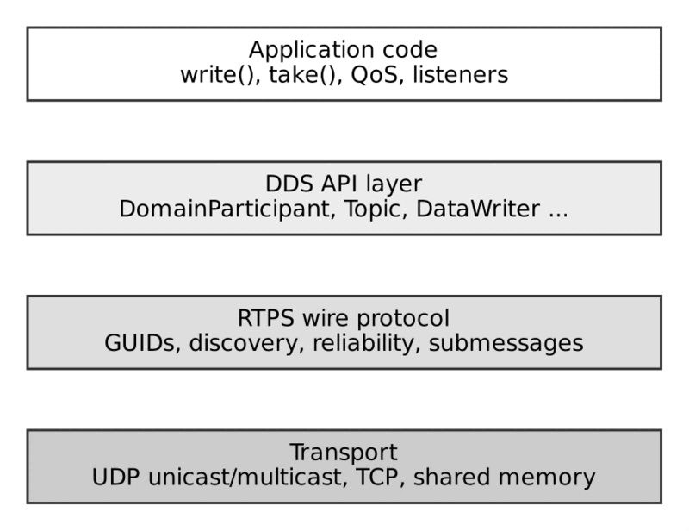
DDS sits above RTPS, which sits above the transport
An engineer debugging at the network level (e.g., with Wireshark’s RTPS dissector — topic 36) is looking directly at the RTPS layer — GUIDs, sequence numbers, submessages — not at DDS-API-level constructs, which is why understanding RTPS concretely (not just “DDS uses some protocol underneath”) matters for serious troubleshooting.

Vendor Interoperability in Practice
Because RTPS is a genuine interoperability standard (not just a shared “inspiration”), different vendors’ implementations are tested against each other at OMG-sponsored interoperability events (a practice sometimes called “plugfests”), and most major vendors publish interoperability compliance statements. That said, senior engineers should be aware of practical caveats (expanded in topic 34):
- RTPS covers the wire protocol, not every QoS behavior’s exact semantics — subtle differences in vendor-specific default values or edge-case behaviors can exist.
- DDS Security and XTypes support/versions can vary by vendor and release, affecting interoperability for those specific features even when basic pub-sub interoperates fine.
- Vendor-proprietary QoS extensions (features beyond the OMG standard) obviously don’t interoperate with other vendors, by definition — use them deliberately and sparingly if cross-vendor interoperability is a requirement.

Summary
RTPS (Real-Time Publish-Subscribe Protocol) is the OMG-standardized wire protocol that underlies DDS, separating the API/programming model (DDS) from the network wire format (RTPS) — a separation that enables genuine cross-vendor interoperability. RTPS was designed to run natively over inherently unreliable, connectionless UDP/multicast transport while layering optional, per-flow reliability on top via HEARTBEAT/ACKNACK, avoiding any broker in the data path. Its entity model (Participants, Writers, Readers, each identified by a GUID) underlies the DDS API entities you interact with in application code, and understanding RTPS concretely — not just as an abstract “protocol that exists” — is essential for real network-level troubleshooting and for reasoning about vendor interoperability guarantees and their practical limits.

Things to Remember
- DDS is the API; RTPS is the wire protocol — this separation is what enables genuine cross-vendor interoperability.
- RTPS runs natively over UDP/multicast by default, adding reliability as an optional protocol-level layer rather than depending on TCP.
- RTPS is inherently peer-to-peer — no broker ever sits in the data path.
- RTPS entities (Participant, Writer, Reader) underlie DDS API entities and are identified on the wire by GUIDs, not API object references.
- Vendor interoperability is real but has practical caveats — QoS edge-case behavior, DDS Security/XTypes version differences, and vendor-proprietary extensions can all affect true interoperability.
- Network-level troubleshooting (e.g., Wireshark) operates at the RTPS layer — knowing RTPS concretely, not just abstractly, is essential for this kind of debugging.
- Treat vendor choice as revisable when staying within standard RTPS/QoS behavior and avoiding proprietary extensions.

17. RTPS Message and Submessage Structure
In one sentence. An RTPS message is one packet with a 20-byte header followed by self-describing, length-prefixed submessages such as DATA, HEARTBEAT and ACKNACK.
Analogy. An RTPS message is an envelope with a sender label, containing several small, labelled notes. Each note starts with a sticker saying what kind it is and how long it is, so a receiver that does not recognise a sticker can skip exactly that many bytes and keep reading. One envelope may carry a timestamp note, two data notes and a roll-call note, saving postage.

Overview
If topic 16 established why RTPS exists, this topic goes one level deeper into what actually goes over the wire. Understanding RTPS’s message/submessage structure is what separates engineers who can competently read a Wireshark capture, diagnose a reliability issue from a packet trace, or reason precisely about bandwidth usage, from those who only understand DDS at the API level.

The Big Picture: One UDP Packet, One RTPS Message, Many Submessages
Every RTPS Message is carried inside a single network packet (typically one UDP datagram) and consists of:
RTPS Message
+-- RTPS Header (fixed, 20 bytes)
+-- One or more Submessages, back to back
+-- Submessage 1 (e.g., INFO_TS)
+-- Submessage 2 (e.g., DATA)
+-- Submessage 3 (e.g., HEARTBEAT)
+-- ...
Packing multiple submessages into one physical packet is a deliberate efficiency design: rather than one packet per logical operation, RTPS batches related submessages together — e.g., a single UDP packet might carry a timestamp submessage followed by several DATA submessages for different samples, followed by a HEARTBEAT, all in one network round-trip.

RTPS Header
The fixed 20-byte header appears once per message, identifying the protocol and sending participant:
protocol
- Size: 4 bytes
- Purpose: Literal "RTPS" — identifies this as an RTPS packet.
protocolVersion
- Size: 2 bytes
- Purpose: RTPS protocol version (e.g., 2.3, 2.5).
vendorId
- Size: 2 bytes
- Purpose: Identifies which vendor’s implementation sent this (RTI, eProsima, Eclipse, etc.) — used for vendor-specific interoperability handling if needed.
guidPrefix
- Size: 12 bytes
- Purpose: The GUID prefix of the sending Participant — combined with per-entity Entity IDs in submessages to form full GUIDs (topic 19).
Everything that follows in the packet is one or more submessages, all implicitly associated with this sending participant’s GUID prefix unless a submessage explicitly overrides it.

Submessage Structure
Each submessage has its own small header followed by submessage-specific content:
Submessage
+-- submessageId (1 byte) - identifies the kind (DATA, HEARTBEAT, ACKNACK, GAP,
INFO_TS, ...)
+-- flags (1 byte) - kind-specific flags (endianness, presence of
optional fields, etc.)
+-- submessageLength (2 bytes) - length of this submessage's content
+-- submessage-specific content
This self-describing, length-prefixed structure is what allows a receiver to parse a sequence of submessages of varying kinds and sizes packed into one packet, and — as mentioned in topic 16 — is what allows the protocol to be extended over time: an older implementation encountering an unrecognized submessage ID it doesn’t understand can, depending on flags, skip over it using the length field rather than failing to parse the rest of the message.

The Core Submessage Kinds
****DATA****
- Purpose: Carries an actual sample’s serialized payload (or key-only data for a dispose/unregister), along with the writer’s GUID, the sample’s sequence number, and instance-related flags.
****HEARTBEAT****
- Purpose: Sent periodically (or on-demand) by a reliable writer, announcing the range of sequence numbers currently available in its history — the trigger for readers to detect and request retransmission of gaps (topic 18).
****ACKNACK****
- Purpose: Sent by a reliable reader in response to a HEARTBEAT (or periodically), acknowledging received sequence numbers and explicitly naming any missing ones (“nacking” them) to request retransmission.
****GAP****
- Purpose: Sent by a writer to explicitly tell a reader “these sequence numbers will never be sent/retransmitted” — e.g., because samples were disposed, expired via Lifespan, or otherwise irrelevantly discarded — so the reader stops waiting for them.
****INFO_TS****
- Purpose: Carries a timestamp applied to the DATA submessage(s) that follow it — used for source-timestamp-based ordering (Destination Order QoS) and for populating SampleInfo.source_timestamp.
****INFO_DST****
- Purpose: Specifies the destination GUID prefix for subsequent submessages, when a message needs to be addressed more specifically than “whoever is listening.”
****INFO_REPLY****
- Purpose: Provides an alternate locator (address/port) the receiver should use for replies, useful in certain NAT/multi-interface network configurations.
****HEARTBEAT_FRAG** / NACK_FRAG**
- Purpose: Fragment-level equivalents of HEARTBEAT/ACKNACK, used when a sample is too large for one packet and must be fragmented (see below).

Example: A Typical Reliable Write, on the Wire
Walking through what actually happens over the network for a single write() call on a RELIABLE DataWriter:
1. Writer's write() call is translated internally into:
Packet 1 (writer -> multicast/unicast):
[RTPS Header (guidPrefix = Writer's Participant)]
[INFO_TS - source timestamp for the sample that follows]
[DATA - the serialized sample, sequence number N, writer GUID]
2. Periodically (or triggered by writer-side heuristics), the writer sends:
Packet 2 (writer -> readers):
[RTPS Header]
[HEARTBEAT - "I have sequence numbers 1 through N available"]
3. Each matched reliable reader responds:
Packet 3 (reader -> writer, unicast):
[RTPS Header (guidPrefix = Reader's Participant)]
[ACKNACK - "I have received up to N, no gaps" (or:
"missing sequence numbers X, Y")]
4. If gaps were nacked, the writer retransmits only those specific samples:
Packet 4 (writer -> reader, unicast):
[RTPS Header]
[DATA - retransmission of sequence number X]
This is precisely why RTPS reliability resembles TCP’s sliding-window retransmission in spirit — selective, sequence-number-driven retransmission — while remaining a per-sample, per-instance, connectionless protocol layered over UDP, not a byte-stream, connection-oriented protocol like TCP itself.

Fragmentation: Handling Large Samples
UDP datagrams have practical size limits (commonly capped well below the theoretical 65,507-byte maximum, often configured around the path MTU, ~1400–9000 bytes depending on jumbo frame support). A DDS sample larger than this limit — e.g., a large point cloud, an image, a big configuration blob — must be fragmented:
- The writer splits the serialized sample into multiple DATA_FRAG submessages, each carrying one fragment plus fragmentation metadata (fragment number, total fragment count).
- The reader reassembles fragments before the sample is delivered to the application — fragment loss under RELIABLE reliability is handled via NACK_FRAG (fragment-level ACKNACK) rather than requiring the entire sample to be resent from scratch.
Understanding fragmentation matters operationally: very large samples increase retransmission cost under packet loss (a single lost fragment can delay delivery of the whole reassembled sample) and interact with network MTU configuration — a frequent tuning consideration in high-bandwidth data topics (e.g., camera/LIDAR feeds).

Practical Relevance for Engineers
- Reading a Wireshark RTPS capture (topic 36) means recognizing this exact structure: one packet, one header, a sequence of submessages — being able to spot a HEARTBEAT/ACKNACK exchange immediately tells you reliability is (or isn’t) functioning as expected.
- Diagnosing “reliable but slow” issues often comes down to observing the HEARTBEAT/ACKNACK cadence and retransmission pattern directly at this level, rather than guessing from application-level symptoms alone.
- Bandwidth estimation for a given Topic and QoS configuration requires accounting for not just DATA submessage payload size, but also periodic HEARTBEAT/ACKNACK overhead — which scales with reliable writer/reader counts and configured heartbeat periods.
- MTU and fragmentation tuning matters directly for large-payload topics — understanding when/why fragmentation kicks in avoids surprises in production bandwidth or latency behavior.

Summary
RTPS packs one or more self-describing, length-prefixed submessages (DATA, HEARTBEAT, ACKNACK, GAP, INFO_TS, and others) behind a single fixed 20-byte header into each network message, typically one per UDP packet — an efficient, extensible design that allows multiple logical operations to be batched into one round-trip and allows the protocol to evolve without breaking older parsers. A reliable write’s full lifecycle on the wire involves DATA (the sample itself), periodic HEARTBEAT announcements of available sequence numbers, and reader-driven ACKNACK responses that trigger selective, per-sample retransmission — closely mirroring TCP’s sliding-window philosophy while remaining a connectionless, per-sample protocol over UDP. Large samples exceeding practical UDP/MTU limits are automatically fragmented and reassembled, with their own fragment-level reliability submessages. Concrete familiarity with this structure is a prerequisite for real network-level DDS troubleshooting and bandwidth reasoning.

Things to Remember
- One RTPS message = one packet (usually) = one header + multiple submessages, batched for efficiency.
- Core submessages: DATA (the sample), HEARTBEAT (writer announces available sequence range), ACKNACK (reader acks/nacks), GAP (writer says “these will never be resent”), INFO_TS (timestamp for following DATA).
- Reliable delivery works like TCP’s sliding window in spirit, but is connectionless, per-sample, and layered over UDP — not a byte-stream protocol.
- Large samples are automatically fragmented (DATA_FRAG) when they exceed practical UDP/MTU limits, with fragment-level reliability via NACK_FRAG.
- The submessage format is self-describing and length-prefixed, enabling protocol extensibility — unrecognized submessages can be skipped rather than breaking parsing.
- HEARTBEAT/ACKNACK overhead is a real bandwidth cost, scaling with reliable writer/reader counts and heartbeat period — factor this into bandwidth planning, not just raw sample payload size.
- Concrete knowledge of this structure is required for effective Wireshark-based RTPS troubleshooting (topic 36) — abstract “DDS uses some protocol” understanding isn’t sufficient at this level.

18. Sequence Numbers, Heartbeats and ACKNACK
In one sentence. Reliability is built on per-writer sequence numbers, writer HEARTBEATs announcing what exists, and reader ACKNACKs naming what is missing.
Analogy. A teacher takes attendance. The writer numbers every sample like handing out numbered worksheets. Every so often the teacher says “I have handed out worksheets 1 to 107!” (HEARTBEAT). Each pupil answers “I’m missing number 42” (ACKNACK). The teacher walks over with just that one sheet. Nobody re-hands the whole stack. If a worksheet has been withdrawn, a GAP notice tells the pupil to stop waiting for it.

Overview
Topic 17 introduced HEARTBEAT and ACKNACK as submessage kinds. This topic goes deep on the mechanism itself — the actual state machine and algorithm that implements RELIABLE reliability (topic 07) over an inherently unreliable UDP transport. This is the single most important protocol-level mechanism to understand deeply, because nearly every “reliable delivery is slow/stuck/not working” production issue is ultimately a question about sequence numbers, heartbeat cadence, or ACKNACK behavior.

Sequence Numbers: The Foundation
Every sample a DataWriter publishes is assigned a monotonically increasing sequence number, scoped per DataWriter (not per instance, not per topic globally):
Writer X's sequence numbers: 1, 2, 3, 4, 5, 6, ...
This applies regardless of which instance each sample belongs to — if a writer publishes samples for instance A, then instance B, then instance A again, the sequence numbers still increment monotonically across all of them (1, 2, 3, …), not per-instance. Sequence numbers are what allow a reader to precisely identify which samples it has received and which are missing — the entire reliability mechanism is built on tracking gaps in this per-writer sequence.

The Writer’s Perspective: What It Tracks
A reliable DataWriter maintains, conceptually, a history cache — the set of samples it currently holds, bounded by History and Resource Limits QoS (topic 09) — along with, for each matched reliable reader, knowledge of:
- The highest sequence number that reader has acknowledged.
- Any specific sequence numbers that reader has explicitly nacked (reported missing).
This per-reader state is what allows a writer serving multiple readers at different “catch-up” points to retransmit the right data to the right reader, rather than broadcasting a one-size-fits-all retransmission.

HEARTBEAT: “Here’s What I Have”
A reliable writer periodically sends a HEARTBEAT submessage announcing the range of sequence numbers currently in its history cache:
HEARTBEAT: firstSN = 42, lastSN = 107
-> "I currently hold samples numbered 42 through 107 (inclusive)."
Key behaviors:
- Sent periodically at an interval configurable via the writer’s Protocol QoS (commonly a few hundred milliseconds by default, vendor-dependent) — this is a direct latency/overhead trade-off: more frequent heartbeats mean faster gap detection and retransmission, at the cost of more network/CPU overhead.
- Also sent on-demand in many implementations, e.g., immediately after a write() call, to minimize latency for the common “no loss occurred” case rather than waiting for the next periodic interval.
- Can be marked with a FINAL flag, indicating the writer does not require an ACKNACK response unless the reader actually has something to report — an optimization to avoid unnecessary ACKNACK traffic when nothing is wrong.

ACKNACK: “Here’s What I’m Missing”
Upon receiving a HEARTBEAT (or periodically/proactively), a reliable reader responds with an ACKNACK submessage:
ACKNACK: base = 106, bitmap = 0b1
-> "I have everything below 106, and sample 106
itself is missing."
The ACKNACK’s sequence-number-set representation efficiently encodes both:
- A base sequence number (everything below this has been fully received).
- A bitmap identifying specific gaps at or above that base.
This compact encoding lets a reader with, say, one missing sample out of ten thousand communicate that gap efficiently, without listing all ten thousand acknowledged numbers individually.

Retransmission
Upon receiving an ACKNACK reporting gaps, the writer retransmits only the specifically nacked sequence numbers via targeted DATA submessages — not the entire history — an important efficiency property that keeps retransmission cost proportional to actual loss, not to total traffic volume.
Writer receives ACKNACK naming missing SN 106
-> Writer resends DATA submessage for SN 106 only (unicast to that specific reader)

The Full Reliable Exchange, End to End
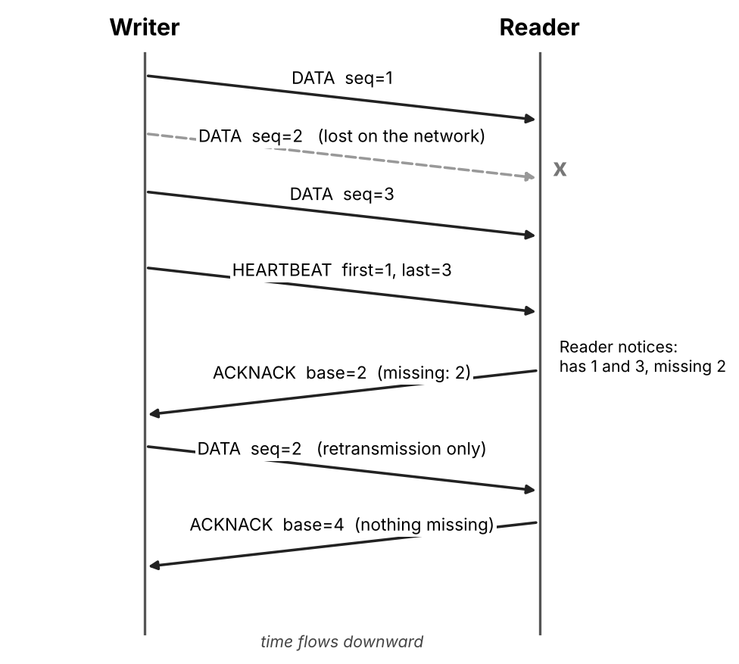
A lost sample is detected and repaired (HEARTBEAT, ACKNACK, retransmission)
This closely resembles TCP’s sliding-window acknowledgment/retransmission philosophy — but crucially, it’s applied per matched writer/reader pair, per sample, over a connectionless transport, and integrated with DDS’s richer instance/QoS model (e.g., a GAP submessage can tell a reader “sequence number 2 will never be resent” if it was explicitly disposed or expired via Lifespan QoS before retransmission could occur — topic 14).

Heartbeat/ACKNACK Tuning: A Real Latency/Overhead Trade-off
This mechanism exposes several tunable parameters (via RTPS Reliability Protocol QoS, vendor-specific naming varies) with direct operational consequences:
****Heartbeat period****
- Effect of increasing it: Slower gap detection/retransmission → higher worst-case latency on loss
- Effect of decreasing it: Faster gap detection → lower loss-recovery latency, but more network/CPU overhead
****heartbeat_response_delay** (reader’s delay before sending ACKNACK)**
- Effect of increasing it: Reduces ACKNACK “storm” risk when many readers respond to one heartbeat simultaneously
- Effect of decreasing it: Faster acknowledgment, but higher risk of many readers responding at once, especially with many readers on a shared multicast group
****nack_response_delay** (writer’s delay before responding to an ACKNACK)**
- Effect of increasing it: Allows batching multiple readers’ nacks before retransmitting, reducing redundant retransmission
- Effect of decreasing it: Faster retransmission response, but potentially more redundant/duplicate retransmissions
Practical implication: for hard real-time systems where worst-case loss-recovery latency matters, heartbeat period and response delays should be tuned aggressively tighter than defaults; for large-fan-out systems with many readers (e.g., hundreds of subscribers to one topic), overly aggressive settings can cause “ACKNACK storms” that themselves degrade network performance — this is a genuine tuning trade-off, not a “lower is always better” setting.

Practical Relevance for Engineers
- A Wireshark capture showing frequent, repeated HEARTBEAT/ACKNACK cycles with nacked sequence numbers is direct evidence of packet loss on the network — a strong signal to investigate network quality, multicast configuration, or NIC/driver issues rather than application logic.
- Unexpectedly high latency on a “reliable” topic is often explainable by heartbeat period being too coarse for the required responsiveness — tightening it is a direct, well-understood lever.
- Large fan-out reliable topics (many readers) require careful heartbeat/ACKNACK tuning to avoid overwhelming the writer or network with acknowledgment traffic — this is a first-order scalability concern for reliable pub-sub at scale.

Summary
DDS’s RELIABLE reliability is implemented via per-writer monotonic sequence numbers, periodic (and on-demand) HEARTBEAT announcements of the writer’s available sequence range, reader-driven ACKNACK responses that efficiently encode acknowledged versus missing sequence numbers via a base-plus-bitmap representation, and targeted, per-sample retransmission of only the specifically nacked data — a mechanism philosophically similar to TCP’s sliding window, but connectionless, per-sample, and layered over UDP. The heartbeat period and various response-delay parameters expose a genuine, non-trivial latency-versus-overhead trade-off that senior engineers must tune deliberately based on real-time requirements and expected reader fan-out, and this mechanism is the concrete, wire-level thing to inspect (e.g., via Wireshark) when diagnosing reliability-related latency or throughput issues in production.

Things to Remember
- Sequence numbers are per-writer and monotonic, spanning all instances that writer publishes — not per-instance, not per-topic-globally.
- HEARTBEAT = “here’s what I have” (writer → readers, periodic + on-demand); ACKNACK = “here’s what I’m missing” (reader → writer, in response).
- ACKNACK uses an efficient base+bitmap encoding, so reporting a few gaps out of thousands of samples is cheap.
- Retransmission is targeted — only the specifically nacked sequence numbers are resent, not the entire history.
- GAP submessages tell a reader “this sequence number will never be resent” (e.g., disposed or expired via Lifespan) — preventing indefinite waiting for unrecoverable data.
- Heartbeat period and response-delay parameters are a real latency-vs-overhead trade-off — tune aggressively for hard real-time, more conservatively for large reader fan-out to avoid ACKNACK storms.
- This is the concrete mechanism to inspect via Wireshark when diagnosing reliability-related latency, throughput, or “stuck” delivery issues.

19. Entity IDs and GUIDs
In one sentence. A GUID is a 16-byte globally unique identity: 12 bytes for the participant plus 4 bytes for the entity inside it.
Analogy. A GUID is like a car licence plate with a country code: the first part says which participant (like the registration district), the last part says which entity inside it (like the specific vehicle). Because the parts come from host, process and counters, nobody needs a central office to hand out numbers. Like a licence plate, it changes if you re-register (restart the process), so never use it as long-term identity.

Overview
Every RTPS Participant, Writer, and Reader referenced throughout topics 16–18 needs a globally unique identifier that appears on the wire — not a language-level object pointer or a DDS-API handle, but an actual bytes-on-the-wire identity that any receiving implementation, regardless of vendor or language, can parse and compare. That identifier is the GUID. Understanding its structure is essential for reading RTPS traces, reasoning about discovery, and understanding how DDS achieves global uniqueness without any central coordinating authority.

GUID Structure: Prefix + Entity ID
A GUID is a fixed 16-byte value composed of two parts:
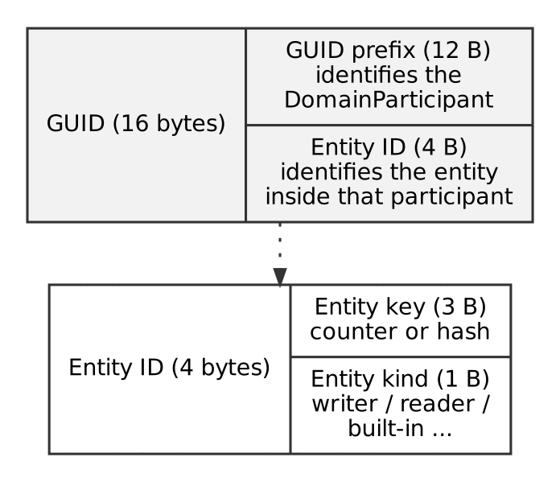
Structure of a GUID
Structure of a GUID

GUID Prefix (12 bytes)
Identifies the DomainParticipant — every RTPS entity belonging to the same participant shares the same 12-byte prefix. Vendors typically derive this from a combination of values intended to make it unique without coordination:
- Parts of the host’s IP address or a vendor-specific host identifier.
- The process ID of the running application.
- A per-participant counter/random component, to distinguish multiple participants in the same process.
The exact algorithm is vendor-specific (RTPS standardizes the format, not the generation algorithm), but the practical effect is: two participants on different hosts, or in different processes on the same host, will essentially never collide — similar in spirit to how UUIDs achieve practical global uniqueness without central coordination.

Entity ID (4 bytes)
Identifies a specific entity (a Writer, a Reader, or the Participant itself) within that GUID prefix’s scope. The Entity ID has a structured format:
Entity ID (4 bytes) = Entity Key (3 bytes) + Entity Kind (1 byte)
- Entity Kind identifies what type of entity this is — a built-in discovery Writer, a built-in discovery Reader, a user-defined Writer, a user-defined Reader, the Participant itself, etc. — via standardized well-known values.
- Entity Key is typically a counter or hash uniquely distinguishing entities of the same kind within one participant (e.g., the 2nd, 3rd, 4th DataWriter created).

Well-Known Entity IDs
Certain Entity IDs are standardized, fixed values — not vendor- or instance-specific — because they identify the built-in discovery entities every RTPS implementation must have, so that discovery itself can bootstrap without prior knowledge:
Well-known entity | Purpose
ENTITYID_PARTICIPANT | Identifies the Participant entity itself.
ENTITYID_SEDP_BUILTIN_PUBLICATIONS_WRITER/READER | The built-in Writer/Reader pair used for SEDP (topic 21) — announcing/discovering DataWriters.
ENTITYID_SEDP_BUILTIN_SUBSCRIPTIONS_WRITER/READER | The built-in Writer/Reader pair for announcing/discovering DataReaders.
ENTITYID_SPDP_BUILTIN_PARTICIPANT_WRITER/READER | The built-in Writer/Reader pair for SPDP (topic 20) — participant-level discovery.
Because these values are fixed by the RTPS specification, any two RTPS implementations — regardless of vendor — know exactly which Entity ID to expect for “the thing that announces new DataWriters,” etc., without any prior negotiation. This is precisely what allows discovery to bootstrap cold: a brand-new participant can send an SPDP announcement and know, by specification, exactly what Entity ID a receiving participant’s SPDP reader will be listening on.

Why This Design Achieves Global Uniqueness Without Coordination
This is worth appreciating as a piece of distributed-systems design: DDS has no central registry, no naming service, no broker assigning identities — yet GUIDs must still be globally unique across an entire domain (and in practice, across the internet, since RTPS doesn’t assume domain-level network isolation). The GUID prefix’s derivation from host/process-specific values, combined with the Entity ID’s per-participant scoping, achieves this the same way UUIDs or IP:port combinations do: by combining enough independently-varying, practically-non-colliding components that collision probability becomes negligible, without requiring any participant to ask permission or check with a central authority before creating an entity.

GUIDs in Practice: What You’ll See

In built-in topic data (topic 03)
Reading the DCPSPublication/DCPSSubscription built-in topics, each discovered DataWriter/DataReader’s identity is exposed as a GUID — useful for building introspection/monitoring tooling that needs to uniquely track specific writers/readers across the domain, independent of any particular language-level handle.
DataReader* builtinPubReader = participant->get_builtin_subscriber()
->lookup_datareader("DCPSPublication");
// Each returned PublicationBuiltinTopicData includes a BuiltinTopicKey_t
// derived from the discovered DataWriter's GUID.

In a Wireshark RTPS capture
Every submessage in an RTPS packet is scoped to a guidPrefix from the packet header (topic 17), combined with per-submessage Entity IDs where relevant (e.g., a DATA submessage’s writerId field). Recognizing well-known Entity IDs (e.g., spotting SPDP or SEDP traffic by their fixed Entity ID values) versus user-defined ones is a practical skill for distinguishing discovery traffic from application data traffic in a capture.

In InstanceHandle_t — a related but distinct concept
It’s worth explicitly distinguishing DDS’s InstanceHandle_t (used at the DDS API level to identify a keyed instance within a Topic, topic 24) from a RTPS GUID (used at the wire-protocol level to identify a Writer, Reader, or Participant entity). These are conceptually different axes — one identifies “which instance of data” within a topic, the other identifies “which participant/writer/reader” on the network — though implementations sometimes derive/relate them internally in vendor-specific ways.

Practical Relevance for Engineers
- Reading RTPS captures competently requires recognizing GUID structure — being able to mentally split a 16-byte GUID into “which participant” (prefix) and “which entity” (Entity ID, including recognizing well-known discovery Entity IDs) is a core diagnostic skill.
- GUID stability across restarts is generally not guaranteed — since prefixes are commonly derived in part from process ID and similar dynamic values, a restarted application will typically get a new GUID, which matters if you’re building tooling that tries to track “the same logical writer” across restarts by GUID alone (you generally shouldn’t — use application-level identity/instance keys for that instead).
- Multi-homed hosts and NAT’d environments can complicate GUID-prefix-derivation assumptions in some vendor implementations — worth investigating vendor-specific behavior if deploying across complex network topologies.

Summary
The GUID is RTPS’s fundamental, wire-level, globally-unique identifier for Participants, Writers, and Readers, composed of a 12-byte GUID Prefix (identifying the DomainParticipant, derived from host/process-specific values to achieve practical uniqueness without central coordination) and a 4-byte Entity ID (identifying the specific entity within that participant, itself split into an Entity Kind and Entity Key). A set of standardized, fixed well-known Entity IDs for built-in discovery Writers/Readers is what allows RTPS discovery to bootstrap cold between any two conformant implementations without prior negotiation. GUIDs are conceptually distinct from DDS’s InstanceHandle_t (which identifies keyed data instances, not network entities) and are generally not stable across application restarts — a detail worth remembering when building GUID-based tooling or diagnostics.

Things to Remember
- GUID = 12-byte GUID Prefix (identifies the Participant) + 4-byte Entity ID (identifies the specific entity within it).
- GUID uniqueness is achieved without any central registry — via host/process-derived prefix components, the same design philosophy as UUIDs.
- Well-known, fixed Entity IDs for built-in discovery entities (SPDP/SEDP writers/readers) are what let RTPS discovery bootstrap cold between any two conformant vendors.
- GUIDs are generally not stable across application restarts — don’t build long-term identity tracking on raw GUIDs alone; use application-level keys instead.
- GUID ≠ InstanceHandle_t — GUID identifies a network entity (Participant/Writer/Reader); InstanceHandle_t identifies a keyed data instance within a Topic. Different axes, don’t conflate them.
- Recognizing GUID structure and well-known Entity IDs is a core skill for reading RTPS/Wireshark captures — it’s how you distinguish discovery traffic from application data and identify which participant/entity a given submessage belongs to.

Part IV: Discovery
How participants and endpoints find each other without any central server.
In a hall with no reception desk, everyone must announce themselves and learn about the others. Chapter 20 is the name-badge shout, chapter 21 is the exchange of business cards, and chapter 22 explains what happens when the hall gets crowded.

20. Simple Participant Discovery Protocol (SPDP)
In one sentence. SPDP is the first discovery layer: participants periodically announce themselves so that others learn they exist.
Analogy. SPDP is a ship’s AIS beacon: every vessel periodically broadcasts “I am here, this is my name, this is how to reach me, this is how long you should keep believing me”. Anyone listening adds the vessel to their chart. If a ship goes quiet for longer than the stated lease, it is removed from the chart. At this stage nobody knows what cargo anyone carries; that comes next.

Overview
SPDP is the mechanism by which DDS DomainParticipants find each other on a network before any topic-level matching can happen. It is the first, coarsest layer of the two-tier discovery system defined by RTPS (the second tier being SEDP, covered in the next document). Without SPDP, no participant would know that any other participant exists — there would be nothing to exchange endpoint metadata with.

Core Idea
Each DomainParticipant periodically announces itself by sending a special RTPS message — the SPDP announcement, carried as a DATA submessage on a well-known built-in topic (DCPSParticipant). This announcement is essentially the participant’s business card. It contains:
- The participant’s GUID prefix (globally unique identifier)
- Supported RTPS protocol version and vendor ID
- The unicast/multicast locators (IP:port pairs) where it can be reached
- Default QoS values for its future endpoints
- Lease duration (how long other participants should consider it “alive” without a fresh announcement)
- Available built-in endpoints (whether it supports SEDP publication/subscription readers/writers, etc.)

How It Works, Step by Step
- Announcement: On startup, a participant sends an SPDP announcement to a well-known multicast address (default 239.255.0.1, port derived from the Domain ID) and/or to a list of configured unicast peers.
- Periodic re-announcement: The participant repeats this announcement at a configurable interval (commonly every 1–3 seconds), refreshing its lease.
- Reception: Any participant listening on that multicast group receives the announcement and adds the new participant to its local discovery database.
- Liveliness / lease expiration: If a participant stops announcing for longer than its declared lease duration, peers consider it gone and clean up all associated state (endpoints, matches).
- Handshake, not negotiation: SPDP is one-way, best-effort, and asynchronous — there’s no acknowledgment protocol at this layer (that granularity belongs to SEDP and to reliable data delivery once matched).

Example: Domain ID and Port Derivation
DDS derives well-known multicast/unicast ports from the Domain ID using a formula (per the RTPS spec):
PB = 7400 # Port Base
DG = 250 # Domain Gain
d0 = 0 # SPDP multicast offset
SPDP multicast port = PB + DG * domainId + d0
For Domain ID 0, this yields port 7400. For Domain ID 5, it yields 8650. This is why two applications on the same Domain ID automatically discover each other on the same machine or LAN — they’re listening on the same multicast port — while different Domain IDs are cleanly isolated at the network level.

Example: Minimal Config (Connext-style pseudocode)
<domain_participant_qos>
<discovery_config>
<participant_liveliness_lease_duration>
<sec>10</sec>
</participant_liveliness_lease_duration>
<participant_liveliness_assert_period>
<sec>3</sec>
</participant_liveliness_assert_period>
</discovery_config>
</domain_participant_qos>
Here, the participant re-asserts itself every 3 seconds, and peers will drop it if nothing is heard for 10 seconds.

Common Pitfalls
- Multicast disabled on the network (common in cloud/VPC environments) → SPDP never completes; must fall back to a static/unicast peer list.
- Lease duration too short relative to CPU load or network jitter → false “participant lost” events and discovery flapping.
- Too many participants on a flat multicast domain → SPDP traffic grows, contributing to the O(n²) discovery scalability problem (see topic 22).

Things to Remember
- SPDP discovers participants, not topics or endpoints — it’s the coarse first layer.
- It relies on periodic, best-effort multicast (or configured unicast) announcements carried on the built-in DCPSParticipant topic.
- Liveliness is lease-based: silence beyond the lease duration means the peer is presumed dead.
- Multicast availability and lease tuning are the two most common sources of real-world SPDP problems.
- SPDP existing successfully is the precondition for SEDP (endpoint-level discovery) to even begin.

21. Simple Endpoint Discovery Protocol (SEDP)
In one sentence. SEDP is the second discovery layer: matched participants exchange the topic, type and QoS of every writer and reader so pairs can be matched.
Analogy. Once ships have spotted each other on the radar (SPDP), they exchange cargo manifests (SEDP): “I carry topic VehiclePosition, type X, delivered RELIABLE.” Each side compares manifests with its own needs and decides which pairs to connect. If you never see data, the first thing to check is whether the manifests really are compatible.

Overview
Once SPDP has established that two DomainParticipants know about each other, SEDP is the second tier of RTPS discovery: it exchanges information about the actual DataWriters and DataReaders (endpoints) each participant hosts, so that writer/reader pairs on matching topics can find and connect to each other.

Core Idea
SEDP uses its own set of built-in topics/endpoints:
- DCPSPublication — announces DataWriters
- DCPSSubscription — announces DataReaders
- DCPSTopic (vendor-optional) — announces Topic definitions
Each announcement contains everything needed to decide whether a match is possible:
- Topic name and type name
- Full QoS policy set (reliability, durability, deadline, ownership, etc.)
- The endpoint’s GUID
- Partition membership
- Content filter expressions (for ContentFilteredTopics)

How It Works, Step by Step
- After SPDP completes, participants use each other’s discovered unicast locators to exchange SEDP data — reliably, unlike the best-effort SPDP announcements.
- Each side’s built-in SEDP DataWriter publishes information about local user-created DataWriters/DataReaders.
- The receiving participant’s discovery listener inspects each announcement and applies the matching algorithm:
  - Topic name must match exactly.
  - Type must be compatible (identical, or compatible under XTypes rules).
  - QoS must be compatible (see topic 15 — request vs. offered).
  - Partition strings must intersect (see topic 13).
- If all criteria pass, the middleware creates an internal match — after which actual user data (DATA submessages) can begin flowing between that writer and reader pair.
- SEDP re-announces on QoS changes (e.g., a writer’s liveliness or deadline QoS is updated at runtime) so peers can re-evaluate compatibility.

Example: Why a Reader Doesn’t See a Writer’s Data
Imagine a writer publishes on topic VehicleStatus with RELIABLE reliability, and a reader subscribes to the same topic but requests RELIABLE too — that matches. But if the reader’s Partition QoS is "Fleet_A" and the writer’s is "Fleet_B", SEDP will discover both endpoints yet refuse to match them, because partitions form disjoint discovery groups even on an identical topic name/type.
Writer: topic=VehicleStatus, partition=["Fleet_B"], reliability=RELIABLE
Reader: topic=VehicleStatus, partition=["Fleet_A"], reliability=RELIABLE
Result: Discovered by SEDP, but NOT matched (partition mismatch)

Example: SEDP Traffic Growth
For N participants each with M endpoints, every participant must receive and process SEDP announcements from every other participant’s endpoints — contributing to the overall O(n²) discovery cost alongside SPDP (this is elaborated further in topic 22).

Common Pitfalls
- Assuming topic name matching alone is sufficient — a huge source of “why won’t my writer/reader connect” bugs is QoS or partition mismatch, not name/type mismatch.
- Forgetting that SEDP announcements are reliable, so they consume real bandwidth and retransmission overhead proportional to the number of endpoints, not just participants.
- Not accounting for SEDP re-announcement storms when QoS is changed dynamically on many endpoints at once.

Things to Remember
- SEDP is the endpoint-level discovery layer, running after SPDP has found the participants.
- It exchanges topic name, type, QoS, and partition info via reliable built-in DataWriters/DataReaders.
- Matching requires: topic name match + type compatibility + QoS compatibility + partition intersection.
- Discovery ≠ Matching: participants/endpoints can be discovered without ever being matched.
- SEDP traffic scales with the number of endpoints, making it a key lever in discovery scalability tuning.

22. Discovery Scalability and Tuning
In one sentence. Default discovery scales as O(n squared); discovery servers, initial peers, static discovery and partitioning keep it manageable.
Analogy. At a party where everyone introduces themselves to everyone else, the number of introductions explodes as the guest list grows. Fixes: hire a receptionist (discovery server) who keeps the guest list, hand out seating cards in advance (static discovery), only introduce people from your own table (initial peers), or hold separate parties (domains/partitions).

Overview
DDS’s default discovery (SPDP + SEDP) is simple and robust for small-to-medium deployments, but it scales poorly by design: every participant talks to every other participant, and every endpoint’s metadata is exchanged with every other participant. This document covers why that happens and the standard mitigation strategies.

The O(n²) Problem
With N participants:
- Each participant sends periodic SPDP announcements that all N-1 others must receive and process.
- Each participant’s SEDP endpoints (M per participant on average) are announced to all other participants, and reliable delivery requires ACKNACK handshakes per remote reader.
Total discovery traffic and CPU cost grows roughly with N² (participants) and N² * M (endpoints), meaning that doubling the number of participants can roughly quadruple discovery overhead — this becomes untenable well before 100+ participants on a flat domain in many real systems, especially with resource-constrained or high-latency links.

Mitigation Strategies

1. Discovery Servers (Centralized Discovery)
Instead of full mesh multicast discovery, participants act as clients of one or more discovery server participants. Clients only talk to the server(s); the server aggregates and redistributes discovery info.
[Client A] --unicast--> [Discovery Server] <--unicast-- [Client B]
This turns discovery traffic from O(n²) into roughly O(n), at the cost of the server(s) becoming a scaling/availability bottleneck (mitigated by running redundant servers).

2. Initial Peers List (No Multicast)
In environments where multicast is unavailable (cloud VPCs, WAN links), configure a static list of unicast peer addresses so SPDP doesn’t rely on multicast discovery at all:
<discovery>
<initial_peers>
<element>10.0.1.5</element>
<element>10.0.1.6</element>
</initial_peers>
</discovery>

3. Static Endpoint Discovery
Skip SEDP entirely by pre-configuring endpoint GUIDs, locators, and QoS out-of-band (typically via XML). Eliminates SEDP traffic completely but sacrifices flexibility — any endpoint change requires redeploying config.

4. Domain / Partition Segmentation
Split a large system into multiple Domain IDs or use Partition QoS to logically segment traffic so that not every participant needs to discover every other one — participants outside a partition/domain simply never see each other’s endpoints.

5. Tuning Announcement Periods
Lengthening SPDP announcement intervals and lease durations reduces steady-state background traffic once the system is stable, at the cost of slower failure detection.

Example: Discovery Server Configuration (RTI Connext style)
# Start a discovery server on domain 0
rtiddsspy -domainId 0
# Or, in code:
DomainParticipantQos qos;
qos.discovery_config.discovery.initial_peers.push_back("rtps@udpv4://10.0.1.10:7400");
qos.discovery_config.builtin_discovery_plugins = DISCOVERYPLUGIN_REMOTE;

Comparison Table
Strategy | Discovery Traffic | Flexibility | Failure Mode
Default multicast SPDP/SEDP | O(n²) | High | Multicast storms, flapping
Discovery Server | ~O(n) | High | Server SPOF (mitigate w/ redundancy)
Static Initial Peers | O(n) unicast | Medium | Manual peer list maintenance
Static Endpoint Discovery | ~O(1) after startup | Low | Config drift on changes

Things to Remember
- Default DDS discovery is O(n²) and becomes a real bottleneck in large or WAN-spanning deployments.
- Discovery servers are the most common production fix, trading a small SPOF risk for near-linear scaling.
- When multicast isn’t available (cloud, VPN, WAN), initial peers lists are mandatory, not optional.
- Static discovery trades runtime flexibility for near-zero discovery overhead — best for fixed, embedded, or safety-critical topologies.
- Segmenting via Domain ID or Partitions reduces the effective N that any one participant must discover.

Part V: Data Modelling and the Type System
How data types are defined, identified, encoded and evolved.
These chapters are about the forms on the boards: how to design them (IDL), how to label rows (keys), how to pack them for shipping (CDR) and how to change them without invalidating old copies (XTypes).

23. IDL and Data Type Definition
In one sentence. IDL is the language-neutral way to define data types; a code generator turns it into native types and serialization code.
Analogy. IDL is the architect’s blueprint, and the code generator is the construction crew that builds the same house in C++, Java or Python from one drawing. Everybody builds from the same plan, so doors and windows (fields) line up regardless of the language.

Overview
DDS is data-centric: the type of data flowing over a topic is a first-class contract between writers and readers. The Interface Definition Language (IDL), standardized by the OMG, is the language-neutral way to define these types. Code generators then translate IDL into native language bindings (C++, Java, Python, C#, Rust, etc.).

Core Idea
An IDL file defines structs, enums, unions, typedefs, and modules (namespaces) that describe the shape of the data exchanged. This same definition is used to:
- Generate strongly-typed language bindings for reading/writing samples.
- Derive the CDR serialization layout (see topic 25).
- Compute type compatibility for XTypes evolution (see topic 26).

Example: A Simple IDL Struct
module Fleet {
enum VehicleStatusCode {
IDLE,
ACTIVE,
FAULT
};
@topic
struct VehicleStatus {
@key
long vehicle_id;
VehicleStatusCode status;
double battery_level;
string<64> location_name;
sequence<double, 3> position; // e.g., x, y, z
};
}
Key annotations:
- @key marks the field(s) that form the instance key (see topic 24) — DDS uses this to distinguish separate “instances” published on the same topic.
- @topic (vendor-specific / newer IDL versions) marks a struct as directly usable as a DDS Topic type.
- string<64> and sequence<double, 3> are bounded types — bounding is important for both wire efficiency and for satisfying safety-critical/embedded memory constraints.

Example: Union and Nested Types
union Command switch (long) {
case 1: string move_command;
case 2: double speed_command;
case 3: boolean stop_command;
};
struct Waypoint {
double x;
double y;
};
struct RoutePlan {
@key long plan_id;
sequence<Waypoint> waypoints;
Command next_action;
};
Unions let a single field carry one of several possible types, discriminated by a switch value — useful for command/control topics with variant payloads.

Example: Code Generation Workflow
# RTI Connext
rtiddsgen -language C++11 VehicleStatus.idl
# Eclipse Cyclone DDS
idlc -l cxx VehicleStatus.idl
# eProsima Fast DDS
fastddsgen VehicleStatus.idl
Each generates: the native type class(es), a TypeSupport class for registering the type with the middleware, and (de)serialization code implementing CDR.

Common Pitfalls
- Using unbounded string/sequence types in resource-constrained or real-time systems — unbounded types force dynamic memory allocation on receive, which is bad for determinism.
- Forgetting @key on the field(s) meant to distinguish instances — without it, all samples land in a single unkeyed instance, defeating features like Ownership and per-instance history.
- Regenerating code from a changed IDL without considering type compatibility rules (topic 26) — this can silently break interoperability with already-deployed writers/readers using the old type.
- Mismatched IDL between vendors’ generators for identical semantics (e.g., default bounds) causing subtle wire incompatibilities — always verify with the target middleware’s IDL compiler.

Things to Remember
- IDL is the vendor-neutral source of truth for a topic’s data type, from which native bindings and wire serialization are both derived.
- @key fields define instance identity — critical to understand before using Ownership, Durability, or instance-based history.
- Prefer bounded strings/sequences for deterministic, real-time-friendly systems.
- The IDL compiler (rtiddsgen, idlc, fastddsgen, etc.) is the bridge between the abstract type and concrete generated code.
- Changing IDL after deployment is a type-evolution problem — see XTypes (topic 26) before doing so carelessly.

24. Keys and Instances
In one sentence. Key fields define instance identity; each instance has its own lifecycle (ALIVE, DISPOSED, NO_WRITERS) and per-instance QoS behaviour.
Analogy. A key is the ID-card number. A topic without keys is a notebook with one single page; a topic with a key is a filing cabinet with one folder per ID. Samples are the individual sheets inside a folder, and the most recent sheet is the current state of that thing. Folder-level rules (History depth, Deadline, Ownership) apply to each folder separately. See chapter 43 for a longer worked example.

Overview
DDS topics aren’t just simple streams of anonymous messages — they can represent collections of independently-tracked objects (“instances”) multiplexed onto a single topic. This is one of DDS’s most distinctive features compared to typical message brokers, and it hinges entirely on the concept of keyed data.

Core Idea
A key is one or more fields in a topic’s data type (marked @key in IDL) whose combined value identifies a distinct instance. All samples published with the same key value belong to the same instance’s timeline; samples with different key values are entirely independent streams that happen to share a topic/type.
Think of a topic like VehicleStatus keyed by vehicle_id: publishing status for vehicles 101, 102, and 103 on the same topic creates three separate instances, each with its own history, ownership, and lifecycle — even though it’s “one topic” from a wiring/QoS perspective.

Instance States
Every instance tracked by a DataReader has one of three states:
State | Meaning
ALIVE | At least one matched writer is actively writing this instance.
NOT_ALIVE_DISPOSED | A writer explicitly called dispose() on this instance — it’s logically “deleted.”
NOT_ALIVE_NO_WRITERS | No writer is currently writing this instance (all writers left/died) but it wasn’t explicitly disposed.

Example: Instance Lifecycle in Code (pseudocode, C++-style API)
VehicleStatus v1;
v1.vehicle_id = 101;
v1.status = ACTIVE;
// register_instance is optional but pre-computes the instance handle for efficiency
InstanceHandle_t handle = writer->register_instance(v1);
v1.status = ACTIVE;
writer->write(v1, handle); // sample 1 for instance 101
v1.battery_level = 42.0;
writer->write(v1, handle); // sample 2, same instance 101
// Vehicle 101 goes offline / is retired:
writer->dispose(v1, handle); // instance -> NOT_ALIVE_DISPOSED for all readers
Meanwhile, a reader can query per-instance:
LoanedSamples<VehicleStatus> samples = reader->take_instance(handle_for_101);
for (auto& s : samples) {
if (s.info().valid_data) {
// process latest data for vehicle 101
} else if (s.info().instance_state() == NOT_ALIVE_DISPOSED) {
// vehicle 101 was explicitly retired
}
}

Example: Instance Handles
An InstanceHandle_t is a cached, opaque, efficient reference to a key value — computed once via register_instance() so that subsequent write()/read()/take() calls don’t need to re-hash/re-compare the full key fields every time. This matters for performance in high-instance-count systems (e.g., thousands of IoT sensors on one topic).

Interaction With Other QoS
- History QoS (topic 9) is applied per instance, not globally — KEEP_LAST(3) means the last 3 samples per instance, not the last 3 samples across the whole topic.
- Ownership QoS (topic 12) with EXCLUSIVE mode is arbitrated per instance — different instances can have different “owning” writers.
- Resource Limits QoS can bound max_instances, max_samples_per_instance, and max_samples independently.

Common Pitfalls
- Forgetting that unkeyed topics (no @key fields) have exactly one implicit instance — all samples share the same instance timeline, which surprises people expecting per-sample independence.
- Not calling dispose() when logically removing an object — leaves a NOT_ALIVE_NO_WRITERS instance lingering in readers’ caches indefinitely (or until resource limits evict it).
- Using large numbers of instances without bounding max_instances, risking unbounded memory growth on the reader side.

Things to Remember
- Keys turn one topic into a multiplexed collection of independent instances — this is central to DDS’s data-centric model.
- Every instance has a state: ALIVE, NOT_ALIVE_DISPOSED, or NOT_ALIVE_NO_WRITERS.
- register_instance() yields a fast, reusable InstanceHandle_t — worth using in high-throughput, high-instance-count scenarios.
- History, Ownership, and Resource Limits QoS all operate at the instance granularity, not the topic granularity.
- Always dispose() instances that are logically going away, to avoid stale state lingering in readers.

25. Serialization (CDR)
In one sentence. CDR is the standard binary encoding that turns typed samples into bytes on the wire, with explicit endianness and alignment.
Analogy. Serialization is packing a suitcase according to airline rules: every item goes into a defined slot in a defined order, and a label states whether the packer was right-handed or left-handed (endianness). The receiver unpacks with the same blueprint (the type), so no item names need to travel with the bags, which is why the format is compact.

Overview
Once a type is defined in IDL, DDS needs a byte-level, wire-compatible way to encode and decode it across languages, compilers, and CPU architectures. That job belongs to CDR — Common Data Representation — the encoding rule set inherited from CORBA and mandated by the RTPS specification for interoperability between DDS vendors.

Core Idea
CDR defines exactly how each IDL primitive and constructed type is laid out in bytes:
- Fixed-size primitives (long, double, boolean, etc.) are encoded directly, honoring alignment rules (e.g., a double must start on an 8-byte boundary).
- Variable-length types (string, sequence) are prefixed with a 4-byte length field.
- Endianness is explicit and negotiated per-message: RTPS submessage headers include a flag indicating whether the payload is big-endian or little-endian CDR, so heterogeneous systems (e.g., ARM little-endian embedded device talking to a big-endian mainframe) can interoperate correctly.

Example: Encoding Walkthrough
Given the struct:
struct Sample {
long id; // 4 bytes
double value; // 8 bytes, needs 8-byte alignment
string<16> label;
};
Encoding { id: 7, value: 3.14, label: "ok" } in little-endian CDR:
Offset 0: 07 00 00 00 -> id = 7 (4 bytes)
Offset 4: 00 00 00 00 -> padding to align value to 8-byte boundary
Offset 8: 1F 85 EB 51 B8 1E 09 40 -> value = 3.14 (8 bytes, IEEE-754)
Offset 16: 03 00 00 00 -> string length = 3 (includes null terminator)
Offset 20: 6F 6B 00 -> "ok\0" (3 bytes)
Notice the 4-byte padding inserted before value — CDR alignment rules require 8-byte types to start on 8-byte boundaries, even though this “wastes” bytes. This is a classic gotcha when hand-rolling parsers or debugging with Wireshark.

Example: XCDR1 vs XCDR2
Modern DDS implementations (RTPS 2.3+, aligned with XTypes) support two CDR variants:
- XCDR1 (Classic CDR): The original encoding, always uses 4-byte length prefixes and full alignment padding — simple but can be wasteful for small fields.
- XCDR2: Introduced with XTypes; supports more compact encodings (DHEADER/EMHEADER for delimited/mutable types), better suited for appendable and mutable extensibility (see topic 26), at some cost in encoding complexity.
The encoding kind used is negotiated as part of type/QoS compatibility, and is visible on the wire in the RTPS submessage’s representation identifier field (e.g., CDR_LE, CDR2_LE, PL_CDR_LE for parameter-list encoded types like discovery data).

Example: Inspecting CDR with Wireshark
When capturing RTPS traffic, Wireshark’s RTPS dissector decodes the encapsulation kind field (0x0001 = CDR_BE, 0x0002 = PL_CDR_BE, etc.) and shows the parsed struct fields directly — an essential debugging technique covered further in the Monitoring/Tooling document (topic 36).

Common Pitfalls
- Manually computing offsets without accounting for alignment padding — a frequent bug source when writing custom deserializers or interop shims.
- Mixing XCDR1 and XCDR2 assumptions between vendors with mismatched XTypes support, causing type “compatible on paper” but garbled on the wire.
- Assuming host-native struct layout matches CDR layout — it usually doesn’t (compilers add their own padding rules that differ from CDR’s).
- Ignoring endianness when writing raw sockets/interop tools outside the vendor SDK.

Things to Remember
- CDR is the RTPS-mandated wire encoding — it’s what actually makes different vendors’ DDS implementations interoperable at the byte level.
- Alignment padding (e.g., 8-byte types need 8-byte boundaries) is a common source of confusion and bugs.
- Endianness is explicit per-message, not assumed — enabling true heterogeneous-architecture interoperability.
- XCDR2 (paired with XTypes) enables more compact, evolution-friendly encodings versus classic XCDR1.
- Tools like Wireshark’s RTPS dissector make CDR debugging tractable without writing a parser by hand.

26. Extensible Types (XTypes)
In one sentence. XTypes allows types to evolve safely using final, appendable or mutable extensibility and compatibility checking at discovery.
Analogy. Think of recipe cards in a shared kitchen. A final card is laminated: it never changes. An appendable card has room at the bottom to add new steps, and old cooks simply stop reading before the new steps. A mutable card labels every step with a number, so steps can be added or shuffled and each cook still finds the ones they know. Choosing the card type is a decision you make before the card is in use.

Overview
Real systems evolve — new fields get added, old ones deprecated — but DDS deployments often can’t be upgraded all at once (think: a fleet of vehicles, or a multi-year defense program). XTypes is the OMG standard that lets writers and readers using different but compatible versions of a type still interoperate, instead of requiring a fully synchronized “big bang” upgrade.

Core Idea: Extensibility Kinds
Every IDL type has an extensibility kind, which governs what kinds of changes are allowed while remaining wire-compatible:
Kind | IDL Annotation | Allows
FINAL | @final | No changes at all — strictest, most compact encoding.
APPENDABLE | @appendable (often the default) | New fields may be appended at the end; existing fields can’t be reordered or removed.
MUTABLE | @mutable | Fields can be added, removed, or reordered; each field is tagged with an explicit ID on the wire.

Example: Appendable Evolution
// v1 - deployed on legacy vehicles
@appendable
struct VehicleStatus {
@key long vehicle_id;
double battery_level;
};
// v2 - deployed on newer vehicles, adds a field
@appendable
struct VehicleStatus {
@key long vehicle_id;
double battery_level;
double tire_pressure; // NEW - appended at the end
};
A v1 reader receiving a v2 sample simply ignores tire_pressure (it wasn’t expecting it). A v2 reader receiving a v1 sample gets a default/absent value for tire_pressure. Both directions work without any redeployment, as long as the new field was appended, not inserted.

Example: Mutable Evolution with Field IDs
@mutable
struct Command {
@id(1) long command_id;
@id(2) string action;
@id(3) @optional double timeout_sec; // added later, marked optional
};
Because each field carries an explicit @id, mutable types tolerate reordering and removal as well as addition — at the cost of a heavier per-field wire header (EMHEADER in XCDR2) versus the leaner appendable/final encodings.

Type Compatibility Checking (TypeObject / TypeConsistencyEnforcement)
During SEDP (topic 21), participants can exchange a TypeObject — a full structural description of the type — instead of relying solely on a type name match. The middleware then runs type consistency checking using rules like:
- Are extensibility kinds compatible?
- Do all common fields have matching types?
- Are any newly required (non-optional) fields on one side unmatched on the other?
QoS policy TypeConsistencyEnforcementQosPolicy lets you control strictness — e.g., DISALLOW_TYPE_COERCION for a strict match, or allowing coercion for looser interoperability.

Example: Optional Fields
struct Telemetry {
@key long sensor_id;
double reading;
@optional string units; // may be absent entirely on the wire
};
@optional fields are explicitly represented as present/absent, letting a schema add fields without forcing every writer to populate them.

Common Pitfalls
- Assuming FINAL types can evolve — they can’t; any field change breaks wire compatibility and requires full redeployment.
- Inserting or reordering fields in an APPENDABLE type — only append-at-the-end changes are safe; reordering silently breaks compatibility.
- Ignoring TypeConsistencyEnforcement QoS settings and being surprised when “compatible-looking” types still refuse to match.
- Not testing both directions (old reader/new writer AND new reader/old writer) — evolution bugs are often asymmetric.

Things to Remember
- XTypes lets systems evolve data types over time without forcing synchronized upgrades — critical for long-lived, incrementally-deployed systems.
- Three extensibility kinds — FINAL, APPENDABLE, MUTABLE — trade off flexibility against wire compactness and complexity.
- APPENDABLE is the common sweet spot: cheap like FINAL, but tolerant of field additions.
- MUTABLE (with explicit @id per field) is the most flexible but has more wire overhead.
- Always test compatibility in both old with new directions before rolling out a type change to a live system.

Part VI: Transport and Performance
Which roads the data travels on, and how to tune them.
Same fair, different question: not what is said, but how the parcels are moved: by cart, by tube, by courier, by radio, and how to avoid traffic jams.

27. Transport Configuration
In one sentence. DDS runs over pluggable transports: UDP (default), TCP for restricted networks, and shared memory for co-located endpoints.
Analogy. Transports are different ways to deliver a parcel: the postal service (UDP) is cheap and fast but offers no promises; a courier with a signed contract (TCP) works across tricky borders; a pneumatic tube between two desks in the same office (shared memory) beats both for latency. During discovery the endpoints swap addresses for each option, and each pair picks the best one that works.

Overview
RTPS is transport-agnostic by design — it defines how messages are structured, not how bytes physically move. DDS implementations plug in one or more transports underneath RTPS, and choosing/tuning the right transport(s) for a given deployment is one of the most consequential engineering decisions in a DDS system.

The Main Transports

UDPv4 / UDPv6 (Default)
The default and most common transport. Connectionless, low overhead, supports both unicast and multicast natively — which is exactly what SPDP/SEDP and efficient fan-out delivery need.
<transport_builtin>
<mask>UDPv4</mask>
</transport_builtin>
Trade-off: UDP has no built-in delivery guarantee or congestion control — DDS’s own RELIABLE QoS layer (ACKNACK, retransmission) compensates for this at the RTPS level.

TCP
Used when multicast/UDP is blocked or unreliable — notably across NAT boundaries, corporate firewalls, or certain cloud networking setups. Provides in-order, connection-oriented delivery at the transport layer, but:
- No native multicast (fan-out must be done via multiple TCP connections).
- Higher latency variability under packet loss (head-of-line blocking).
- Requires explicit peer addressing (no multicast-based discovery).
<transport_builtin>
<mask>TCPv4</mask>
</transport_builtin>
<property>
<value>
<element>
<name>dds.transport.TCPv4.tcp1.server_bind_port</name>
<value>7400</value>
</element>
</value>
</property>

Shared Memory (SHMEM)
For DataWriters and DataReaders co-located on the same host, SHMEM bypasses the network stack entirely, writing samples directly into a shared memory segment. This drastically reduces latency (microseconds instead of the sub-millisecond-to-millisecond range typical of UDP loopback) — critical for high-frequency intra-host pub/sub (e.g., robotics control loops).
<transport_builtin>
<mask>SHMEM|UDPv4</mask>
</transport_builtin>
Several vendors (check yours; Eclipse Cyclone DDS needs its Iceoryx integration and explicit configuration) will automatically prefer SHMEM over UDP for co-located endpoints when both are enabled, since locators are exchanged during discovery and the “best” reachable transport is chosen per-pair.

Example: Multi-Transport Locator Negotiation
A participant can advertise locators for multiple transports simultaneously during SPDP/SEDP:
Locators for Participant A:
SHMEM: shmem://12345
UDPv4: udpv4://192.168.1.10:7411
TCPv4: tcpv4://192.168.1.10:7400
A remote participant on the same host picks SHMEM; a remote participant on the same LAN picks UDPv4; a remote participant behind a firewall that blocks UDP picks TCPv4 — all transparently, without any application code changes.

Example: Interface Binding
Multi-homed hosts often need to restrict which NICs DDS uses:
<property>
<value>
<element>
<name>dds.transport.UDPv4.builtin.parent.allow_interfaces</name>
<value>eth0</value>
</element>
</value>
</property>

Common Pitfalls
- Enabling only UDP in environments (cloud VPCs, Kubernetes) where multicast and sometimes even broad UDP is restricted — leads to silent discovery failure (see topic 22 for the initial-peers workaround).
- Forgetting that TCP transport requires explicitly-addressed peers since it has no multicast-based auto-discovery.
- Not tuning UDP socket buffer sizes (send_socket_buffer_size / recv_socket_buffer_size) under high-throughput workloads — default OS buffer sizes are often too small and cause silent packet drops.
- Assuming SHMEM “just works” across containers — container network namespaces can isolate shared memory segments, requiring explicit shared-mount configuration.

Things to Remember
- RTPS is transport-agnostic; DDS vendors plug in UDP, TCP, and SHMEM (among others) underneath it.
- UDP (uni/multicast) is the default and best fit for most LAN deployments; TCP is the fallback for NAT/firewall-restricted networks; SHMEM is the low-latency choice for co-located endpoints.
- Multiple transports can be enabled simultaneously — DDS automatically selects the best reachable one per writer/reader pair via locator negotiation during discovery.
- Socket buffer sizing and NIC binding are common, high-impact tuning knobs, especially under load.
- Container/cloud networking often breaks multicast and sometimes SHMEM assumptions — plan transport configuration explicitly for those environments.

28. Multicast vs Unicast Delivery
In one sentence. Unicast sends one copy per reader; multicast sends one copy to a group; the right choice depends on reader count and what the network supports.
Analogy. Unicast is phoning each person individually; multicast is a radio broadcast that anyone tuned to the frequency hears. Radio wins when the audience is large, but many cloud and office networks simply have the radio masts switched off. Reliable repair messages (“I missed one”) still travel back by individual phone call.

Overview
Once writers and readers are matched, DDS still has a choice for how to physically send each sample: as one packet per reader (unicast) or as one packet shared by all interested readers on the network segment (multicast). This choice has major implications for network load, switch/router behavior, and scalability with fan-out.

Unicast Delivery
Each sample is sent as an individually-addressed UDP (or TCP) packet to every matched reader’s locator.
Writer --> [packet copy 1] --> Reader A
Writer --> [packet copy 2] --> Reader B
Writer --> [packet copy 3] --> Reader C
- Pros: Works everywhere, including networks where multicast is disabled (cloud VPCs, WAN links); simpler to reason about and firewall.
- Cons: Network and CPU load scale linearly with the number of readers — a writer with 100 readers sends 100 copies of every sample.

Multicast Delivery
The writer sends one packet to a multicast group address; the network (switches/routers with IGMP snooping, PIM, etc.) replicates it only to segments with interested subscribers.
Writer --> [1 packet] --> Multicast Group 239.255.1.5 --> Reader A, B, C (all receive
the same packet)
- Pros: Dramatically reduces writer-side send load and network bandwidth for high fan-out (many readers on one topic) — the classic use case is broadcasting sensor or state data to many consumers.
- Cons: Requires multicast-capable network infrastructure (properly configured IGMP snooping/querier, PIM for cross-subnet routing); often disabled or unreliable in cloud environments, VPNs, and some enterprise networks; harder to firewall/secure cleanly; UDP multicast is inherently best-effort, so RELIABLE QoS still needs unicast-based ACKNACK/retransmission on top.

Example: QoS Configuration
Most DDS vendors allow per-endpoint control over which delivery mode to prefer:
<datawriter_qos>
<multicast>
<value>
<element>
<receive_address>239.255.1.5</receive_address>
<receive_port>7411</receive_port>
</element>
</value>
</multicast>
</datawriter_qos>
And on the reader side, requesting to receive via multicast:
<datareader_qos>
<multicast>
<value>
<element>
<receive_address>239.255.1.5</receive_address>
<receive_port>7411</receive_port>
</element>
</value>
</multicast>
</datareader_qos>

Example: Hybrid Approach for Reliable Multicast
Best-effort data can go out over multicast for efficient fan-out, but the retransmission of missed samples (detected via HEARTBEAT/ACKNACK, topic 18) is typically done via unicast back to the specific reader that reported the gap — combining multicast’s fan-out efficiency with unicast’s precision for repair traffic. Some vendors also support multicast-based retransmission for very large reader counts, at the cost of “over-delivering” repairs to readers that didn’t need them.

Decision Guide
Scenario | Recommended Mode
Few readers (1–5), point-to-point | Unicast
Many readers (dozens+) on a well-configured LAN | Multicast
Cloud VPC / Kubernetes / WAN | Unicast (multicast often unsupported)
High-frequency, high-fan-out sensor broadcast | Multicast, with unicast repair
Security-sensitive / needs per-reader firewall rules | Unicast

Common Pitfalls
- Assuming multicast is always more efficient — with only 1–2 readers, multicast adds complexity (IGMP dependency) for no real gain over unicast.
- Deploying multicast-reliant configurations into cloud/container environments without verifying multicast support first — a very common source of “works on my laptop, fails in production” bugs.
- Not accounting for switch-level multicast flooding when IGMP snooping isn’t properly configured — turning “efficient” multicast into a broadcast storm.
- Overlooking that RELIABLE QoS’s repair traffic is often unicast even when the primary data path is multicast — bandwidth planning must account for both.

Things to Remember
- Unicast: universal compatibility, linear network cost with reader count.
- Multicast: highly efficient fan-out, but depends on correctly configured network infrastructure and is often unavailable in cloud/VPN environments.
- Reliable delivery typically layers unicast repair traffic on top of either delivery mode.
- The right choice depends on reader count, network environment, and security/firewall requirements — there’s no universal default beyond “check what your network actually supports.”
- Always validate multicast connectivity explicitly before relying on it in cloud or containerized deployments.

29. Performance Tuning and Batching
In one sentence. Performance tuning is mostly a trade between latency and throughput: batching, flow control, send queues and thread pools are the dials.
Analogy. Batching is the difference between a taxi per passenger and a bus. A taxi leaves immediately (low latency, many vehicles); a bus waits until it is fuller (high throughput, higher delay). A flow controller is the traffic light on the on-ramp: it stops one eager sender from flooding the motorway.

Overview
DDS is used in domains ranging from sub-millisecond trading systems to high-throughput sensor fusion pipelines, and the “right” performance configuration differs enormously by use case. This document covers the primary knobs: batching, send queues, thread pools, and the fundamental latency-vs-throughput trade-off.

The Latency vs. Throughput Trade-off
- Low-latency configurations send each sample immediately, minimizing per-sample delay but maximizing per-sample overhead (packet headers, syscalls, interrupts).
- High-throughput configurations accumulate multiple samples before sending, amortizing overhead across a batch — at the cost of added latency for the first samples in the batch (they wait for the batch to fill or a timer to expire).
There is no configuration that optimizes both simultaneously; tuning is about picking the right point on this curve for your workload.

Batching QoS
Batching groups multiple small samples into a single larger network packet before sending.
<datawriter_qos>
<batch>
<enable>true</enable>
<max_samples>50</max_samples>
<max_data_bytes>8192</max_data_bytes>
<max_flush_delay>
<sec>0</sec>
<nanosec>5000000</nanosec> <!-- 5ms max wait before flush -->
</max_flush_delay>
</batch>
</datawriter_qos>
- max_samples / max_data_bytes: batch flushes once either limit is hit.
- max_flush_delay: a ceiling on how long a partially-full batch will wait before being sent anyway — this bounds the worst-case added latency.
Example impact: For a system publishing 10,000 small (50-byte) samples/sec, sending each individually might mean 10,000 UDP packets/sec (each with ~28+ bytes of IP/UDP header plus RTPS overhead) — batching 50 samples per packet cuts packet count by 50x, at a worst-case added latency equal to max_flush_delay.

Send Queues and Asynchronous Publishing
Rather than blocking the calling thread on write() until the sample is fully serialized and handed to the OS socket, many implementations offer an asynchronous publisher mode with a dedicated send queue and background flushing thread:
<datawriter_qos>
<publish_mode>
<kind>ASYNCHRONOUS_PUBLISH_MODE_QOS</kind>
<flow_controller_name>DDS_DEFAULT_FLOW_CONTROLLER_NAME</flow_controller_name>
</publish_mode>
</datawriter_qos>
This decouples the application’s write() call latency from actual network send latency — critical for applications that can’t tolerate blocking on I/O in their hot path (e.g., a control loop thread).

Thread Pools and Receive Processing
Reader-side receive processing (deserialization, listener callback dispatch) can be single-threaded (simple, ordered) or backed by a thread pool (parallel dispatch across many topics/instances):
<receiver_pool>
<thread_pool_size>4</thread_pool_size>
</receiver_pool>
More threads increase throughput for CPU-bound deserialization/processing workloads but add complexity around ordering guarantees and can increase context-switch overhead if over-provisioned relative to available cores.

Flow Controllers
Flow controllers rate-limit a writer’s outbound bandwidth, useful for preventing a fast writer from overwhelming slower readers or shared network links:
<property>
<name>dds.flow_controller.token_bucket.my_limiter.token_bucket.max_tokens</name>
<value>1000000</value> <!-- bytes/sec -->
</property>

Example: Tuning Checklist for a High-Throughput Pipeline
- Enable batching with a small max_flush_delay (e.g., 1–5ms) tuned to the acceptable added latency.
- Switch to asynchronous publish mode to keep the hot path non-blocking.
- Increase socket buffer sizes (send_socket_buffer_size/recv_socket_buffer_size) to avoid OS-level packet drops under burst load.
- Use KEEP_LAST history with a tuned depth instead of KEEP_ALL to bound memory and avoid unbounded queue growth (see topic 9).
- Profile with vendor tools (e.g., RTI Monitor, Cyclone DDS tracing) to identify whether the bottleneck is CPU (serialization), network (bandwidth), or OS (socket buffers).

Common Pitfalls
- Enabling batching for latency-critical control-loop topics — the added max_flush_delay can silently violate real-time deadlines.
- Leaving default socket buffer sizes in high-throughput deployments, causing invisible packet loss that RELIABLE QoS then “fixes” via costly retransmission storms.
- Over-provisioning thread pools beyond available CPU cores, causing contention instead of parallelism gains.
- Forgetting that async publish mode changes write() semantics (return before actually sent) — code that assumes synchronous delivery can behave unexpectedly.

Things to Remember
- Batching trades a small, bounded added latency for large gains in throughput and reduced per-packet overhead — tune max_flush_delay to your latency budget.
- Asynchronous publish mode decouples application-thread latency from network send latency.
- Thread pool sizing should match available CPU cores and workload characteristics, not be maximized blindly.
- Flow controllers protect against writers overwhelming slower consumers or shared links.
- Always profile before tuning — CPU, network, and OS-level bottlenecks each call for different fixes.

30. WAN and Routing (Routing/Gateway Services)
In one sentence. Routing/gateway services bridge domains across WAN links, applying NAT traversal and topic filtering at the border.
Analogy. A routing service is an embassy with a customs desk. Each site keeps its own internal laws (domain); the embassy decides which topics may cross, filters them (only alarms, not every reading), and re-publishes them on the other side. It also deals with the awkward geography between sites: firewalls and NAT.

Overview
DDS’s default discovery and delivery model (multicast SPDP/SEDP, direct writer-to-reader RTPS) is fundamentally a LAN-centric design. Bridging DDS data across WAN links, between separate domains, through NAT boundaries, or across security enclaves requires dedicated Routing Service (or “Gateway”) components that most major vendors provide.

Why Not Just Run DDS Directly Over a WAN?
- Multicast typically doesn’t route across WAN links (topic 22/28).
- O(n²) discovery traffic becomes untenable over high-latency, low-bandwidth links.
- NAT traversal is not natively handled by RTPS locators (which advertise potentially private/internal IPs).
- WAN links often need traffic shaping, filtering, or protocol conversion that raw peer-to-peer DDS doesn’t provide.

Routing Service: The Core Pattern
A Routing Service instance acts as a DDS participant on each side of a boundary, subscribing to topics on one side and re-publishing them on the other — effectively bridging two otherwise-isolated DDS “clouds” (different domains, different physical sites, or a LAN and a WAN-connected remote site).
[Site A: Domain 0] <--DDS--> [Routing Service] <--WAN/TCP--> [Routing Service]
<--DDS--> [Site B: Domain 1]
Each Routing Service is configured with:
- Domain routes: which local domain(s) it participates in.
- Session/topic routes: which topics get bridged, with optional transformation (renaming, filtering, QoS translation) between the two sides.

Example: Routing Service XML Config (RTI-style)
<routing_service name="SiteBridge">
<domain_route name="Bridge">
<participant name="SiteA">
<domain_id>0</domain_id>
</participant>
<participant name="SiteB">
<domain_id>1</domain_id>
</participant>
<topic_route name="VehicleStatusBridge">
<input participant="SiteA">
<topic_name>VehicleStatus</topic_name>
<registered_type_name>Fleet::VehicleStatus</registered_type_name>
</input>
<output participant="SiteB">
<topic_name>VehicleStatus</topic_name>
<registered_type_name>Fleet::VehicleStatus</registered_type_name>
</output>
</topic_route>
</domain_route>
</routing_service>

Example: Content Filtering Across the Bridge
Routing Services commonly apply a ContentFilteredTopic expression on the input side to limit what actually crosses an expensive WAN link:
<input participant="SiteA">
<topic_name>VehicleStatus</topic_name>
<content_filter_expression>battery_level &lt; 20</content_filter_expression>
</input>
Here, only low-battery alerts cross the WAN, dramatically reducing bandwidth usage versus mirroring the full topic.

NAT Traversal
Because RTPS locators embed IP:port information discovered locally, a participant behind NAT will (by default) advertise its private address, which is useless to a remote peer. Solutions include:
- Manually configuring public locators for NAT-facing participants.
- Using a Routing Service or relay positioned with a routable address on both sides, so internal participants never need to be reachable directly from the WAN.
- Vendor-specific “Cloud Discovery Service” or relay products designed specifically for NAT/WAN scenarios (e.g., RTI Cloud Discovery Service, Zenoh-based bridges for some ROS 2 deployments).

Common Pitfalls
- Trying to run raw multicast DDS discovery directly across a WAN link — it typically doesn’t route, and even if tunneled, the O(n²) discovery traffic doesn’t respect WAN bandwidth/latency budgets.
- Bridging every topic across a WAN link by default instead of selectively routing/filtering only what’s needed — wastes expensive bandwidth.
- Forgetting that a Routing Service introduces an extra network hop and re-serialization step, adding latency that must be budgeted for in real-time systems.
- Not planning for Routing Service redundancy — a single bridge instance is a single point of failure for cross-site connectivity.

Things to Remember
- Native DDS discovery/delivery is LAN-oriented; WAN, NAT, and cross-domain bridging require a dedicated Routing/Gateway Service layer.
- Routing Services subscribe on one side and republish on the other, optionally applying content filtering, QoS translation, or topic renaming.
- Content filtering at the bridge point is a key technique for controlling expensive WAN bandwidth usage.
- NAT traversal requires explicit public locator configuration or a relay/gateway with a routable address.
- Treat cross-site bridges as critical infrastructure requiring redundancy planning, just like any other network chokepoint.

Part VII: Security
Authentication, access control and encryption.
A nightclub with a guest list: who you are, where you may go, and who may read what you say.

31. DDS Security Overview
In one sentence. DDS Security adds authentication, access control, cryptography, logging and data tagging as pluggable layers.
Analogy. DDS Security is a nightclub: the bouncer checks your passport (authentication), the guest list says which rooms you may enter (access control), the conversation inside is held in sealed envelopes (encryption) and the cashier signs every receipt (signing). Each role is a separate plug-in, so you can swap the bouncer without rebuilding the club.

Overview
The DDS Security specification (OMG, an extension to core DDS) adds authentication, access control, and encryption/signing to DDS without changing the core pub/sub programming model. It’s built as a pluggable architecture — each security function is provided by an independently replaceable plugin, so organizations can use built-in reference implementations or bring their own (e.g., for FIPS compliance or custom PKI integration).

The Five Plugin Categories
- Authentication Plugin — verifies participant identity, typically via X.509 certificates and a shared Identity CA (see topic 32).
- Access Control Plugin — enforces what a given (authenticated) participant may publish/subscribe to, using a Governance document (domain-wide security rules) and a Permissions document (per-participant grants) (topic 32).
- Cryptographic Plugin — handles encryption and signing of both discovery metadata and user data (topic 33).
- Logging Plugin — produces a security audit trail (who did what, matched/rejected connections, etc.).
- Data Tagging Plugin — optionally tags individual samples with security labels for fine-grained downstream policy enforcement (less commonly used than the first four).

How the Pieces Fit Together
+--------------------+
| Identity CA | (issues participant certs)
+--------------------+
|
v
Participant A <--Authentication--> Participant B
| |
v v
Access Control (Governance + Permissions) checked per-topic
| |
v v
Cryptographic Plugin encrypts/signs discovery + user data

Example: A Secured Deployment Layer Cake
- PKI setup: Generate an Identity CA and issue X.509 certificates + private keys to each participant.
- Governance document: Domain-wide XML specifying, e.g., “all topics in this domain require encryption and access control by default,” signed by a Permissions CA.
- Permissions document: Per-participant XML granting specific publish/subscribe rights to specific topics/partitions, also signed.
- QoS activation: Each DomainParticipant is configured with property QoS pointing to its identity certificate, private key, governance file, and permissions file.
<domain_participant_qos>
<property>
<value>
<element>
<name>dds.sec.auth.identity_ca</name>
<value>file:///certs/identity_ca.pem</value>
</element>
<element>
<name>dds.sec.auth.identity_certificate</name>
<value>file:///certs/participant1_cert.pem</value>
</element>
<element>
<name>dds.sec.auth.private_key</name>
<value>file:///certs/participant1_key.pem</value>
</element>
<element>
<name>dds.sec.access.governance</name>
<value>file:///certs/governance.p7s</value>
</element>
<element>
<name>dds.sec.access.permissions</name>
<value>file:///certs/permissions_participant1.p7s</value>
</element>
</value>
</property>
</domain_participant_qos>

Backward Compatibility
A key design goal: a domain can contain a mix of secured and unsecured participants during migration, with Governance rules controlling whether unsecured participants are allowed to join at all, or only for specific (non-sensitive) topics.

Common Pitfalls
- Treating DDS Security as “encryption only” — access control (who can publish/subscribe to what) is equally, if not more, important in most threat models.
- Underestimating the operational burden of certificate lifecycle management (issuance, rotation, revocation) at fleet scale.
- Leaving discovery metadata unencrypted while encrypting user data — an attacker can still map out the entire topic/participant topology from unprotected SPDP/SEDP traffic if this isn’t configured correctly.
- Performance-testing without security enabled, then being surprised by the CPU/latency cost of per-message crypto operations once security is turned on in production.

Things to Remember
- DDS Security is a pluggable, standards-based extension covering authentication, access control, encryption/signing, logging, and (optionally) data tagging.
- Governance + Permissions documents, both cryptographically signed, define the domain-wide and per-participant security policy respectively.
- Discovery traffic itself can and should be protected, not just user data — otherwise topology mapping is trivial for an eavesdropper.
- Mixed secured/unsecured domains are supported for migration but must be deliberately governed.
- Budget for both the PKI/certificate operational overhead and the runtime CPU cost of cryptographic operations when planning a secured deployment.

32. Authentication and Access Control
In one sentence. Authentication proves identity via certificates signed by a CA; access control uses signed governance and permissions documents.
Analogy. Authentication is the passport: a document signed by a trusted authority that proves who you are. Access control is the visa: a signed document that says what you may do in this particular country. Governance is the country’s law (what is required of everyone); permissions are your personal visa conditions.

Overview
This document drills into the first two of DDS Security’s plugin categories (introduced in topic 31): Authentication (proving who a participant is) and Access Control (deciding what an authenticated participant may do). Together they form the identity and authorization backbone of a secured DDS domain.

Authentication: Identity CA and Certificates
The default DDS Security authentication plugin (DDS:Auth:PKI-DH) uses:
- An Identity CA — a trusted root certificate authority that signs every participant’s identity certificate.
- Per-participant X.509 certificates and private keys.
- A Diffie-Hellman key exchange during the handshake, which also establishes the shared secret used to derive session keys for the Cryptographic plugin (topic 33).

Handshake Flow (Simplified)
Participant A Participant B
| --- SPDP announcement (unsecured) ----> |
| <---------- SPDP announcement --------- |
| --- Handshake Request (cert + DH) ----> |
| <--- Handshake Reply (cert + DH) ------ |
| --- Handshake Final (verified) -------> |
| [Mutual authentication complete] |
Both sides validate the peer’s certificate against the shared Identity CA before proceeding — if validation fails, no further discovery or data exchange occurs with that peer.

Access Control: Governance + Permissions
Once authenticated, what a participant may do is governed by two signed XML documents:

Governance Document (Domain-Wide Policy)
<domain_rule>
<domains>
<id_range><min>0</min><max>0</max></id_range>
</domains>
<allow_unauthenticated_participants>false</allow_unauthenticated_participants>
<enable_join_access_control>true</enable_join_access_control>
<discovery_protection_kind>ENCRYPT</discovery_protection_kind>
<liveliness_protection_kind>SIGN</liveliness_protection_kind>
<rtps_protection_kind>ENCRYPT</rtps_protection_kind>
<topic_access_rules>
<topic_rule>
<topic_expression>VehicleStatus</topic_expression>
<enable_discovery_protection>true</enable_discovery_protection>
<enable_read_access_control>true</enable_read_access_control>
<enable_write_access_control>true</enable_write_access_control>
<metadata_protection_kind>ENCRYPT</metadata_protection_kind>
<data_protection_kind>ENCRYPT</data_protection_kind>
</topic_rule>
</topic_access_rules>
</domain_rule>
This sets the default security posture for the domain and specific topics — e.g., mandating encryption for the VehicleStatus topic specifically.

Permissions Document (Per-Participant Grants)
<permissions>
<grant name="Participant1Grant">
<subject_name>CN=vehicle-101,O=FleetCorp</subject_name>
<validity>
<not_before>2026-01-01T00:00:00</not_before>
<not_after>2027-01-01T00:00:00</not_after>
</validity>
<allow_rule>
<domains><id>0</id></domains>
<publish>
<topics><topic>VehicleStatus</topic></topics>
</publish>
<subscribe>
<topics><topic>FleetCommand</topic></topics>
</subscribe>
</allow_rule>
<deny_rule>
<domains><id>0</id></domains>
<publish>
<topics><topic>*</topic></topics>
</publish>
</deny_rule>
<default>DENY</default>
</grant>
</permissions>
Note the pattern: an explicit allow_rule grants specific publish/subscribe rights, a deny_rule can explicitly block others, and default: DENY ensures anything not explicitly allowed is refused — a standard least-privilege, default-deny security posture.

Example: Rejecting an Unauthorized Publisher
If vehicle-101’s permissions only allow publishing VehicleStatus but its application code mistakenly tries to publish on FleetCommand, the Access Control plugin rejects the DataWriter’s creation (or blocks matching) locally — the middleware itself enforces the policy without needing the application to self-police.

Common Pitfalls
- Setting allow_unauthenticated_participants: true “temporarily” for debugging and forgetting to revert it before production deployment.
- Overly broad topic expressions (*) in permissions grants, defeating the purpose of least-privilege access control.
- Certificate expiration (not_after) silently disconnecting participants in long-running deployments if renewal isn’t automated.
- Misunderstanding that Access Control decisions are enforced locally by each participant based on its own copy of the governance/permissions documents — a compromised or misconfigured single participant can only be as dangerous as its own signed permissions allow.

Things to Remember
- Authentication establishes verified identity via X.509 certs and a shared Identity CA, using a DH-based handshake that also seeds session key material.
- Access Control is driven by two signed documents: a domain-wide Governance policy and per-participant Permissions grants.
- Best practice is default-deny with narrowly-scoped allow rules per participant/topic.
- Both documents are cryptographically signed to prevent tampering, and validated locally by each participant.
- Certificate and permission lifecycle management (issuance, rotation, expiration) is an ongoing operational responsibility, not a one-time setup task.

33. Data Encryption and Signing
In one sentence. Data can be encrypted, signed, or both per topic; session keys keep the overhead acceptable.
Analogy. Signing is a wax seal: it proves who sent the letter and that it was not altered, but anyone can still read it. Encryption is a locked box: nobody can read it, but the box alone does not prove who sent it. A session key is a temporary key made for just this meeting, so the master key is never exposed on every message.

Overview
The third pillar of DDS Security (after Authentication and Access Control) is the Cryptographic Plugin, responsible for actually protecting data in transit — both the discovery metadata exchanged via SPDP/SEDP and the user data flowing between matched writers and readers. This document covers per-topic protection kinds, message signing, and the key exchange overhead involved.

Protection Kinds
DDS Security defines a spectrum of protection levels, configurable independently for different message categories via the Governance document:
NONE
- Effect: No cryptographic protection.
SIGN
- Effect: Message is signed (integrity + authenticity) but sent in plaintext — tampering is detectable, but content is readable by anyone who can capture traffic.
ENCRYPT
- Effect: Message is both encrypted and signed — confidential and tamper-evident.
SIGN_WITH_ORIGIN_AUTHENTICATION / ENCRYPT_WITH_ORIGIN_AUTHENTICATION
- Effect: Adds per-sender key derivation so that origin can be cryptographically distinguished even among multiple writers of the same topic — useful when you need “which specific writer sent this” guarantees at the crypto layer, not just “signed by a legitimate writer.”
These can be set at three independent granularities:
- rtps_protection_kind — protects the whole RTPS message envelope.
- discovery_protection_kind — protects SPDP/SEDP metadata specifically.
- Per-topic metadata_protection_kind / data_protection_kind — fine-grained control per topic, e.g., encrypting a sensitive FleetCommand topic while leaving a public SystemHeartbeat topic merely signed.

Example: Per-Topic Configuration
<topic_access_rules>
<topic_rule>
<topic_expression>FleetCommand</topic_expression>
<metadata_protection_kind>ENCRYPT</metadata_protection_kind>
<data_protection_kind>ENCRYPT</data_protection_kind>
</topic_rule>
<topic_rule>
<topic_expression>SystemHeartbeat</topic_expression>
<metadata_protection_kind>SIGN</metadata_protection_kind>
<data_protection_kind>SIGN</data_protection_kind>
</topic_rule>
</topic_access_rules>
FleetCommand (e.g., “stop vehicle,” “change route”) gets full confidentiality + integrity; SystemHeartbeat (non-sensitive liveliness pings) only needs tamper detection, saving CPU cycles on encryption for a high-frequency, low-sensitivity topic.

Key Exchange and Session Keys
- During the Authentication handshake (topic 32), a Diffie-Hellman exchange establishes a shared secret between each pair of authenticated participants.
- This shared secret seeds symmetric session keys (typically AES-GCM in the reference implementation) used for actual message encryption/signing — asymmetric crypto (expensive) is used only during the handshake, while the high-volume data path uses fast symmetric crypto.
- Session keys are periodically rekeyed, both on a schedule and in response to events like a reader leaving the group, to preserve forward secrecy for group communication.

Example: Overhead Illustration
For a topic with ENCRYPT protection, each RTPS submessage carries additional overhead:
Plaintext CDR payload: [ ... N bytes ... ]
Encrypted (AES-GCM) payload: [ IV (12B) | ciphertext (N bytes) | auth tag (16B) ]
So roughly 28 extra bytes per message for AES-GCM’s IV and authentication tag, plus the CPU cost of the encryption operation itself — usually negligible per-message on modern hardware, but non-trivial in aggregate at very high message rates (tens of thousands of msgs/sec) or on constrained embedded CPUs.

Group Key Distribution for Multi-Reader Topics
When multiple readers subscribe to the same encrypted topic, the writer doesn’t necessarily encrypt separately per reader — a shared group key is distributed to all authorized readers so the writer can encrypt once and multicast/unicast the same ciphertext to all of them, preserving multicast delivery efficiency (topic 28) even under encryption.

Common Pitfalls
- Applying ENCRYPT uniformly to every topic “to be safe,” incurring unnecessary CPU/bandwidth overhead on high-frequency, non-sensitive topics — use SIGN or NONE where appropriate instead.
- Forgetting discovery_protection_kind — leaving discovery metadata unprotected can leak the entire system topology even when user data is fully encrypted.
- Not budgeting for rekey events in latency-sensitive systems — a rekey can introduce a brief processing pause for affected readers/writers.
- Assuming encryption alone provides authorization — encryption protects confidentiality/integrity, but Access Control (topic 32) is what actually decides who’s allowed to read/write in the first place.

Things to Remember
- The Cryptographic Plugin offers a graduated spectrum (NONE → SIGN → ENCRYPT, with optional origin authentication) applicable independently to discovery metadata, RTPS envelopes, and per-topic data.
- Session keys are symmetric (fast) and derived from a per-pair DH exchange established once during the Authentication handshake.
- Group key distribution preserves multicast efficiency even for encrypted multi-reader topics.
- Choose protection levels per topic based on actual sensitivity and frequency — blanket encryption isn’t always the right trade-off.
- Always protect discovery metadata, not just user data, or topology stays exposed to a passive eavesdropper.

Part VIII: Ecosystem, Interoperability and Operations
Working with several vendors, debugging in production, ROS 2 and resilient designs.
Everything you need once the system is running in the real world and something goes wrong at 3 a.m.

34. Vendor Interoperability
In one sentence. Vendors interoperate through RTPS, but defaults, QoS extensions, XTypes maturity and security plug-ins can differ.
Analogy. Different DDS vendors are like different brands of power plugs sharing one socket standard: the pins match, so things connect. But one brand’s plug may have a built-in surge protector (a proprietary QoS extension) that simply is not there on the other brand, so test the mixed setup instead of assuming.

Overview
One of DDS’s core value propositions is that RTPS is a standardized wire protocol — meaning DataWriters from one vendor’s implementation should interoperate with DataReaders from another’s. In practice, this works well for the common cases but has real, well-known edge cases worth understanding. The major implementations are RTI Connext DDS, eProsima Fast DDS, Eclipse Cyclone DDS, and OpenDDS.

Why Interoperability Mostly Works
The OMG RTPS specification standardizes:
- Wire message format (headers, submessages)
- CDR serialization rules
- Discovery protocol behavior (SPDP/SEDP)
- QoS semantics and compatibility matching rules
Vendors that pass the OMG RTPS interoperability demonstrations/testing can be expected to discover and exchange data with each other for standard use cases — this has been demonstrated at OMG interoperability events for years across all major implementations.

Common Interoperability Pitfalls

1. Vendor-Specific QoS Extensions
Each vendor offers extensions beyond the standard QoS set (e.g., RTI’s TRANSPORT_SELECTION QoS, Cyclone’s specific ignorelocal behavior). These extensions are invisible/ignored by other vendors’ implementations — usually harmless, but can create subtle behavioral differences at the edges.

2. XTypes Support Maturity
Not all vendors implement the full XTypes (topic 26) specification, or implement different subsets/versions of it. A MUTABLE type using advanced TypeObject exchange might work perfectly between two RTI Connext participants but fail to match against an older Cyclone DDS version with partial XTypes support — falling back to name-only or basic type checking, or failing to match at all.

3. Discovery Timing and Defaults
Default lease durations, announcement periods, and initial-peer behaviors differ slightly across vendors. Mixed-vendor systems sometimes see asymmetric discovery timing (Vendor A discovers Vendor B quickly, but B takes longer to discover A) due to differing default retry/backoff behavior.

4. Built-in Topic QoS Defaults
Vendors sometimes ship with different default QoS values for user-created topics (e.g., default history depth, default reliability). Since QoS compatibility is a request vs. offered check (topic 15), a mismatch here between vendors’ defaults is a common source of “why aren’t my endpoints matching” bugs when the application code doesn’t explicitly set every relevant QoS policy.

5. Security Plugin Interop
DDS Security’s reference plugins are standardized, but not every vendor bundles them identically, and custom/proprietary security plugins are (by design) not required to interoperate with other vendors’ custom plugins — only the standard “builtin” plugin set is interoperability-tested.

Example: A Real Debugging Scenario
Symptom: RTI Connext writer and Cyclone DDS reader discover each other
(visible in each side's participant list) but samples never arrive.
Investigation:
1. Confirm topic name and registered type name match exactly (case-sensitive).
2. Compare QoS profiles side-by-side - found: Connext writer had
RELIABLE + TRANSIENT_LOCAL durability; Cyclone reader defaulted to
VOLATILE durability with no explicit override in its QoS profile.
3. Per QoS compatibility rules (topic 15), TRANSIENT_LOCAL offered vs.
VOLATILE requested IS compatible (offered durability >= requested is fine)...
but on closer inspection, the actual issue was BEST_EFFORT vs RELIABLE mismatch
in the reverse direction, which is NOT compatible.
4. Fix: explicitly set matching Reliability QoS on both sides rather than
relying on each vendor's differing defaults.
This illustrates the most common real-world interop bug pattern: implicit vendor-default QoS mismatches, not fundamental wire-protocol incompatibility.

Best Practices for Multi-Vendor Systems
- Always explicitly set QoS relevant to matching (reliability, durability, history) rather than relying on vendor defaults.
- Use FINAL or APPENDABLE (not MUTABLE) types when mixing vendors with uncertain/partial XTypes support, for the broadest compatibility.
- Test discovery and matching explicitly in a mixed-vendor lab environment before assuming production interoperability.
- Use vendor-neutral tools (Wireshark’s RTPS dissector, rtiddsspy-equivalent generic spy tools) to verify wire-level compatibility independent of any single vendor’s diagnostic tooling.
- Track which OMG interoperability test suite version each vendor’s release has passed, especially for newer features like XTypes 1.3 and DDS Security.

Things to Remember
- RTPS standardization means cross-vendor interoperability generally works for core pub/sub — this has been proven at OMG interop events for years.
- The most common real-world interop failures come from implicit QoS default mismatches, not fundamental protocol incompatibility.
- XTypes and DDS Security feature support maturity varies by vendor and version — verify before relying on advanced features across vendors.
- Explicitly specifying QoS (rather than relying on defaults) is the single highest-leverage practice for reliable multi-vendor interoperability.
- When in doubt, verify at the wire level (Wireshark RTPS dissector) rather than trusting only vendor-specific diagnostic tools.

35. Content-Filtered and Multi-Topics
In one sentence. ContentFilteredTopic delivers only samples matching a filter expression; MultiTopic combines several topics into one derived view.
Analogy. A ContentFilteredTopic is an email rule on the sender’s side: only messages with “speed greater than 80” are ever sent to you, so the postman carries less. A MultiTopic is a database JOIN: two boards (Position, Velocity) are merged by key into a single combined row.

Overview
Beyond the plain Topic, DDS defines two specialized topic types that let readers reduce or reshape the data they receive before it ever leaves the writer’s side of the network (for content filters propagated to the writer) or combine multiple topics into one logical view. These are ContentFilteredTopic and MultiTopic.

ContentFilteredTopic
A ContentFilteredTopic wraps a base topic with an SQL-like filter expression. A DataReader created on it only receives samples matching the filter — and critically, well-behaved DDS implementations propagate this filter to the writer side during discovery, so non-matching samples aren’t even sent, saving bandwidth.

Example: Basic Filter
Topic<VehicleStatus> baseTopic(participant, "VehicleStatus");
ContentFilteredTopic<VehicleStatus> lowBatteryTopic(
baseTopic,
"LowBatteryVehicles",
Filter("battery_level < %0 AND status = %1", {"20", "'ACTIVE'"})
);
DataReader<VehicleStatus> reader(subscriber, lowBatteryTopic);
Only samples where battery_level < 20 AND status = 'ACTIVE' are delivered to this reader — a vehicle with battery_level = 80 never crosses the wire to this particular reader (assuming writer-side filtering is supported and negotiated, as it is by most major vendors).

Filter Expression Syntax
DDS filter expressions resemble SQL WHERE clauses:
battery_level < 20 AND status = 'ACTIVE'
vehicle_id BETWEEN 100 AND 200
location_name LIKE 'Warehouse%'
Parameters (%0, %1, …) can be updated at runtime without recreating the ContentFilteredTopic:
lowBatteryTopic.set_expression_parameters({"15", "'ACTIVE'"});

Why Writer-Side Filtering Matters
Without CFT: Writer sends ALL samples --> Network --> Reader discards unwanted ones
locally
With CFT: Writer evaluates filter locally --> only matching samples cross the
network
For high-frequency topics with many uninterested readers (e.g., a fleet of 10,000 vehicles but a reader only interested in 5 of them), this difference is enormous for bandwidth and CPU usage.

MultiTopic
A MultiTopic lets a reader subscribe to a derived, computed view that joins/aggregates data across multiple related topics — conceptually similar to a SQL JOIN or SELECT projection, computed by the DDS middleware itself.

Example
// Assume two topics: "VehicleLocation" (vehicle_id, x, y)
// and "VehicleStatus" (vehicle_id, battery_level, status)
MultiTopic<VehicleSummary> summaryTopic(
participant,
"VehicleSummary",
"SELECT vehicle_id, x, y, battery_level FROM VehicleLocation, VehicleStatus WHERE"
"VehicleLocation.vehicle_id = VehicleStatus.vehicle_id"
);
DataReader<VehicleSummary> reader(subscriber, summaryTopic);
The reader sees a single combined VehicleSummary sample whenever either constituent topic updates for a given vehicle_id, without the application needing to manually correlate two separate DataReaders itself.
Note: MultiTopic support and exact semantics vary meaningfully by vendor — it’s a less universally implemented feature than ContentFilteredTopic, and some vendors deprecate or only partially support it in favor of application-level correlation. Always verify vendor support before designing around it.

Comparison
ContentFilteredTopic
- Purpose: Filter rows (samples) by predicate
- Writer-Side Optimization: Yes (widely supported)
- Vendor Support: Broad, mature
MultiTopic
- Purpose: Join/project across multiple topics
- Writer-Side Optimization: N/A (reader-side composition)
- Vendor Support: Partial/varies

Common Pitfalls
- Writing complex filter expressions that some vendors’ filter engines don’t support (e.g., certain string functions) — always check the vendor’s supported expression grammar subset.
- Assuming filter parameter updates are free — updating parameters can trigger SEDP re-announcement/re-matching in some implementations, adding overhead if done extremely frequently.
- Relying on MultiTopic for critical application logic without verifying the target vendor’s support level and exact join semantics, given its lower/varying adoption.
- Forgetting that ContentFilteredTopic filtering happens on already-serialized-and-then-deserialized-for-evaluation data on the writer side — extremely complex filters can add non-trivial CPU cost on high-frequency writers with many distinct reader filters to evaluate.

Things to Remember
- ContentFilteredTopic lets readers request only samples matching an SQL-like predicate, with writer-side filtering (in most implementations) saving real network bandwidth.
- MultiTopic provides a middleware-level join/projection across related topics, but has less consistent vendor support than ContentFilteredTopic.
- Filter parameters can be updated at runtime without recreating the topic, enabling dynamic interest changes.
- Always validate a given vendor’s supported filter expression grammar and MultiTopic semantics before architecting around them.
- These features are key tools for reducing bandwidth and application-level correlation complexity in large, high-fan-out systems.

36. Monitoring, Debugging and Tooling
In one sentence. Wireshark, built-in topics, admin consoles and status listeners are the diagnostic toolbox for a DDS system.
Analogy. Diagnostics are the doctor’s toolkit: Wireshark is the X-ray that shows the raw bones (RTPS packets), built-in topics are the patient’s own chart (who is on the network), and status listeners are the bedside monitor beeping when something changes.

Overview
Because DDS is decentralized (no broker to inspect) and much of its behavior — discovery, matching, QoS negotiation — happens invisibly beneath the application layer, dedicated tooling is essential for debugging real systems. This document covers the primary categories: wire-level inspection, admin/monitoring consoles, and built-in introspection topics.

Wireshark RTPS Dissector
Wireshark ships with a built-in RTPS dissector that decodes DDS wire traffic directly — showing SPDP/SEDP announcements, DATA/HEARTBEAT/ACKNACK submessages, and (with the type registered or PL_CDR parameter lists) actual sample field contents.

Example Workflow
# Capture UDP multicast discovery + data traffic on a domain
sudo tcpdump -i eth0 -w capture.pcap 'udp port 7400 or udp portrange 7410-7420'
# Open in Wireshark, filter to RTPS traffic:
rtps
# Narrow to a specific submessage type:
rtps.sm.id == 0x15 # ACKNACK submessages, useful for reliability debugging
This is the ground-truth tool for answering “is data actually leaving the writer’s socket, and in what shape?” — independent of any vendor’s own claims.

Admin Consoles
Most vendors provide a GUI or web-based admin console for live introspection of a running system:
- RTI Admin Console / RTI Monitor — visualizes discovered participants, endpoints, QoS, matching status, and (with monitoring library instrumentation) live throughput/latency graphs per DataWriter/DataReader.
- Eclipse Cyclone DDS — offers ddsperf for performance testing and integrates with generic DDS spy tools; visualization typically via third-party or custom tooling.
- eProsima Fast DDS — provides fastdds discovery CLI tooling and Fast DDS Monitor, a dedicated GUI for live topology/QoS visualization.
These tools typically answer questions like: “Are these two endpoints actually matched?” “What QoS did each side actually request/offer?” “Is this writer’s queue backing up?”

Built-In Topics
DDS mandates a set of built-in topics that expose the discovery database itself as ordinary (read-only) DDS topics an application can subscribe to:
Built-in Topic | Exposes
DCPSParticipant | Discovered participants (SPDP data)
DCPSPublication | Discovered DataWriters (SEDP data)
DCPSSubscription | Discovered DataReaders (SEDP data)
DCPSTopic | Discovered Topic definitions (vendor-optional)

Example: Programmatic Discovery Introspection
Subscriber builtinSub = participant.builtin_subscriber();
DataReader<ParticipantBuiltinTopicData> partReader =
builtinSub.lookup_datareader("DCPSParticipant");
auto samples = partReader.read();
for (auto& s : samples) {
std::cout << "Discovered participant: " << s.data().key()
<< " from vendor: " << s.data().vendor_id() << std::endl;
}
This lets an application build its own live topology dashboard, health-check tool, or custom alerting entirely using standard DDS APIs — no vendor-specific tooling required.

Status Conditions and Listeners for Diagnostics
Beyond dedicated tools, applications should actively use DDS’s built-in status/listener mechanisms for early problem detection:
class DiagListener : public DataWriterListener<VehicleStatus> {
void on_offered_incompatible_qos(DataWriter<VehicleStatus>& writer,
const OfferedIncompatibleQosStatus& status)
override {
std::cerr << "QoS mismatch! Policy: " << status.last_policy_id()
<< " total incompatible matches: " << status.total_count() << std::endl;
}
void on_publication_matched(DataWriter<VehicleStatus>& writer,
const PublicationMatchedStatus& status) override {
std::cout << "Matched readers: " << status.current_count() << std::endl;
}
};
on_offered_incompatible_qos is one of the single most useful diagnostic callbacks in DDS — it fires precisely when a writer and reader were discovered but refused to match due to QoS incompatibility, directly pinpointing the offending policy.

Example: A Debugging Checklist
- Confirm both sides appear in DCPSParticipant — if not, it’s an SPDP/network problem (multicast, firewall).
- Confirm the endpoint appears in DCPSPublication/DCPSSubscription on the peer — if not, SEDP delivery/reliability issue.
- Check on_offered_incompatible_qos / on_requested_incompatible_qos listener callbacks for a QoS mismatch.
- Verify topic name, registered type name, and partition strings match exactly.
- Use Wireshark to confirm samples are actually on the wire if all of the above look correct but data still isn’t arriving.

Things to Remember
- Wireshark’s RTPS dissector is the vendor-neutral ground truth for wire-level debugging.
- Vendor admin consoles (RTI Admin Console/Monitor, Fast DDS Monitor, etc.) provide live, higher-level topology and performance visualization.
- Built-in topics (DCPSParticipant, DCPSPublication, DCPSSubscription) expose the discovery database via the standard DDS API itself — useful for custom tooling.
- The on_offered_incompatible_qos / on_requested_incompatible_qos listener callbacks are the fastest way to pinpoint QoS mismatch bugs.
- A systematic debugging checklist (participant → endpoint → QoS → wire) resolves the large majority of real-world “why won’t my data flow” issues.

37. DDS in ROS 2
In one sentence. ROS 2 sits on DDS via the rmw layer; ROS 2 QoS profiles map directly onto DDS QoS policies.
Analogy. DDS is a robot’s nervous system, and ROS 2 is the brain’s software that uses it. The rmw layer is the spinal cord adapter that lets ROS 2 plug into different DDS vendors. ROS 2 “nodes” are DDS participants, “topics” are DDS topics, and QoS presets such as sensor data are just curated QoS bundles.

Overview
ROS 2 (Robot Operating System 2) replaced ROS 1’s custom TCP-based transport with DDS as its default middleware, gaining decentralized discovery, built-in QoS control, and multi-vendor interoperability out of the box. Understanding how ROS 2 concepts map onto DDS primitives is essential for any engineer debugging or tuning ROS 2 systems at the middleware level.

The rmw Abstraction Layer
ROS 2 doesn’t talk to a specific DDS vendor directly — it uses the ROS Middleware (rmw) abstraction interface, with a swappable implementation per vendor:
rmw Implementation | Underlying DDS
rmw_fastrtps_cpp | eProsima Fast DDS (ROS 2 default for many distros)
rmw_cyclonedds_cpp | Eclipse Cyclone DDS
rmw_connextdds | RTI Connext DDS
rmw_gurumdds_cpp | GurumNetworks GurumDDS
Switching is typically just an environment variable:
export RMW_IMPLEMENTATION=rmw_cyclonedds_cpp
ros2 run my_package my_node
This lets teams choose based on licensing, embedded footprint, security certification, or performance characteristics without changing application code.

ROS 2 Concepts → DDS Concepts
ROS 2 Concept | DDS Equivalent
Node | DomainParticipant (roughly — some rmw layers use one participant per node, others share)
Topic | DDS Topic
Publisher/Subscription | DataWriter / DataReader
Message (.msg file) | IDL-generated type (ROS 2 message definitions compile to DDS-compatible IDL under the hood)
Service | Two DDS topics (request + reply) under the hood, correlated by a GUID
ROS Domain ID (ROS_DOMAIN_ID) | DDS Domain ID directly

Example: ROS 2 QoS Profiles Map Directly to DDS QoS
from rclpy.qos import QoSProfile, ReliabilityPolicy, DurabilityPolicy, HistoryPolicy
qos = QoSProfile(
reliability=ReliabilityPolicy.RELIABLE,
durability=DurabilityPolicy.TRANSIENT_LOCAL,
history=HistoryPolicy.KEEP_LAST,
depth=10
)
publisher = node.create_publisher(SensorMsg, 'sensor_data', qos)
This is a thin wrapper directly setting the underlying DDS ReliabilityQosPolicy, DurabilityQosPolicy, and HistoryQosPolicy (topics 7, 8, 9) — a TRANSIENT_LOCAL publisher, for instance, will deliver its last samples to late-joining subscribers exactly as raw DDS would.

Common ROS 2 QoS Presets
- Sensor Data profile: BEST_EFFORT + VOLATILE — optimized for high-rate, loss-tolerant streams like camera/lidar data.
- Default profile: RELIABLE + VOLATILE — general-purpose command/state topics.
- Services: Always RELIABLE (a lost request or reply would break the request/response semantic entirely).
QoS mismatch in ROS 2 manifests exactly like raw DDS: a publisher on BEST_EFFORT and a subscriber requesting RELIABLE will discover each other but silently fail to match — a very common ROS 2 gotcha, especially when mixing a sensor driver’s BEST_EFFORT publisher with a naively-default RELIABLE subscriber.

Example: Domain Bridging Between Robots
Multiple robots on the same network but needing isolation typically use different ROS_DOMAIN_ID values (mapping directly to DDS Domain ID isolation, topic 2):
# Robot 1
export ROS_DOMAIN_ID=1
# Robot 2
export ROS_DOMAIN_ID=2
Cross-robot communication then requires an explicit DDS Routing Service bridge (topic 30) or ROS 2’s own domain_bridge package, rather than accidental cross-talk — a deliberate safety feature for multi-robot fleets.

Discovery Tuning in ROS 2
Because ROS 2 nodes often run in Docker/Kubernetes where multicast is unreliable, SIMPLE discovery (raw SPDP/SEDP) is sometimes swapped for Fast DDS Discovery Server or Cyclone DDS’s own tuning options — directly applying the discovery scalability techniques from topic 22 to large robot fleets or multi-container deployments.

Common Pitfalls
- Mixing BEST_EFFORT sensor publishers with RELIABLE-default subscribers, causing silent non-matching — always check QoS compatibility explicitly, especially with third-party driver packages.
- Assuming all ROS_DOMAIN_ID values are safely isolated on a shared network without verifying multicast/network segmentation actually enforces it.
- Not accounting for rmw-implementation-specific default QoS or performance differences when switching vendors mid-project.
- Running many ROS 2 nodes without discovery server tuning at fleet scale, hitting the same O(n²) discovery wall discussed in topic 22.

Things to Remember
- ROS 2 uses DDS as its default middleware via the swappable rmw abstraction layer, supporting multiple vendor backends.
- ROS 2 QoS profiles are thin wrappers directly over DDS QoS policies — the same compatibility (request vs. offered) rules apply.
- ROS_DOMAIN_ID maps directly onto DDS Domain ID for network-level isolation between robot fleets.
- QoS mismatches (especially BEST_EFFORT vs RELIABLE) are a very common real-world ROS 2 debugging scenario, directly traceable to core DDS QoS compatibility rules.
- At fleet scale, ROS 2 systems benefit from the same discovery scalability techniques (discovery servers, static peers) used in general DDS deployments.

38. Failover, Redundancy and Fault Tolerance Patterns
In one sentence. Redundancy patterns combine Ownership, Liveliness, Durability and redundant discovery so that failures heal themselves.
Analogy. Fault tolerance is a theatre with understudies: the lead actor (primary writer) performs, the understudy (backup) waits in the wings and steps in when the lead stops responding. The prompter (durability) hands the understudy the script (state) so the show continues without the audience noticing.

Overview
DDS’s decentralized architecture gives it strong natural building blocks for fault-tolerant systems — no broker means no single point of failure at the messaging layer itself. This document ties together three QoS mechanisms covered earlier — Ownership/Ownership Strength (topic 12), Liveliness (topic 11), and multi-writer patterns — into concrete failover and redundancy designs.

Pattern 1: Hot/Warm Standby via Ownership Strength
The most common DDS redundancy pattern: multiple writers publish the same keyed instance, with EXCLUSIVE ownership and different OwnershipStrength values. Readers only “see” data from the highest-strength live writer; if that writer fails (liveliness lost), the next-highest-strength writer’s data becomes visible automatically — no application-level failover logic required.
// Primary controller
writerQos.ownership.kind = EXCLUSIVE_OWNERSHIP_QOS;
writerQos.ownership_strength.value = 100; // highest strength = primary
// Backup controller
writerQos.ownership.kind = EXCLUSIVE_OWNERSHIP_QOS;
writerQos.ownership_strength.value = 50; // lower strength = standby
Normal operation: Reader sees data from Primary (strength 100)
Primary fails: Liveliness lost -> Reader automatically starts seeing Backup (
strength 50)
Primary recovers: Reader automatically switches back to Primary (strength 100) once
it re-announces
This is entirely middleware-managed — the standby writer can even be actively publishing the whole time (hot standby) and simply be ignored by readers until needed, achieving zero-downtime failover.

Pattern 2: Liveliness-Based Failure Detection
LivelinessQosPolicy (topic 11) determines how quickly a failed writer is actually detected:
writerQos.liveliness.kind = MANUAL_BY_TOPIC_LIVELINESS_QOS;
writerQos.liveliness.lease_duration = Duration(1, 0); // 1 second
Faster lease durations mean faster failover but more assertion traffic and higher risk of false-positive failover under transient network jitter — this is a direct trade-off engineers must tune per application criticality.

Pattern 3: Redundant Discovery Infrastructure
As discussed in topic 22, centralized discovery servers (used for scalability) reintroduce a potential single point of failure — mitigated by running multiple discovery servers that clients connect to redundantly:
<discovery_config>
<discovery>
<initial_peers>
<element>rtps@udpv4://10.0.1.10:7400</element> <!-- Discovery Server 1 -->
<element>rtps@udpv4://10.0.1.11:7400</element> <!-- Discovery Server 2 -->
</initial_peers>
</discovery>
</discovery_config>
Clients maintain connections to both; loss of one discovery server doesn’t halt new discovery, only reduces redundancy until it’s restored.

Pattern 4: Durability for State Recovery
TRANSIENT_LOCAL or TRANSIENT/PERSISTENT Durability QoS (topic 8) ensures that a restarted or newly-joined reader can recover last-known state without needing a separate out-of-band state-sync mechanism — critical for failover scenarios where a backup component needs to “catch up” instantly upon activation.

Example: Combining Patterns for a Redundant Control System
[Primary Controller] --EXCLUSIVE, strength=100, TRANSIENT_LOCAL--\
+--> [State
Topic] -->
[Actuator
Reader]
[Backup Controller] --EXCLUSIVE, strength=50, TRANSIENT_LOCAL --/
Both controllers publish continuously (hot standby).
Actuator reader always sees Primary's data while Primary is alive.
On Primary failure (liveliness lease expires), Actuator reader
automatically and transparently starts receiving Backup's data
- with TRANSIENT_LOCAL ensuring even a reader that (re)joins
mid-failover gets the latest state immediately, not just future updates.

Common Pitfalls
- Setting overly aggressive liveliness lease durations without load-testing under real network jitter — causes false-positive failovers (“flapping”) between primary and backup.
- Forgetting that EXCLUSIVE ownership arbitration is per-instance (topic 24) — a multi-instance topic needs every instance’s strength values considered independently, not just a single “global” primary/backup assumption.
- Relying on a single discovery server without redundancy, reintroducing the exact SPOF that DDS’s decentralized model was meant to avoid.
- Not testing the “recovery” direction (primary comes back online) — some systems handle failover correctly but have bugs in fail-back logic, causing unexpected oscillation or a permanently “stuck” backup.

Things to Remember
- EXCLUSIVE Ownership + OwnershipStrength is the core DDS pattern for automatic, middleware-managed hot/warm standby failover — no custom application failover logic required.
- Liveliness lease duration directly controls failover speed vs. false-positive risk — tune deliberately, don’t leave at defaults for critical systems.
- Discovery infrastructure (if centralized for scalability) needs its own redundancy plan to avoid reintroducing a single point of failure.
- Durability QoS (TRANSIENT_LOCAL/TRANSIENT/PERSISTENT) ensures recovering or newly-joined components get immediate state, which is essential for fast, correct failover.
- Always test both failover and fail-back directions, and test under realistic network jitter, not just clean shutdown scenarios.

Part IX: Illustrated Deep Dives
Diagrams, the internal flow, configuration files and instances, in more detail.
A set of annotated floor plans and worked examples for readers who learn best by seeing and tracing.

39. DDS Use Cases: A Visual Atlas
In one sentence. A visual atlas of how DDS ideas appear in common system layouts.
Analogy. Treat this chapter as a book of floor plans. Each diagram shows one architecture: a robot, a fleet, a factory loop, a trading desk, a hospital ward. Look for the QoS labels on the arrows; they explain why each flow is configured the way it is.

Overview
Each figure below shows one architecture or mechanism. Read the labels on the arrows: they are the QoS choices, and they explain why that flow is configured the way it is.

1. Core Pub/Sub Decoupling (vs. Broker-Based Messaging)
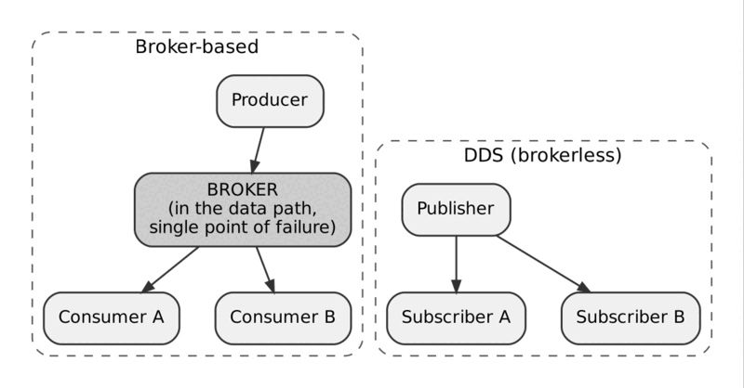
Broker-based messaging versus brokerless DDS
With a broker, every message takes an extra hop through a process that must be operated, scaled and kept alive. With DDS, publishers and subscribers connect directly after discovery. See topic 01.

2. Domain and Partition Isolation
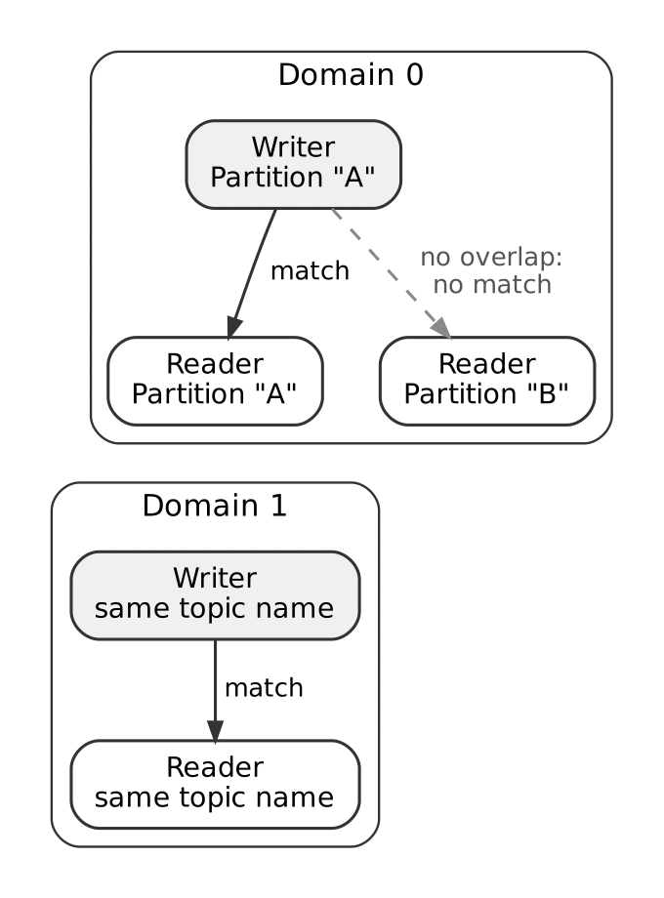
Domains are hard walls; partitions are soft filters
Entities in different domains never discover each other. Within one domain, a writer and reader with the same topic match only if their partitions overlap. See topics 02 and 13.

3. Two-Tier Discovery: SPDP, then SEDP
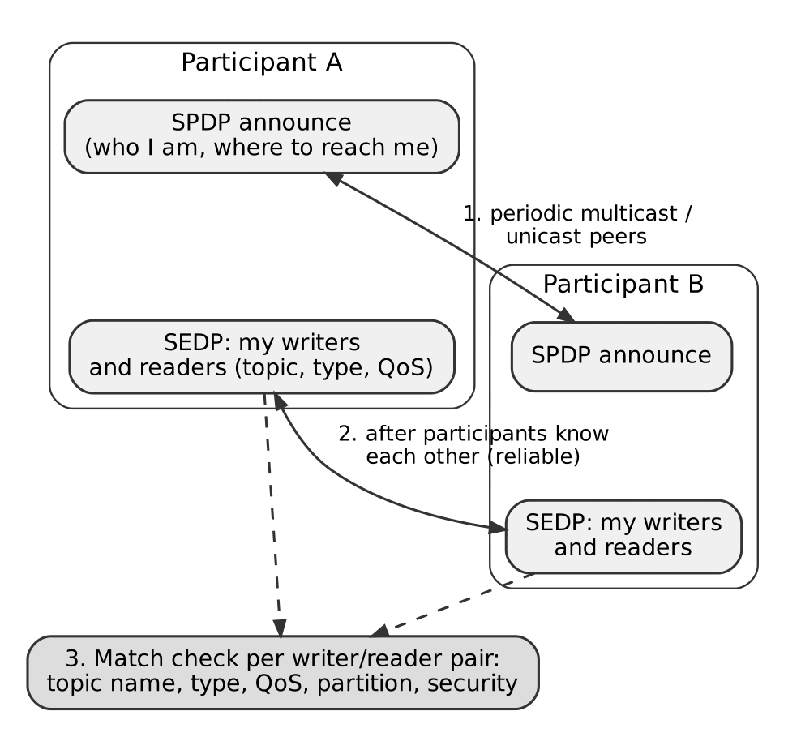
SPDP finds participants, SEDP matches endpoints
First participants learn that each other exist (SPDP). Only then do they exchange endpoint details (SEDP) and run the match check. See topics 20 and 21.

4. QoS Request vs. Offered
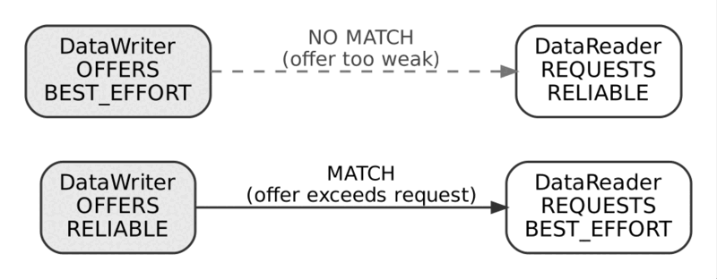
A writer’s offer must meet the reader’s request
A RELIABLE writer can serve a BEST_EFFORT reader. The reverse does not match, and the mismatch is silent unless you listen for the status event. See topic 15.

5. Keyed Instances: One Topic, Many Independent Streams
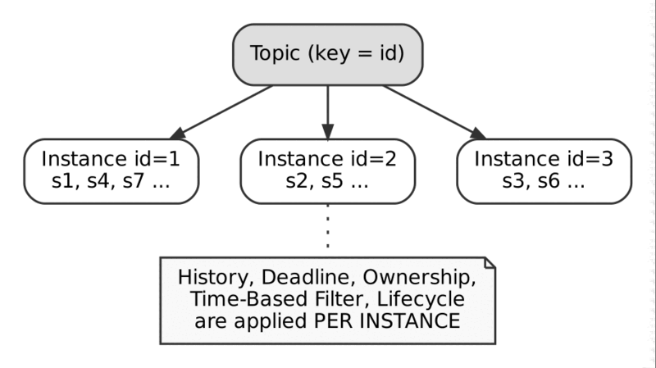
A keyed topic contains one instance per key value
Each key value is its own instance with its own history, deadline and ownership. See topics 24 and 43.

6. Reliable Delivery: HEARTBEAT, ACKNACK, Retransmit
A lost sample is detected and repaired
Sample 2 is lost. The HEARTBEAT announces what exists, the ACKNACK names what is missing, and only sample 2 is retransmitted. See topic 18.

7. Multicast Fan-Out vs. Unicast Fan-Out
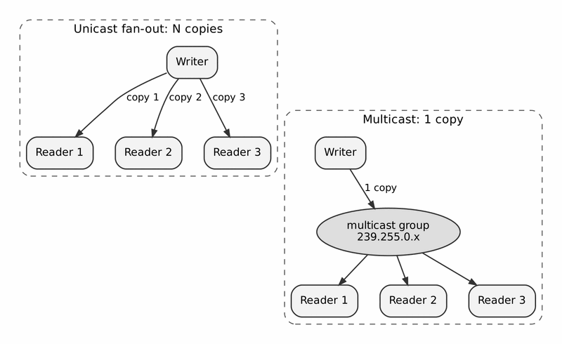
One copy to a group versus one copy per reader
Multicast scales with a constant number of copies, but only if the network supports it. See topic 28 and Appendix D.

8. Ownership Strength: Hot/Warm Standby Failover
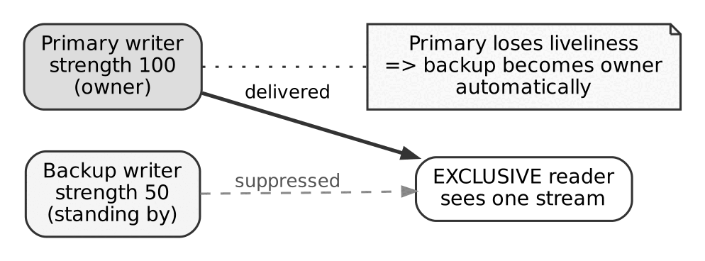
The strongest live writer is heard; the backup takes over on failure
The backup is suppressed while the primary is alive. When the primary loses liveliness, the backup is promoted automatically. See topics 11, 12 and 38.

9. Content-Filtered Topic: Writer-Side Savings
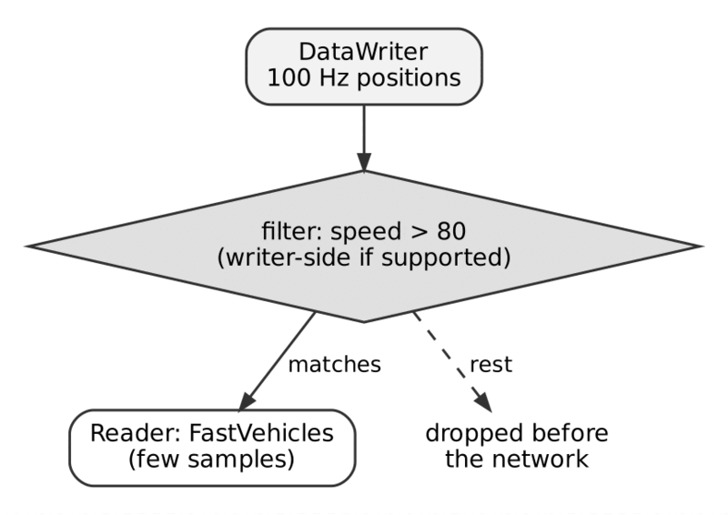
Only matching samples cross the network
If the vendor supports writer-side filtering, non-matching samples are never sent to that reader. See topic 35.

10. Robotics / ROS 2: Sensor Fusion on One Robot
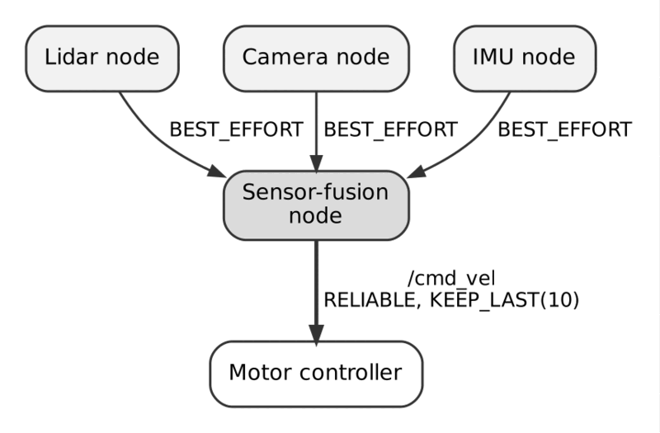
High-rate sensors use BEST_EFFORT, commands use RELIABLE
Sensor streams are best-effort because a newer reading supersedes an older one. The command stream is reliable because every command matters. See topic 37.

11. Multi-Robot Fleet: Domain Isolation Plus an Explicit Bridge
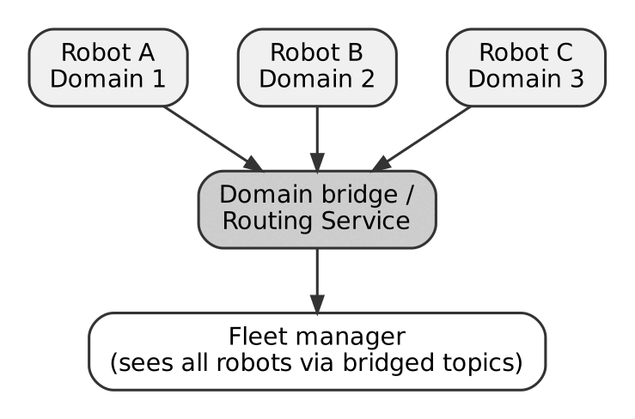
Each robot is its own domain; a bridge shares selected topics
Isolation keeps robots from cross-talking. The bridge decides which topics the fleet manager can see. See topic 30.

12. Industrial / SCADA: A Deterministic Control Loop
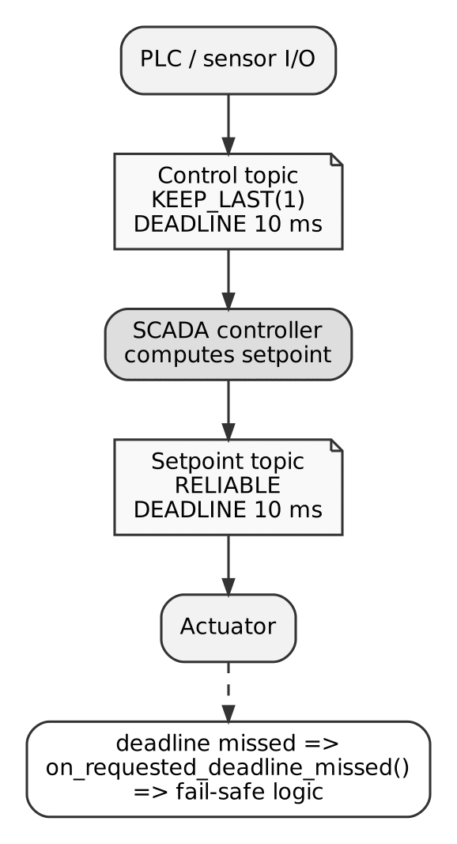
A 10 ms deadline guards the loop
If the deadline is missed, the reader’s on_requested_deadline_missed fires and the fail-safe logic takes over. See topic 10.

13. Financial Trading: Low-Latency Market Data
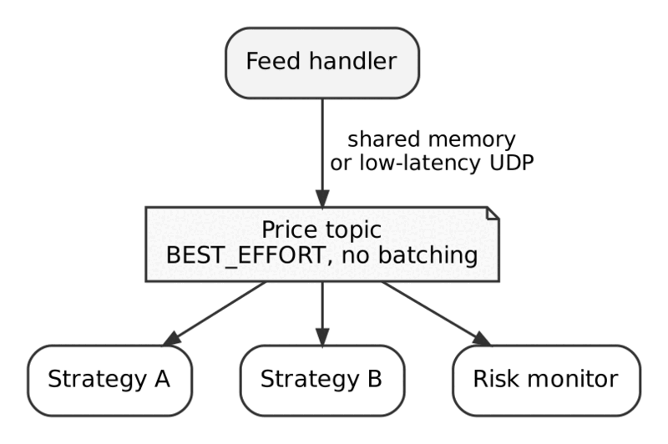
Latency over throughput: no batching, shared memory or fast UDP
Every tick is sent immediately. Batching is deliberately off because it adds delay. See topic 29.

14. IoT / Smart Building: High Fan-Out, Low Bandwidth
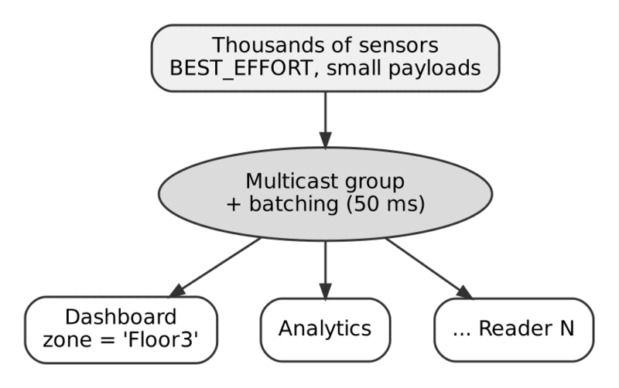
Many sensors, multicast, batching and per-dashboard filters
Small best-effort samples, batching to cut packet counts, and content filters so each dashboard sees only its zone. See topics 28, 29 and 35.

15. Healthcare / Medical Devices: Reliable and Secure
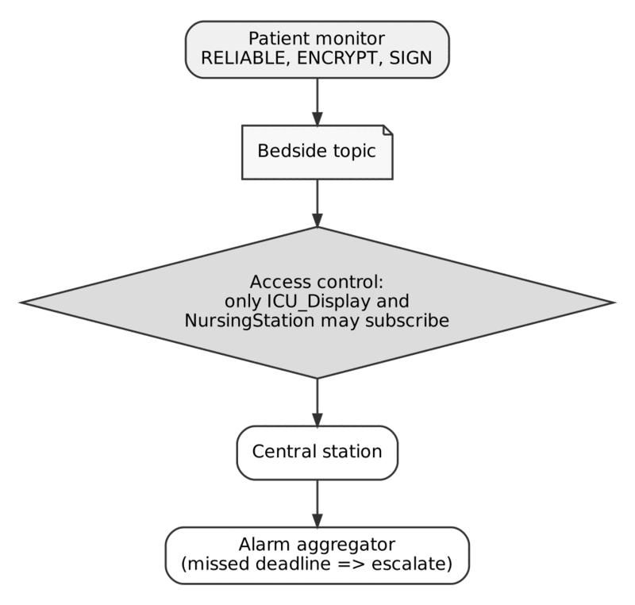
Reliable delivery, encryption and access control around a bedside topic
Only authenticated, authorised participants may subscribe. Missed deadlines escalate to an alarm. See topics 31 to 33.

16. WAN Bridging Across Sites
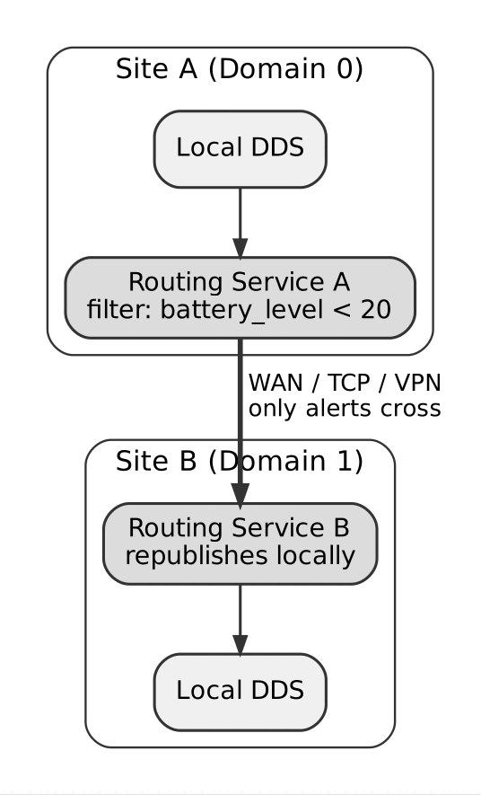
Routing services forward only alert-worthy samples over the WAN
Each site stays in its own domain. Filtering at the border keeps the expensive link for what matters. See topic 30.

17. Security Layering (Defense in Depth)
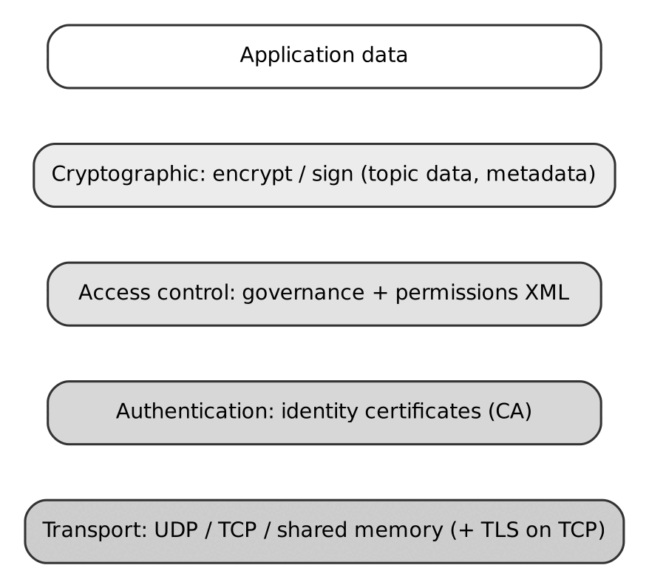
Authentication, access control and cryptography stacked above the transport
Each layer is a separate plug-in and each protects against a different failure. See topics 31 to 33.

18. Discovery Scalability: Mesh vs. Discovery Server
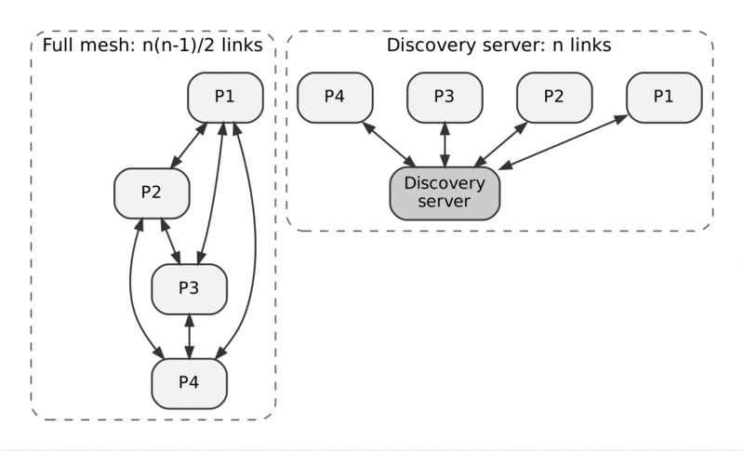
Full mesh grows as n squared; a discovery server grows as n
A discovery server replaces most pairwise announcements with one connection per participant. See topic 22.

19. Type Evolution with XTypes (Appendable)
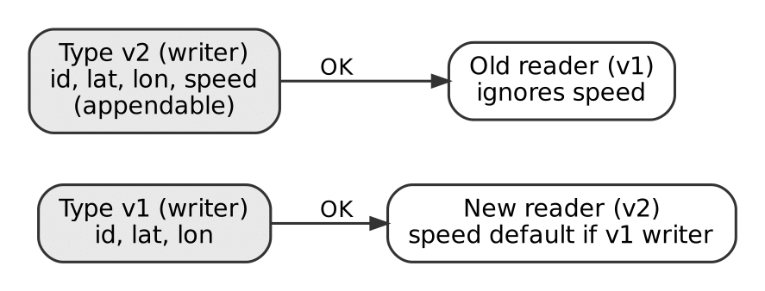
Old and new readers and writers keep working
Adding a field at the end of an appendable type lets old readers ignore it and new readers fill in a default. See topic 26.

Which Figure Maps to Which Use Case
Figure | Use it to explain
1, 18 | Why DDS needs no broker and how discovery scales
2, 3, 4 | How endpoints find and match each other
5, 6 | Instances and reliable delivery
7, 9, 14 | Efficient delivery to many readers
8, 12, 15 | Failover, deadlines and safety
10, 11, 16 | Robots, fleets and sites
13 | Latency-first design
17 | Security
19 | Type evolution

40. Internal Communication Flow, Step by Step
In one sentence. A write() call travels through QoS checks, history, serialization, transport and the reader’s cache before an application sees it.
Analogy. Follow a parcel through a sorting facility: it is registered at the counter (history cache), boxed to a standard size (serialization), loaded onto the right vehicle (transport), unloaded and sorted at the destination (receive thread, matching), and finally placed in the recipient’s pigeonhole (reader cache) where they collect it.

Overview
From your code’s point of view, write() returns and a reader somewhere calls take(). In between, a fixed sequence of steps runs. Knowing the sequence tells you where to look when data is late, missing or duplicated.
The steps are the same for every conformant vendor, because they are defined by the DDS specification and the RTPS wire protocol. Library-specific details are flagged as such.

The Components Involved
- Application code: creates entities, calls write() and take().
- DDS API layer: the vendor library linked into your process.
- DataWriter and DataReader internals: history caches, QoS enforcement, sequence numbering.
- RTPS layer: builds and parses messages and runs discovery and reliability.
- Transport: UDP, shared memory or TCP.
- Operating system: sockets, or shared memory segments.

Phase 1: Discovery (Before Any Data Flows)
- A process creates a DomainParticipant. It starts SPDP: it announces its GUID prefix, protocol version, vendor ID and addresses (locators) to the well-known multicast address and to any configured unicast peers. Announcements repeat periodically (topic 20).
- Participants that hear each other on the same domain add each other to their discovery databases.
- They then run SEDP over built-in reliable writers and readers. Each side learns the other’s writers and readers: topic name, type, QoS (topic 21).
- For every writer/reader pair, each side checks topic, type, QoS compatibility, partition overlap and security. A compatible pair is matched, and the application gets on_publication_matched or on_subscription_matched.
There are no “hello” and “hello-ack” messages in the RTPS sense. SPDP is a periodic one-way announcement, and SEDP is ordinary RTPS data exchange between built-in endpoints.

Phase 2: What Happens on write()
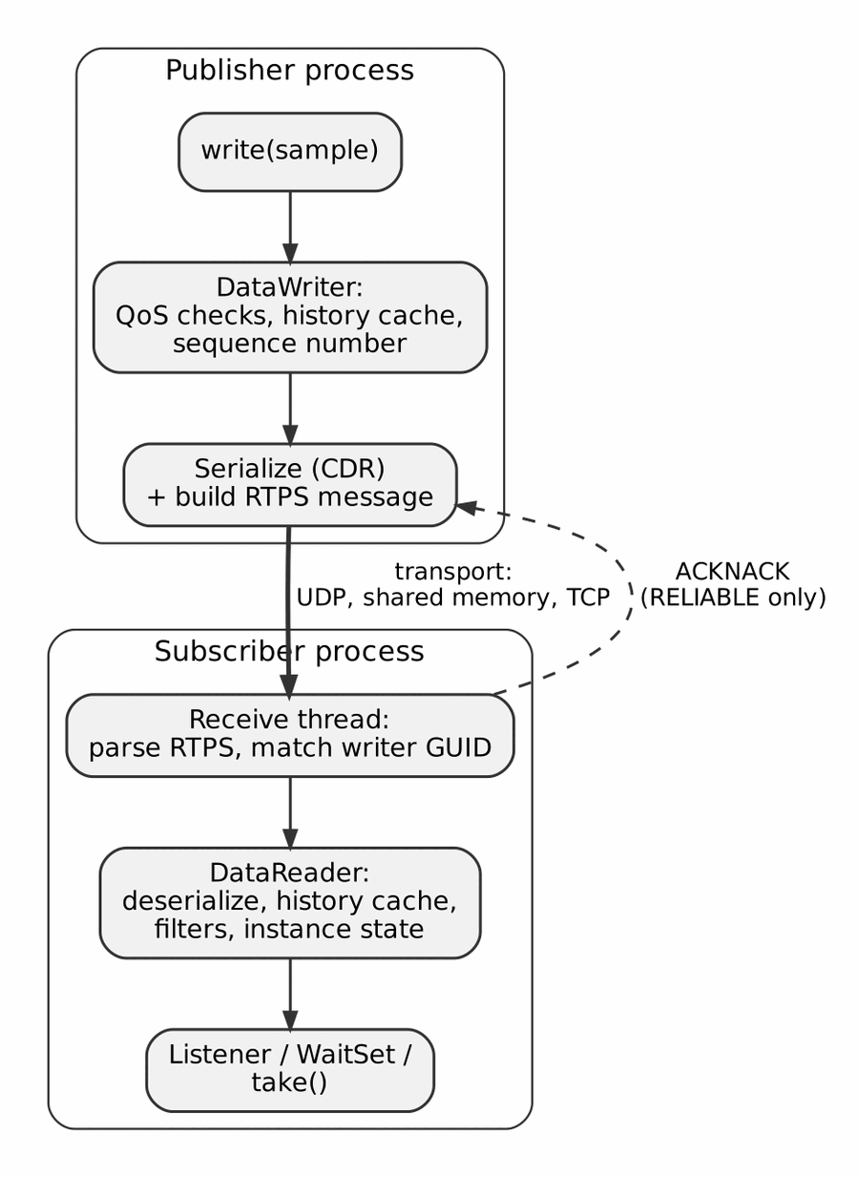
The path of one sample from writer to reader
- Checks. The DataWriter checks QoS limits (for example RESOURCE_LIMITS). A RELIABLE writer with a full history may block for up to max_blocking_time (topic 07).
- History. The sample is stored in the writer’s history cache and gets the next sequence number (topic 18).
- Serialization. The sample is encoded with CDR (topic 25).
- Message building. An RTPS message is built: header, optional INFO_TS, then a DATA submessage. Large samples become DATA_FRAG submessages (topic 17).
- Transport. The message goes out over the transport chosen for each matched reader: UDP unicast or multicast, shared memory, or TCP (topic 27).
- Receive. The reader’s receive thread parses the message, finds the target reader by GUID and discards samples that the reader should not receive (for example filtered or duplicate samples).
- Reader cache. The sample is deserialized and stored in the DataReader’s history cache with its SampleInfo (sample, view and instance state).
- Delivery. The application is informed through a listener, a WaitSet condition, or simply finds the sample on its next read() or take().

What Differs by Reliability
BEST_EFFORT. After step 5, the writer does nothing more. If a packet is lost, the sample is gone.
RELIABLE. The writer keeps the sample in its history cache and periodically sends a HEARTBEAT. The reader answers with an ACKNACK that names any missing sequence numbers, and the writer retransmits only those. Acknowledgements are per sequence number, not “ACK per packet”. The writer may drop a sample from its cache once all matched reliable readers have acknowledged it and the history policy allows it (topics 09 and 18).

Transport Choice and What You Can See
The transport is chosen per matched pair, based on the locators exchanged during discovery.
- Different hosts. UDP (or TCP) goes through the network interface, so Wireshark sees it.
- Same host, UDP. Traffic goes through the loopback interface (lo). Capture on lo, not on the physical interface.
- Same host, shared memory. Samples are placed in a shared segment, so no UDP data packets appear at all. Discovery usually still appears as UDP.
Whether shared memory is used by default depends on the vendor and the build. Some stacks enable it by default; others require an extra component and explicit configuration. For Eclipse Cyclone DDS, shared memory depends on the Iceoryx integration and must be enabled in the configuration. If a capture shows discovery but no data on the same host, shared memory is the likely explanation. To check, temporarily disable it in the configuration and capture again.

Summary
Discovery first finds participants (SPDP) and then matches endpoints (SEDP). A write passes through QoS checks, history, serialization, RTPS message building and a transport. On the way back, RELIABLE flows add HEARTBEAT and ACKNACK. The visible traffic depends on the transport chosen per pair.

Things to Remember
- Discovery precedes data: SPDP finds participants, SEDP matches endpoints.
- Every write gets a per-writer sequence number and enters the writer’s history cache.
- RELIABLE adds HEARTBEAT and ACKNACK with selective retransmission; BEST_EFFORT never retransmits.
- Transport is chosen per matched pair: same host may use loopback UDP or shared memory.
- No data in a capture on the same host usually means shared memory (or you captured the wrong interface).
- Shared-memory defaults are vendor- and build-specific; verify them, do not assume.

41. DDS Configuration and QoS Profiles
In one sentence. QoS and transport settings are normally kept in XML files outside the code, as reusable named profiles.
Analogy. XML profiles are a menu of ready-made meal sets: “State”, “Command”, “Periodic”. The application orders by name instead of specifying every ingredient. The names are a local convention; the ingredients (QoS policies) are what the standard defines.

Overview
DDS behaviour comes from two kinds of configuration, and keeping them apart avoids a lot of confusion.
- Middleware configuration: network interfaces, discovery peers, multicast on or off, transports, logging, security files. This is vendor-specific, and each vendor has its own format.
- QoS configuration: the reliability, durability, history and other policies of individual entities. The DDS-XML specification defines a standard XML format for QoS profiles, but not every vendor reads it.

Middleware Configuration by Vendor
Vendor | Typical mechanism
Eclipse Cyclone DDS | One XML file, selected with the CYCLONEDDS_URI environment variable (a file URI or inline XML)
eProsima Fast DDS | XML profiles file, selected with FASTRTPS_DEFAULT_PROFILES_FILE
RTI Connext | USER_QOS_PROFILES.xml in the working directory, or paths in NDDS_QOS_PROFILES

A minimal Cyclone DDS configuration
<CycloneDDS xmlns="https://cdds.io/config">
<Domain id="any">
<General>
<Interfaces>
<NetworkInterface name="eth0"/>
</Interfaces>
<AllowMulticast>default</AllowMulticast>
</General>
<Discovery>
<Peers>
<Peer address="192.168.1.10"/>
</Peers>
</Discovery>
<Tracing>
<Verbosity>config</Verbosity>
<OutputFile>cdds.log</OutputFile>
</Tracing>
</Domain>
</CycloneDDS>
What each part does:
- Domain id="any" applies the settings to every domain this process joins.
- NetworkInterface selects which network card DDS uses. On machines with several interfaces (Wi-Fi, Ethernet, Docker bridges) this is one of the most common fixes for “nodes cannot see each other”.
- AllowMulticast controls multicast. Set it to false where multicast is blocked.
- Peers lists unicast discovery peers, for networks without multicast (topic 22).
- Tracing writes a configuration dump and log. With Verbosity set to config, the log starts by listing every effective setting, which is the quickest way to verify that your file was actually read.
Element names changed between Cyclone DDS releases. Check the documentation of the version you run.

A Library of QoS Patterns
Teams often define a small set of named QoS profiles and give each topic one of them, so that nobody has to reason about individual policies each time. The set below is one widely used example. The names are a convention. They are not defined by the DDS standard, and they are not ROS 2’s own presets.
Profile | For | Key settings
State | Current status of a component | RELIABLE, TRANSIENT_LOCAL, KEEP_LAST, ordered by source timestamp
Command | Short-lived control commands | RELIABLE, VOLATILE, KEEP_ALL, LIFESPAN of about 2 s
Event | Notifications, logs | Defaults (BEST_EFFORT-leaning, VOLATILE), KEEP_LAST
Alarm | Critical alerts | RELIABLE, TRANSIENT_LOCAL, KEEP_ALL, ordered by source timestamp
Periodic | High-rate sensors, telemetry | BEST_EFFORT, zero latency budget, ordered by source timestamp
Watchdog | Heartbeats and keep-alives | RELIABLE, ordered by source timestamp; deadline left to the application
Specification | Rarely changing configuration | RELIABLE, TRANSIENT_LOCAL, KEEP_LAST depth 1
Two notes on this table:
- Some sets of profiles specify PERSISTENT durability for configuration data. Stacks without a durability service downgrade it to TRANSIENT_LOCAL, which is why you may see that substitution with a comment in such files.
- autodispose_unregistered_instances = false in the writer data lifecycle QoS means that when a writer unregisters an instance, the instance is not automatically disposed. Readers therefore keep the last value and see NO_WRITERS rather than DISPOSED. This is useful when a publisher restarts and you do not want readers to treat the data as deleted.

How an application picks a profile
The code should not contain if (profile == "StatePattern"). The usual approaches are:
- Profile by name, loaded from XML, where the vendor supports it. In RTI Connext and Fast DDS you reference a profile such as Library::Profile when creating the entity.
- A small helper in your own code that maps a topic or message category to a QoS object. Everything that creates writers and readers uses the helper, so changing a policy for one category is a one-line change.
- ROS 2: the QoS is set in code through rclcpp::QoS and preset profiles, and can be overridden at launch time with the qos_overrides parameters for individual topics. ROS 2 does not load these DDS XML profile libraries for you through rmw_cyclonedds_cpp.
Whichever you choose, derive the writer’s and reader’s QoS from one shared profile per topic. It makes incompatible QoS impossible by construction (topic 15).

Summary
Separate middleware configuration (network, discovery, transports, logging; vendor-specific) from QoS configuration (policies; standard XML format exists but is not read by every stack). A small library of named QoS profiles keeps designs consistent. Verify the effective configuration with the vendor’s configuration dump.

Things to Remember
- Two kinds of configuration: middleware (vendor-specific) and QoS (policy-based).
- Select the Cyclone DDS file with CYCLONEDDS_URI; Fast DDS uses FASTRTPS_DEFAULT_PROFILES_FILE; RTI uses NDDS_QOS_PROFILES or USER_QOS_PROFILES.xml.
- Choose the network interface explicitly on multi-homed machines.
- Turn on the config dump to see which settings are really in effect.
- Pattern names such as State and Command are conventions, not standards.
- Derive writer and reader QoS from one profile per topic.

42. The DDS Entity Hierarchy Illustrated
In one sentence. A labelled picture of how Domain, Partition, Topic, Publisher/Subscriber and DataWriter/DataReader fit together.
Analogy. If chapters 2 to 5 were the rooms of a house, this chapter is the floor plan with the doors marked: which rooms are sealed off completely (domains), which are separated by curtains (partitions), and which furniture (topics) is shared.

Overview
This chapter puts the entities of chapters 2 to 5 into one picture, with the isolation boundaries marked.
Domain, participant, topic, publisher, subscriber, writer, reader

Reading the Picture
- Domain ID is the highest isolation layer. Only participants with the same Domain ID can discover each other. Nothing crosses a domain boundary unless a bridge such as a Routing Service republishes it.
- DomainParticipant is the application’s membership of one domain and the factory for all other entities.
- Topic is the schema (name plus type) that writers and readers share.
- Publisher and Subscriber group writers and readers and carry Partition and Presentation QoS.
- DataWriter and DataReader are the endpoints that move samples.

Domains Versus Partitions
Domains are hard walls; partitions are soft filters inside a domain
Two entities must be in the same domain before partitions even matter. Inside a domain:
- A writer and reader match only if the partition names of their Publisher and Subscriber overlap. Wildcards such as * are allowed.
- The default partition is the empty string. Two entities that both use the default match each other. An entity left at the default does not match one that sets a non-empty partition, unless that partition list also contains the empty string or a wildcard.
- A subscriber that wants to see everything can use the wildcard *.
A common misconception is that the default (empty) partition matches all partitions. It does not. It matches other default-partition entities. To observe every partition, use a wildcard.

Matching in Four Steps
- Same Domain ID.
- Same topic name and compatible type.
- Overlapping partitions.
- Compatible QoS (offered at least requested for most policies), and permitted by security, if enabled.
If any step fails the pair does not match, and no data flows between those two endpoints.

Summary
Domains are hard walls and partitions are soft filters inside a domain. The entity tree is Domain, then DomainParticipant, then Topic plus Publisher/Subscriber, then DataWriter/DataReader. Matching checks domain, topic and type, partition, QoS and security, in that order.

Things to Remember
- Domain = hard isolation; Partition = soft, runtime-changeable filter inside a domain.
- The default partition (empty string) matches only other default-partition entities, not everything.
- Use a wildcard partition for monitoring tools that must see all partitions.
- Four-step match: domain, topic and type, partition, QoS (and security).

43. Instances in DDS, Clarified
In one sentence. An instance is one logical thing identified by its key; samples are that thing’s successive states.
Analogy. A spreadsheet row. The key is the row ID, the instance is the row itself, a sample is the row’s contents at one moment, and writing again overwrites the current state while history keeps a few previous versions according to QoS.

Overview
The word instance confuses many newcomers, because in object-oriented programming it means “an object of a class”. In DDS it means something different.
A DDS instance is one logical thing in the real world, identified by the key fields of the topic’s data type. A sample is one observation of that thing’s state.

The Core Idea
- Sample = the current state or measurement (Car 001 is going 50 km/h).
- Instance = the persistent identity of the thing (Car 001).
All samples with the same key value belong to the same instance. A sample with a different key value belongs to a different instance.
Sample | vehicle_id (key) | Speed | Belongs to
1 | Car_001 | 50 | Instance Car_001
2 | Car_002 | 70 | Instance Car_002
3 | Car_001 | 55 | Instance Car_001
4 | Car_001 | 0 | Instance Car_001
Samples 1, 3 and 4 update the same instance. Sample 2 updates another one.

Keyed and Non-Keyed Topics
Keys are declared in the type definition, in IDL with the @key annotation (topic 23).
struct VehicleStatus {
@key string vehicle_id;
double speed_kmh;
};
- Keyed topic: each distinct key value is one instance.
- Non-keyed topic: the whole topic behaves as a single instance. Every sample updates the same logical thing.

Why Instances Matter
Per-instance state. The reader’s cache holds samples grouped by instance. With KEEP_LAST and depth 1, the cache holds the latest state of every vehicle (topic 09).
Per-instance QoS behaviour. History, Deadline, Ownership, Time-Based Filter and Lifespan are evaluated per instance. A missed deadline is reported for one vehicle, not for the topic as a whole. Exclusive ownership can have a different owner for each vehicle (topic 12).
Instance lifecycle. An instance can be ALIVE, NOT_ALIVE_DISPOSED (a writer called dispose(), meaning the thing no longer exists) or NOT_ALIVE_NO_WRITERS (no live writer remains for it). See topic 24.
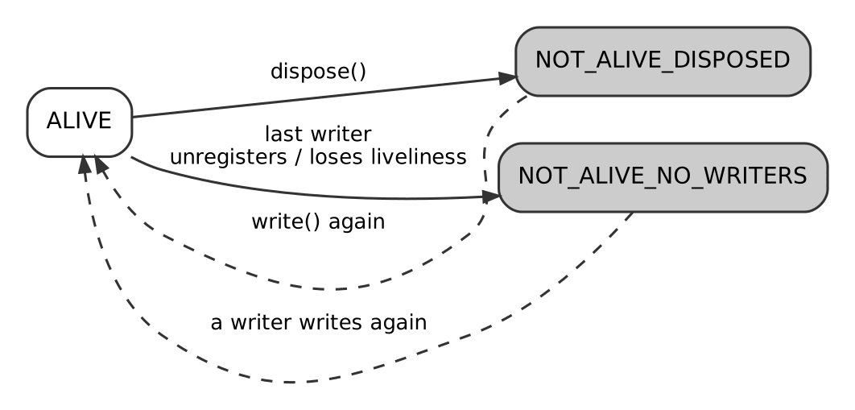
The instance lifecycle
Late joiners. With TRANSIENT_LOCAL and KEEP_LAST depth 1, a late reader receives the latest sample of every instance (topic 08).

How Code Works With Instances
The exact API names differ between languages and vendors. The standard DDS C++ API has these concepts:
Operation | Meaning
register_instance(sample) | Tell DDS about an instance up front and get an instance handle (an optimisation)
write(sample) | Update the instance identified by the key in the sample
dispose(sample) | The thing no longer exists
unregister_instance(sample) | This writer stops writing this instance
lookup_instance(sample) | Get the handle for a key value
get_key_value(handle) | Recover the key from a handle (useful when a notification has no data)
read / take with an instance handle | Read only that instance’s samples
read_next_instance / take_next_instance | Iterate across instances in handle order
Instance handles are local identifiers: use them within a process, not across the network (see also topic 19 on GUIDs).

Summary
An instance is the persistent identity of one logical thing, defined by the key fields. Samples are its successive states. DDS applies history, deadline, ownership and lifecycle per instance, which is what lets one topic carry thousands of independent entities.

Things to Remember
- Instance = identity (key value); Sample = state at a moment.
- Keys are declared in the type with @key, not by a QoS setting.
- Non-keyed topics have one instance.
- History, Deadline, Ownership, Time-Based Filter and Lifespan act per instance.
- dispose() means “this thing no longer exists”; silence does not.
- Instance handles are local; do not send them over the network.

Appendix A: The Refresher
Every chapter’s Things to Remember, in chapter order. Read this when you need a fast refresh of the whole subject. Tap a chapter title to jump to the full explanation.

Part I: Foundations
01. What is DDS
- DDS is a specification, not a product — many interoperable vendor implementations exist.
- Data-centric: DDS understands the data’s type, key, and instance lifecycle — not just bytes.
- Brokerless / peer-to-peer: no intermediary sits in the data path → no single point of failure, lower latency.
- Three-way decoupling: space (auto-discovery), time (durability for late joiners), flow (independent producer/consumer rates).
- QoS is per-topic/per-entity, not global — a single app can mix reliable+durable and best-effort+volatile flows.
- Interoperability guaranteed by RTPS, the companion OMG wire-protocol standard.
- Best fit: real-time, safety-critical, low-latency, highly dynamic systems (robotics, avionics, industrial control).
- Not the best fit for durable event-log replay at massive scale (that’s Kafka’s specialty) or huge fleets of constrained/intermittent devices (that’s MQTT’s specialty).
02. Domain and DomainParticipant
- Domain ID isolates communication logically, not just physically — different domain IDs never see each other, even on the same LAN/host.
- Domain ID determines discovery ports via a standard formula (PB + DG × domain_id in default RTPS discovery) — useful for running isolated test environments side by side.
- DomainParticipant is the factory for Topics, Publishers, Subscribers, DataWriters, and DataReaders — deleting it cascades to all children.
- Default to one participant per process per domain unless you have a specific reason (multiple domains, isolated QoS/security scope) for more — extra participants increase discovery overhead.
- Domain ID mismatch is the #1 “nodes can’t see each other” bug — always check this first when troubleshooting connectivity.
- Domains ≠ Partitions — Partitions (topic 13) are a finer-grained, in-domain filtering mechanism; Domains are a hard, protocol-level isolation boundary.
03. Topics and Data Types
- Topic = Name + Type + QoS — all three must be compatible for a writer and reader to match.
- Data types are normally defined in IDL and compiled into language bindings by a vendor code generator.
- Topic name ≠ type name — a Topic name is the matching key; the type name defines the data shape; they’re registered separately.
- ContentFilteredTopic lets readers subscribe to a filtered subset of a Topic, sometimes with writer-side filtering to save bandwidth.
- Built-in Topics (DCPSParticipant, DCPSPublication, DCPSSubscription) give free, standardized introspection into the domain’s live state.
- Treat Topic names and key-field design as a public API contract — changing them later breaks compatibility across independently deployed applications.
- Split by QoS needs, not just by “relatedness” — don’t force high-rate and low-rate data into the same Topic.
04. Publishers and Subscribers
- Publisher owns DataWriters; Subscriber owns DataReaders — deleting the container cascades to its children.
- Partition and Presentation QoS are set on Publisher/Subscriber, not on individual DataWriters/DataReaders.
- suspend_publications()/resume_publications() (Publisher) and begin_access()/end_access() (Subscriber), paired with PRESENTATION QoS, enable atomic/coherent multi-writer or multi-reader updates.
- One default Publisher + one default Subscriber per participant is the common case — add more only for distinct partitions, distinct default QoS, or independent coherent groups.
- Reliability/Durability/History/Deadline/Ownership/etc. live at the DataWriter/DataReader (or Topic) level, not the Publisher/Subscriber level — don’t confuse the two layers of QoS.
05. DataWriters and DataReaders
- Each DataWriter/DataReader binds to exactly one Topic and carries most of the fine-grained QoS.
- write() publishes; dispose() explicitly signals an instance no longer exists — silence alone does not communicate deletion.
- read() is non-destructive; take() removes samples from the reader’s cache — pick deliberately based on whether you need re-readability.
- SampleInfo exposes three independent states: sample (read/not-read), view (new/not-new), instance (alive/disposed/no-writers) — use them to filter precisely.
- Three consumption models: listeners (callbacks), WaitSets (controlled blocking on conditions), polling (application-driven cadence) — match the model to your threading/real-time needs.
- Matching requires: same topic name + compatible type + compatible QoS (requested ≤ offered) + overlapping partitions + (if enabled) compatible security — watch on_subscription_matched/on_publication_matched to detect it.
- Forgetting dispose() is one of the most common real-world DDS correctness bugs — don’t rely on readers “figuring out” an instance is gone.

Part II: Quality of Service
06. QoS Framework Overview
- QoS is a set of independent, named policies, not a single setting — over 20 exist, each with its own semantics.
- Policies attach at different entity levels (Participant, Topic, Publisher/Subscriber, DataWriter/DataReader) with inheritance of defaults from higher levels.
- Mutable policies can be changed via set_qos() at runtime; immutable policies require deleting and recreating the entity.
- The requested-vs-offered compatibility model determines whether a writer/reader pair matches — most (not all) policies require “offered ≥ requested.”
- Incompatible QoS fails silently from a data-flow perspective — watch on_offered_incompatible_qos/on_requested_incompatible_qos to diagnose non-matching entities.
- Prefer external XML QoS profiles over hardcoded QoS in production systems, for maintainability and deployment-specific tuning.
- QoS lets independent data flows in the same system have wildly different delivery contracts — this is DDS’s core differentiator vs. uniform broker-based delivery.
07. Reliability QoS
- Reliability is set per DataWriter/DataReader, not globally — mixing reliable and best-effort Topics in one app is normal and expected.
- BEST_EFFORT: no retransmission, lowest latency — best for high-rate, latest-value-wins data.
- RELIABLE: guaranteed, in-order eventual delivery via HEARTBEAT/ACKNACK retransmission — best for commands, config, alarms.
- Compatibility is asymmetric: RELIABLE writer + BEST_EFFORT reader = OK; BEST_EFFORT writer + RELIABLE reader = incompatible, silent non-match.
- RELIABLE writers can block on write() when unacknowledged samples fill available resources — always set max_blocking_time explicitly.
- Always pair RELIABLE with deliberate History/Resource Limits settings (topic 09) to avoid unbounded memory growth or unexpected blocking.
- Check on_requested_incompatible_qos first when a reader unexpectedly receives no data.
08. Durability QoS
- Durability = decoupling in time — controls whether late-joining readers get past data.
- Four levels, increasing strength/cost: VOLATILE < TRANSIENT_LOCAL < TRANSIENT < PERSISTENT.
- TRANSIENT_LOCAL is the practical default for “current state/config” topics — no extra infrastructure needed, but data is lost if the writer process dies.
- TRANSIENT/PERSISTENT require a separate durability service — reach for these only when data must survive the writer (or whole system) restarting.
- Durability interacts with History — what’s replayed to a late joiner is bounded by History depth, per instance.
- DISPOSED instance state is durable too — late joiners can learn an instance used to exist and was removed, not just silently miss it.
- Compatibility is ordered: a writer must offer durability ≥ what the reader requests, or they won’t match.
09. History and Resource Limits QoS
- History and Resource Limits apply per instance, not as a flat global count.
- KEEP_LAST depth=1 = “only the latest value matters” (default, low memory) — good for state/telemetry.
- KEEP_ALL = “every sample matters, none can be skipped” — required for commands/events, needs careful Resource Limits sizing.
- RELIABLE ≠ “every sample guaranteed” unless paired with KEEP_ALL (or a sufficiently deep KEEP_LAST) — RELIABLE + shallow KEEP_LAST can still skip old samples for a slow reader.
- max_samples_per_instance must be ≥ history.depth for KEEP_LAST — inconsistent settings are a configuration error.
- Always set explicit Resource Limits in production — don’t rely on unbounded defaults, which can hide memory growth until load reveals it.
- A slow/disconnected reliable reader can cause writer write() to block — this is precisely what Resource Limits + max_blocking_time are meant to bound.
10. Deadline QoS
- Deadline is per-instance, not per-DataWriter/DataReader as a whole — each keyed instance gets independent timing.
- It detects staleness (missed update rate), not sample loss — that’s Reliability’s job.
- Any write() on an instance resets its deadline timer; missing the period fires on_offered_deadline_missed (writer) or on_requested_deadline_missed (reader).
- Deadline ≠ Liveliness — Deadline is per-instance update-rate monitoring; Liveliness (topic 11) is per-entity “is this writer/participant still alive at all” monitoring.
- Compatibility: writer’s offered period must be ≤ reader’s requested period.
- Always implement the missed-deadline listener/handling — configuring the QoS without reacting to the event leaves the feature inert.
- Set realistic margin above actual publish rate to avoid spurious missed-deadline noise from normal jitter.
11. Liveliness QoS
- Liveliness detects “is the writer/participant still alive,” not data freshness — that’s Deadline’s job.
- Three kinds: AUTOMATIC (middleware handles it, participant-wide, zero app code — the default), MANUAL_BY_PARTICIPANT (app asserts, counts for whole participant), MANUAL_BY_TOPIC (app asserts per DataWriter — most granular).
- write() counts as a liveliness assertion under manual kinds — you don’t always need a separate assert_liveliness() call if you’re actively publishing.
- Losing liveliness transitions instances toward NOT_ALIVE_NO_WRITERS and fires on_liveliness_changed on matched readers.
- Compatibility requires kind ≥ requested AND lease_duration ≤ requested — both dimensions must be satisfied.
- Set lease durations with real margin to avoid false-positive “not alive” flapping from jitter.
- Pairs naturally with Ownership QoS for redundant-writer failover: liveliness loss on the exclusive owner is the failover trigger.
12. Ownership and Ownership Strength QoS
- SHARED (default): all writers’ samples delivered, no arbitration.
- EXCLUSIVE: only the highest-ownership_strength, currently-live writer’s samples are delivered per instance — automatic failover on liveliness loss.
- Ownership arbitration is per-instance, not per-topic — different instances of the same topic can have different current owners.
- Failover is triggered by Liveliness loss (topic 11) — tune lease duration deliberately to balance failover speed vs. false-positive risk.
- ownership_strength is mutable at runtime via set_qos(), enabling dynamic, application-driven re-prioritization of redundant sources.
- Compatibility requires an exact kind match (EXCLUSIVE with EXCLUSIVE, SHARED with SHARED) — not an “offered ≥ requested” ordering like most other policies.
- All writers of the same instance must agree on the same Ownership kind — mixing SHARED and EXCLUSIVE writers for one instance is invalid.
13. Partition QoS
- Partition is set on Publisher/Subscriber, not DataWriter/DataReader — inherited by everything created underneath.
- Matching is by set intersection with wildcard support, not equality — any overlapping partition name (including both empty-string defaults) allows a match.
- Partition is mutable at runtime via set_qos() — ideal for dynamic regrouping without recreating entities.
- Default partition is "" — Partition is opt-in isolation; leaving it unset doesn’t break basic connectivity.
- Use Domain for hard/security boundaries; use Partition for lighter-weight, potentially dynamic logical subdivision within one environment.
- Never use Partition as an access-control/security mechanism — it’s a convenience filter, not enforced security (use DDS Security, topic 32, for that).
- Wildcards (*, ?) are extremely useful for monitoring/diagnostic tooling that needs cross-partition visibility.
14. Lifespan and Time-Based Filter QoS
- Lifespan (writer-side): expires samples older than duration — removed from writer queue, reader cache, and durability replay alike.
- Time-Based Filter (reader-side): delivers at most one sample per instance per minimum_separation — a per-reader throttle, not a writer-side rate change.
- Both operate per keyed instance, not as one global limit across a topic.
- Lifespan prevents “stale burst on reconnect” — critical for RELIABLE + durable topics where late delivery of old data would be actively harmful.
- Time-Based Filter lets one writer efficiently serve consumers needing very different update rates, without multiple Topics or multiple publish rates.
- Check whether your vendor applies Time-Based Filter at the writer (saves network bandwidth) or only at the reader (saves application processing only) — this affects its usefulness on constrained links.
- Use together for Topics with both real-time and monitoring/UI-style consumers.
15. QoS Compatibility and Matching Rules
- Most policies use “offered ≥ requested”; Ownership requires an exact kind match; Partition uses set intersection, not an ordering — know which model applies to which policy.
- Incompatible QoS fails silently — no exception, just entities that never match; always monitor on_requested_incompatible_qos/on_offered_incompatible_qos.
- status.last_policy_id tells you exactly which policy caused the mismatch — use it instead of guessing.
- History, Resource Limits, Lifespan, and Time-Based Filter are not part of matching — they affect data content/delivery after a match, not whether a match occurs.
- Follow a systematic troubleshooting order: match status → incompatible-QoS status → topic/type → partition → domain → security.
- Derive writer and reader QoS from a shared base profile per Topic to prevent requested/offered drift by construction, rather than debugging mismatches reactively.
- Domain ID and Partition mismatches are among the most common, easily-overlooked causes of “no data arriving” — check them early, not last.

Part III: The RTPS Wire Protocol
16. RTPS Protocol Overview
- DDS is the API; RTPS is the wire protocol — this separation is what enables genuine cross-vendor interoperability.
- RTPS runs natively over UDP/multicast by default, adding reliability as an optional protocol-level layer rather than depending on TCP.
- RTPS is inherently peer-to-peer — no broker ever sits in the data path.
- RTPS entities (Participant, Writer, Reader) underlie DDS API entities and are identified on the wire by GUIDs, not API object references.
- Vendor interoperability is real but has practical caveats — QoS edge-case behavior, DDS Security/XTypes version differences, and vendor-proprietary extensions can all affect true interoperability.
- Network-level troubleshooting (e.g., Wireshark) operates at the RTPS layer — knowing RTPS concretely, not just abstractly, is essential for this kind of debugging.
- Treat vendor choice as revisable when staying within standard RTPS/QoS behavior and avoiding proprietary extensions.
17. RTPS Message and Submessage Structure
- One RTPS message = one packet (usually) = one header + multiple submessages, batched for efficiency.
- Core submessages: DATA (the sample), HEARTBEAT (writer announces available sequence range), ACKNACK (reader acks/nacks), GAP (writer says “these will never be resent”), INFO_TS (timestamp for following DATA).
- Reliable delivery works like TCP’s sliding window in spirit, but is connectionless, per-sample, and layered over UDP — not a byte-stream protocol.
- Large samples are automatically fragmented (DATA_FRAG) when they exceed practical UDP/MTU limits, with fragment-level reliability via NACK_FRAG.
- The submessage format is self-describing and length-prefixed, enabling protocol extensibility — unrecognized submessages can be skipped rather than breaking parsing.
- HEARTBEAT/ACKNACK overhead is a real bandwidth cost, scaling with reliable writer/reader counts and heartbeat period — factor this into bandwidth planning, not just raw sample payload size.
- Concrete knowledge of this structure is required for effective Wireshark-based RTPS troubleshooting (topic 36) — abstract “DDS uses some protocol” understanding isn’t sufficient at this level.
18. Sequence Numbers, Heartbeats and ACKNACK
- Sequence numbers are per-writer and monotonic, spanning all instances that writer publishes — not per-instance, not per-topic-globally.
- HEARTBEAT = “here’s what I have” (writer → readers, periodic + on-demand); ACKNACK = “here’s what I’m missing” (reader → writer, in response).
- ACKNACK uses an efficient base+bitmap encoding, so reporting a few gaps out of thousands of samples is cheap.
- Retransmission is targeted — only the specifically nacked sequence numbers are resent, not the entire history.
- GAP submessages tell a reader “this sequence number will never be resent” (e.g., disposed or expired via Lifespan) — preventing indefinite waiting for unrecoverable data.
- Heartbeat period and response-delay parameters are a real latency-vs-overhead trade-off — tune aggressively for hard real-time, more conservatively for large reader fan-out to avoid ACKNACK storms.
- This is the concrete mechanism to inspect via Wireshark when diagnosing reliability-related latency, throughput, or “stuck” delivery issues.
19. Entity IDs and GUIDs
- GUID = 12-byte GUID Prefix (identifies the Participant) + 4-byte Entity ID (identifies the specific entity within it).
- GUID uniqueness is achieved without any central registry — via host/process-derived prefix components, the same design philosophy as UUIDs.
- Well-known, fixed Entity IDs for built-in discovery entities (SPDP/SEDP writers/readers) are what let RTPS discovery bootstrap cold between any two conformant vendors.
- GUIDs are generally not stable across application restarts — don’t build long-term identity tracking on raw GUIDs alone; use application-level keys instead.
- GUID ≠ InstanceHandle_t — GUID identifies a network entity (Participant/Writer/Reader); InstanceHandle_t identifies a keyed data instance within a Topic. Different axes, don’t conflate them.
- Recognizing GUID structure and well-known Entity IDs is a core skill for reading RTPS/Wireshark captures — it’s how you distinguish discovery traffic from application data and identify which participant/entity a given submessage belongs to.

Part IV: Discovery
20. Simple Participant Discovery Protocol (SPDP)
- SPDP discovers participants, not topics or endpoints — it’s the coarse first layer.
- It relies on periodic, best-effort multicast (or configured unicast) announcements carried on the built-in DCPSParticipant topic.
- Liveliness is lease-based: silence beyond the lease duration means the peer is presumed dead.
- Multicast availability and lease tuning are the two most common sources of real-world SPDP problems.
- SPDP existing successfully is the precondition for SEDP (endpoint-level discovery) to even begin.
21. Simple Endpoint Discovery Protocol (SEDP)
- SEDP is the endpoint-level discovery layer, running after SPDP has found the participants.
- It exchanges topic name, type, QoS, and partition info via reliable built-in DataWriters/DataReaders.
- Matching requires: topic name match + type compatibility + QoS compatibility + partition intersection.
- Discovery ≠ Matching: participants/endpoints can be discovered without ever being matched.
- SEDP traffic scales with the number of endpoints, making it a key lever in discovery scalability tuning.
22. Discovery Scalability and Tuning
- Default DDS discovery is O(n²) and becomes a real bottleneck in large or WAN-spanning deployments.
- Discovery servers are the most common production fix, trading a small SPOF risk for near-linear scaling.
- When multicast isn’t available (cloud, VPN, WAN), initial peers lists are mandatory, not optional.
- Static discovery trades runtime flexibility for near-zero discovery overhead — best for fixed, embedded, or safety-critical topologies.
- Segmenting via Domain ID or Partitions reduces the effective N that any one participant must discover.

Part V: Data Modelling and the Type System
23. IDL and Data Type Definition
- IDL is the vendor-neutral source of truth for a topic’s data type, from which native bindings and wire serialization are both derived.
- @key fields define instance identity — critical to understand before using Ownership, Durability, or instance-based history.
- Prefer bounded strings/sequences for deterministic, real-time-friendly systems.
- The IDL compiler (rtiddsgen, idlc, fastddsgen, etc.) is the bridge between the abstract type and concrete generated code.
- Changing IDL after deployment is a type-evolution problem — see XTypes (topic 26) before doing so carelessly.
24. Keys and Instances
- Keys turn one topic into a multiplexed collection of independent instances — this is central to DDS’s data-centric model.
- Every instance has a state: ALIVE, NOT_ALIVE_DISPOSED, or NOT_ALIVE_NO_WRITERS.
- register_instance() yields a fast, reusable InstanceHandle_t — worth using in high-throughput, high-instance-count scenarios.
- History, Ownership, and Resource Limits QoS all operate at the instance granularity, not the topic granularity.
- Always dispose() instances that are logically going away, to avoid stale state lingering in readers.
25. Serialization (CDR)
- CDR is the RTPS-mandated wire encoding — it’s what actually makes different vendors’ DDS implementations interoperable at the byte level.
- Alignment padding (e.g., 8-byte types need 8-byte boundaries) is a common source of confusion and bugs.
- Endianness is explicit per-message, not assumed — enabling true heterogeneous-architecture interoperability.
- XCDR2 (paired with XTypes) enables more compact, evolution-friendly encodings versus classic XCDR1.
- Tools like Wireshark’s RTPS dissector make CDR debugging tractable without writing a parser by hand.
26. Extensible Types (XTypes)
- XTypes lets systems evolve data types over time without forcing synchronized upgrades — critical for long-lived, incrementally-deployed systems.
- Three extensibility kinds — FINAL, APPENDABLE, MUTABLE — trade off flexibility against wire compactness and complexity.
- APPENDABLE is the common sweet spot: cheap like FINAL, but tolerant of field additions.
- MUTABLE (with explicit @id per field) is the most flexible but has more wire overhead.
- Always test compatibility in both old with new directions before rolling out a type change to a live system.

Part VI: Transport and Performance
27. Transport Configuration
- RTPS is transport-agnostic; DDS vendors plug in UDP, TCP, and SHMEM (among others) underneath it.
- UDP (uni/multicast) is the default and best fit for most LAN deployments; TCP is the fallback for NAT/firewall-restricted networks; SHMEM is the low-latency choice for co-located endpoints.
- Multiple transports can be enabled simultaneously — DDS automatically selects the best reachable one per writer/reader pair via locator negotiation during discovery.
- Socket buffer sizing and NIC binding are common, high-impact tuning knobs, especially under load.
- Container/cloud networking often breaks multicast and sometimes SHMEM assumptions — plan transport configuration explicitly for those environments.
28. Multicast vs Unicast Delivery
- Unicast: universal compatibility, linear network cost with reader count.
- Multicast: highly efficient fan-out, but depends on correctly configured network infrastructure and is often unavailable in cloud/VPN environments.
- Reliable delivery typically layers unicast repair traffic on top of either delivery mode.
- The right choice depends on reader count, network environment, and security/firewall requirements — there’s no universal default beyond “check what your network actually supports.”
- Always validate multicast connectivity explicitly before relying on it in cloud or containerized deployments.
29. Performance Tuning and Batching
- Batching trades a small, bounded added latency for large gains in throughput and reduced per-packet overhead — tune max_flush_delay to your latency budget.
- Asynchronous publish mode decouples application-thread latency from network send latency.
- Thread pool sizing should match available CPU cores and workload characteristics, not be maximized blindly.
- Flow controllers protect against writers overwhelming slower consumers or shared links.
- Always profile before tuning — CPU, network, and OS-level bottlenecks each call for different fixes.
30. WAN and Routing (Routing/Gateway Services)
- Native DDS discovery/delivery is LAN-oriented; WAN, NAT, and cross-domain bridging require a dedicated Routing/Gateway Service layer.
- Routing Services subscribe on one side and republish on the other, optionally applying content filtering, QoS translation, or topic renaming.
- Content filtering at the bridge point is a key technique for controlling expensive WAN bandwidth usage.
- NAT traversal requires explicit public locator configuration or a relay/gateway with a routable address.
- Treat cross-site bridges as critical infrastructure requiring redundancy planning, just like any other network chokepoint.

Part VII: Security
31. DDS Security Overview
- DDS Security is a pluggable, standards-based extension covering authentication, access control, encryption/signing, logging, and (optionally) data tagging.
- Governance + Permissions documents, both cryptographically signed, define the domain-wide and per-participant security policy respectively.
- Discovery traffic itself can and should be protected, not just user data — otherwise topology mapping is trivial for an eavesdropper.
- Mixed secured/unsecured domains are supported for migration but must be deliberately governed.
- Budget for both the PKI/certificate operational overhead and the runtime CPU cost of cryptographic operations when planning a secured deployment.
32. Authentication and Access Control
- Authentication establishes verified identity via X.509 certs and a shared Identity CA, using a DH-based handshake that also seeds session key material.
- Access Control is driven by two signed documents: a domain-wide Governance policy and per-participant Permissions grants.
- Best practice is default-deny with narrowly-scoped allow rules per participant/topic.
- Both documents are cryptographically signed to prevent tampering, and validated locally by each participant.
- Certificate and permission lifecycle management (issuance, rotation, expiration) is an ongoing operational responsibility, not a one-time setup task.
33. Data Encryption and Signing
- The Cryptographic Plugin offers a graduated spectrum (NONE → SIGN → ENCRYPT, with optional origin authentication) applicable independently to discovery metadata, RTPS envelopes, and per-topic data.
- Session keys are symmetric (fast) and derived from a per-pair DH exchange established once during the Authentication handshake.
- Group key distribution preserves multicast efficiency even for encrypted multi-reader topics.
- Choose protection levels per topic based on actual sensitivity and frequency — blanket encryption isn’t always the right trade-off.
- Always protect discovery metadata, not just user data, or topology stays exposed to a passive eavesdropper.

Part VIII: Ecosystem, Interoperability and Operations
34. Vendor Interoperability
- RTPS standardization means cross-vendor interoperability generally works for core pub/sub — this has been proven at OMG interop events for years.
- The most common real-world interop failures come from implicit QoS default mismatches, not fundamental protocol incompatibility.
- XTypes and DDS Security feature support maturity varies by vendor and version — verify before relying on advanced features across vendors.
- Explicitly specifying QoS (rather than relying on defaults) is the single highest-leverage practice for reliable multi-vendor interoperability.
- When in doubt, verify at the wire level (Wireshark RTPS dissector) rather than trusting only vendor-specific diagnostic tools.
35. Content-Filtered and Multi-Topics
- ContentFilteredTopic lets readers request only samples matching an SQL-like predicate, with writer-side filtering (in most implementations) saving real network bandwidth.
- MultiTopic provides a middleware-level join/projection across related topics, but has less consistent vendor support than ContentFilteredTopic.
- Filter parameters can be updated at runtime without recreating the topic, enabling dynamic interest changes.
- Always validate a given vendor’s supported filter expression grammar and MultiTopic semantics before architecting around them.
- These features are key tools for reducing bandwidth and application-level correlation complexity in large, high-fan-out systems.
36. Monitoring, Debugging and Tooling
- Wireshark’s RTPS dissector is the vendor-neutral ground truth for wire-level debugging.
- Vendor admin consoles (RTI Admin Console/Monitor, Fast DDS Monitor, etc.) provide live, higher-level topology and performance visualization.
- Built-in topics (DCPSParticipant, DCPSPublication, DCPSSubscription) expose the discovery database via the standard DDS API itself — useful for custom tooling.
- The on_offered_incompatible_qos / on_requested_incompatible_qos listener callbacks are the fastest way to pinpoint QoS mismatch bugs.
- A systematic debugging checklist (participant → endpoint → QoS → wire) resolves the large majority of real-world “why won’t my data flow” issues.
37. DDS in ROS 2
- ROS 2 uses DDS as its default middleware via the swappable rmw abstraction layer, supporting multiple vendor backends.
- ROS 2 QoS profiles are thin wrappers directly over DDS QoS policies — the same compatibility (request vs. offered) rules apply.
- ROS_DOMAIN_ID maps directly onto DDS Domain ID for network-level isolation between robot fleets.
- QoS mismatches (especially BEST_EFFORT vs RELIABLE) are a very common real-world ROS 2 debugging scenario, directly traceable to core DDS QoS compatibility rules.
- At fleet scale, ROS 2 systems benefit from the same discovery scalability techniques (discovery servers, static peers) used in general DDS deployments.
38. Failover, Redundancy and Fault Tolerance Patterns
- EXCLUSIVE Ownership + OwnershipStrength is the core DDS pattern for automatic, middleware-managed hot/warm standby failover — no custom application failover logic required.
- Liveliness lease duration directly controls failover speed vs. false-positive risk — tune deliberately, don’t leave at defaults for critical systems.
- Discovery infrastructure (if centralized for scalability) needs its own redundancy plan to avoid reintroducing a single point of failure.
- Durability QoS (TRANSIENT_LOCAL/TRANSIENT/PERSISTENT) ensures recovering or newly-joined components get immediate state, which is essential for fast, correct failover.
- Always test both failover and fail-back directions, and test under realistic network jitter, not just clean shutdown scenarios.

Part IX: Illustrated Deep Dives
40. Internal Communication Flow, Step by Step
- Discovery precedes data: SPDP finds participants, SEDP matches endpoints.
- Every write gets a per-writer sequence number and enters the writer’s history cache.
- RELIABLE adds HEARTBEAT and ACKNACK with selective retransmission; BEST_EFFORT never retransmits.
- Transport is chosen per matched pair: same host may use loopback UDP or shared memory.
- No data in a capture on the same host usually means shared memory (or you captured the wrong interface).
- Shared-memory defaults are vendor- and build-specific; verify them, do not assume.
41. DDS Configuration and QoS Profiles
- Two kinds of configuration: middleware (vendor-specific) and QoS (policy-based).
- Select the Cyclone DDS file with CYCLONEDDS_URI; Fast DDS uses FASTRTPS_DEFAULT_PROFILES_FILE; RTI uses NDDS_QOS_PROFILES or USER_QOS_PROFILES.xml.
- Choose the network interface explicitly on multi-homed machines.
- Turn on the config dump to see which settings are really in effect.
- Pattern names such as State and Command are conventions, not standards.
- Derive writer and reader QoS from one profile per topic.
42. The DDS Entity Hierarchy Illustrated
- Domain = hard isolation; Partition = soft, runtime-changeable filter inside a domain.
- The default partition (empty string) matches only other default-partition entities, not everything.
- Use a wildcard partition for monitoring tools that must see all partitions.
- Four-step match: domain, topic and type, partition, QoS (and security).
43. Instances in DDS, Clarified
- Instance = identity (key value); Sample = state at a moment.
- Keys are declared in the type with @key, not by a QoS setting.
- Non-keyed topics have one instance.
- History, Deadline, Ownership, Time-Based Filter and Lifespan act per instance.
- dispose() means “this thing no longer exists”; silence does not.
- Instance handles are local; do not send them over the network.

Appendix B: Cheat Sheets
One-page facts for quick lookup. Defaults listed are those of the DDS specification; vendors and ROS 2 may differ, so verify them for your stack.

B.1 QoS Policies at a Glance
Each entry reads: Policy (where it is set; whether it can change after creation; matching rule). Defaults follow.
Reliability (Topic, Writer, Reader; immutable; offered at least requested)
BEST_EFFORT or RELIABLE. Spec default: Reader BEST_EFFORT, Writer RELIABLE. ROS 2 defaults both to reliable.
Durability (Topic, Writer, Reader; immutable; offered at least requested)
VOLATILE < TRANSIENT_LOCAL < TRANSIENT < PERSISTENT. Default VOLATILE.
History (Topic, Writer, Reader; immutable; not part of matching)
KEEP_LAST with depth, or KEEP_ALL. Default KEEP_LAST, depth 1.
Resource Limits (Topic, Writer, Reader; immutable; not part of matching)
max_samples, max_instances, max_samples_per_instance. Default unlimited.
Deadline (Topic, Writer, Reader; mutable; offered period at most requested)
Maximum time between updates per instance. Default infinite.
Liveliness (Topic, Writer, Reader; immutable; kind at least requested, lease at most requested)
AUTOMATIC < MANUAL_BY_PARTICIPANT < MANUAL_BY_TOPIC, plus lease_duration. Default AUTOMATIC, infinite lease.
Ownership (Topic, Writer, Reader; immutable; exact match)
SHARED or EXCLUSIVE. Default SHARED.
Ownership Strength (Writer; mutable; not matched)
Integer. The highest live strength wins under EXCLUSIVE. Default 0.
Partition (Publisher, Subscriber; mutable; names must overlap)
List of strings, wildcards allowed. Default: empty string.
Lifespan (Topic, Writer; mutable; not part of matching)
Expiry time for samples. Default infinite.
Time-Based Filter (Reader; mutable; not part of matching)
minimum_separation per instance. Default 0 (no filtering).
Latency Budget (Topic, Writer, Reader; mutable; offered at most requested)
Hint for acceptable delay. Default 0.
Destination Order (Topic, Writer, Reader; immutable; offered at least requested)
BY_RECEPTION_TIMESTAMP < BY_SOURCE_TIMESTAMP. Default by reception.
Presentation (Publisher, Subscriber; immutable; offered at least requested)
access_scope (INSTANCE, TOPIC, GROUP), coherent_access, ordered_access.
Writer Data Lifecycle (Writer; mutable; not matched)
autodispose_unregistered_instances, default true.

B.2 Compatibility in One Table
Rule | Policies
Offered must be at least as strong as requested | Reliability, Durability, Deadline (period shorter is stronger), Liveliness (kind and lease), Latency Budget, Destination Order, Presentation
Exact match | Ownership
Names must overlap | Partition
Not part of matching | History, Resource Limits, Lifespan, Time-Based Filter

B.3 Default Discovery Ports (RTPS)
The standard port mapping uses these constants.
Constant | Value
PB (port base) | 7400
DG (domain gain) | 250
PG (participant gain) | 2
d0 | 0
d1 | 10
d2 | 1
d3 | 11

Purpose | Formula
Discovery multicast | PB + DG × domainId + d0
Discovery unicast | PB + DG × domainId + d1 + PG × participantId
User-data multicast | PB + DG × domainId + d2
User-data unicast | PB + DG × domainId + d3 + PG × participantId
Worked example for domain 5: discovery multicast port is 7400 + 250 × 5 = 8650. The default discovery multicast address is 239.255.0.1.
Firewalls: open UDP for this range (for example 7400 to 7500 for low domain IDs), and allow the multicast group.

B.4 Choosing QoS by Kind of Data
High-rate sensor stream
- Reliability: BEST_EFFORT
- Durability: VOLATILE
- History: KEEP_LAST 1
- Extras: Time-Based Filter for slow consumers
Current state of a component
- Reliability: RELIABLE
- Durability: TRANSIENT_LOCAL
- History: KEEP_LAST 1
- Extras: Deadline if staleness matters
Configuration
- Reliability: RELIABLE
- Durability: TRANSIENT_LOCAL
- History: KEEP_LAST 1
- Extras: Needs the writer to stay alive; use TRANSIENT otherwise
Command
- Reliability: RELIABLE
- Durability: VOLATILE
- History: KEEP_ALL
- Extras: Short Lifespan so old commands never arrive late
Alarm / event
- Reliability: RELIABLE
- Durability: TRANSIENT_LOCAL
- History: KEEP_ALL
- Extras: Source-timestamp ordering
Heartbeat of a service
- Reliability: RELIABLE
- Durability: VOLATILE
- History: KEEP_LAST 1
- Extras: Liveliness with a lease
Redundant source
- Reliability: any
- Durability: any
- History: any
- Extras: EXCLUSIVE ownership plus liveliness

B.5 Reader Sample States
Dimension | Values
Sample state | READ, NOT_READ
View state | NEW, NOT_NEW
Instance state | ALIVE, NOT_ALIVE_DISPOSED, NOT_ALIVE_NO_WRITERS

B.6 RTPS Submessages
Name | Meaning
DATA | One serialized sample (or key only)
DATA_FRAG | One fragment of a large sample
HEARTBEAT | Writer: “I hold sequence numbers first to last”
ACKNACK | Reader: “I have everything below base; these are missing”
GAP | Writer: “these sequence numbers will never come”
INFO_TS | Timestamp for the following DATA
INFO_DST | Destination participant for what follows
NACK_FRAG, HEARTBEAT_FRAG | Fragment-level equivalents

Appendix C: Troubleshooting Checklist

Reader Receives No Data
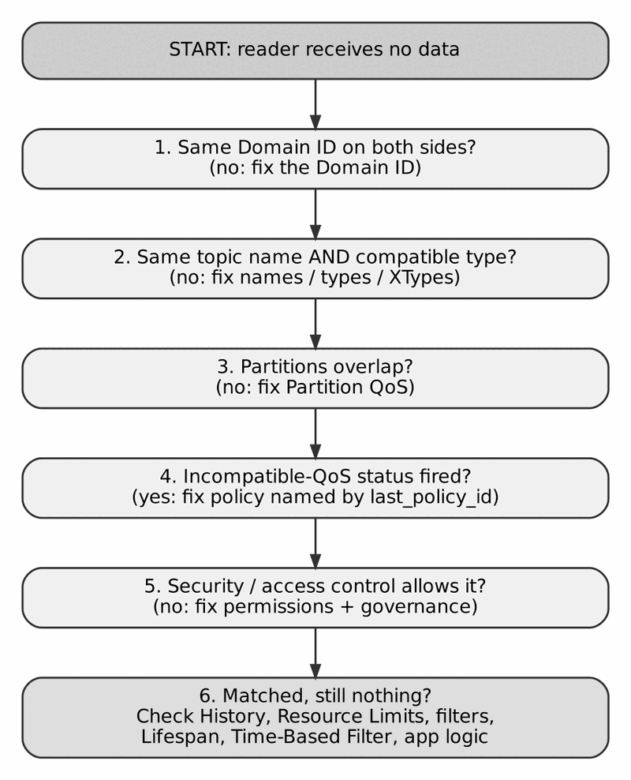
Work through the checks in this order
Work through the checks top to bottom. Most problems are found in the first four.
- Domain ID. Confirm both sides use the same value. In ROS 2 this is ROS_DOMAIN_ID.
- Topic name and type. Names are case-sensitive and, in ROS 2, include the namespace. Types must match or be XTypes-compatible.
- Partition. Two entities match only if their partition lists overlap. Remember that the default partition does not match a non-empty one.
- QoS. Listen for on_requested_incompatible_qos and on_offered_incompatible_qos. The last_policy_id field names the offending policy.
- Security. If DDS Security is on, check certificates, governance and permissions.
- Matched but still silent. Then the problem is after matching: History and Resource Limits dropping samples, content filters, Lifespan expiring samples, a Time-Based Filter throttling, or application logic (for example calling read() with a sample-state mask that excludes what you want).

Matching Works, But the Network Is the Problem
- Multicast blocked (typical in clouds, VPNs, Wi-Fi with client isolation): configure unicast peers or a discovery server.
- Wrong interface on multi-homed hosts: select the network interface explicitly.
- Firewall: allow the UDP ports from Appendix B.3.
- Containers: use host networking or configure peers; shared memory does not cross container namespaces unless the shared mount is arranged.

Latency or Loss
Symptom | Likely cause | First check
Reliable topic is slow | Heartbeat period too coarse, or retransmission storm | HEARTBEAT and ACKNACK cadence in Wireshark
write() blocks | Reliable writer with a full history and a slow reader | Resource Limits, max_blocking_time
Large samples drop | Fragment loss or small socket buffers | MTU, DATA_FRAG counts, receive buffer size
Frequent “lost” events | Lease too short for the network jitter | Liveliness lease and Deadline margins
Memory grows | KEEP_ALL with unlimited limits and a stuck reader | Resource Limits, disconnected readers

A Short Diagnostic Routine
- Run your vendor’s configuration dump and confirm the active settings.
- List discovered participants and endpoints (built-in topics or a tool; see Appendix E).
- Compare writer and reader QoS side by side.
- Capture traffic on the correct interface and filter on rtps.
- Only then change code.

Appendix D: Networking Primer: Unicast and Multicast
DDS discovery and fan-out lean heavily on multicast, so a basic grasp of how Ethernet and IP deliver it explains many “works on my laptop” failures.

Unicast, Multicast, Broadcast
Unicast is one sender to one receiver. The destination is one specific network interface, and only that device processes the frame.
Multicast is one sender to a group. A device receives group traffic only after it has joined the group. A single copy leaves the sender and the network replicates it only where receivers exist.
Broadcast goes to every device on the local network. Multicast is the targeted version of it.
 | Unicast | Multicast
Destination | One device | A group of devices
Copies for N readers | N | 1
Needs group management | No | Yes (IGMP, snooping, sometimes PIM)
Typical DDS use | Reliable repair, TCP, WAN | Discovery, high fan-out data

How IPv4 Multicast Reaches Ethernet
IPv4 multicast addresses are in the range 224.0.0.0 to 239.255.255.255. The Ethernet multicast MAC address is built from the fixed prefix 01:00:5E plus the low 23 bits of the IP address. DDS’s default discovery group, 239.255.0.1, falls in the administratively scoped range, which is meant for use inside an organisation.

Joining a Group: IGMP
A host that wants a group sends an IGMP membership report.
- In IGMPv2 the report is sent to the group address itself. In IGMPv3 reports go to 224.0.0.22. (A leave message in IGMPv2 goes to 224.0.0.2, the all-routers group.)
- IGMP messages are link-local, with a TTL of 1. They never cross a router.
- A querier (normally a router or a configured switch) periodically asks “who still wants which group?”. Hosts answer with reports. Silence causes the group to be pruned.

Switches: IGMP Snooping
Without help, a switch floods multicast to every port, like broadcast. With IGMP snooping, the switch listens to the reports and forwards a group only to the ports that joined. Snooping needs a querier on the segment. When snooping is on and no querier exists, multicast delivery can silently stop after a few minutes, which is a classic cause of DDS discovery that works for a while and then fails.

Across Routers
Multicast does not cross routers unless multicast routing (for example PIM) is configured. Many corporate and cloud networks do not offer it. For such networks, use unicast peers or a discovery server (topic 22), or route selected topics through a bridge (topic 30).

What This Means for DDS
- Discovery on one LAN usually just works with multicast.
- No multicast (cloud, VPN, many Wi-Fi networks): configure unicast peers.
- Large reader counts benefit from multicast data delivery, if the switches handle it.
- Repairs of lost reliable samples still travel by unicast.
- TTL for DDS multicast can be configured when traffic must pass beyond one hop.

Things to Remember
- Multicast needs group membership (IGMP) and a switch that understands it (snooping plus a querier).
- IGMP reports go to the group (v2) or 224.0.0.22 (v3); IGMP stays link-local.
- Multicast does not cross routers by default.
- When multicast fails, use unicast peers or a discovery server.

Appendix E: Tools for Tracing, Decoding and Debugging

Wireshark and tshark
Wireshark has a built-in RTPS dissector. It decodes headers, submessages, GUIDs, sequence numbers and (for many types) the serialized payload.
# capture the default discovery range
tcpdump -i eth0 -w dds.pcap \
'udp portrange 7400-7500'
# read it, RTPS only
tshark -r dds.pcap -Y rtps
# only HEARTBEAT and ACKNACK exchanges
tshark -r dds.pcap -Y \
'rtps.sm.id == 0x07 || rtps.sm.id == 0x06'
Remember to capture on the right interface: lo for same-host UDP traffic. Shared-memory data never appears on any interface (topic 40). Display filter field names can vary slightly by Wireshark version.

Vendor Tools
Tool names and availability vary by vendor and release. Check your installation.
Stack | Typical tools
RTI Connext | Admin Console, Monitor, rtiddsspy for subscribing to data, rtiddsping for connectivity checks
eProsima Fast DDS | fastdds command-line tool (discovery server, shared-memory maintenance, XML validation), Fast DDS Spy and Monitor
Eclipse Cyclone DDS | cyclonedds command-line tool (listing, subscribing, type information in recent versions), ddsperf for performance tests
ROS 2 | ros2 topic list, ros2 topic info --verbose (shows the QoS of each endpoint), ros2 topic echo, ros2 doctor
ros2 topic info /name --verbose is the fastest way to compare publisher and subscriber QoS when two ROS 2 nodes do not connect.

Built-in Topics
Every DDS implementation exposes DCPSParticipant, DCPSPublication and DCPSSubscription. A short program that reads these gives you a live inventory of the domain with no extra tooling (topic 36).

Decoding RTPS by Hand
The RTPS header is 20 bytes: the ASCII text RTPS, a 2-byte version, a 2-byte vendor ID and a 12-byte GUID prefix. Each submessage starts with a 4-byte header: id (1 byte), flags (1 byte, bit 0 is the endianness flag) and length (2 bytes).
Submessage IDs you will see most often:
ID | Submessage
0x01 | PAD
0x06 | ACKNACK
0x07 | HEARTBEAT
0x08 | GAP
0x09 | INFO_TS
0x0c | INFO_SRC
0x0e | INFO_DST
0x12 | NACK_FRAG
0x13 | HEARTBEAT_FRAG
0x15 | DATA
0x16 | DATA_FRAG
A minimal walker over one packet, tested against a synthetic message:
import struct
NAMES = {0x01:"PAD",0x06:"ACKNACK",0x07:"HEARTBEAT",0x08:"GAP",
0x09:"INFO_TS",0x0c:"INFO_SRC",0x0d:"INFO_REPLY_IP4",
0x0e:"INFO_DST",0x0f:"INFO_REPLY",0x12:"NACK_FRAG",
0x13:"HEARTBEAT_FRAG",0x15:"DATA",0x16:"DATA_FRAG"}
def decode(pkt: bytes):
if pkt[:4] != b"RTPS":
raise ValueError("not an RTPS packet")
ver = (pkt[4], pkt[5])
vendor = pkt[6:8].hex()
prefix = pkt[8:20].hex()
print(f"RTPS {ver[0]}.{ver[1]} vendor=0x{vendor} "
f"prefix={prefix}")
off = 20
while off + 4 <= len(pkt):
sid, flags = pkt[off], pkt[off + 1]
little = bool(flags & 0x01) # E flag
fmt = "<H" if little else ">H"
(length,) = struct.unpack_from(fmt, pkt, off + 2)
if length == 0: # runs to end of packet
length = len(pkt) - off - 4
name = NAMES.get(sid, f"UNKNOWN(0x{sid:02x})")
print(f" {name:<14} flags=0x{flags:02x} len={length}")
off += 4 + length
This only lists the submessages. Decoding a DATA payload requires the sample’s type, because the CDR encoding contains no field names (topic 25). For full payload decoding, use Wireshark, which can use type information from discovery in many cases, or your vendor’s own tools.

Things to Remember
- Capture on the right interface and filter with rtps.
- HEARTBEAT / ACKNACK patterns reveal loss and tuning problems.
- ros2 topic info --verbose compares endpoint QoS in one command.
- Built-in topics give a free inventory of every writer and reader.
- RTPS submessages are length-prefixed, so a decoder can skip what it does not know.

Appendix F: Glossary of DDS Terms
Terms are in alphabetical order. A chapter number in brackets shows where to read more.
ACKNACK
RTPS submessage sent by a reliable reader. It acknowledges what has been received and names missing sequence numbers. [18]
Appendable
XTypes extensibility kind. New members may be added at the end of a type. [26]
Authentication
Proving identity to other participants, using certificates signed by a trusted authority. [32]
Best effort
Reliability kind with no retransmission. [7]
Built-in topics
Standard topics (DCPSParticipant, DCPSPublication, DCPSSubscription) that describe the domain’s discovered entities. [3, 36]
CDR
Common Data Representation, the standard binary encoding of samples. [25]
ContentFilteredTopic
A view of a topic that delivers only samples matching a filter expression. [35]
Coherent access
Presentation setting that makes related changes visible to readers as one unit. [4]
Deadline
Per-instance promise and expectation of a maximum time between updates. [10]
Destination order
Whether samples are ordered by reception time or by source timestamp.
Discovery
The process by which participants and endpoints find and match each other. [20 to 22]
Dispose
A writer’s explicit statement that an instance no longer exists. [5, 24]
Domain
A logical network of participants sharing a Domain ID. Different domains are isolated. [2]
DomainParticipant
An application’s membership in a domain and the factory for all other entities. [2]
DataReader
The endpoint that receives samples for one topic. [5]
DataWriter
The endpoint that publishes samples for one topic. [5]
Durability
QoS controlling whether late joiners receive earlier samples. [8]
Endpoint
An RTPS writer or reader.
Entity ID
The 4-byte part of a GUID that identifies an entity within a participant. [19]
Exclusive ownership
Only the strongest live writer of an instance is delivered. [12]
Final
XTypes extensibility kind. The type never changes. [26]
GAP
RTPS submessage stating that certain sequence numbers will never be sent. [17, 18]
GUID
16-byte globally unique identifier: 12-byte participant prefix plus 4-byte entity ID. [19]
Heartbeat
RTPS submessage from a reliable writer announcing the range of available sequence numbers. [18]
History
QoS controlling how many samples are kept per instance. [9]
IDL
Interface Definition Language, used to define data types. [23]
IGMP
Protocol hosts use to join IPv4 multicast groups. [Appendix D]
Instance
One logical thing identified by a key value. [24, 43]
Instance handle
A local identifier for an instance. Not a GUID. [19, 43]
Instance state
ALIVE, NOT_ALIVE_DISPOSED or NOT_ALIVE_NO_WRITERS. [24]
Key
The fields of a type, marked @key, that identify an instance. [24]
Late joiner
A reader that matches after samples were published. [8]
Lease duration
Maximum time an entity may stay silent before it is considered not alive. [11, 20]
Lifespan
QoS that expires samples after a duration. [14]
Liveliness
QoS describing how a writer proves it is still alive. [11]
Locator
A network address and port at which an endpoint can be reached. [20]
Match
The state in which a writer and a reader are connected because their topic, type, QoS, partition and security are compatible. [5, 15]
Multicast
One-to-many network delivery to a group. [28, Appendix D]
MultiTopic
A derived topic that joins data from several topics. [35]
Mutable (QoS)
A QoS policy that can be changed after creation. [6]
Mutable (XTypes)
Extensibility kind where every member has an ID, allowing members to be added or reordered. [26]
Offered / requested
A writer offers a level of service; a reader requests a level. They match when the offer satisfies the request. [6, 15]
Ownership
QoS defining whether multiple writers may update the same instance (SHARED) or only one (EXCLUSIVE). [12]
Participant
See DomainParticipant.
Partition
String labels on Publisher or Subscriber that must overlap for entities to match. [13]
Persistent
Durability kind backed by disk storage in a durability service. [8]
Presentation
Publisher/Subscriber QoS controlling coherent and ordered access. [4]
Publisher
Container that owns DataWriters. [4]
QoS
Quality of Service: a set of policies that define how data is delivered. [6]
Reliable
Reliability kind with retransmission of lost samples. [7]
Resource limits
Hard caps on samples, instances and samples per instance. [9]
RTPS
Real-Time Publish-Subscribe, the interoperable wire protocol. [16]
Sample
One update of an instance’s state. [24, 43]
Sample info
Metadata delivered with each sample: states, timestamps, instance handle.
Sequence number
Per-writer counter assigned to every sample. [18]
SEDP
Simple Endpoint Discovery Protocol. [21]
Shared memory transport
Transport for endpoints on the same host that bypasses the network stack. [27]
SPDP
Simple Participant Discovery Protocol. [20]
Status condition
Condition object used with WaitSets to react to entity status changes. [5]
Subscriber
Container that owns DataReaders. [4]
Submessage
A unit inside an RTPS message, such as DATA or HEARTBEAT. [17]
Take / Read
take() returns samples and removes them from the reader cache; read() leaves them. [5]
Time-based filter
Reader QoS limiting delivery to one sample per instance per interval. [14]
Topic
A named, typed channel: name plus type plus QoS. [3]
Transient
Durability kind where a separate service keeps data in memory. [8]
Transient local
Durability kind where the writer keeps data for late joiners. [8]
Type object
XTypes description of a type, exchanged at discovery for compatibility checks. [26]
Unicast
One-to-one network delivery. [28, Appendix D]
Volatile
Durability kind that keeps nothing for late joiners. [8]
WaitSet
Mechanism that blocks a thread until one of its attached conditions is true. [5]
XCDR
Versions of CDR used with XTypes (XCDR1, XCDR2). [25]
XTypes
The Extensible and Dynamic Topic Types specification. [26]

