An Architectural Analysis of Offline-First Data Collection Systems: A Comparative Study of KoboToolbox and Custom Python Frameworks for Cross-Platform Mobile Deployment

Section 1: Executive Summary and Strategic Recommendations

1.1 Statement of the Core Problem

This report presents a formal architectural analysis of three potential strategies for developing a robust, offline-first mobile application for site surveys, akin to a private "CompanyCam." The primary drivers for this analysis are the need for unwavering robustness under intermittent network conditions, a desire for a solution perceived as "smaller and simpler" than the existing KoboToolbox platform, and a stated technical preference for the Flask web framework.
A review of supplementary project documentation ¹ reveals a critical context: the client has already implemented a "KoboToolbox Bridge MVP." This Minimum Viable Product successfully utilizes a self-hosted KoboToolbox server as a backend, with a custom Flask-based bridge application polling its API to synchronize data with CompanyCam.¹
This existing success is constrained by what the project documentation terms a "Critical Limitation": the solution relies on the KoboCollect data collection app, which is Android-Only.¹ Therefore, the central, unstated business problem is not hypothetical. The core query is a strategic investigation into the best path to achieve robust, cross-platform (specifically iOS) data collection, given the functional and technical limitations of the current MVP.

1.2 Summary of Options Analyzed

This analysis evaluates the three specified options, reframed by the core problem of achieving robust iOS support:
- KoboToolbox Ecosystem (Full or Headless): Continuing to use the self-hosted KoboToolbox server, either with its own clients or as a "headless" backend (the current MVP model). This option's cross-platform viability is assessed via its web-based client, Enketo.
- Hybrid "Port" (Kobo-to-Flask Logic): An investigation into the feasibility of extracting KoboToolbox's "sync logic" from its Django backend and porting it to a custom Flask application.
- Full-Custom Stack (Flask, BeeWare, SQLite): A from-scratch development of a bespoke system, as detailed in project notes, featuring a Flask backend, a Python-native mobile application built with the BeeWare framework, and a custom-designed, SQLite-based offline-first synchronization engine.

1.3 The "Simplicity Paradox"

A central finding of this report is a fundamental conflict between the client's two primary goals: the desire for a "smaller and simpler" solution and the (implied) mandatory requirement for robust, cross-platform support. This conflict is termed the "Simplicity Paradox."
The client perceives the KoboToolbox stack—a complex, multi-container Docker-based system ²—as operationally complex. The hypothesis is that a custom Flask/BeeWare stack (Option 3) would be "smaller and simpler."
This hypothesis is incorrect. The architectural complexity of KoboToolbox is a necessary consequence of its primary function: providing battle-tested, robust, offline-first data synchronization that can handle intermittent connectivity, data/media queuing, and upload retries.⁴ This is a notoriously "hard problem" in the field of distributed systems.⁵
Option 3 (Full-Custom Stack) does not avoid this complexity; it in-sources it. The client would be trading a known, solvable operational complexity (managing the Kobo-Docker stack) for a vastly larger and more-risk-laden developmental complexity (designing, building, testing, and maintaining a custom, stateful, distributed synchronization engine from scratch).

1.4 Strategic Recommendations

Based on the exhaustive analysis in this report, the decision is reduced to two mutually exclusive strategic paths. Option 2 is determined to be non-viable and should not be pursued.
- Recommendation A (The Pragmatic, Low-Risk Path): Retain the KoboToolbox Backend (Modified Option 1) and Accept Android-Only Hardware Policy.
  - If robust iOS support is a "nice-to-have" and not a hard-line business requirement, the most pragmatic and low-risk path is to retain the current, proven "KoboToolbox Bridge MVP."
  - This solution is battle-tested by the humanitarian aid sector ⁸, guarantees data robustness on its supported platform ⁴, and the client has already successfully built the Flask-based API integration bridge.¹
  - The "Critical Limitation" ¹ is then managed as a business and hardware policy (i.e., field teams must be equipped with Android devices) rather than as a technical problem to be solved.
- Recommendation B (The Strategic, High-Risk Path): If iOS Support is Mandatory, Commit to the Full-Custom Stack (Option 3).
  - If robust iOS support is a non-negotiable, mission-critical business requirement, the client must commit to the Full-Custom Stack (Option 3).
  - This report will demonstrate (Section 3.2.2) that Kobo's native iOS-compatible solution (Enketo) is not robust and carries a high risk of irreversible data loss ¹¹, making it unsuitable for this project.
  - In choosing this path, the client must abandon the "smaller and simpler" hypothesis. This is a significant, high-risk, and expensive R&D project. It requires budgeting for 6-12 months of dedicated engineering effort, focused primarily on the development and field-stabilization of the custom synchronization engine (detailed in Section 5.3), before work on application-level features can be prioritized.
- Option 2 (Hybrid "Port") is determined to be non-viable. As detailed in Section 4, this option is based on a fundamental misunderstanding of Kobo's architecture. There is no Python-based "sync logic" to "port." This path is functionally identical to, and therefore subsumed by, the high-risk, from-scratch build of Option 3.

Section 2: Evaluation Framework and Baseline Analysis

2.1 Evaluation Metrics

To provide a structured and objective comparison, all options are assessed against a uniform set of criteria derived from the project's stated and implied goals:
- Offline-First Robustness: This is the most critical metric. It evaluates the reliability of the client-side application to capture, securely store (both structured data and media files), and queue data with zero data loss when offline. It also includes the system's ability to reliably synchronize this data to the server, handling connection interruptions, retries, and confirmation of receipt.⁴
- Cross-Platform Capability: Assesses the availability and maturity of first-class, native (or near-native) application clients for both Android and iOS. A "robust" solution must be available for both platforms to meet the implied project goal.
- Development Effort & Risk: A measure of the time-to-market, required engineering resources, and the technical risks associated with implementation. This includes risks of data-loss bugs, schedule overruns, or total project failure.
- Long-Term Maintainability: An analysis of the total cost of ownership. This metric weighs operational complexity (e.g., managing a multi-container server stack ²) against development complexity (e.g., debugging a custom, stateful sync engine).
- Alignment with Client Goals: A direct assessment of how each option satisfies the stated preference for a "smaller and simpler" architecture and the use of the Flask framework.

2.2 Baseline: The "KoboToolbox Bridge MVP"

The provided project documentation ¹ establishes the current baseline, here referred to as the "KoboToolbox Bridge MVP." This existing implementation serves as a proof-of-concept for the "headless" KoboToolbox model and defines the starting point for this analysis.
The architecture of the MVP consists of:
- Data Collection Client: The KoBoCollect app on Android devices. This is used for all offline data and photo capture.¹
- Data Inbox Server: A self-hosted, private KoboToolbox server.¹ This server is deployed using the Kobo-Docker stack ² and acts as the immediate, persistent "inbox" for all field submissions. KoBoCollect syncs directly to this server.
- Bridge Application: A custom Flask Bridge application.¹ This application runs a background scheduler (e.g., apscheduler ¹) that automatically polls the private KoboToolbox server's API every five minutes.¹
- Endpoint: The CompanyCam API. The Flask Bridge fetches new submissions from KoboToolbox and pushes the data and photos to CompanyCam to create new projects.¹
This model has successfully proven the viability of using KoboToolbox as a "headless" backend. The Flask Bridge correctly interacts with Kobo's v2 KPI API ¹² to list forms and download submissions, including media attachments.
The "Critical Limitation" identified in the project's own documentation is that this entire workflow is dependent on the KoBoCollect app, which has no iOS version.¹ This limitation is the primary motivator for this entire architectural review. The central question is how to replace this one component (the Android-only client) with a robust, cross-platform alternative.

Section 3: Option 1 (In-Depth Analysis): Adopting the KoboToolbox Ecosystem

This option evaluates the merits and limitations of staying within the KoboToolbox ecosystem, either by retaining the current "headless" model or by adopting Kobo's native cross-platform solution.

3.1 Architectural Overview: The Self-Hosted Kobo Server

The client's assessment of KoboToolbox as "complex" is accurate from an operational perspective. It is not a single, monolithic Django application. It is a "stack of docker containers" ³ orchestrated by docker-compose and managed by a Python-based setup script, kobo-install.¹⁴
A self-hosted KoboToolbox instance ¹⁵ typically consists of the following key services running in separate containers ²:
- kpi (Kobo-Projects Interface): The primary server, written in Django.¹⁶ This component handles the user interface, project (form) management, permissions, reporting, and, most importantly, the v2 REST API.¹⁶ The client's Flask Bridge already interacts with this component.
- kobocat (Kobo-Cat): A legacy Django backend.¹⁸ It serves as the ODK (Open Data Kit) compliant submission receiver. When KoboCollect syncs, it is sending its data to kobocat.
- enketo-express: A Node.js application that serves Enketo, the web-based form client.³
- Databases: The stack utilizes PostgreSQL for relational data (users, projects, etc.) and MongoDB for storing submission data.²
- Supporting Services: nginx (web proxy), redis (cache and task queue).
This microservice architecture, while operationally complex to manage, is precisely what allows KoboToolbox to function at scale and handle the different facets of form deployment, data collection, and API access.

3.2 Client-Side Solutions within the Kobo Ecosystem

The core of the problem lies in the data collection client. The Kobo ecosystem offers two distinct clients.

3.2.1 The "Gold Standard" Client: KoboCollect (Android)

This is the client currently in use by the MVP.¹ It is a fork of the widely respected ODK Collect ³, which is the industry standard for mobile data collection in "challenging environments" such as humanitarian crises and field research.¹⁰
Its primary feature is its offline-first robustness. The application is designed from the ground up to assume zero connectivity.
- All data (form responses, photos, GPS points) is stored first in a local database on the Android device.²¹
- When the user finalizes a form, it is moved to an "upload queue."
- The app can be configured to attempt sending this queue immediately or only when manually triggered.⁴
- The synchronization process is "proofed even against poor Internet connection quality." If a connection is interrupted during the transfer of a record, the server will not integrate the "half received data." The client will simply re-send the entire record on its next attempt.
- Critically, the client only removes the record from its local upload queue after the server has successfully received the entire record and sent back a success confirmation.⁴
This "store-and-forward" mechanism, built with native Android services, is what guarantees zero data loss, even over days or weeks of offline use.²³
Assessment:
- Robustness: 10/10. This is the battle-tested benchmark for this project.
- Cross-Platform Capability: 0/10. It is Android-only, with no iOS version. This is the central problem.

3.2.2 The iOS-Compatible Client: Enketo (Web)

The KoboToolbox ecosystem's only answer for iOS support is Enketo.²⁴ Enketo is a web application that renders Kobo's forms in any modern mobile browser, including Safari on iOS.²⁵
Enketo is designed to work offline. When a user first loads a form with an internet connection, Enketo caches the entire form and its application logic in the browser's HTML5 offline storage.²⁶ The user can then bookmark the form, go offline, collect data (including photos), and the data will be stored persistently within the browser.²⁶ When a connection is re-established, Enketo's internal logic will automatically attempt to upload the queued records to the server, similar to KoboCollect.⁴
This sounds like a perfect solution. It is not.
The KoboToolbox project's own support documentation contains a "showstopper" warning regarding Enketo on iOS:
"iOS (running on iPhones and iPads) devices have several known limitations with using offline-enabled forms... Data loss. When collecting data through Enekto, users should never clear the browser's cache... Clearing your browser's cache (during data collection) will remove all the information stored in the browser... This data loss is irreversible." ¹¹
This vulnerability is echoed by community members, who note, "Wrong handling of browser (cache) will create data loss!".²⁸
This is not a minor bug; it is a fundamental flaw of the browser-cache persistence model, especially on iOS, which gives users (and the OS itself) a simple, one-button way to wipe all this "offline" data. A field technician with a week's worth of un-synced site surveys could have their data irreversibly destroyed by a simple "Clear History and Website Data" action.
Assessment:
- Robustness: 2/10. The risk of irreversible, user-initiated data loss makes Enketo a non-viable solution for a professional, robust site survey tool.
- Cross-Platform Capability: 8/10. It technically runs on all platforms.
This finding is the primary justification for this report. Option 1 (Kobo Ecosystem) fails to provide a robust cross-platform solution. This forces the project to consider the high-risk, high-effort path of building a custom client (Option 3).

3.3 The "Headless" Model (The Client's Current MVP)

While the Kobo clients are a dead-end for this project's goals, the Kobo server remains a viable, robust backend. The client's MVP ¹ already proves this.
The Kobo kpi v2 API is a mature, fully-featured REST API.¹² The workflow for the Flask Bridge to extract data is:
- Authenticate: Use the API Key (Token) obtained from the KoboToolbox user account settings.¹²
- List Projects (Assets): Make a GET request to /api/v2/assets/?asset_type=survey.²⁹ This returns a list of all forms, from which the Flask Bridge can find the "Site Survey" form's unique asset UID.
- Get Submission Data: Make a GET request to /api/v2/assets/{asset_uid}/data/.²⁹ This returns a JSON object containing a paginated list of all submissions for that form.
- Get Media Attachments: This is the most critical part. Each submission record in the JSON from the previous step will contain an _attachments key. This key holds an array of objects, one for each media file (e.g., photo) attached to the submission.³¹ Each of these objects contains a download_url.³¹ The Flask Bridge can then make an authenticated GET request to this URL to download the raw photo, which it can then stream or pass on to the CompanyCam API.
This "headless" model is stable, well-documented, and already implemented by the client. The Kobo server acts as a robust, field-tested "data inbox" that has already solved the problems of ODK-compliance, data storage, and API access.

3.4 Assessment of Option 1

- Offline-First Robustness: Dichotomous. 10/10 for the Android-only KoboCollect client. 2/10 for the iOS-compatible Enketo client, due to the high risk of irreversible data loss.¹¹
- Cross-Platform Capability: Fails. It cannot provide a robust client on iOS.
- Development Effort: Very Low. The client has already built the Flask bridge to support the "headless" model.¹ The work is largely complete.
- Long-Term Maintainability: Presents high operational overhead (managing the Kobo-Docker stack ²) but low code maintenance (the Kobo stack is maintained by the open-source community, and the client's Flask bridge is small).
- Alignment with Client Goals: Fails. The core Kobo backend is Django ¹⁶, not Flask, and its operational complexity is the opposite of the "smaller and simpler" goal.

Section 4: Option 2 (Feasibility Analysis): Porting KoboToolbox Sync Logic to Flask

This option, as proposed, is to build a custom solution "by porting sync logic from Kobo to Flask." This option is based on a fundamental (but understandable) misconception of KoboToolbox's architecture.

4.1 The "Porting" Fallacy

The query implies that there is a discrete, self-contained Python-based "sync logic" module within the KoboToolbox (Django) backend that can be isolated, extracted, and "ported" to a new Flask application. This is not the case.

4.2 Deconstruction of Kobo's Sync Architecture

KoboToolbox's "sync" capability is not a single piece of code. It is an asymmetrical, client-server protocol based on the ODK (Open Data Kit) standard.¹⁹
- Client-Side Logic (The "Offline-First" Engine):
  - All the critical "sync logic"—the offline data storage, the persistent queue, the connection state detection, the retry mechanism, and the "store-and-forward" guarantee ⁴—resides entirely within the data collection client.
  - In the KoboToolbox ecosystem, this logic is implemented twice, in two completely different languages:
    - Java/Kotlin: For the KoboCollect Android app.²¹
    - JavaScript: For the Enketo web-form app, which uses browser storage.²⁶
  - There is no Python-based client-side sync logic in the KoboToolbox project.
- Server-Side Logic (The "Receiver"):
  - The Python/Django backend (kpi and kobocat) functions as a passive API receiver.¹⁸
  - Its "logic" is simply to expose ODK-compliant REST API endpoints that accept HTTP POST requests containing form submissions.²⁹ It validates the submission against the form, stores it in the MongoDB, and returns a "success" or "failure" message.
  - It does not manage client-side state. It does not initiate sync. It is a passive participant in the protocol.

4.3 Conclusion: Non-Viable

The conclusion is definitive: there is no Python "sync logic" to "port" to a Flask application to create a new client.
The only "logic" that could be "ported" is that of the server—the API endpoints for receiving data. But the client's stated goal is to use Flask for the backend anyway, so they would be building these receiving endpoints regardless.
"Porting" the client-side logic, which is the "offline-first" part, would require a complete, from-scratch re-implementation of the entire KoboCollect/ODK Collect application—its local database schema, its persistent queue, its state management, and its HTTP submission protocol—in Python, for the BeeWare framework.
This makes Option 2 functionally identical to Option 3: a complete, from-scratch build of a custom client. Therefore, this option is non-viable as a distinct path and is fully subsumed by the analysis of Option 3.

Section 5: Option 3 (Architectural Deep Dive): Custom Flask, BeeWare, and SQLite Sync

This option represents the client's hypothesized "smaller and simpler" solution. It involves abandoning the KoboToolbox ecosystem entirely and building a 100% custom, Python-native stack.

5.1 The Envisioned Architecture

The proposed stack consists of three new, custom-built components:
- Backend: A custom Flask server (per client preference). This server would be responsible for user authentication, defining survey structures (e.g., via JSON), and providing API endpoints to receive submitted data and media files. It would use a PostgreSQL database as its central "source of truth."
- Frontend Client: A cross-platform mobile application written entirely in Python using the BeeWare project.³⁶
  - Toga: The BeeWare UI toolkit, used to create a "rich, native user interface" from a single Python codebase.³⁷
  - Briefcase: The BeeWare packaging tool, used to compile and bundle the Python application (with its dependencies) into native iOS (Xcode project) and Android (APK/AAB) packages.³⁸
- Client Datastore & Sync: The BeeWare application would use an embedded SQLite database ⁴¹ for local, offline storage. A custom-built sync mechanism would be responsible for moving data from the local SQLite database to the Flask-based server.

5.2 The "UI vs. Data" Gap in BeeWare

A critical analysis of the BeeWare framework is necessary to understand the scope of this undertaking. BeeWare is a promising and ambitious project that aims to make Python a first-class citizen for mobile and desktop development.³⁶
However, BeeWare is primarily a UI and packaging framework, not a data-layer or sync framework.
The Toga UI toolkit provides DataSource objects, such as toga.ListSource and toga.TreeSource.⁴³ It is essential to understand that these are not a persistence solution. They are simple, in-memory data structures (akin to Python lists or dicts) designed to efficiently bind data to native UI widgets (like a toga.Table or toga.DetailedList) and handle UI updates when the data changes.⁴³
Toga does provide platform-agnostic APIs to access the application's designated file system locations, such as app.paths.data and app.paths.cache.⁴⁴ This is where the developer would manually place the SQLite database file and save any captured media (photos, videos).
The implication is stark: BeeWare provides the tools to build the house (native widgets) and the truck to deliver it (Briefcase packaging), but it provides no plumbing, electrical, or foundation. The developer is 100% responsible for building the entire data persistence and synchronization layer from scratch.

5.3 Scoping the Core Challenge: The Custom Sync Engine

This is the "hard problem" of distributed systems.⁵ This is the hidden, multi-month engineering project that directly contradicts the "smaller and simpler" goal. To achieve a level of robustness approaching that of KoboCollect ⁴, the client must design, build, test, and debug the following sub-systems from scratch, all in Python, running inside the BeeWare mobile application:
- Local Persistence Layer: Code to create and interact with the embedded SQLite database. This involves using the standard sqlite3 library ⁴⁵ or a Python ORM like SQLAlchemy (which adds its own packaging complexity).
- Secure Media Storage: Application logic to capture photos/videos from the device's camera (via Toga's APIs, if available, or native platform bridges) and save them securely and robustly to the app.paths.data directory.⁴⁴
- Change Data Capture (CDC): The app must log every local change (data inserts, edits, and media captures) to know what needs to be synced. This typically involves creating a separate "operations log" or "event" table within the SQLite database that records every pending change.⁴⁶
- Persistent Background Queue: A robust, persistent, client-side task queue. When a user saves a survey, a "sync" task must be added to this queue. This queue must be persistent (i.e., its state must be saved to the SQLite DB) so it can survive application kills and device restarts. This is a complex piece of state-management logic.⁴⁷
- Connection State Management & Background Execution: The most difficult part of mobile development. The app needs a background service that:
  - Monitors the device's network connectivity.
  - Triggers the "sync" queue processor when a connection is found.
  - This is notoriously difficult on iOS and Android, which aggressively terminate background processes to conserve battery life.49 Native apps (like KoboCollect) use platform-specific services (like Android's WorkManager 6) to handle this. Achieving this level of background reliability from a BeeWare (Python) application will be a significant and
unpredictable engineering challenge.
- Resumable/Chunked Media Uploads: A simple requests.post() call to upload a 20MB photo or 100MB video file will fail on an intermittent connection.⁵⁰ The custom sync engine must implement a "chunked" upload protocol, sending the file in small, resumable pieces.
- Server-Side API: The Flask backend must be designed to handle this complexity. It needs endpoints to:
  - Receive batches of data changes transactionally.
  - Receive file chunks and reassemble them on the server.
  - Handle authentication for all requests.
- Conflict Resolution Strategy: The system must have a defined strategy for when (not if) conflicts occur. A simple "last-write-wins" strategy is common, but the server must be designed to enforce this.⁵

5.4 Analysis of "Off-the-Shelf" Python Sync Libraries

The scope in Section 5.3 assumes a 100% "build from scratch" approach. An alternative is to find an existing, "off-the-shelf" Python library for client-server synchronization. A market scan for such tools reveals a critical gap:
- PouchDB/CouchDB Model: This is the gold standard for this exact problem. PouchDB is a JavaScript database designed to run in the browser (or a mobile app) and seamlessly sync with a CouchDB-compatible server.⁵¹ It handles offline-first, queuing, and conflict resolution automatically. However, it is JavaScript-based and therefore incompatible with the Python-native BeeWare stack.
- Mobync: This is a protocol and library set for online-offline sync.⁵⁴ It has a Python server implementation, which is promising. However, its client implementation is for Dart/Flutter, not Python.⁵⁴ It is incompatible with BeeWare.
- python-sync-db: This is a Python library built on SQLAlchemy designed for centralized database synchronization.⁴⁶ It is the closest match to the project's needs. However, a review of its documentation reveals it is not a mature, battle-tested solution. Its own documentation states it is "currently undergoing testing in a real application" and, more critically, has "restrictions" such as "Push and pull... can't be invoked parallel to other transactions".⁴⁶ This lack of concurrency-safe, production-ready guarantees makes it a high-risk choice.
- LiteSync: This is a fork of SQLite that adds replication capabilities.⁵⁶ This is not a pure Python library; it is a custom-compiled C library. Integrating a custom C library into the BeeWare/Briefcase build-and-packaging pipeline ⁴⁰ for all target architectures (iOS ARM64, iOS Simulator, Android ARMv7/ARM64, etc.) is a monumental build-engineering task that would introduce extreme complexity and fragility. This approach is antithetical to the "simpler" goal.
Conclusion: There are no mature, battle-tested, "plug-and-play" Python libraries for robust, client-server (SQLite-to-Postgres) offline-first synchronization that are suitable for a cross-platform BeeWare mobile client.
This confirms that Option 3 requires the "build from scratch" approach detailed in Section 5.3.

5.5 Assessment of Option 3

- Offline-First Robustness: 1/10 (at launch). The system will be inherently fragile and prone to data loss, sync failures, and edge-case bugs. It will require 6-12+ months of dedicated development and, more importantly, extensive field testing to approach the level of robustness that KoboCollect provides today.
- Cross-Platform Capability: 10/10. This is the entire purpose of this option. BeeWare is designed specifically to provide a Python-native path to both iOS and Android.³⁶
- Development Effort & Risk: Extremely High. The custom sync engine (Section 5.3) is a major, high-risk, high-cost R&D project in itself. The risk of data loss bugs or project failure due to the complexity of background tasks on mobile operating systems is significant.
- Long-Term Maintainability: Very High. The client will own, and be solely responsible for debugging and maintaining, a complex, stateful, custom-built distributed system. This is a significant, permanent maintenance burden.
- Alignment with Client Goals: Partial. It succeeds on the "Flask preference." It fails catastrophically on the "smaller and simpler" goal. The development and maintenance complexity of this option is an order of magnitude greater than that of Option 1.

Section 6: Comparative Analysis and Final Recommendations

6.1 Decision Matrix: Option 1 vs. Option 3

The analysis demonstrates that Option 2 (Hybrid "Port") is non-viable. The strategic decision is therefore a direct confrontation between the pragmatic, proven limitations of Option 1 and the high-risk, high-effort potential of Option 3. The following table synthesizes the findings for the two viable paths.

Evaluation Metric | Option 1: KoboToolbox Ecosystem (Headless) | Option 3: Custom BeeWare/Flask Stack
Offline-First Robustness | Extremely High (Battle-Tested). Leverages the KoboCollect/ODK client, which has proven guarantees against data loss in poor connectivity.⁴ | Extremely Low (To-Be-Built). Requires a custom, high-risk sync engine. High risk of data loss and bugs, especially in early versions.⁵
Android Support | Excellent. Utilizes the native, robust, and feature-rich KoboCollect client.¹ | Good (Theoretically). BeeWare/Briefcase supports Android deployment.³⁷
iOS Support | Poor / High-Risk. The only native Kobo solution (Enketo) has known, "irreversible" data-loss issues on iOS.¹¹ This is a non-starter. | Good (Theoretically). This is the primary driver for this option. BeeWare/Briefcase is designed to package Python for iOS.³⁷
Development Effort | Very Low. The client has already built the core Flask API bridge.¹ The work is 90% complete. | Extremely High (6-12+ months). The custom sync engine (Section 5.3) is a major, complex R&D project in itself.
Technical Risk | Low. Uses a globally-tested, open-source stack. The integration points (v2 API) are stable and proven by the client's MVP. | Extremely High. High probability of data loss bugs, silent sync failures, and massive development overruns. The "hard problem" of sync.⁷
Long-Term Maintainability | Operational Complexity. The burden is on operations to manage the Kobo-Docker stack.² Code maintenance is low. | Development Complexity. The burden is on engineering to own, debug, and maintain a complex, custom distributed system forever.
Alignment: "Smaller & Simpler" | Fails. Perceived as a large, complex monolithic stack.² | Fails. The development and maintenance are an order of magnitude more complex than Option 1. This is the "Simplicity Paradox."
Alignment: "Flask Preference" | Partial. The Kobo backend is Django ¹⁶, but the client's Bridge is already Flask, isolating the team from Django. | Succeeds. The backend is Flask.

6.2 The Core Architectural Trade-Off: Robustness vs. iOS Support

The analysis and decision matrix reveal a stark and unavoidable architectural trade-off. The client is at a critical impasse where the stated goals are in direct conflict.
- Path 1 (Kobo) provides guaranteed, battle-tested robustness at the non-negotiable cost of an Android-only hardware policy.
- Path 3 (Custom) provides the potential for robust, cross-platform (iOS) support, at the non-negotiable cost of a massive, high-risk, high-complexity, and expensive engineering project.
The client's initial hypothesis—that a "smaller and simpler" solution could be built to provide robust, cross-platform support—is proven by this analysis to be false. The client must now choose which constraint to relax:
- Relax the platform constraint (accept Android-only).
- Relax the simplicity/budget/risk constraint (commit to a massive build).

6.3 Final Strategic Recommendations

Based on this analysis, two divergent but clear paths are recommended.

Recommendation 1 (The "Pragmatic" Path): If iOS support can be deprioritized, STOP and Retain the KoboToolbox Ecosystem (Option 1).

If robust iOS support is a "nice-to-have" or a future goal, but not a mission-critical, immediate business requirement, the most sensible and pragmatic path is to stop further development and retain the current "KoboToolbox Bridge MVP."
- Action Plan:
  - Formally accept the "Android-Only" limitation ¹ as a business and hardware constraint.
  - Equip all field personnel with a standard, supported Android device.
  - Continue using the proven, robust KoboCollect client for data capture.
  - Continue using the existing, already-built Flask "Bridge" ¹ to pull data from the Kobo API and sync to CompanyCam.
- Justification:
  - This is the only path that aligns with the "simpler" goal from a development and risk perspective.
  - The "complexity" of this solution is operational (managing the Kobo-Docker stack), which is a well-understood, solvable problem with mature tools. This is vastly preferable to the developmental complexity and data-loss risk of Option 3.
  - This solution is already 90% complete and proven to work.

Recommendation 2 (The "Strategic" Path): If iOS support is MANDATORY, Commit to the Full-Custom Build (Option 3).

If, after a business review, iOS support is determined to be a non-negotiable, mandatory requirement for the project's success, then the client must commit fully to Option 3. The analysis proves that Kobo's Enketo client is not a robust alternative.¹¹
- Action Plan:
  - The client must abandon the "smaller and simpler" hypothesis. This is a large, complex, and expensive distributed systems project.
  - Secure a budget for a dedicated engineering team (e.g., 2-3 developers) for a minimum of 6-9 months, with the explicit understanding that this is an R&D project with a high risk of failure.
  - The project roadmap must prioritize the core infrastructure. The sole focus of the first 6 months must be on building and field-stabilizing the client-side sync engine, as detailed in Section 5.3. Application-level "CompanyCam" features (photo-markup, project-sharing, etc.) must be deferred until this core, high-risk infrastructure is proven to be robust.
  - The team must build a comprehensive test suite, including automated tests for "connection dropped" scenarios and long-term, real-world field testing, to mitigate the high risk of data loss.

Recommendation 3 (Alternative Investigation): "Buy" Before "Build."

Before committing to the high-risk, high-cost "build" path of Recommendation 2, a final, two-week "Request for Information" (RFI) phase is advised. This RFI should investigate commercial "buy" options that may have been overlooked.
- Investigate commercial, headless data-collection platforms that provide a robust client SDK (Software Development Kit) for both iOS and Android.⁵⁷ This would offload the "hard problem" of sync to a vendor.
- Investigate mature, non-Python, cross-platform frameworks (e.g., Flutter) that do have mature, open-source sync libraries (like Mobync ⁵⁴). This would be a more viable "build" path than attempting it with Python/BeeWare, which lacks the mature data-layer tooling.

Section 7: Appendix and Deeper Technical References

7.1 KoboToolbox v2 API Endpoints for Media and Data Extraction

- Authentication: Retrieve API Token from https://[your-server]/token/?format=json ¹² or from the Account Settings page.¹²
- List All Projects (Forms): GET /api/v2/assets/?asset_type=survey.²⁹
- Get Project (Form) Details: GET /api/v2/assets/{asset_uid}/.²⁹
- Get All Submissions: GET /api/v2/assets/{asset_uid}/data/.²⁹
- Get Single Submission: GET /api/v2/assets/{asset_uid}/data/{submission_id}/.²⁹
- Media Attachment URL: In the JSON response from a data endpoint, find the _attachments array. Each object within contains a download_url that can be requested (with an Authorization: Token... header) to fetch the file.³¹

7.2 ODK (Open Data Kit) Protocol Overview

KoboToolbox is built upon the Open Data Kit (ODK) standard.⁸ ODK is a suite of open-source tools for mobile data collection.¹⁹ Understanding this relationship clarifies why Kobo is structured the way it is. ODK consists of:
- ODK Collect: The Android-based mobile client (which KoboCollect is a fork of).²⁰
- ODK Central: The server component for form and submission management (which kpi and kobocat replace/implement).
- XLSForm: The Excel-based standard used to define forms.⁶¹
The robustness attributed to KoboToolbox is, in large part, inherited from the design principles of the ODK standard, which was purpose-built for offline-first operation in resource-constrained environments.¹⁹

7.3 Further Reading: The Complexity of Offline-First Sync

The implementation of a custom sync engine (Section 5.3) is a well-known "hard problem" in computer science. The following resources elaborate on the challenges:
- Duplication of Business Logic: A common challenge is that to make the offline experience "feature-rich," developers often end up duplicating all of the backend's business logic onto the client, which creates a maintenance nightmare.⁵
- The "Trivial" Example Fallacy: Many online tutorials describe "offline-first" for a simple "Todo" app with one data model. These examples do not scale to a production system with multiple data tables (projects, surveys, photos) and media file (image) syncing.⁶
- State of Sync on Mobile: The challenge of reliably running background sync on modern mobile operating systems (iOS, Android) cannot be overstated. The OS itself is often an adversary, terminating background processes to save battery, which can corrupt a naive sync-in-progress.⁴⁹ This is a primary source of risk for a non-native (BeeWare) implementation.

Works cited
- README_KoboToolbox_MVP.md
- Stack of docker containers to all server-side components of KoBoToolbox (kpi, kobocat, enketo-express). - GitHub, accessed November 15, 2025, https://github.com/kobotoolbox/kobo-docker
- KoboToolbox - GitHub, accessed November 15, 2025, https://github.com/kobotoolbox
- Collecting Data Offline - KoboToolbox documentation, accessed November 15, 2025, https://support.kobotoolbox.org/data-offline.html
- I still haven't found the "holy grail architecture" for offline-first with backe... | Hacker News, accessed November 15, 2025, https://news.ycombinator.com/item?id=28691771
- How do you design offline capability with sync with the backend? : r/androiddev - Reddit, accessed November 15, 2025, https://www.reddit.com/r/androiddev/comments/v3h66s/how_do_you_design_offline_capability_with_sync/
- Builing an offline-first app with build-from-scratch Sync Engine - DEV Community, accessed November 15, 2025, https://dev.to/daliskafroyan/builing-an-offline-first-app-with-build-from-scratch-sync-engine-4a5e
- What is ODK? Competitors, Complementary Techs & Usage - Sumble, accessed November 15, 2025, https://sumble.com/tech/odk
- Top ODK Alternatives in 2025 - Slashdot, accessed November 15, 2025, https://slashdot.org/software/p/ODK/alternatives
- Offline smartphone apps for qualitative research and data collection? - Reddit, accessed November 15, 2025, https://www.reddit.com/r/UXResearch/comments/11bj9yx/offline_smartphone_apps_for_qualitative_research/
- Troubleshooting Enketo Web Forms - KoboToolbox documentation, accessed November 15, 2025, https://support.kobotoolbox.org/troubleshooting_webforms.html
- Getting started with the API - KoboToolbox documentation, accessed November 15, 2025, https://support.kobotoolbox.org/api.html
- A command-line installer for setting up and running KoboToolbox on a remote server or local computer, using kobo-docker. - GitHub, accessed November 15, 2025, https://github.com/kobotoolbox/kobo-install
- Install kobotoolbox on ubuntu20 server - Kobo On Your Own Server, accessed November 15, 2025, https://community.kobotoolbox.org/t/install-kobotoolbox-on-ubuntu20-server/31144
- kobotoolbox architecture: database, user management, accessed November 15, 2025, https://community.kobotoolbox.org/t/kobotoolbox-architecture-database-user-management/677
- kpi is the server for KoboToolbox. It includes an API for users to access data and manage their forms, question library, sharing settings, create reports, and export data. - GitHub, accessed November 15, 2025, https://github.com/kobotoolbox/kpi
- kobotoolbox repositories - GitHub, accessed November 15, 2025, https://github.com/orgs/kobotoolbox/repositories
- kobotoolbox/kobocat: Our (backend) server for providing blank forms to Collect and Enketo and for receiving and storing submissions. - GitHub, accessed November 15, 2025, https://github.com/kobotoolbox/kobocat
- ODK - Collect data anywhere, accessed November 15, 2025, https://getodk.org/
- 10 best tools for building and deploying mobile data collection projects, accessed November 15, 2025, https://datafordev.com/10-tools-to-build-and-deploy-mobile-data-collection-projects/
- 8 Apps for Data Collection in Research - Teamscope, accessed November 15, 2025, https://www.teamscopeapp.com/mobile-data-collection-guide/7-mobile-data-collection-apps-for-field-research
- Getting started with data collection apps: Seven to choose from - SurveyCTO, accessed November 15, 2025, https://www.surveycto.com/data-collection-quality/data-collection-apps/
- How long are offline functions effective for? - KoboToolbox Community Forum, accessed November 15, 2025, https://community.kobotoolbox.org/t/how-long-are-offline-functions-effective-for/46213
- What Are Enketo Web Forms? - KoboToolbox documentation, accessed November 15, 2025, https://support.kobotoolbox.org/enketo.html
- Topics — KoboToolbox documentation, accessed November 15, 2025, https://support.kobotoolbox.org/
- Frequently Asked Questions - Enketo, accessed November 15, 2025, https://enketo.org/faq/
- Guide: Data collection with Enketo & ODK Collect - Ona Data Help Center, accessed November 15, 2025, https://help.ona.io/knowledge-base/guide-using-enketo-odk-collect/
- Using Enketo for offline survey (Web Form: Advantages & Disadvantages) - Data Collection, accessed November 15, 2025, https://community.kobotoolbox.org/t/using-enketo-for-offline-survey-web-form-advantages-disadvantages/35094
- Migrating from v1 to v2 API - KoboToolbox documentation, accessed November 15, 2025, https://support.kobotoolbox.org/migrating_api.html
- KoBo API examples, using new KPI endpoints - KoboToolbox Community Forum, accessed November 15, 2025, https://community.kobotoolbox.org/t/kobo-api-examples-using-new-kpi-endpoints/2742
- Phot from kobotoolbox api, accessed November 15, 2025, https://community.kobotoolbox.org/t/phot-from-kobotoolbox-api/26401
- Clarify attachments handling in the API - KoboToolbox Community Forum, accessed November 15, 2025, https://community.kobotoolbox.org/t/clarify-attachments-handling-in-the-api/29715
- Requirements to install KoBoToolbox on a self hosted server, accessed November 15, 2025, https://community.kobotoolbox.org/t/requirements-to-install-kobotoolbox-on-a-self-hosted-server/20210
- KoboCollect – Apps on Google Play, accessed November 15, 2025, https://play.google.com/store/apps/details/KoboCollect?id=org.koboc.collect.android&hl=en_ZA
- Introducing Enketo Express, accessed November 15, 2025, https://blog.enketo.org/enketo-express/
- Goals - BeeWare, accessed November 15, 2025, https://beeware.org/about/goal/
- Write once. Deploy everywhere.— BeeWare, accessed November 15, 2025, https://beeware.org/
- BeeWare Tutorial, accessed November 15, 2025, https://tutorial.beeware.org/
- BeeWare and the State of Python on Mobile - Talk Python to Me Ep. 499 - YouTube, accessed November 15, 2025, https://www.youtube.com/watch?v=rSiq8iijkKg
- beeware/Python-Apple-support: A meta-package for building a version of Python that can be embedded into a macOS, iOS, tvOS or watchOS project. - GitHub, accessed November 15, 2025, https://github.com/beeware/Python-Apple-support
- Building an Offline-First Data Workflow with SQLite and Python | by firman brilian | Medium, accessed November 15, 2025, https://medium.com/@firmanbrilian/%EF%B8%8F-building-an-offline-first-data-workflow-with-sqlite-and-python-468e6ef7c478
- Episode #499 - BeeWare and the State of Python on Mobile | Talk Python To Me Podcast, accessed November 15, 2025, https://talkpython.fm/episodes/show/499/beeware-and-the-state-of-python-on-mobile
- Data Sources - Toga 0.5.2, accessed November 15, 2025, https://toga.readthedocs.io/en/stable/topics/data-sources.html
- Resources - Toga 0.5.2, accessed November 15, 2025, https://toga.beeware.org/en/stable/reference/api/resources/index.html
- sqlite3 — DB-API 2.0 interface for SQLite databases — Python 3.14.0 documentation, accessed November 15, 2025, https://docs.python.org/3/library/sqlite3.html
- bintlabs/python-sync-db: Experimental database synchronization for sqlalchemy - GitHub, accessed November 15, 2025, https://github.com/bintlabs/python-sync-db
- Python multiprocessing queue makes code hang with large data - Stack Overflow, accessed November 15, 2025, https://stackoverflow.com/questions/59951832/python-multiprocessing-queue-makes-code-hang-with-large-data
- How to Handle File Upload Issues in Python Web Frameworks - Best Practices and Solutions - MoldStud, accessed November 15, 2025, https://moldstud.com/articles/p-how-to-handle-file-upload-issues-in-python-web-frameworks-best-practices-and-solutions
- Best practice to implement offline sync in flutter app ? : r/FlutterDev - Reddit, accessed November 15, 2025, https://www.reddit.com/r/FlutterDev/comments/1g2ed7e/best_practice_to_implement_offline_sync_in/
- http upload of huge files over slow network (interruptible) : r/Python - Reddit, accessed November 15, 2025, https://www.reddit.com/r/Python/comments/b1cw6h/http_upload_of_huge_files_over_slow_network/
- PouchDB, the JavaScript Database that Syncs!, accessed November 15, 2025, https://pouchdb.com/
- PouchDB or SQLite which one is better for building offline first desktop applications and why? : r/Database - Reddit, accessed November 15, 2025, https://www.reddit.com/r/Database/comments/1co28xl/pouchdb_or_sqlite_which_one_is_better_for/
- Distributed offline editing with couch/pouchdb - Yjs Community, accessed November 15, 2025, https://discuss.yjs.dev/t/distributed-offline-editing-with-couch-pouchdb/340
- mobync/python-server: Mobync is a protocol that allows mobile applications running on distributed clients to get synced to a single source of truth and work offline and online - GitHub, accessed November 15, 2025, https://github.com/mobync/python-server
- Offline-first sync on client -- library? - Questions / Help - Elixir Forum, accessed November 15, 2025, https://elixirforum.com/t/offline-first-sync-on-client-library/42216
- Python - LiteSync - SQLite Replication and Synchronization, accessed November 15, 2025, https://www.litesync.io/en/sqlite-replication-python.html
- RxDB – The Ultimate Offline Database with Sync and Encryption, accessed November 15, 2025, https://rxdb.info/articles/offline-database.html
- Sync API | Contentful Docs, accessed November 15, 2025, https://www.contentful.com/developers/docs/concepts/sync/
- Sync API for Developers | Headless CMS Blog - Contentstack, accessed November 15, 2025, https://www.contentstack.com/blog/product-updates/introducing-the-contentstack-sync-api-for-developers
- Offline Content Sync Dotnet Maui Headless CMS - iNest Web, accessed November 15, 2025, https://www.inestweb.com/offline-content-sync-dotnet-maui-headless-cms/
- KoboToolbox, accessed November 15, 2025, https://www.kobotoolbox.org/

In the last update, I wrote about the process of adding an async grammar checker and TeX import into LibreOffice. This update adds a feature LibreOffice should have probably added many years ago: real scientific Python.
LibreOffice has lagged behind Excel in data science workflows. With my recent work in WriterAgent, you can now leverage the full Python ecosystem: Run NumPy in Calc, generate pandas DataFrames from Writer, or let AI agents create scripts and insert results into your documents.
My focus in NumPy at first was exposing it to the LLMs so they could write scripts and insert the results into a document, but I eventually realized Python should be enabled for meatbags too. The implementation is simple, robust, and fast enough, but getting here required rejecting previous approaches.

The ABI Problem
The problem is that NumPy is not pure Python. It ships compiled C and C++ extensions containing a wide variety of high-performance math implementations that must match the exact Python ABI they were built against: minor version, architecture, compiler, and build flags. LibreOffice (for many operating systems) embeds its own Python interpreter.
If you simply append a user’s packages to LibreOffice’s sys.path and import NumPy, you will quickly crash because the binary interface between the extension and NumPy’s files is incompatible.
Two common “solutions” look attractive on paper but create long-term headaches.
1. Vendor the NumPy stack into the .oxt file. It at first sounds reasonable: “users just install the extension and it works.” The challenge is that the full scientific stack is large—easily 50–100 MB uncompressed, and that is before you multiply by the number of platforms and Python versions.
Security and bug-fix updates become the extension’s responsibility. Users who want MKL-accelerated NumPy have to use a specific pinned version of Python that matches the LibreOffice version. The download size balloons to about a gigabyte, even for those who will never run a single line of Python.
2. Vendoring pip and auto-installing packages into LibreOffice’s embedded Python at startup is the approach taken by LibrePythonista. It is clever, but adds a different layer of fragility. If the Python code hangs or crashes, it takes down LibreOffice. You are now tightly coupled to whatever Python version LibreOffice ships with. When LibreOffice upgrades, installed packages break.
Both approaches also make the extension more complex. LibrePythonista ended up writing a lot of path manipulation and other code that has to work on every platform that LibreOffice supports. That code is easy to get subtly wrong and hard to test comprehensively.

The Design I Chose: User Venv + Subprocess Bridge
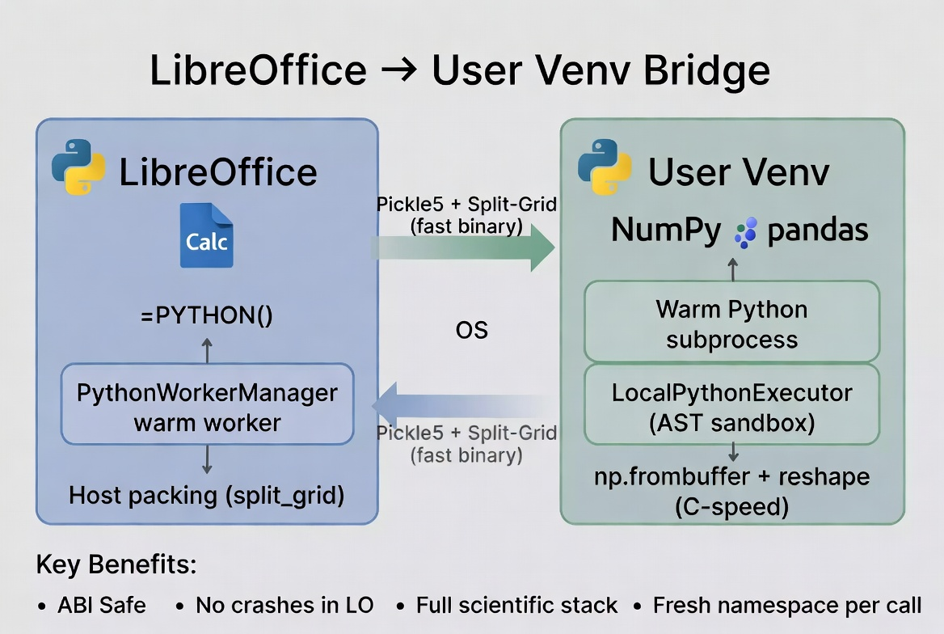
WriterAgent takes a different path. You just point LibreOffice to a Python virtual environment (venv) directory with whatever version of Python and packages you want. WriterAgent never imports NumPy (or any third-party package) inside LibreOffice’s embedded Python.
Instead, it spawns (and keeps running) an external Python worker process. When you send data cross-process, both sides don’t need to be running the same version, they just need to be able to parse JSON or whatever data format is used.
There are many benefits from this design. If you have already created a custom high-performance MKL or OpenBLAS build, you can use it. A crash inside a user script will not take down LibreOffice.
You should be able to say things like “Run a Monte Carlo simulation of portfolio returns using NumPy and create a histogram.” The agent calls the run_venv_python_script tool (specialized domain python), receives the serialized result, and then uses the existing tools (create_chart, etc.) to place the output.

=PYTHON() in Calc
I also added a first-class formula to Calc: =PYTHON("np.mean(data)", B1:B1000)
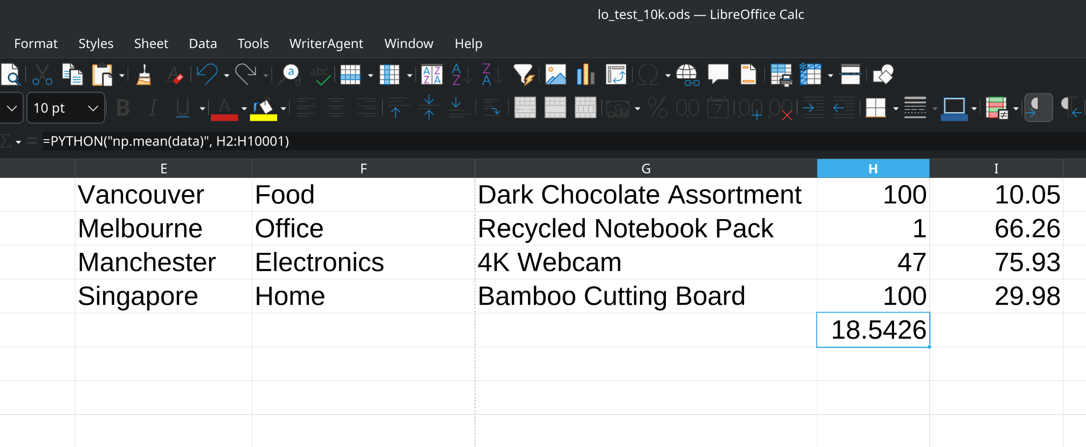
The data variable is a special variable containing the passed-in ranges, dynamically injected into your Python’s namespace at runtime. You can return the result as a result variable, or it will use the last line of code by deafult.
The only downside of =PYTHON() so far is that most of LibreOffice expects a function to return a single data point. If you want to return an array, you need to select the proper number of rows in advance and use a matrix key (Ctrl+Shift+Enter) so one worker invocation can fill an entire range without N separate round-trips.
Having to select the proper number of rows in advance and remember to press Ctrl+Shift+Enter is a drag, so I’ve created ways to have scripts with the flexibility to overwrite multiple cells.
Once I found out that the default is to return just a single value, sharing code between cells becomes very important. Fortunately, LibreOffice automatically supports the feature if you write something like this: =PYTHON($A$1,B1:B1000).We’ve moved beyond OOP – Object Oriented Programming to COP – Cell Oriented Programming!

The xl() Hack
Microsoft’s Python-in-Excel forces you to write xl(“A1:B100”) inside the Python code. That string is opaque to Calc’s formula engine, so the dependency graph breaks. When you edit any cell, Excel has to re-run every Python cell in row-major order just to be safe. Move a cell, insert a row, or rename a sheet and your pipelines silently stop working or produce stale results.
WriterAgent’s =PYTHON() keeps the dependency declaration where Calc expects it: in the arguments. You get true incremental recalc and explicit ordering without fragile sheet layout. The Python code itself stays clean and readable because it just receives data: no string parsing or magic xl() calls required.
When you have a bunch of random “global variables” or tweakable parameters that you want your Python code to respect: simulation counts, thresholds, etc., the cleanest pattern is to gather them all together into a single range (for example, A5 – A30), and pass that in. This keeps the formula short, makes the parameters clear, and doesn’t break the recalculation engine.

Shared kernel and initialization scripts
Right now the default behavior is isolated (each =PYTHON() cell gets its own fresh namespace), but you can turn on a shared kernel. In shared mode every =PYTHON() cell in the same spreadsheet shares one persistent Python namespace.
Variables, DataFrames, helper functions — everything you define in one cell is instantly available in the next. The only thing you have to keep in mind that your cells run in dependency order, not left to right. A new menu item to Reset Python Session to wipe the namespace clean and start fresh.
To make multi-cell workflows even more powerful I added initialization scripts. In Calc, you can create a special script named “Init” and attach it to your spreadsheet. The script runs once when the first Python function is called. Put your heavy imports, custom helper functions, or one-time setup code in there and every subsequent =PYTHON() cell starts with that environment and variables already setup.

The Monaco editor for rich-text Python editing
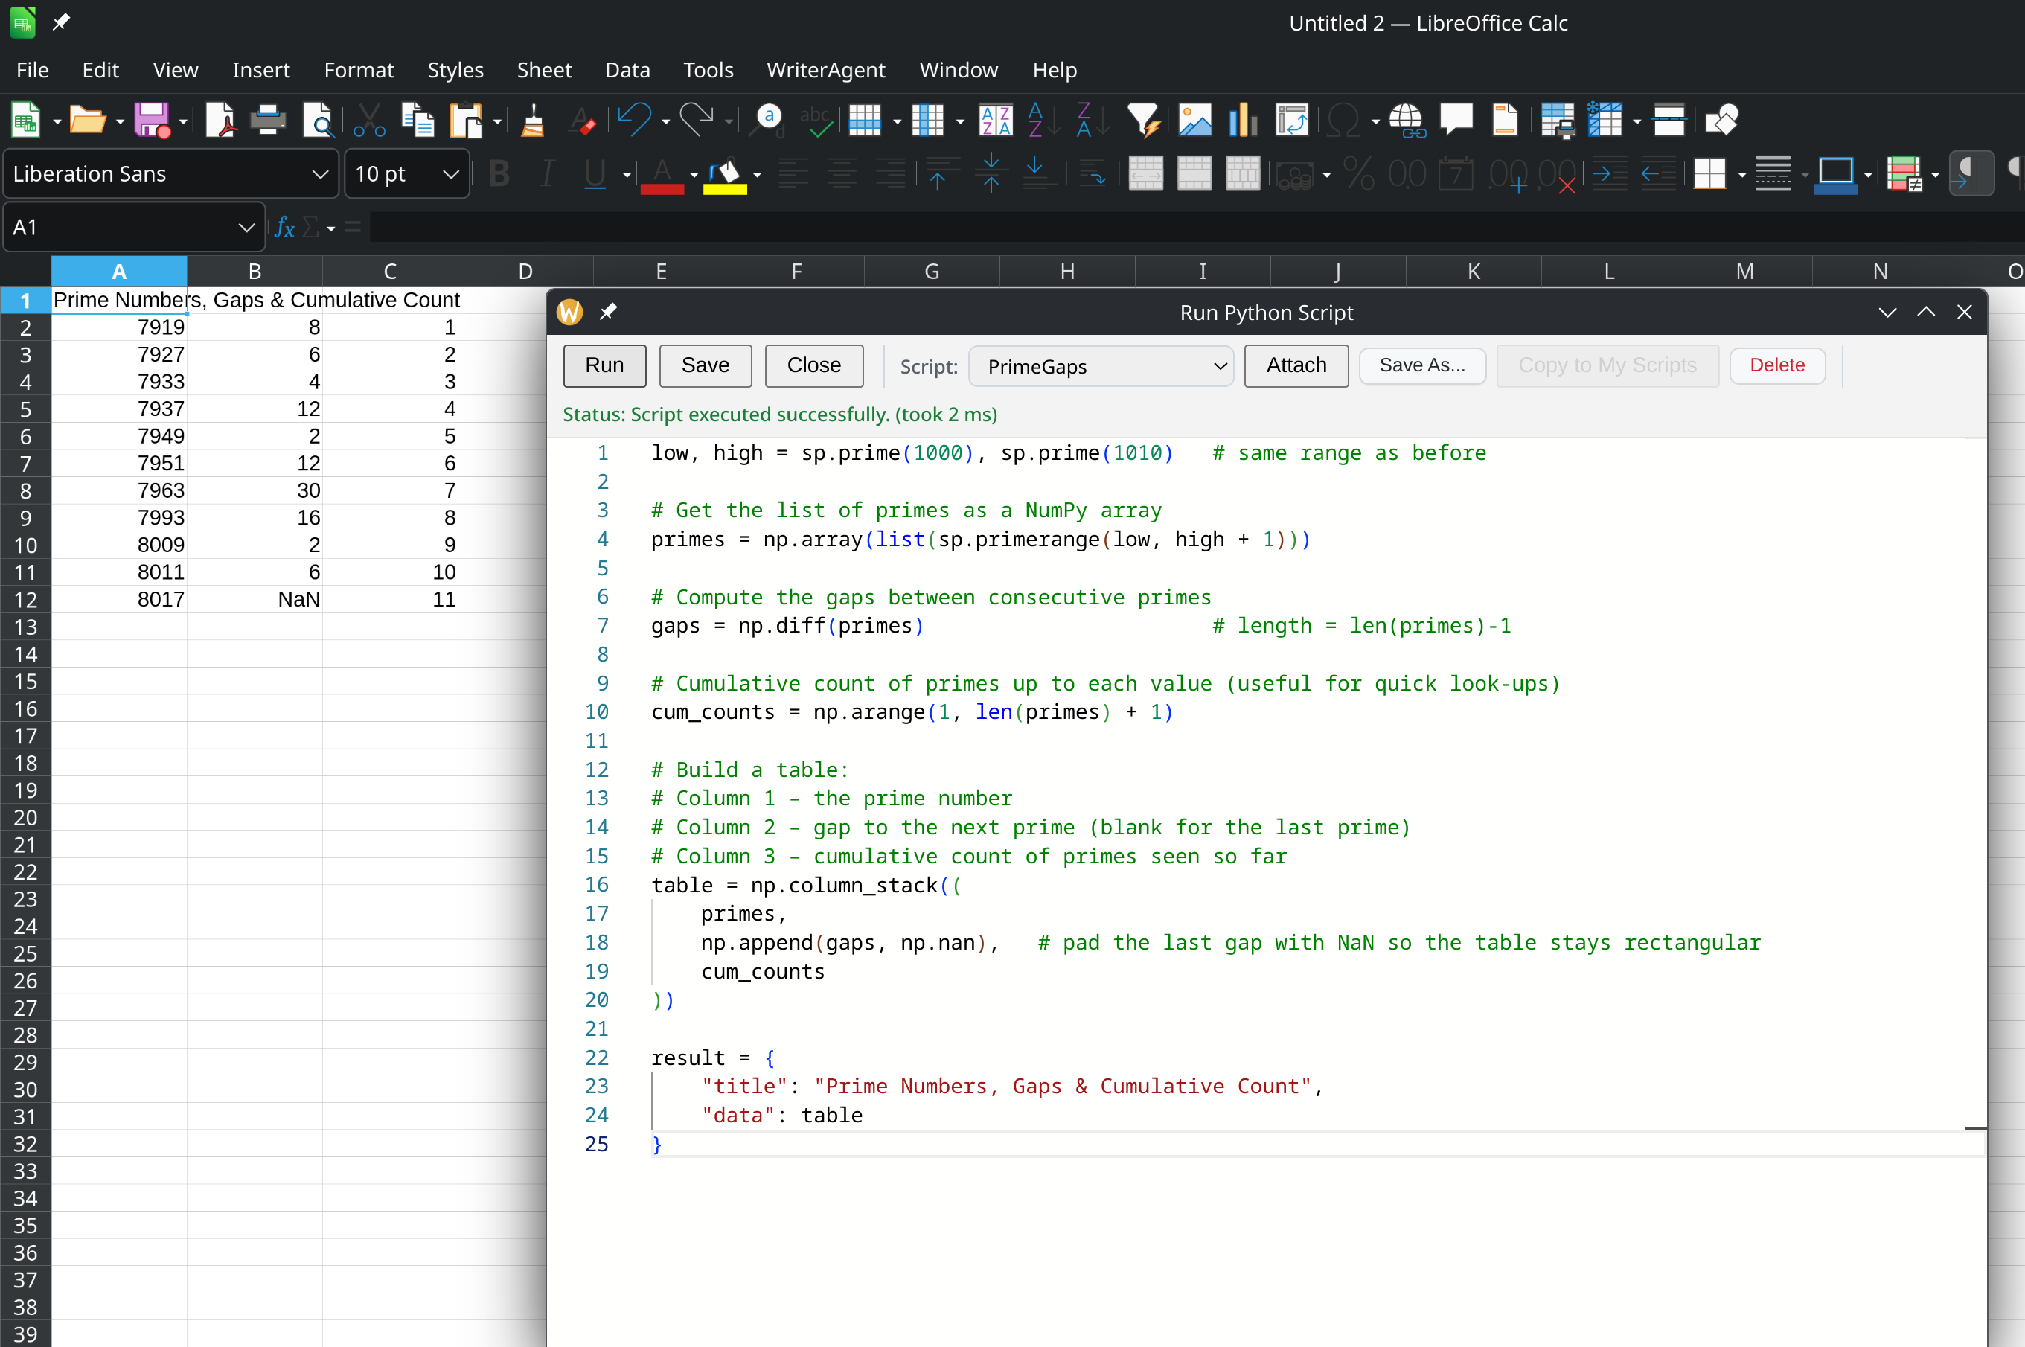
Once I had Python external communication working, adding a full-featured code editor with color-syntax highlighting was mostly a matter of exposing the same pipe to a new child: pywebview + the official Monaco bundle, which is bundled with the extension but runs in the user’s subprocess.
You can save any script to a personal scratchpad that lives in your WriterAgent JSON config file (so it travels with you across documents and machines). Or you can attach it directly to the current document so the script travels inside the .ods/.odt file itself.

Cross-Process Serialization
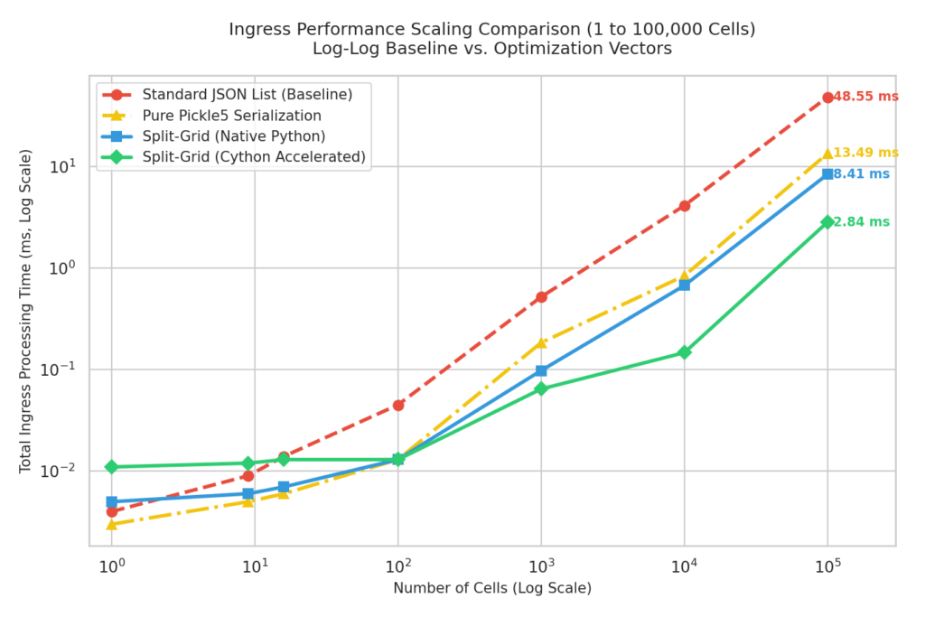
There’s overhead to send data to / from another process, so I spent some time optimizing it. I started with basic JSON: “((1.51321),(1514213.3),(5.14159))” which the receiving side has to chew through cell-by-cell. I soon realized that it’s much more efficient to have host pack the entire range into a single float64 array.later
Empty cells and strings become NaN, while the string values ride along in a dictionary keyed by their position. The whole thing gets wrapped in pickle protocol 5 and sent across the pipe. On the child side, where NumPy lives, np.frombuffer, plus a reshape turns that raw buffer into a proper ndarray in microseconds.
After profiling and optimizing the Python packing, I decided to try to implement the routines in Cython as an experiment. Cython is a variant of Python which can be compiled into native code. For most of WriterAgent (and every) Python codebase, the performance benefit from compiling the entire codebase to x64 wouldn’t even be noticeable. Most of the time, a well-designed Python program is running native code already. If your Python code is slow, it will be slow in C++ or Rust.
Serializing and deserializing 100,000 numbers takes about 50 ms with standard JSON, 12 ms with pickle (Python’s native binary serializer), and with the split-grid Cython version, it takes 1.3 ms. Microsoft sends all of your Python calculations to their servers in the cloud, so you’ll never get results in milliseconds, and if you aren’t connected to the Internet, they’ll never arrive.
Since I didn’t want to make binaries for Windows, Mac, x64, ARM, etc, I just setup some GitHub Actions using cibuildwheel to build all the necessary binaries for the different processors and Python versions. I don’t have to bother making binaries for those operating systems, GitHub will do it for free! At runtime the extension does a graceful fallback to the pure-Python if the native module is missing. The Settings -> Python -> Test button shows you whether Cython is active.
The 150 lines of Cython take 200KB per platform and Python version, but that is the first-time Cython tax. Any new functions will take a tiny amount of additional space. I’m not sure if I’ll find another reason to write native code, but it’s nice to have the infrastructure. For now it gives x64 Linux users a performance win while keeping the extension fully portable.

Thanks for reading! Try it out, and tell me what breaks, this is still early: https://github.com/KeithCu/writeragent
If you enjoyed this article, here are the rest in the series:
Week 1: Initial fork, sidebar chat, multi-turn tools, and async streaming
Week 2 & 3: MCP, research sub-agent, voice support, and evaluation dashboard
Week 4-6: State machines, formal verification, and specialized toolsets
Week 6 & 7: Async grammar checking and TeX import support

