# Physical Mockup — Automatic Plant Watering Elephant

## Summary

For this iteration, I focused on making the body fit real components, validating the watering logic on the bench  
  
Diagram of the Elephant Watering System Architecture

## Key Design Decisions

* Form + function together: the elephant trunk is a natural outlet for a water hose and makes the object approachable at home.
* Real dimensions: I adjusted the Fusion 360 model to actual parts—motor (≈3.5 cm), hose (0.8–0.9 cm) with a 9 mm trunk channel, and space in the hat for Arduino Uno (7.5×5.5 cm), a 9V battery, motor driver (4.5×2 cm), and moisture sensor board (4.5×2 cm).
* Safety and clarity: relay‑driven pump (external power) and logic that only waters on stable dry readings; the mockup makes wiring and behavior transparent.

## Current Implementation Progress

* 3D Design and Print: refined the body and hat in Fusion 360, split parts, added mounting holes; printed in PLA (0.2 mm layers, 15–20% infill). The body was printed on its side with tree supports. The motor mount inside the body reduces vibration and looks cleaner.
* Bench Electronics Test: Arduino Uno + relay + pump (5–6 V); capacitive soil sensor on A0. Calibration: dry ≈800, wet ≈380. Water ON at 30% moisture, OFF at 40%. Safety: 15 s max pump run and 10 min cooldown. Sampling used 1 sample/sec for testing; for real use I’ll target 30–60 s to save power.

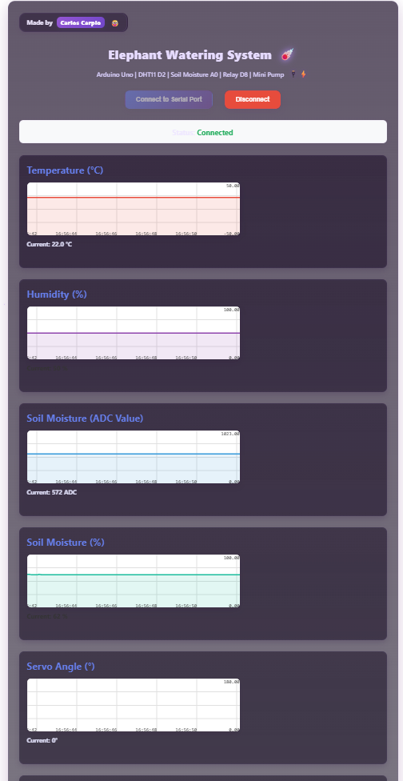  
Signals Plot

## Final Outcome of This Iteration

* A printed elephant body and hat that fit the tube, motor, and electronics.
* A clear, user‑facing paper UI that communicates the system state and actions.
* Verified watering logic on the bench: the relay/pump toggles automatically based on soil moisture percentage with safety limits.

## New Elements and Why They Improve UX

* Bigger trunk channel (9 mm) for better flow and easy hose fit.
* Stability‑based watering with time safety limits to prevent overwatering and motor stress.
* Rotating table

## Next Steps

* Install the real LCD and buttons (replace the paper UI).
* Integrate DHT11 to make watering climate‑aware.
* Run a 24–48 h moisture logging test and tune thresholds.
* Add a rotating base in the next version so the elephant can water multiple plants.