AstroMark — Research, Proposals and Recommendations
  - A symbolic notation and metadata format for annotating astronomical images
Greg Benson, with Claude Code
4 September 2026
Table of Contents

Status: nothing in this document has been adopted. Every recommendation is a recommendation for the team to accept, modify or reject. Where the evidence is thin, or the record is silent, the text says so rather than papering over it.
Companion artifacts: AstroMark-Research.pptx presents the same material as a 59-slide walkthrough; examples/ holds the code that generates every figure and number here, deterministic from a seed.

AstroMark — research
Design research for AstroMark: an open standard for annotating astronomical images, with a symbolic notation and a vector metadata format. Strong gravitational lenses first (astromark/lens/1.0), astronomy-general later.
Everything here is a proposal for team review. Nothing has been adopted. The recommendations are recommendations; where the evidence is thin or the record is silent, that is said rather than papered over.

Read in this order
 | file | what it is
1 | 00-executive-summary.md | the recommendation and what to decide, in two pages
2 | 03-notation-proposals.md | the symbolic notation — four proposals, rendered and measured
3 | 04-metadata-proposals.md | the metadata format — six proposals, encoded and measured
4 | 09-jwst-examples.md | worked examples on real JWST candidates, every mark derived from a recorded measurement
5 | 07-recommendation.md | the pick, the trade named, the migration
— | AstroMark-Research.pptx | the whole thing as a 59-slide walkthrough, for the team review
— | AstroMark-Research.docx | every document in this directory as one Word report — 91 pages, 15 figures inline, for reading and commenting
Supporting:
file | what it is
naming-study.md | why “AstroMark”, and the core-plus-profiles architecture (earlier study)
01-prior-art/ | how other fields solved this — medical imaging, computer vision, web standards, astronomy, notation design, accessibility
02-requirements.md | the requirement register, R1–R41, each traced to its source
05-accessibility-design.md | colour as reinforcement, and the automated test that proves it
06-llm-ergonomics.md | what the format costs a model to read and write
08-draft-spec/ | the recommended option written out, ready to implement or reject
examples/ | the reference cutout, every rendered arm, every encoding, and the tools that made them

The three questions Greg asked, answered
Should we consider accessibility — a notation that doesn’t rely on colour, with colour to help differentiate? Yes, and the reasoning changes the notation rather than just the palette. Role is carried by glyph shape, polarity by stroke texture; colour reinforces and never carries alone. This is testable rather than aspirational: of 136 pairs of marks that can share a panel, 123 are not reliably separable by colour under some vision condition, and zero are separated by colour alone. See 05-accessibility-design.md.
Can the symbols be concise but readable? They can be considerably thinner than today, but the measurement says the problem was misdiagnosed. The on-image legend plate is 3.7–6.6% of the panel — about half the total ink, and in most decks more than every arrow, circle and label combined. The fix is a territory rule, not thinner strokes: no ink inside the image rectangle that is not about a specific location in it, with the key moved to a caption band below. See 03-notation-proposals.md.
Can marks be resized to emphasise them? Yes, once you notice that some marks encode a measurement in their size — the ring radius is θ_E. So every drawn scalar is tagged METRIC or PRESENTATIONAL, and emphasis scales only the presentational ones. A ring can shout without its radius moving a pixel: emphasise the stroke, never the path.

Reproducing the numbers
cd examples
python make_reference_cutout.py # the synthetic scene, from a seed
python render_proposals.py # all seven arms
python measure.py all # metrics + contact, CVD, polarity and A/B sheets
python make_encodings.py # the same annotation in every metadata proposal
python make_jwst_examples.py --variants # the three JWST candidates + the six-panel case
python migrate_lensmark.py <deck> # convert a real lensmark/1.0 deck, and report what it costs
python cvd.py selftest # CIEDE2000 against Sharma et al. reference pairs
python cvd.py pairtest reference/marks-table.json # the accessibility gate
python embargo_check.py --spec # the model-facing spec against both protected corpora
cd .. && ~/.venvs/workshop/bin/python build_deck.py # rebuild the presentation
~/.venvs/workshop/bin/python build_docx.py # rebuild the Word report
Requires ~/.venvs/lensmark (PIL, numpy). Everything is deterministic from a seed.

Two notices
STScI embargo. The nine Hubble cutouts the project has been annotating are embargoed pending a public feature. Nothing derived from them is committed here: examples/internal/ holds those renders and is gitignored. The committed examples use a synthetic reference cutout that carries no embargo and can ship with the standard permanently.
Golden-grader embargo. Per reproductions/lensjudge/golden/README.md §EMBARGO rule 1, meeting transcripts may never reach a model-facing artifact. A notation spec is model-facing, so the draft spec in 08-draft-spec/ is written at mechanism level from the adjudicated enum artifacts, not from the transcript-quoting workshop prose, and is checked mechanically with ngram_check.py and the banned lexicon. The research prose in this directory is human-facing and cites the workshop reports by path.

Status of the evidence
Honest about what is measured and what is not:
- Measured: ink coverage, occlusion, stroke contrast, encoding sizes in characters, the colour-difference gate, the reference arms against real LensMark renders.
- Derived, not measured: token counts (no Claude tokenizer available offline; character ratios are reported, which is what the decision turns on).
- Not tested: whether image + coordinate metadata teaches a model better than an annotated PNG. That is Greg’s hypothesis on the record and remains open; 06-llm-ergonomics.md names the experiment that would settle it.
- Judgement, declared as such: which of the four notations to adopt. The measurements narrow it; they do not decide it.

Part I — The recommendation

Executive summary
AstroMark: the symbolic notation and the metadata format. Research, proposals and a draft spec, for the team to choose from. 2026-09-03.
Nothing here is adopted. Recommendations are recommendations; the measurements are real and reproducible; the gaps are named rather than smoothed over.

The recommendation in one table
 | Pick | Why
Notation | N1 Terminator alphabet, with N4 Evidence graph prototyped beside it | N1 keeps the arrow and costs least to adopt; N4 is the only one that fixes the defect that started this
Container | P1 evolved bespoke | the cheapest decision; converters are 57–161 lines
Identity | prefixed terms in one versioned vocabulary file that generates every other surface | this is where the real problem is
Model surfaces | read the compact line form, write JSON under a flat closed schema | the only arrangement that satisfies both the schema requirement and the token budget
Portrayal | out of the record, into a versioned style document | so no field can carry meaning through its appearance
First thing to build | the vocabulary file | the only artifact every proposal shares

Four findings that changed the design

1. The container barely matters; the vocabulary is everything
Every structural problem in the current format is a vocabulary-identity problem: the enums are defined in six uncoordinated places, θ_E is stored twice and kept in sync by a prompt rule, the estimation method is a free string, and what counts as a lens galaxy is decided by
def _is_deflector(label): return bool(label) and "deflector" in label.lower()
duplicated in Python and TypeScript — so a label reading spiral arm, NOT a deflector renders in the colour that means lens mass. Not one of these would have been prevented by GeoJSON, by Web Annotation, or by tables. Choose the container for cheapness; put the rigour in the vocabulary, where a CI check can hold it.

2. “Too heavy” was not about stroke width
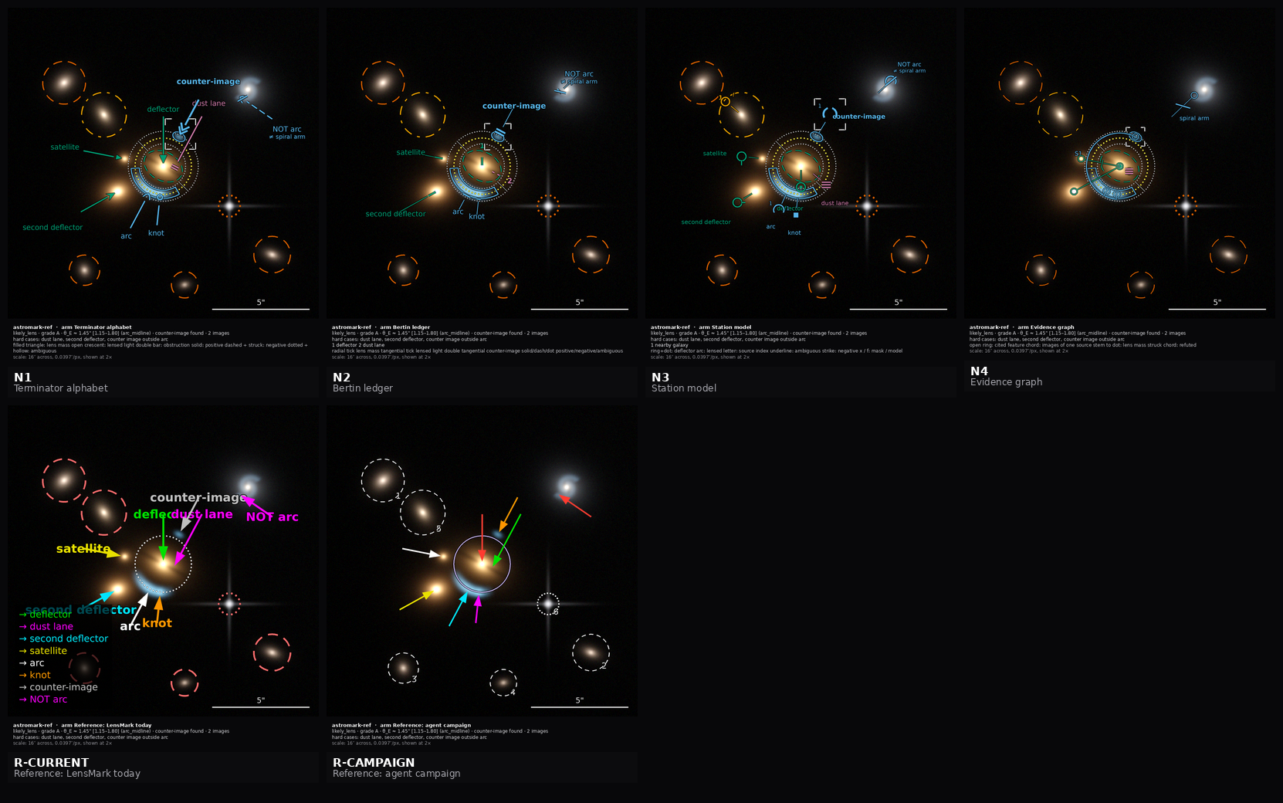
Every notation arm on the reference scene, with the two reference arms and the null arm. Normalised for how much each says, today’s notation costs 3.2x more ink per unit of meaning than the best candidate.
The on-image legend plate is 3.7–6.6% of the panel — roughly half the total ink, and in most decks more than every arrow, circle, ring and label combined. The annotations the room liked best are 3–8× thinner inside the image mainly because they moved the key below it.
That produces one rule that settles the apparent contradiction in the record between “labels go on the object” and “the legend obscured the image” — both true, and about different things:
No ink inside the image rectangle that is not about a specific location in that image.
Normalised for how much each notation actually says, today’s costs 3.2× more ink per unit of meaning than the best candidate, while expressing five fewer things.

3. Emphasis is a partition, not a multiplier
Greg asked for marks that can be resized to draw the eye. The obstacle is that some marks encode a measurement in their size — the ring radius is θ_E. So every drawn scalar is tagged METRIC or PRESENTATIONAL, and emphasis scales only the presentational ones. A ring at key gets heavier, closer-spaced dots and a stronger casing while its radius does not move a pixel.
Emphasise the stroke, never the path.

4. Accessibility is testable, and the test is worth having
Of 136 pairs of marks that can share a panel, 123 — ninety percent — are not reliably separable by colour under normal vision, deuteranopia, protanopia, tritanopia or greyscale. Zero are separated by colour alone, because role is carried by glyph shape and polarity by stroke texture.
The floor had to be calibrated rather than guessed: pure red against pure green still measures ΔE2000 = 12.9 under deuteranopia, almost all of it lightness, so a floor at 12 would wave through the canonical confusion. It is set at 15.

What exists now
Working code, all deterministic, in examples/: a synthetic reference cutout containing every hard case the notation must express (dust lane, second deflector, bound satellite, a counter-image farther out than the arc, a spiral arm that mimics an arc); a prototype renderer implementing all four notations plus two reference arms and a null arm; colour-vision simulation with CIEDE2000 verified against the Sharma et al. reference pairs; the measurement harness; and an embargo checker.
Figures: every arm rendered, contact sheets at three sizes, a polarity triad with all labels removed, and CVD sheets.
A draft spec in 08-draft-spec/: core, lens profile, render rules, an 80-term vocabulary across 10 schemes, and a generator that emits the JSON Schema, pydantic Literals, TypeScript unions and documentation from that one file, with --check as the staleness gate. The schema is flat (0 $ref) and closed, and the reference annotation validates against it.

Confidence
Measured and reproducible: ink, occlusion, contrast, encoding sizes in characters, the colour gate, the reference arms against real LensMark renders (R-CURRENT measures 6.23% against a real 6.4–10.8%; R-CAMPAIGN 1.99% against a real 1.2–2.3%).
Derived: token counts. No Claude tokenizer offline; character ratios are exact and are what the decision turns on.
Untested: whether image plus coordinate metadata teaches a model better than an annotated PNG. This is Greg’s hypothesis on the record, the format is partly designed around it, and it should be run before the format freezes. The experiment is cheap now that all the encodings exist.
Judgement, declared as such: N1 versus N4. The measurements rule out the status quo; they do not choose between two good candidates.

Six decisions for the review
- Notation: N1, N4, or N1 with N4’s source chord grafted in?
- Container: accept P1 plus prefixed-term identity, or spend the argument on the container?
- Do the six notation-independent changes land regardless? (2× render; METRIC/PRESENTATIONAL tagging; the emphasis enum; annulus keep-out in the label solver; demotion-to-index; the caption band.) I would say yes.
- Is the read/write asymmetry acceptable, given it means two surfaces and a round-trip test?
- Does polarity need a fourth, neutral value for a dust lane — a real feature that neither supports nor refutes? (This surfaced while building the reference annotation and is not in the workshop record.)
- Who runs the few-shot experiment, and does the freeze wait for it?
Start with the vocabulary file either way. It is the part that is not in dispute.

Part II — What the format must do

Requirements register
Status: consolidated 2026-09-03 from the workshop record, the LensMark codebase, and the annotation campaigns. Every row traces to a source. Nothing here is new invention.
Sources, by shorthand: W04 workshops/2026-08-31-LensMark/04-annotation-standard.md (the standard as discussed) · W02 .../02-inspection-method.md (the evidence hierarchy) · W03 .../03-hubble9-rounds.md (the five annotation rounds) · W10 .../10-decisions-actions-open-questions.md · PROP .../analysis/proposals.json (43 adjudicated proposals in groups contract_schema, propose_prompt) · CODE apps/LensMark/ as it stands · CAMP the Fable annotation campaigns.

A. What the notation must be able to SAY
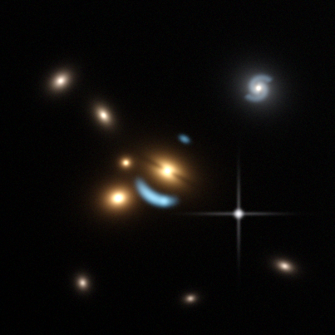
The synthetic reference scene. Built to contain every case the notation must express: a dust lane across the deflector, a second deflector, a bound satellite, a counter-image farther out than the arc, and a spiral arm that mimics an arc. Reproducible from a seed; no embargo.
# | Requirement | Source | Today
R1 | A controlled role vocabulary, orthogonal to the display label — ~17 lens roles | PROP contract_schema-01 (P0) | free-text label, 40 chars, matched by substring
R2 | Lens mass is never a lensed image. deflector / second deflector / satellite are one family | W04 §2.1 | one deflector assumed
R3 | Polarity: positive / negative / ambiguous, as a typed field — on the roles that can bear on the claim, and absent on those that cannot | PROP -02, -03 (P0/P1) | polarity only in label wording
R4 | An alternative enum naming the non-lens reading, required when polarity ≠ positive | PROP contract_schema-03 | absent
R5 | Source grouping — these marks are images of one source; a system may have two sources | PROP contract_schema-13 | inexpressible
R6 | An unpaired but definitely-lensed feature is still marked | W04 §2.1, PROP propose_prompt-03 | second arc left unmarked
R7 | A secondary ring around a second deflector | W04 §2.5, PROP contract_schema-09 | “exactly one ring” — inexpressible
R8 | A dust lane inside the deflector, recorded as a hard case and not as evidence against lensing | W04, PROP propose_prompt-02 (P0) | no label, no rule
R9 | hard_case tags for the morphologies that are still lenses | PROP contract_schema-11 (P0) | absent
R10 | Mask treatment: cut out, or fit as its own light component | PROP contract_schema-15 | all masks identical
R11 | Never-mask rule: the deflector’s halo and bound satellites are lens mass | W04 §2.8 | a satellite can be masked
R12 | Segmentation polygons, lens light versus lensed light, with asymmetric tolerance | W04 §2.9, PROP contract_schema-20 | no polygon type
R13 | Counter-image search status: found / not found / not searched | PROP contract_schema-10 | unrecorded
R13 deserves emphasis: “no counter-image found” must be distinguishable from “did not look”. That is a three-valued absence, and in a structured-output schema a null and a missing key are the same thing to many model outputs — so it has to be an explicit enum member.

B. Measurement
# | Requirement | Source | Today
R14 | θ_E is a radius, never a diameter | W04 §2.5 | correct, undocumented
R15 | The ring is centred on the deflector’s light and follows the deflector mark if it moves | PROP contract_schema-06 | center_ref exists, lint-only
R16 | Radius = the radial midpoint of the main image, not its edge and not half the separation | PROP contract_schema-06 | prompt makes half-separation primary — not the room’s convention
R17 | Explicit lower / upper bounds replace the disowned term alt | W04 §2.5, PROP -07/-08/-09 | alt_arcsec; two decks carry (alt) rings
R18 | A coded estimation method, not a free string | PROP contract_schema-08 | free string
R19 | A measurement lives in exactly one place. | audit | θ_E stored twice, unlinked, synced by a prompt rule
R20 | The expected radial ordering is a guide, never a rejection ground — a counter-image may lie farther out than the arc | W02 L3 | absent

C. Portrayal, and its separation from the record
# | Requirement | Source | Today
R21 | Marks are a vector overlay, never burned into pixels | W04 §2.7 | satisfied; purpose unstated
R22 | Colour must not carry meaning alone; role by shape, polarity by texture | PROP contract_schema-05, WCAG 1.4.1 | green = deflector, enforced by substring match
R23 | Thin but legible; the overlay must let the image through | W04 §2.3 | 6.4–10.8% ink; the legend plate is ~half of it
R24 | Resizable for emphasis, without disturbing any measured size | Greg, 2026-09-03 | no emphasis channel
R25 | Labels on the object; the key below the image, once per sheet | W04 §2.3 + CAMP | legend on by default, plate on the image
R26 | Deterministic render: same document → byte-identical PNG | CODE, 9 golden SHA-256s | satisfied
R27 | Portrayal is a versioned artifact, not inlined per file | audit | the whole style table is copied into every file (10.4%)

D. Provenance, review, process
# | Requirement | Source | Today
R28 | Every mark records who or what made it, at what effort, in which run | CODE | satisfied
R29 | A reviewer verdict per mark, with the edit delta, through propose→critique→accept | CODE | satisfied
R30 | RA/Dec travels with the annotation, recorded once per image | W04 §2.6 (D2) | optional and absent from all nine decks
R31 | Item geometry stays image-relative, because modelling consumes image-centred offsets | W02 L0 | satisfied
R32 | The arcsec scale must be supplied and its provenance recorded | W04 §2.7 | satisfied (scale_source: assumed)
R33 | Multiple renderings of one cutout share one geometry frame | PROP contract_schema-21 | one image per cutout

E. Machine and governance
# | Requirement | Source
R34 | Models emit under a flat, closed JSON Schema — no $ref | CODE, tested
R35 | A 50-example few-shot payload must be affordable | W10 A11
R36 | Free text for people, stripped for models — provably, by a closed key allow-list | golden README §EMBARGO rule 1
R37 | One generator for the vocabulary; adding a term must touch one file | audit: six uncoordinated copies
R38 | A general core plus domain profiles; the lens vocabulary is not in the core | naming-study.md
R39 | A core-only reader must degrade gracefully on an unknown profile | R38
R40 | Round-trip with the existing exporters: COCO, DS9, masks, few-shot | CODE (57–161 LOC each)
R41 | The spec must be usable standalone by a model — every semantic rule in the document, not only in a prompt | W10 D18

F. The two hard constraints
The embargo. reproductions/lensjudge/golden/README.md §EMBARGO rule 1: Xiaosheng’s free text, explicitly including meeting transcripts, may never be quoted, paraphrased or summarised into any model-facing artifact — prompt, rubric, exemplar, or trace. A notation spec is meant to be handed to a model, so every sentence of the spec must be mechanism-level. Enum names, geometry rules and procedure ordering are mechanisms and are fine. Wording is not.
This is why R36 matters structurally rather than as hygiene: if free text and semantics can share a field, “strip the free text” is a judgement call. If they cannot, it is a key allow-list and the guarantee is by construction.
Verification: workshops/2026-08-31-LensMark/build/ngram_check.py (4-gram against the transcript turns) plus reproductions/lensjudge/golden/banned_lexicon.txt (298 entries).
STScI. The nine Hubble cutouts are embargoed pending a public feature — internal only, never published or uploaded. Hence the synthetic reference cutout: it carries no embargo, is reproducible from a seed, and can ship with the standard permanently. Renders over the real nine live in examples/internal/, which is gitignored.

G. What the record does not settle
Carried forward honestly, because a spec that pretends these are decided would be wrong.
- The nominal ring’s colour — grey in Xiaosheng’s prompt sequence, white in LensMark, green in one campaign round. The adjudicated proposals fix only the bound rings. Open.
- The A/B/D grade boundaries. Grade C is defined on the record; A, B and D are not. W02 calls this the largest hole in the capture.
- The few-shot payload format, and Greg’s hypothesis that image + coordinate metadata beats an annotated PNG. Untested. 06-llm-ergonomics.md prices the encodings but does not test the hypothesis.
- Whether the live marker offsets were systematic — a renderer-side question nothing addresses.
- The p_lens bands in the adjudicated proposals are the distiller’s proposal for consistency, explicitly not values from the room. They need ratifying.
- Which roles polarity applies to — now settled, and worth recording how. The first draft made polarity mandatory on every mark. That is wrong, and the counterexample is not an edge case: a field star or a masked galaxy asserts nothing for or against lensing, and in a real deck 82% of items are mask circles. Forcing them to be positive made that value mean two things at once. The fix is in the vocabulary, not the schema shape: each role carries takes_polarity, and polarity is required where it is true and must be absent where it is false. Eleven of the twenty marks in the reference scene carry polarity; the other nine are inventory or measurement. A fourth “neutral” value, and a split into separate presence and bearing axes, were both considered and rejected — presence does not vary here, and where it genuinely does it is already carried better by counter_image: found | not_found | not_searched at system level. Neither the fault nor the fix is in the workshop record; both came out of building the reference annotation and then being challenged on field objects.

Part III — How other fields solved this

Prior art: how other fields solved this
Sixty-six formats surveyed across eight domains — radiology, medical vocabularies, computer vision, web and geospatial standards, astronomy overlays, astronomy metadata, notation-design theory, and accessibility. Primary sources wherever they could be reached.
file | domain
medical-imaging.md | DICOM SR, GSPS, RT Structure Sets, SEG, and NCI AIM — the closest and most instructive prior art
vocabularies-and-grading.md | RadLex, RadElement, BI-RADS / Lung-RADS / PI-RADS, SNOMED, IHE MRRT, OME-Zarr
astronomy-overlays.md | DS9 regions, CRTF, astropy regions, Aladin/JS9/Firefly, Zooniverse, Space Warps, Galaxy Zoo
astronomy-metadata.md | AVM, FITS/WCS, IVOA (VOTable, VOEvent, MOC, DALI, UCD), SIMBAD/CDS
notation-design.md | Bertin, WMO station model, FGDC geologic symbols, ISO 19117 and 7010, chart symbols, SMuFL, blazon, chess
computer-vision-and-web.md | COCO, VOC, CVAT, Label Studio; W3C Web Annotation, IIIF, SVG, OGC SE, GeoJSON
accessibility.md | WCAG, CVD simulation models, Okabe-Ito and Tol palettes, cartographic legibility

Convergences
Mechanisms that unrelated domains arrived at independently. The synthesis found each of these in between six and ten of the eight domains — a rule invented separately by radiologists, cartographers, the IVOA and citizen-science engineers is not optional.

1. A term is an opaque code; the display string is documentation
DICOM states it normatively: Code Meaning is non-normative, identity is scheme + value. RadElement mints RDE1695.2 and treats the display name as a mutable annotation. Galaxy Zoo 2 keeps t01.a01 stable while the question wording changes. Zooniverse learned this the hard way — its export stores the answer display string "Yes" rather than an answer id, so rewording a button silently changes the meaning of every historical record.
DICOM states it normatively, and then closes the obvious loophole in the very next sentence:
“the Value of Code Meaning (0008,0104) shall never be used as a key, index or decision value, rather the combination of Coding Scheme Designator and Code Value may be used. Code Meaning is a purely annotative, descriptive Attribute.” … “This does not imply that Code Meaning can be filled with arbitrary free text.” — PS3.3 §8.3
Seven domains, one answer. The current LensMark design — identity is the 40-character English label, tested by substring match — is precisely the anti-pattern that sentence exists to forbid.

2. Portrayal lives outside the record, keyed by term
DICOM GSPS is a separate instance referencing images. OME-Zarr keeps image-label.colors parallel to the labels. ISO 19117 exists solely to separate data from portrayal. CRTF partitions with a single token: any line beginning ann is display-only and never reaches measurement.
The most damning instance is internal: DS9 got this wrong for regions and right for catalogues in the same application. A DS9 region line is 38 characters of geometry and 106 characters of portrayal — 74% drawing instructions — while the DS9 Catalog Tool’s Symbol Editor stores rules evaluated against the data ([string equal $Class SNR] → diamond, red) and no row stores a colour.
The root cause is worth naming, because it generalises: a DS9 region file is a serialization of what is on the screen, not a record of what is true. Six separate defects follow from that one framing, and each is a correct decision for a screen dump. See astronomy-overlays.md §1.

3. Geometry and semantics are two objects joined by a stable id
Medicine settled this three separate times over thirty years: RT Structure Set (1997) splits one region across three sequences joined by an integer key; AIM (2008) made the split its founding thesis; DICOM SR does it with relationship types. Zooniverse reached the same place in 2020 via ADR-25, having shipped the nested version first and measured the pain. IHE MRRT does it. JS9 does it in miniature with parent/child.

4. Never join by ordinal index
The corollary, and the trap that catches everyone. Zooniverse’s ADR-25 diagnosed positional indexing as the bug — and then replaced it with markIndex, still an ordinal into the value array, so deleting mark 1 silently reassigns every downstream answer. Galaxy Zoo 2 embedded the human slug in its column names, so rewording a question would rename every column.
Use a stable opaque id. Hold the display string separately.

5. Absence and uncertainty are coded values, never nulls
DICOM CID 240 is exactly three codes: Present, Absent, Undetermined — and AIM’s boolean isPresent is the recorded counter-example, because a boolean cannot say undetermined. RadElement goes to four: present, absent, indeterminate (assessed, cannot decide), unknown (not assessed). WMO code table 2700 distinguishes 9 = “sky obscured” from a missing observation. Galaxy Zoo 2 makes “no bulge” a first-class answer with its own column rather than an empty cell.
This is the answer to counter_image: not_found versus not_searched, arrived at independently by three fields.

6. Version the vocabulary separately from the schema; retire, never delete
DICOM PS3.3 §8.11 requires receivers to keep recognising retired codes. RadLex Playbook runs a four-value lifecycle with a TRIAL tier and a written policy that historical codes are never overwritten. SNOMED records replacements as typed links — same as, replaced by, possibly equivalent to — because “this term was replaced” and “this term was a duplicate” are different facts. Zooniverse stamps every record with workflow_version and filters by version range.

7. The rich canonical form needs a flat companion, or it does not get written
Seven domains — and in four of them the flat companion is what actually shipped. dcmqi’s authoring JSON over DICOM SR; IVOA’s desise flat JSON over Turtle; DALI’s numeric arrays over STC-S. This is independent confirmation of the read/write asymmetry in 06-llm-ergonomics.md, reached by four standards bodies before this project thought of it.

8. Generation provenance is three-valued
DICOM reuses AUTOMATIC / SEMIAUTOMATIC / MANUAL with identical glosses across four different objects. The middle value is the one everyone omits and everyone needs.

9. Redundant achromatic encoding, in the data model
DICOM Graphic Layers carry a greyscale value and a CIELab colour as paired recommended display values — since ~1999, and DICOM retired its RGB attribute in favour of device-independent CIELab in 2004. FGDC assigns dash pattern to locational accuracy independently of colour. WCAG 1.4.1 states the rule normatively.
Astronomy has no prior art here at all — not one region format addresses colour-vision deficiency, and DS9 and CRTF both default everything to green — but the channels (point shapes, dash patterns, line widths) exist and round-trip through every implementation.

Where the domains genuinely disagree
How heavy should term identity be? DICOM’s four-field coded entry, RadElement’s opaque numeric RDE1695.2, or a prefixed string lens:arc. The triple is the most rigorous and the most verbose; 04-metadata-proposals.md takes the middle path, and §8 of medical-imaging.md explains why the full apparatus is the thing that killed the one project that tried it.
Should a grade be stored or derived? BI-RADS stores an assessed category. PI-RADS derives the overall category from component scores via a published lookup table, storing the evidence rather than only the verdict. For a project trying to make two annotators grade alike, the derived model is the stronger one — and it is the direct answer to the undefined A/B/D boundaries.
Nest or flatten? Computer-vision formats nest semantics inside the annotation; medicine and citizen science both moved away from nesting after shipping it. The cost of flattening is that a model emitting the document must keep two id spaces consistent.
Is colour record or portrayal? Everyone says portrayal — except AVM, whose Spectral.ColorAssignment records that a given data channel was mapped to blue when the picture was made. That is not a contradiction, it is a distinction AstroMark does not currently make: the colour of a mark is portrayal, but which band became which channel in the underlying rendering is record, and belongs with the image metadata. Worth fixing before circulation.
How many kinds of doubt are there? FGDC insists on two orthogonal axes, and its standard exists because the field’s informal terms “have not been always clear whether they reflect uncertainty in a feature’s scientific interpretation, its mapped location, or both.” AstroMark has a channel for the first and none for the second.
Expressiveness versus emittability — the deepest conflict, and really an argument about who writes the file. DICOM SR, AIM, STC-S and SLD/SE all say model the domain properly. GeoJSON, DALI and desise all say close the vocabulary and refuse extension. When the writer is a language model under a schema, the second camp wins.

The finding that sharpened a definition
RadElement separates presence (present / absent / indeterminate / unknown) from the term itself, which prompted the question of whether AstroMark’s polarity was conflating is this feature really there? with does it bear on the lensing claim?
On examination it is not conflating them, and the two-axis answer is the wrong lesson to draw. Presence does not vary in this domain: a mark exists because an annotator drew it. Where presence genuinely does vary it is already carried, better and at the right level, by counter_image: found | not_found | not_searched — a fact about the search, not about a mark.
What the objection did correctly expose is narrower and real: polarity was being demanded of roles that cannot bear on the claim at all. A field star or a masked galaxy asserts nothing for or against lensing, and in a real deck 82% of items are exactly that. The fix is takes_polarity on each role in the vocabulary — required where true, forbidden where false — rather than a fourth value or a second axis. See 02-requirements.md §G.6.

Two warnings worth carrying to the review
A correct design does not win by being correct. DICOM GSPS has been the right answer since 1999, is supported by every PACS, and lost in practice to burning annotations into a flattened image because that was easier. If AstroMark’s overlay path is harder than exporting a PNG with marks drawn on it, people will export the PNG.
A well-designed standard with no maintainer dies anyway. The synthesis counted eight documented deaths across five domains, and every one of them was well designed — AIM’s reference repository archived with its last substantive commit in 2014; ACR Assist; STC-S never ratified after seventeen years. What they lacked was a maintainer, an encoding, a conformance suite, or worked examples. For a three-person group that is the governing risk, and it is an argument for the smallest mechanism that holds rather than the most correct one.
Space Warps encoded “not a lens” as the absence of markers. In a strong-lensing citizen-science project — the nearest possible neighbour to this work — a volunteer placing no marks was the rejection. The reasoning behind a negative was never recorded, only its outcome. That is the same gap the workshop identified in the current annotations, reached independently, and it is the strongest argument for making negative evidence a first-class mark.

Prior art: radiology and medical imaging
Greg asked whether other fields have notations for image markup, “like in radiology”. They do, and medicine solved this problem thirty years ago — thoroughly enough that most of AstroMark’s open questions have a settled answer here. It also contains the single most instructive failure in the survey.

1. The coded entry: a term is never a string
The foundational move. In DICOM, every semantic term is a coded entry of three mandatory fields plus an optional version:
field | tag | role
Code Value | (0008,0100) | the opaque, stable identity
Coding Scheme Designator | (0008,0102) | which vocabulary it comes from
Code Meaning | (0008,0104) | the human-readable string
Coding Scheme Version | (0008,0103) | optional
And the rule that makes it work is normative, in the standard’s own words, with the loophole closed in the next sentence:
“the Value of Code Meaning (0008,0104) shall never be used as a key, index or decision value, rather the combination of Coding Scheme Designator (0008,0102) and Code Value (0008,0100) … may be used. Code Meaning (0008,0104) is a purely annotative, descriptive Attribute.” … “This does not imply that Code Meaning (0008,0104) can be filled with arbitrary free text.” — PS3.3 §8.3
Identity is scheme + value; the English string is documentation. Two systems that disagree about the wording still agree about the concept.
Compare the current LensMark position, where identity is the English string and is tested by substring match. Those two designs differ as a vocabulary differs from a convention.
Versioning. The code is never versioned; the list it was drawn from is. Context Identifier + Context UID + Context Group Version + Mapping Resource travel with the instance, so a reader can reconstruct which vocabulary was in force when the record was written. That is “grade B meant something different before v0.4” as a runtime mechanism instead of a documentation promise.
Local extension without forking. Coding Scheme Designators beginning 99 are reserved for private schemes, and a Context Group Extension Flag makes a local addition self-declaring. A survey can add its own terms and remain readable.
Deprecation. PS3.3 §8.11, “Retired Codes and Expected Behavior”: retired codes may still be sent and receivers are expected to keep recognising them. A term is never deleted, because deleting one silently changes the meaning of every record that used it.
One source, many artifacts. PS3.16 is authored once in DocBook, and every context group page ships generated exports — HTML, FHIR JSON, FHIR XML, IHE SVS XML — plus a stable keyword. This is the “single generator” principle at standards-body scale, and it is the model for 08-draft-spec/generate.py.

2. GSPS: portrayal as a separate object
A Grayscale Softcopy Presentation State is a separate instance with its own identity that references images. The pixels are never modified. This is the overlay-not-burned-in rule, standardised around 1999.
Two details worth stealing outright:
Meaning rides on a Graphic Layer, not on colour. A layer carries an id, an order, a description and two recommended display values — a greyscale value and a CIELab colour. Redundant achromatic encoding is not an accessibility afterthought here; it is in the data model. DICOM also retired its RGB attribute in favour of CIELab in 2004, so “the same red” means the same red on two monitors.
Compound graphics carry their own fallback. A semantic mark must ship an alternate rendering in primitive shapes, linked by the same instance id. A renderer that understands the semantic type draws it richly; one that does not still draws something correct. For AstroMark the Einstein-radius circle is a compound graphic in exactly this sense — a measurement whose pixel radius is computed, not drawn.

3. Where the measurement lives
TID 300: a measurement is a single numeric content item whose concept name is the coded quantity, whose value carries a UCUM coded unit, with method as a coded modifier hung off the same node and asymmetric uncertainty in a dedicated context group.
The part that matters most for AstroMark is the direction of derivation:
The number is primary, and the geometry is INFERRED FROM it. The shape is a witness, not a second copy.
That is precisely the fix for θ_E being stored twice and kept in sync by a prompt rule. Put the measurement on the finding; let the drawn circle be derived.

4. Negation and uncertainty are coded values
CID 240 “Present-Absent” is non-extensible and has exactly three codes: Present, Absent, Undetermined.
AIM had isPresent as a boolean on its observation entity — the right instinct, the wrong type, because a boolean cannot say “undetermined”. DICOM’s three-valued coded version is strictly better, and the standard even records the earlier version it fixed.
There is more: a numeric value may be replaced entirely by a qualifier code — “not a number”, “measurement failure”, “value out of range” — so a failed measurement is recorded as a failure rather than as a missing field or a zero.
And TID 1500’s “Qualitative Evaluations” container holds coded questions with coded answers, which makes “Is this an arc?” → “No — spiral arm” structurally identical to the positive case.
This is the answer to negative evidence, and it is better than what any astronomy format offers.

5. Two identities per mark
DICOM carries both a Tracking Identifier (this mark) and a Tracking Unique Identifier (the physical thing this mark is of), replicated onto GSPS graphic objects and SEG segments.
Grouping is then emergent: four marks that share a tracking UID are four images of one object, and the same mechanism links marks across files, sessions and observers. Many-to-many works without contorting the document into a graph. This is a better answer than AstroMark’s current source tag, and it generalises to comparing two annotators’ marks on the same feature.
The honest caveat from practice: DICOM’s tracking ids are frequently left empty, because something has to propose the shared identity when a human draws the second image. It is a tooling obligation, not a schema one.

6. Provenance on four independent axes
DICOM keeps these separate and never collapses them: who observed (person or device, inheritable and overridable per mark), how it was made, what produced it (algorithm name, version, parameters), and what it superseded (predecessor documents — correction is a new instance citing the old, not an in-place edit).
The “how” axis is three-valued: AUTOMATIC, SEMIAUTOMATIC, MANUAL.
That middle value is the one people always forget and always need. A model-proposed arc that a human nudged is neither machine-made nor hand-made, and with a two-valued enum it is mislabelled forever.
This is a real gap in the current design. LensMark’s created_by.kind plus status: edited covers it by accident; making it explicit is cheap and it is exactly the propose-then-correct workflow the project runs.

7. Factoring the long tail
DICOM’s bulk annotation model requires — mandatorily — that a group of near-identical marks factor out their commonality: one shape type, one property code, one generation method, then bulk coordinate arrays. Re-stating the shared fields per mark is illegal.
A cutout with two hundred field galaxies to mask costs an order of magnitude fewer tokens this way. Directly relevant to the few-shot budget in 06-llm-ergonomics.md.

8. The cautionary tale: AIM
NCI’s Annotation and Image Markup got the central abstraction exactly right and died anyway.
AIM’s founding thesis is the record/portrayal split this project has independently arrived at: markup is the graphical symbols placed over an image; annotation is the explanatory information about the pixels. That is the correct architecture, stated clearly, in 2008.
It is dead. The reference implementation repository is archived; its last substantive commit was 2014-04-29.
Three verifiable reasons, each a warning:
It violated its own thesis in its own schema. GeometricShapeEntity — the markup class, the one that was supposed to carry no meaning — carries lineColor, lineOpacity, lineStyle and lineThickness. The standard that invented the separation put portrayal on the geometry object anyway. If the schema permits it, it will happen.
It made every relationship its own class. The AIM 4.0 schema has 124 complex types, of which 58 are …Statement classes, with names like ImagingObservationEntityIsIdentifiedByTwoDimensionGeometricShapeEntityStatement. Expressiveness paid for with an unwritable surface.
It imported ISO/HL7 datatype machinery because it looked rigorous. Every scalar became an ISO 21090 type requiring a companion schema. The ceremony exceeded what its users would carry.
This is the sharpest evidence for the recommendation in 07-recommendation.md to take P4’s term identity and leave P4’s ceremony. The coded-concept architecture is right. The full apparatus is what killed the one project that tried it.

9. Two more failures worth naming
RT Structure Set: the optional coded field loses to the required free-text one. In the most widely deployed structured annotation object in medicine, ROI Name is Type 2 — must be present, may be empty, free text — while the coded semantics are Type 3, optional. Predictably, the name became the de facto key and downstream systems match on it.
That is the LensMark substring-match bug, in a thirty-year-old international standard, for the same structural reason: whichever field is mandatory becomes the identity, regardless of what the designers intended.
GSPS is excellent and under-used. It has been in the standard since ~1999, is supported by essentially every PACS, and is the right design. The workflow that dominates in practice is still burning annotations into a flattened capture image, because it is easier and every viewer can show it.
A correct design does not win by being correct. If AstroMark’s overlay path is harder than exporting a PNG with the marks drawn on, people will export the PNG. The three-file contract has to be the path of least resistance, not the virtuous one.

10. What to take
take | from
Term identity is scheme + opaque code; the human string is non-normative | DICOM coded entry
Version the context group, not the code; retire, never delete | PS3.3 §8.11
Reserve a prefix for local terms so a survey can extend without forking | 99-prefixed schemes
One authored source generating every downstream artifact | PS3.16 → HTML / FHIR / SVS
Portrayal is a separate, referenced, versioned object | GSPS
Ship a greyscale value beside the colour, in the data model | Graphic Layer’s paired display values
A semantic mark carries a primitive fallback rendering | Compound Graphic Sequence
The measurement is primary; the drawn shape is inferred from it | TID 300
Presence is three-valued and coded, never a boolean | CID 240
Two identities: this mark, and the thing it is of | Tracking Identifier / Tracking UID
Generation method is three-valued: automatic, semiautomatic, manual | SR observer context
Factor near-identical marks; forbid restating shared fields | bulk annotations

avoid | evidence
Declaring a record/portrayal split and then putting style on the geometry object | AIM 4.0’s own XSD
Expressiveness that produces an unwritable surface | 58 …Statement classes
A mandatory free-text name beside an optional coded one | RT Structure Set
Assuming a correct overlay design will be adopted because it is correct | GSPS vs burned-in captures

Prior art: controlled vocabularies and graded assessment
Medicine’s semantic half, as distinct from its geometry half. This is where the answer to AstroMark’s undefined grade boundaries lives.

1. Term identity and lifecycle
RadElement mints a permanent code for every enumerated value, derived from its parent term’s id plus an ordinal assigned at first registration: RDE1695.2 = “indeterminate”. Documents store the code; the display name is a mutable annotation on it.
Three independent clocks, never conflated:
clock | what it versions
a monotonic integer per term | that term changed
a lifecycle status per term, with its own date and a preserved history array | where that term is in its life
a semver version for the format | the grammar changed
RadLex Playbook runs a four-value lifecycle with a TRIAL tier and a written policy: historical codes are never overwritten or deleted; TRIAL codes may change without notice; anything else needs committee approval. A trial tier is what lets a three-person group add a term without committing to it forever — directly applicable to the provisional status in the draft vocabulary.
SNOMED records replacement as a typed link, not a bare pointer, and three types cover almost everything: same as (it was a duplicate), replaced by (one unambiguous successor), possibly equivalent to (the old term was vaguer than any new one). “This term was replaced” and “this term was a duplicate” are different facts and a single replaced_by field cannot tell them apart.
RadElement also defines a legal, obviously-provisional identifier form — TO_BE_DETERMINED123 — that an author or model may emit before the registry has assigned a real id, documented as being rewritten on registration. That is a neat answer to “what does a model write when it needs a term that does not exist yet”, which otherwise becomes a free-text leak.

2. Graded assessment — the answer to the grade problem
BI-RADS defines its scale as a three-column table:
ordinal category | numeric probability band | the specific next observation that would settle it |
plus a published expected prevalence for each grade, and it keeps “incomplete / cannot assess” as a category of its own rather than a missing value.
That is precisely the shape the workshop record is missing. Grades A–D are used but only the borderline class has a definition, “what would confirm it” lives in prose, and there is no expected prevalence to check a grader against.
PI-RADS goes further and makes the overall grade a DERIVED field, computed from coded component scores by a published lookup table. The evidence is stored; the verdict is computed. Every numeric threshold is named once and referenced.
For a project whose stated goal is consistent grading between two people, the derived model is strictly stronger: it makes disagreement locatable. Two graders who disagree on the verdict but agree on the evidence have a different problem from two who disagree on the evidence.
ACR BI-RADS publishes a term-level, side-by-side old-versus-new changelog as a first-class release artifact, with a stated reason for each removal. Not a diff — a rationale.

3. Presence is four-valued, and it is a different axis from the term
RadElement’s near-universal value set: present / absent / indeterminate / unknown, where indeterminate means “I assessed it and cannot decide” and unknown means “I did not assess it”.
This is the finding that changes an AstroMark recommendation. The current polarity field conflates two questions — is this feature really there? and does it bear on the lensing claim? A dust lane is unambiguously present and bears neither way. These are two axes. See README.md §“The finding that changed a recommendation”.

4. Structure and governance
IHE MRRT splits the document into geometry with stable ids and coded content referencing them — the same split medicine reached three other times.
OME-Zarr (the computational-pathology contrast case) keeps image-label.colors as a list keyed by label value, parallel to the labels rather than inside them, and carries exactly one version stamp for the whole document rather than a version key per block.
The RSNA/ACR review process is sized for a small group and worth copying almost verbatim: a completeness check by whoever holds the registry; one reviewer checking conformance to the written standard, explicitly instructed not to relitigate the science; then publication. Three stages, named roles, an explicit scope limit on the reviewer.

Prior art: astronomy overlay and region formats
The incumbents AstroMark must live beside — and the domain where the gaps are largest.

1. DS9 regions: the format that cannot be replaced and should not be copied
Dominant and immovable. Every viewer reads it. It is also, structurally, the thing AstroMark exists to improve on.

The root of it
Six separate things are wrong with the region format, and they share one cause:
A DS9 region file is a serialization of what is on the screen, not a record of what is true.
Seen that way, the individual defects stop looking like oversights and start looking like correct decisions for a different problem. If the file is what I drew in this session, then of course colour belongs in it, of course window state belongs in it, of course it need not name the image (you have it open) or the author (it is you), and of course the version is decoration. Every one of those choices is right for a screen dump and wrong for a scientific record.
That framing is an inference. Everything below it is checkable against the DS9 reference, the astropy source and JS9’s published API.

The specifics
A line from DS9’s own reference test file:
circle(202.48643,47.208449,3.9640007") # color=pink width=3 font="times 10 normal roman" text={Circle} tag={foo} tag={foo bar} This is a Comment
38 characters of geometry; 106 characters of portrayal and free text. Three-quarters of the line is drawing instructions.
What it lacks entirely: provenance, author, timestamp, review state, uncertainty, a respected version declaration — and, critically, any reference to the image it describes. An image;-frame region file is meaningless without out-of-band knowledge of which image it belongs to.
The version trap. DS9 files begin # Region file format: DS9 version 4.1, and the dominant reference parser (astropy regions) skips every # line except two special cases. The version declaration is discarded by the reader that matters, so there is no mechanism by which DS9 could ever ship a breaking change safely.
The - prefix is not negative evidence. It “flags the region with a boolean NOT for later analysis” — set arithmetic on a pixel mask, an instruction to exclude those pixels from an aperture. It says nothing about what the feature is. CRTF’s - is the same. This is worth stating plainly because it is easy to assume otherwise.
Exports drop shapes silently. The reference documents, per target format, long lists of shapes that are simply ignored. Exporting to CIAO drops LINE, VECTOR, PROJECTION, SEGMENT, TEXT, RULER, COMPASS, ELLIPSE ANNULUS, BOX ANNULUS, EPANDA and BPANDA — with no error. A format whose exporters lose content without complaining teaches people to distrust the file rather than the tool.
Window state is filed as record metadata. astropy regions correctly splits RegionMeta from RegionVisual, and then files DS9’s select, highlite, fixed, edit, move, rotate and delete under RegionMeta. Those are GUI affordances — whether you can drag this shape — not facts about the sky. This is the screen-state thesis showing up in the reference implementation’s own taxonomy.
tag={} is the good part. Zero or more repeated, unordered labels per region, and JS9 builds a real boolean algebra over them ((circle && foo1) || foo2). Many-to-many grouping — four marks are images of one source; one mark sits in a blend belonging to two — works natively here, where a structural container cannot. DS9’s own container, composite, does not survive a round trip: astropy parses it only to lift metadata onto its members. The label mechanism survived; the containment mechanism did not.

2. The same authors got it right elsewhere
The DS9 Catalog Tool’s Symbol Editor stores no colour per row. It stores a rule evaluated against the catalogue’s own columns — condition [string equal $Class SNR] → shape diamond, colour red, size $Jmag/2. — and portrayal falls out of the data. Symbols are converted to regions only at the moment they must be handed to a dumber consumer.
This is the record/portrayal separation, demonstrated by the same authors, in the same application, who got it wrong for regions. Take the architecture, not the Tcl: a flat lookup table term → {glyph, stroke, dash, colour, z} rather than a general expression language.
Which is the fair reading. DS9 did not fail from ignorance. The same team solved this correctly for catalogues, at a different time, for a problem framed differently. And two of its choices are better than most modern formats manage: tag={} is stronger grouping than a scalar group id, and the format proves that a line-oriented text serialization is culturally acceptable in this field — which is evidence for the compact read surface in 06-llm-ergonomics.md. The format is thirty years old, it won, and it is still what everyone reads.

3. What JS9 proves about colour carrying meaning
JS9 documents colour as a first-class region selector: JS9.GetRegions("red"), JS9.ListRegions("circle || red"), JS9.ChangeRegions("!red", {...}), with a full boolean algebra.
Once tools grow a query language over colour, the palette is frozen forever — changing it breaks every saved query. This is the concrete downstream cost of letting a hue mean “lens galaxy”, and it is the strongest available argument for the redundant-encoding rule.
JS9 also demonstrates the bolt-on failure: it kept DS9’s # key=value comment tail and added a JSON object, and documents a “hybrid” line carrying both property systems at once.

4. CRTF’s one good idea
A single line-level token partitions the file: any line beginning ann is an annotation, “used by display tasks, and are for visual reference only”, never fed to masking or measurement. One token, no schema branching, no separate file.
AstroMark has exactly this need — a scale bar, a compass and a “look here” bracket are portrayal; an Einstein-radius circle and a mask circle are record. Make it a required field with no default, so omitting it is a schema error rather than a silent promotion of decoration into the record.

5. Citizen science, and the strong-lensing cautionary tale
Space Warps — the nearest possible neighbour to this project — encoded rejection as the absence of markers: “we interpret no markers being placed as a rejection”. The null set carried the statement “not a lens”. The reasoning behind a negative was never recorded, only its outcome. That is the same gap the workshop identified in the current annotations, reached independently by a strong-lensing project at scale.
Galaxy Zoo 2 is the positive model, twice over. Its decision tree — 11 tasks, 37 responses, each with a stable id and a Next pointer — is one machine-readable source that mechanically generates the released catalogue’s column names, six columns per response, across 304,122 galaxies. And it encodes non-existence positively: “no bulge” and “star or artifact” are first-class answers with their own columns, not empty cells.
Its trap, worth avoiding exactly: GZ2 put the human-readable slug inside the column name, so rewording a question would rename every column. Keep the id opaque; hold the slug in a label field.
Zooniverse stamps every classification with workflow_id, workflow_version (minor increments when task text changes) and classifier_version, and its aggregation filters by version range. That is “grade B meant something different before v0.4” as a runtime mechanism. But its export stores the answer’s display string rather than an answer id — so rewording a button silently changes the meaning of every historical record.

6. IVOA geometry: the settled answer
STC-S tried to put frame, reference position, flavour, fill factor, error, resolution, size, pixel size and nested set operations inside a geometry string. It spent seventeen years as a Working Draft, contradicted itself in its own text (§3 says region operations are unsupported; §4 defines them), and was never ratified.
DALI xtypes replaced it: geometry is a bare typed numeric array with a one-token discriminator — xtype="circle" with value 148.9 69.1 2.0. Frames, units and uncertainties are pushed out to metadata. That is AstroMark’s {kind, u, v, r} shape, already ratified by a standards body, and it won a seventeen-year head-to-head against the alternative.

Prior art: astronomy metadata and vocabulary standards
The register AstroMark must sound like, and the bodies it must not offend.

1. AVM — the nearest existing neighbour
Astronomy Visualization Metadata is the closest thing that already exists: metadata embedded directly in astronomical image files, covering title, caption, credit, colour-to-wavelength assignment, coordinate projection and a subject taxonomy. It is what any reviewer will ask about first.
What it does not do is the whole gap AstroMark fills: it describes the image, not features within the image. There is no geometry, no per-feature semantics, no polarity, no provenance per mark, no render contract. The spec should say this plainly and cite AVM rather than ignore it.
Its transferable mechanism is the X local-extension hierarchy, with normative wording worth copying almost verbatim: general AVM-compliant readers must ignore terms in the local extension space and must not error on them. That is the graceful-degradation rule for unknown profiles, already written by an astronomy standard.

2. IVOA Vocabularies — one source, generated everything
A term is a resolvable URI; there is exactly one authoritative source file; every downstream artifact is generated from it by content negotiation on that URI. This is the same “single generator” principle as DICOM’s PS3.16, in the register this project actually publishes in.
Two details:
desise — “dead simple semantics”. Alongside the rich RDF rendering, IVOA ships a flat, generated, RDF-free JSON version with a fixed minimal shape: {uri, flavour, terms: {id: {label, description, wider, narrower}}}. A consumer that wants the vocabulary without an RDF stack gets one. That is precisely what a model-facing enum list needs, and it is generated, not maintained.
The VEP process requires every proposed term to arrive with (a) id, label and definition, (b) its relation to existing terms, and critically (c) a “Used-In” URI proving the term is already in real use. A vocabulary that only accepts terms already in use cannot inflate.

3. UCD — the two-clock split, proven over twenty years
The grammar has been frozen as a Recommendation since 2005. The word list is maintained separately and updated regularly. Two artifacts, two cadences, one stable and one alive.
This is the strongest available evidence for splitting AstroMark’s JSON Schema (frozen; changes almost never) from its vocabulary file (alive; changes with the science). It is the same conclusion 04-metadata-proposals.md reaches from the audit, reached here by twenty years of practice.
UCD also composes: the uncertainty of a quantity derives its identity from the quantity — stat.error;pos.angDistance is the error on pos.angDistance. AstroMark could get θ_E’s uncertainty term for free by composition rather than by declaring a separate one.

4. VOEvent — a graded assertion, already standardised in astronomy
VOEvent’s <Why> / <Inference> models the assertion as a separate object from the geometry, referencing it, with N assertions permitted over one observation, each carrying a controlled-vocabulary concept and a probability.
An astronomy standard already does the thing AstroMark needs — a graded, referenced, multiple-interpretation claim about an observation — and it is the right precedent to cite when someone asks why the format separates marks from findings.

5. Do not mint terms that already exist
The IVOA object-type vocabulary already publishes URIs for the objects being marked, including grav-lens and lensed-image (with lensed-g, lensed-q variants), alongside the Unified Astronomy Thesaurus.
AstroMark should reference these rather than invent parallel class terms. Minting lens:deflector where http://www.ivoa.net/rdf/object-type#grav-lens exists is how a standard makes itself un-interoperable and irritates the body whose recommendation it needs.
The distinction to hold: AstroMark’s own vocabulary should cover the things that are specific to annotation — polarity, treatment, estimation method, review verdict, emphasis, hard-case class — and should borrow the astronomical object classes. That is a change to the draft vocabulary worth making before it is circulated.

6. FITS and WCS
The keyword model, and how a cutout records its sky position and orientation. AstroMark’s image.wcs block and the north_up / east_left flags are a thin projection of this; the spec should state the correspondence so a reader can round-trip to a FITS header without guessing.

Prior art: computer vision and web standards

Computer vision
The domain closest in mechanics to LensMark, and therefore most useful for where it falls short of a scientific record rather than a training set.
LVIS scopes exhaustiveness explicitly, with two arrays per image: categories confirmed absent, and categories present but not exhaustively annotated — with unknown as the default third state that is never scored. This is the direct analogue of the counter-image search status, and it is the mechanism that lets a corpus be honest about what it did not look at.
Open Images carries three ideas worth taking: - every qualifier is a trit — present / absent / unknown, encoded 1 / 0 / −1 — so a negative statement is a first-class row with the same weight as a positive one; - raw disagreement is stored rather than a consensus; - IsDepiction marks that an object has the appearance of a term without being an instance of it. That is exactly the spiral-arm-that-looks-like-an-arc case, and it argues for encoding it as a structured pair — {appearance_of: arc, is: spiral_arm} — rather than as a negated label string.
Label Studio splits geometry from semantics into separate entries in one flat array, linked by a shared id, with a field naming which control produced each statement. And it makes grouping a typed, directed edge record living in that same array — {type: relation, from_id, to_id, labels: [...]} — rather than a scalar group id on each mark. Directed typed edges express “counter-image of” in a way a shared tag cannot.
LabelMe, from 2005, already had non-destructive rejection: <deleted>0</deleted> and <verified>0</verified> as flags rather than removal, with author and time on the mark and on the geometry separately.
CVAT/Datumaro keeps one lossless core document, generates ~26 export formats from it, and publishes a machine-readable table of exactly what each projection loses. That is the honest version of what exports/ already does informally.
The universal weakness: none of these formats has a place for uncertainty, for a reviewer’s disagreement, or for why a negative is a negative. They are training-set formats, and a scientific record needs more.

Web and geospatial standards
OGC Symbology Encoding / SLD is the purest statement of record-portrayal separation: the style is one separately-versioned rule set where each rule is a predicate over the data’s own coded fields plus a drawing instruction. Data files carry no style at all.
Its warning is equally clear: SE requires every element to be an expression, and leaves those expressions untyped, which makes it verbose to emit, hard to validate, and effectively unusable by a generative client. Take the architecture, and make the mapping a flat lookup table.
W3C Web Annotation contributes two things beyond the body/target model:
- Three typed provenance fields, not one author string: creator (the agent whose intent the claim expresses), generator (the software that produced the record), and renderedVia (the tool that drew it). A model proposal and a human proposal are then the same shape with a different creator type — which is what makes propose-then-correct measurable.
- Grouping with a three-way distinction: Composite (these marks jointly constitute the claim), List (ordered), Independents (each stands alone). “These four marks are images of one source” is a Composite; that is a different assertion from a mere tag.
GeoJSON contributes a negative result and a positive discipline. The negative: it has no circle primitive, which disqualifies it here since nine of twenty marks are circles whose radius is the datum. The positive: RFC 7946 §7 closes the type vocabulary absolutely — implementations MUST NOT extend the fixed set — and publishes a numbered example corpus as a primary artifact. A closed type list plus worked examples is why GeoJSON interoperates and SE does not.
SKOS supplies the field discipline for the vocabulary file: a stable opaque identity that never changes, a notation (the short code that is actually serialised), a prefLabel for display, altLabel for synonyms, a definition, and broader/narrower relations. The draft vocabulary follows this shape.

Prior art: how durable symbolic notations are designed
The theory, and the sign systems that actually survived. This informs the visual notation rather than the file format.

1. Bertin’s visual variables
Position, size, shape, value (lightness), colour hue, orientation, texture — each with different properties. Some are selective (you can pick out all marks sharing that value at a glance), some ordered (you can rank them), some only associative.
The consequences that shape AstroMark:
- Size is ordered and quantitative, which is why it is the natural carrier of a measurement — and therefore why it cannot also carry emphasis.
- Shape is associative only — not selective, not ordered. It is good for “which kind is this?” and bad for “find all of these quickly”, which is why role families rather than individual roles must be the coarse layer.
- Texture is selective and ordered — which is what makes solid > dashed > dotted read as decreasing certainty rather than as three arbitrary categories.
- Value is ordered and selective, and it is the right home for emphasis for exactly that reason.

2. The WMO station model — the best worked example of density
A surface station plot packs about ten variables into one compact glyph, legible at a glance after brief training. Three transferable mechanisms:
Block the code space by family so a new member is guessable without a legend. The present-weather table is 100 codes in ten decades: 00–19 no precipitation now, 20–29 precipitation in the past hour but not now, 30–39 duststorm or blowing snow, and so on. A code you have never seen is still placed by its decade.
Give “obscured” and “not observed” distinct first-class codes, rather than one null. Cloud cover runs 0–8 oktas, then 9 = sky obscured — an observation, not a missing value. Compare counter_image: not_found versus not_searched.
Hold units and estimation method once, in a fixed header slot, as a coded indicator governing the measurement reported elsewhere. One indicator says both “estimated versus anemometer” and “m/s versus knots”, and it governs the wind value. The estimation method travels with the reading, not in prose.

3. FGDC geologic symbols — two kinds of doubt on two variables
The single most directly applicable rule in the survey:
Put two independent kinds of doubt on two independent visual variables, and forbid either variable from carrying the other.
FGDC uses dash pattern for locational accuracy — solid = accurately located, long dash = approximate, short dash = inferred — entirely independently of what the line is. The identity of the feature and the confidence in its position are two questions, and conflating them loses both.
AstroMark currently has one texture channel doing polarity. There is a second kind of doubt in this domain — how well a mark’s position is known — and it has no channel at all. Worth deciding deliberately rather than by omission.

4. Standards that made a sign system survive
- ISO 19117 Portrayal exists solely to separate data from its depiction — the same architecture as DICOM GSPS and the DS9 Symbol Editor, arrived at independently.
- ISO 7010 registers safety symbols centrally with a stated review process; its lesson is that a sign system needs a registry, not just a design.
- IHO chart symbols (INT 1) demonstrate a legend printed once per chart series, not once per chart — the same conclusion the ink measurements force here.
- SMuFL gives music notation a stable code point per glyph with the visual design left to the font: term identity separated from portrayal, in a notation eight centuries old.
- Heraldic blazon is a textual notation from which any herald redraws the same image. It is the historical proof that a compact text form and a visual form can be two renderings of one record — which is the read/write asymmetry in 06-llm-ergonomics.md.
- FIDE algebraic notation is the minimal case: a closed vocabulary, one line per move, learnable in minutes, and unchanged for decades because it never tried to express anything else.

Prior art: accessible visual encoding

The normative rule
WCAG 2.2 SC 1.4.1, “Use of Color”: colour must not be the only visual means of conveying information. Its conformance test is operational and is exactly the right one here — remove the colour; is the information still there?
That test is implemented in examples/cvd.py and reported in 05-accessibility-design.md.

Simulation models
- Brettel, Viénot & Mollon (1997) and Viénot, Brettel & Mollon (1999) — the projection-based dichromat models.
- Machado, Oliveira & Fernandes (2009) — a physiologically-based model with severity parameters, and the one used here. Matrices are inlined in the repo rather than imported, because a library that changes version would make the verification irreproducible.
All operate on linear RGB. Skipping the sRGB decode is the most common error in CVD code and it materially changes the answer.

Palettes
Okabe–Ito Color Universal Design (8 colours) and Paul Tol’s qualitative schemes are the defensible choices. The important fine print, routinely missed: a palette labelled “colour-blind safe” is safe up to a stated number of colours. ColorBrewer encodes this explicitly, publishing a per-cardinality blind array — a scheme safe at 3 colours may not be safe at 6.
The transferable mechanism: attach machine-readable, cardinality-indexed accessibility claims to the vocabulary itself, and have tooling read them rather than re-derive them.

Two hard numbers
Exactly three lightness levels exist. At a 3:1 contrast ratio between adjacent grades, the achievable relative luminances between black and white are L = 0.000, 0.100, 0.400 — a fourth would require L ≥ 1.30, which does not exist. This is a mathematical bound, and it independently confirms that the emphasis channel gets three values (muted, normal, key) and cannot get four.
Texture needs an octave. Three rules, enforced at style-release time: 1. any two textures used together must differ in period by ≥ 2.0× — a full octave; 2. every period must be ≥ 3× the stroke width; 3. every texture must survive the rasterisation floor at the smallest intended output size.
The current dashed-galaxy versus dotted-star convention should be checked against rule 1 rather than assumed.

Casing, not halo
Cartographic practice: draw every stroke and glyph two-tone — a core ink plus a casing at the opposite lightness pole, with contrast(core, casing) ≥ 3:1 and ideally ≥ 7:1. LensMark already does this for labels (a dark halo) but not for geometry, which is why thin strokes fail over bright cores. The render rules extend it to every stroke.

Ship a mono profile
The strongest single recommendation: publish a second, mandatory portrayal profile called mono that maps every ink to one achromatic value, and make the build assert that term recovery from the mono render equals term recovery from the default render. That converts WCAG’s operational test into a build-time gate rather than a review step.

What astronomy offers
Nothing. Not one region format addresses colour-vision deficiency, and DS9 and CRTF both default everything to green. The channels exist and round-trip widely — DS9 point shapes (circle|box|diamond|cross|x|arrow|boxcircle), dash patterns with explicit dash lists, line widths; Aladin Lite catalogue shapes; CRTF line styles — so the work is to make redundancy a normative rule and a conformance test, not to invent new machinery.

Part IV — The symbolic notation

The symbolic notation: four proposals, measured
Status: four working prototypes, rendered and measured, 2026-09-03. Reproduce with examples/render_proposals.py then examples/measure.py all.
Every figure referenced here renders the same twenty marks from one neutral content file (examples/content.json), compiled to each notation. The sheets therefore compare notations rather than annotators — which is the discipline that makes any of the numbers below mean anything.

0. What the measurements changed
I expected “the annotation is too heavy” to be about stroke width. It is not.
 | ink over the panel | of which, the on-image legend plate
LensMark today, deck-01 | 7.7% | 4.6%
deck-04 | 10.8% | 6.6%
deck-08 | 9.7% | 5.3%
deck-07 (legend off) | 9.0% | 0%
The agent campaign the room liked | 1.2–2.3% | 0% — its key sits below the image
The legend plate is roughly half the total ink, and in most decks it is more than every arrow, circle, ring and label combined. Note deck-07: thirty items and no plate, and it still lands below the eleven-item decks that have one.
That single measurement produces the rule that organises everything else:

No ink inside the image rectangle that is not about a specific location in that image.
This resolves the apparent contradiction in the record — “labels go on the object” and “the legend obscured the image” are both true, and they are about different things. Identification belongs on the object; the key belongs in a caption band below the image, where it costs zero image pixels. The notation key is printed once per sheet, not once per panel; the real sin of the campaign’s legend was not that it existed but that it repeated nine identical copies of information that was constant across the set.
One principled exception: the scale bar may sit inside the image, because a length comparison requires physical adjacency to the pixels being compared. A compass does not qualify — it is a property of the whole rectangle, so it goes in the band.

1. The shared substrate
All four proposals inherit these, so the comparison has one variable.
The canonical render is 2×. This is forced by arithmetic, not taste. A stroke must land at ≥ 1.25 output pixels or it aliases into a grey smear indistinguishable from noise. At 403 px the bound-ring dots (0.65 px), θ_E dots (0.9 px) and leader hairlines (0.9 px) are all below that floor. At 806 px they clear it. Any proposal to thin the notation at 1× is arithmetically unsound.
Three geometry families, and the distinction is load-bearing everywhere:
family | what it asserts | is its size meaningful?
designating | a location — deflector, arc, counter-image, knot, dust lane | no, size is free
extent | a measurement — mask radius, θ_E and its bounds | yes, the radius IS the datum
region | a boundary — segmentation polygons | yes, the vertices ARE the datum
Keep-clear. No mark may cover the pixels it refers to. Pointers stop short of their target, circles ride the boundary, polygons are outline-only.
Casing, not halo. Every stroke is drawn twice — a casing pass in a contrasting ink at moderate alpha, then the stroke. This is what replaces the current hard black text halo, which is half of the “blocky” complaint on the record.

2. The emphasis mechanic
Greg asked for a way to resize marks to draw the eye. The difficulty is that some marks encode a measurement in their size — the ring radius is θ_E — so scaling for emphasis would corrupt data.
The answer is a partition, not a multiplier. Every drawn scalar is tagged:
PRESENTATIONAL — emphasis scales these | METRIC — emphasis never touches these
stroke width, glyph size, label size and face | circle radius (mask, θ_E, bounds)
casing width, dot radius and spacing | polygon vertices
layer alpha, shaft length, tail position | pointer head position
So a θ_E ring at key gets heavier, closer-spaced dots and a stronger casing — it visibly shouts — while its radius does not move by one pixel. Emphasise the stroke, never the path.
Design decisions inside that, each with a reason:
- emphasis: muted | normal | key, an ordinal enum, not a float. A float invites a model to emit 1.37, and makes cross-panel comparison meaningless. Three steps is also about the limit of what a reader can rank reliably.
- The attention mark is corner brackets, not a halo ring. This notation has already spent circles on measurement; a new circle around a feature reads as another measured radius. A square never does. Its size derives from the feature it wraps, so it is not a second free size channel.
- A guard rail: dot_r ≤ 0.08 × r_metric. Fattening a dotted circle’s dots biases the radius a reader measures off the ink; the cap bounds that. A small mask circle therefore cannot be emphasised past a point, which is correct — a 7 px circle is not what you want the eye on.
- Per-layer alpha, never per-stroke. Two overlapping muted strokes at per-stroke alpha double-composite and darken — an order-dependent bug that is painful to reproduce. Each emphasis level gets its own sublayer, drawn at full alpha, with the layer’s alpha scaled once.
- Emphasis is a document field, so it is inside the content hash. Changing it changes the render, which is correct and consistent. A viewer-side hover highlight, if ever wanted, lives in the browser preview and never touches the canonical PNG.
Two golden assertions come with it: emphasis absent must render byte-identical to emphasis: "normal" (or every existing deck’s golden breaks), and the radius recovered from the ink must be identical across all three levels to 0.1% (which is what catches an emphasis multiplier leaking into a metric path).

3. The four proposals

N1 — Terminator alphabet
Keep the pointer; move all semantic weight into the shape at the business end.
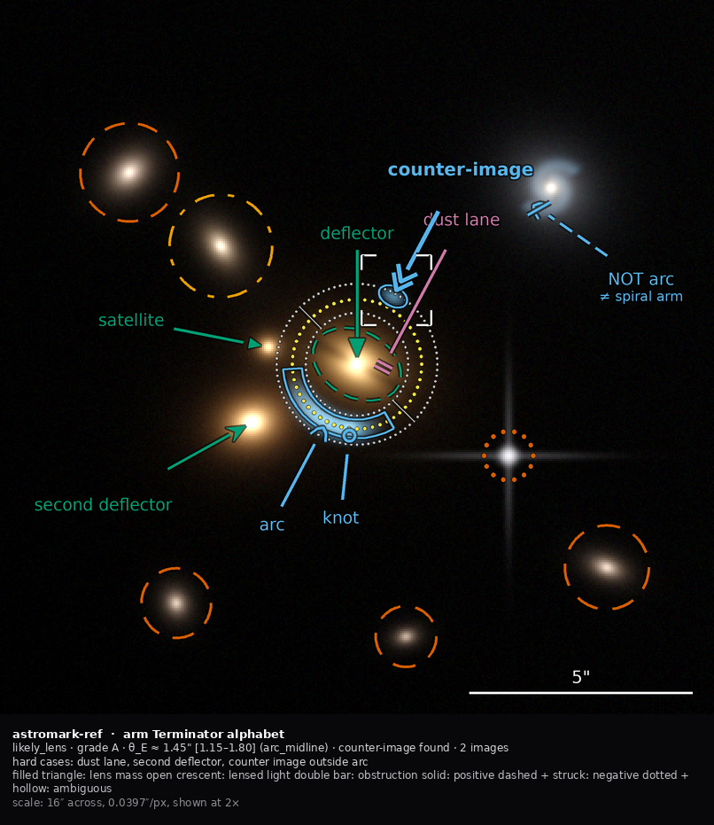
N1, Terminator alphabet. Semantics live in the shape at the business end; polarity is the shaft texture, reinforced by a strike on negatives.
The arrow is the one mark the room has consistently endorsed, so N1 keeps it and thins everything else. Semantics live in the terminator, inscribed in a circle of constant silhouette area so no role looks heavier than another.
- Lens mass — filled silhouettes (“mass is solid”): deflector a filled triangle; second deflector the same with a notched base; satellite a smaller triangle.
- Lensed light — open, curved forms (“light is thin and curved”): arc a crescent tick; lensed image an open chevron; counter-image a nested double chevron (“the other one”); knot a small open circle.
- Obstruction — bars (“a bar is a wall, not an arrow”): dust lane a double bar.
Polarity is the shaft texture — solid, long-dash, dotted — reinforced on negatives by a cross-bar struck through the terminator. Two channels, because negative is the rarest and most consequential mark.
Does well: highest role resolution of the four; evolutionary, so adoption is cheapest; the terminator sits where the eye already goes. Breaks: below ~9 px the individual shapes collapse and only the three families survive, so the families must be designed as the thumbnail layer; seventeen shapes is a real vocabulary needing a key card.

N2 — Bertin ledger
Assign each visual variable to exactly one semantic dimension; the assignment table is the spec.
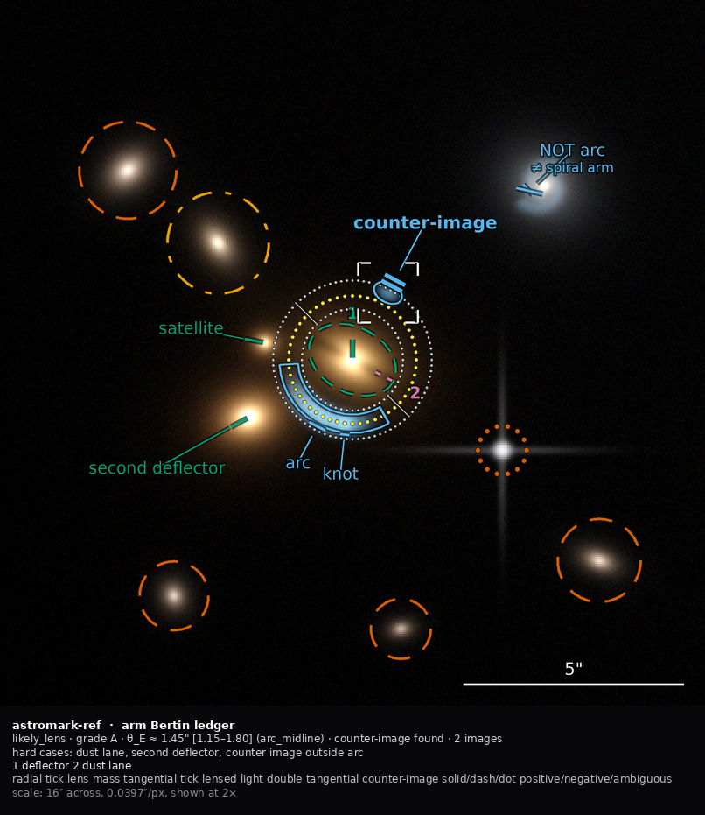
N2, Bertin ledger. Tick orientation is derived from the radius vector: tangential means lensed light, which really is tangentially stretched.
Rather than starting from a shape catalogue, N2 starts from Bertin’s seven variables and forbids any dimension from claiming a second. The mark inventory falls out of the table.
The move that makes it genuinely different: orientation is derived from the physics. Each designating mark is a two-stroke tick whose angle comes from the radius vector to the nearest lens-mass item — tangential means lensed light (which really is tangentially stretched), radial means lens mass. The mark is the physics, which makes it mnemonic for astronomers and cheap to teach.
Does well: orientation survives downscaling far better than shape — 235 px per panel versus 300 px — so it is the most thumbnail-robust; the ledger makes “which variable is free?” a one-word question, which matters when the standard is extended by people who were not in the room. Breaks: orientation is undefined at the deflector itself, where the radius vector is degenerate (the prototype handles this explicitly — a lens-mass mark is measured from the primary deflector, and the primary falls back to a fixed vertical tick); a tangential tick lying along a tangential arc can be read as part of it, so it must be offset outward.

N3 — Station model
One compact badge per object; one fixation instead of three.
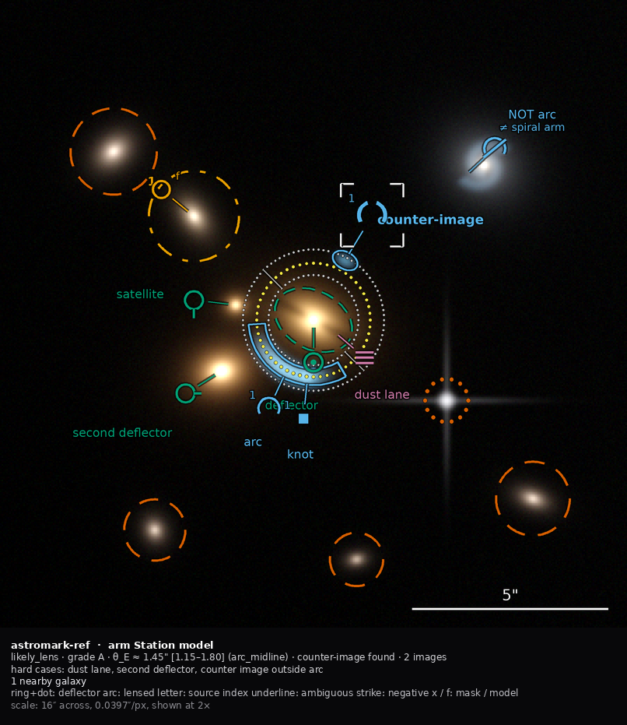
N3, Station model. One compact badge per object, carrying role, polarity, source index and treatment in slots.
Modelled on the WMO surface station plot. A badge sits off the object on the ray from panel centre, joined by a hairline stem, with slots: a role ideogram, a polarity underline or strike (one stroke — this is what makes it cheap), a source index letter, and a treatment mark (× mask, f fit). A badge appears only when it carries something the mark’s own style does not.
Does well: lowest ink per object; carries source membership, which nothing in the current system can express at all; it is what a discipline-wide notation actually looks like, which matters for the stated adoption goal. Breaks: badges sit off the object, so the reader must trust the stem, and stems cross things on crowded panels; it demands literacy — an unbriefed astronomer cannot read A ⌒⌒ ×, which is in direct tension with the room’s preference for plain labels on the object.

N4 — Evidence graph
Annotate the argument, not the objects. The primitive is a link.
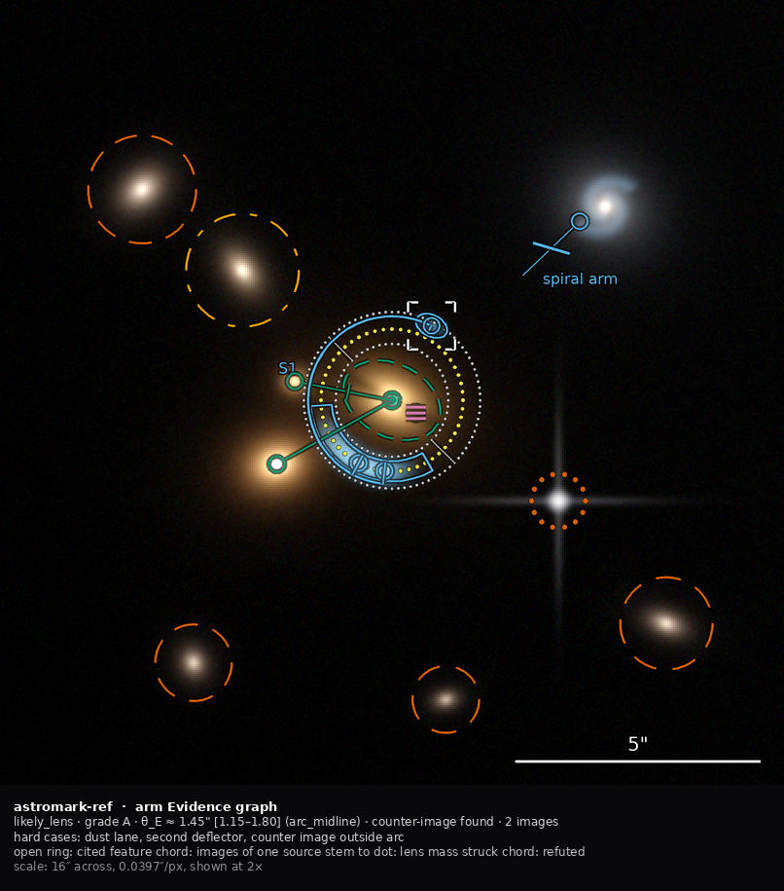
N4, Evidence graph. Anchors, a source chord tying the images of one source, and stems to a mass dot. A struck chord means refuted.
A strong-lens claim is the assertion “these blobs are images of one source behind that mass”. N4 draws that assertion and lets the objects be implied by their participation in it.
- an anchor (a small open ring) is the only mark that touches a feature;
- a source chord — a hairline arc concentric with the θ_E ring, with radial ties down to its anchors — says “these are images of one source, tangential, at this radius” in one stroke;
- a stem from each lens-mass anchor to a filled dot at the centre says “this is mass”; two stems converging on one dot draws a group-scale deflector;
- a refutation stroke across a chord says “these are not images of one source, because ⟨…⟩”.
Polarity is structural rather than decorative: a positive panel has an unbroken chord, a negative panel’s chord is struck. From across a room, the non-lens is the panel whose graph is broken.
Does well: the only proposal where negative evidence is a first-class visual object rather than a styling of a positive one — which is the defect that motivated this whole exercise; lowest ink of the four; topology survives downscaling when glyph shape does not. Breaks: poor role resolution — it separates lens mass, lensed light, field and obstruction and nothing finer, so knots and second deflectors need a badge borrowed from N3; it needs a θ_E estimate before a chord can be drawn; it is the most unfamiliar and has the highest explanation cost.

4. Measured results
Rendered at 806 px, measured against the un-annotated null arm.
arm | statements | ink % | ink/statement | occlusion % | contrast p5
N1 Terminator alphabet | 20 | 3.55 | 0.178 | 10.95 | 0.136
N2 Bertin ledger | 20 | 3.07 | 0.154 | 11.12 | 0.137
N3 Station model | 20 | 3.27 | 0.163 | 11.59 | 0.137
N4 Evidence graph | 20 | 2.57 | 0.128 | 11.35 | 0.110
R-CURRENT (LensMark today) | 15 | 6.23 | 0.416 | 12.77 | 0.120
R-CAMPAIGN (agent campaign) | 15 | 1.99 | 0.133 | 6.16 | 0.091
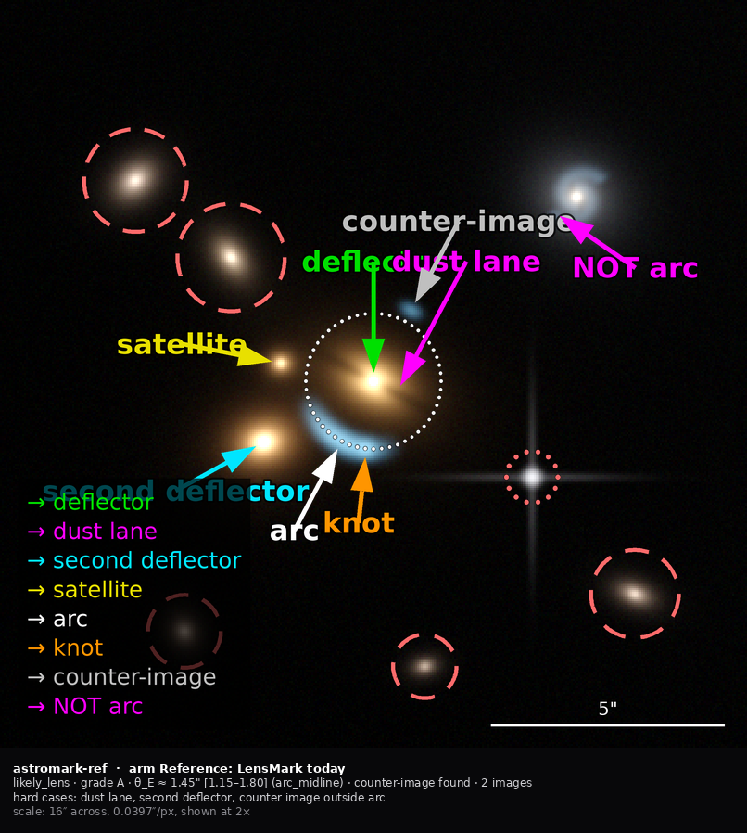
The reference arm: today’s LensMark notation at its own constants. The on-image legend plate is the single largest consumer of ink, and five of the twenty statements cannot be made at all.
Read the ink/statement column, not the ink column. Raw ink penalises an arm for saying more, and the two reference arms cannot express bound rings, segmentation polygons, treatment, polarity or source grouping — five of the twenty statements. They look thinner for free.
Normalised, the result is clean: today’s notation costs 3.2× more ink per unit of meaning than N4, and 2.3× more than the worst candidate. All four candidates sit in the same band as the campaign the room liked, while expressing five more things.
Two honest caveats:
- Occlusion is worse for every candidate (≈11%) than for the campaign (6.2%) — for the same reason. The candidates draw bound rings and two segmentation polygons that necessarily lie over informative pixels. This is a real cost of expressing more, not an artefact, and the room should decide whether bounds and segmentation earn their occlusion.
- The harness validates against reality: R-CURRENT measures 6.23% against 6.4–10.8% for real LensMark renders, and R-CAMPAIGN 1.99% against the campaign’s measured 1.2–2.3%. The prototype reference arms reproduce the real thing closely enough to trust the comparison.

Thumbnail thresholds
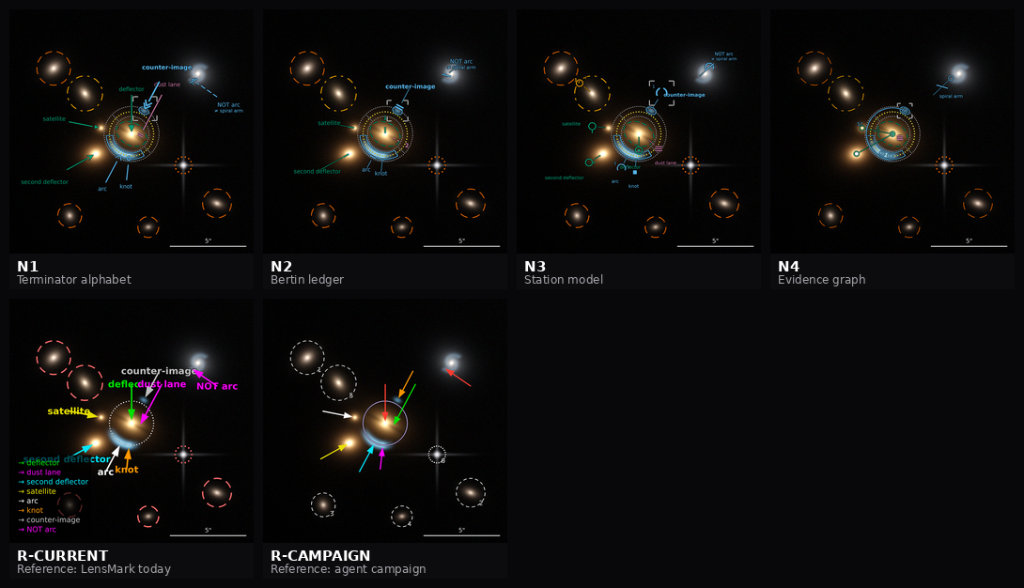
The thumbnail test at 260 px per panel. Text is unreadable in every arm at this size, so only the visual channel remains.
What survives downscaling, measured against a 0.030·m glyph:
channel | minimum panel size
stroke texture (solid / dash / dot) | 167 px — most robust
orientation (30° steps) | 235 px
shape | 300 px
shape family only | 200 px
text | 367 px
At 260 px per panel — a 3×3 contact sheet on a laptop — text is unreadable in every arm. Only the visual channel remains. That is the empirical case for putting polarity in texture and role in shape or orientation, and against any design that relies on reading a label.

5. Recommendation on the notation
Prototype N1 and N4 as the two poles; treat N2 as the specification method and N3 as the crowding fallback.
- N1 is the evolutionary pole. It keeps the arrow, fixes polarity, roles and bounds at the lowest adoption cost, and is what ships if the standard has to be presentable at the January AAS meeting.
- N4 is the revolutionary pole. It is the only one that fixes the actual named defect — a viewer flipping through nine panels cannot tell which is the non-lens — at the level of the mark rather than the label. Its source chord is the one genuinely new idea in the option space.
- N2 is not really a fifth notation; it is how to write the spec for whichever wins. The ledger table is what makes the accessibility constraint structural instead of a checklist.
- N3’s source-index slot is worth stealing into whichever wins, because source membership is inexpressible today and costs two characters.
Six changes are notation-independent and worth doing whichever proposal is chosen, in this order: the 2× canonical render → METRIC/PRESENTATIONAL scalar tagging → the emphasis enum with layered compositing → keep-out geometry in the label solver → demotion-to-index → the caption band and legend.mode. Only the sign inventory is a bet.
(On keep-out geometry: implementing it exposed a real bug. Using each circle’s bounding box rather than its annulus blocked most label placements and demoted four labels in N2 that had no need to demote. A label may sit inside a large mask circle; it must only avoid lying on the ring, where it would read as naming a point on it.)

6. Figures
file | what
examples/reference/n1.png … n4.png | each proposal on the reference scene, with caption band
examples/reference/r-current.png | today’s LensMark notation at its own constants
examples/reference/r-campaign.png | the agent campaign’s style
examples/reference/null.png | the un-annotated cutout — the arm that asks which marks earn their ink
examples/reference/contact-{528,328,260}.png | the thumbnail test at three sizes
examples/reference/polarity-triad.png | positive / negative / ambiguous, labels removed
examples/reference/cvd-sheet.png | every arm under four vision conditions
examples/reference/metrics.json | the numbers above, machine-readable

Accessibility: colour as reinforcement, and the test that proves it
Status: designed and verified, 2026-09-03. Reproduce with examples/cvd.py and examples/measure.py sheets.
Greg asked: should we have a symbol notation that doesn’t rely on colour, but can use colour to help further differentiate? The answer is yes, and it is worth being precise about why, because the reasoning changes the notation rather than just the palette.

1. Why this is not a courtesy
The workshop deferred accessibility behind reliability, and that was the right call at the time. But three facts make it cheaper to do now than later:
- The current colour key is already broken on its own terms. In the campaign that produced the best annotations so far, red and green were locked to deflector and arc, but four other colours were assigned opportunistically — and cyan meant “unrelated field object” on some panels and “lensed feature” on others within the same nine-panel set. A key that is not self-consistent for normal vision is not a colour-vision problem; it is a vocabulary problem that colour was asked to solve and could not.
- Roughly 8% of men have a colour-vision deficiency. In a three-person group that is a coin-flip; in the community the standard is aimed at, it is a certainty.
- Figures get printed, photocopied, and projected. Greyscale is not an edge case in astronomy; it is the second most common way a figure is seen.
The governing standard is WCAG 2.2 SC 1.4.1, “Use of Color”: colour must not be the only visual means of conveying information. Note what it does and does not say — it does not ban colour, and it does not require an ugly palette. It requires redundancy.

2. The channel assignment
Semantic dimension | Primary channel | Reinforced by
role family (lens mass / lensed light / obstruction / field / measurement) | glyph shape — filled, open-curved, bar, circle | colour
role within family | glyph detail, or tick orientation in N2 | —
polarity (positive / negative / ambiguous) | stroke texture — solid / dashed / dotted | a strike through the terminator on negatives
measured quantity (θ_E, mask radius) | size — reserved exclusively for measurement | —
emphasis | stroke weight, glyph scale, corner brackets | —
source membership | an index letter, or a chord in N4 | colour
Two consequences fall out of the table rather than being imposed:
Size cannot carry emphasis, because size is already spoken for by measurement. That is the whole reason the emphasis mechanic is a stroke-weight multiplier and not a scale factor.
Colour cannot carry polarity. The workshop had already reached this conclusion independently — the proposal to reserve white for “ambiguous” and grey for “NOT” was rejected in favour of line style. The accessibility analysis arrives at the same place from a different direction, which is mild evidence that it is right.

3. The palette
Okabe-Ito, the standard colour-vision-safe qualitative set. Used as reinforcement only, so nothing breaks if a viewer cannot separate two of them.
Family | Hex | Role
lens mass | #009E73 bluish green | deflector, second deflector, satellite, lens-light segmentation
lensed light | #56B4E9 sky blue | arc, knot, counter-image, lensed-light segmentation
obstruction | #CC79A7 reddish purple | dust lane
field object | #D55E00 vermillion | galaxy and star masks
modelled, not masked | #E69F00 orange | a field galaxy fitted rather than cut out
measurement | #F0E442 yellow | the nominal Einstein ring
bound | #BFBFBF grey | lower and upper θ_E rings

4. The test
This is the part worth keeping regardless of which notation wins, because it converts a review step into an assertion.
for every pair of semantically distinct marks that can appear on one panel:
compute CIEDE2000 between their inks under
normal vision, deuteranopia, protanopia, tritanopia, greyscale
if the smallest of those is below the floor:
assert glyph shape OR stroke texture OR orientation differs
The criterion is deliberately not “colour difference is large”. A palette does not pass by being colourful. It passes by never letting colour be the only thing separating two meanings.
Simulation uses Machado, Oliveira & Fernandes (2009) severity-1.0 matrices, inlined in the repo rather than imported — a library that changes version would make the verification itself irreproducible. Matrices operate on linear RGB, so sRGB is decoded before and re-encoded after; skipping that step is the most common error in CVD code and it materially changes the answer.

Calibrating the floor, which produced a finding
The floor was initially set at ΔE2000 = 12 and the test passed a pair it obviously should have failed. Measuring the canonical case explains why:
Pure red #FF0000 against pure green #00E000 still measures ΔE2000 = 12.9 under deuteranopia simulation — because almost everything that survives is a lightness difference (L* 53 vs 78), not hue.
So a floor at 12 waves through the exact confusion the criterion exists to catch. The floor is set at 15, above that residual. Large filled areas would tolerate less; this notation is made of thin strokes and small terminators, which tolerate more.

Result
GATE: PASS
pairs checked: 136 | below the ΔE floor: 123 | separated by colour alone: 0
123 of 136 mark pairs — 90% — are not reliably separable by colour under some vision condition. Every one of them is separated by shape, texture or orientation instead. That number is the argument for the whole design: a notation that leaned on colour would be illegible to a large fraction of its audience nine times out of ten, and would not know it.

5. Visual evidence
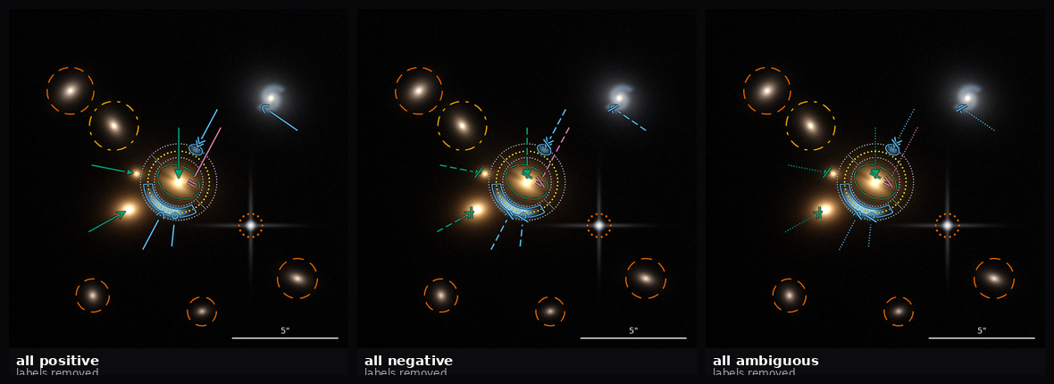
The polarity triad: one document rendered three times, all marks positive, all negative, all ambiguous, with every label removed. Solid, dashed and dotted are unmistakable with no text.
- examples/reference/polarity-triad.png — the same document rendered three times, all marks positive, all negative, all ambiguous, with every label removed. Solid, dashed and dotted are unmistakable with no text at all. If this sheet were ambiguous, the polarity channel would have failed.
- examples/reference/cvd-sheet.png — every arm through all four simulations.
- examples/reference/contact-260.png — at 260 px per panel, text is unreadable in every arm. Only the visual channel survives, which is the empirical case for putting polarity in texture and role in shape.
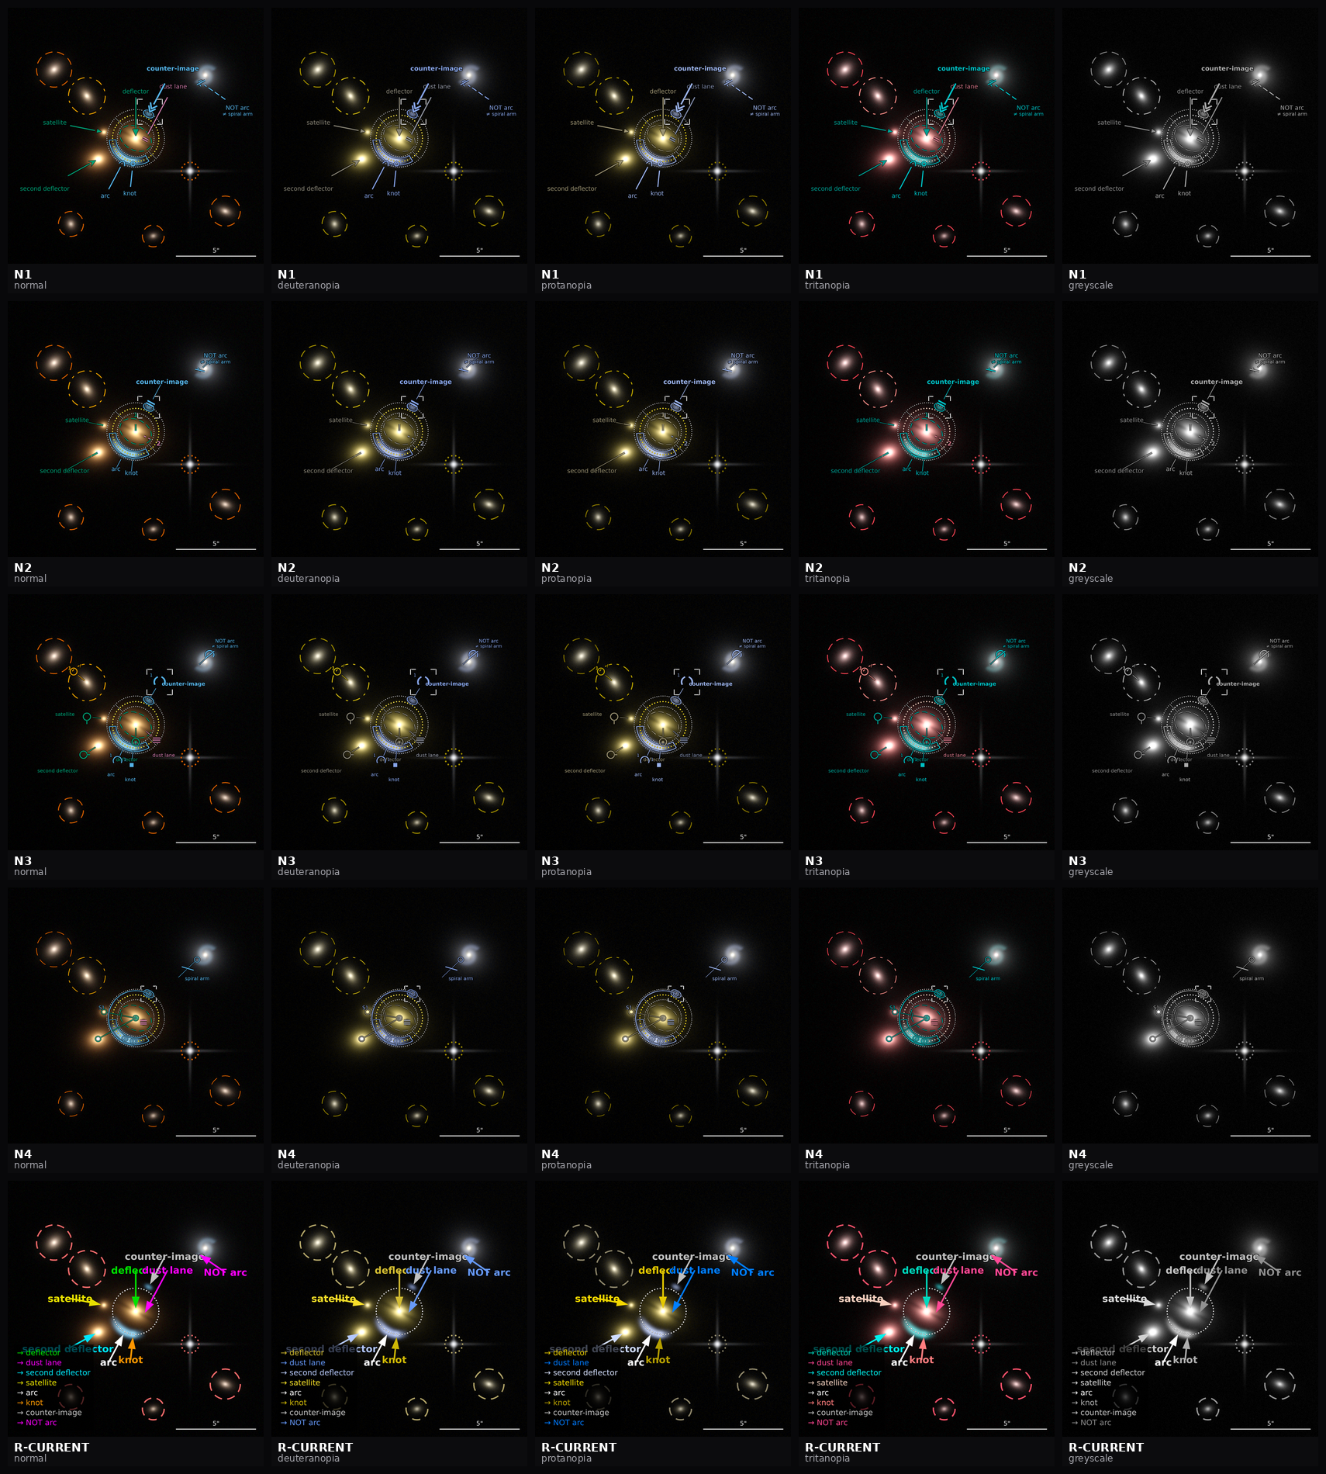
Every arm under normal vision, deuteranopia, protanopia, tritanopia and greyscale.

6. Limits, stated
- The gate tests inks, not rendered pixels. Two marks with distinguishable inks can still be confusable if one sits on a saturated galaxy core. That is what the contrast metric is for, and it is a separate measurement.
- Machado severity 1.0 models dichromacy. Anomalous trichromacy — deuteranomaly, the most common deficiency at ~4.6% of men — is milder, so testing at severity 1.0 is conservative in the right direction but is not the same as testing the most common case.
- Nothing here addresses non-visual access. A screen-reader path would mean a text serialization of the annotation, which the line form in 06-llm-ergonomics.md happens to provide almost for free — an unplanned second use worth noting, not a claim to have solved it.

Part V — The metadata representation

The metadata representation: six proposals, and the axis that actually decides
Status: option space designed, all six encoded and measured, 2026-09-03. Reproduce with examples/make_encodings.py; the encodings are in examples/encodings/.

0. The finding that reframes the question
I expected this to be a choice between containers — bespoke JSON, GeoJSON, Web Annotation, tables. Auditing what actually went wrong with lensmark/1.0 says otherwise. Here is every structural problem in the current format, and what each one really is:
Audit finding | What it actually is
Enums defined in six uncoordinated places | term identity, unowned
θ_E stored twice and unlinked | identity of a measured quantity
theta_e.method a free string despite three named rules | a term with no vocabulary
green = deflector; mask_red reserved by item type | a term smuggled into portrayal
prose refers to arrows by colour | a term with no referenceable id
the whole style table copied into every data file | portrayal had no identity, so it was inlined
no role field — semantics in a 40-char label, matched by substring | a term hidden in free text
no polarity | a missing term
no polygon, no secondary ring, no source grouping | missing terms, and a missing grouping term
Nine for nine, they are vocabulary-identity problems. Not one would have been prevented by GeoJSON, by Web Annotation, or by tables.
The sharpest instance is worth seeing in full. This is how the current system decides what is a lens galaxy:
# lensmark/validate.py:75
def _is_deflector(label): return bool(label) and "deflector" in label.lower()
mirrored independently in frontend/src/geometry.ts. A label reading spiral arm, NOT a deflector is therefore coloured green — the colour that means lens mass. The semantics of the standard ride on substring-matching an optional 40-character string, in two languages, with no shared definition.
So the axis that decides this is not the container:
Where does semantic identity live — in a separately versioned vocabulary artifact that is the single generator of every other surface, or in the shape of the document?
Choose the container for cheapness. Choose the vocabulary machinery for rigour.

1. The six proposals
Each is encoded in full in examples/encodings/, all saying the same thing about the same image.

P1 — Evolved bespoke
Keep the discriminated union on type. Add semantics as orthogonal fields (role, polarity, alternative, source) rather than new types. Hoist the style table and the vocabulary out into separately versioned side documents referenced by hash.
{"id": "m-mimic", "type": "vector", "role": "lens:arc", "polarity": "negative",
"alternative": "lens:spiral_arm",
"tail": [0.851, 0.358], "head": [0.739, 0.282]}
Easy: smallest diff from what exists — the renderer, frontend and all four exporters change by a field lookup, not a rewrite; golden render tests keep working; humans already read this shape. Hard: every new geometry is a new class in three or more places with no generator, so it inherits the exact failure being fixed unless code generation is added; the core/profile boundary is a naming convention, not a mechanism. Failure mode: it silently reverts to lens-only, and the third enum copy reappears the first time the frontend needs a role dropdown.

P2 — GeoJSON-shaped
FeatureCollection; the core owns geometry, the profile owns properties. The boundary is structural rather than conventional, which is genuinely attractive.
It fails on a fact about this data. GeoJSON has no circle, and nine of the twenty marks are circles whose radius IS the datum — mask radii and θ_E. The options are a 64-gon, which destroys the record (the exporters need radius_arcsec, not vertices), or Point + properties.radius, at which point the geometry member no longer holds the geometry:
{"type": "Feature", "id": "m-ring",
"geometry": {"type": "Point", "coordinates": [0.5, 0.51]},
"properties": {"radius_arcsec": 1.45,
"_geojson_note": "radius is not representable in GeoJSON geometry"}}
RFC 7946 also mandates WGS84 lon/lat and deliberately removed the crs member, so using it for normalized image coordinates is a knowing violation. And measured: it is the largest encoding of the six. You pay the standard’s tax and get none of its tooling. Failure mode: the first colleague who opens it in QGIS files a bug you answer with “it isn’t really GeoJSON.”

P3 — W3C Web Annotation (JSON-LD)
body + target + selector. Review is native: a critique is an Annotation whose target is another Annotation’s IRI — exactly the propose→critique→accept loop, expressed without inventing anything, and it generalises to critiques-of-critiques for free. Every term is a dereferenceable IRI, so vocabulary versioning and profile membership are solved by the URL.
Hard: JSON-LD is open by construction — @context remapping, value-or-array polymorphism at nearly every site. There is no plausible flat, closed JSON Schema for it, so it fails the structured-output requirement unless you define a sub-profile that is no longer Web Annotation, at which point the standard’s authority — the entire reason to pick it — is gone. Geometry via SvgSelector embeds SVG-in-a-string, which is hostile to radius_arcsec (an SVG r is in pixels) and to content hashing. Failure mode: correct and unusable; every implementer ships a private subset no other consumer can read, which is the observed history of most adopters.

P4 — Markup / annotation split with coded concepts
The DICOM SR and NCI AIM lineage. Geometry (markup) carries no meaning at all; meaning (observations) is a set of coded concepts that reference markup. Every term is a {scheme, code, meaning} triple where identity is scheme+code and the English string is display only.
"markup": [{"id": "k8", "shape": "vector", "points": [[0.851,0.358],[0.739,0.282]]}],
"observations": [{"id": "o-m-mimic", "about": ["k8"],
"concept": {"scheme":"AM-LENS","code":"ARC","meaning":"arc"},
"polarity": {"scheme":"AM-CORE","code":"NEG","meaning":"negative"},
"because": {"scheme":"AM-LENS","code":"SPIRAL_ARM","meaning":"spiral arm"}}]
This is the only proposal in which “green means deflector” is structurally impossible, because portrayal is not in the record and semantics can only be a code. Vocabulary versioning is genuinely solved — a scheme versions independently of the schema, so a morphology profile is a vocabulary release with zero core-schema change. And the θ_E double-storage bug is unrepresentable: a measurement is an observation with value, unit, bounds and coded method, which cannot be duplicated into a geometry field.
Hard: 9.4× the compact form; the model must emit a three-key object where an enum string would do, with three chances to be inconsistent; two id spaces to track. Failure mode, honestly: the ceremony is abandoned under deadline. Someone adds "role": "arc" beside the coded concept “just for the frontend”, and within a release you have both, unlinked — which is the θ_E bug, reproduced.
The salvage — and the single most valuable idea in this document. What is worth having is term identity, not the triple. "role": "lens:arc" — one prefixed string resolved in a versioned, SKOS-shaped vocabulary file carrying label, definition, profile, status and replaced_by — keeps token cost at enum level while retaining everything that matters: profile membership visible in the term, graceful degradation (an unknown morph: prefix is recognisably not-mine rather than merely invalid), and vocabulary versioned separately from schema. Call it P4-lite. It composes with P1, P2 and P6.

P5 — Dual surface
Canonical JSON plus a normative line notation with enforced round-tripping. Fully covered in 06-llm-ergonomics.md; the measured result is 2.1 kB against 14.4 kB, and a 50-example payload of ~30k tokens against ~205k. It is orthogonal to P1–P4 and P6, which is itself a finding — this is not a competing container but a second surface any container can have.

P6 — Relational / columnar
Not a document: marks / assertions / reviews / sources as typed rows, shipped as FITS BINTABLE, VOTable or Parquet. Astronomy-native — this is how every catalogue in the field ships, and what an archive accepts without argument. Corpus queries become trivial, and those queries are the research questions: “every counter-image mark the reviewer called wrong_position”, “θ_E residual versus hard-case class”, stratified few-shot selection.
Hard: hostile to single-document editing and to git; a human cannot read one cutout’s annotation without performing a join in their head; the content hash and deterministic render need a document to hash, so you must define a canonical flattening — which is a document format. Failure mode: you build the document format anyway and the tables become a derived warehouse. Which is fine — but then P6 was never the record, it was the export. Its real contribution is as a criterion: measure every other candidate against P6’s query and degradation story.

Considered and rejected as primaries
DS9 region format, extended. The incumbent, and the adoption precedent the room itself cited. It has grouping (tag={}, multi-valued and many-to-many — genuinely good) and inline portrayal. It is often said to have polarity, and it does not: the - prefix on a region “flags the region with a boolean NOT for later analysis” — it is set arithmetic on a pixel mask, an instruction to exclude those pixels from an aperture, not an assertion about what the feature is. But it has no provenance, no review state, no uncertainty, no grouping semantics beyond a string bag — and exports/ds9.py already abuses tag={id:…} to smuggle identity through it. Extending it means forking a format you do not control whose reference parser is C inside SAOimageDS9. Keep it as an export — it already is one, at 161 lines — never as the record. It does prove that a line-oriented notation is culturally acceptable in this field, which is evidence for P5.
RDF/OWL, ontology-first. Right for vocabulary governance, wrong for everything else: no flat schema, no token budget, no human-editable file. Steal the SKOS shape — a term has prefLabel, definition, broader, status, deprecated, replacedBy — as a plain JSON vocabulary file. That artifact is P4-lite’s backbone and is compatible with all six proposals.

2. Measured size
Encoding | chars | ×smallest | 50-example payload (derived)
P5 model-read surface | 2,091 | 1.0 | ~30k tokens
P6 relational | 8,089 | 3.9 | ~116k
P1 evolved bespoke | 14,362 | 6.9 | ~205k
P3 Web Annotation | 17,777 | 8.5 | ~254k
P4 coded concepts | 19,678 | 9.4 | ~281k
P2 GeoJSON-shaped | 19,762 | 9.5 | ~282k
Character counts exact; token figures derived at 3.5 chars/token, not measured.

3. How to decide, if the team wants to decide by evidence
Four gates. Fail one and the candidate is out regardless of its other merits.
gate | test
G1 flat, closed structured-output schema | 0 $ref, additionalProperties:false everywhere, honoured by a live API call
G2 round-trip fidelity | convert the 19 real decks out and back; the result must re-render byte-identical to the nine golden SHA-256s
G3 embargo separability | strip_free_text provable by a closed key allow-list, not a type-sniffing walk
G4 expressiveness | all 22 fixture statements expressible; the 16 P0 statements as first-class constructs
Predicted casualties, recorded before the gates are run: P3 fails G1 (no flat closed schema is possible without ceasing to be Web Annotation); P2 fails G2 (circles are the majority of marks and GeoJSON cannot hold a radius in its geometry).
No weighted sum. Report the matrix and decide by dominance; where nothing dominates, name the trade in a sentence and take it to the room as a decision rather than a number. A weighted sum here would only encode the weighter’s prior with false precision.

The 22 statements the notation must be able to make
The first sixteen are P0 — they must be first-class constructs, not conventions.
1 main deflector · 2 second deflector · 3 satellite (lens mass, never masked) · 4 arc of source S1 · 5 counter-image of S1, farther out than the arc · 6 both arcs lensed but unpairable · 7 two sources · 8 NOT an arc — a spiral arm · 9 ambiguous: counter-image or projection · 10 θ_E = 1.45″ nominal, ≥1.15, ≤1.80, by arc-midline · 11 the ring is centred on the deflector mark and follows it · 12 a secondary ring from a second deflector · 13 a dust lane, a hard case and not evidence against · 14 mask this galaxy, model that one · 15 lens-light versus lensed-light polygons · 16 searched for a counter-image and did not find one (≠ did not look) · 17 provenance and reviewer verdict · 18 this mark is an edit of that one · 19 two hard-case classes at once · 20 the counter-image’s colour disagrees · 21 sky position and PA · 22 everything above, with all free text removed, still says 1–16 and 19 ← the embargo test, and the sharpest discriminator in the list.
The current format scores zero on statements 2, 6, 7, 8, 9, 12, 15 and 16.

4. Recommendation
Container: P1 evolved. Identity: P4-lite. Read surface: P5. Export: P6 and DS9 unchanged.
Concretely:
- a vocabulary file is built first and is the single generator of the pydantic Literals, the JSON Schema enums, the TypeScript unions, the prompt’s vocabulary section and the docs table, with a CI check that fails on staleness;
- terms are prefixed strings — lens:arc, core:negative — not bare enums and not triples;
- portrayal leaves the data file and becomes a versioned, hash-referenced style document;
- models read the line form and write JSON under a flat closed schema.
The reasoning is that all six containers would work, and what killed lensmark/1.0 was not a wrong choice but erosion — nothing prevented drift. So the axis that matters is the one where a mechanism can be installed. That mechanism is compatible with every proposal here, and it is worth more than the choice among them.
One thing to do regardless of which container the team picks: build the vocabulary file. It is the only artifact all six proposals share, and the only one whose absence caused every problem in the audit. Building it before the container is chosen is not premature — it is the part that is not in dispute.

Machine ergonomics: what the format costs a model to read and write
Status: measured, 2026-09-03. Reproduce with examples/make_encodings.py.
Greg’s stated goal for the format is that it be “useful for humans and for LLMs to consume and learn from.” Those two audiences pull in opposite directions, and this section is where the tension gets priced rather than argued about.

1. The measurement
One annotation — the reference scene, 20 marks covering 12 roles, both polarities, all three geometry kinds — encoded in every candidate. Same content, so the differences are the format.
Encoding | chars | ×smallest | derived tokens | 50-example payload
P5 model-read surface | 2,091 | 1.0 | ~600 | ~30k
P5 line notation (full) | 2,173 | 1.0 | ~620 | ~31k
P6 relational | 8,089 | 3.9 | ~2,300 | ~116k
P1 evolved bespoke | 14,362 | 6.9 | ~4,100 | ~205k
P3 W3C Web Annotation | 17,777 | 8.5 | ~5,100 | ~254k
P4 coded concepts | 19,678 | 9.4 | ~5,600 | ~281k
P2 GeoJSON-shaped | 19,762 | 9.5 | ~5,600 | ~282k
Character counts are exact. Token figures are derived at 3.5 chars/token, not measured — no Claude tokenizer is available offline and a different tokenizer family would give a misleading absolute. The ratios are what the decision turns on, and ratios are near tokenizer-independent.

Three results worth stating plainly
The compact form is not a marginal saving. A 50-example few-shot payload is the difference between roughly 30k tokens and roughly 205k. That is not “cheaper”; it is the difference between the few-shot experiment the team has planned being routine and being a budget decision every time it runs.
GeoJSON is the most expensive encoding, not the cheapest. This surprised me. The wrapper ({"type":"Feature","geometry":{...},"properties":{...}} around every mark) costs more than the bespoke schema it was supposed to simplify, and it buys nothing here because nine of the twenty marks are circles — and GeoJSON has no circle. Their radius, which is the datum for a mask and for θ_E, gets exiled into properties, so the geometry member no longer holds the geometry. You pay the standard’s tax and get none of its tooling.
The verbosity of the rigorous option is real. P4’s coded concepts — the DICOM SR and NCI AIM lineage, where every term is a {scheme, code, meaning} triple — costs 9.4× the compact form. That buys something genuine (see 04-metadata-proposals.md), but it should be bought knowingly.

2. The asymmetry that resolves the tension
The requirement that models emit under a flat, closed JSON Schema is not negotiable — it is what makes malformed output impossible rather than merely unlikely, and LensMark already depends on it. The requirement that fifty examples fit in a payload is also not negotiable.
Those look contradictory. They are not, because the read surface and the write surface do not have to be the same surface:
Models READ the compact line form and WRITE the JSON form.
Reading is where the volume is — fifty examples, every one of them costing tokens. Writing is where the correctness matters — one document, schema-enforced, repairable. Splitting them satisfies both constraints at once, and nothing else in the option space does.
This is not a novel trick; it is what the existing pipeline already half-does. exports/fewshot.py already emits a prose markdown card alongside each example precisely because the raw JSON is a poor thing to learn from. The proposal is to replace that ad-hoc card with a normative, round-trippable line form.

3. What the line form looks like
The entire reference annotation — every mark, both polarities, the bounds, the source grouping, the review verdict — in 2.1 kB:
#astromark lens/1.0 frame=norm,tl,+x-right,+y-down size=arcsec
#system likely_lens grade=A p=0.92 cimg=found n=2 hard=dust_lane,second_deflector,counter_image_outside_arc
#source S1 images=2 config=double thE=1.45"
defl + 0.500,0.350 -> 0.500,0.510
dust + 0.624,0.349 -> 0.530,0.526
defl2 + 0.235,0.657 -> 0.353,0.591
sat + 0.244,0.460 -> 0.376,0.486
arc + 0.394,0.709 -> 0.458,0.590 S1 ; rev=wrong_position 0.31"
knot + 0.480,0.700 -> 0.490,0.600 S1
cimg + 0.614,0.296 -> 0.550,0.415 S1 emph=key
arc - 0.851,0.358 -> 0.739,0.282 alt=spiral_arm
ring + @m-defl r=1.45" S1 [1.15,1.8] method=arc_midline
ring + @m-defl r=1.15" S1 bound=lower
gal + 0.181,0.241 r=1.1" treat=mask
star + 0.713,0.638 r=0.55" treat=mask
Read the eighth line: arc - ... alt=spiral_arm. That single line says “there is an arc-shaped feature here, it argues AGAINST lensing, and the reason is that it is a spiral arm.” The current format cannot say that at all, in any number of characters.

Honest costs
- Polygons dominate it. Three segmentation polygons account for about 1.4 kB of the 2.1 kB. Without them the annotation is roughly 800 characters. Segmentation is inherently verbose in any text form; if the few-shot payload is tight, polygons are the first thing to drop from the read surface.
- No API-level grammar enforcement. Structured output applies to JSON, not to text. A text surface needs a parser and a repair layer. Mitigating fact: lensmark/validate.py is already a 267-line repair layer whose n_repaired and n_invalid counters are treated as dataset columns — the project has already accepted repair-on-parse as design rather than failure.
- Two surfaces can drift. This is the real risk and it has a real answer: generate both from one definition, and put a round-trip property test over the whole corpus in CI. If a field can be added to one surface without the other, the design has already failed.

4. What this does not settle
Greg’s hypothesis on the record — that giving a model the image plus independent coordinate metadata beats giving it an annotated PNG — is untested, and nothing here tests it. This section measures what each encoding costs, not what it teaches. The experiment that would settle it is:
the same cutouts, the same model, three payload variants — annotated PNG only; original PNG plus the line form; original PNG plus the line form plus the annotated PNG — scored on the existing propose pipeline against the human decks.
That experiment is cheap now that the encodings exist, and it is the single highest-value thing to run before the format is frozen. Until it is run, the read/write asymmetry is justified by token cost alone — which is sufficient, but it is a weaker claim than the one the team actually wants.

Part VI — Worked examples on real JWST data

Worked examples on real JWST data
Status: three candidates annotated, 2026-09-03. Reproduce with examples/make_jwst_examples.py then examples/render_proposals.py.
The synthetic reference scene (examples/reference/) exists because it can ship with the standard and because it can be built to contain every hard case. These examples exist for the opposite reason: to show the notation carrying measurements that already exist, on systems the team knows.

Source, and why it is safe to use
jwst-strong-lens-search/top100_clean/ — the top hundred candidates from the one-shot search of the public JWST NIRCam archive (4.48 deg², 5,391 targets, ten surviving adversarial verification). Public archive data with no embargo, unlike the nine Hubble cutouts.
Each figure is 752×562 holding six 240×240 panels: three stretches of the 10″ field on the top row, three of the 3.5″ zoom below. North up, east left. The accompanying top100_clean.csv carries 41 columns per candidate, including the verifier grade, the blind Einstein radius with its stated method, the arc radius and position angle, whether a counter-image was seen, and the verifier’s written reasoning.

The claim these examples make
Every mark is derived from a recorded measurement, not placed by eye.
Arc positions come from blind_arc_radius_arcsec and blind_arc_pa_deg; the nominal ring from blind_theta_E_arcsec and blind_theta_E_method; counter-image positions from the coordinates the verifier wrote into their own note. The transform is stated in the script: for a feature at position angle PA and radius r in a panel of width FOV, u = 0.5 − r·sin(PA)/FOV, v = 0.5 − r·cos(PA)/FOV.
So these figures test whether the notation can express what was already measured — which is the actual claim, and a stronger test than annotating by eye.

The three, and what each one strains

rank 1 — J3440482-522486, a published lens
SL2S J02176-0513, grade A, 3 of 3 verifiers. A blue tangential crescent east of a red elliptical with a compact counter-image nearly opposite; θ_E = 1.15″ by half-separation.
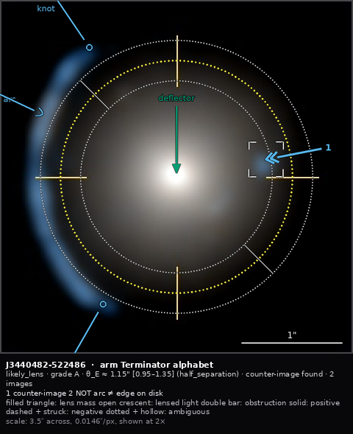
Rank 1, J3440482-522486 — the published lens SL2S J02176-0513. The counter-image carries emphasis=key, hence the corner brackets; its label demoted to the index 1 because it sits too near the panel edge. The mark at upper right is negative polarity: the verifier’s own correction that the NE streak is a field galaxy, not a second arc.
The clean positive case, and it exercises three things at once: emphasis: key on the counter-image (corner brackets, and its label demoting to an index because it sits too near the panel edge — the designed failure, working); a coded method recording that half-separation was the rule used; and a negative mark for the verifier’s own correction, that the NE streak runs radially rather than tangentially and is a field galaxy, not a second arc.

rank 2 — J15199556+2122210, searched and not found
Grade A. A single thin tangential arc, ridge 1.44–1.52″, mean 1.48″ by arc midline.
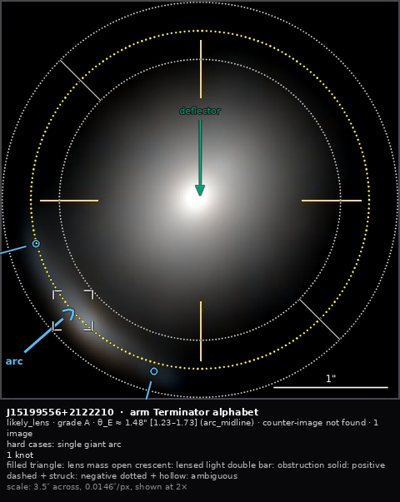
Rank 2, J15199556+2122210 — a single tangential arc. The caption records counter-image NOT FOUND, which is a different statement from not searched.
counter_image: not_found — and that is a different statement from not_searched. The verifier looked at every stretch and none was visible, which is why θ_E rests on the arc radius alone and “could be ~10% high if the source is offset”. Hard case: single_giant_arc.
This is the three-valued absence that DICOM, RadElement, WMO and Galaxy Zoo all arrived at independently (01-prior-art/README.md §5), and here it carries real consequence.

rank 3 — J34707505-219476, the counter-image is farther out than the arc
Grade A. Five blue knots at r 1.24–1.49″ over PA 95–162, plus a blue blob antipodal to the chain at r = 1.88″ — the same colour as the knots, and therefore a plausible counter-image, but at a greater radius than the arc, which is the reverse of the usual configuration.
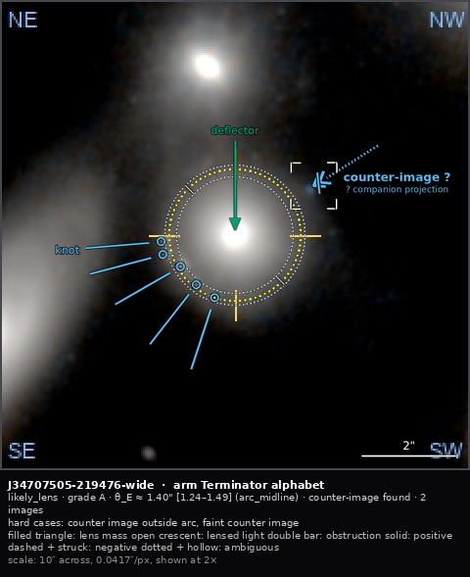
Rank 3, J34707505-219476, on the 10 arcsec field. The blue blob antipodal to the knot chain lies FARTHER out than the arc, so it is marked ambiguous with a named alternative, and the ring records that half-separation was declined.
The verifier explicitly declined half-separation for that reason. The annotation records exactly that: the blob is polarity: ambiguous with alternative: companion_projection — drawn with a dotted shaft and a hollow struck terminator — and the ring carries method: arc_midline, so the decision is recoverable rather than lost. Had the blob been accepted, θ_E would be nearer 1.6″.

The finding this produced
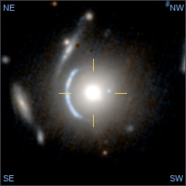
One of the six panels the verifiers actually saw. The rank-3 counter-image at r = 1.88 arcsec falls outside the 3.5 arcsec zoom entirely, so the same annotation is unrenderable there — which is why a mark’s coordinates are meaningless without a declared frame.
The rank-3 counter-image at r = 1.88″ falls outside the 3.5″ zoom panel. The same annotation is simply unrenderable there; it is rendered on the 10″ field instead.
That is the clearest possible demonstration that a mark’s coordinates are meaningless without a declared frame — and that the two field-of-view groups in this figure do not share one. It also shows why the six-panel layout exists: the zoom shows the arc, the wide field shows the counter-image.
The current format has one image per record. It cannot say “these six renderings are of one sky”, cannot say which panel the marks were placed on, and cannot carry a per-panel scale. examples/jwst/variants-*.json writes that case out. This is requirement R33, made concrete by real data rather than argued for.

Files
file | what
examples/jwst/<id>.png | the extracted colour 3.5″ panel
examples/jwst/<id>-wide.png | the colour 10″ panel, where a mark falls outside the zoom
examples/jwst/content-<id>.json | the annotation, in the neutral content form
examples/jwst/<id>-n1.png, -n4.png | rendered under two notations
examples/jwst/<id>-panels/ | all six panels, extracted
examples/jwst/variants-<id>.json | the six-renderings-of-one-sky case

Part VII — Recommendation

Recommendation
Status: a recommendation for the team, not a decision. Where the evidence is thin, that is said.

The short version
 | Recommendation
Notation | N1 Terminator alphabet for adoption now; N4 Evidence graph prototyped alongside it: the only one that fixes the named defect
Metadata container | P1 evolved bespoke — the cheapest decision, and the one that will absorb the most argument
Semantic identity | P4-lite: prefixed terms (lens:arc) resolved in one versioned vocabulary file that generates every other surface
Model surfaces | models read the compact line form (~30k tokens for 50 examples), write JSON under a flat closed schema
Portrayal | leaves the record entirely, into a versioned style document referenced by hash
Accessibility | hard constraint: role by shape, polarity by texture, colour redundant — enforced by an automated ΔE test
Do first, regardless | build the vocabulary file

1. Why the container is the least important decision
I began expecting this to be a choice between GeoJSON, Web Annotation, coded concepts and bespoke JSON. The audit says otherwise. Every structural problem in lensmark/1.0 — six uncoordinated copies of the vocabulary, θ_E stored twice and unlinked, a free-string estimation method, colour carrying semantics, no role field, no polarity, no grouping — is a vocabulary-identity problem. None would have been prevented by any of the containers.
The sharpest illustration is the current definition of a lens galaxy:
def _is_deflector(label): return bool(label) and "deflector" in label.lower()
duplicated independently in Python and TypeScript. A label reading spiral arm, NOT a deflector renders green — the colour meaning lens mass. The semantics of the standard ride on substring-matching an optional 40-character string.
So: choose the container for cheapness, and the vocabulary machinery for rigour. Converters between containers are 57–161 lines each. The vocabulary is the part that decays.
What killed the current format was not a wrong choice; it was erosion — nothing prevented drift. The axis that matters is therefore the one where a mechanism can be installed:
One vocabulary file → generated pydantic Literals, generated JSON Schema enums, generated TypeScript unions, generated prompt vocabulary, generated documentation, with a CI check that fails when any of them is stale.
08-draft-spec/generate.py implements exactly this, and --check is the gate. Adding a role touches one file. Today it touches six.

2. Why P1 rather than the more principled options
P4 (coded concepts, the DICOM SR and NCI AIM lineage) is architecturally the best answer and I am recommending against it. It is the only proposal in which “green means deflector” is structurally impossible, and in which the θ_E double-storage bug is unrepresentable. That is real.
It costs 9.4× the compact form, demands two id spaces, and — decisively — the medical standards sustain that discipline because an institution curates the vocabularies. A three-person group is not that institution. The honest prediction is that the ceremony gets abandoned under deadline, someone adds "role": "arc" beside the coded concept “just for the frontend”, and within a release there are two unlinked representations. Which is the bug being fixed.
So take the identity and leave the ceremony. "role": "lens:arc" — one prefixed string resolved in a versioned, SKOS-shaped vocabulary — retains what matters: profile membership visible in the term, graceful degradation on an unknown prefix, and vocabulary versioned separately from schema. At enum cost.
P2 (GeoJSON) fails on a fact about this data. GeoJSON has no circle, and nine of twenty marks are circles whose radius is the datum. And measured, it is the largest encoding of the six — you pay the standard’s tax and get none of its tooling.
P3 (Web Annotation) fails the flat-schema gate. Its native review model — a critique is an annotation targeting another annotation — is genuinely the best answer to that problem, and worth stealing conceptually. But no flat closed JSON Schema exists for JSON-LD without ceasing to be Web Annotation, at which point the standard’s authority is gone.
P6 (relational) is the right export, not the record. Best corpus-query story by far; hostile to per-cutout editing and to git. Keep it as the thing an archive ingests.

3. The notation
Adopt N1 now; prototype N4 alongside.
N1 keeps the pointer — the one mark the room has consistently endorsed — and moves the semantics into the terminator shape, with polarity in the shaft texture. It has the highest role resolution of the four and the lowest adoption cost, and it is what can be presented at the January meeting.
But N4 is the only proposal that fixes the defect that motivated this work. Flipping through nine panels of the current output, a viewer cannot tell which one is the non-lens: the marks on a lookalike use exactly the same palette and weight as the marks on a real lens. N4 makes a positive panel one with an unbroken chord and a negative panel one whose chord is struck — visible at thumbnail size, in greyscale, from across a room. Its source chord is the one genuinely new idea in the option space, and it should not be discarded because it is unfamiliar.
N2 is not a fifth notation; it is how to write the spec for whichever wins. Assigning each of Bertin’s visual variables to exactly one semantic dimension is what makes the accessibility constraint structural rather than a checklist.
N3’s source-index slot is worth stealing regardless, because source membership is inexpressible today and costs two characters.

The measured case
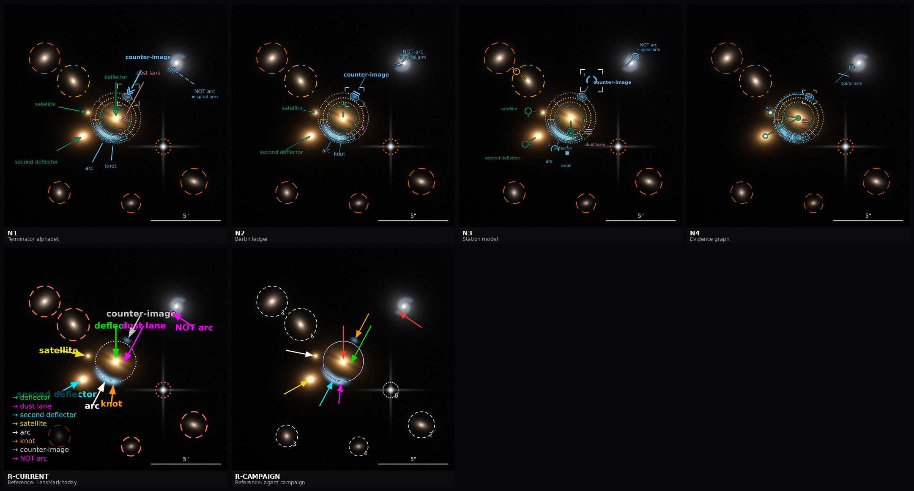
All seven arms side by side at 528 px per panel, including the null arm — the one that asks which marks earn their ink.
arm | ink/statement | statements
N4 Evidence graph | 0.128 | 20
N2 Bertin ledger | 0.154 | 20
N3 Station model | 0.163 | 20
N1 Terminator alphabet | 0.178 | 20
R-CAMPAIGN | 0.133 | 15
R-CURRENT (today) | 0.416 | 15
Today’s notation costs 3.2× more ink per unit of meaning than the best candidate while expressing five fewer things. Read the normalised column: raw ink penalises an arm for saying more.

4. Six changes worth making whichever proposal wins
Notation-independent, individually valuable, in dependency order:
- 2× canonical render. Forced by arithmetic — three stroke elements are below the aliasing floor at native size.
- Tag every drawn scalar METRIC or PRESENTATIONAL. This is the whole answer to “resize for emphasis”: a ring can shout without its radius moving.
- The emphasis enum with layered compositing.
- Keep-out geometry in the label solver, using each circle’s annulus rather than its bounding box. Roughly a twenty-line change and the largest single legibility win available.
- Demotion-to-index so crowding degrades deterministically.
- The caption band, and remove the on-image legend plate from the contract. The plate is ~half the current ink.
Only the sign inventory is a bet. These six are not.

5. Migration
lensmark/1.0 → astromark/lens/1.0 is mechanical for everything except the parts that were never expressible.
today | becomes | lossless?
schema_version: "lensmark/1.0" | schema + profile | yes
items[].type | marks[].type | yes
items[].label | role (inferred from the label vocabulary) + label for display | lossy where a label is free text — needs a human pass over existing decks
items[].color | dropped from the record; derived from role via the style document | intentionally lossy
mask_circle.kind | role + treatment | yes; treatment defaults to mask
system.theta_e.alt_arcsec | lower_arcsec or upper_arcsec by comparison with the nominal | yes, and the two decks carrying (alt) rings are fixed by it
einstein_ring.theta_e_arcsec | geometry only; the measurement lives in system.theta_e | yes — this removes the duplicate
style_defaults (inlined) | style_ref by id and hash | yes
legend.show | legend.mode | yes
— | polarity, alternative, source, hard_case, counter_image, bound, polygons | new; nothing to migrate
The label→role pass is the only part needing human judgement, and it is bounded: nineteen decks.

6. What I could not settle
Stated plainly, because a recommendation that hides its gaps is worse than one that admits them.
- Greg’s few-shot hypothesis is untested. Whether image + coordinate metadata teaches a model better than an annotated PNG is the question the format is partly designed around, and nothing here tests it. 06-llm-ergonomics.md names the experiment; it is cheap now that the encodings exist, and it should run before the format is frozen.
- Token counts are derived, not measured. No Claude tokenizer offline. Character ratios are exact and are what the decision turns on, but the absolute numbers carry an assumption.
- N1 versus N4 is a judgement, not a measurement. The metrics narrow the field and rule out the status quo; they do not choose between two good candidates. The nine-panel forced-choice test — can a reader pick the non-lens from thumbnails alone — would discriminate them, and needs human readers to be worth anything.
- The grade boundaries remain undefined for A, B and D. The format carries grades; it cannot make them carry one meaning for two annotators. That is a separate piece of work and it blocks any inter-annotator agreement measurement.
- Where a dust lane sits in the polarity scheme. It is a real feature (so not negative) that does not support lensing (so positive reads oddly). The current encoding marks it positive and tags the system, which works — but it suggests polarity may want a fourth, neutral value. This surfaced while authoring the reference annotation and is not in the workshop record.
- Occlusion is worse for every candidate than for the campaign reference (≈11% against 6.2%), because the candidates draw bound rings and segmentation polygons the references cannot express. Whether those earn their occlusion is a judgement for the room.

6b. What the prior-art survey changed
Sixty-six formats across eight domains (01-prior-art/). Five findings altered the design rather than merely confirming it.
Presence and polarity are two axes, not one. RadElement separates present / absent / indeterminate / unknown from the term itself. AstroMark’s polarity currently conflates “is this feature really there?” with “does it bear on the lensing claim?” — which is exactly why a dust lane sits awkwardly. This is a better answer than adding a fourth polarity value, and it supersedes what open question 5 originally proposed.
Borrow the object classes; do not mint them. The IVOA object-type vocabulary already publishes grav-lens and lensed-image as URIs, alongside the Unified Astronomy Thesaurus. AstroMark’s own vocabulary should cover what is specific to annotation — polarity, treatment, estimation method, review verdict, emphasis, hard case — and reference the existing astronomical classes. Minting parallel terms is how a standard makes itself un-interoperable and irritates the body whose recommendation it will need. Recorded as an action in the vocabulary file.
Generation method is three-valued. DICOM’s AUTOMATIC / SEMIAUTOMATIC / MANUAL. The middle value is the one everyone omits and everyone needs — a model-proposed arc that a human nudged is neither machine-made nor hand-made, and a two-valued enum mislabels it forever. That is precisely the propose-then-correct workflow this project runs, so the field should be explicit rather than inferred from status: edited.
The grade problem has a worked answer. BI-RADS defines its scale as a three-column table — ordinal category, numeric probability band, and the specific next observation that would settle it — plus a published expected prevalence per grade. PI-RADS goes further and derives the overall category from coded component scores by a published lookup table, storing the evidence rather than only the verdict. For a project whose goal is consistent grading between annotators, the derived model makes disagreement locatable: two graders who differ on the verdict but agree on the evidence have a different problem from two who differ on the evidence. This is the most actionable unclaimed idea in the survey, and it addresses the undefined A/B/D boundaries directly.
Two hard numbers for the render rules. Exactly three lightness levels fit between black and white at 3:1 contrast (0.000, 0.100, 0.400; a fourth needs 1.30, which does not exist) — which independently confirms that the emphasis channel gets three values and cannot get four. And two textures used together must differ in period by a full octave, with every period at least 3× the stroke width. Both are now in 08-draft-spec/render-rules.md.
And one warning worth carrying into the room: a correct design does not win by being correct. DICOM GSPS has been the right overlay answer since 1999, is supported by every PACS, and lost in practice to burning annotations into a flattened image, because that was easier. If AstroMark’s overlay path is harder than exporting a PNG with the marks drawn on, people will export the PNG.

7. What to decide at the review
- Notation: N1 now, or N4, or N1 with N4’s chord grafted in?
- Container: accept P1 + P4-lite identity, or spend the argument on the container?
- Do the six notation-independent changes land regardless? (I would say yes.)
- Is the read/write asymmetry — models read lines, write JSON — acceptable, given it means two surfaces and a round-trip test in CI?
- Should presence and polarity become two separate axes, per the RadElement finding?
- Who runs the few-shot experiment, and does the format freeze wait for it?

8. The one thing to do first
Build the vocabulary file. It is the only artifact all six proposals share, and the only one whose absence caused every problem in the audit. Building it before the container is chosen is not premature — it is the part that is not in dispute.
A draft is already at 08-draft-spec/astromark-vocab-lens-1.0.json: 80 terms across 10 schemes, with definitions, families, statuses, deprecations and a governance rule sized for three people. It generates a flat closed schema that the reference annotation validates against today.

Part VIII — Draft specification

AstroMark core, version 1.0 — draft
Status: draft for review. Not adopted.
AstroMark records annotations on an astronomical image as vector geometry with controlled semantic terms, separately from how those annotations are drawn. This document defines the core. Domain vocabulary lives in a profile; the lens profile is astromark/lens/1.0.

1. Purpose and scope
The record exists so that one person can communicate precisely with another about what is visible in an image, and so that a model can receive that judgement in a form it can be corrected on. It serves both search and modelling: roles, treatments and image-relative coordinates are modelling inputs, not only descriptions.
This specification is written to be handed to a model on its own. Every semantic rule is in this document and in the vocabulary file, not only in a prompt.

2. The three-file contract
file | role
<id>.png | the original image, never modified
<id>.astromark.json | the record: geometry, terms, provenance
<id>.annot.png | a deterministic render, derived from the record
The record is primary and the render is derived, never the reverse. Annotations are an overlay; they are never burned into the image. A consumer that has only the render has lost the record.

3. Coordinates and units
Geometry is normalized: [u, v] with u rightward, v downward, origin at the top-left corner, so [0,0] is the top-left and [1,1] the bottom-right of the image. Geometry is therefore independent of pixel dimensions and of any resampling.
Sizes are in arcseconds, never pixels. Conversion uses pixel_scale_arcsec, which must equal cutout_arcsec / width.
Geometry is image-relative on purpose. Lens modelling consumes image-centred offsets, so converting to sky coordinates at rest would lose the frame the modeller works in. Sky position is recorded once per image, in image.wcs, and derived per mark by exporters when needed.
Orientation is declared by north_up and east_left. When both are true, north is toward smaller v and east toward smaller u, so north-east is the upper left.

4. Marks
A mark is one statement about one place in the image. Every mark carries:
field | meaning
id | stable within the document
type | vector, point, circle, or polygon
role | a term from the profile’s role scheme: what the feature is
polarity | core:positive, core:negative, or core:ambiguous: what the mark does to the interpretation. Only on roles that take it — see below
alternative | required when polarity is not positive: the competing reading
Roles and polarity are orthogonal in meaning but not independent in applicability. role: lens:arc with polarity: core:negative and alternative: lens:spiral_arm states that an arc-shaped feature is a spiral arm. That statement is first-class; it is not encoded in a label.
Polarity applies only to roles that can bear on the interpretation. Each role in a profile declares takes_polarity. Where it is true, polarity is required. Where it is false — a field galaxy to be masked, a star, a detector artefact, a measured ring — polarity must be absent, because such a mark asserts that something is there and to be treated a certain way, and says nothing for or against the interpretation. Demanding a value there would make one of the values mean two different things, and would apply it to the majority of marks in a typical annotation.

4.1 Three geometry families, and why the distinction matters
family | types | is size meaningful?
designating | vector, point | no — a pointer’s length is presentational
extent | circle | yes — the radius is the datum
region | polygon | yes — the vertices are the datum
This distinction governs the emphasis rule in §7 and the render rules. A circle’s radius_arcsec is a measurement; nothing presentational may alter it.

4.2 Reference rather than duplication
A circle may carry center_ref instead of center, naming the mark whose position it tracks. An Einstein ring centred on a deflector mark uses center_ref, so the two cannot drift apart. A dangling center_ref is a validation error, not a warning.
The same principle governs measurements: a measured quantity is recorded in exactly one place. The Einstein radius lives in system.theta_e. A ring mark carries geometry; it does not carry a second copy of the measurement.

5. The system block
One per document: the claim being made about the image as a whole — a verdict, a graded confidence, the measured quantity with its bounds and coded estimation method, the search status for expected counterparts, and free text for people.
Three-valued search status is deliberate. “Not found” must be distinguishable from “did not look”, and in a structured-output schema a null and an absent key are the same thing to many producers, so absence is an explicit term rather than a missing field.

6. Portrayal is not in the record
The record says what is true. A separate, versioned style document says how it is drawn, and is referenced by id and hash. Two consequences, both intended:
- No field of the record may carry meaning through its appearance. A colour cannot mean a role. Deleting every presentational value from a document must not change what the document says.
- A style document can be revised — thinner strokes, a different palette — without touching a single record, and a record renders identically under a pinned style forever.

7. Emphasis
emphasis is core:muted, core:normal or core:key, and it is presentational.
Every drawn scalar is classified:
PRESENTATIONAL — emphasis scales these | METRIC — emphasis never touches these
stroke width, glyph size, label size | circle radius
casing width, dot radius and spacing | polygon vertices
layer alpha, pointer tail position | pointer head position
A ring at core:key is drawn with heavier, closer-spaced dots and a stronger casing. Its radius does not change. Emphasis scales the stroke, never the path.
Two constraints follow. A dotted circle’s dot radius is capped at 0.08 × radius, because oversized dots bias the radius a reader measures off the ink. And emphasis is part of the record, so it is inside the content hash and changes the render — which is correct, and is why a viewer’s transient highlight must never be written to the record.

8. Provenance and review
Every mark records what produced it and, when reviewed, a verdict from the review vocabulary with the magnitude of any correction. This is what makes a propose-then-correct workflow measurable rather than anecdotal: the disagreement between a proposal and a reviewer is data, and it is retained even when the mark is rejected.

9. Free text
Free text exists for people. system.description and per-mark rationale are prose fields.
Every other field is a term or a number. This is a structural commitment, not a convention: it makes “remove all free text” a closed allow-list over keys rather than a judgement about content. A consumer that must not receive prose can therefore be given a provably clean document.

10. Determinism
The same record and the same style document produce a byte-identical render. The record’s content hash covers everything except the render block. A render records the hash of the record it was made from, so a stale render is detectable rather than merely suspected.

11. Profiles
The core defines geometry, coordinates, provenance, portrayal separation and the render contract. It defines no domain terms.
A profile supplies vocabulary. Terms are prefixed strings — lens:arc, core:negative — so a reader that does not implement a profile can tell that a term belongs to one, and skip the mark, rather than failing validation. A bare enum cannot express “not mine”; it can only be invalid.
Adding a profile is a vocabulary release. It requires no change to this document.

12. Conformance
A conforming producer:
- emits geometry in normalized coordinates and sizes in arcseconds;
- uses only terms defined in the core and in a declared profile;
- supplies alternative whenever polarity is not positive;
- records a measured quantity in exactly one place;
- writes no meaning into any presentational field.
A conforming consumer:
- resolves center_ref rather than assuming a coordinate;
- treats an unknown profile prefix as skippable, not invalid;
- never alters a metric value when rendering emphasis.

AstroMark lens profile, version 1.0 — draft
Status: draft for review. Not adopted. Profile of astromark/1.0. Vocabulary: astromark-vocab/lens-1.0.
This profile supplies the terms for annotating strong gravitational lens candidates. The core supplies geometry, portrayal separation, provenance and the render contract, and defines no domain terms.

1. Families
Every role belongs to one family. The family, not the individual role, is what survives at thumbnail size, so it carries the coarsest and most important distinction.
family | contains | the distinction it protects
lens mass | deflector, second deflector, satellite, lens-light region | mass that bends light
lensed light | lensed image, arc, counter-image, counter-arc, knot, secondary ring, lensed-light region | deflected light
obstruction | dust lane, artifact | something that hides or imitates
field | field galaxy, nearby galaxy, companion galaxy, star, ambiguous structure | not part of the system
measurement | Einstein ring | a quantity, not a feature
A lens-mass object is never a lensed image. This is the single most consequential rule in the profile and the one most often broken: a galaxy that is bending light is labelled as a lens, whatever its position relative to the visible arcs.

2. Roles
The full table with definitions is generated at generated/vocabulary.md. Four terms carry rules that are not obvious from their names:
lens:satellite — a galaxy bound to the deflector. It is lens mass and a separate light component for modelling. It is never a mask target. Circling it is an error, not a preference.
lens:counter_image — the image of the same source lying across the deflector. It may lie at a greater radius than the main image. Lensing permits this, so a larger radius is never a ground for rejecting a candidate, and never a reason to shrink the ring to it.
lens:knot — a compact bright region within a lensed image. A whole compact lensed image is a lensed image, not a knot.
lens:dust_lane — an obscuring band inside the deflector. It explains why part of a lensed image may be invisible. It is not evidence against lensing. A system carrying a dust-lane mark records lens:dust_lane_case in hard_case.

3. Polarity, and what a negative mark is for
A negative mark is how the record states a refutation:
{"id": "m8", "type": "vector", "role": "lens:arc",
"polarity": "core:negative", "alternative": "lens:spiral_arm",
"tail": [0.851, 0.358], "head": [0.739, 0.282]}
There is an arc-shaped feature here; it argues against lensing, because it is a spiral arm. An annotation of a non-lens is as informative as an annotation of a lens, and the format must be able to carry the reasoning either way.
core:ambiguous is the class for evidence that supports two readings at once, and is the natural class for a borderline system: the record shows the feature and its alternative rather than choosing silently.

4. The Einstein radius
system.theta_e carries value_arcsec, lower_arcsec, upper_arcsec and a coded method.
θ_E is a radius, never a diameter.
The nominal value is taken at the radial midpoint of the main lensed image — not its inner edge, not its outer edge, and not half the separation between the main image and the opposite one. That last rule is available as a cross-check (lens:half_separation) but is not the primary rule, because the opposite image may lie farther out than the main image.
Bounds are the inner and outer edges of the main image. lower ≤ value ≤ upper is a validation constraint. The term alt is deprecated: a bound whose direction is unstated is not a bound.
Precision is recognition-level, not model-fit level. A ring drawn to a few tenths of an arcsecond is correct; one tuned past that is over-claiming, since a circle is already an approximation to an elliptical critical curve.
Ring marks. At most one nominal ring per source, plus optional lower and upper bound rings. Every ring uses center_ref to track a deflector mark. A ring imprinted by a second deflector is a mark with role lens:secondary_ring, not a second nominal ring.
The drawn circle is not the observed ring. These are two different things and the name invites confusing them:
what you are marking | role | carries polarity?
the circle recording how large θ_E is | lens:einstein_ring | no
the ring of light visible in the data | lens:arc / lens:lensed_image marks, or a lens:lensed_light region, with the source’s config set to ring | yes
So a near-complete Einstein ring in the image is marked as lensed light in a ring configuration, and the einstein_ring mark beside it records only its size. Marking the observed ring only as an einstein_ring loses the evidence: it records the measurement and drops the thing being measured.
The asymmetry has a reason. θ_E is downstream of the lensing interpretation — it can only be computed once a lens has been assumed — so it presupposes the claim and cannot be evidence for it. That is also why the size of θ_E is supporting evidence and never the sole ground for a verdict, a rule this profile puts in the schema rather than leaving to a prompt.
Doubt is carried accordingly, on three separate channels: uncertainty in the measurement by lower_arcsec/upper_arcsec and the coded method; doubt about the interpretation by polarity on the evidential marks; and a ring simply drawn in the wrong place or at the wrong size by a review verdict of wrong_size.

5. Counterpart search
system.counter_image records core:found, core:not_found or core:not_searched.
core:not_found asserts that a search was carried out — across the deflector from every marked lensed image, at all radii out to the edge of the cutout — and that none was located. It is not the default, and it is not the same statement as core:not_searched.
When a candidate is tested and fails, it is recorded with a negative or ambiguous polarity and the reason, rather than left unmarked. A test that produced a result is evidence; silence is not.

6. Sources and multiplicity
source tags a mark as an image of a particular physical source (S1, S2, …), and system.sources declares each source with its image count and configuration.
Two lensed features that cannot be paired are both marked. Whether they come from one source or two is a separate question, recorded in sources or left open — it never justifies leaving a clearly lensed feature unmarked.
Deflector-side roles never carry a source tag: a lens is not an image of anything.

7. Field objects and their treatment
A circle mark on a field object carries treatment:
- core:mask — exclude these pixels from the fit.
- core:model — the object’s light reaches the lens system, so fit it as its own component.
Never circled: the deflector, its extended halo, a bound satellite, any lensed image, any counter-image, or the diffraction spikes of an already-marked star. These are lens mass or lensed light; they are modelled, not removed. The first four are validation errors rather than style warnings.
The deflector’s light extends well beyond its bright core. Treating the visible core as the whole galaxy is a modelling error the record should not encourage.

8. Hard cases
system.hard_case records the morphologies that make a system difficult but leave it a lens: a dust lane, a second deflector, a merged pair, a faint counterpart, a counterpart outside the main image, two sources, a single giant arc, group scale, low signal-to-noise, an obscured arc, dominating lens light.
These are for retrieval as much as for reading. A corpus that cannot be filtered to its hard cases cannot be used to teach them.

9. Segmentation
Two region classes, with deliberately asymmetric tolerance:
- lens:lens_light — the deflector’s light. Tolerant: roughly half the visible halo. Tracing the faintest isophote claims a boundary the data does not support.
- lens:lensed_light — lensed light, including faint opposite images. Recall matters here. A missed faint counterpart is a real error; an approximate outer boundary is not.

10. What the profile deliberately does not decide
Recorded because a specification that pretends these are settled would be wrong.
- The grade scale. Grades are carried as A–D, but only the borderline class has a definition on record. The boundaries need setting before grades can be compared across annotators.
- The probability bands attached to verdicts are a proposal for consistency, not measured values. They need ratifying.
- The nominal ring’s colour, which is a style question and belongs in the style document, but on which practice has differed.
- Which roles take polarity is settled but unratified. Fifteen of the twenty roles declare takes_polarity: true. The five that do not are field_galaxy, nearby_galaxy, star, artifact and einstein_ring.
- The principle: a role takes polarity when the mark can bear on whether the lensing interpretation is true. Inventory roles cannot — they assert only that something is present and how it should be treated. Measurement roles cannot either, for a different reason: θ_E is downstream of the interpretation, computable only once a lens has been assumed, so it presupposes the claim and cannot be evidence for it. Excluding it also puts an existing domain rule into the schema rather than a prompt — that the size of θ_E is supporting evidence and never the sole ground for a verdict.
- The distinction the name einstein_ring invites, and which must not be lost: the drawn circle recording how large the ring is takes no polarity, while the observed ring of light in the data is powerful evidence — and it is a different mark. An observed ring is marked as arc / lensed_image marks, or a lensed_light region, with the source’s config set to ring; all of those take polarity.
- Two boundary calls are judgement and the room should confirm them: companion_galaxy takes polarity because it records the outcome of a failed counter-image test, while nearby_galaxy does not because it is a modelling instruction.

AstroMark render rules, version 1.0 — draft
Status: draft for review. Not adopted.
How an AstroMark record is drawn. These rules live in a versioned style document, separate from the record, so the notation can be revised without touching a single annotation and a record renders identically under a pinned style forever.
Numbers are fractions of m = min(width, height) of the output image unless stated otherwise.

1. Output geometry
The canonical render is 2× the cutout, with the base upsampled by nearest-neighbour — astronomical pixels are never interpolated — and the overlay drawn at 3× supersample of that, then downsampled with a Lanczos filter and composited.
The 2× factor is forced by arithmetic, not preference. A stroke narrower than about 1.25 output pixels aliases into a grey smear indistinguishable from noise. At the native size of a typical cutout, three elements of this notation fall below that floor:
element | fraction of m | at 403 px | at 806 px
bound-ring dot radius | 0.0016 | 0.65 px ✗ | 1.3 px ✓
Einstein-ring dot radius | 0.0022 | 0.9 px ✗ | 1.8 px ✓
leader hairline | 0.0022 | 0.9 px ✗ | 1.8 px ✓
Any proposal to thin the notation at 1× is unsound for this reason.

2. The territory rule
No ink inside the image rectangle that is not about a specific location in that image.
This is the governing constraint, and it is derived from measurement: in the current renders the on-image legend plate occupies 3.7–6.6% of the panel, which is roughly half the total ink and, in most cases, more than every mark combined.
Consequences:
- Identification is in-place. Every mark that needs naming carries its label near the mark. A label is a role name, never a colour name.
- The key is a caption band below the image, costing zero image pixels. Canonical output is width × (height + caption).
- The notation key is printed once per sheet, not once per panel. Nine copies of a constant key is the failure mode to avoid.
- The one exception is the scale bar, which may sit inside the image because a length comparison requires physical adjacency to the pixels being compared. A compass does not qualify: it is a property of the whole rectangle and belongs in the band.

3. Stroke widths and casing
element | fraction of m
pointer shaft, primary stroke | 0.0040
glyph outline | 0.0038
measured circle | 0.0036
leader hairline, anchor | 0.0022
region outline | 0.0028
attention bracket | 0.0030
Every stroke is drawn twice: a casing pass at w + 2 × 0.0022·m in a contrasting ink at moderate alpha, then the stroke itself. Over sky the casing is nearly invisible; over a bright core it supplies the contrast a bare thin stroke lacks. This replaces a hard, opaque text halo, which is legible but heavy.
Dotted circles take a one-pixel casing only. A full casing on a dotted ring doubles its apparent ink and makes it read as a dashed line.
Casing colour is resolved at authoring time, not at render time, and written into the record as dark, light or a resolved value. A renderer that samples the base image to choose is no longer a pure function of its inputs, and the same record over a re-stretched image would produce different ink.

4. Keep-clear
No mark may cover the pixels it refers to.
- A pointer’s tip stops 0.010·m short of its target; the terminator extends backwards from there.
- A measured circle rides the boundary of what it encloses.
- A region polygon is outline-only, or filled at no more than 6% alpha.

5. Line style carries polarity
polarity | shaft | terminator
positive | solid | as the role family specifies
negative | long dash, 0.020 on / 0.010 off | plus a cross-bar struck through it
ambiguous | dotted, 0.0024 dot / 0.0055 spacing | drawn hollow where the positive form is filled
Three numeric rules govern the texture channel, checked when a style document is released:
- any two textures used together must differ in period by at least 2.0× — a full octave;
- every period must be at least 3× the stroke width;
- every texture must survive the rasterisation floor at the smallest intended output size.
Rule 1 is the one most easily violated by intuition: a dashed circle and a dotted circle that look different at full size can converge at thumbnail scale if their periods are close. The existing dashed-galaxy versus dotted-star convention should be measured against it rather than assumed.
Negative gets two redundant channels: it is the rarest mark and the most consequential.
Polarity is carried by line style: texture is the channel that survives downscaling best. Measured discriminability thresholds, for a 0.030·m glyph:
channel | minimum panel
stroke texture | 167 px
orientation, 30° steps | 235 px
glyph shape | 300 px
shape family only | 200 px
text | 367 px
At 260 px per panel — an ordinary contact sheet — text is unreadable. Any distinction that exists only in a label has vanished at that size.

6. Colour is redundant
Role family is carried by glyph shape, polarity by stroke texture. Colour reinforces and never carries alone (WCAG 2.2 SC 1.4.1).
Palette: Okabe-Ito. Lens mass #009E73, lensed light #56B4E9, obstruction #CC79A7, field #D55E00, modelled-not-masked #E69F00, measurement #F0E442, bounds #BFBFBF.
The conformance test is mechanical, not a review step: for every pair of marks that can share a panel, if their inks are closer than ΔE2000 = 15 under normal vision, deuteranopia, protanopia, tritanopia or greyscale, then their glyph shape, stroke texture or orientation must differ. The floor is 15 rather than 12 since pure red against pure green still measures 12.9 under deuteranopia — nearly all of it a lightness difference — and a lower floor would pass the exact confusion the rule exists to catch.

7. Emphasis
Presentational multipliers only:
 | stroke | glyph | label | dot | layer alpha
core:muted | ×0.75 | ×0.85 | ×0.85 | ×0.80 | 0.55
core:normal | ×1.00 | ×1.00 | ×1.00 | ×1.00 | 1.00
core:key | ×1.60 | ×1.25 | ×1.08 | ×1.40 | 1.00
Three levels, and exactly three. This is a bound, not a preference. At a 3:1 contrast ratio between adjacent grades, the achievable relative luminances between black and white are 0.000, 0.100 and 0.400; a fourth grade would need a luminance of 1.30, which does not exist. An ordinal emphasis channel carried by lightness therefore cannot have four values.
Never applied: a circle’s radius, a polygon’s vertices, a pointer’s head position.
Guard rail. A dotted circle’s dot radius is capped at 0.08 × radius, because oversized dots bias the radius a reader measures off the ink. A small circle therefore cannot be emphasised past a point, which is correct.
Attention mark. At core:key only, four corner brackets forming a square around the feature. Not a ring: circles are already spent on measurement here, and a new circle reads as another measured radius. The square’s size derives from the feature it wraps, so it introduces no second free size channel.
Compositing. Each emphasis level draws into its own sublayer at full alpha; the layer’s alpha is scaled once and the layers composited bottom-up. Per-stroke alpha would let two overlapping muted strokes double-composite and darken — an order-dependent defect that is difficult to reproduce.
Draw order: labels, then muted, normal and key geometry, then key brackets, then the caption band. Labels sit below geometry so a label can never hide a mark.

8. Labels
Sizes: primary 0.023·m, alternative-reading second line 0.019·m, index digit 0.017·m. Floor: 11 output pixels for any string that must be read.
Regular weight throughout. Bold is reserved for the single core:key label — one reservation makes bold mean something; universal bold means nothing.
Placement is a greedy search: preferred side first, then perpendiculars and diagonals, at increasing offsets. Candidates are rejected against a keep-out set that includes other placed labels, every pointer head and apex, and — importantly — the annulus of every measured circle at radius ± 0.012·m. A label lying on a ring is read as naming a point on that ring.
The keep-out for a circle is its annulus, not its bounding box. A label may legitimately sit inside a large mask circle; it must only avoid the ring itself. Using the bounding box blocks most placements on a crowded panel and forces needless demotions.
Deterministic failure. When no placement is found, the label demotes to an index digit at the mark and its text moves to the caption band. Crowding then degrades predictably instead of producing overlap. The renderer reports how many labels demoted, so a lint can flag a panel that is carrying too much.

9. Capacity
Guidance, from ink budget and reading effort:
- ink ≤ 3.5% of the panel, hard ceiling 5%
- occlusion of informative pixels below 1.5% where the content allows
- at most 5 labelled marks nominal, 7 hard — beyond that, demote to indices
- texture marks (masks, rings) are read as a set, not individually; ~25 is legible
- at most 2 region polygons
- at most 6 distinct glyph types visible at once
- two labelled marks closer than 0.09·m cannot both carry a full label

10. Determinism
Same record plus same style document produces byte-identical output. No background sampling at render time, no system fonts, no ordering that depends on a hash map’s iteration.
Two assertions belong in the test suite:
- A record with no emphasis renders byte-identical to one with core:normal throughout, so adding the field does not invalidate existing renders.
- The radius recovered from the rendered ink is identical across all three emphasis levels to within 0.1%. This is what catches a presentational multiplier leaking into a metric path.

Appendix A — The naming study

Naming the annotation standard — study and recommendation
Date: 2026-09-03 · For: Greg Benson, Xiaosheng Huang, Nate Kvinnesland · Status: recommendation for review — nothing here has been adopted.
Question asked. What should the new standard for annotating astronomical images be called? It must serve strong gravitational lenses today and extend to astronomical image annotation generally, and it must survive being said from an AAS podium, typed as a package name, and printed in a paper title.
Method in one line. Two agent fleets: 4 generation angles → 25 candidates → 3 web collision-check batches → 3 independent judging lenses, then an adversarial verification round that re-checked the finalists and the three names the room itself had floated. Every registry and domain state below was queried, not guessed. Full method and limitations in §10.

1. Recommendation

AstroMark, with a core-plus-profiles architecture.
Layer | Name | Notes
The standard | AstroMark | what you publish, cite and take to the AAS
The notation (the sign set) | AstroMark Notation | arrow roles and colours, mask circles, the ring, polygons, polarity
The file format | AstroMark JSON | extension .astromark.json
Core schema | astromark/1.0 | geometry, coordinates, provenance, render contract
Lens vocabulary | astromark/lens/1.0 | arcs, counter-images, deflectors, θ_E, satellites, dust lanes
The app | LensMark | keeps its name; becomes the reference implementation of the lens profile
The one-line case. AstroMark is the only candidate in the field with zero astronomy prior art — verified across ASCL, the arXiv API, the full IVOA document index and the astropy affiliated registry, each with a control query proving the search path actually works — while also being self-describing enough that it needs no explanation from a podium, and staying in the -Mark family so that nothing already built has to be renamed.
Why the architecture matters more than the word. Four different things needed names and the room had been trying to find one word for all of them (§2). Separating them means the ApJ paper is about the lens profile of AstroMark rather than a lens-only format — a better framing for the paper, and the difference between a standard that can grow and one that must be renamed at exactly the moment adoption starts.
Migration is mechanical. lensmark/1.0 → astromark/lens/1.0; the -config, -critique, -patch and -manifest sibling schemas restem 1:1. apps/LensMark keeps its directory, its name and its role.

Actions this recommendation implies
# | Action | Why | Urgency
1 | Register astromark.io | verified free; a standard needs a domain it controls for JSON Schema $id URLs and the profile registry. astromark.org is taken by an unrelated stargazing-outreach site | before any public mention
2 | Take the GitHub org astromark-std | github.com/astromark belongs to a working astronomer (Mark Booth, 10 repos incl. the AtLAST sensitivity calculator). Do not squat near him | before first push
3 | Claim PyPI astromark and npm astromark | both verified free | before first release
4 | Trademark clearance by counsel | unresolved — Justia, Trademarkia and the USPTO API all refused programmatic access, so no clearance was performed for any name in this study | before public launch
5 | Read and cite AVM (Astronomy Visualization Metadata) | the nearest existing standard; the spec should say what AstroMark does that AVM does not | before writing the spec
6 | Always write the internal capital: AstroMark, never astromark in prose | separates it from npm’s astro namespace and from the astrology practice that owns the bare lowercase word | style rule

Residual risks, stated plainly
None of these is an astronomy collision; all are search-hygiene:
- Astrology owns the bare word. astromark.us is Mark Dodich’s astrology practice, operating since
  - For a scientific standard this is an unwelcome first search result. Mitigation and counter-evidence: astropy, astroquery, astroplan, astroalign and astroML have made the astro- prefix thoroughly astronomical in practice; nobody reads astropy as astrology. The risk is real but small.
- Astromart is one letter away — the leading amateur-astronomy classifieds portal, which lands in precisely the audience the standard courts.
- npm’s astro is the Astro web framework (5,097,604 downloads/week across 7,860 packages), so a JS toolchain named astromark risks being read as a framework integration. Matters little for a Python/JSON standard with a small frontend; matters more if you ever ship browser tooling.
- Two low-star GitHub projects already use the name: a school gradebook (4★) and a Markdown editor (1★). Neither is in astronomy; the Markdown editor is mildly adjacent.
- astromark.org and astromark.com are gone; .io is the available option.

2. Why the naming question was hard: four things need names
The workshop record (workshops/2026-08-31-LensMark/04-annotation-standard.md §2.11) shows the room circling names — LensMark, LensDown, “lens markup standard”, AstroMark, CosmoMark — without landing. The reason is that four distinct things were competing for one word:
# | Thing | State before this study
1 | The app — hand/model/voice annotation UI, the propose/critique loop | named LensMark; the room decided to keep it
2 | The symbolic notation — green = deflector, dotted ring, dashed vs dotted mask circles, planned polarity and polygons | unnamed
3 | The metadata format — normalized-coordinate vector JSON, provenance, deterministic render contract, schema_version: "lensmark/1.0" | unnamed
4 | The standard as a whole — what gets published, cited and adopted | unnamed
Naming (4) separately from (1) is what unlocks everything else. A general core plus domain profiles means the lens work is a coequal profile rather than a legacy stem:
astromark/1.0 core: geometry, coordinates, provenance, render contract
astromark/lens/1.0 arcs, counter-images, deflectors, theta_E, satellites, dust lanes
astromark/morphology/1.0 (later)
astromark/transient/1.0 (later)
astromark/artifact/1.0 (later)

3. The decision rule the study produced
The most useful finding was not a name but a rule, surfaced by the astronomy-community judge and borne out across the whole field:
In astronomy, names that became standards are dry and self-describing — FITS, WCS, VOTable, MOC, SAMP, HEALPix, region files. Names that are memorable, witty or erudite belong to tools — SExtractor, DS9, TOPCAT, emcee. Tools are chosen. Standards are conformed to.
A three-person group asking a community to conform to a format named in Latin or Greek reads as a conceit. That single rule eliminated the entire etymology cluster the generators were proudest of — Symbolon, Sigla, Signary, Legenda, Vidimus, Indicium, Obelus — not on prior art but on register and on spellability after one hearing, which is the mechanism word-of-mouth adoption actually runs on.
A second rule emerged from the instrument-word cluster: do not name the standard after a word that already denotes something in the images being annotated. Lucida is the brightest star of a constellation. Alidade is the azimuth support structure of a radio dish. Reticle is a focal-plane mark. Each collides with live vocabulary about the very objects the format describes.

4. Evidence for AstroMark

4.1 Astronomy prior art: none, and the search was controlled
Source | Query | Result | Control
ASCL | astromark | 0 codes | cosmomc → 17, lenstronomy → 15
arXiv API | all:"AstroMark" | 0 results | all:"CosmoMC" → 82
IVOA document index | full 357 KB index fetched | 0 (the 47 Mark substring hits are all the editor Markus Demleitner) | —
astropy affiliated registry | 55 packages | 0 containing mark | —
Spellings astro-mark, astromarkup and astromarker were checked separately and are equally empty. There is no existing astronomy annotation or markup tool by that name. The nearest genuine prior art is historical and differently named: Astronomical Markup Language (AML), Astronomical Instrument Markup Language (AIML) and Remote Telescope Markup Language, all 1999-era XML efforts.

4.2 Namespace state
Namespace | State | Method
PyPI astromark | free | JSON API → HTTP 404
npm astromark | free | registry.npmjs.org → Not found
GitHub astromark | taken — Mark Booth, a working astronomer, 10 public repos, account since 2015 | GitHub API
astromark.io | free | whois → “Domain not found”; dig NS and A both empty
astromark.org | registered 2022-05-25, Tucows, Wix-hosted — “Astro Mark, Stargazing Guide” outreach site | RDAP (PIR) HTTP 200, corroborated by whois + dig
astromark.com | taken, parked for sale (Afternic) | dig NS

5. The three names the room already floated
All three were checked; none collides with anything in astronomy. That is the only good news, and it was not sufficient for two of them.

LensMark, as the name of the general standard — rejected
Keep it for the app. Do not promote it. Two independent reasons:
- The stem is both too narrow and ambiguous. It asserts gravitational lensing on every morphology, transient and artifact annotation the standard will eventually carry — a transient broker emitting .lensmark.json is a category error. Worse, in any imaging context the bare word “lens” reads as camera or ophthalmic glass, so for an image-annotation standard it does not even reliably signal gravitational lensing.
- It is the most crowded of the three, and crowded in the adjacent space:
  - lensmark.org is registered and live (2023-04-04, Key-Systems) serving Lensmark — Photo-monitoring Solution for WordPress, a citizen-science photo-monitoring plugin built as a bachelor thesis at Bern University of Applied Sciences for Gantrisch Nature Park (github.com/mrtn97/lensmark-plugin).
  - “LensMark – Picture Border Editor” is a live paid iOS app (App Store id6760441266) that reads EXIF and renders camera metadata as designed overlays on photographs. That is an image-annotation product wearing the name.
  - Lensmark.kz — a funded contact-lens distributor in Almaty, founded 2012.
  - LensMark II — a laser inscription system for marking ophthalmic lenses (Laserop Ltd).
  - lensmark.com is parked for sale at HugeDomains.
- Flag for the team: none of this forces a rename of the research app, but the live commercial iOS collision is directly adjacent and is the name in this study most likely to attract a live trademark. Worth knowing before publication rather than after.

CosmoMark — rejected on semantics despite the cleanest slate
PyPI, npm, cosmomark.org and cosmomark.io are all free — the best availability in the study. It still fails, for a reason that can be quantified: ASCL lists 31 distinct code names beginning with Cosmo — CosmoMC, CosmoSIS, CosmoHammer, CosmoBolognaLib, CosmoPower, CosmoLike, CosmoNest, CosmoPMC, CosmoRec, CosmoLattice, CosmoTransitions, CosmoSlik, CosmoCov, CosmoFlow, CosmoGRaPH, CosmoGraphNet and more — and every one is a cosmological computation code: samplers, likelihoods, Boltzmann solvers, emulators. An astronomer places CosmoMark in that family by reflex, and the -Mark suffix then reads as benchmark, so the compound parses most naturally as “a benchmarking suite for cosmology codes.” Nothing in the name signals images, annotation or geometry — and the standard does no cosmology, so the name over-claims one field while saying nothing about the one it serves.

AstroMark — recommended, see §1 and §4.

6. Runner-up: Markstone
Take this if the team prefers a distinctive proper noun over a self-describing one.
For: PyPI, npm and crates.io are all free — the only candidate clear on all three. It transcribes correctly after one hearing by natives and non-natives alike (two of the highest-frequency morphemes in English, fully transparent orthography). Zero astronomy usage (arXiv all:markstone → 0). It is a 60× sharper search token than the nearest rival (GitHub code search: 1,604 hits vs 96,768 for indicium). And the meaning is exactly right: Old English mearcstān (Bosworth-Toller, attested in charter bounds) is a boundary stone that two parties agree on and inscribe with who set it and when — which is precisely this file: geometry that fixes a boundary of meaning, plus sha256, author, method and date saying who set it. Nothing in that ages.
Against: it carries no astronomy signal whatsoever, so every talk must teach the name before using it, and it pattern-matches to a private-equity firm first. That firm brings baggage: Markstone Capital Partners (Tel Aviv/LA, $800M 2004 vintage) carries a 2010 $18M New York Attorney General settlement. All three obvious domains are registered — and note markstone.org has a registry expiry of 2026-09-07, four days from this report, currently a dead placeholder host; worth watching if this name is chosen. github.com/markstone is a dormant squat. Trademark: the one live US registration is class 33 (alcoholic beverages); the Markstone Capital mark is dead since 2011; no live class 9 conflict surfaced.

7. Killed by verification — the two names the first pass liked most
The verification round exists because the first pass ranked these #1 on two of three lenses. Both fell.

SkyMark — blocked
The first pass claimed astrometry.net “owns” the word. That claim was half wrong and the verification says so: skymark appears zero times in Lang et al. 2010 (arXiv:0910.2233, AJ 139:1782 — quad appears 181 times), zero times in the astrometry.net source, and on exactly one documentation page (doc/readme.rst, 8 lines, introduced 2012-05-18 by Dustin Lang). “The skymark file” would not confuse anyone; astrometry.net says index file 45 times and never skymark file.
But two collisions both earlier passes missed are worse:
- KStars/Ekos ships the literal string SkyMark as a visible GUI label — kstars/ekos/align/opsastrometryindexfiles.ui line 1326, a column header in the Astrometry Index Files settings dialog, with skymarksize as a variable in the accompanying .cpp. KStars is a mainstream cross-platform astronomy application in every Linux distribution.
- Starlink’s IRAS90 has an application literally named SKYMARK whose stated purpose is “Draw markers at specified positions” on sky images, with the positions logged to a reusable file. That is this project’s concept, under this exact name — albeit in a long-obsolete package.
Namespace seals it: PyPI and npm free, but the GitHub org is squatted, and every obvious domain (.com, .org, .net, .io, .dev, .app, .ai) is registered — only .sh is free. Bare-word search page 1 is 100% commercial, 0% astronomy — Skymark Airlines dominates. The SkyMapper phonetic-confusion claim was an overreach (2 vs 3 syllables, different stress and coda); the real residual is same-domain adjacency in reference lists.

PlateMark — blocked
It has the best namespace in the entire study: PyPI, npm, .org, .io and .net all verified free three ways each (registry whois, RDAP, NXDOMAIN). It dies on semantics anyway.
“Plate” in astronomy is not fading — it is growing, and every live sense is an image-metadata sense:
- Plate solving. ASTAP, the most widely used astrometric solver, released v2026.09.03 describing itself as a “plate solver” and listing “Star annotation” and “Deep sky annotation” features in the same breath. This is the most damaging collision: adjacent tool, adjacent function, same word.
- Plate scale. Rubin/LSSTCam documentation (updated May 2026) states the 0.2 arcsec/pixel plate scale. Universal in instrument papers, never going away.
- Photographic plates — measurably growing. arXiv title/abstract counts for “photographic plate”: 19 in 2014–2016 vs 31 in 2024–2026. DASCH finished scanning in early 2024 (429,274 plates) and released DR7 on 2024-12-29 with 23,574,404,199 measurements of 252,458,490 sources.
- SDSS. Plug plates are operationally retired, but DR19 still documents spec files as FIELD(PLATE)-MJD-CATALOGID(FIBER) and the glossary still defines “Plate.”
Why this is a permanent tax rather than a two-second correction: a harmless homonym is one the listener discards instantly because the wrong reading is absurd (nobody thinks Python is a snake in a code review). Here every wrong reading is plausible and adjacent. And there is a sharper irony worth recording: the format’s headline property is vector geometry in normalized coordinates — explicitly plate-scale-independent. Naming it “Plate”-anything primes the exact property the design was built to repudiate.
Discoverability compounds it: “platemark” is an established art term (the ridge embossed by an intaglio plate), and the bare word is owned by a printmaking podcast, a 1999-vintage interior-design firm on the .com, and two 2026 restaurant-menu products on .dev and .app.

8. Blocked on prior art
Name | Intended expansion | What blocks it
AVAM | Astronomical Vector Annotation Metadata | AVM — Astronomy Visualization Metadata, the IVOA-endorsed standard for metadata embedded in astronomical image files. One inserted letter from the single nearest existing standard in concept space; indistinguishable by ear from a podium
AAM | Astronomical Annotation Metadata | AAM = Author Accepted Manuscript, everyday scholarly-publishing vocabulary every astronomer meets through arXiv deposit; also one letter from AVM
IMAS | Image Markup and Annotation Standard | ITER’s IMAS (Integrated Modelling & Analysis Suite), an established big-science data standard; the neighbour AIMS is already double-blocked in astronomy
VERSA | Vector-Encoded Region Standard for Astronomy | Versa Networks (SD-WAN vendor, registered marks); “vice versa” pollutes every search
GLOSS | Geometry, Labels and Overlay Semantics Standard | GLOSS = Global Sea Level Observing System (IOC/UNESCO); gloss is an established Haskell 2D-vector-graphics package family
CAIRN | Coordinate-Anchored Image Region Notation | CAIRNS — the Cluster And Infall Region Nearby Survey (Rines et al. 2003–05), one letter away in the same literature; also Cairn Research Ltd (scientific imaging hardware) and phonetically on top of Cairo
Blazon | heraldry’s formal description, from which any herald re-draws the image | blazar — one letter, near-homophone, and one of the most-annotated source classes in high-energy astrophysics
Stencil | — | Entrenched in computational astrophysics (finite-difference stencils, 26 astro-ph abstracts); Stencil.js owns the software namespace
Dioptra | Hero of Alexandria’s sighting instrument | NIST’s Dioptra, an active AI/ML test platform (300★), whose audience overlaps the survey-ML community you are courting
Indicium | Latin indicium, the evidence of a witness | Live Rust crate (v0.6.10, 2026-07-12, 928,613 downloads); Indicium Tech, a $92.8M-ARR data/AI consultancy in your exact category with a pending USPTO Class 35 application; plural indicia already means the metadata block printed on a published object

9. The rest of the field
Generated and collision-checked, not recommended. Recorded so the ground is not re-covered.
Name | The deciding objection
VOMA (Vector Overlay Metadata for Astronomy) | The VO- prefix is IVOA’s de facto namespace (VOTable, VOEvent, VOSpace, VOResource, VO-DML, VOUnits). Using it without sponsorship reads as claiming an endorsement you do not have — and invites the rename at the exact moment of adoption. Also one letter from VOMS. An acronym additionally freezes today’s implementation into the permanent name.
Reticle | Semiconductor lithography owns it commercially (a reticle is the photomask patterning a wafer); gun-sight crosshair is the consumer reading; github.com/reticle is an org with 11 repos and PyPI is taken
Waymark | PyPI waymark actively maintained (v0.22.0); waymark.com is an AI ad-video company; Waymarking.com is the geocaching incumbent
Signary | Heard once, lands as “signatory” or “seminary”; .sgy is a hard clash with SEG-Y seismic data; GitHub org taken
Sigla | One vowel from sigma, the most-spoken word in an astronomy talk; in Italian/Spanish/Portuguese it is the ordinary word for “acronym”
Legenda | The format already contains a legend block; Legenda is also the Modern Humanities Research Association’s academic imprint; a common noun for “caption” in five European languages
Vidimus | A conjugated verb, not a noun; PyPI taken by a conceptually adjacent provenance-attestation package
Symbolon | Strongest modern association is the Symbolon astrology card deck — the worst possible adjacency for an astronomy standard; PyPI held by a live 2026 package
Lucida | Lucida already means the brightest star of a constellation; the Lucida typeface family ships on every Mac and PC
Obelus | The historical obelus marks a passage as spurious or to be deleted — a negative valence for a standard that must record confirming and refuting evidence neutrally; the modern glyph is the division sign
Alidade | In radio astronomy “the alidade” is the rotating azimuth support structure of a large dish; one phoneme from Aladin, the CDS sky atlas that already dominates image-plus-overlay work
Stave | No astronomical connection at all; “score” collides with the numeric grade the schema already carries; asyml/stave is an existing annotation-tool framework

10. Method, provenance and limitations

What was run
Pass | Agents | Shape | Cost
Generation + collision check | 10 | 4 independent naming angles (mark-lineage, astro-acronym, metaphor, architecture) → 25 distinct candidates → 3 web-search collision batches → 3 independent judging lenses (astronomy-community adoption, engineering/spec ergonomics, ten-year longevity) | 674,575 tokens, 210 tool calls, ~29 min
Adversarial verification | 4 | Re-checked the two leaders against primary sources with instructions to refute; vetted the three names the room itself had floated, which the first pass had been told to skip | 301,901 tokens, 193 tool calls, ~12 min
The verification pass earned its keep: it overturned the first pass’s top two names (SkyMark and PlateMark), corrected a claim the first pass had gotten wrong in both directions (the astrometry.net “skymark” usage — real but far less entrenched than reported, while two worse collisions had been missed entirely), and refuted an availability claim (Indicium’s Rust crate was reported gone; it ships 928k downloads).

Sources actually queried
ASCL, the arXiv API (metadata and, for Lang et al. 2010, the PDF via pdftotext), the full IVOA document index, the astropy affiliated-package registry, PyPI JSON and simple APIs, the npm registry, crates.io, the GitHub REST and code-search APIs, RDAP (PIR and Identity Digital), registry whois, dig, and project source trees (astrometry.net, KStars/Ekos) fetched and grepped directly.

Limitations — read these before relying on the study
- NASA ADS was never queried. Its API returns HTTP 401 without a token and the SciX web UI returns an empty HTTP 202 to a fetcher. Control-verified arXiv and ASCL searches were substituted. Full-text literature usage of any candidate is therefore not established — only title/abstract and code-registry usage.
- No trademark clearance was performed for any name. Justia and Trademarkia return HTTP 403 to programmatic access and the USPTO search API refused the request. The trademark facts that do appear (Markstone class 33, Markstone Capital’s dead mark, Indicium’s pending Class 35) came from secondary sources. Counsel must clear the chosen name before public launch — most urgently if the team ever promotes LensMark outward, since it has real commercial users.
- Domain and registry states are as of 2026-09-03 and change. markstone.org expires 2026-09-07.
- Judging is judgement. The three lenses were scored independently and deliberately not reconciled; §3’s decision rule is the study’s inference from their agreement, not a measured fact.

Prior art worth reading before writing the spec
- AVM — Astronomy Visualization Metadata: IVOA-endorsed, metadata embedded directly in astronomical image files (JPEG/TIFF/PNG/GIF), covering title/caption/credit, colour-to-wavelength assignment and coordinate projection. The nearest neighbour in concept space; the spec should state plainly what AstroMark adds (vector annotation geometry, semantic roles, polarity, a deterministic render contract).
- DS9 region format — the community’s existing de facto shape-overlay format and the adoption precedent the room itself cited.
- Historical: Astronomical Markup Language (AML), Astronomical Instrument Markup Language (AIML), Remote Telescope Markup Language — 1999-era XML efforts, all dormant.

11. Open questions for the follow-up session
- Adopt AstroMark, or Markstone, or neither? The -Mark family is what lets LensMark survive unchanged; that is an argument of convenience, and the room may weigh it differently.
- Does the notation layer need its own name at all, or is “AstroMark Notation” enough?
- Profile naming convention: astromark/lens/1.0 (path-style, recommended) vs astromark.lens/1.0 (dotted). Path-style matches the existing lensmark/1.0 shape and reads better in a $id URL.
- When does the rename land relative to the paper? The safest order is: decide the name, register the namespaces, then write the spec section, then restem the repo — not the reverse.
This study makes no changes to apps/LensMark or to the workshop package. The room’s naming discussion is recorded at workshops/2026-08-31-LensMark/04-annotation-standard.md §2.11 as an open item; this report is the answer to it, pending review.

Appendix B — Verification and provenance

Verification
Run 2026-09-03. Every check is reproducible from examples/ and 08-draft-spec/.
# | Check | Result
1 | Determinism. Rebuild the reference cutout from its seed; compare bytes. | PASS — identical (322450f9f5ee4344…)
2 | CIEDE2000 correctness. Nine reference pairs from Sharma, Wu & Dalal (2005), including the pairs that break naive implementations. | PASS
3 | Accessibility gate. Every pair of marks that can share a panel, under normal vision + deuteranopia + protanopia + tritanopia + greyscale. | PASS — 136 pairs, 123 below the ΔE floor, 0 separated by colour alone
4 | Generator staleness. All four downstream artifacts regenerated from the vocabulary file and compared. | PASS — 4/4 current
5 | Gate G1: structured-output shape. $ref count and open objects in the generated schema. | PASS — 0 $ref, 0 open objects
6 | Schema usability. The reference annotation validated against the generated schema. | PASS
7 | Embargo, model-facing. Both spec documents and the render rules, against the transcript 4-grams and the 298-entry banned lexicon. | PASS — 0 lexicon hits, 0 collisions of any kind
8 | Repo hygiene. Changes outside formats/; embargoed imagery under formats/. | PASS — 0 changes, internal/ ignored

Reference-arm validation
The prototype’s reference arms reproduce the real thing closely enough to trust the comparison:
arm | prototype | real
R-CURRENT (LensMark today) | 6.23% ink | 6.4–10.8% across the nine decks
R-CAMPAIGN (agent campaign) | 1.99% ink | 1.2–2.3% measured on the campaign renders

Migration, executed rather than asserted
examples/migrate_lensmark.py converts a real lensmark/1.0 deck. On deck-08 (29 marks, the group-scale two-deflector ring): all four arrow labels mapped to roles lexically, 24 mask circles defaulted to treatment: mask, and four system-level fields need a human pass — counter_image, n_images, hard_case and sources. Those four are not conversion failures; they are the things lensmark/1.0 had no way to record.

A verification gap this exposed
The first build of AstroMark-Research.pptx rendered correctly through LibreOffice to a 59-page PDF, and PowerPoint refused to open it. One caption box on a code slide had been given a negative height (cy = -146304 EMU) when the code block ran long enough to push it past the slide edge.
LibreOffice silently tolerates a non-positive shape extent. PowerPoint treats it as corruption and offers to repair the file. So rendering a deck to PDF is not sufficient verification that it opens.
Two fixes, both in build_deck.py:
- every textbox clamps its width and height to a positive minimum, and the code-slide layout budgets its vertical space before drawing rather than after;
- Deck.validate() runs before every save and refuses to write a file containing a non-positive extent, an off-slide origin, or a shape overrunning the bottom margin.
The structural checks that now pass on the built file: XML well-formed in every part, no non-positive extents, no duplicate shape ids, every table’s row cell-count matching its column count, and every relationship id resolving.

The same gap, caught a second time
Building the Word report hit the identical class of problem. The link flattener — which turns cross-document Markdown links into plain text, since inside one document they point at nothing — used a regex that also matched the caption half of an image reference ![caption](path). Every one of the fifteen figures was silently stripped before pandoc ever saw it.
The build reported success, because the assertion compared the number of image references in the assembled Markdown (0, after stripping) against the number of shapes in the document (0). Two zeros agreeing is not a check.
Fixed twice over: the flattener now refuses to match after a !, and the assertion is three-way — figures injected, references surviving into the Markdown, and shapes present in the document must all agree. A figure eaten before pandoc, or one that fails to resolve after, now fails the build.
Structural checks that pass on the built .docx: every XML part well-formed, all 15 media files present with no dangling relationship ids, 15 drawings with no non-positive extents, and updateFields set so the table of contents fills on first open.

The three-way assertion earned its keep immediately
On its first run after being added, the figure assertion failed: 15 injected, 16 references in the markdown, 15 shapes in the document. The sixteenth was a literal ! + caption inside a code span in this very file, where the image-stripping bug above is documented. The count was right — 15 figures really did render — but the counter was counting image syntax inside code.
Fixed by stripping fenced blocks and inline code before counting. Worth recording because a check that had only ever seen agreement had not been shown to detect anything; this one detected a real discrepancy the first time the inputs changed underneath it.

What is NOT verified
- Token counts are derived, not measured. No Claude tokenizer is available offline. Character counts are exact and the ratios between encodings are what the decision turns on.
- No live structured-output call was made against the generated schema. It is flat and closed by static check, and validates the reference document, but gate G1’s live half is unrun.
- No human legibility testing. The thumbnail forced-choice test — can a reader pick the non-lens from a contact sheet — is specified but needs human readers to mean anything.
- The few-shot hypothesis is untested. See 06-llm-ergonomics.md §4.
- Anomalous trichromacy (deuteranomaly, the most common deficiency) is not simulated; the gate tests dichromacy at severity 1.0, which is conservative but not the same thing.

Embargo check: adjudication of 4-gram collisions in the research prose
Run: python examples/embargo_check.py 0*.md README.md --json qa/embargo-research-prose.json Date: 2026-09-03. Raw report: embargo-research-prose.json.

Final state (19 files, 2026-09-03)
set | result
Banned lexicon (298 strings from the written comments), all 19 files | 0 hits
Model-facing spec (08-draft-spec/*.md) | all CLEAN — 0 collisions of any kind
Human-facing research prose | 6 generic collisions, adjudicated below
The spec is held to the strict bar because it is meant to be handed to a model. It reaches it by being written from the adjudicated enum artifacts rather than from transcript-quoting prose — the same discipline the embargo asks for, applied at the source rather than at the check.

Result
Banned lexicon (the 298 strings from the written comments): 0 hits in every file. That is the check that matters most, and it is clean.
4-gram collisions against the transcript: 18 spans, all adjudicated GENERIC. The tool’s own classifier escalated 7 of them as SUBSTANTIVE because they contain a content-class word. Each is adjudicated below by hand. None reproduces domain meaning; all are ordinary English constructions that collide by chance with a 21,078-n-gram corpus.
span | file | disposition
rather than starting from | 03 | generic — no domain noun; describes a design method, not a lens
in full this is | 04 | generic — sentence connective
the shape of the | 04 | generic — “shape” here is a JSON structure, not a lens feature
this is the part | 05 | generic — discourse pointer
is the difference between | 06 | generic — comparative connective
the reason is that | 06 | generic — causal connective
if the source is | 09 | generic — conditional clause. The surrounding sentence paraphrases a verifier agent’s written note in top100_clean.csv, which is machine-generated text and not part of either protected corpus
is the only one, the only one that, this is not a, this is not the, this is the only, why this is not, is that it is, it is the same, it has to be | various | function words only; classified GENERIC mechanically

Why blind pass/fail is the wrong instrument here
ngram_check.py is a deliberately strict tripwire built for short proposed prompt text, where any collision deserves a look. Applied to long-form prose it will always flag ordinary English, because four function words in a row appear in any 21k-n-gram corpus. The correct use is triage, not a gate: a hit is a prompt to check, and the check is whether the shared span carries meaning from the protected source. None of these do.

The stricter standard, applied to the spec
The research prose in this directory is human-facing and cites the workshop reports by path. The draft spec in 08-draft-spec/ is model-facing and is held to a higher bar: it is written from the adjudicated enum artifacts in analysis/proposals.json rather than from transcript-quoting prose, and every collision it produces is adjudicated in the same way before the spec is considered finished.

