Bank Application with Data Providers

Introduction:

As per given requirements for assignment task, Task has been implement a rest service that accepts requests to validate a bank account and returns information if the requested account is valid. The service doesn't store any data but instead sends validation requests to other account data providers, aggregates this data and returns to the client.

Implementation Overview :

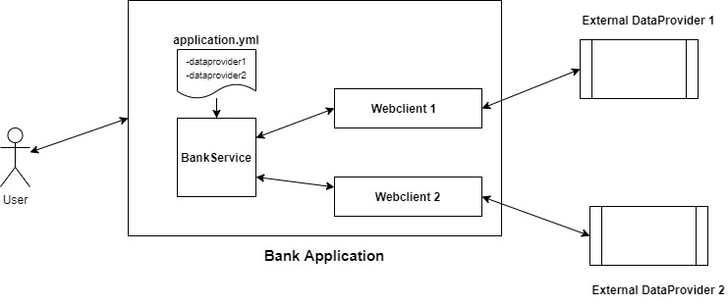

- User is initiating the request (includes accountnumber, dataproviders) to “bank_app”
- “bank_app” is processing the request and find the appropriate dataprovider(using webclient) to make external service call
- “Webclient” communicate with “Dataprovider” and trying to retrieve the results
- “Dataprovider” receives the account_number and check if its existed or not; If existed returns isValid as true or else “false”
- Based on external call response, “bank_app” prepares response and send back to client.

Application Urls:

Bank Application | http://localhost:4040/api/bankaccount
Data Provider1 | http://localhost:5050/api/validateBankAccount
Data Provider2 | http://localhost:6060/api/validateBankAccount

Application Project Setup, Startup and Configuration:

Application is setup with three different projects.

- “bank_app” acts as main project to process the request and invoke the external services using Webclient
- “dataprovider1” acts as Data Provider annd validates the given bank account valid or not
- “dataprovider2” acts as Data Provider annd validates the given bank account valid or not

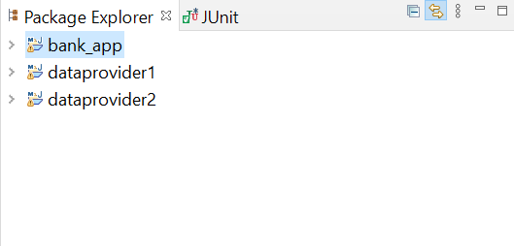
Every Project is configured with Production & Non-Production Configuration with profiles such as dev, sit, uat, prod.

For Application Startup, we supposed to provide the profile infomartion as well

Example :

java -jar bank_app.jar -Dspring.profiles.active=prod

Sample Execution:

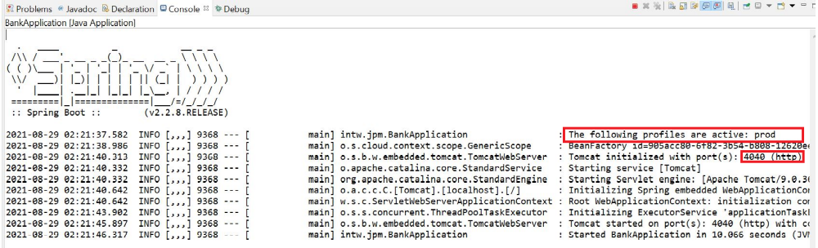

Test Results (Using Postman Rest Client):

Case 1: Validation failures with both data providers due to server failure

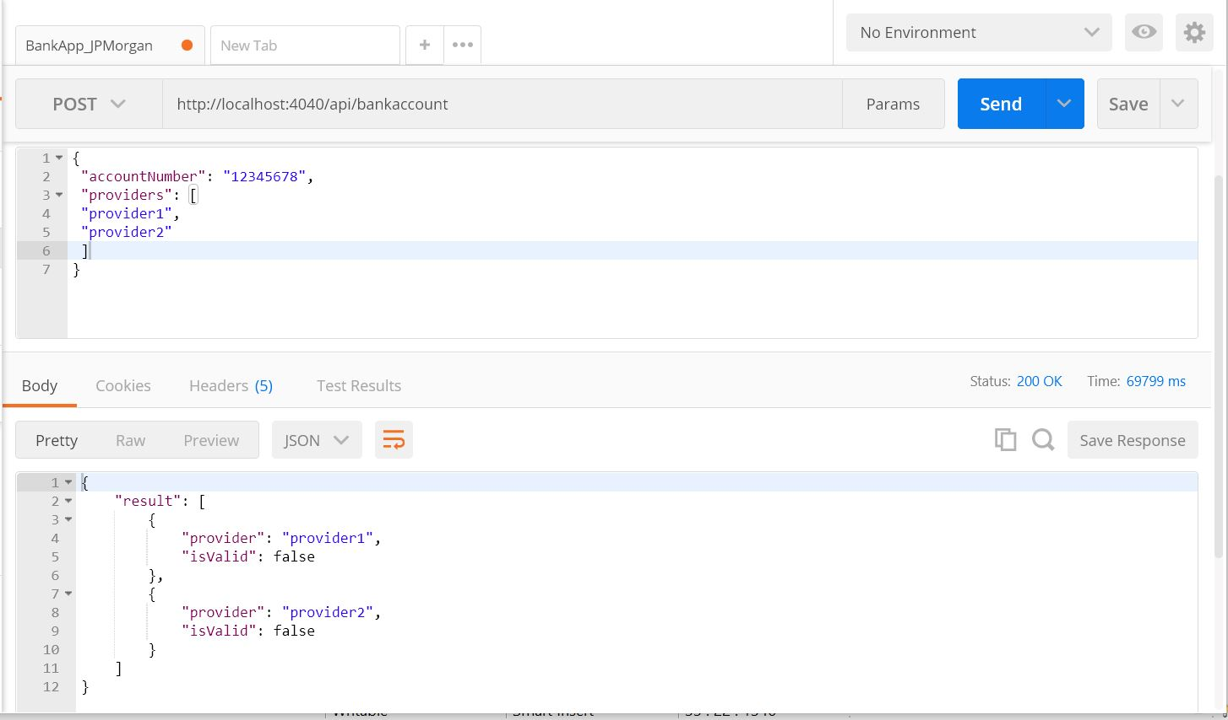

Case 2: Validation success with dataprovider1 and failure with dataprovider2

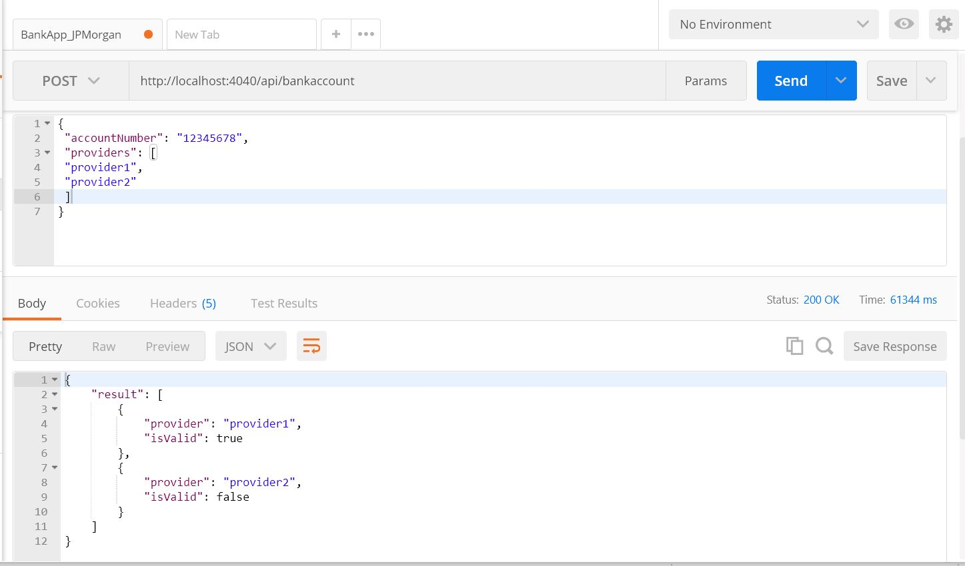

Case 3: Validation success with both dataproviders

