# Setting up a GeoServer WMS

GeoServer is a free, open source server application written in Java that allows users to share geospatial data using Open Geospatial Consortium (OGC)-compliant services, including Web Feature Services (WFS) and Web Map Services (WMS) (<http://geoserver.org/display/GEOS/Welcome>). This section describes deploying GeoServer using the OpenGeo Suite ([http://opengeo.org/pro-ducts/suite/](http://opengeo.org/products/suite/)) for OneGeology WMS services, targeting [3-Star accreditation](http://onegeology.org/technical_progress/accreditationForm.cfm), with some additional configuration considerations for use of application schemas in GeoServer to deploy 'advanced' 3-Star services that can take advantage of the lithology and age query functions offered by the OneGeology portal. The examples and discussion here were written using GeoServer version 2.3.4. New versions are released frequently, and if you have a different version, some dialog boxes or procedures may be different.

## Prerequisites

You may set up and configure a web map service on any PC or laptop that is accessible from the internet, and is running the appropriate software, which in this section of the cookbook is GeoServer. The discussion here assumes that data to be served are vector data available in an ESRI shapefile; GeoServer can also deploy services based on raster data (e.g. GeoTIFF), but the workflow for raster based services is not described here. See the [GeoServer documentation](http://docs.geoserver.org/stable/en/user/data/raster/index.html).

## Software installation

GeoServer is built on the Java framework and therefore supported on many different platforms, such as Linux, Mac OS X and Windows. Java applications such as GeoServer need to be run through a Java servlet engine. The servlet engine is an application that provides the host environment within which Java applications run; the servlet engine provides the wrapper that allows the Java program to run on different operating systems.

### Install using OpenGeo Suite (recommended)

The OpenGeo Suite (<http://opengeo.org/>) provides an integrated, free, open-source package that includes GeoServer, along with the Postgres/PostGIS database and a variety of other components for managing data and working with OGC services, all configured to work together. The Suite is available in a free community edition or paid edition that includes technical support. When installing the suite, be sure to install the pgAdmin III administration tool, which can be used to create new databases, tables, views, and users, execute SQL statements, modify user permissions, and much more. Although these tasks can still be accomplished via the psql command shell in Postgres, pgAdmin III makes life much easier.

### Install GeoServer stand alone on Windows

Alternatively, GeoServer can be installed alone. The two primary ways to [install GeoServer](http://docs.geoserver.org/stable/en/user/installation/index.html) on Windows are: 1) by launching the Windows exe executable file, or 2) by deploying the web archive (war) file. The Windows exe installer will install the Jetty servlet engine and create a Windows Service for automatic startup. The war file must be deployed in a previously existing servlet engine; this typically means copying the file into a specific file directory specified by the servlet engine configuration.

The latest version of GeoServer can be found at <http://geoserver.org/display/GEOS/Download>. It is recommended to install the stable version. No GeoServer extensions/plugins are required. Installing GeoServer using the Windows exe installer is a straight-forward process: download the latest stable version of GeoServer and launch the executable file, which starts a GeoServer set-up wizard. Once GeoServer is installed and the service running, point your web browser to http://localhost:8080/geoserver/ to confirm the installation. You should see a welcome page that looks like Figure 1. Log in using the username and password set during installation. The default username and password is admin/geoserver. After installation, be sure to resolve any notices about security related issues that are displayed on your local GeoServer homepage.

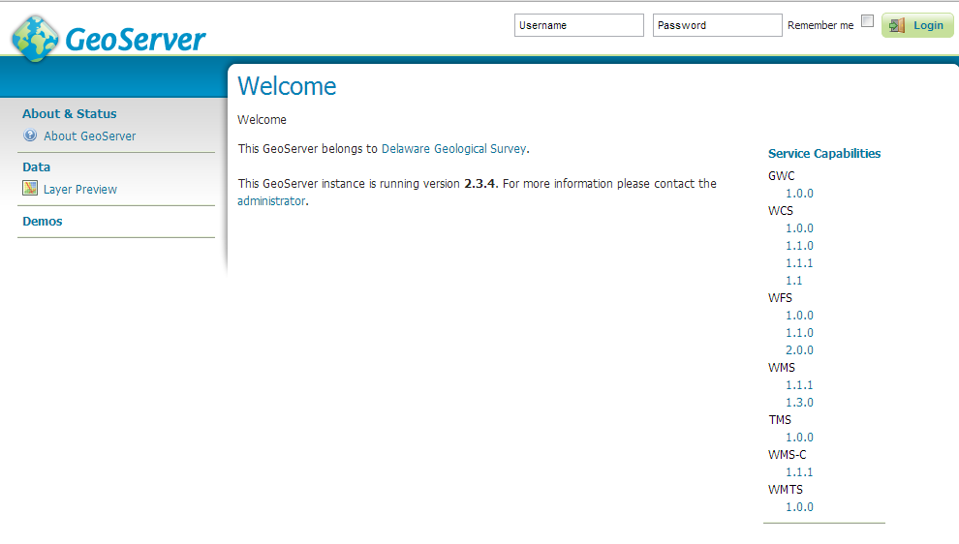

Figure 1. Geoserver welcome page.

## Configuring your GeoServer WMS

This procedure assumes that you have a working GeoServer deployed, and that you have administrative privileges necessary to rename applications in the containing servlet engine (typically Tomcat or Jetty), and to create workspaces, stores and layers in the GeoServer instance.

### Assigning the service name

OneGeology mandates that the WMS service URL must include the exact wording of the service title with all spaces in the service title replaced with underscore characters (_) (see <http://onegeology.org/wmsCookbookP/2_3.html>). For example, if the service title is "BGS Bedrock and Superficial Geology" the service URL must include the string "BGS_Bedrock_and_Superficial_Geology", like "http://ogc.bgs.ac.uk/cgi-bin/**BGS_Bedrock_and_Superficial_Geology**/wms/…". To conform to this rule using GeoServer, the web application name in the servlet engine must be the required service title string, because that is what GeoServer uses to construct the service root URL.

Need instructions here (tomcat and jetty?)

### Logging in

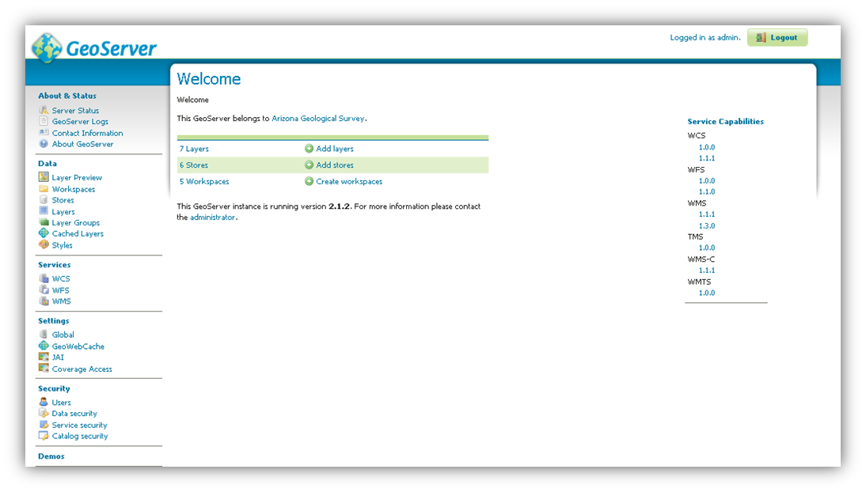

Figure 2: the GeoServer Web Administration Interface

To deploy a web service in the GeoServer environment, your first step is to log in to the **Web Administration Interface** for the GeoServer instance you will be using to deploy your data as a web service (Figure 2). The Web Administration Interface is a browser-based user interface for administering server software via an Internet connection.

In order for your services to be publicly accessible, configure the host and port of your GeoServer instance in such a way that your GeoServer instance can be accessed remotely. To access the Web Administration Interface of a GeoServer instance, open your web browser and enter the appropriate web address into the navigation bar. GeoServer is usually installed such that the administrative interface can be accessed at a URL with the following address pattern using a web browser:

**http**://<**host**>:<**port**>/**geoserver**/**web**/, <**port**> is usually **8080,** and <host> is the name or IP address of the server.

The default account settings for GeoServer are as follows:

Username: admin  
Password: geoserver

For security reasons, it is recommended that you change your password to something more secure as soon as possible.

### Service-Level Metadata

Within the GeoServer Web Administration Interface (Figure 2), click Contact Information, under About & Status. This brings you to a **Contact Information** form (Figure 3) in which you can provide contact information for your GeoServer instance. The information entered here is used to provide service-level metadata for the web service that is accessed by the OGC GetCapabilities request, so information entered here should be as precise and comprehensive as possible.

To deploy your service in compliance with OneGeology conventions, your server-level metadata and layer configuration will need to meet very specific requirements; see the [WMS profile](http://onegeology.org/wmsCookbookP/2.html) section for details.

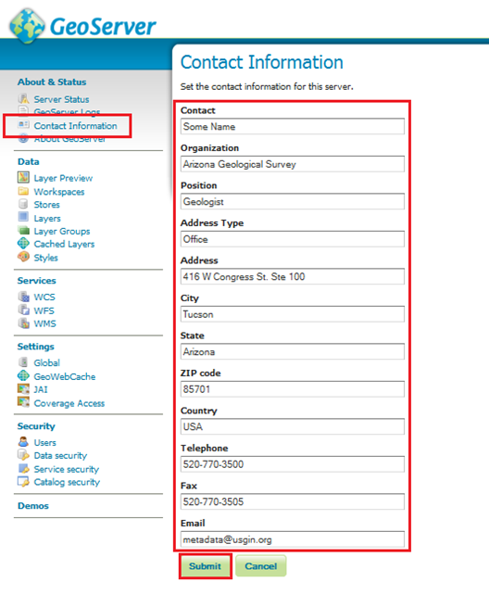

Figure 3: GeoServer Contact Information

### Creating a Workspace

A GeoServer workspace is associated with a Namespace URI that will appear in WMS getFeatureInfo XML responses, and the workspace name will be used as the prefix for XML elements. OneGeology WMS services do not specify requirements for GeoServer workspace names.

1. On the left side of the GeoServer **Web Administration Interface**, under **Data**, click **Workspaces**. This will bring you to the **Workspaces** page, wherein you can manage existing workspaces and create new workspaces.
2. Click **Add New Workspace**. This will bring you to the **Edit Workspace** page for your new workspace.
3. Two fields are present on the Edit Workspace page:
4. **Name**: The **workspace name**; may contain spaces or special characters. This name will in general not be seen or needed by users accessing OneGeology WMS services.
5. **Namespace URI**: A URI associated with your project. If the schema for data used to support the WMS is identified by a URI, use that here, otherwise any URI that is unique to this service will suffice.
6. When you are finished, click **Save**.

### Add Data

#### Connecting to Shapefile

1. First, place the shapefile of the intended data source in a file location that can be accessed by your GeoServer instance. For the following example file location, a folder named “shapefiles” was created to house shapefiles in the geoserver installation directory: %installLocation%\geoserver\data\shapefiles
2. On the left side of the GeoServer Web Administration Interface, under Data, click Stores. This will bring you to the Stores page.

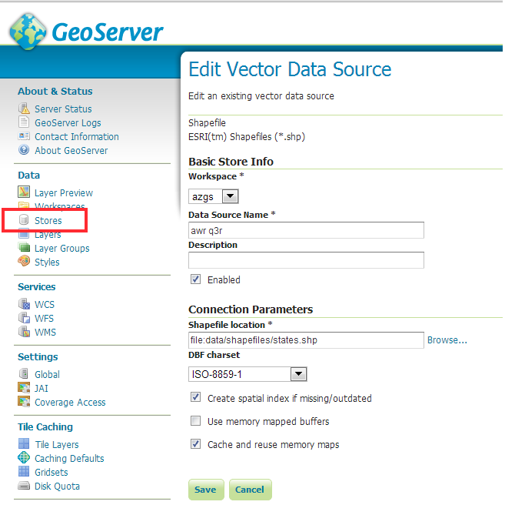

Figure 4. Create data store for Shapefile.

1. On the Stores page, click Add New Store. This will bring you to the New Data Source page (Figure 4).
2. On the New Data Source page, choose Shapefile as the source by clicking Shapefile. This will bring you to the New Vector Data Source page.
3. In the Workspace drop down menu, select the workspace you created in the last step.
4. Type a name for your data store in the Data Source Name field. This will be the WMS layer name and must conform the OneGeology layer naming conventions set out in the [cookbook, section 2.5](http://onegeology.org/wmsCookbookP/2_5.html).
5. add a description if desired
6. Make sure that the Enabled checkbox is checked.
7. Under Connection Parameters, click Browse… and navigate to the saved shapefile. The file will have to be accessible in the file system on the server that is hosting GeoServer.
8. Click Save.

#### Connecting to PostGIS Database

1. On the left side of the GeoServer **Web Administration Interface**, under **Data**, click **Stores**. This will bring you to the **Stores** page. On the **Stores** page, click **Add New Store**.
2. This will bring you to the **New Data Source** page.
3. On the **New Data Source** page, choose **PostGIS** as the data source by clicking **PostGIS**. This will bring you to the **New Vector Data Source** page. Complete the following steps:
4. Select the workspace you created in the last step
5. Type a name for your data store in the **Data Source Name field** (spaces are acceptable here); add a description if desired
6. Make sure that the **Enabled** checkbox is checked
7. Set the **Connection Parameters** for your PostGIS data source; if the PostGIS data source is located on a remote server, you will need to provide the appropriate host, port, database name, user name, and password to access it:
8. **Host**: use “localhost” if the PostGIS data source is on the same machine as your GeoServer instance (the typical situation); more specific host information will be necessary if your PostGIS data source is on a remote server
9. **Port**: default is 5432, your PostGIS instance may use a different port, check to make sure.
10. **Database name**: this information will depend on the PostGIS data source
11. **Schema**: this information will depend on the PostGIS data source
12. **User name**: this information will depend on the PostGIS data source
13. **Password**: this information will depend on the PostGIS data source
14. When finished, click **Save**.

### Adding Layers to a Workspace

Having created a workspace and specified a data source for your web service, you will now populate your web service with data layers from your workspace.

On the left side of the GeoServer **Web Administration Interface**, under **Data**, click **Layers**. This will bring up the **Layers** page.

On the **Layers** page, click **Add a new resource**. This will take you to the **New Layer** page.

On the **New Layer** page, use the pulldown menu at the top of the page to select the data source you specified in the last step. Doing so will populate the **New Layer** page with a list of layers that may be published; click **Publish** to make the associated layer publicly accessible to anyone who connects to your web service.

**Note: You may publish the same layer multiple times. To do so, click **Publish again**.

After clicking **Publish**, the **Edit Layer** page for the corresponding layer automatically appears (Figure 5). The **Edit Layer** page contains two tabs, **Data** and **Publishing**.

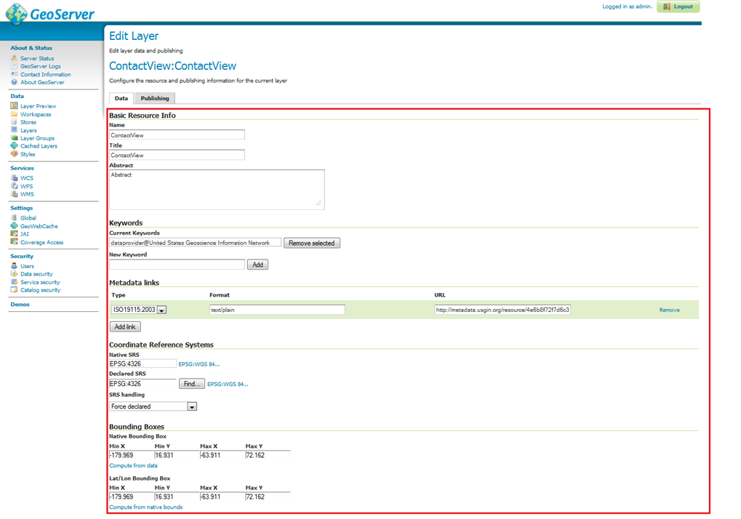

Figure 5: The Edit Layer page



#### The Data tab of the Edit Layer page

The **Data** tab contains fields within which you may specify the title, abstract, bounding box, spatial reference system, keywords, and metadata links for each layer in your web service. This information will be present within the **Capabilities document** produced by your web service in response to a **GetCapabilities** request, so it is very important to enter this information carefully for each layer in your web service.

If you wish to deploy your service in compliance with OneGeology standards, the information you enter for your layers will need to meet requirements set forth in the [cookbook](http://onegeology.org/wmsCookbookP/2_5.html).

It is recommended to enter the bounding boxes for your service manually, as doing so permits you to provide a more useful bounding box for your web service.

**Note: GeoServer occasionally enters a loop of web errors. To fix this, we recommend restarting the service on Apache-Tomcat. It also helps to use Mozilla Firefox or Google Chrome for debugging (rather than Internet Explorer).

#### The Publishing tab of the Edit Layer page

After populating the fields in the **Data** tab, click the **Publishing** tab.

The **Publishing** tab contains **Layer Style** settings for the corresponding layer of your web service. **Layer Style** settings are dependent on the geometry of the layer (point, line, polygon). See the Styling section of this document for more details.

Generally, it is faster and more precise to import **Layer Style** settings from an existing style than it is to manually specify values for each field in the **Publishing** tab. To import **Layer Style** settings from an existing style, select the desired style from the **Available Styles** list.

To populate the **Available Styles** list, you might need to import layer styles from an SLD file. For further instructions, see "How to Create a Styled Layer Descriptor (SLD) using Arc2Earth".

When you have populated the fields in the **Publishing** tab, click **Save**.

### Importing Layer Styles from an SLD File

On the left side of the GeoServer **Web Administration Interface**, under **Data**, click **Styles**. This will open the **Styles** page.

If the Style you want is not listed on the **Styles** page, you will need to add it to the list by clicking **Add a New Style**. This brings you to the **Style Editor** page.

On the Style Editor page, you have the choice to copy/paste an SLD or upload a .sld XML document. The **Validate** button may be used to validate the SLD file against a schema before using it. Click **Submit** to add the SLD to the list on the **Styles** page.

* 1. **Finishing Up**

Repeat this process until all data you wish to publish has been added to the desired workspace. When finished, return to Testing Your Web Service.

### GeoServer Troubleshooting

Q: I made a change in the database on my server and now the service is not working.

A: Try clearing the cache and reloading GeoServer on the Server Status page (Figure 22). If that doesn’t work, try hard restarting the service through Apache Tomcat.

## How to Create a Styled Layer Descriptor (SLD) using Arc2Earth

Arc2Earth is a plugin for ArcGIS that is available in several different editions. The **Community** edition is free and provides access to the SLD generator. Arc2Earth is available at <http://www.arc2earth.com/>.

1. Install the Arc2Earth plugin
2. Open ArcMap
3. Open the ArcMap project containing the layer or layers to export as SLDs
4. Select the desired layer in the catalog tree
5. In the Arc2Earth toolbar, click Export > Export Layer Style to SLD
6. Navigate to the appropriate location
7. Click **Export**

After your SLD has been exported, open the .sld in any XML or text editor. Note that the Arc2Earth plug-in adds an outline (stroke) to polygon layers. If you are working with polygon layers, the stroke may need to be tailored or removed manually. Also, it may be necessary to customize the heading for your SLD, or change the schema location.

**Note**: though .sld files, like any XML document, may be edited by a generic text editor, such as the **Notepad** or **Wordpad** text editors included with Windows operating systems, some text editors are better suited to working with XML documents than others. One example of a free-and-open-source text editor designed with XML support is [Notepad++](http://notepad-plus-plus.org/) (be sure to get the [XML tools plugin](http://sourceforge.net/projects/notepad-plus/forums/forum/482781/topic/3717096)).

Below is a snippet of an SLD created using Arc2Earth (Code Example 2).

## Alternative GeoServer configurations

### AppSchema extension and OneGeology advanced 3-star services.