# Connecting to a Shapefile data source

1. First, place the shapefile of the intended data source in a file location that can be accessed by your GeoServer instance. For the following example file location, a folder named “shapefiles” was created to house shapefiles in the geoserver installation directory: %installLocation%\geoserver\data\shapefiles
2. On the left side of the GeoServer Web Administration Interface, under Data, click Stores. This will bring you to the Stores page.

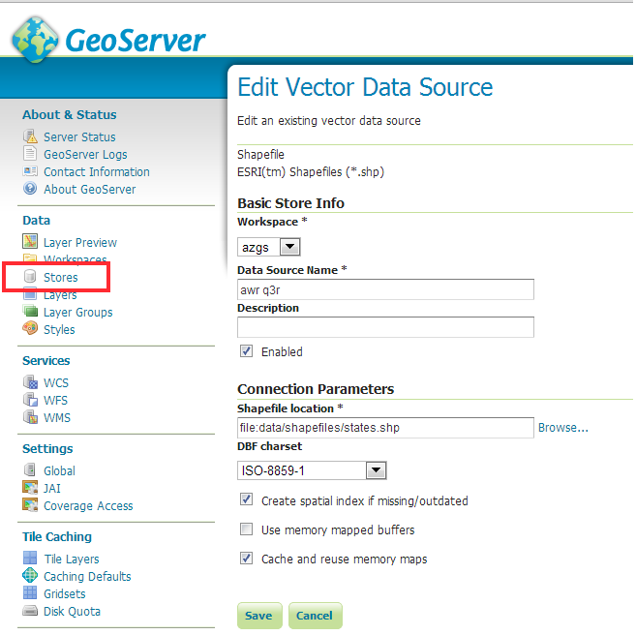

Figure 4. Create data store for Shapefile.

1. On the Stores page, click Add New Store. This will bring you to the New Data Source page (Figure 4).
2. On the New Data Source page, choose Shapefile as the source by clicking Shapefile. This will bring you to the New Vector Data Source page.
3. In the Workspace drop down menu, select the workspace you created in the last step.
4. Type a name for your data store in the Data Source Name field. This will be the WMS layer name and must conform the OneGeology layer naming conventions set out in the [cookbook, section 2.5](http://onegeology.org/wmsCookbookP/2_5.html).
5. add a description if desired
6. Make sure that the Enabled checkbox is checked.
7. Under Connection Parameters, click Browse… and navigate to the saved shapefile. The file will have to be accessible in the file system on the server that is hosting GeoServer.
8. Click Save.

## Using Application Schemas Extension

Shapefiles use dBase tables to contain thematic property data, and the field names in a shape file are limited to 10 characters in length. Because some of the fields in the GeoSciML-Portrayal schema are longer than 10 characters a more complicated configuration utilizing the GeoServer Application Schema extension must be used for GeoServer GeoSciML-Portrayal implementation based on a shapefile. This extension allows data sources to be configured with a mapping from field names in the data source to XML element names in the representation of that data returned by a WMS getFeatureInfo request. This field name mapping is essential for enabling user-defined map legend schemes based on OGC Styled Layer Descriptor (SLD) files that expect GeoSciML-portrayal field names.

The application scheme extension must be downloaded and installed separately, as it is not part of the standard GeoServer 2.3 installation. Once the extension is installed, you will need to create a mapping file, and restart GeoServer to enable the new configuration.

A.7.1 Install Application Schema .jar Files

See this page <http://sourceforge.net/projects/geoserver/files/GeoServer%20Extensions/>  for app-schema versions and downloads.

1. Download the app-schema plugin zip file for the same version of your GeoServer instance.
2. Unzip the app-schema plugin zip file to obtain the jar files inside. Do not unzip the jar files.
3. Place the jar files in the WEB-INF/lib directory of your GeoServer installation.
4. Restart GeoServer to load the extension.

### A.7.2 Create Mapping File

The mapping file is an XML file that maps fields from the data source into the fields of the XML output schema. For this example, the data source is a shapefile; this could be used as a workflow with continuation from Section A.4.1. The example mapping file, below, uses field names in a shapefile that are the automatically truncated names generated by ESRI software mapping from the long field names to the valid Shapefile field names. If other field names are used in the shapefile (e.g. the recommended abbreviations in [Cookbook Appendix L.5)](http://onegeology.org/wmsCookbookP/appendixL_5.html), the strings in the sourceExpression/OCQL elements should be modified appropriately.

<?xml version="1.0" encoding="UTF-8"?>

<as:AppSchemaDataAccess xmlns:as="http://www.geotools.org/app-schema"

xmlns:ogc="http://www.opengis.net/ogc" xmlns:xs="http://www.w3.org/2001/XMLSchema" xmlns:xsi="http://www.w3.org/2001/XMLSchema-instance"

xsi:schemaLocation="http://www.geotools.org/app-schema AppSchemaDataAccess.xsd">

<namespaces>

<Namespace>

<prefix>gsmlp</prefix>

<uri>http://xmlns.geosciml.org/geosciml-portrayal/2.0</uri>

</Namespace>

<Namespace>

<prefix>gml</prefix>

<uri>http://www.opengis.net/gml</uri>

</Namespace>

</namespaces>

<sourceDataStores>

<DataStore>

<id>shapefile</id>

<parameters>

<Parameter>

<name>url</name>

<value>file:/home/geoserver/downloads/shapefiles/GeologicUnitView.shp</value>

</Parameter>

<Parameter>

<name>memory mapped buffer</name>

<value>false</value>

</Parameter>

<Parameter>

<name>create spatial index</name>

<value>true</value>

</Parameter>

<Parameter>

<name>charset</name>

<value>ISO-8859-1</value>

</Parameter>

</parameters>

</DataStore>

</sourceDataStores>

<targetTypes>

<FeatureType>

<schemaUri>http://schemas.usgin.org/files/geologic-units/2.0/GeoSciML.xsd</schemaUri>

</FeatureType>

</targetTypes>

<typeMappings>

<FeatureTypeMapping>

<sourceDataStore>shapefile</sourceDataStore>

<sourceType>GeologicUnitView</sourceType>

<targetElement>gsmlp:GeologicUnitView</targetElement>

<attributeMappings>

<AttributeMapping>

<targetAttribute>gsmlp:GeologicUnitView</targetAttribute>

<idExpression>

<OCQL>getId()</OCQL>

</idExpression>

</AttributeMapping>

<AttributeMapping>

<targetAttribute>gsmlp:identifier</targetAttribute>

<sourceExpression>

<OCQL>identifier</OCQL>

</sourceExpression>

</AttributeMapping>

<AttributeMapping>

<targetAttribute>gsmlp:name</targetAttribute>

<sourceExpression>

<OCQL>name</OCQL>

</sourceExpression>

</AttributeMapping>

<AttributeMapping>

<targetAttribute>gsmlp:description</targetAttribute>

<sourceExpression>

<OCQL>descriptio</OCQL>

</sourceExpression>

</AttributeMapping>

<AttributeMapping>

<targetAttribute>gsmlp:geologicUnitType</targetAttribute>

<sourceExpression>

<OCQL>geologicUn</OCQL>

</sourceExpression>

</AttributeMapping>

<AttributeMapping>

<targetAttribute>gsmlp:rank</targetAttribute>

<sourceExpression>

<OCQL>rank</OCQL>

</sourceExpression>

</AttributeMapping>

<AttributeMapping>

<targetAttribute>gsmlp:lithology</targetAttribute>

<sourceExpression>

<OCQL>lithology</OCQL>

</sourceExpression>

</AttributeMapping>

<AttributeMapping>

<targetAttribute>gsmlp:geologicHistory</targetAttribute>

<sourceExpression>

<OCQL>geologicHi</OCQL>

</sourceExpression>

</AttributeMapping>

<AttributeMapping>

<targetAttribute>gsmlp:observationMethod</targetAttribute>

<sourceExpression>

<OCQL>observatio</OCQL>

</sourceExpression>

</AttributeMapping>

<AttributeMapping>

<targetAttribute>gsmlp:positionalAccuracy</targetAttribute>

<sourceExpression>

<OCQL>positional</OCQL>

</sourceExpression>

</AttributeMapping>

<AttributeMapping>

<targetAttribute>gsmlp:source</targetAttribute>

<sourceExpression>

<OCQL>source</OCQL>

</sourceExpression>

</AttributeMapping>

<AttributeMapping>

<targetAttribute>gsmlp:geologicUnitType_uri</targetAttribute>

<sourceExpression>

<OCQL>geologic_1</OCQL>

</sourceExpression>

</AttributeMapping>

<AttributeMapping>

<targetAttribute>gsmlp:representativeLithology_uri</targetAttribute>

<sourceExpression>

<OCQL>representa</OCQL>

</sourceExpression>

</AttributeMapping>

<AttributeMapping>

<targetAttribute>gsmlp:representativeAge_uri</targetAttribute>

<sourceExpression>

<OCQL>represen_1</OCQL>

</sourceExpression>

</AttributeMapping>

<AttributeMapping>

<targetAttribute>gsmlp:representativeOlderAge_uri</targetAttribute>

<sourceExpression>

<OCQL>represen_2</OCQL>

</sourceExpression>

</AttributeMapping>

<AttributeMapping>

<targetAttribute>gsmlp:representativeYoungerAge_uri</targetAttribute>

<sourceExpression>

<OCQL>represen_3</OCQL>

</sourceExpression>

</AttributeMapping>

<AttributeMapping>

<targetAttribute>gsmlp:specification_uri</targetAttribute>

<sourceExpression>

<OCQL>specificat</OCQL>

</sourceExpression>

</AttributeMapping>

<AttributeMapping>

<targetAttribute>gsmlp:metadata_uri</targetAttribute>

<sourceExpression>

<OCQL>metadata_u</OCQL>

</sourceExpression>

</AttributeMapping>

<AttributeMapping>

<targetAttribute>gsmlp:genericSymbolizer</targetAttribute>

<sourceExpression>

<OCQL>genericSym</OCQL>

</sourceExpression>

</AttributeMapping>

<AttributeMapping>

<targetAttribute>gsmlp:shape</targetAttribute>

<sourceExpression>

<OCQL>the_geom</OCQL>

</sourceExpression>

</AttributeMapping>

</attributeMappings>

</FeatureTypeMapping>

</typeMappings>

</as:AppSchemaDataAccess>

Create this mapping file with the prefix and namespace binding, the connection parameters (data source here is a shapefile), the online location of the schema (XSD), and the field mapping.

See helpful GeoServer documentation at the following locations:

<http://docs.geoserver.org/stable/en/user/data/app-schema/mapping-file.html>

<http://docs.geoserver.org/stable/en/user/data/app-schema/data-stores.html#shapefile>

Place the file in the GeoServer file location of the datastore. An example file location might be:

C:\Program Files (x86)\OpenGeo\OpenGeo Suite\webapps\geoserver\data\workspaces\gsmlp\Lithostratigraphy\

Where gsmlp is the Workspace, and Lithostratigraphy is the Data Store name.

### A.7.3. Edit datastore.xml file.

This file is located in the same Data Store directory. To enable application-schemas, this file must indicate that the shapefile is no longer used for field names, but the mapping file instead. Example datastore.xml, after editing:

<dataStore>

<id>DataStoreInfoImpl--1739a454:14097568969:-7fe7</id>

<name>GeologicUnitView</name>

<enabled>true</enabled>

<workspace>

<id>WorkspaceInfoImpl--1739a454:14097568969:-7fe9</id>

</workspace>

<connectionParameters>

<entry key="dbtype">app-schema</entry>

<entry key="url">file:workspaces/gsmlp/GeologicUnitView/GeologicUnitViewAZGS.xml</entry>

<entry key="namespace">http://xmlns.geosciml.org/geosciml-portrayal/2.0</entry>

</connectionParameters>

<__default>false</__default>

</dataStore>

### A.7.4 Restart GeoServer

After restarting GeoServer, the datastore for the desired layer will now read the field names from the mapping file, while still pulling the data from the indicated shapefile. The same can be done with data connections to PostGIS or any other type of data store.