|  |
| --- |
| The USGIN Data and Metadata Repository Application |
| Getting familiar with the Repository: Entering, Editing, and Searching Data |
| Abstract here |

<http://repository.stategeothermaldata.org/repository/>

Contents

Contents 1

Getting Familiar with the Repository 2

Home 3

Find Resources 3

Searching: The AASG Data Repository 3

Browse Collections 4

Resource Entry into Repository 5

Create a New Resource 5

Entering Data: Fields 5

Harvest Remote/local Metadata 8

A Quick Guide to Entering Metadata 9

# Introduction

This document describes the USGIN Django repository application developed by Ryan Clark.

# Getting Familiar with the Repository

The Home Page

## Home

The home page also contains

**“Contact”**

**“Login”**

**“Register”**

Contact: when you need assistance.

Login: Sign into your account

Register: Create an account

(Fill in all your information)

The home page contains the links you will need to navigate the site.

The top Menu Bar includes:

**“**[**Home**](#The Home Page)**”**

[**“Browse Collections”**](#Browse Collections)

[**“Find Resources**](#Find Resources)**”**

There is a panel for site information, terms of use, and a description about the metadata.

A very useful Item on the home page is the Magnifying Glass Icon; this Icon takes you to an associated search site. All submitted data that has been processed through the repository or catalog ends up on this site, after it has been validated and published.

## Find Resources

### Searching: The Data Repository

When searching for data, the search page for the Repository application (at [%repositoryHost%/- repository/search](https://urldefense.proofpoint.com/v1/url?u=http://repository.stategeothermaldata.org/repository/search&k=WP1bMHVseboJL1xhlI0uEw%3D%3D%0A&r=bOy6mGD%2FWILwYL88%2FEce%2Bw%3D%3D%0A&m=PXC4Nuq86agillaqQbFBT3Eu%2FjO7ILse5bdE71UqYKQ%3D%0A&s=c7886e4dc7423c576170472e39847fd270441c0d3ae608f359ff0dba8387d121)) is NOT the definitive resource to conduct your search. The Repository is the place to edit, adjust and add new metadata records to the data system. Datasets submitted can be in process in the system, but not yet editable on the repository page.

## Browse Collections

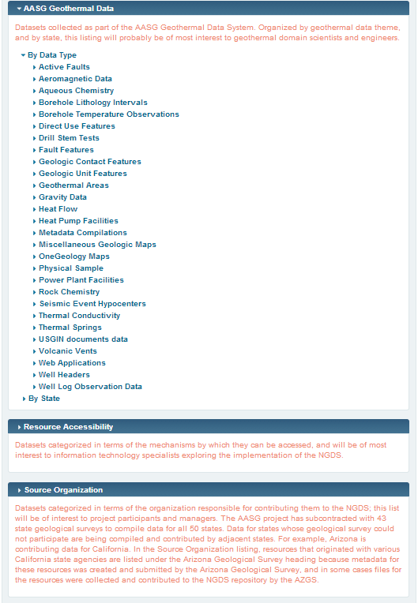

**Data Providers** will deal primarily within their own Source Organization collection.

There the Data Provider can make new sub collections and add resources.

**Metadata Admins** will have access to all collections for purposes of adding and editing resources.

**The most used collections** for both Data Provider and Metadata Admin will be: Data Type; State; Source Organization; & Downloadable Files.

The Browse Collections Page offers a hierarchical form of collections.

*Collections are a way to keep data organized and relevant. This facilitates the search for data.*

One resource may belong to many collections, as long as it is relevant to the specified collection.

There are three master collections in the Browse Collection tree:

**Master Collections:**

AASG Geothermal Data

Resource Accessibility

Source Organization

These master collections have sub (or child) collections; the child collections may also have sub collections. There is no limit to the number of collections nested inside another collection.

*The more familiar with collections in the Browse Collection tree, the easier navigation will be for the user.*

# Entering Resources into Repository



After logging in, there are two options on the Home page for entering a new resource: Create a new Resource, or, Harvest Remote (and local) Metadata.

## Create a New Resource

Select the “Create a New Resource” link after logging in; the user then will be sent to a fresh page where new data can be entered into the system, example below.

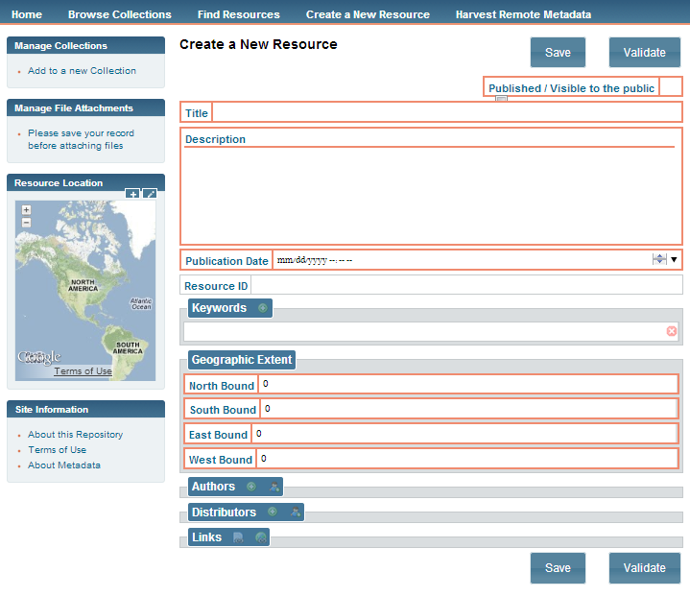

### Entering Data: Fields

When filling out fields, make sure that the content is spelled correctly and that the data is as well formed as possible. The goal is to leave no field empty when publishing.

#### Manage collections:

This is a very important field to populate. You want, at least, the state name, the type of data being submitted (which may be a collection you have already made), the Source Organization/Data Provider, and the Resource Accessibility Type.

* To add a collection, select the link “Add to a new Collection”.
* Type in the box what collection you want to add the resource to. (If you don’t know a collection, start typing the relevant state name; a drop down list will appear)
* A dropdown list will appear; select the collection that is relevant to your resource.

#### 

#### Manage File Attachments:

File attachments cannot be added until the new Resource record has been completed and saved. The file attachment link is under Manage File Attachments. The link will open a Browse box where you will locate the file to be uploaded. Select your file, then click on UPLOAD. You can add one file at a time and each file added will open a “Links” box for that resource. Your file metadata will appear in the “Links” field box.

* The URL has been auto populated and should not be altered.
* You can change the “Name” to make the file title reflect a recognizable name for the specific data within.
* Adding a “Description” is not mandatory but provides additional information on your data.
* Finally, add the “Distributor”. When you begin to type, a drop down box will appear with any distributor listed in your record. Choose the Distributor name from the drop down list or enter a new name.
* Save the Resource record a final time.

#### Resource Location:

Depending on the type of resource, you can use the bounding box to draw a rectangle or you can manually enter extents into each box: North, South, East, and West.

**Drawing a Polygon:** Zoom in by clicking on the map and using the mouse wheel, or by using the left plus sign (on the map). When at desired point, select the plus symbol in the blue box for Resource Location and to the right. Place the pointer at one corner of the desired box extent, then hold down left mouse button and drag to finish the bounding box.

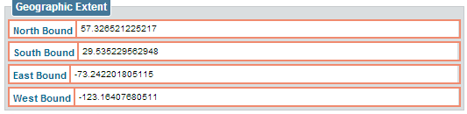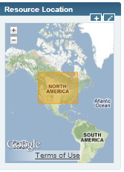

#### Title:

The title should be descriptive and short, i.e. “Arizona Borehole Temperatures”. Never include degree symbols, ampersands, or any other non-commonly used special characters.

#### Description:

The Description may also be the Abstract; this content should be spelled correctly and contain clear details about what the resource is. The description should not include the file name, any non-commonly used special characters, and must be at least 50 characters in length.

#### Publication Date:

Publication Date can be entered by clicking in the field and selecting a date; if the resource is much older you can enter it manually by selecting the arrow on the right of the month or year field box and typing or selecting the date.

#### Resource ID:

Optional, if the resource already has its own unique ID, enter it here; if not - one will be automatically entered.

#### Keywords:

To enter keywords, click on the green button next to the word “Keywords”. Empty fields will open for the user to complete. Each keyword or key term must be on a separate line. You may add as many as needed; please be sure that they are spelled correctly and that no symbols are entered.

#### Geographic Extent:

See Resource Location above

#### Authors/Distributors:

An author is the data provider; the distributor is the organization/site/person who hosts the data. These two may be the same. There must be at least one of each.

Enter an author/distributor by selecting either the green button to obtain a new template with empty fields to complete, OR select the button next to it and type in the organization or person to see if they have been entered in the system.



#### Save:

When the fields are completed, click on the Save button. After the Resource is saved, you can attach files (under Manage File Attachments)

#### Links: Service and Data

To enter a Service Type, click on the earth Icon which will open a window with a drop down arrow of selections: WMS, WFS, WCS, OPEN Dap, and ESRI (endpoint).

For data such as URL’s, use the paper icon and fill out URL, Name, and Distributor. If you need to upload a file see Manage File Attachments. Uploaded files automatically populate the URL field.

#### Validation:

Validation is possible when all required fields have been populated with data about a resource. If you have problems validating and see no unpopulated field, make sure to take out non-commonly used characters and check to see if your User (My Account) Information is all filled out.

#### Published/Visible to Public:

This is important; if you start a metadata record, have the intention to save it then, else the resource is in jeopardy of being deleted.

## Harvest Remote/local Metadata

Harvesting Remote or local metadata is for those who do not have a direct URL or File to upload into the repository. Harvesting is mostly used when you have data that needs to be processed, such as FGDC, XML, an Atom Feed, or a CSV.

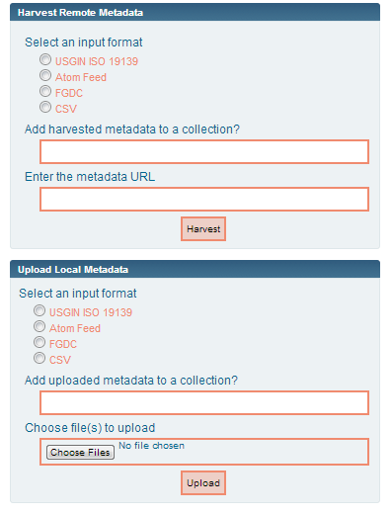

The difference between the two options, remote and local is:

**Remote** means any data online (this does not include ftp sites).

**Local** refers to the document on a local machine or server.

For Help entering the fields see [Entering Data: Fields](#Entering Data: Fields).

**Tip:** If you have a lot of data that requires the same fields such as keywords and extents, it’s best to use a CSV file to do this, as it can process multiple records. Just make sure to go back and edit/publish them.

The CSV requires specific values.

The Field Names are available in the metadata compilation content model, in the AASG Data Repository.

The Field names have to be the first row, then the data populated in the columns. You can do this in EXCEL and then save as a CSV File.

# A Quick Guide to Entering Metadata

1. Register. Make sure to fill all fields for your account.
2. If you have specific permission requirements you would like to implement, contact through email or through the link on the top-right hand of the home page.
3. Know your work environment; make sure you know where your collection is within the Browse page under Source organization.
4. Understanding the buttons to the side of each collection: File icon is to create a new collection within the collection you are focusing on i.e. a child collection; the paper icon is to add a new record to the collection you’re focusing on; the trash can icon is to delete the collection (this does not mean the records within the collection will be deleted along with it).
5. Is your data local or remote? Do you have the file on your computer or is it online (data on ftp sites are not considered online resources)? Knowing where your data is will help to choose which harvester to use.
6. Have you already made a collection for the data you’re about to enter? If not, Do so BEFORE entering individual or bulk data.
7. Using your choice of harvester, either enter the URL or File into the appropriate box. Above that box enter the name of your collection(s) where you want the data to live; you may add more than one if it appears in the drop down list. Collection names are comma separated. Now choose what type of data you’re submitting: XML, FGDC, CSV, etc. from the provided options.
8. When submitted, you will land on a page with resource link(s) to your new UNPUBLISHED data.