Reviewing, Deploying & Validating Services Submitted for the NGDS

**Introduction**

The National Geothermal Data System (NGDS) is an interoperable, distributed data system providing access to information resources related to geothermal energy. Data is added to the system from a network of data providers.

In order to keep the NGDS running smoothly, contributed data should meet the information exchange specifications for the system. The purpose of this document is to step through a suggested workflow for publishing NGDS data services that meet the system specifications.

**Ingredients**

Creating, editing and publishing data to NGDS requires three key ingredients: data, hardware and software.

**Data:** Input geothermal data into one of the United State Geoscience Information Network (USGIN) content models. These models are available for download from the USGIN models webpage: <http://schemas.usgin.org/models/>.

**Hardware:** Hardware requirements will be determined by software requirements and amount of traffic hitting the server.

**Software:** Software requirements can vary. Minimally, a data management system and software that can create web services are needed. For the purpose of this document, we will focus on the software needed to deploy web services using ArcGIS and OpenGeoSuite.

Generally, you will need:

* Data processing, editing and management software, for example: Excel, Access, ArcGIS Desktop and the Excel To NGDS Service Tool
  + This document will consider use of ArcMap for the workflow in using the ‘Excel To NGDS Service Tool’ for data processing. If not using ArcMap, Appendix G of this document describes manual review of a dataset. Use of OpenGeo Suite to create Web Services is described in Section 7.2.
* Enterprise database management system (pick one): Microsoft SQL Server, Oracle, PostgreSQL
* Geospatial data server (pick one): ArcGIS Server or Geoserver/OpenGeoSuite

Table of Contents

Section 1: Data QA/QC

Section 2: Create URIs

Section 3: Run the Excel to NGDS Service Tool

Section 4: Fix Errors Indicated by the Excel to NGDS Service Tool

Section 5: Finish Creating the Feature Class

5A. Finish Creating the Feature Class using Microsoft Access

5B. Finish Creating the Feature Class using ArcMap

Section 6: Load Data Into Production Database and Publish Services

Section 6.1: Load Data and Publish Service Using ArcGIS

A. Load Data

B. Create an ArcMap Project

C. Publish services using ArcGIS Server

Section 6.2: Load Data and Publish Service Using GeoServer

A. Load Data

B. Publish services using GeoServer

Section 7: Validating Services

A. WMS Validation

B. WFS Validation

Section 8: Create A New Resource in the Repository

Appendix A – Rewrite Rule Examples

Appendix B – Naming Conventions

Appendix C - Service Description Example

Appendix D – Online Resource Examples

Appendix E - Performing a Reprojection and Creating the Feature Class

Appendix F: Creating an ArcGIS (v.10) Service

Appendix G: Manually Reviewing the Data and Creating the NGDS Service

Section G1: Import Excel Data Into Access and Review Data Types

Section G1a: Excel to Geodatabase without Access

Section G2: Register Access Table with ArcGIS Geodatabase

Section G3: Create a Feature Class

# 

# 

# 

# 

# 

# 

# 

# 

# 

# 

# 

# 

# 

# 

# 

# 

# 

# 

# Section 1: Data QA/QC

It is assumed for the workflow of this document that your data is already in one of the Excel NGDS content models. If not, download the appropriate content model from the USGIN model schemas site: <http://schemas.usgin.org/models/>, input your data and proceed. For more information on entering your data into the content models, visit the USGIN content models tutorial <http://usgin.org/content/working-your-content-model>.

1. **Field Names in First Row**. For use of the ‘Excel to NGDS Service” tool to process your data (Section 3), ensure that the first row of your datasheet contains the field names.
2. **Check for Reasonable Data**. Ensure that data is of good quality and is as described in the ‘Description’ field of the FieldList tab in the Excel content model workbook.
3. **Create Meaningful Labels**. Label field should contain a description that is meaningful because the text in this field will be the label for the records when viewed in a map document. For example, a record in the Label field in the AZBoreholeTemperatures service might read “Temperature Observation for well api:412548976”.

# Section 2: Create URIs

***Understanding URIs***

URIs, or Uniform Resource Identifiers, dereference to an online resource. These online resources are representations of the service data, like an online file or XML representation of the data service. An implemented rewrite rule enables the return of these resources by inputting the URI into a web browser.

Project developers with NGDS use a rule based approach to rewrite http URIs to URLs, retrieving those useful representations of information resources. For NGDS data services, all URIs should follow a pattern:

http:/resources.usgin.org/uri-gin/[name authority]/[token]/[unique identifier]/

In the Borehole Temperature Observation content model, the ObservationURI for a single record might be:

http:/resources.usgin.org/uri-gin/azgs/bhtemp/0003/

where “azgs” is the **name authority**, “bhtemp” is the **token** and “0003” is the unique identifier. Find a list of assigned name authorities and tokens for NGDS project participants<https://github.com/usgin/uriredirect/wiki/NGDS-Name-Authorities-and-Tokens>. For all records in the Borehole Temperature dataset, the unique identifier should be the only part of the ObservationURI that changes.

**NOTE:** URIs must end with a ‘/’ to work.

For a more in-depth description of URIs, with redirection diagrams, visit<http://usgin.org/content/usgin-uris>.

***Creating URIs***

1. In Excel, fill out URI columns/fields, as required. The URI will be unique for each record in the dataset, as well as for each unique resource type in the dataset. Resource types might include well headers, geologic unit descriptions, sources.
2. Insert temporary ‘working’ columns in worksheet, as needed. Remember to delete them later.
3. Create an Excel formula that combines the URI ‘root’ (http://resources.usgin.org/uri-gin/[name authority]/[token]/) and the unique identifier, per record. This process is the same for return of online files or XML-representations of the data service.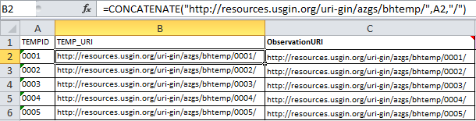
4. For implementation of a URI redirection (making your URI function as a URL in a browser), email [URIredirection@usgin.org](mailto:URIredirection@usgin.org).

# Section 3: Run the Excel to NGDS Service Tool

In order to facilitate the process of reviewing the data to confirm that it conforms to the information exchange schemas, we have created an ArcGIS data processing tool. This tool can be downloaded from the USGIN GitHub Repository at <https://github.com/usgin/ExcelToNGDSServiceTool>. The inputted Excel file is validated against the appropriate schema (.xsd), then a Geodatabase (.mdb) is created that houses a Feature Class which ready for service deployment. If this tool will not be used and a manual review of the data is required, see Appendix G.

1. Go to <https://github.com/usgin/ExcelToNGDSServiceTool>
2. Click the **Zip button** to download the repository as a **Zip file**.
3. Save the **entire** unzipped folder‘ExcelToNGDSServiceTool-master’ to C:\Users\[user]\Documents\ArcGIS\
4. Open ArcMap
5. Open the Catalog window (within ArcMap)
6. Navigate in Catalog to your Home directory, then choose the Documents\ArcGIS folder
7. Open the ‘ExcelToNGDSServiceTool’ folder saved in Step 3
8. Open the Toolbox ‘ExcelToNGDSService’
9. Double-click the script ‘Excel to Service’
   1. Drag the Excel file reviewed in Sections 1 and 2 into the Excel file box, or browse to select it
   2. Select the sheet containing the data (if multiple tabs exist in your Excel workbook)
   3. Select the appropriate schema
   4. Enter the Service Name, ideally in the format: State Prefix + Service (see Appendix B)
   5. The Validation Only button validates the Excel spreadsheet without creating the Feature Class; leave this button unchecked to create the Feature Class

As the Tool runs the Excel file is **Not Modified**. Data changes will only appear in the ArcGIS Feature Class that is created. If the Tool output states that the conversion was successful a geodatabase will have been created in the same folder as the original Excel file. Inside the geodatabase there will be a Feature Class for each of the layers of the service.

The following text outlines the checks completed by the tool. If you receive validation failures, proceed to Section 4. If the tool completes and validation is successful, proceed to Section 5. The Tool will compare the Excel file with the schema to check the following conditions:

* Data is checked that it conforms to Windows 1252 (encoding used by server) - **Validation Fail** otherwise
  + *See* [*https://en.wikipedia.org/wiki/Windows-1252*](https://en.wikipedia.org/wiki/Windows-1252) *for a Win 1252 character table*
* Number of fields must be the same in the Excel file as in schema - **Validation Fail** otherwise
* Order of fields must be the same in the Excel file as in schema - **Validation Fail** otherwise
* Field names must be the same in the Excel file as in schema - **Validation Fail** otherwise
* If a field name contains the word “URI,” data in that column is checked and modified to:
  + Remove whitespace and carriage returns from the URI
  + URI is checked that it contains “<http://resources.usgin.org/uri-gin/>” - **Validation Fail** otherwise
  + Checked that they contain at least 7 backslashes - **Validation Fail** otherwise
  + Checked that they end with a backslash and if not a backslash is added
  + If the field is the first URI field then this is the primary URI field and the URIs in this field are checked to make sure they are each unique - **Validation Fail** otherwise
  + Appropriate use of the name authority and token are **NOT** checked
* Cells containing more than 255 characters are given an appropriately long field length in the ArcGIS Feature Class created by the tool so all data is preserved
* Latitude and Longitude Coordinate fields (LatDegree, LatDegreeWGS84, LongDegree, and LongDegreeWGS84) are checked to assure that their values fall within -90 to 90 and -180 to 180 respectively - **Validation Fail** otherwise.
* The SRS field, if found, is checked that the coordinate system is either:
  + WGS 84 (if the cell contains the numbers 4326 for EPSG:4326 or 84 for WGS84)
  + NAD 27 (if the cell contains the numbers 4267 for EPSG:4267 or 27 for NAD27)
  + NAD 83 (if the cell contains the numbers 4269 for EPSG:4269 or 83 for NAD83)
  + Anything else in this column will be considered “Unknown” and WGS 84 will be used for the coordinate system, thus possibly requiring a manual reprojection at the end (see Appendix E if manual reprojection is necessary)
  + When creating the Feature Class, the Tool will apply the appropriate projection and reproject to WGS 84 as necessary, writing EPSG:4326 in the ‘SRS’ field.
* Fields indicated by the schema as required are given the following values if empty:
  + Text fields given the value “Missing”
  + Double fields given the value “-9999”
  + Date fields give the value "1/1/1900T00:00"
* Fields that are not empty are checked that their data is of the correct type. If the data is not of the correct type for the field then:
  + Text fields given the value “Missing” (if a required field) or left empty (if not a required field)
  + Double fields given the value “-9999” (if a required field) or left empty (if not a required field)
  + Date fields, if not recognized as a date field in Excel, are converted from the following formats to the type date: “1/28/1975T00:00” or “1/28/1975T00:00:00” or “1975-1-28T00:00:00” or “1975-1-28T00:00” or “1/28/1975” or “1975-1-28.” If conversion is not possible and the field is required there is a **Validation Fail** otherwise the field is left empty

# 

# Section 4: Fix Errors Indicated by the Excel to NGDS Service Tool

1. **Fix any errors in the Excel file that caused a Validation Fail** - Notices given that the tool is changing a cell value do not need to be fixed manually. The change will appear in the final Feature Class attribute table.
2. **Schema Field Mismatch Errors** - Any errors with the fields of the Excel file not matching will likely necessitate downloading the schema (XSD) from <http://schemas.usgin.org/models/> and modifying the Excel file in review to match the fields of the schema. Field names are found after ‘<xs:element name=’ with the following exceptions, which must not be fields in the Excel file.
   1. <xs:element name=[Layer Name] …
   2. <xs:element name="OBJECTID" type="xs:int" minOccurs="0">
   3. <xs:element name="Shape" type="gml:MultiCurvePropertyType">
3. **Date Issues** - Dates in Excel need to be either recognized by Excel as a date or as text in the format “1/28/1975T00:00” or “1/28/1975T00:00:00” or “1975-1-28T00:00:00” or “1975-1-28T00:00” or “1/28/1975” or “1975-1-28” (without the quotes).
4. **Spatial Reference System Warning** - If the tool is unable to determine which coordinate system the data is in, or reproject as necessary, a coordinate system of WGS 84 will be assumed and "EPSG:4326" will be written in the SRS column. A warning indicating that the spatial reference system will need to be **defined** and *then* a **reprojection** to WGS 84 will be required will be issued. To first define the projection follow the steps below and then see Appendix E for instructions on performing a reprojection.
   1. In ArcCatalog, open ArcToolbox window
   2. Expand Data Management Tools, Projections and Transformations, Feature
   3. Double-click on ‘Define Projection’
   4. Double-click on ‘Project’
      1. Add Feature Class that needs to have its projection defined as the ‘Input Dataset’
      2. Select the ‘Input Coordinate System’ indicated by the **Original** Excel file (the SRS field in the new Feature Class has already been updated to say "EPSG:4326" but the coordinates were not changed).
      3. Follow the steps in Appendix E to reproject to WGS 84 (EPSG:4326)
5. Run the tool again until the Validation is successful.

# 

# Section 5: Finish Creating the Feature Class

## 5A. Finish Creating the Feature Class using Microsoft Access

If the Excel file validates, the ArcMap tool creates a Feature Class within a Personal geodatabase (.mdb). By opening the .mdb directly using Microsoft Access, data and fields can be easily manipulated. Microsoft provides a free runtime version of Access which can be installed on any Windows desktop, and run any Access database application (<http://www.microsoft.com/en-us/download/details.aspx?id=4438>).

The following steps need to be performed to finish creating the NDGS Feature Class:

1. Open the Access database (.mdb)
2. In Design View, **move the Shape** field to the end, so it is the last field. This is important for the eventual service to validate against the schema.
3. **RelatedResources** field: This field is meant to correlate other relevant services or online documents. If other services from the same state are running, find a column of matching data (ID or APINo, for example) to correlate with dataset. Joining by this field, populate the RelatedResources field with the main URI from the other service data.
4. If the service contains multiple layers then the following additional steps will need to be performed:
   1. Open ArcCatalog and navigate to the geodatabase just created.
   2. Feature classes will be made by the tool for every layer name. In ArcCatalog delete the Feature Classes not being used.
   3. Close ArcCatalog and open the Access database (.mdb)
   4. The fields in each Feature Class are created by the tool to be identical. In Design View use the schema to delete the fields that do not belong from each Feature Class.
   5. Edit the URIs in each layer to be unique, if necessary. For example, AnalysisURI field in Aqueous Chemistry and Rock Chemistry layers will need to be unique.

## 5B. Finish Creating the Feature Class using ArcMap

If the Excel file validates, the ArcMap tool creates a Feature Class within a Personal geodatabase (.mdb). NGDS schemas require that the ‘Shape’ field be the last field in the finished web feature service, and hence the last field in the Feature Class. The ExceltoNGDSServices tool does not place the Shape field at the end, so this must be performed manually. As explained in Section 5A, this can be done with use of Microsoft Access. The following outlines how this can be done using ArcMap alone, where an XML document of the Feature Class is exported from the Personal geodatabase (.mdb) and imported into a File geodatabase (.gdb).

1. Open ArcCatalog
2. Right-click the Feature Class created in Section 3, and choose ‘Export’ ➔ ‘XML Workspace Document’
   1. In the dialog box, choose ‘Schema Only’
   2. Specify an output location and a file name
   3. Click ‘Next’ ➔ ‘Finish’
3. Open XML Workspace document in an editor (Notepad++ or XMLSpy, for example) and manually move the ‘Shape’ field to the end. From here you can also edit the field names, field sizes, move other things around if necessary. The following is an excerpt from an XML Workspace Document; the entire text represents the ‘Shape’ field and will need to be moved to the last field:

<Field xsi:type="esri:Field">

<Name>Shape</Name>

<Type>esriFieldTypeGeometry</Type>

<IsNullable>false</IsNullable>

<Length>0</Length>

<Precision>0</Precision>

<Scale>0</Scale>

<Required>true</Required>

<GeometryDef xsi:type="esri:GeometryDef">

<AvgNumPoints>0</AvgNumPoints>

<GeometryType>esriGeometryPoint</GeometryType>

<HasM>false</HasM>

<HasZ>false</HasZ>

<SpatialReference xsi:type="esri:GeographicCoordinateSystem">

<WKT>GEOGCS[&quot;GCS_WGS_1984&quot;,DATUM[&quot;D_WGS_1984&quot;,SPHEROI

D[&quot;WGS_1984&quot;,6378137.0,298.257223563]],PRIMEM[&quot;Greenwich&quot;,0.

0],UNIT[&quot;Degree&quot;,0.0174532925199433]]</WKT>

<XOrigin>-400</XOrigin>

<YOrigin>-400</YOrigin>

<XYScale>999999999.99999988</XYScale>

<ZOrigin>-100000</ZOrigin>

<ZScale>10000</ZScale>

<MOrigin>-100000</MOrigin>

<MScale>10000</MScale>

<XYTolerance>8.983152841195215e-009</XYTolerance>

<ZTolerance>0.001</ZTolerance>

<MTolerance>0.001</MTolerance>

<HighPrecision>true</HighPrecision>

<LeftLongitude>-180</LeftLongitude>

<WKID>4326</WKID>

</SpatialReference>

<GridSize0>3.7252903001966386e-007</GridSize0>

</GeometryDef>

<ModelName>Shape</ModelName>

</Field>

1. Create a new, empty File Geodatabase by right-clicking in desired file location in ArcMap and choose ‘New’ ➔ ‘Create New File Geodatabase’
2. Right-click the new File Geodatabase and choose ‘Import’ ➔ ‘XML Workspace Document...’
   1. In the dialog box, choose ‘Schema Only’ and navigate to the .xml file created in Step 2. This will create a new Feature Class from the edited XML
3. Right-click the new Feature Class and choose ‘Load’ ➔ ‘Load Data...’
   1. Input the original Feature Class created in Section 3
   2. Map the fields from the original to the new Feature Class created in Step 4

*From here, you are ready to create an ArcMap project (.mxd, see Section 6.1B) and create a web service using ArcServer (see Section 6). Section 8 is dedicated to creating metadata and making your new service available within the NGDS.*

# Section 6: Load Data Into Production Database and Publish Services

The final step is to load data into the production database and deploy services. This can be done in an ArcGIS environment or using open source tools. To deploy services, the data first needs to be loaded into a database that is connected to the internet. The data is then published to the internet using ArcGIS Server or Geoserver.

There are two loading and publishing scenarios presented in this document:

1. Section 6.1: Load data and publish services using ArcGIS
2. Section 6.2: Load data and publish services using OpenGeo Suite Tools

A distributed enterprise database system is recommended for staging and publishing web services. Schema-valid data tables are edited in a ‘staging database’ and pushed to a ‘production database’ for service deployment.

## Section 6.1: Load Data and Publish Service Using ArcGIS

ArcCatalog will be used to load data from the personal geodatabase into the staging and production databases.

The staging database at the Arizona Geological Survey is currently a Microsoft SQL Server database. The production database is a PostGIS-enabled PostgreSQL database.

In this section, an ArcSDE connection will first be made to the Microsoft Server SQL database. After the data from the personal database is loaded into the SQL database, a replica of that dataset will be created in the PostGIS-enabled PostgreSQL database.

### A. Load Data

1. Open ArcCatalog.
2. Connect to personal geodatabase folder.
   1. Click on Connect to Folder icon if you need to connect to the database folder.
3. Connect to staging and production enterprise geodatabases (ArcSDE Connection):
   1. Double-click Add Spatial Database Connection
   2. A new window opens, Spatial Database Connection Properties. Input the values as they appear in the image below (request password from program manager):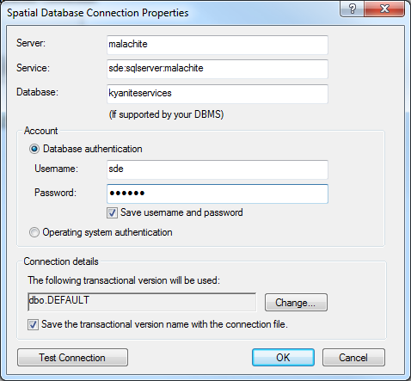

**Staging geodatabase connection properties**

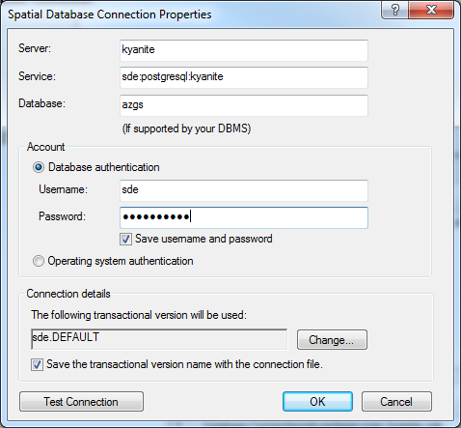

**Production geodatabase connection properties**

1. In ArcCatalog, copy Feature Class from geodatabase created in Section 5 and paste into staging database.
2. Right-click the Feature Class in staging database, select Add Global IDs.
3. Right-click the Feature Class in staging database, select Register as Versioned. **DO NOT** check the box next to Register the selected objects with the option to move edits to base.
4. Create Replica
   1. Open ArcToolbox window
   2. Expand Data Management Tools, Distributed Geodatabase
   3. Double-click on Create Replica; parameter values should be
      1. Replica Datasets: input Feature Class from staging database
      2. Replica Type: ONE_WAY_REPLICA
      3. Geodatabase to replicate data to: input production database
      4. Replica Name: should be the same name as the Feature Class name in the staging database
      5. Click OK

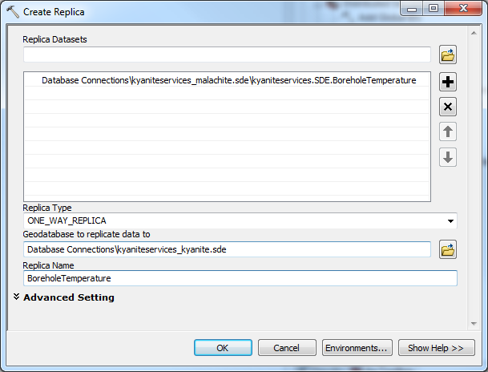

**Create Replica**

The data is ready to add to ArcMap.

### B. Create an ArcMap Project

1. Open a Blank ArcMap
2. Add Feature Class from production database
3. Click Add Data
4. Navigate to Feature Class
5. Symbolize layer
   1. From the Feature Class, right click and select Properties. Under the Symbology tab, choose Import.
   2. Choose a layer from the project schemas site <http://schemas.usgin.org/models/> selecting the layer file that corresponds to the content model.
   3. Select Value Field on which field in the dataset will be symbolized, if prompted. For example, BoreholeTemperatures services are symbolized by the “MeasuredTemperature” field; ActiveFaults services are symbolized by the “Symbol” field; SeismicHypocenters services are symbolized by the “Magnitude” field.
   4. Click OK. Layer symbology has been applied.
   5. Click OK again to close Layer Properties window.
6. Create metadata for the map document. The text will display on the arcgis services rest page, near the bottom under “Document Info”.
   1. From the ArcMap File dropdown menu, select Map Document Properties
   2. Title (example): “Arizona Borehole Temperature”
   3. Summary (example): “Arizona Borehole Temperatures”
   4. Author, just the organization (example): “Arizona Geological Survey”
   5. Credits (example): “Data provided by the Arizona Geological Survey; service provided by the Arizona Geological Survey”.
   6. **NOTE:** If data is being served by another state, then you can specify that. For example, Illinois is serving Borehole Temperature Data for the State of Massachusetts. The credits in this case might read “Data provided by the Massachusetts Geological Survey; service provided by the Illinois State Geological Survey”.
   7. Tags (example): “geothermal, wells, geochemistry, water, temperatures, borehole, aasg, wms, wfs”
   8. Check box next to “Store relative pathnames to data sources”
7. Create data frame metadata. Text will appear in the “Description” area on the arcgis services rest page.
   1. Right-click Data Frame, select Properties.
   2. Click on General tab. Fill out the following information:
      1. Name (example): “AZBoreholeTemperatures”
      2. Description (example): “This layer contains data describing borehole temperatures in the state of Arizona, obtained by the AASG for the Geothermal Data Project. The data table includes general information on the location of the borehole, temperature at some depth within the well, measurement procedure, location uncertainty and remarks. Citations are included in the dataset.
         1. The HeaderURI for a particular borehole is the cross-referencing link (foreign key) used to associate the borehole with web based information on the well construction, pictures or other information, specific to one feature.
         2. The data is displayed using a temperature gradient color scheme ramping from green (cool) to red (hot). Layer files containing the symbology for these data layers can be found in the USGIN repository at http://repository.usgin.org/uri_gin/usgin/dlio/206. The original data and metadata can be viewed or downloaded from the USGIN Repository at <http://repository.usgin.org/uri_gin/usgin/dlio/318>.”

**NOTE:** At the end of the Description, include a link to the repository page (as shown above). For NGDS data, go t[o http://repository.stategeothermaldata.org/repository/browse/](http://repository.stategeothermaldata.org/repository/browse/) and copy the link of the page for the appropriate dataset.

* + 1. Credits (example): “Data provided by the Arizona Geological Survey; service provided by the Arizona Geological Survey”.
       1. If data is being served by another state, then you can specify that. For example, Illinois is serving Borehole Temperature Data for the State of Massachusetts. The credits in this case might read “Data provided by the Massachusetts Geological Survey; service provided by the Illinois State Geological Survey”.

1. Create layer metadata. The text will appear in the Layer description on the arcgis services rest page)
   * 1. Right-click layer. Select Properties.
     2. Click on General Tab. Enter the following:
        1. Layer Name (example): BoreholeTemperature
        2. Description: Same as Data Frame
        3. Credits: Same as Data Frame
2. Save the map document.

### C. Publish services using ArcGIS Server

This document assumes that ArcGIS Server is installed and configured properly. Refer to ArcGIS Desktop 10.0 help documentation for more details about server configuration: http://help.arcgis.com/en/arcgisdesktop/10.0/help/index.html#/What_is_ArcGIS_Server/005300000001000000/

1. Confirm that data from production database are connected to ArcMap layers
   1. Open ArcMap.
   2. If the links are broken (indicated by a little red exclamation point next to the layer), repair data sources. Refer to ArcGIS Desktop Help document on [Repairing Broken Data Links](http://help.arcgis.com/en/arcgisdesktop/10.0/help/index.html#//00s500000020000000).

P@ssword+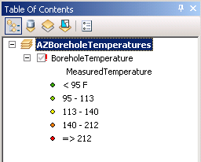

* 1. Save and Close ArcMap.

1. Publish Service
   1. Open ArcCatalog.
   2. Connect to GIS Server.
   3. Expand GIS Servers

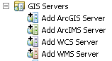

* 1. If needed, make the initial connection to ArcGIS Server.
     1. Double-click Add ArcGIS Server
        1. Select Manage GIS Services; click Next
        2. Input Server URL and Host Name
        3. Follow prompts to connect to server
        4. Once connected, the connection should remain
  2. To publish service (See Appendix F for screenshots)
     1. Right-click on ArcGIS Server
     2. Select Add New Service …
        1. Add GIS Service window pops up. Fill in fields:
           1. Name: Map service name. See Appendix B for service names.
           2. Type: Select Map Service
           3. Description: Type description. See service example description in Appendix C.
        2. Click Next. A new window pops up. Fill in parameter fields:
           1. Map Document: Navigate to and select ArcMap service document
           2. Directory: Select output directory. This should most likely be the default c:\arcgisserver\arcgisoutput
           3. Server Cache Directory: Select Cache directory. This should most likely be the default c:\arcgisserver\arcgiscache
           4. Maximum Number of Records Returned by Server: default value (1000) okay
        3. Click Next. A new window pops up. Select capabilities and operations.
           1. Check boxes next to:
           2. Mapping

Map

Query

Data

* + - * 1. WMS

Fill out WMS service properties (metadata). This will be the contact information for the data provider.

Change the OnlineResource; see Appendix D for examples.

Enable the “Use layer names from the map document”

* + - * 1. WFS

Fill out WFS service properties (metadata). This will be the contact information for the service provider.

Change the OnlineResource; see Appendix D for examples.

Enter the correct namespace (found in first line of schema).

Enter the prefix “aasg”.

* + - 1. Click Next. A new window pops up. Accept defaults for pooling.
      2. Click Next. A new window pops up. Accept defaults for processes.
      3. Click Next. A new window pops up. Select radio button to start service right now.
      4. Click Finish

The service has been created and needs to be validated against the schema. Proceed to Section 8.

## Section 6.2: Load Data and Publish Service Using GeoServer

GeoServer can be installed separately, or part of a software package known as OpenGeo Suite (<http://opengeo.org/>) which includes Postgres and PostGIS (database management systems) and OpenLayers. These are free and open-source software options. OpenGeo Suite is recommended and the following workflow describes loading a shapefile into PostGIS environment using this software. Using the PostGIS interface, a shapefile will be imported then converted to a table within the PostGIS database. This data table will be the source of data for the web service. For a more in-depth explanation of GeoServer set up and installation, see repository.stategeothermaldata.org/resources/documents/NGDS/GeoserverDocumentation.docx.

### A. Load Data

1. Click Start in the OpenGeo Suite Dashboard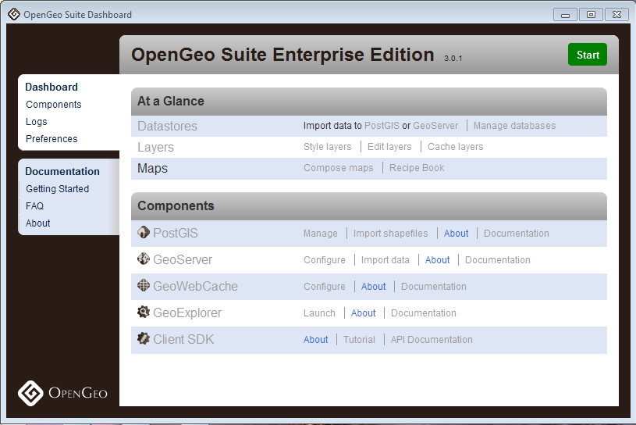
2. Under Components, click ‘Import shapefiles’ next the the PostGIS icon.
3. Click ‘View connection details’ to connect to database and folder for deployment.
4. Click Add File; navigate to schema-valid shapefile (shp) or database file (dbf).
5. Highlight file which now appears in the field and click Import; If the shapefile has a 'geom' field and a defined SRID, the spatial index will be automatically created with the Shape to PostGIS Converter.

Proceed to section 10.2 to connect to this database and deploy the service using GeoServer.

### B. Publish services using GeoServer

The following outlines how to use OpenGeo Suite on Windows platform to deploy WMS/WFS services using a connection to PostGIS database tables. From the GeoServer somepage, under About & Status, click Contact Information to enter the service provider information that will serve as your metadata contact information in service requests. For the following example, the GeoServer data directory was assigned as file location C:\Program Files (x86)\OpenGeo\OpenGeo Suite\webapps\geoserver\data.

1. Using the OpenGeo Suite Dashboard, click Start and choose GeoServer to open the GeoServer interface.

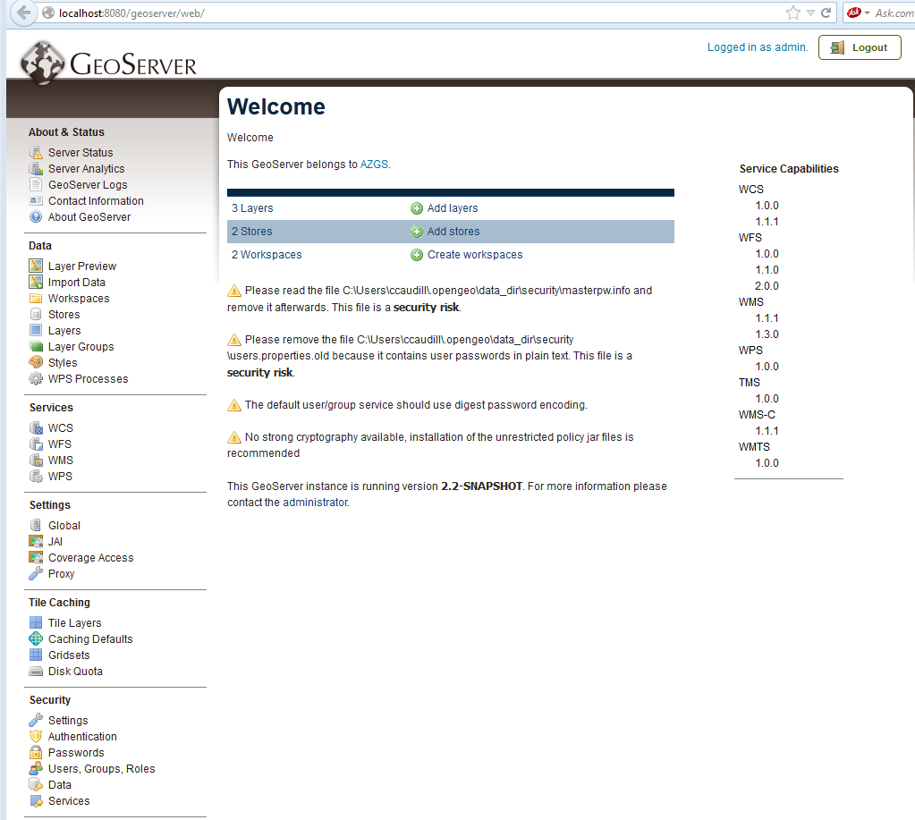

1. Under Data, click Workspaces.
   1. Click Add new workspace. The workspace specifies a namespace, so each data type will need its own separate workspace.
   2. Choose a name to identify your workspace (i.e., ThermalSprings)
   3. Fill in the namespace, given in the first line of an NGDS schema, or XSD, (<http://schemas.usgin.org/models/>)
   4. Fill in the Contact information (metadata). This will serve as the contact information for the data provider.
   5. Click Submit
2. Under Stores, click Add new Store. The Store will house the connection parameters to the data table in PostGIS database.
   1. If using PostGIS, choose this from the Vector Data Sources list. Choose the workspace you’ve just created from the drop-down list. The Data Source Name* will be the name of the data table as it appears exactly in your PostGIS database (i.e., azthermalsprings).
   2. Click the box next to “Enabled”.
   3. Once connection parameters are filled in, click Save.
3. Under Layers, click Add a new resource.
   1. From the drop-down list, choose the workspace:Store you’ve just created.
   2. If connected to PostGIS database, this should give all the available tables in the specified folder. Navigate through the list to the data table (i.e., azthermalsprings) and click Publish to the right of that data table name.
   3. This takes you to Edit Layer.
   4. In the Data tab, under Bounding Boxes, choose ‘Compute from data’ under ‘Native Bounding Box; choose ‘Compute from native bounds’ under ‘Lat/Lon Bounding Box’. This will pull locational bounding boxes from the data table.
   5. Click Save at bottom.
4. If ArcMap was used to create the original data table, it is important to note that GeoServer will not correctly read the SRID. This must be manually indicated by creating a SQL view of your layer that will serve as your web service. Under Layers, click Add a new resource.
   1. Choose the workspace:Store you created previously.
   2. When the available data tables pop up, there is an bolded option at the top labeled ‘Configure new SQL view...’ Click this.
   3. In the Create new SQL view page, fill in the ‘View Name’ that will serve as the final layer name, as indicated by the appropriate schema.
   4. In ‘SQL statement’ use a SQL statement that will call all the fields from the desired data table as such:

select * from azthermalsprings

Click Refresh.

* 1. When the fields appear, check objectid as the Identifier. For the shape field, type is indicated as Geometry. The SRID box must be filled in with the correct EPSG code (i.e., 4326). Click Save.
  2. This takes you to Edit Layer.
  3. In the Data tab, under Bounding Boxes, choose ‘Compute from data’ under ‘Native Bounding Box; choose ‘Compute from native bounds’ under ‘Lat/Lon Bounding Box’. This will pull locational bounding boxes from the data table.
  4. In the publishing tab, under WMS Settings, a Style (or symbology) may be chosen.
     1. To add a Style: under Styles from GeoServer home, click Add a new style.
     2. Choose a name and the workspace for this style (i.e., ThermalSprings)
     3. To use the SLDs for the NGDS project, scroll down to SLD file and click Browse. Browse to your downloaded SLD copies, avaialbe from<http://repository.stategeothermaldata.org/repository/resource/50ec3aefb656b70647f32e38bc1b7479/>
     4. Click Upload. Click Submit.
  5. Click Save.

1. Perform a GetFeature request to confirm data return. Construct a GetFeature URL, where the typeName=workspace:layer. For example:

[http://localhost:8080/geoserver/wfs?service=wfs&version=1.3.0&request=GetFeature&typeName=ThermalSpring:ThermalSpring](http://localhost:8080/geoserver/wfs?service=wfs&version=1.3.0&request=GetFeature&typeName=ThermalSpring:AZThermalSprings)

1. Create app-schema configuration for the new service. Creating an additional configuration file (mapping file) for GeoServer allows the use of "app-schemas" which will automatically download the indicated web-accessible schema (.xsd) and be referenced in the GetFeature request. This solves a problem with service deployment using ArcGIS, where custom schema locations is necessary. (For more in-depth explanation of app-schema implementation and associated files, see [http://repository.stategeothermaldata.org/resources/documents](http://repository.stategeothermaldata.org/resources/documents/GeoserverDocumentation.docx)

[/GeoserverDocumentation.docx](http://repository.stategeothermaldata.org/resources/documents/GeoserverDocumentation.docx) )

* 1. If necessary, download the app-schema extension from <http://sourceforge.net/projects/geoserver/files/GeoServer%20Extensions/>
     1. Download the app-schema plugin zip file for the same version of GeoServer.
     2. Unzip the app-schema plugin zip file to obtain the jar files inside. Do not unzip the jar files.
     3. Place the jar files in the WEB-INF/lib directory of your GeoServer installation.
     4. Restart GeoServer to load the extension.
  2. Create a mapping file and place in appropriate location. Example location: C:\Program Files (x86)\OpenGeo\OpenGeo Suite\webapps\geoserver\data\workspaces\

HeatFlow\azheatflow

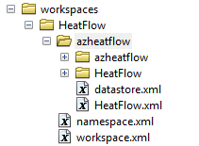

See an example working directory here: <https://github.com/ccaudill/GeoserverWorkspace/tree/master/HeatFlow>

Example mapping file: <https://github.com/ccaudill/GeoserverWorkspace/blob/master/HeatFlow/azheatflow/HeatFlow.xml>

* 1. Edit datastore.xml

Example datastore file: <https://github.com/ccaudill/GeoserverWorkspace/blob/master/HeatFlow/azheatflow/datastore.xml>

1. Perform a GetFeature request to confirm data return and use of schema. Construct a GetFeature URL, where the typeName=workspace:layer. For example:

<http://localhost:8080/geoserver/wfs?service=wfs&version=1.3.0&request=GetFeature&typeName=HeatFlow:HeatFlow>

The service has been created and needs to be validated against the schema.

# Section 7: Validating Services

WMS and WFS services must be validated to ensure the data will be interoperable within the system. For WMS, visual confirmation in a GIS program is sufficient for validation. For WFS, the GetFeature URL for the service will be validated against the schema (schema validation).

### A. WMS Validation

Validate the WMS service using WMS Capabilities URL.

ArcMap

* 1. Navigate to the service rest page and click on ‘WMS’
  2. Copy the WMS GetCapabilites URL, just left of the ‘?’
  3. Open ArcCatalog. Expand GIS Servers. Choose ‘Add WMS Server’
  4. Paste in the URL and click ‘Get Layers’ and ‘OK’. Drag the added layer into ArcMap.
  5. Ensure that the WMS draws with correct symbology. Also, choose the Identify tool and select a feature. Click on a URI to test the redirects.

uDig free and open-source desktop GIS, available here:<http://udig.refractions.net/>

* 1. Click on the “Layer” drop-down list and choose “Add”
  2. Choosing data type to add, click “Web Map Server”. Paste the WMS GetCapabilities URL into the box.
  3. Click “Next”. This should add the data directly to the map.
  4. To display feature attributes, select the layer in the “Layers” box on the left. On the right, select “Info.”
  5. Click on a feature on the map and open the “Information” tab on the bottom to display attributes as listed in the service. Click on a URI to test the redirects.

### B. WFS Validation

Validate the service against the schema using WFS GetFeature request URL.

USGIN WFS Validator tool:<http://schemas.usgin.org/validate/wfs>

* 1. Input the WFS GetCapabilites URL from the service and click Submit
  2. Choose the FeatureType and Number of Features to validate
  3. Choose the Content Model and Version to validate the service against. This will actually validate the GetFeature request against the schema (XSD). The version of the content model should be the latest version used; see<http://schemas.usgin.org/models/> for the versions in use.

Free versions of XML Explorer and Notepad ++

available here: <http://xmlexplorer.codeplex.com/>, <http://notepad-plus-plus.org/>

* 1. Navigate to the service rest page and click on ‘WFS’
  2. Create a Get Feature Request: In the browser, change the URL by deleting “Capabilites” and replacing with “Feature” and adding to the end of the URL the layer name. This is shown below in bolded text:

http://services.azgs.az.gov/ArcGIS/services/aasggeothermal/AZActiveFaults/MapServer/WFSServer?request=GetCapabilities&service=WFS

http://services.azgs.az.gov/ArcGIS/services/aasggeothermal/AZActiveFaults/MapServer/WFSServer?request=GetFeature&service=WFS&TypeName=ActiveFault&MaxFeatures=2

* 1. Copy this URL. In XML Explorer “Open Url …”. Paste in the Url. Once loaded save the file. Open in Notepad++.
  2. From <http://schemas.usgin.org/models/> save the schema (.xsd) to validate file against to a local file location.
  3. In Notepad++:
     1. In the first element, in the attribute “xsi:schemaLocation=”, find the 2nd URL that appears (will end with the layer name) and delete. In it’s place, write the name of the .xsd saved in step d above (i.e., ActiveFault1.1.xsd).
     2. Save the document as .xml and having the same name and in the same location file location as the .xsd saved in step d (i.e., ActiveFault1.1.xml). Close.
  4. Open XML Explorer; Click Open and navigate to the xml file that was just edited in step e.
     1. Upon opening this .xml file, the program will look at the indicated schema to automatically validate the file.
        1. Any returns with a red X will mean a change in the data, field type, or field heading is needed, and likely a re-import of the Feature Class into a staging or deployment database.
        2. A return of no errors indicates that the .xml file (and hence the GetFeature request and the service) was successfully validated.

# Section 8: Create A New Resource in the Repository

Creating a new resource in the NGDS repository that represents this data service exposes it to the catalog where it becomes searchable within the system. This also creates metadata for the service. This step is necessary to fulfill the Tier 3 USGIN requirements. For additional information on accessing the repository (and data delivery cycle in general), please visit <http://usgin.org/sites/usgin.org/files/Data_Delivery_Cycle.pdf>. For more information on metadata and how the repository and catalog fit into the project architecture, visit <http://usgin.org/sites/usgin.org/files/sgd-repository_tutorial.pdf>. The following is a walk-through of how to create a repository resource, and thus metadata, for your new data service.

1. Go to [http://repository.stategeothermaldata.org/repository/](http://repository.stategeothermaldata.org/repository/browse/) to Create a New Resource for the service, if it does not already exist.
2. Upload the an Excel file, database file, or shapefile that represents this service to the repository by clicking “Attach a new file” under the Manage File Attachments on screen left when creating your new resource. After uploading, the file name may be changed at the bottom of the page under Links.
3. It is important to add the links to the service as this allows the service to be added to the searchable catalog interface at <http://search.geothermaldata.org/>.
   1. Scroll to the bottom of the page to the Links section. Click the Globe icon.
   2. Add links for ESRI, OGC:WFS, and OGC:WMS services copied from the REST page.
      1. Example ESRI link: <http://mapserver.kgs.ku.edu/arcgis/rest/services/NGDS/KSBoreholeTemperatures/MapServer>
      2. Example OGC:WFS link: <http://mapserver.kgs.ku.edu/arcgis/services/NGDS/KSBoreholeTemperatures/MapServer/WFSServer?request=GetCapabilities&service=WFS>
      3. Example OGC:WMS link: <http://mapserver.kgs.ku.edu/arcgis/services/NGDS/KSBoreholeTemperatures/MapServer/WMSServer?request=GetCapabilities&service=WMS>
4. Edit Author and Distributor information.
5. Add Keywords.
6. Add Description (must be greater than 50 characters).
7. Add to Collections on screen left. Collections are categorizations of metadata, where state, organization, and data type are specified.
8. Click Save.

# Appendix A – Rewrite Rule Examples

Rewrites for return of online file location

In the ‘Redirect to’ field at <http://resources.usgin.org/admin/>, the root redirect URI http:/resources.usgin.org/uri-gin/ will replace the root of the online file location.

online file location example:

http://kgs.uky.edu/kgsweb/geothermal/ar/Logs/123.tiff

file (or unique record identifier): 123.tiff

name authority: args

resource type: logs_tiff

pattern: (.+)/

‘Redirect to’: http://kgs.uky.edu/kgsweb/geothermal/ar/Logs/$1

final URI in spreadsheet: http:/resources.usgin.org/uri-gin/args/logs_tiff/123.tiff/

where pattern (.+)/ and $1 in the ‘Redirect to’ field indicates the online file has a simple one-folder path. An example of redirecting to a file having more than one folder to redirect to is as follows:

online file location example:

http://kgs.uky.edu/kgsweb/geothermal/ar/Logs/OilandGas/documents/123.tiff

file (or unique record identifier): 123.tiff

name authority: args

resource type: logs_docs

pattern: (.+)/(.+)/(.+)/

‘Redirect to’: http://kgs.uky.edu/kgsweb/geothermal/ar/Logs/$1/$2/$3

final URI in spreadsheet: http:/resources.usgin.org/uri-gin/args/logs_docs/OilandGas/documents/123.tiff/

Rewrites for return of XML representations of data service

These will be entered into the ‘Redirect to’ field at <http://resources.usgin.org/admin/>

General pattern for rewrites are as follows. Replace the highlighted portions; see examples below.

[HostURL]/[ServiceName]/MapServer/WFSServer?request=GetFeature&service=WFS&TypeName=aasg:[LayerName]&FILTER=%3Cogc:Filter%3E%3Cogc:PropertyIsEqualTo%3E%3Cogc:PropertyName%3Eaasg:[FieldNameForURI]%3C/ogc:PropertyName%3E%3Cogc:Literal%3Ehttp://resources.usgin.org/uri-gin/[NameAuthority]/[Token]/$1/%3C/ogc:Literal%3E%3C/ogc:PropertyIsEqualTo%3E%3C/ogc:Filter%3E

Arizona-hosted example:

HostURL: http://services.azgs.az.gov/arcgis/services/aasggeothermal/

ServiceName: NMWellLogs

LayerName: WellLog

FieldNameForURI: LogURI

NameAuthority: nmbgmr

Token: welllog

Pattern: (.+)/

Media type: application/xml

Redirect to:

http://services.azgs.az.gov/arcgis/services/aasggeothermal/NMWellLogs/MapServer/WFSServer?request=GetFeature&service=WFS&TypeName=aasg:WellLog&FILTER%3Cogc:Filter%3E%3Cogc:PropertyIsEqualTo%3E%3Cogc:PropertyName%3Eaasg:LogURI%3C/ogc:PropertyName%3E%3Cogc:Literal%3Ehttp://resources.usgin.org/uri-gin/nmbgmr/welllog/$1/%3C/ogc:Literal%3E%3C/ogc:PropertyIsEqualTo%3E%3C/ogc:Filter%3E

Illinois-hosted examples:

http://geothermal.isgs.illinois.edu/arcgis/services/aasggeothermal/MEaqWellChemistry/MapServer/WFSServer?request=GetFeature&service=WFS&TypeName=aasg:$1&FILTER=%3Cogc:Filter%3E%3Cogc:PropertyIsEqualTo%3E%3Cogc:PropertyName%3Eaasg:AnalysisURI%3C/ogc:PropertyName%3E%3Cogc:Literal%3Ehttp://resources.usgin.org/uri-gin/megs/chemistry/aqchem/$1/$2/%3C/ogc:Literal%3E%3C/ogc:PropertyIsEqualTo%3E%3C/ogc:Filter%3E

http://geothermal.isgs.illinois.edu/arcgis/services/aasggeothermal/ILDrillStemTests/MapServer/WFSServer?request=GetFeature&service=WFS&TypeName=aasg:DrillStemTest&FILTER=%3Cogc:Filter%3E%3Cogc:PropertyIsEqualTo%3E%3Cogc:PropertyName%3Eaasg:ObservationURI%3C/ogc:PropertyName%3E%3Cogc:Literal%3Ehttp://resources.usgin.org/uri-gin/isgs/dst/$1/%3C/ogc:Literal%3E%3C/ogc:PropertyIsEqualTo%3E%3C/ogc:Filter%3E

# Appendix B – Naming Conventions

Data Frame (Service Name) and Layer Names must be without special characters or spaces. The layer name must be as exactly specified ‘element name’ in schema. The service name must include the state’s abbreviated name concatenated with the Service type (usually plural). The following is a list of service names and layer names approved for use in the NGDS/USGIN schema:

|  |  |
| --- | --- |
| Service Names + State Prefix (eg AZActiveFaults) | Layer Name |
| State Prefix + ActiveFaults | ActiveFault |
| State Prefix + AqueousChemistry1_10 | BaseMetals |
| State Prefix + AqueousChemistry1_10 | CommonAnalytes |
| State Prefix + AqueousChemistry1_10 | FreeGas |
| State Prefix + AqueousChemistry1_10 | GasIsotopes |
| State Prefix + AqueousChemistry1_10 | IsotopesDissolved |
| State Prefix + AqueousChemistry1_10 | MajorDissolvedConstituents |
| State Prefix + AqueousChemistry1_10 | MinorDissolvedConstituents |
| State Prefix + AqueousChemistry1_10 | Nitrogen |
| State Prefix + AqueousChemistry1_10 | SingleAnalyte |
| State Prefix + AqueousChemistry1_10 | WaterDissolvedGas |
| State Prefix + AqueousChemistry1_10 | WaterIsotopes |
| State Prefix + AqueousChemistry1_10 | WaterQuality |
| State Prefix + BoreholeLithIntercepts | BoreholeLithIntercept |
| State Prefix + BoreholeLithIntervals | BoreholeLithInterval |
| State Prefix + BoreholeTemperatures | BoreholeTemperature |
| State Prefix + ContourLines | ContourLine |
| State Prefix + DirectUseSites | DirectUseSite |
| State Prefix + DrillStemTests | DrillStemTest |
| State Prefix + FluidFluxInjectionDisposal | FluidFluxInjection |
| State Prefix + GeothermalAreas | GeothermalArea |
| State Prefix + GravityStations | GravityStation |
| State Prefix + HeatFlow1_23 | HeatFlow |
| State Prefix + HeatPumpFacilities | HeatPumpFacility |
| State Prefix + HydraulicProperties | HyraulicProperty |
| State Prefix + LASFileLocations | BoreholeTemperatureLASLog |
| State Prefix + PhysicalSamples | PhysicalSample |
| State Prefix + PowerPlantProduction | PlantProduction |
| State Prefix + PowerPlantFacilities | PowerPlantFacility |
| State Prefix + RadiogenicHeatProduction | RadiogenicHeatProduction |
| State Prefix + RockChemistry | Isotopes |
| State Prefix + RockChemistry | NobleGases |
| State Prefix + RockChemistry | RareEarths |
| State Prefix + RockChemistry | SingleAnalytes |
| State Prefix + RockChemistry | StableIsotopes |
| State Prefix + RockChemistry | TraceElements |
| State Prefix + RockChemistry | USeries |
| State Prefix + RockChemistry | Volatiles |
| State Prefix + RockChemistry | WRMajorElements |
| State Prefix + SeismicHypocenters | Hypocenter |
| State Prefix + TemperatureLogs | BoreholeTemperatureGeophysicalLog |
| State Prefix + ThermalConductivity | ThermalConductivity |
| State Prefix + ThermalSprings | ThermalSpring |
| State Prefix + VolcanicVents | VolcanicVent |
| State Prefix + WellHeaders | Wellheader |
| State Prefix + WellLogs | WellLog |
| State Prefix + WellTests | WellTest |

# Appendix C - Service Description Example

Service Description Example

This web map service (WMS) was published using ArcGIS Server v. 10.0 and is compliant with OGC (Open Geospatial Consortium) version 1.30 specifications. This service provides dynamic, spatially referenced geographic information using data collected for the National Geothermal Data System (http://www.geothermaldata.org/). In addition to the WMS capabilities, this service was designed to be interoperable with both WFS (Web Feature Services) as well as KML (Keyhole Markup Language). The WFS capabilities allow the client to query, make additions and/or modifications to an existing dataset. WFS can be utilized through the interoperability extension in ArcCatalog. For more information on using the ArcGIS data interoperability extension visit http://www.esri.com/software/arcgis/extensions/datainteroperability /common-questions.html. A KML service allows the client to view an image of the data in three dimensions, using free software available for download on the internet such as ArcGIS Explorer or Google Earth. For more information on OGC specifications, visit http://www.opengeospatial.org/standards.

# 

# Appendix D – Online Resource Examples

For AZGS-hosted services:

<http://services.azgs.az.gov/ArcGIS/services/aasggeothermal/OKBoreholeTemperatures/MapServer/WMSServer>

<http://services.azgs.az.gov/ArcGIS/services/aasggeothermal/OKBoreholeTemperatures/MapServer/WFSServer>

For Illinois-hosted services:

<http://geothermal.isgs.illinois.edu/arcgis/services/aasggeothermal/MEaqWellChemistry/MapServer/WMSServer>

<http://geothermal.isgs.illinois.edu/arcgis/services/aasggeothermal/MEaqWellChemistry/MapServer/WFSServer>

For Kentucky-hosted services:

<http://kgs.uky.edu/arcgis/services/aasggeothermal/LAWellheaders/MapServer/WMSServer>

<http://kgs.uky.edu/arcgis/services/aasggeothermal/LAWellheaders/MapServer/WFSServer>

# Appendix E - Performing a Reprojection and Creating the Feature Class

Coordinates of original data (North America) might reference NAD 83 or NAD 27 SRS. The specified coordinate system for NGDS is European Petroleum Survey Group (EPSG) 4326, which is the code equivalent to WGS 84. Therefore, to conform to the NGDS EPSG:4326 specification, the NAD 83 or NAD 27 data needs to be geographically transformed. Use the tools in ArcToolbox to perform the projection and transformation.

1. In ArcCatalog, open ArcToolbox window
2. Expand Data Management Tools, Projections and Transformations, Feature
3. Double-click on ‘Project’
   1. Add Feature Class that needs to be projected as the ‘Input Dataset’
   2. ‘Input Coordinate System’ value defaults to the coordinate system for the Feature Class.
   3. Specify output location for the Feature Class to be the same database as the table. Name the Feature Class the layer name (Appendix B). Feature class name for Arizona Borehole Temperature example would be “AZBoreholeTemperatureWGS84”.
   4. Select Output Coordinate System.
   5. Select Geographic Transformation. Common transformations for North America:
      1. NAD 27 -> WGS 84: NAD_1927_To_WGS_1984_4
      2. NAD 83 -> WGS 84: NAD_1983_To_WGS_1984_1
4. Click OK.

For other transformations, please refer to the ArcGIS documentation that is included in the ArcGIS installation. This typically can be found in the following system directory:

C:\Program Files (x86)\ArcGIS\Desktop10.0\Documentation\geographic_transformations.pdf

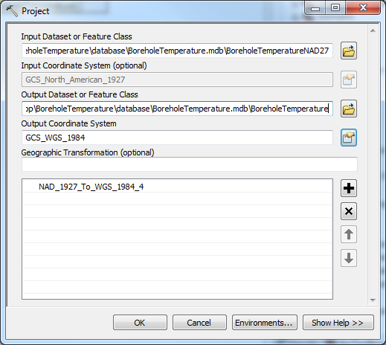

**SECTION 7: CALCULATE NEW COORDINATES**

The last step in the data transformation process is calculating WGS84 coordinates and the EPSG.

1. In ArcCatalog, open ArcToolbox window
2. Expand Data Management Tools, Fields
3. Double-click on calculate field
   1. Add Feature Class from Section 6 as the Input Table
   2. Calculate Latitude
      1. Select LatDegree for field name
      2. Type !shape.firstpoint.Y! in Expression field
      3. Select Python_9.3 for Expression Type
      4. Click OK
   3. Calculate Longitude
      1. Select LongDegree for field name
      2. Type !shape.firstpoint.X! in Expression field
      3. Select Python_9.3 for Expression Type
      4. Click OK
   4. Double-click on calculate field, again
      1. Input same Feature Class
      2. Select SRS for field name
      3. Assuming data has gone through data transformation process and is now in a WGS 84 projection, type "EPSG:4326" in Expression field (quotes included).
      4. Select VB for Expression Type
      5. Click OK

The data is now transformed into the NGDS specified spatial reference system and the SRS field is updated to read EPSG:4326.

# Appendix F: Creating an ArcGIS (v.10) Service

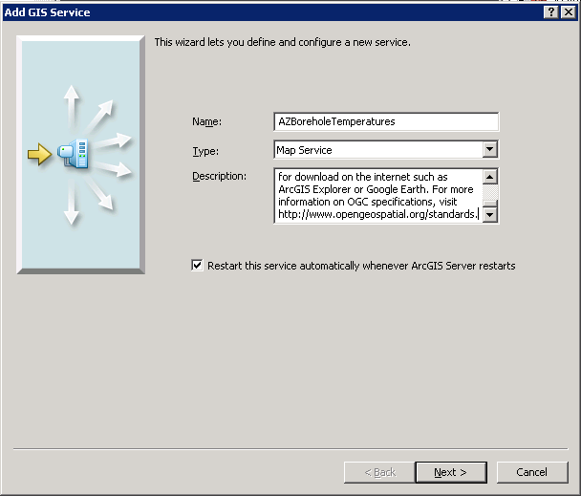

**Add ArcGIS Service: Service Name and Description**

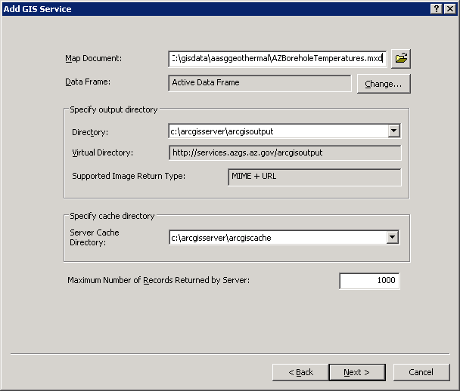

**Add ArcGIS Service: Select Map Service Document**

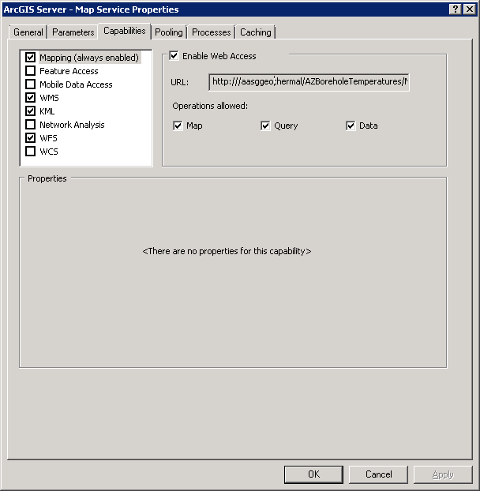

**Add ArcGIS Service: Select Capabilities**

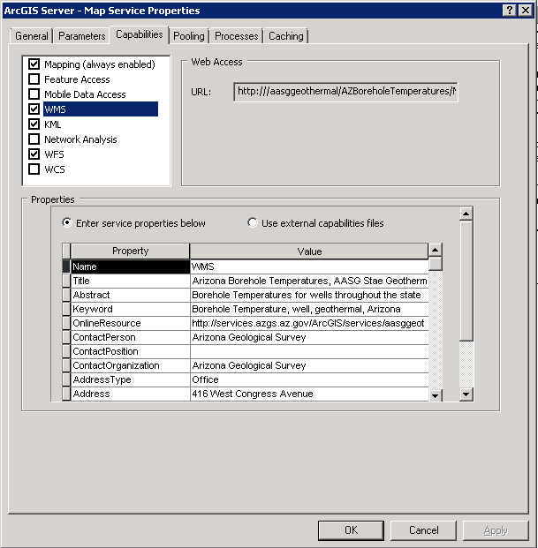

**Add ArcGIS Service: WMS Capabilities - Enter metadata or link to external capabilities file**

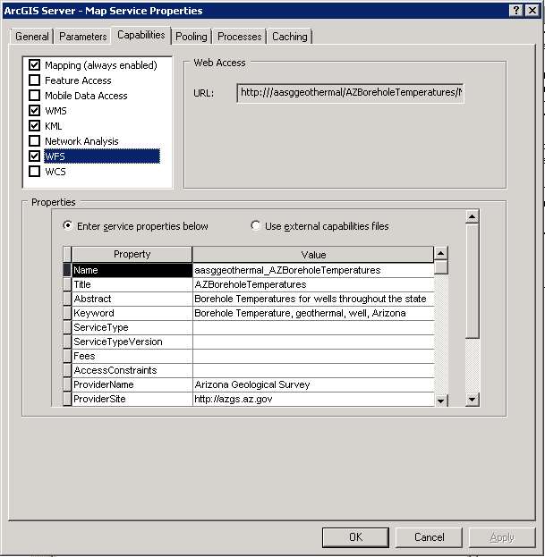

**Add ArcGIS Service: WFS Capabilities - Enter metadata or link to external capabilities file**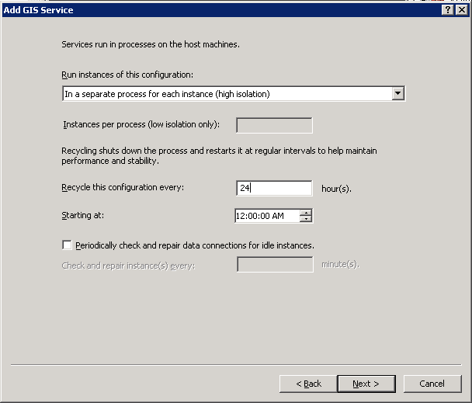

**Add ArcGIS Service: Processes**

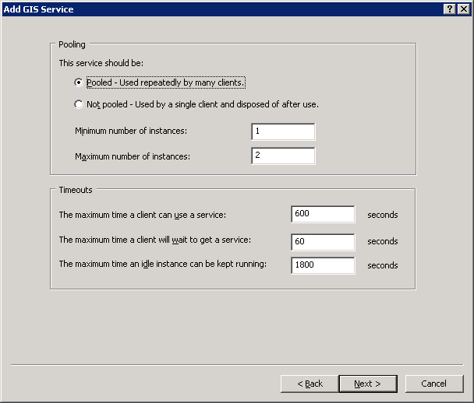**Add ArcGIS Service: Pooling**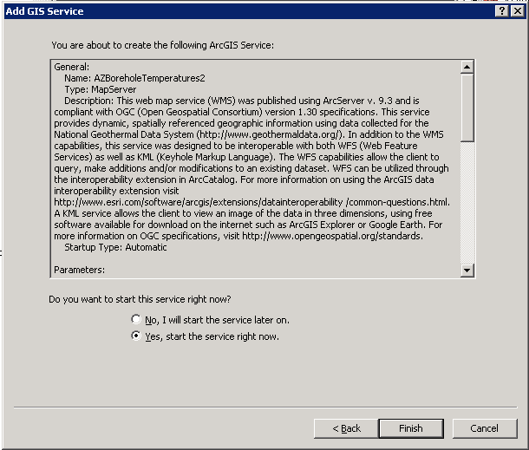

**Add ArcGIS Service: Start Services**

# Appendix G: Manually Reviewing the Data and Creating the NGDS Service

If the Excel to NGDS Service is unable to be used below are the directions to be followed.

## Section G1: Import Excel Data Into Access and Review Data Types

Access provides a bridge between Excel and ArcMap, creating a database from the Excel file. Access is also where data types can be specified and Shape and OBJECTID fields can be maintained. Microsoft provides a free runtime version of Microsoft Access which can be installed on any Windows desktop, and run any Microsoft Access database application (<http://www.microsoft.com/en-us/download/details.aspx?id=4438>). Although use of Access is highly recommended, it is possible to create a Feature Class from an Excel file without use Access or having a shapefile. Please proceed to Section 3a for this procedure. To import the Excel file into Access:

1. Open Access
2. Create a new .mdb database (2002-2003 format)
3. Import data
   1. Click the ‘External Data’ tab, then the Excel icon 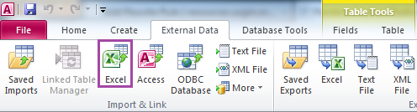
   2. Get External Data - Excel Spreadsheet Window opens. Browse to Excel Workbook, select worksheet and click open. Click OK.
   3. Import Spreadsheet Wizard Opens. Select the worksheet that corresponds to the tab from the Excel Workbook which contains the data. This worksheet will most likely be suffixed “Template”. Click Next.
   4. Check the box next to ‘First Row Contains Column Headings’. Click Next.
   5. Click Next on Field Options window. Field data types will be addressed later.
   6. Choose ‘No primary key’. Click Next.
   7. Import to Table: This is where you can name the imported table. It is recommended that the new Access table is prefixed with the content model type and suffixed with the word Table. For example, if you imported data from the Borehole Temperature Observation content model, name the table “BoreholeTemperatureObservationTable”. This convention allows a later differentiation from this table and the Feature Class that will eventually be created from this table.
4. Address Import Errors: If the Excel import has errors in Access, evaluate the error (usually a data type conversion error, where number fields must not contain alpha-numeric characters). Delete the imported table from Access. Re-open the Excel Workbook and fix errors. Re-import the table into Access.
5. Review field names, field order and data types in Access
   1. Right-click table and select Design View. Here you will see the field names, field order and data types for the table. Compare these against the schema (<http://schemas.usgin.org/models/>).
   2. Field names, field order and data types should match the schema exactly. If field names, field order and data types are different in the Access table, make necessary changes. 
      1. Field names: check spelling and capitalization. Correct any spellings and capitalizations if necessary.
      2. Field order: verify that the fields in the table have the same ordering as the fields in the schema. If not, move fields in Access to match the schema field ordering.
      3. Data types: verify that the data type for a field matches the data type defined in the schema. If it doesn’t match, change it.

**NOTE:** Save the Design View after changing each data type. If a warning appears that records will be deleted, cancel the change and reformat data in Access.

* + - 1. If schema data type = string, then field data type in Access table could be one of three data types:
         1. Text (255 character limit)
         2. Memo
         3. Date/Time (format: yyyy-mm-dd\Thh:n)

The data type will depend on the type of information that is going into the field. Text data type should be sufficient for most fields. Memo is recommended for fields that will have a lot of text (i.e. notes, sources). Date/Time data type should be used for date fields.

* + - 1. If schema data type = double, then field data type in Access table should be:
         1. Number
    1. Reformating data in Access
       1. Do this only if you get a warning when saving data type changes in Design View!
          1. Switch to the Table View in Access.
          2. For date fields, it may be necessary to replace the ‘T’ with a space to keep the correct data format. Do a find and replace for the column, replacing the ‘T’ with a space. Save and again change the data type & format mask in the Design View.
          3. For number fields, ensure that no letter characters exist in the data in those fields. When all letter characters have been removed, so back to the Design View and correct the data type.
          4. Return to Design View after you modify the data.
  1. Save changes. There may be a warning that some data may be lost. This error pops up when saving the table after changing a data type from ‘text’ to ‘number’. This is due to the restricted size of number fields. Unless the number character string is more than 255 characters, ignore this warning.

1. Replace special characters
   1. Certain characters are not accepted by ArcCatalog for SDE Feature Classes. These are usually found in chemical analysis datasets, and must be removed before deploying if using Arc products for service deployment.
   2. Open Access Table (Datasheet View)
   3. Replace the following characters:
      1. δ (replace with “delta”)
      2. μ (replace with “mu”)
2. RelatedResources field: This field is meant to correlate other relevant services or other relevant online documents. If other services from the same state are running, find a column of matching data (ID or APINo, for example) to correlate with dataset. Joining the two datasets by this field (under ‘Create’ then ‘Query Design’ in Access), populate the RelatedResources field with the main URI from the other service data.

Please continue to Section 2 of this document.

## Section G1a: Excel to Geodatabase without Access

This method is not generally recommended due to the inability to choose “Memo” data type. In Access, this data type indicates that the string of text characters may exceed 255. Be aware that when indicating “Text” data type in ArcMap for a given field, the characters in that field will be limited to 255. In this section, you will create a File Geodatabase and a Feature Class, importing the data types from a specified Excel content model using ArcMap. Navigate to the Excel file (table) in ArcCatalog.

**Note:** the spatial reference for NGDS services is WGS 1984. If the SRS field data indicates another coordinate system (such as NAD 27 or NAD 83), then create a Feature Class using that coordinate system.

1. Right click in the Contents space to create New - File Geodatabase.
2. Right click the new geodatabase and choose Import - Table (Single).
   1. Choose the working Excel file created in Sections 1 & 2 for “Input Rows”.
   2. Rename the new table.
3. Right-click on new table, select Create Feature Class, select From XY Table...
4. Input fields:
   1. X Field => LongDegree
   2. Y Field => LatDegree
   3. Z Field => <None>
   4. Coordinate System of Input Coordinates: Click button, navigate to the coordinate system that corresponds to the value entered in the SRS field.
   5. Specify output location for the Feature Class to be the same database as the table. Name the Feature Class. If the spatial reference is WGS 84, name the Feature Class the layer name (Appendix B) that will be used in your service. If not, add the spatial reference to the end of the layer name.

For example, for an Arizona Borehole Temperature Observation service, the Feature Class should be named “AZBoreholeTemperature”. If the original data indicated an SRS of NAD 27, then the Feature Class should be named “AZBoreholeTemperatureNAD27”.

If the data has a spatial reference other than WGS 84, project and transform the data as described in Section 6 of this document.

1. Create another New Feature Class by right clicking in the Contents space and choosing New - Feature Class.
   1. Name the Feature Class suffixed with ‘_content model’ to avoid confusion.
   2. Choose the feature type: Point Features.
   3. Choose the Geographic Coordinate Systems
      1. World
         1. WGS 1984
   4. XY Tolerance is default.
   5. Configuration Keyword is default.
   6. In the next window specifying fields, choose Import. Navigate to the Excel file of the relevant content model (these can be downloaded from <http://schemas.usgin.org/models/>).
   7. Modify the data types indicated by the FieldList worksheet in the Excel NGDS content model and the schema (XSD) file (also available from the USGIN model schemas site).
      1. OBJECTID field will automatically be indicated as ‘Object ID’ data type
      2. SHAPE field will automatically be indicated as ‘Geometry’ data type
      3. If schema data type = string, then field data type in ArcMap could be one of the following data types:
         * 1. Text (255 character limit)
           2. Date/Time (format: yyyy-mm-dd\Thh:n)
      4. If schema data type = double, then field data type in ArcMap should be:
         * 1. Double
   8. Click Finish.
2. Append the data to the content model to preserve data types.
   1. Open ArcToolbox.
      1. Choose Data Management Tools.
         1. Choose Append.
   2. Input Datasets => Feature Class with data created in numbers 1 - 2 of this Section.
   3. Target Datasets => empty content model Feature Class created in number 5 of this Section.
   4. Choose ‘No Test’ to map the fields of one Feature Class to the other.
   5. Click OK; the Feature Class will now have the correct data types as specified by the schema.

Continue to Section 5 of this document.

## Section G2: Register Access Table with ArcGIS Geodatabase

An Access file with the .mdb extension is a personal geodatabase in ArcGIS. To eventually publish data using ArcGIS Server, the Access table must be registered with an ArcGIS geodatabase.

1. Open ArcCatalog.
2. Navigate to the database created in Section 3. Double-click to open the database.
   1. Click on Connect to Folder icon if you need to connect to the database folder.
3. Right click the table with the data and select ‘Register with Geodatabase.’ This creates the OBJECTID field, a require for publishing services with ArcGIS Server.
4. Close ArcCatalog.
5. Re-open the Access database. Open the table in Design View. Move the OBJECTID field so it is the first field. This is a schema specification. Save (right click on the tab) and close the database.

## Section G3: Create a Feature Class

In this section, you will create a point Feature Class from the latitude and longitude values in the table you registered with the geodatabase in Section 4. The SRS (Spatial Reference System) field of the table contains the spatial reference system value that should be used when setting the input coordinate system in the process outlined below.

**Note:** the spatial reference for NGDS services is WGS 1984. If the SRS field data indicates another coordinate system (such as NAD 27 or NAD 83), then create a Feature Class using that coordinate system.

1. Open ArcCatalog.
2. Navigate to same database.
3. Right-click on table, select Create Feature Class, select From XY Table...

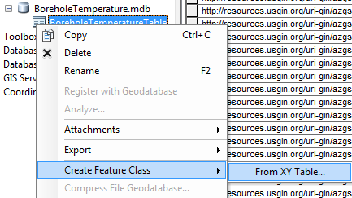

**Create Feature Class From XY Table**

1. Input fields:
   1. X Field => LongDegree or UTM_E
   2. Y Field => LatDegree or UTM_N
   3. Z Field => <None>
   4. Coordinate System of Input Coordinates: Click button.
      1. Click Select. . . button in next window and navigate to the coordinate system that corresponds to the SRS. If input coordinates are latitude and longitude, select the appropriate geographic coordinate system. If input coordinates are UTM coordinates, select the projected coordinate system for the appropriate UTM Zone and datum (i.e. NAD 1983 UTM Zone 12N.prj).
   5. Specify output location for the Feature Class to be the same database as the table. Name the Feature Class. If the spatial reference is WGS 84, name the Feature Class the layer name (Appendix B) that will be used in your service. If not, add the spatial reference to the end of the layer name.

For example, for an Arizona Borehole Temperature Observation service, the Feature Class should be named “AZBoreholeTemperature”. If the original data indicated an SRS of NAD 27, then the Feature Class should be named “AZBoreholeTemperatureNAD27”.

If the data has a spatial reference of WGS 84, then proceed to Section 5. Otherwise, project and transform the data as described Appendix E.

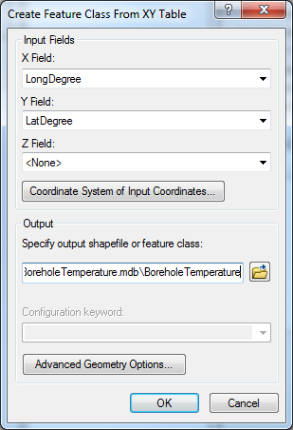

**Select coordinates and Spatial Reference Properties**

