**Reviewing, Deploying & Validating Services Submitted for the NGDS**

**INTRODUCTION**

The National Geothermal Data System (NGDS) is an interoperable, distributed data system providing access to information resources related to geothermal energy. Data is added to the system from a network of data providers.

To make best use of all data in the system, contributed data should meet the information exchange specifications for the system. The purpose of this document is to step through a suggested workflow for publishing NGDS data services that meet the system specifications.

**INGREDIENTS**

Creating, editing and publishing data to NGDS requires three key ingredients: data, hardware and software.

**Data:** Input geothermal data into one of the United State Geoscience Information Network (USGIN) content models. These models are available for download from the USGIN models webpage: <http://schemas.usgin.org/models/>.

**Hardware:** Hardware requirements will be determined by software requirements and amount of traffic hitting the server.

**Software:** Software requirements can vary. Minimally, a data management system and software that can create web services are needed. For the purpose of this document, we will focus on the software needed to deploy web services using ArcGIS and OpenGeoSuite.

Generally, you will need:

* Data processing, editing and management software: Excel, Access, ArcGIS Desktop
* Enterprise database management system, such as: Microsoft SQL Server, Oracle, PostgreSQL
* Geospatial data server, such as: ArcGIS Server or Geoserver/OpenGeoSuite

**SECTION 1: DATA QA/QC**

It is assumed that your data is already in one of the Excel NGDS content models. If not, download the appropriate content model from the USGIN) model schemas site: <http://schemas.usgin.org/models/>, input your data and proceed.

According to the interchange specifications, some data fields in the content model are required to have data in them. The FieldList worksheet in the Excel NGDS content model and the schema (XSD) file (also available from the USGIN model schemas site) for the content model declare a cardinality for each field. This cardinality value indicates whether or not a field is required to have data in it.

For the Data QA/QC process, check the fields in the worksheet suffixed Template in the Excel content model workbook (i.e. WellTestTemplate worksheet in the Well Tests content model Excel Template <http://schemas.usgin.org/models/#WellTest>) against cardinality value for that field.

1. Check Fields for Required Data(Ignore Shape field here)
   1. Look in the Cardinality column in the FieldList worksheet in the Excel Template to see which fields require data. The Cardinality values for the :
      1. Required field = 1
      2. Not required = 0..1
   2. Also, you may check the XSD file that dictates which fields require data in the content model. To view the schema, download the latest schema version available at <http://schemas.usgin.org/models/>. Choose the XSD button under Files.
      1. Required field = <xs:element...> tag does not have minOccurs="0"
      2. Not required = <xs:element...> tag has minOccurs="0"

**NOTE:** If the required fields in the Excel workbook differ from the schema, always rely on the schema. Search for required fields that are missing data (search and replace for blank cell works well)

1. Calculate Values for Missing Data
   1. If a required field is missing data (blank cell), determine the data type from the Excel Workbook FieldList or the XSD schema. Enter the following values, by data type, for missing data (type: value)
      1. string: Missing
      2. date: 1/1/1900T00:00
      3. double: -999
2. Check for Reasonable Data – Make sure fields contain data that makes sense as described in the Excel content model workbook FieldList tab Description for that field.
3. Address Issues – Note unresolvable issues in the ‘ReviewersComment’ tab. The Excel workbook can then be sent to the appropriate entity to address the issues, if necessary.
4. Create Meaningful Labels – Label field should contain a description that is meaningful because the text in this field will be the label for the records when viewed in a map document. For example, a record in the Label field in the AZBoreholeTemperatures service might read “Temperature Observation for well api:412548976”

**SECTION 2: CREATE URIs AND REWRITE RULES**

URIs, or Uniform Resource Identifiers, dereference to an online resource. These online resources are representations of the service data, like an online file or XML representation of the data service. An implemented rewrite rule enables the return of these resources by inputting the URI into a web browser. The NGDS site <http://resources.usgin.org/admin/> uses a rule based approach to rewrite http URIs to URLs, retrieving those useful representations of information resources. For NGDS data services, all URIs should follow a pattern:

http:/resources.usgin.org/uri-gin/[name authority]/[token]/[unique identifier]/

In the Borehole Temperature Observation content model, the ObservationURI for a single record might look like this:

http:/resources.usgin.org/uri-gin/azgs/bhtemp/0003/

where “azgs” is the name authority, “bhtemp” is the token and “0003” is the unique identifier. For all records in the Borehole Temperature dataset, the unique identifier should be the only part of the ObservationURI that changes.

**NOTE:** URIs must end with a ‘/’ to work.

For NGDS URIs, go to <http://resources.usgin.org/admin/> to set up the redirection for the URIs. Here, you will create the root of the URI that follows the pattern: “http:/resources.usgin.org/uri-gin/[name authority]/[token]/”.

**You will need to login for this step. Following the workshop, please contact the Arizona Geological Survey to get a login and password**.

1. Log on to redirection site:<http://resources.usgin.org/admin/>

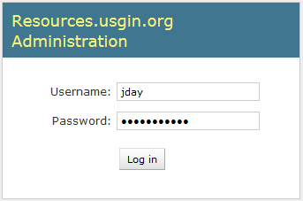

After you login, the site administration home page opens:

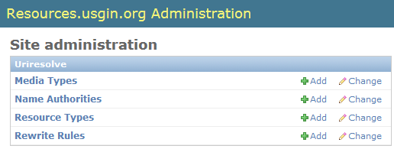

1. Add Resource Type
   1. Click ‘Add’ next to Resource Types. A new page will open. Four fields need to be filled out on the new page.
      1. Name Authority: Select a name authority on the new page that opens. The name authority indicates the data provider (state survey or other entity that submitted the data). For a list of name authorities and providers, please refer to this document: <http://repository.stategeothermaldata.org/resources/documents/NGDS/resources.usgin_admin_naming_authority_codes.xlsx>. You may also create a new name authority under Name Authorities at the Site Administration home page.
      2. Label: Type in label value
      3. Description: Type in description
      4. Token: Create the token for the resource type. This token must be unique for the name authority and should represent the data type. Do not use spaces. The following are examples of layer names and corresponding tokens:
         1. WellHeader = well
         2. BoreholeTemperature = bhtemp
         3. WellLog = welllog
         4. BoreholeLithInterval = bhlithinterval
      5. Click Save
   2. Return to the Site Administration home page
2. Add Rewrite Rules:
   1. Click ‘Add’ button next to Rewrite Rules. A new page will open with the following fields; all fields except Description are mandatory.
      1. Label: Type in label value
      2. Description: Type in description
      3. Name authority: Select name authority. It should be the same name authority selected when you created the resource type (Section 2.a.i.)
      4. Resource Type: Select the resource type you created (Section 2). If you didn’t create a resource type before, click the plus sign next to Resource Type and follow the steps outlined in the previous section, “Add Resource Type”.
      5. Pattern: (.+)/ indicates additional information (such as a file name or other file folders) will follow the root URI (see Appendix A for more details)
         1. (.+)/ appropriate for return of XML representation of the data service, or for return of online file with a simple one-folder directory
         2. (.+)/(.+)/ necessary for two-folder directories
         3. (.+)/ (.+)/ (.+)/ necessary for three-folder directories
      6. Media Type: If a file is available for records in the data service, choose the appropriate file type to return from the Media Type drop-down list. Otherwise, where no online files are available, an XML-representation of the data service can be returned. For this case, choose the Media Type “application/XML”.
      7. Redirect to:
         1. file location: The root redirect URI http:/resources.usgin.org/uri-gin/ will replace the root of the online file location, which is indicated in the ‘Redirect to’ field. See Appendix A for examples.
         2. XML representation of the data service: See Appendix A for examples of how to form the redirect rule, then enter that into this field.
   2. Click Save
   3. You can now create the URI for your data records in the Excel workbook
3. Create URIs
   1. In Excel, fill out URI columns/fields, as required. The URI will be unique for each record in the dataset, as well as for each unique resource type in the dataset. Resource types might include well headers, geologic unit descriptions, sources.
   2. Insert temporary ‘working’ columns in worksheet, as needed. Remember to delete them later.
      1. Create an Excel formula that combines the URI ‘root’ (http:/resources.usgin.org/uri-gin/[name authority]/[token]/) and the unique identifier, per record. This process is the same for return of online files or XML-representations of the data service.

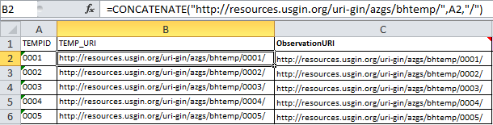

**SECTION 3: IMPORT EXCEL DATA INTO ACCESS AND REVIEW DATA TYPE**

Access provides a bridge between Excel and ArcMap, creating a database from the Excel file. Access is also where data types can be specified and Shape and OBJECTID fields can be maintained. Microsoft provides a free runtime version of Microsoft Access which can be installed on any Windows desktop, and run any Microsoft Access database application (<http://www.microsoft.com/en-us/download/details.aspx?id=4438>). Although use of Access is highly recommended, it is possible to create a Feature Class from an Excel file without use Access or having a shapefile. **Please proceed to Section 3a for this procedure**. To import the Excel file into Access:

1. Open Access
2. Create a new .mdb database (2002-2003 format)
3. Import data
   1. Click the ‘External Data’ tab, then the Excel icon 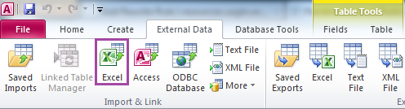
   2. Get External Data - Excel Spreadsheet Window opens. Browse to Excel Workbook, select worksheet and click open. Click OK.
   3. Import Spreadsheet Wizard Opens. Select the worksheet that corresponds to the tab from the Excel Workbook which contains the data. This worksheet will most likely be suffixed “Template”. Click Next.
   4. Check the box next to ‘First Row Contains Column Headings’. Click Next.
   5. Click Next on Field Options window. Field data types will be addressed later.
   6. Choose ‘No primary key’. Click Next.
   7. Import to Table: This is where you can name the imported table. It is recommended that the new Access table is prefixed with the content model type and suffixed with the word Table. For example, if you imported data from the Borehole Temperature Observation content model, name the table “BoreholeTemperatureObservationTable”. This convention allows a later differentiation from this table and the Feature Class that will eventually be created from this table.
4. Address Import Errors: If the Excel import has errors in Access, evaluate the error (usually a data type conversion error, where number fields must not contain alpha-numeric characters). Delete the imported table from Access. Re-open the Excel Workbook and fix errors. Re-import the table into Access.
5. Review field names, field order and data types in Access
   1. Right-click table and select Design View. Here you will see the field names, field order and data types for the table. Compare these against the schema (<http://schemas.usgin.org/models/>).
   2. Field names, field order and data types should match the schema exactly. If field names, field order and data types are different in the Access table, make necessary changes. 
      1. Field names: check spelling and capitalization. Correct any spellings and capitalizations if necessary.
      2. Field order: verify that the fields in the table have the same ordering as the fields in the schema. If not, move fields in Access to match the schema field ordering.
      3. Data types: verify that the data type for a field matches the data type defined in the schema. If it doesn’t match, change it.

**NOTE:** Save the Design View after changing each data type. If a warning appears that records will be deleted, cancel the change and reformat data in Access.

* + - 1. If schema data type = string, then field data type in Access table could be one of three data types:
         1. Text (255 character limit)
         2. Memo
         3. Date/Time (format: yyyy-mm-dd\Thh:n)

The data type will depend on the type of information that is going into the field. Text data type should be sufficient for most fields. Memo is recommended for fields that will have a lot of text (i.e. notes, sources). Date/Time data type should be used for date fields.

* + - 1. If schema data type = double, then field data type in Access table should be:
         1. Number
    1. Reformatting data in Access
       1. Do this only if you get a warning when saving data type changes in Design View!
          1. Switch to the Table View in Access.
          2. For date fields, it may be necessary to replace the ‘T’ with a space to keep the correct data format. Do a find and replace for the column, replacing the ‘T’ with a space. Save and again change the data type & format mask in the Design View.
          3. For number fields, ensure that no letter characters exist in the data in those fields. When all letter characters have been removed, so back to the Design View and correct the data type.
          4. Return to Design View after you modify the data.
  1. Save changes. There may be a warning that some data may be lost. This error pops up when saving the table after changing a data type from ‘text’ to ‘number’. This is due to the restricted size of number fields. Unless the number character string is more than 255 characters, ignore this warning.

1. Replace special characters
   1. Certain characters are not accepted by ArcCatalog for SDE feature classes. These are usually found in chemical analysis datasets, and must be removed before deploying if using Arc products for service deployment.
   2. Open Access Table (Datasheet View)
   3. Replace the following characters:
      1. δ (replace with “delta”)
      2. & (replace with “and”)
      3. ° (replace with “degree”)
      4. μ (replace with “mu”)
      5. * (no replacement)
2. RelatedResources field: This field is meant to correlate other relevant services or other relevant online documents. If other services from the same state are running, find a column of matching data (ID or APINo, for example) to correlate with dataset. Joining the two datasets by this field (under ‘Create’ then ‘Query Design’ in Access), populate the RelatedResources field with the main URI from the other service data.

Please continue to Section 4 of this document.

**SECTION 3a: EXCEL TO GEODATABASE WITHOUT ACCESS**

This method is not generally recommended due to the inability to choose “Memo” data type. In Access, this data type indicates that the string of text characters may exceed 255. Be aware that when indicating “Text” data type in ArcMap for a given field, the characters in that field will be limited to 255. In this section, you will create a File Geodatabase and a Feature Class, importing the data types from a specified Excel content model using ArcMap. Navigate to the Excel file (table) in ArcCatalog.

**Note:** the spatial reference for NGDS services is WGS 1984. If the SRS field data indicates another coordinate system (such as NAD 27 or NAD 83), then create a feature class using that coordinate system.

1. Right click in the Contents space to create New - File Geodatabase.
2. Right click the new geodatabase and choose Import - Table (Single).
   1. Choose the working Excel file created in Sections 1 & 2 for “Input Rows”.
   2. Rename the new table.
3. Right-click on new table, select Create Feature Class, select From XY Table...
4. Input fields:
   1. X Field => LongDegree
   2. Y Field => LatDegree
   3. Z Field => <None>
   4. Coordinate System of Input Coordinates: Click button, navigate to the coordinate system that corresponds to the value entered in the SRS field.
   5. Specify output location for the feature class to be the same database as the table. Name the feature class. If the spatial reference is WGS 84, name the feature class the layer name (Appendix B) that will be used in your service. If not, add the spatial reference to the end of the layer name.

For example, for an Arizona Borehole Temperature Observation service, the feature class should be named “AZBoreholeTemperature”. If the original data indicated an SRS of NAD 27, then the feature class should be named “AZBoreholeTemperatureNAD27”.

If the data has a spatial reference other than WGS 84, project and transform the data as described in Section 6 of this document.

1. Create another New Feature Class by right clicking in the Contents space and choosing New - Feature Class.
   1. Name the Feature Class suffixed with ‘_content model’ to avoid confusion.
   2. Choose the feature type: Point Features.
   3. Choose the Geographic Coordinate Systems
      1. World
         1. WGS 1984
   4. XY Tolerance is default.
   5. Configuration Keyword is default.
   6. In the next window specifying fields, choose Import. Navigate to the Excel file of the relevant content model (these can be downloaded from <http://schemas.usgin.org/models/>).
   7. Modify the data types indicated by the FieldList worksheet in the Excel NGDS content model and the schema (XSD) file (also available from the USGIN model schemas site).
      1. OBJECTID field will automatically be indicated as ‘Object ID’ data type
      2. SHAPE field will automatically be indicated as ‘Geometry’ data type
      3. If schema data type = string, then field data type in ArcMap could be one of the following data types:
         * 1. Text (255 character limit)
           2. Date/Time (format: yyyy-mm-dd\Thh:n)
      4. If schema data type = double, then field data type in ArcMap should be:
         * 1. Double
   8. Click Finish.
2. Append the data to the content model to preserve data types.
   1. Open ArcToolbox.
      1. Choose Data Management Tools.
         1. Choose Append.
   2. Input Datasets => Feature Class with data created in numbers 1 - 2 of this Section.
   3. Target Datasets => empty content model Feature Class created in number 5 of this Section.
   4. Choose ‘No Test’ to map the fields of one Feature Class to the other.
   5. Click OK; the Feature Class will now have the correct data types as specified by the schema.

Continue to Section 8 of this document.

**SECTION 4: REGISTER ACCESS TABLE WITH ARCGIS GEODATABASE**

An Access file with the .mdb extension is a personal geodatabase in ArcGIS. To eventually publish data using ArcGIS Server, the Access table must be registered with an ArcGIS geodatabase.

1. Open ArcCatalog.
2. Navigate to the database created in Section 3. Double-click to open the database.
   1. Click on Connect to Folder icon if you need to connect to the database folder.
3. Right click the table with the data and select ‘Register with Geodatabase.’ This creates the OBJECTID field, a require for publishing services with ArcGIS Server.
4. Close ArcCatalog.
5. Re-open the Access database. Open the table in Design View. Move the OBJECTID field so it is the first field. This is a schema specification. Save (right click on the tab) and close the database.

**SECTION 5: CREATE A FEATURE CLASS**

In this section, you will create a point feature class from the latitude and longitude values in the table you registered with the geodatabase in Section 4. The SRS (Spatial Reference System) field of the table contains the spatial reference system value that should be used when setting the input coordinate system in the process outlined below.

**Note:** the spatial reference for NGDS services is WGS 1984. If the SRS field data indicates another coordinate system (such as NAD 27 or NAD 83), then create a feature class using that coordinate system.

1. Open ArcCatalog.
2. Navigate to same database.
3. Right-click on table, select Create Feature Class, select From XY Table...
4. Input fields:
   1. X Field => LongDegree or UTM_E
   2. Y Field => LatDegree or UTM_N
   3. Z Field => <None>
   4. Coordinate System of Input Coordinates: Click button.
      1. Click Select. . . button in next window and navigate to the coordinate system that corresponds to the SRS. If input coordinates are latitude and longitude, select the appropriate geographic coordinate system. If input coordinates are UTM coordinates, select the projected coordinate system for the appropriate UTM Zone and datum (i.e. NAD 1983 UTM Zone 12N.prj).
   5. Specify output location for the feature class to be the same database as the table. Name the feature class. If the spatial reference is WGS 84, name the feature class the layer name (Appendix B) that will be used in your service. If not, add the spatial reference to the end of the layer name.

For example, for an Arizona Borehole Temperature Observation service, the feature class should be named “AZBoreholeTemperature”. If the original data indicated an SRS of NAD 27, then the feature class should be named “AZBoreholeTemperatureNAD27”.

If the data has a spatial reference of WGS 84, then proceed to Section 8. Otherwise, project and transform the data as described in the next section.

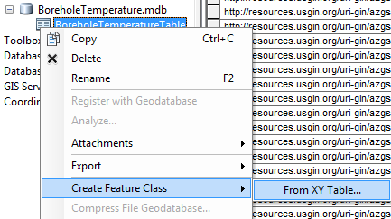

**Create Feature Class From XY Table**

**Select coordinates and Spatial Reference Properties**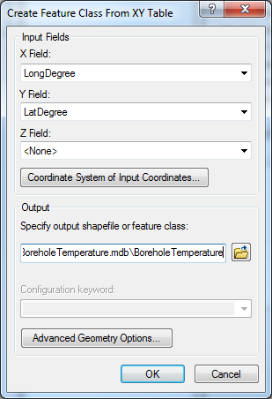

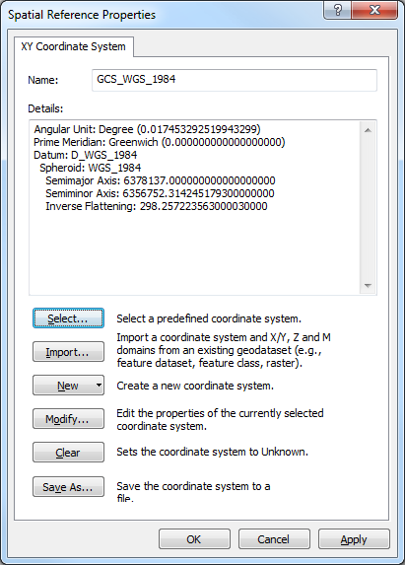

**SECTION 6: PROJECT AND TRANSFORM DATA**

Coordinates of original data (North America) might reference NAD 83 or NAD 27 SRS. The specified coordinate system for NGDS is WGS 84. Therefore, to conform to the NGDS WGS 84 specification, the NAD 83 or NAD 27 data needs to be geographically transformed. Use the tools in ArcToolbox to perform the projection and transformation.

1. In ArcCatalog, open ArcToolbox window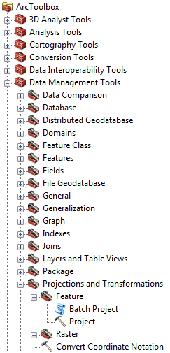
2. Expand Data Management Tools, Projections and Transformations, Feature
3. Double-click on Project
   1. Add feature class that needs to be projected as the Input Dataset
   2. Input Coordinate System value defaults to the coordinate system you defined in Section 5 for the feature class. If default is ‘unknown’, then return to Section 5.
   3. Specify output location for the feature class to be the same database as the table. Name the feature class the layer name (Appendix B). Feature class name for Arizona Borehole Temperature example would be “AZBoreholeTemperatureWGS84”.
   4. Select Output Coordinate System.
   5. Select Geographic Transformation. Common transformations for North America:
      1. NAD 27 -> WGS 84: NAD_1927_To_WGS_1984_4
      2. NAD 83 -> WGS 84: NAD_1983_To_WGS_1984_1
4. Click OK.

For other transformations, please refer to the ArcGIS documentation that is included in the ArcGIS installation. This typically can be found in the following system directory:

C:\Program Files (x86)\ArcGIS\Desktop10.0\Documentation\geographic_transformations.pdf

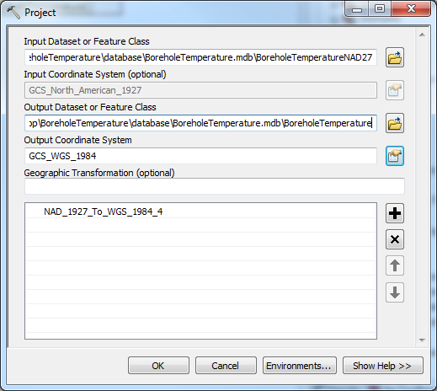

**SECTION 7: CALCULATE NEW COORDINATES**

The last step in the data transformation process is calculating WGS84 coordinates and the EPSG.

1. In ArcCatalog, open ArcToolbox window
2. Expand Data Management Tools, Fields
3. Double-click on calculate field
   1. Add feature class from Section 6 as the Input Table
   2. Calculate Latitude
      1. Select LatDegree for field name
      2. Type !shape.firstpoint.Y! in Expression field
      3. Select Python_9.3 for Expression Type
      4. Click OK
   3. Calculate Longitude
      1. Select LongDegree for field name
      2. Type !shape.firstpoint.X! in Expression field
      3. Select Python_9.3 for Expression Type
      4. Click OK
   4. Double-click on calculate field, again
      1. Input same feature class
      2. Select SRS for field name
      3. Assuming data has gone through data transformation process and is now in a WGS 84 projection, type "EPSG:4326" in Expression field (quotes included). "WGS84" is also acceptable.
      4. Select VB for Expression Type
      5. Click OK

Data is ready to be loaded into the database.

**SECTION 8: LOAD DATA INTO PRODUCTION DATABASE AND PUBLISH SERVICES**

The final step is to load data into the production database and deploy services. This can be done in an ArcGIS environment or using open source tools.

To deploy services, the data first needs to be loaded into a database that is connected to the internet. The data is then published to the internet using ArcGIS Server or Geoserver.

There are two loading and publishing scenarios presented in this document:

1. **Section 8.1**: Load data and publish services using ArcGIS
2. **Section 8.2**: Load data and publish services using GeoServer/OpenGeo Suite Tools

A distributed enterprise database system is recommended for staging and publishing web services. Schema-valid data tables are edited in a ‘staging database’ and pushed to a ‘production database’ for service deployment.

**SECTION 8.1: LOAD DATA AND PUBLISH SERVICES USING ARCGIS**

ArcCatalog will be used to load data from the personal geodatabase into the staging and production databases.

The staging database at the Arizona Geological Survey is currently a Microsoft SQL Server database. The production database is a PostGIS-enabled PostgreSQL database.

In this section, an ArcSDE connection will first be made to the Microsoft Server SQL database. After the data from the personal database is loaded into the SQL database, a replica of that dataset will be created in the PostGIS-enabled PostgreSQL database.

**A. Load Data**

1. Open ArcCatalog.
2. Connect to personal geodatabase folder.
   1. Click on Connect to Folder icon if you need to connect to the database folder.
3. Connect to staging and production enterprise geodatabases (ArcSDE Connection):

**For purposes of this workshop, choose the “staging” database under Database Connections and proceed to number 4 of this Section.**

* 1. Double-click Add Spatial Database Connection
  2. A new window opens, Spatial Database Connection Properties. Input the values as they appear in the image below (request password from program manager):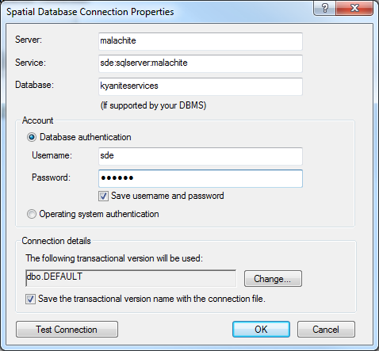

**Staging geodatabase connection properties**

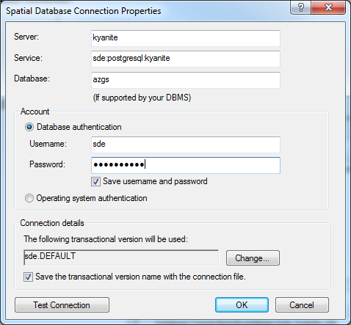

**Production geodatabase connection properties**

1. In ArcCatalog, copy feature class from personal database and paste into staging database.
2. Right-click the feature class in staging database, select Add Global IDs.
3. Right-click the feature class in staging database, select Register as Versioned. **DO NOT** check the box next to Register the selected objects with the option to move edits to base.
4. Create Replica
   1. Open ArcToolbox window
   2. Expand Data Management Tools, Distributed Geodatabase
   3. Double-click on Create Replica; parameter values should be
      1. Replica Datasets: input feature class from staging database
      2. Replica Type: ONE_WAY_REPLICA
      3. Geodatabase to replicate data to: input production database

**The workshop production database is named “production”. Please choose this to replicate to.**

* + 1. Replica Name: should be the same name as the feature class name in the staging database
    2. Click OK

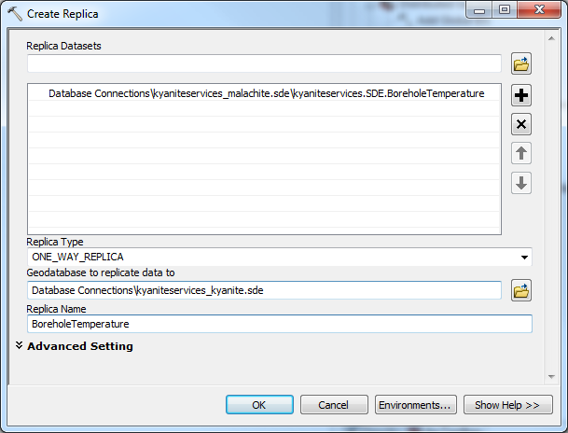

**Create Replica**

The data is ready to add to ArcMap.

**B. Create an ArcMap Project**

1. Open a Blank ArcMap
2. Add feature class from production database
3. Click Add Data
4. Navigate to feature class
5. Symbolize layer
   1. Download the layer files for content model symbologies here: <http://repository.stategeothermaldata.org/repository/resource/98ddf901b9782a25982e01af3b068fdc/>
   2. Unzip download and place in project directory.
   3. Right click the Feature Class and select Properties.
   4. Click on Symbology tab. Click Import.
   5. Navigate to layer files in the project directory.
   6. Select the layer file that corresponds to the content model.
   7. Select Value Field.
   8. Click OK. Layer symbology has been applied.
   9. Click OK again to close Layer Properties window.
6. Create metadata for the map document. The text will display on the arcgis services rest page, near the bottom under “Document Info”.
   1. From the ArcMap File dropdown menu, select Map Document Properties
   2. Title (example): “Arizona Borehole Temperature”
   3. Summary (example): “Arizona Borehole Temperatures”
   4. Author, just the organization (example): “Arizona Geological Survey”
   5. Credits (example): “Data provided by the Arizona Geological Survey; service provided by the Arizona Geological Survey”.
   6. **NOTE:** If data is being served by another state, then you can specify that. For example, Illinois is serving Borehole Temperature Data for the State of Massachusetts. The credits in this case might read “Data provided by the Massachusetts Geological Survey; service provided by the Illinois State Geological Survey”.
   7. Tags (example): “geothermal, wells, geochemistry, water, temperatures, borehole, aasg, wms, wfs”
   8. Check box next to “Store relative pathnames to data sources”
7. Create data frame metadata. Text will appear in the “Description” area on the arcgis services rest page.
   1. Right-click Data Frame, select Properties.
   2. Click on General tab. Fill out the following information:
      1. Name (example): “AZBoreholeTemperatures”
      2. Description (example): “This layer contains data describing borehole temperatures in the state of Arizona, obtained by the AASG for the Geothermal Data Project. The data table includes general information on the location of the borehole, temperature at some depth within the well, measurement procedure, location uncertainty and remarks. Citations are included in the dataset.
         1. The HeaderURI for a particular borehole is the cross-referencing link (foreign key) used to associate the borehole with web based information on the well construction, pictures or other information, specific to one feature.
         2. The data is displayed using a temperature gradient color scheme ramping from green (cool) to red (hot). Layer files containing the symbology for these data layers can be found in the USGIN repository at http://repository.usgin.org/uri_gin/usgin/dlio/206. The original data and metadata can be viewed or downloaded from the USGIN Repository at <http://repository.usgin.org/uri_gin/usgin/dlio/318>.”

**NOTE:** At the end of the Description, include a link to the repository page (as shown above). For NGDS data, go t[o http://repository.stategeothermaldata.org/repository/browse/](http://repository.stategeothermaldata.org/repository/browse/) and copy the link of the page for the appropriate dataset.

* + 1. Credits (example): “Data provided by the Arizona Geological Survey; service provided by the Arizona Geological Survey”.
       1. If data is being served by another state, then you can specify that. For example, Illinois is serving Borehole Temperature Data for the State of Massachusetts. The credits in this case might read “Data provided by the Massachusetts Geological Survey; service provided by the Illinois State Geological Survey”.

1. Create layer metadata. The text will appear in the Layer description on the arcgis services rest page)
   * 1. Right-click layer. Select Properties.
     2. Click on General Tab. Enter the following:
        1. Layer Name (example): Borehole Temperature
        2. Description: Same as Data Frame
        3. Credits: Same as Data Frame
2. Save the map document.

**C. Publish services using ArcGIS Server**

**For purposes of this workshop, a temporary test database has been set up to practice service deployment. To access this database, please enter the following URL in a browser: http://kyanite/ArcGIS/Manager/**

**User name: kyanite\reno**

**Password: reno**

**Follow the steps indicated in the wizard to publish your service. Then, proceed to Section 9 to validate your published service.**

This document assumes that ArcGIS Server is installed and configured properly. Refer to ArcGIS Desktop 10.0 help documentation for more details about server configuration: http://help.arcgis.com/en/arcgisdesktop/10.0/help/index.html#/What_is_ArcGIS_Server/005300000001000000/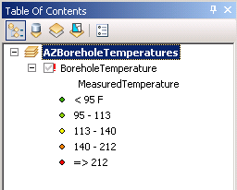

1. Confirm that data from production database are connected to ArcMap layers
   1. Open ArcMap.
   2. If the links are broken (indicated by a little red exclamation point next to the layer), repair data sources. Refer to ArcGIS Desktop Help document on [Repairing Broken Data Links](http://help.arcgis.com/en/arcgisdesktop/10.0/help/index.html#//00s500000020000000).
   3. Save and Close ArcMap.
2. Publish Service
   1. Open ArcCatalog.
   2. Connect to GIS Server.
   3. Expand GIS Servers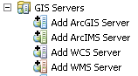
   4. If needed, make the initial connection to ArcGIS Server.
      1. Double-click Add ArcGIS Server
         1. Select Manage GIS Services; click Next
         2. Input Server URL and Host Name
         3. Follow prompts to connect to server
         4. Once connected, the connection should remain
   5. To publish service (See Appendix F for screenshots)
      1. Right-click on ArcGIS Server
      2. Select Add New Service …
         1. Add GIS Service window pops up. Fill in fields:
            1. Name: Map service name. See Appendix B for service names.
            2. Type: Select Map Service
            3. Description: Type description. See service example description in Appendix C.
         2. Click Next. A new window pops up. Fill in parameter fields:
            1. Map Document: Navigate to and select ArcMap service document
            2. Directory: Select output directory. This should most likely be the default c:\arcgisserver\arcgisoutput
            3. Server Cache Directory: Select Cache directory. This should most likely be the default c:\arcgisserver\arcgiscache
            4. Maximum Number of Records Returned by Server: default value (1000) okay
         3. Click Next. A new window pops up. Select capabilities and operations.
            1. Check boxes next to:
            2. Mapping

Map

Query

Data

* + - * 1. WMS

Fill out WMS service properties (metadata). This will be the contact information for the data provider.

Change the OnlineResource; see Appendix D for examples.

Enable the “Use layer names from the map document”

* + - * 1. WFS

Fill out WFS service properties (metadata). This will be the contact information for the service provider.

Change the OnlineResource; see Appendix D for examples.

Enter the correct namespace (found in first line of schema).

Enter the prefix “aasg”.

* + - 1. Click Next. A new window pops up. Accept defaults for pooling.
      2. Click Next. A new window pops up. Accept defaults for processes.
      3. Click Next. A new window pops up. Select radio button to start service right now.
      4. Click Finish

**SECTION 8.2: LOAD DATA AND PUBLISH SERVICES USING GeoServer**

**A. Load Data**

GeoServer can be installed separately, or part of a software package known as OpenGeo Suite (<http://opengeo.org/>) which includes Postgres and PostGIS (database management systems) and OpenLayers. These are free and open-source software options. OpenGeo Suite is recommended and the following workflow describes loading a shapefile into PostGIS environment using this software. Using the PostGIS interface, a shapefile will be imported then converted to a table within the PostGIS database. This data table will be the source of data for the web service. For a more in-depth explanation of GeoServer set up and installation, see repository.stategeothermaldata.org/resources/documents/NGDS/GeoserverDocumentation.docx.

1. Click Start in the OpenGeo Suite Dashboard.

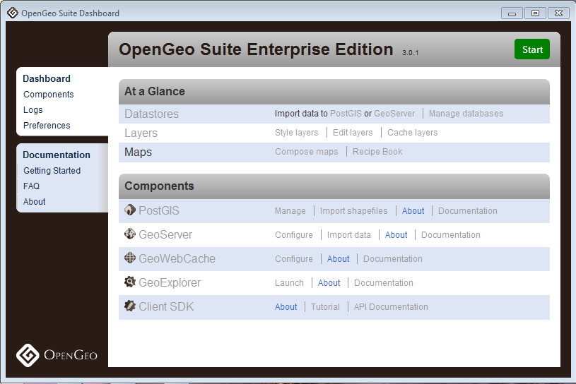

1. Under Components, click ‘Import shapefiles’ next the PostGIS icon.
2. Click ‘View connection details’ to connect to database and folder for deployment.
3. Click Add File; navigate to schema-valid shapefile (shp) or database file (dbf).
4. Highlight file which now appears in the field and click Import; If the shapefile has a 'geom' field and a defined SRID, the spatial index will be automatically created with the Shape to PostGIS Converter.

Proceed to section 10.2 to connect to this database and deploy the service using GeoServer.

**B. Publish services using GeoServer**

The following outlines how to use OpenGeo Suite on Windows platform to deploy WMS/WFS services using a connection to PostGIS database tables. From the GeoServer homepage, under About & Status, click Contact Information to enter the service provider information that will serve as your metadata contact information in service requests. For the following example, the GeoServer data directory was assigned as file location C:\Program Files (x86)\OpenGeo\OpenGeo Suite\webapps\geoserver\data.

1. Using the OpenGeo Suite Dashboard, click Start and choose GeoServer to open the GeoServer interface.

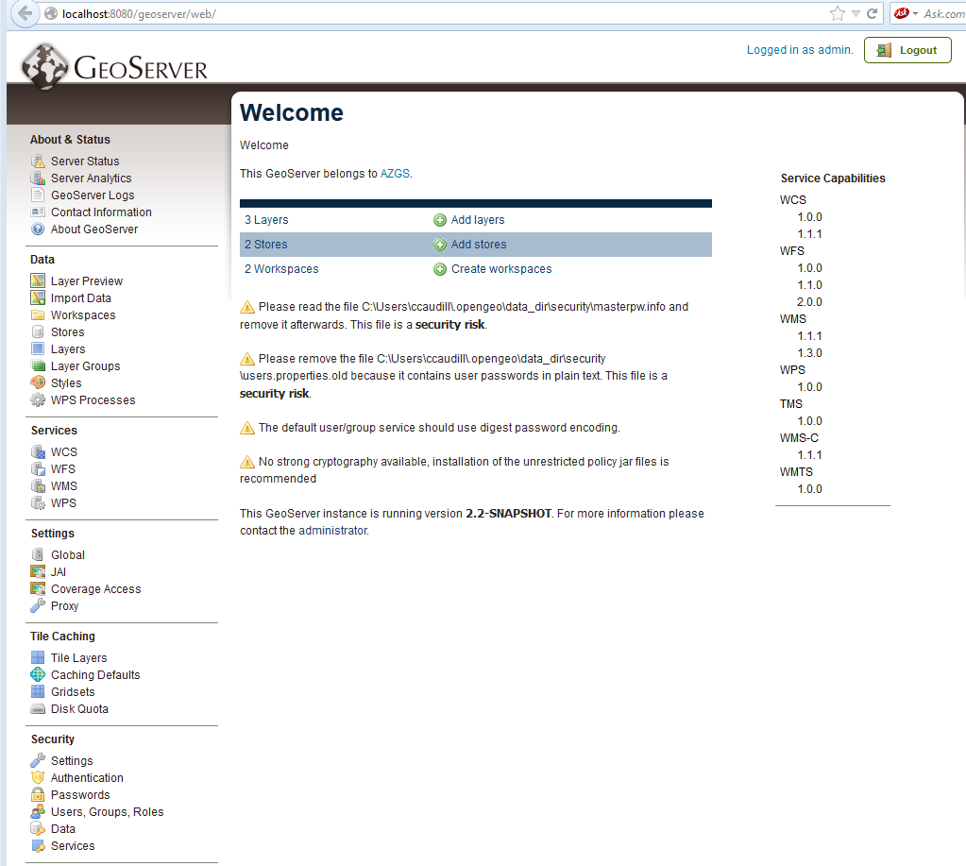

1. Under Data, click Workspaces.
   1. Click Add new workspace. The workspace specifies a namespace, so each data type will need its own separate workspace.
   2. Choose a name to identify your workspace (i.e., ThermalSprings)
   3. Fill in the namespace, given in the first line of an NGDS schema, or XSD, (<http://schemas.usgin.org/models/>)
   4. Fill in the Contact information (metadata). This will serve as the contact information for the data provider.
   5. Click Submit
2. Under Stores, click Add new Store. The Store will house the connection parameters to the data table in PostGIS database.
   1. If using PostGIS, choose this from the Vector Data Sources list. Choose the workspace you’ve just created from the drop-down list. The Data Source Name* will be the name of the data table as it appears exactly in your PostGIS database (i.e., azthermalsprings).
   2. Click the box next to “Enabled”.
   3. Once connection parameters are filled in, click Save.
3. Under Layers, click Add a new resource.
   1. From the drop-down list, choose the workspace:Store you’ve just created.
   2. If connected to PostGIS database, this should give all the available tables in the specified folder. Navigate through the list to the data table (i.e., azthermalsprings) and click Publish to the right of that data table name.
   3. This takes you to Edit Layer.
   4. In the Data tab, under Bounding Boxes, choose ‘Compute from data’ under ‘Native Bounding Box; choose ‘Compute from native bounds’ under ‘Lat/Lon Bounding Box’. This will pull locational bounding boxes from the data table.
   5. Click Save at bottom.
4. If ArcMap was used to create the original data table, it is important to note that GeoServer will not correctly read the SRID. This must be manually indicated by creating a SQL view of your layer that will serve as your web service. Under Layers, click Add a new resource.
   1. Choose the workspace:Store you created previously.
   2. When the available data tables pop up, there is a bolded option at the top labeled ‘Configure new SQL view...’ Click this.
   3. In the Create new SQL view page, fill in the ‘View Name’ that will serve as the final layer name, as indicated by the appropriate schema.
   4. In ‘SQL statement’ use a SQL statement that will call all the fields from the desired data table as such:

select * from azthermalsprings

Click Refresh.

* 1. When the fields appear, check objectid as the Identifier. For the shape field, type is indicated as Geometry. The SRID box must be filled in with the correct EPSG code (i.e., 4326). Click Save.
  2. This takes you to Edit Layer.
  3. In the Data tab, under Bounding Boxes, choose ‘Compute from data’ under ‘Native Bounding Box; choose ‘Compute from native bounds’ under ‘Lat/Lon Bounding Box’. This will pull locational bounding boxes from the data table.
  4. In the publishing tab, under WMS Settings, a Style (or symbology) may be chosen.
     1. To add a Style: under Styles from GeoServer home, click Add a new style.
     2. Choose a name and the workspace for this style (i.e., ThermalSprings)
     3. To use the SLDs for the NGDS project, scroll down to SLD file and click Browse. Browse to your downloaded SLD copies, available from<http://repository.stategeothermaldata.org/repository/resource/50ec3aefb656b70647f32e38bc1b7479/>
     4. Click Upload. Click Submit.
  5. Click Save.

1. Perform a GetFeature request to confirm data return. Construct a GetFeature URL, where the typeName=workspace:layer. For example:

[http://localhost:8080/geoserver/wfs?service=wfs&version=1.3.0&request=GetFeature&typeName=ThermalSpring:ThermalSpring](http://localhost:8080/geoserver/wfs?service=wfs&version=1.3.0&request=GetFeature&typeName=ThermalSpring:AZThermalSprings)

1. Create app-schema configuration for the new service. Creating an additional configuration file (mapping file) for GeoServer allows the use of "app-schemas" which will automatically download the indicated web-accessible schema (.xsd) and be referenced in the GetFeature request. This solves a problem with service deployment using ArcGIS, where custom schema locations are necessary. (For more in-depth explanation of app-schema implementation and associated files, see [http://repository.stategeothermaldata.org/resources/documents](http://repository.stategeothermaldata.org/resources/documents/GeoserverDocumentation.docx)

[/GeoserverDocumentation.docx](http://repository.stategeothermaldata.org/resources/documents/GeoserverDocumentation.docx) )

* 1. If necessary, download the app-schema extension from <http://sourceforge.net/projects/geoserver/files/GeoServer%20Extensions/>
     1. Download the app-schema plugin zip file for the same version of GeoServer.
     2. Unzip the app-schema plugin zip file to obtain the jar files inside. Do not unzip the jar files.
     3. Place the jar files in the WEB-INF/lib directory of your GeoServer installation.
     4. Restart GeoServer to load the extension.
  2. Create a mapping file and place in appropriate location. Example location: C:\Program Files (x86)\OpenGeo\OpenGeo Suite\webapps\geoserver\data\workspaces\

HeatFlow\azheatflow

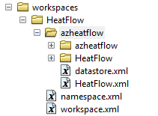

Example mapping file: <http://repository.stategeothermaldata.org/resources/documents/App-Schema-Mapping-Files/HeatFlow.xml>

* 1. Edit datastore.xml

Example datastore file: <http://repository.stategeothermaldata.org/resources/documents/App-Schema-Mapping-Files/datastore.xml>

1. Perform a GetFeature request to confirm data return and use of schema. Construct a GetFeature URL, where the typeName=workspace:layer. For example:

<http://localhost:8080/geoserver/wfs?service=wfs&version=1.3.0&request=GetFeature&typeName=HeatFlow:HeatFlow>

The service has been created and needs to be validated against the schema.

**SECTION 9: VALIDATING SERVICES**

WMS and WFS services must be validated to ensure the data will be interoperable within the system. For WMS, visual confirmation in a GIS program is sufficient for validation. For WFS, the GetFeature URL for the service will be validated against the schema (schema validation).

1. Validating the WMS service using WMS Capabilities

ArcMap

* 1. Navigate to the service rest page and click on ‘WMS’
  2. Copy the WMS GetCapabilites URL, just left of the ‘?’
  3. Open ArcCatalog. Expand GIS Servers. Choose ‘Add WMS Server’
  4. Paste in the URL and click ‘Get Layers’ and ‘OK’. Drag the added layer into ArcMap.
  5. Ensure that the WMS draws with correct symbology. Also, choose the Identify tool and select a feature. Click on a URI to test the redirects.

uDig free and open-source desktop GIS, available here:<http://udig.refractions.net/>

* 1. Click on the “Layer” drop-down list and choose “Add”
  2. Choosing data type to add, click “Web Map Server”. Paste the WMS GetCapabilities URL into the box.
  3. Click “Next”. This should add the data directly to the map.
  4. To display feature attributes, select the layer in the “Layers” box on the left. On the right, select “Info.”
  5. Click on a feature on the map and open the “Information” tab on the bottom to display attributes as listed in the service. Click on a URI to test the redirects.

1. Schema Validation using WFS GetFeature request

Free versions of XML Explorer and Notepad ++

available here: <http://xmlexplorer.codeplex.com/>, <http://notepad-plus-plus.org/>

* 1. Navigate to the service rest page and click on ‘WFS’
  2. Create a Get Feature Request: In the browser, change the URL by deleting “Capabilites” and replacing with “Feature” and adding to the end of the URL the layer name. This is shown below in bolded text:

http://services.azgs.az.gov/ArcGIS/services/aasggeothermal/AZActiveFaults/MapServer/WFSServer?request=GetCapabilities&service=WFS

http://services.azgs.az.gov/ArcGIS/services/aasggeothermal/AZActiveFaults/MapServer/WFSServer?request=GetFeature&service=WFS&TypeName=ActiveFault&MaxFeatures=2

* 1. Copy this URL. In XML Explorer “Open Url …”. Paste in the Url. Once loaded save the file. Open in Notepad++.
  2. From <http://schemas.usgin.org/models/> save the schema (.xsd) to validate file against to a local file location.
  3. In Notepad++:
     1. In the first element, in the attribute “xsi:schemaLocation=”, find the 2nd URL that appears (will end with the layer name) and delete. In its place, write the name of the .xsd saved in step d above (i.e., ActiveFault1.1.xsd).
     2. Save the document as .xml and having the same name and in the same location file location as the .xsd saved in step d (i.e., ActiveFault1.1.xml). Close.
  4. Open XML Explorer; Click Open and navigate to the xml file that was just edited in step e.
     1. Upon opening this .xml file, the program will look at the indicated schema to automatically validate the file.
        1. Any returns with a red X will mean a change in the data, field type, or field heading is needed, and likely a re-import of the feature class into a staging or deployment database.
        2. A return of no errors indicates that the .xml file (and hence the GetFeature request and the service) was successfully validated.

USGIN WFS Validator tool:<http://schemas.usgin.org/validate/wfs>

* 1. Input the WFS GetCapabilites URL from the service and click Submit
  2. Choose the FeatureType and Number of Features to validate
  3. Choose the Content Model and Version to validate the service against. This will actually validate the GetFeature request against the schema (XSD). The version of the content model should be the latest version used; see<http://schemas.usgin.org/models/> for the versions in use.

**SECTION** **10: REPOSITORY**

Creating a new resource in the NGDS repository that represents this data service exposes it to the catalog where it becomes searchable within the system. This also creates metadata for the service. This step is necessary to fulfill the Tier 3 USGIN requirements.

1. Go to [http://repository.stategeothermaldata.org/repository/](http://repository.stategeothermaldata.org/repository/browse/) to Create a New Resource.
2. Upload the Excel file, database file, or shapefile that represents this service to the repository by clicking “Attach a new file” under the Manage File Attachments on screen left when creating your new resource. After uploading, the file name may be changed at the bottom of the page under Links.
3. It is important to add the links to the service as this allows the service to be added to the searchable catalog interface at <http://search.geothermaldata.org/>.
   1. Scroll to the bottom of the page to the Links section. Click the Globe icon.
   2. Add links for ESRI, OGC:WFS, and OGC:WMS services copied from the REST page.
      1. Example ESRI link: <http://mapserver.kgs.ku.edu/arcgis/rest/services/NGDS/KSBoreholeTemperatures/MapServer>
      2. Example OGC:WFS link: <http://mapserver.kgs.ku.edu/arcgis/services/NGDS/KSBoreholeTemperatures/MapServer/WFSServer?request=GetCapabilities&service=WFS>
      3. Example OGC:WMS link: <http://mapserver.kgs.ku.edu/arcgis/services/NGDS/KSBoreholeTemperatures/MapServer/WMSServer?request=GetCapabilities&service=WMS>
4. Edit Author and Distributor information.
5. Add Keywords.
6. Add Description (must be greater than 50 characters).
7. Add to Collections on screen left. Collections are categorizations of metadata, where state, organization, and data type are specified.
8. Click Save.

**Appendix A – Rewrite Rule Examples**

Rewrites for return of online file location

In the ‘Redirect to’ field at <http://resources.usgin.org/admin/>, the root redirect URI http:/resources.usgin.org/uri-gin/ will replace the root of the online file location.

online file location example:

http://kgs.uky.edu/kgsweb/geothermal/ar/Logs/123.tiff

file (or unique record identifier): 123.tiff

name authority: args

resource type: logs_tiff

pattern: (.+)/

‘Redirect to’: http://kgs.uky.edu/kgsweb/geothermal/ar/Logs/$1

final URI in spreadsheet: http:/resources.usgin.org/uri-gin/args/logs_tiff/123.tiff/

where pattern (.+)/ and $1 in the ‘Redirect to’ field indicates the online file has a simple one-folder path. An example of redirecting to a file having more than one folder to redirect to is as follows:

online file location example:

http://kgs.uky.edu/kgsweb/geothermal/ar/Logs/OilandGas/documents/123.tiff

file (or unique record identifier): 123.tiff

name authority: args

resource type: logs_docs

pattern: (.+)/(.+)/(.+)/

‘Redirect to’: http://kgs.uky.edu/kgsweb/geothermal/ar/Logs/$1/$2/$3

final URI in spreadsheet: http:/resources.usgin.org/uri-gin/args/logs_docs/OilandGas/documents/123.tiff/

Rewrites for return of XML representations of data service

These will be entered into the ‘Redirect to’ field at <http://resources.usgin.org/admin/>

General pattern for rewrites are as follows. Replace the highlighted portions; see examples below.

[HostURL]/[ServiceName]/MapServer/WFSServer?request=GetFeature&service=WFS&TypeName=aasg:[LayerName]&FILTER=%3Cogc:Filter%3E%3Cogc:PropertyIsEqualTo%3E%3Cogc:PropertyName%3Eaasg:[FieldNameForURI]%3C/ogc:PropertyName%3E%3Cogc:Literal%3Ehttp://resources.usgin.org/uri-gin/[NameAuthority]/[Token]/$1/%3C/ogc:Literal%3E%3C/ogc:PropertyIsEqualTo%3E%3C/ogc:Filter%3E

Arizona-hosted example:

HostURL: http://services.azgs.az.gov/arcgis/services/aasggeothermal/

ServiceName: NMWellLogs

LayerName: WellLog

FieldNameForURI: LogURI

NameAuthority: nmbgmr

Token: welllog

Pattern: (.+)/

Media type: application/xml

Redirect to:

http://services.azgs.az.gov/arcgis/services/aasggeothermal/NMWellLogs/MapServer/WFSServer?request=GetFeature&service=WFS&TypeName=aasg:WellLog&FILTER=%3Cogc:Filter%3E%3Cogc:PropertyIsEqualTo%3E%3Cogc:PropertyName%3Eaasg:LogURI%3C/ogc:PropertyName%3E%3Cogc:Literal%3Ehttp://resources.usgin.org/uri-gin/nmbgmr/welllog/$1/%3C/ogc:Literal%3E%3C/ogc:PropertyIsEqualTo%3E%3C/ogc:Filter%3E

Illinois-hosted examples:

http://geothermal.isgs.illinois.edu/arcgis/services/aasggeothermal/MEaqWellChemistry/MapServer/WFSServer?request=GetFeature&service=WFS&TypeName=aasg:$1&FILTER=%3Cogc:Filter%3E%3Cogc:PropertyIsEqualTo%3E%3Cogc:PropertyName%3Eaasg:AnalysisURI%3C/ogc:PropertyName%3E%3Cogc:Literal%3Ehttp://resources.usgin.org/uri-gin/megs/chemistry/aqchem/$1/$2/%3C/ogc:Literal%3E%3C/ogc:PropertyIsEqualTo%3E%3C/ogc:Filter%3E

http://geothermal.isgs.illinois.edu/arcgis/services/aasggeothermal/ILDrillStemTests/MapServer/WFSServer?request=GetFeature&service=WFS&TypeName=aasg:DrillStemTest&FILTER=%3Cogc:Filter%3E%3Cogc:PropertyIsEqualTo%3E%3Cogc:PropertyName%3Eaasg:ObservationURI%3C/ogc:PropertyName%3E%3Cogc:Literal%3Ehttp://resources.usgin.org/uri-gin/isgs/dst/$1/%3C/ogc:Literal%3E%3C/ogc:PropertyIsEqualTo%3E%3C/ogc:Filter%3E

**Appendix B – Naming Conventions**

Data Frame (Service Name) and Layer Names must be without special characters or spaces. The layer name must be as exactly specified ‘element name’ in schema. The service name must include the state’s abbreviated name concatenated with the Service type (usually plural). The following is a list of service names and layer names approved for use in the NGDS/USGIN schema:

|  |  |
| --- | --- |
| Service Names + State Prefix (eg AZActiveFaults) | Layer Name |
| State Prefix + ActiveFaults | ActiveFault |
| State Prefix + aqSpringChemistry | BaseMetals |
| State Prefix + aqSpringChemistry | CommonAnalytes |
| State Prefix + aqSpringChemistry | FreeGas |
| State Prefix + aqSpringChemistry | GasIsotopes |
| State Prefix + aqSpringChemistry | IsotopesDissolved |
| State Prefix + aqSpringChemistry | MajorDissolvedConstituents |
| State Prefix + aqSpringChemistry | MinorDissolvedConstituents |
| State Prefix + aqSpringChemistry | Nitrogen |
| State Prefix + aqSpringChemistry | WaterDissolvedGas |
| State Prefix + aqSpringChemistry | WaterIsotopes |
| State Prefix + aqSpringChemistry | WaterQuality |
| State Prefix + AqueousChemistry1_10 | BaseMetals |
| State Prefix + AqueousChemistry1_10 | CommonAnalytes |
| State Prefix + AqueousChemistry1_10 | FreeGas |
| State Prefix + AqueousChemistry1_10 | GasIsotopes |
| State Prefix + AqueousChemistry1_10 | IsotopesDissolved |
| State Prefix + AqueousChemistry1_10 | MajorDissolvedConstituents |
| State Prefix + AqueousChemistry1_10 | MinorDissolvedConstituents |
| State Prefix + AqueousChemistry1_10 | Nitrogen |
| State Prefix + AqueousChemistry1_10 | SingleAnalyte |
| State Prefix + AqueousChemistry1_10 | WaterDissolvedGas |
| State Prefix + AqueousChemistry1_10 | WaterIsotopes |
| State Prefix + AqueousChemistry1_10 | WaterQuality |
| State Prefix + aqWellChemistry | BaseMetals |
| State Prefix + aqWellChemistry | CommonAnalytes |
| State Prefix + aqWellChemistry | FreeGas |
| State Prefix + aqWellChemistry | GasIsotopes |
| State Prefix + aqWellChemistry | IsotopesDissolved |
| State Prefix + aqWellChemistry | MajorDissolvedConstituents |
| State Prefix + aqWellChemistry | MinorDissolvedConstituents |
| State Prefix + aqWellChemistry | Nitrogen |
| State Prefix + aqWellChemistry | WaterDissolvedGas |
| State Prefix + aqWellChemistry | WaterIsotopes |
| State Prefix + aqWellChemistry | WaterQuality |
| State Prefix + BoreholeLithIntercepts | BoreholeLithIntercept |
| State Prefix + BoreholeLithIntervals | BoreholeLithInterval |
| State Prefix + BoreholeTemperatures | BoreholeTemperature |
| State Prefix + DirectUseSites | DirectUseSite |
| State Prefix + DrillStemTests | DrillStemTest |
| State Prefix + GeothermalAreas | GeothermalArea |
| State Prefix + HeatFlow | HeatFlow |
| State Prefix + HeatFlow1_23 | HeatFlow |
| State Prefix + HeatPumpFacilities | HeatPumpFacility |
| State Prefix + LASFileLocations | BoreholeTemperatureLASLog |
| State Prefix + PhysicalSamples | PhysicalSample |
| State Prefix + PowerPlants | PowerPlant |
| State Prefix + RadiogenicHeatProduction | RadiogenicHeatProduction |
| State Prefix + RockChemistry | Isotopes |
| State Prefix + RockChemistry | NobleGases |
| State Prefix + RockChemistry | RareEarths |
| State Prefix + RockChemistry | SingleAnalytes |
| State Prefix + RockChemistry | StableIsotopes |
| State Prefix + RockChemistry | TraceElements |
| State Prefix + RockChemistry | U-Series |
| State Prefix + RockChemistry | Volatiles |
| State Prefix + RockChemistry | WRMajorElements |
| State Prefix + SeismicHypocenters | Hypocenter |
| State Prefix + TemperatureLogs | BoreholeTemperatureGeophysicalLog |
| State Prefix + ThermalConductivity | ThermalConductivity |
| State Prefix + ThermalSprings | ThermalSpring |
| State Prefix + VolcanicVents | VolcanicVent |
| State Prefix + WellHeaders | Wellheader |
| State Prefix + WellLogs | WellLog |

**Appendix C - Service Description Example**

Service Description Example

This web map service (WMS) was published using ArcGIS Server v. 10.0 and is compliant with OGC (Open Geospatial Consortium) version 1.30 specifications. This service provides dynamic, spatially referenced geographic information using data collected for the National Geothermal Data System (http://www.geothermaldata.org/). In addition to the WMS capabilities, this service was designed to be interoperable with both WFS (Web Feature Services) as well as KML (Keyhole Markup Language). The WFS capabilities allow the client to query, make additions and/or modifications to an existing dataset. WFS can be utilized through the interoperability extension in ArcCatalog. For more information on using the ArcGIS data interoperability extension visit http://www.esri.com/software/arcgis/extensions/datainteroperability /common-questions.html. A KML service allows the client to view an image of the data in three dimensions, using free software available for download on the internet such as ArcGIS Explorer or Google Earth. For more information on OGC specifications, visit http://www.opengeospatial.org/standards.

**Appendix D – Online Resource Examples**

For AZGS-hosted services

http://services.azgs.az.gov/ArcGIS/services/aasggeothermal/OKBoreholeTemperatures/MapServer/WMSServer

http://services.azgs.az.gov/ArcGIS/services/aasggeothermal/OKBoreholeTemperatures/MapServer/WFSServer

For Illinois-hosted services

http://geothermal.isgs.illinois.edu/arcgis/services/aasggeothermal/MEaqWellChemistry/MapServer/WMSServer

http://geothermal.isgs.illinois.edu/arcgis/services/aasggeothermal/MEaqWellChemistry/MapServer/WFSServer

For Kentucky-hosted services

http://kgs.uky.edu/arcgis/services/aasggeothermal/LAWellheaders/MapServer/WMSServer

http://kgs.uky.edu/arcgis/services/aasggeothermal/LAWellheaders/MapServer/WFSServer

**Appendix E - Useful bookmarks**

[URI Redirection Site](http://www.google.com/url?q=http%3A%2F%2Fresources.usgin.org%2Fadmin%2F&sa=D&sntz=1&usg=AFQjCNGI9_GRYTzUM_i5X4t24GuclecQag)

[U](http://repository.stategeothermaldata.org/repository/browse/)[SGIN Repository](http://www.google.com/url?q=http%3A%2F%2Frepository.stategeothermaldata.org%2Frepository%2Fbrowse%2F&sa=D&sntz=1&usg=AFQjCNG1cXujZtFt-89LGrAI7tN05tzo4Q)

[XML Explorer](http://xmlexplorer.codeplex.com/)

[Symbology](http://repository.stategeothermaldata.org/repository/resource/98ddf901b9782a25982e01af3b068fdc/)

[slds](http://repository.stategeothermaldata.org/repository/resource/50ec3aefb656b70647f32e38bc1b7479/)

[WFS Validator](http://debug.usgin.org/validate/wfs)

[Best Practices for USGIN Web Service Hosting | USGIN Lab](http://lab.usgin.org/groups/best-practices-usgin-web-service-hosting/)

[USGIN Content Models](http://schemas.usgin.org/models/)

[NGDS Feature Search & Map](http://data.geothermaldatasystem.org/)

**Appendix F: Creating an ArcGIS (v.10) Service**

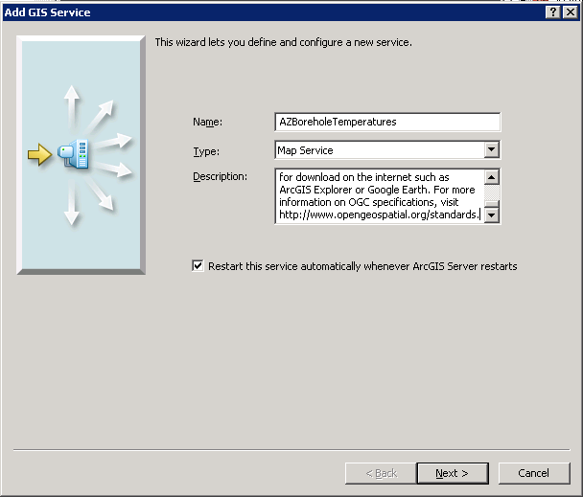

**Add ArcGIS Service: Service Name and Description**

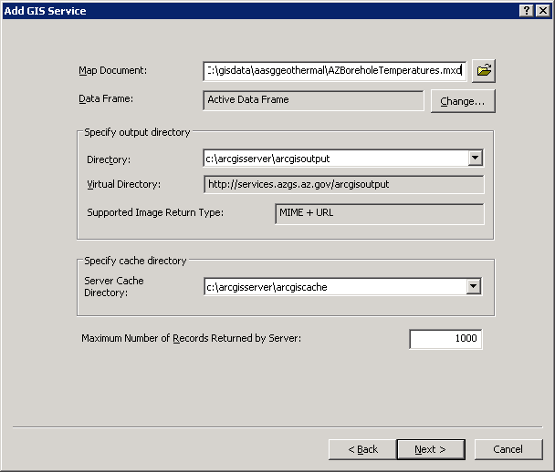

**Add ArcGIS Service: Select Map Service Document**

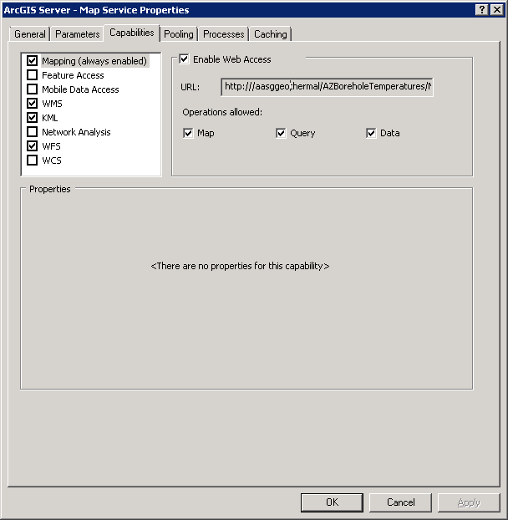

**Add ArcGIS Service: Select Capabilities**

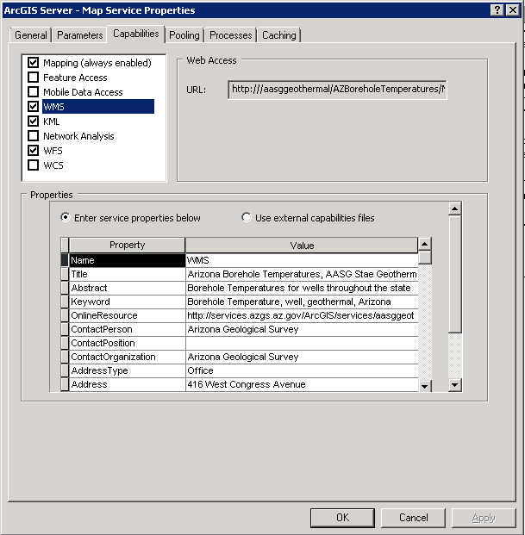

**Add ArcGIS Service: WMS Capabilities - Enter metadata or link to external capabilities file**

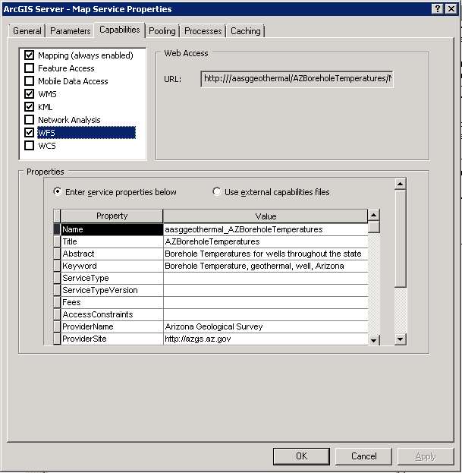

**Add ArcGIS Service: WFS Capabilities - Enter metadata or link to external capabilities file**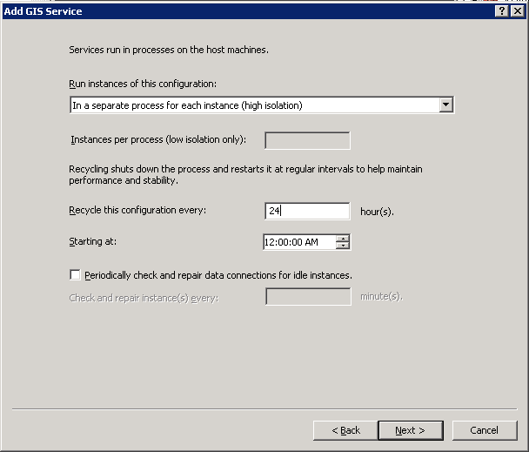

**Add ArcGIS Service: Processes**

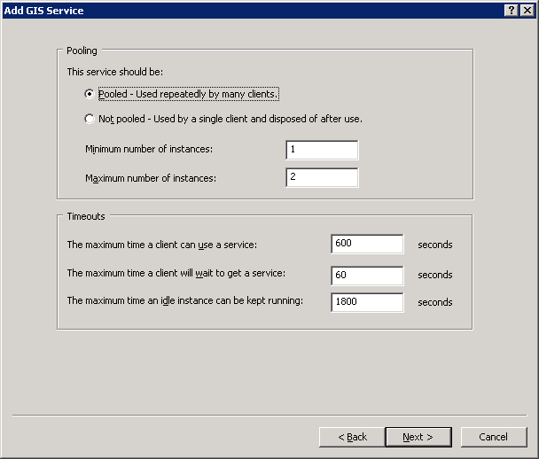**Add ArcGIS Service: Pooling**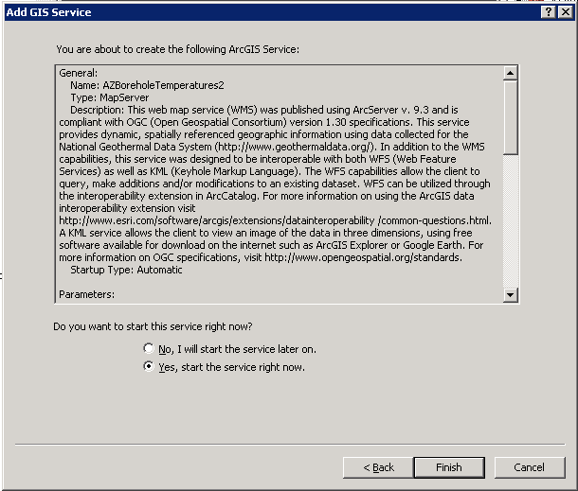

**Add ArcGIS Service: Start Services**