**United States Legislative Markup**

**Review Guide for**

**Version 2.0 of the USLM Schema**

Prepared by: Government Publishing Office

Revised: April 11, 2023

Contents

1 Introduction 3

2 Conventions Used in the User Guide 3

3 Brief USLM Background 3

4 Existing Documentation 4

5 What Has Not Changed 4

6 Schema Changes 5

6.1 Changed Models 5

6.1.1 Table of Contents and Indexes 5

6.1.2 Notes 7

6.2 New Models 7

6.2.1 Collections 7

6.2.2 Lists 9

6.2.3 Preface 9

6.2.4 Back Matter 9

6.2.5 Rule Preamble 9

6.2.6 Appropriations 9

6.3 New PropertyTypes 10

6.4 New Attributes 11

6.5 Model Extensions 11

6.5.1 LawDoc 11

6.5.2 Level 13

6.5.3 HeadingStructure 13

6.5.4 Amendments 13

6.5.5 Appendix 13

6.5.6 Signature 13

6.6 Tables 13

6.7 Document Actions 13

6.8 Document Titles 14

6.9 Content Tagging 14

6.10 Page and Line Numbering 14

6.11 Other New Elements 14

7 Feedback 15

8 Appendix 16

# Introduction

This Review Guide is intended to help users to understand changes in the 2.0 version of the United States Legislative Markup (USLM) schema so that users can provide meaningful feedback on the changes. This guide assumes that the reader is familiar with the 1.0 version of the USLM schema and is generally knowledgeable about XML schemas in XSD format. For more information about the 1.0 version, see section 4 of this document for links to existing documentation.

This guide reflects USLM schema version 2.0.12.

# Conventions Used in the User Guide

The following conventions are used in the User Guide:

* XML element names are denoted with angled brackets. For example, <title> is an XML element.
* XML attribute names are denoted with an “@” prefix. For example, @href is an XML attribute.
* Enumerated values are denoted in courier. For example, landscape is an enumeration.
* String values are denoted with double quotes. For example, “title1-s1” is a string value.
* A new ***term*** being defined is shown in bold italic.
* A new **element**or **attribute** being defined is shown in bold.

# Brief USLM Background

The USLM schema was first developed in 2013 by the Office of the Law Revision Counsel of the U.S. House of Representatives (OLRC) in order to produce the United States Code in XML. Since 2013, the OLRC regularly produces a USLM version of the United States Code for download at <http://uscode.house.gov/download/download.shtml>. The USLM version of the U.S. Code is updated continuously as new laws are enacted.

The original goals of the USLM schema included:

1. *Allow existing titles of the United States Code to be converted into XML.*
2. *Support ongoing maintenance of the United States Code.*
3. *Support the drafting of new positive law codification bills and related materials.*
4. *Provide a flexible foundation to meet future needs of Congress.*
5. *Compatibility with existing legislative documents in other XML formats.*

Building on the “flexible foundation” in goal number four above, the Government Publishing Office (GPO) is coordinating the 2.0 update to USLM that extends its use to the following document sets[1]:

* Enrolled Bills
* Public Laws
* Statutes at Large
* Statute Compilations
* Federal Register (FR)
* Code of Federal Regulations (CFR)

# Existing Documentation

User documentation for the 1.0 version of the schema can be found at <https://github.com/usgpo/uslm/blob/master/USLM-User-Guide.pdf> and <https://github.com/usgpo/uslm/blob/master/USLM-User-Guide.md>.

The XSD schema and CSS stylesheets for online viewing can be downloaded at: <http://uscode.house.gov/download/resources/schemaandcss.zip> and <https://github.com/usgpo/uslm>. Note that the CSS stylesheet is informational only. It produces a draft view of the documents.

Note: These resources and more are available on GPO’s Developers Hub at <https://www.govinfo.gov/developers>.

# What Has Not Changed

Version 2.0 of USLM is largely an incremental change to the schema. While many new elements have been added and several content models have been extended, the fundamental design of the schema has not changed. The following principles, documented in the 1.0 User Guide, continue in version 2.0:

* Abstract and Concrete Models
* Inheritance
* Attribute Model
* Core Document Model
* Metadata Model
* Hierarchy Model
* Versioning Model
* Presentation Model
* Relationship to HTML
* Identification Model
* Referencing Model

Many of these models have been extended to accommodate the additional document types and their structures. These extensions are backwards-compatible except in a few cases described below.

# Schema Changes

## Changed Models

The items described in this section are areas where the structure and content of the new document types required modifications to the schema model that are not compatible with the existing 1.0 model.

### Table of Contents and Indexes

The 1.0 model for a Table of Contents (ToC) was format-oriented, using the <layout> tag as a tabular form with rows and columns. The new 2.0 model is semantic, where a ToC consists of a set of “items”.

There are three different types of items:

**<**referenceItem**>** *refers to specific content in the document (versus a concept or a grouping). The referenceItem may also contain lower level referenceItems if the content being referred to contains lower level content.*

**<**headingItem**>** *a columnar-type heading for the items below it. e.g. “Sec.” or “Page”. This is commonly repeated on following pages.*

**<**groupItem**>** *an item in a ToCIndex that collects a number of referenceItems or other groupItems under a heading. The groupItem may or may not refer to a specific place in the document. groupItems may also contain nested groupItems.*

Each item may consist of one or more of the following elements:

**<**designator**>** *a reference to a numbered item in a table of contents or index.*

**<**label**>** *a textual reference in a table of contents or index.*

**<**target**>** *a reference to the target in a table of contents. This is used to provide various items in the last column of the multiple column table of contents entry. It has the same attributes as for references.*

Below are two examples of this ToC model.

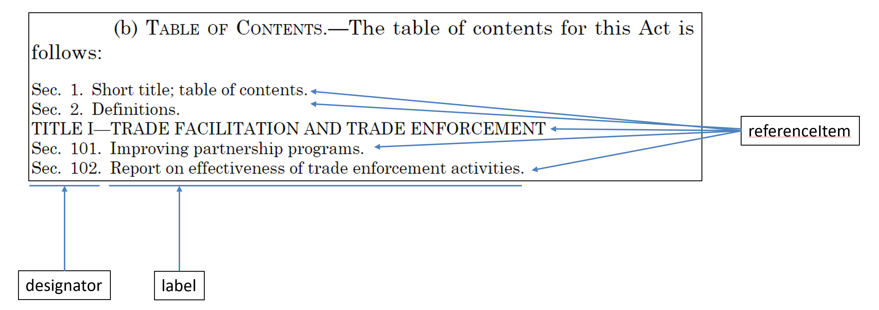

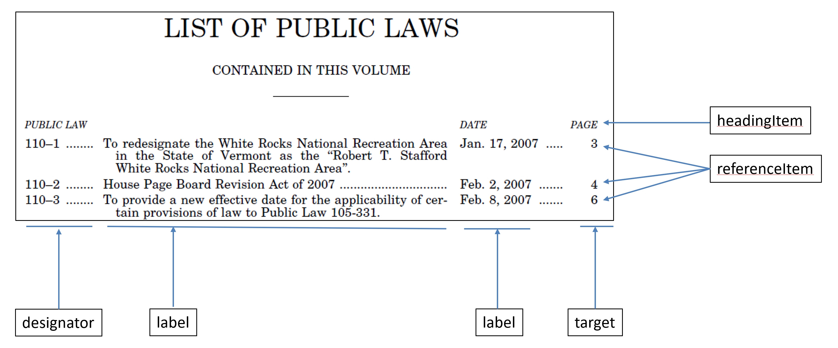

This same model, using items, designators, labels and targets, is also used for indexes that are found in legislative publications, such as the Popular Name Index. Below is an illustration of how the model can be used for an index.

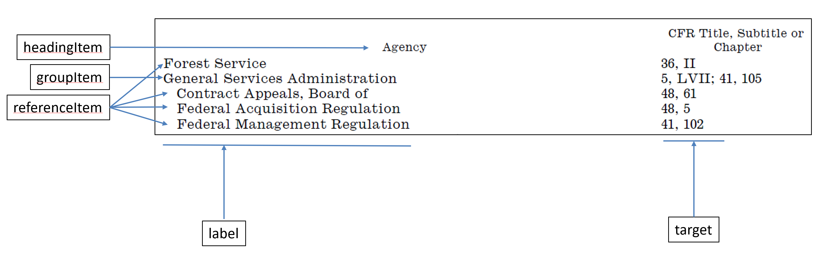

Elements of this type are:

toc, **index, tableOfTitlesAndChapters, listOfAgencies, listOfSectionsAffected, listOfBillsEnacted, listOfPublicLaws, listOfPrivateLaws, listOfConcurrentResolutions, listOfProclamations, popularNameIndex, subjectIndex**

### Notes

In version 1.0 of the schema, all notes had the same model, including footnotes and U.S. Code notes. The wider variety of notes in other document types drove a new model that has two types of notes:

#### NoteType Elements

A regular NoteType element is rendered directly in the main content flow. A U.S. Code note is an example of a NoteType element. Elements of this type are:

note, sourceCredit, statutoryNote, editorialNote, changeNote, **authority, source, effectiveDateNote, frDocID, billingCode, editionNote, organizationNote, citationNote, explanationNote, findingAidsNote**

#### PositionNotetype elements

The content of a PositionedNoteType element is rendered at a different position from where it logically refers. A footnote is an example of a positioned note. The positioned note has attributes for where it should be rendered. Elements of this type are:

footnote, **sidenote, leftRunningHead, rightRunningHead, ear[2], endMarker, page, line**

## New Models

### Collections

Some documents such as the Federal Register are a collection of other sub-documents. In fact, a daily issue of the Federal Register is a collection of collections. In order to support this type of document, USLM 2.0 introduces a new “CollectionType” which is described as:

***The collection core type is the basic element in a document that is a collection of items, potentially from external sources. Collections may contain individual items and/or other collections.***

A <collection> will contain a set of <component> elements. The <component> element acts as a wrapper for the individual document or fragment of the collection. The <component> may directly contain the content of the component, or it may point to the content by its @origin attribute.

The following elements are instances of CollectionType:

**notices, rules, proposedRules, presidentialDocs, agencyGroup, publicLaws, privateLaws, concurrentResolutions**

Below is an example of a collection used to group multiple document-specific units in an issue of the Federal Register:

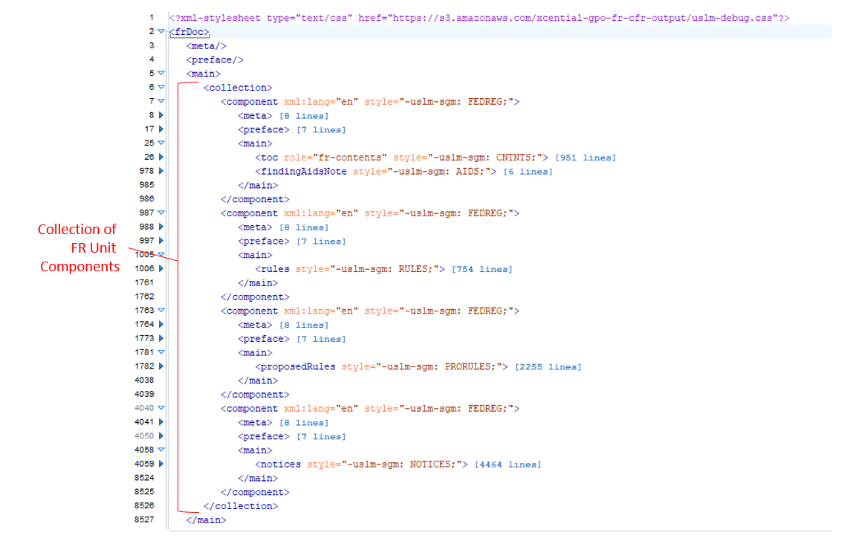

### Lists

USLM 1.0 does not have a model for lists. It depends on an external namespace (XHTML) for them. Lists are common, and the requirements are subtly different from XHTML. Thus, it was determined that USLM 2.0 needs to have a simple model for them. The relevant elements are:

**list, listHeading, listItem, listContent**

### Preface

The <preface> element is a container for rendered material that precedes the main body of the document.

***Documents may optionally have a preface before the main body of the document. Some information in the preface may be duplicated in the meta section. The content in the meta section would be normalized, whereas the content in the preface would contain the text as it is rendered for the user.***

For instance:

<meta><congress>115</congress></meta>

<preface><congress>One Hundred Fifteenth Congress of the United States</congress></preface>

The size and content of a preface can vary widely. For enrolled bills, the preface includes the Bill ID, the congress and session, and the enrolled dateline. The preface for a volume of a CFR title includes a cover page with numerous items, several notes and notices, a Table of Contents, publisher information, etc. See the illustration below. The content model for <preface> allows the same PropertyType elements as the <meta> section, a table of contents, notes, and other general content. Examples of these preface elements are in the Appendix.

### Back Matter

Back matter includes indexes, glossaries, lists and other general matter that may follow the end of the main body of the document. Back matter does not include appendix material. The back matter of a volume of a CFR title may be dozens of pages long and include the following: A note on finding aids, Table of CFR Title and Chapters, List of Agencies, List of sections affected, and an end marker.

### Rule Preamble

In the Federal Register, each rule has a rule preamble that usually follows a regular pattern, typically ending with “words of issuance”.

### Appropriations

Appropriation bills have unique constructs when compared to other legislative proposals. USLM 2.0 adds elements and attributes to capture the structure and data behind an appropriation account in an appropriation act.

***The <appropriations> element is used for nesting the various levels of appropriation agencies, bureaus, and departments, as well as the various budget areas within agencies, bureaus, and departments. The level attribute is used to distinguish major, intermediate, and small levels of appropriation language.***

Appropriation attributes:

@level ***The level attribute specifies which level the appropriations element is. This corresponds to major, intermediate, and small in the Bill DTD.***

@forType ***The forType attribute defines which type of budget grouping the appropriation is for (for example, agency, bureau, or account).***

@forvalue ***The forValue attribute defines which budget grouping the appropriation is for. This could be a URI that points to a web page giving details of the agency or account, for example.***

## New PropertyTypes

USLM 2.0 defines many more PropertyType elements. These elements are typically found in the meta and/or preface section of a document and capture important metadata about the document. This extension allows modeling of the following new document properties:

**docStage, docPart, publicPrivate, congress, session, citableAs, enrolledDateline, starPrint, processedBy, actionDescription, actionInstruction, organization, volume, issue, startingPage, endingPage, startingProvision, endingProvision, provisionRange, affected, subject, coverTitle, coverText, currentThroughPublicLaw, containsShortTitle, createdDate, currentChamber, distributionCode, relatedDocument, relatedDocuments**

## New Attributes

A number of new attributes are introduced in USLM 2.0, including:

@styleType *The @styleType attribute is used to set the overall semantic type of the block. This has rendering implications. Only a predefined set of values is allowed, which were carried over from Bill DTD and Comp DTD styles, such as “OLC” and “USC”.*

@scope *Use the @scope attribute to specify the scope within which the @identifier attribute is valid. Typically, @scope is formatted as a URL, referring to a specific context. @scope is used for terms within in definitions to specify the scope of the definition.*

@legisDate *The @legisDate attribute is used for a logical legislative date, which may be different from the calendar date.*

@verticalSpace *The @verticalSpace attribute indicates the amount of vertical space associated with a line break (<br>) element. If the attribute is not present, single line (i.e. the next line) is the default. If the attribute is present, the value is the amount of space to allow, in addition to the normal position of the next line. The value may specify units, using CSS syntax (e.g. "4em" or "12pt"). If no units are given, the units are assumed to be points. The values "nextPage" and "nextColumn" are used to force a page break or column break.*

@inEffect *@inEffect is a Boolean attribute that is used for provisions that are not in effect in the law at the time of the document publication. This attribute is typically used in statute compilations. The default is “true”.*

In addition to these USLM attributes, attributes from other namespaces are allowed in various elements, including table elements.

## Model Extensions

The items in this section have been extended from USLM 1.0 for compatibility. Both existing and new documents are valid against the extended models.

### LawDoc

The U.S. Code titles have very little prefatory material before the main body of text and no material after the end of the main body of text. Some other legislative and regulatory documents have much more material before and after the main text. To support this, the model for LawDocType has been extended with optional elements as illustrated below.

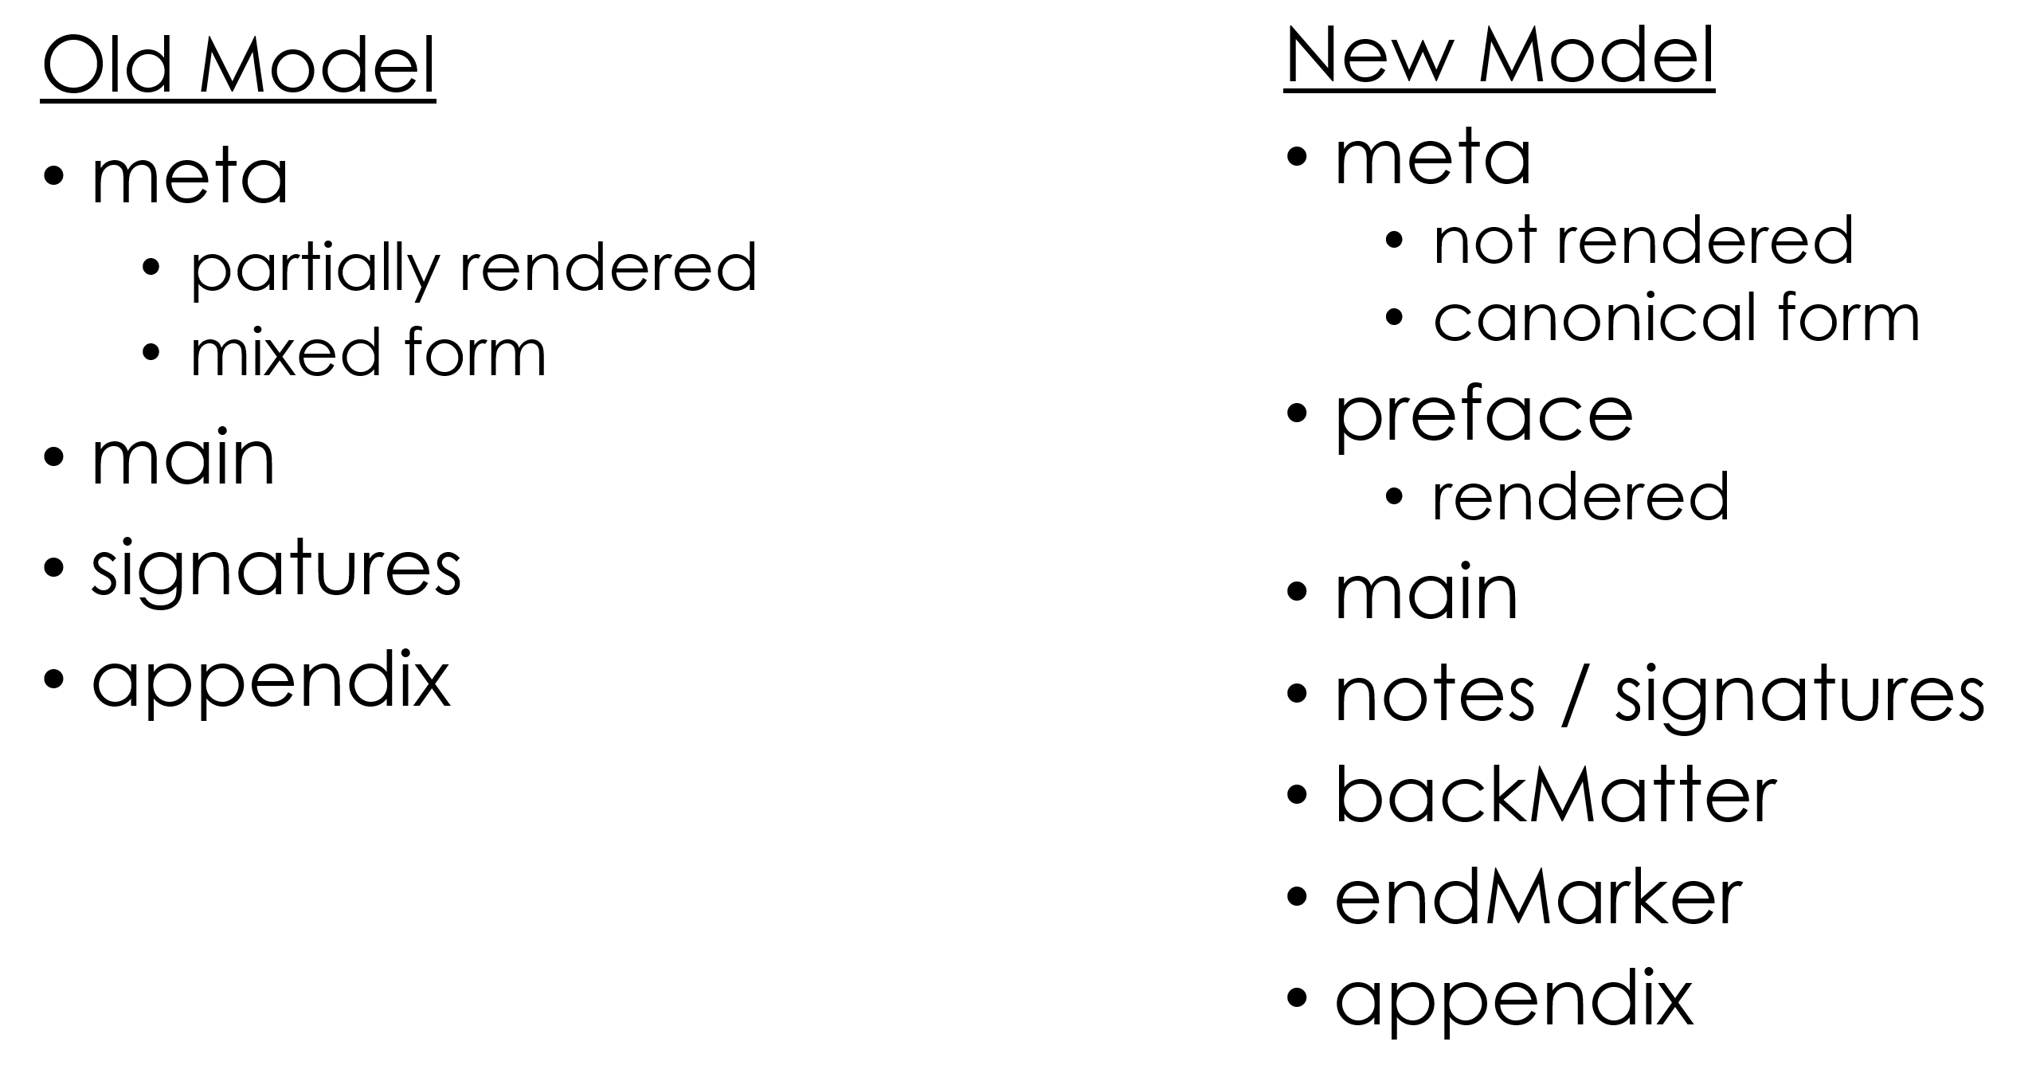

An optional <preface> element (discussed above) may come before <main>. The optional elements <attestation>, <signatures>, <notes>, <backmatter>, and <endMarker> may follow <main> before an <appendix>. This extension allows modelling of the following documents:

lawDoc, bill, resolution, uscDoc, **pLaw, statutesAtLarge, amendment, frDoc, rule, presidentialDoc, cfrDoc, statuteCompilation**

### Level

The “level” model, used in all hierarchical provisions, allows a more flexible arrangement of num, heading, ToC, appropriations and appendix elements within a level. For instance, a <heading> can precede <num> which was not allowed in USLM 1.0.

### HeadingStructure

HeadingStructure now allows a more flexible arrangement of headings, subheadings, and notes.

### Amendments

In order to allow the use of the element <action> in the context of bill actions, the existing use of <action> within amendments has been changed to <amendingAction>.

The existing action “renumber” was renamed “redesignate” to better match the terminology used in Congress. Additional action of “conform” and “unknown” were added.

### Appendix

The model for <appendix> was modified to better match actual appendix instances (previously unused).

### Signature

The model for <signatures> was modified to better match actual signature instances (previously unused). Elements were added for **<notation>** and **<autograph>**.

## Tables

In USLM 1.0, the table model was not defined, and the use of XHTML tables was encouraged. In USLM 2.0, the table model is still based on XHTML, but it has been significantly customized to meet the needs of the documents being modeled. The basic structure is XHTML 1.0, with the standard <table>, <caption>, <thead>, <tfoot>, <tbody>, <colgroup>, <col>, <tr>, and <td> elements taken from the XHTML namespace. Inline, p, and note elements from USLM are allowed in table cells along with character content. Attributes were added to match USLM processing needs with similar names to those used in Bill DTD:

**@stubHierarchy**, **@textHierarchy**, **@blockStyle**, **@leaders**, **@leaderAlign, @id, @identifier, @orientation**

## Document Actions

Legislative actions on a document were modelled more thoroughly. Elements were added for **<action>**, **<actionDescription>**, **<actionInstruction>, <committee>, <sponsor>, <cosponsor>,** and **<nonsponsor>**.

An example of these elements in use from 115 HCONRES 18 ENR:

<action>  
 <actionDescription>Agreed to</actionDescription>  
 <date date="2017-02-10">February 10, 2017</date>  
</action>

## Document Titles

Legislative document titles were modelled more thoroughly. Elements were added for **<longTitle>**, **<docTitle>**, **<officialTitle>**, and **<shortTitle>**.

An example of these elements in use from 115 HR 255 ENR:

<longTitle>An Act</docTitle>  
<officialTitle>To authorize the National Science Foundation to support entrepreneurial programs for women.</officialTitle>  
</longTitle>

## Content Tagging

Two elements were added for general content tagging.

term *A <term> is a word or phrase that is being defined. The <term> element surrounds the words for the term being defined. It is quite possible for multiple <term> elements to be specified within a definition. When a <term> is the words, in the alternate language, then the xml:lang attribute must be used. <term> elements can also be used for synonyms or near-synonyms which are also specified within the definition. The containing element (such as a section) has a @role="definitions" to indicate that definitions are contained within it.*

entity *An <entity> is a generic inline element to identify a text fragment introducing or referring to an ontological concept. This is modelled after the Akoma Ntoso <entity> element. The @role attribute can be used to distinguish the concept, for instance, a NAICS code or SEC code would be <entity @role="NAICS"> or <entity @role="SEC">.*

## Page and Line Numbering

**<page>** and **<line>** elements were introduced to note where page and line boundaries occurred in a published document. These are both typed as notes. The content models of some elements were modified specifically to allow these elements to exist at the actual boundary locations. Page and line numbers are used for citations and references in some document types, for example page numbers for citations to statutes at large.

## Other New Elements

The following new elements were added to support content found in the new document types and in new stages of existing document types.

(StatementType) <**resolvingClause>**, **<wordsOfIssuance>**

(ContentType) <**figure>**, **<figCaption>**

(InlineType) <**headingText>**, **<span>**, **<committee>**

(all doc types) **<attestation>**

# Feedback

To submit feedback, questions, or comments about the USLM 2.0 schema and this Review Guide, please open a GitHub issue at <https://github.com/usgpo/uslm/issues>.

# Appendix

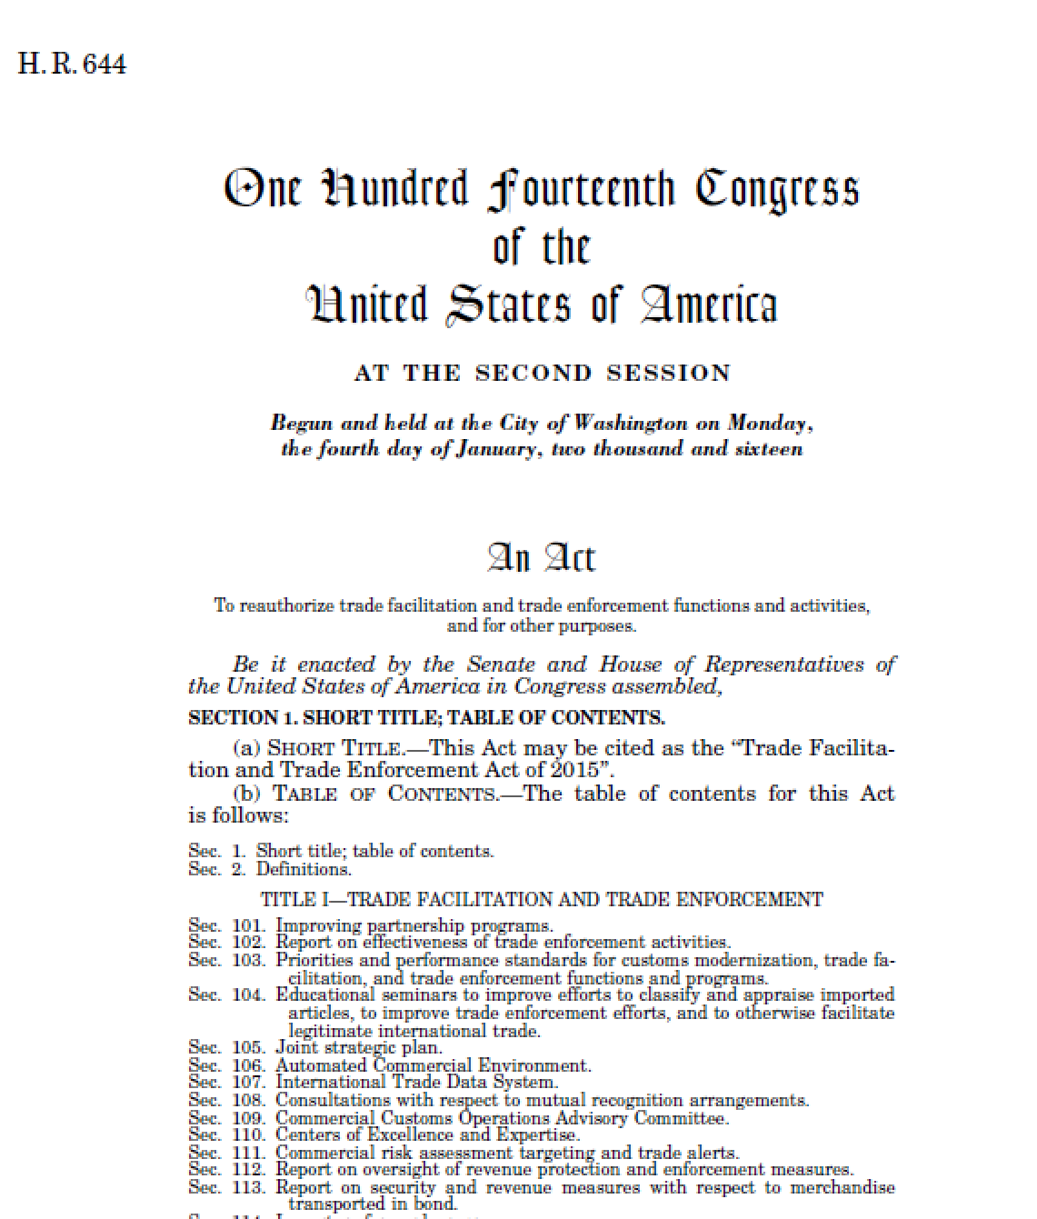

Figure 1 Bill Preface

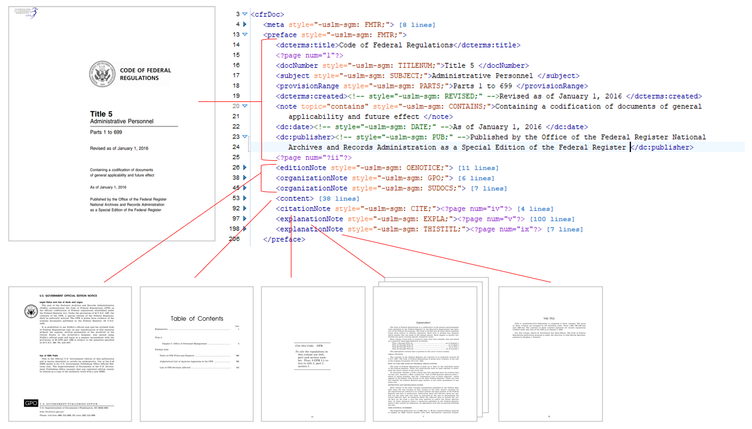

Figure 2 CFR Preface: Content displayed at the beginning of each CFR title in the preface is shown, including the cover page, official edition note, GPO and superintendent of documents notes, title contents, citing note, explanation note, and this title note.

1. *In 2017, the Government Publishing Office and the Office of the Federal Register initiated a project to convert a subset of the Federal Register and Code of Federal Regulations from SGML into USLM XML. The regulatory project was carried out in parallel to a legislative project to convert a subset of Enrolled Bills, Public Laws, and the Statutes at Large from GPO locator-coded text into USLM XML.*
2. An ear contains text to be printed in the outside margin and is used in the CFR.