Review of PHAST

Bugs:
1. Every time I run PHAST version 2 it creates a file with a name like "4afdbc1d_11452.dyn". These files appear to be temporary files used by PHAST. If so, PHAST should delete them when it is done with them.
I had accidentally included some profiling in the linking of the program that generated the .dyn files. I have removed the option.
2. If a model name contains a space in it, PHAST can't handle it. For example I had the following in a batch file.
call "C:\Program Files (x86)\USGS\phast-1.5.1\bin2\phast.bat" "ex 2"
phastinput read the input file but PHAST tried to use a file name of "ex" instead of "ex 2".
Revised phast to allow space in file name. Works with phast.bat.
3. PHAST requires too much precision in the input files. A lack of precision in the 15th decimal position of an input can significantly change the results. For example, I set up a model using ModelMuse with specified head and specified flux boundaries. The illustration below shows the objects used to specify the two boundary zones. The green area represents the area that is intended to be a specified flux boundary.
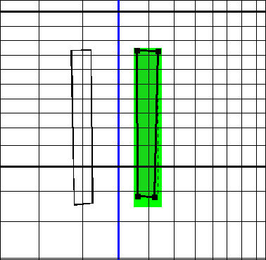
With PHAST Version 1, the boundaries are identified correctly as illustrated below in Model Viewer. The orange cubes represent flux boundaries.
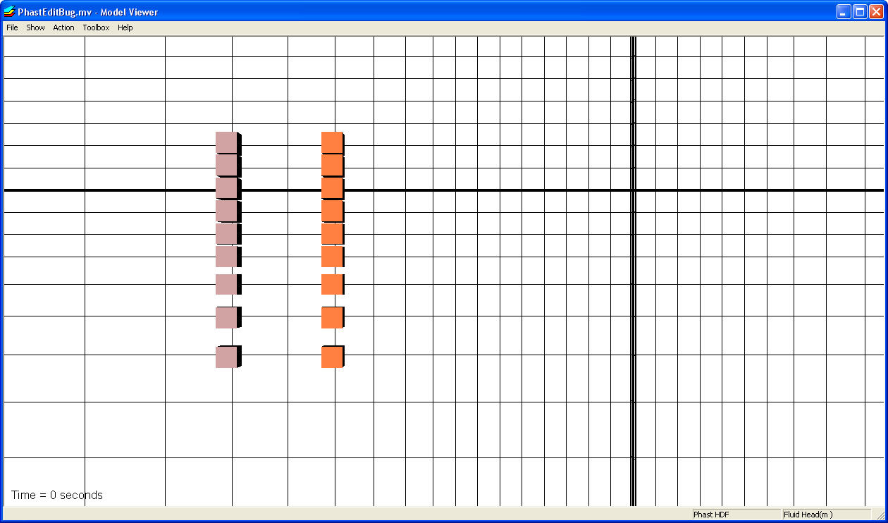
When the same model is run using PHAST Version 2, the boundaries are not identified correctly as illustrated below in Model Viewer.
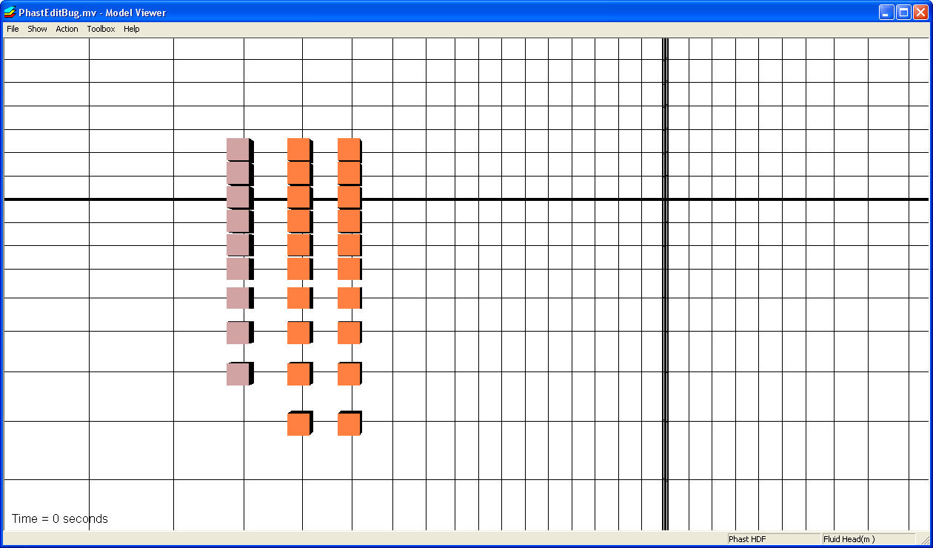
The problem is due to the excessive precision required by PHAST in the specification of flux and leaky boundaries. The grid has the following coordinates among others.
GRID
-nonuniform X ... 12096.2392970805 12305.6042015724 ...

The boundary between cells is halfway between those two positions or 12200.92174932645 when specified with a precision of 16 decimal digits. However, the zone definition for the flux boundary only uses a precision of 15 decimal digits.
FLUX_BC
-zone 12200.9217493264 9990.59606464842 118.571428571429 12392.8395789619 11087.2686898594 118.571428571429
-face Z
-flux
0 1
Because a double-precision number may only have a precision of 15 decimal digits, requiring more precision seems excessive.
I suggest that when determining whether or not a flux or leaky boundary applies to a particular cell, the area of intersection between the zone and cell be divided by the cell area. The quotient should then be converted to single precision. Only if this single-precision quotient is greater than zero should the flux or leaky boundary be applied to the cell.

I have modified the code to calculate the fraction of the cell face that is covered by a leaky or flux boundary condition. This fraction is then compared to a tolerance to determine whether the boundary condition will be applied to the cell. The tolerance parameter is included as input to the GRID data block. Default tolerance for the fraction tolerance is 1e-7. So, by default, if the fraction of the cell face covered by a leaky or flux boundary is less than 1e-7, then the boundary condition is not applied.
GRID; -area_tolerance 1e-7

Questions, Concerns, and Suggestions:
ModelMuse allows the user to specify zones with polygons on the top, front and side views of the model. With PHAST version 1, these polygons were used to identify box zones. With PHAST version 2, new sorts of zones are available including prisms and wedges. In addition the flux and leaky boundaries have been modified to allow multiple flux or leaky boundaries in the same face of the same cell. It looks like it would be worthwhile for ModelMuse to support creating multiple flux and leaky boundary conditions on a single cell face. Prisms could be used to defining flux or leaky boundaries on the top or bottom of a cell. However, prisms are not allowed for the front or side view of the model so ModelMuse would need to break up any polygons into a series of non-overlapping boxes and wedges. Depending on the complexity of the polygon, the number of wedges or boxes could become large resulting in extra work for PHAST. PHAST would need to determine the amount of overlap between zones even if ModelMuse had generated zones that never overlapped because there is no way to indicate that the zones don't overlap. In addition, the large number of zones might result in more rounding error. If prisms could be defined on the front or side views, the number of zones could be reduced. It might also be worthwhile to add a keyword that could be used to indicate that a zone does not overlap within any other zone that defines a flux or leaky boundary so that PHAST doesn't have to check for overlap.
PHASTINPUT processes the .trans.dat file to produce the Phast.tmp file and it is PHASTINPUT that determines which properties and boundary conditions are applied to elements and cells. It does all the geometric processing zone by zone, overlaying results on the grid. The Phast.tmp file has element-by-element and cell-by-cell definitions, which require little geometric processing other than indexing, such as translating i,j,k to natural number. It has been my assumption that the time required for PHASTINPUT will be small relative to the time of a PHAST simulation, and so far, the assumption seems to be justified. I realize if may be difficult to split up zones to make acceptable input for PHASTINPUT, but I don’t think processing time will be an issue. If processing time for PHASTINPUT turns out to be too slow when you generate many zones with ModelMuse, then I’ll revise the algorithms, possibly allowing other orientations for prisms. I am reluctant to do that because I think the vertical prisms are easiest for people to conceptualize, accounts for most ArcInfo coverages, and fits most geologic systems.
Page 3: "Within the bounds of the scattered points (the convex hull), natural neighbor interpolation is implemented, which uses an area weighting scheme to assign a value to a target point based on a set of the nearest of the scattered points; outside the convex hull, the elevation of the closest point is assigned to a target point."
This approach can lead to discontinuous elevation assignments.
True.
For example, in the distribution of points shown below, all the points on the convex hull would be assigned elevations of 1 but some points just outside the convex hull would be assigned elevations of 2. The point marked with X is an example of a point just outside the convex hull that would be assigned an elevation of 2. I think it would be appropriate to point out this possibility somewhere in the text although the abstract might not be the best place to do it.
I added a section on interpolation (4.2.3) to describe the interpolation methods and mention some of the possible shortcomings of the interpolation methods.
Another option would be to handle points outside the convex hull in a different way; they could be assigned the value of the nearest location on the convex hull regardless of whether that location is one of the scattered points. I would be OK with either option.
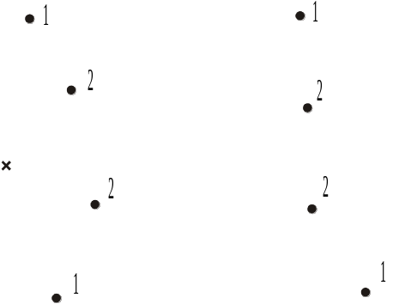
The current method does not calculate the location of the convex hull; all I know is that the interpolation method fails. So I am opting for option 1, with further explanation in text.
Page 3: "The interpolation capabilities allow head and chemical data to be saved at the end of one run and used as initial conditions for a subsequent run, even if the grid spacing has been changed."
Three dimensional interpolation can be dangerous if not used carefully. The first illustration below shows an example of the danger. The illustration shows a vertical cross section through the model. There are 9 points. The points in the bottom layer have values ranging from 1 to 5 and the points in the top layer have values ranging from 6 to 9. The color of each cell represents the value assigned to that cell. What the user would probably want in this case is for all the elements in the bottom layer to have values between 1 and 5 (blue or green colors) and all the elements in the top layer to have values between 6 and 9 (Light green, yellow, orange, or red). That isn't what is happening however. The reason can be seen in the second illustration below. The first illustration below has a vertical exaggeration of 10:1 while the second illustration has no vertical exaggeration. In the second illustration, it is obvious that the points in the top layer are closer to some elements on the bottom layer than are any of the points on the bottom layer and vice versa.
Some users might be tempted to use a set of scattered values of hydraulic conductivity to assign hydraulic conductivity to all the elements. Because groundwater models typically have a much larger horizontal extent than vertical extent, interpolating among scattered points in this way could result in inappropriate values being assigned to some elements. I think the users should be warned of this danger somewhere in the document although the abstract might not be the best place to do it.
I agree that interpolation is a difficult issue. I opted for the 2-D (natural neighbor) and 3-D (closest point) schemes as the least of potential evils. I would like to use natural neighbor for both, with a point at infinity to handle outside the convex hull, but I did not find any easily accessible code. However, I’m not sure any scheme would easily produce the vertical distribution that you describe. One would have to use an “anisotropy” factor to stretch coordinates, which would have its own issues for what anisotropy is appropriate and what the expected interpolated values would be. Better would be to pair the points top and bottom at the same horizontal location, which would produce the distribution you expected. For 3-D, closest point is at least robust and is consistent with a geological structure that has a distribution of zones with different properties, such as are generated with geologic models and stochastic hydrologic models. But I agree some additional discussion is warranted and have added a new section.
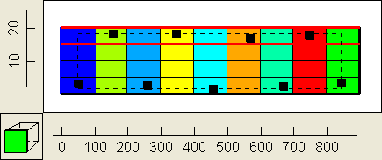
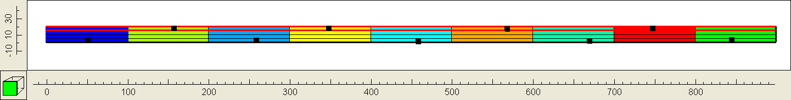
p. 44 description of "Line 7" I don't know how the reading of the Shapefiles is handled in PHAST but you should be sure to use the shape index (.shx) file to locate the starting point of each shape rather than assuming that each shape begins immediately after the end of the previous shape. Sometimes when a user edits a Shapefile to remove some points in a Shape, only the data for that Shape is rewritten leaving an unused area between it and the next Shape. See http://www.esri.com/library/whitepapers/pdfs/shapefile.pdf for a description of the Shape index file.
I use the shapelib software to read the data. I assumed it gave me a correct set of points. Is this not the case?
P. 63 near end of first paragraph in "Notes"
"Note that the concentration of the solid reactants varies spatially as porosity varies, so that if porosity is defined to vary spatially, then logically, the concentrations of solid-phase reactants also must be defined to vary spatially."
Would the following work for defining the spatial variation in solid reactants? (1) Define a composition in the chemistry input file for the case where the porosity equals zero. (2) Use the mixture option with one of the mixture end members being the composition defined in step 1 and the other end member being -1 indicating absence of the reactants. (3) use a mixture fraction equal to (1-porosity) for each cell.
I don’t think so. PHAST wants the amount of reactant per liter of water. At zero porosity, this number is infinite.
I have modified PHAST to allow a different unit for the solid reactants, mol/L rock. I added 6 identifiers to the UNITS data block (-equilibrium_phases, -exchange, -surface, -solid_solutions, -kinetics, and –gas_phase) with the option of either WATER or ROCK. Water is the default and works as the previous version of PHAST. ROCK converts the moles of solid reactants per liter rock to moles per liter water by multiplying by (1-phi)/phi, where phi is the porosity of the cell. The conversion happens as the initial conditions are distributed to the cells.
p. 83. The manuscript states that "Use of the -water_table is not recommended because the data are grid dependent". Why not allow the water table to be defined with points so that the water table is not grid-dependent?
You can indeed do this if you define the water table on a horizontal plane of points (x, y, Z, elev), where Z is constant. However, you would use –points or –xyz instead of –water_table. I’ve added some text to make this clearer.
p. 134. Is it possible to use one STEADY_FLOW data block to generate a steady flow initial condition which is then used as the initial condition for additional transient calculations by specifying a second STEADY_FLOW data block in the same input file in which STEADY_FLOW is set to False?
No. You have to make one run to generate the steady flow heads and then use them as initial conditions in the transient run. It’s a good suggestion that I’ll consider in the future.
p. 201. First incomplete paragraph. The example uses a well to monitor data at frequent intervals without generating a large output file. However, the fact that a non-zero pumping rate is specified means that the flow solution could be affected. Could ZONE_FLOW be used instead to achieve the same result?
ZONE_FLOW only writes rates of flow through zone boundaries and boundary condition cells, it does not write concentration data. The well gives the concentrations in water flowing to the well. However, if the well intersects more than one cell, the concentrations will be the average composition of water flowing into the well.
p. 214. Example 6.7 simulates chemistry in a small section of the model from the previous example. Would it make sense to modify PHAST so that only part of the modeled domain was active for the chemical calculations but a larger region was used to simulate groundwater flow? This might allow the user to set up a single model without running into problems with long simulation times but also without needing to coordinate two separate models. Some other solute transport programs such as MT3DMS and GWT use this approach.
It makes sense, but it is not something we can do easily.
P. 246. In PHASTHDF, the numbering starts at zero rather than 1. This may prove confusing to users who are not programmers.
We have decided to leave the numbering starting at zero. Partly because we don’t want to break something, but also because the numbering strategy is taken directly from HDF in their definitions of hyperslabs. The selected items are checked, so I think that the resulting selection is clear.
p. 247. If the output file format is the same as an .xyz.tsv file, maybe the default extension should be xyz.tsv instead of .h5.sel. Of course, the program should confirm overwriting any existing . xyz.tsv files.
Thanks, this one would have slipped through.

Editorial suggestions:
Page 3, paragraph 3. "A drain boundary condition has been added."
This line ought to be the start of a new paragraph.
OK, with more description of the flow aggregation regions.
Page 6, paragraph 4. "A drain boundary condition has been added."
This line ought to be the start of a new paragraph.
OK, with more description of the flow aggregation regions.
Page 32. The following sentence is used in part of the definition of a "Wedge",
"The orientation identifier specifies the axis (X, Y, or Z) that is parallel to the axis of the axis of the right angle of the wedge plus a number (1-4) that identifies the orientation of the right angle."
In it, the phrase "axis of the axis of the" can be changed to "axis of the".
OK.
In three dimensions, the wedge has more than one right angle. An alternative wording might be "The orientation identifier specifies the axis (X, Y, or Z) that is parallel to the plane containing the hypotenuse face of the wedge plus a number (1-4) that identifies the orientation of the right angle."
OK.
Page 33. lines 9-10 "or by assignment of the elevation of the closest point outside the convex hull."
OK.
Insert "scattered" before" point" to clarify that locations on the convex hull that are not one of the scattered points are not used for the interpolation outside the convex hull.
OK.
Page 36. figure 4.6. I found it difficult to distinguish between the lines for "cell edge" and "element face intersection with cell face”. It was only after careful examination that I saw that the lines were different colors. I suggest changing the color of one of the lines so that there is more contrast in color. Another option would be to use a distinctive pattern such as a dotted line for one of them.
Replaced figure with different coloring.
p. 42. I would be helpful to have an example of a prism where the perimeter is defined by points such as the following
-prism
-top constant grid 20
-bottom constant grid 17.5
-perimeter points GRID
0 0
500 0
500 900
0 900
end_points
The example prisms all use Shapefiles.
Good idea. Added a points example.
p. 44 description of "Line 7" What happens when a Shapefile contains more than one Shape? Does PHAST always read the first shape or does it read the next Shape in the Shapefile each time the name of the Shapefile is used. From the example on p. 153, it looks like the latter but what it does should be stated explicitly.
PHAST does not actually use the shape. It assumes only a set of x,y points that is used to define a perimeter, or a set of x, y, z points (z from an attribute) that is used to define a top or bottom surface. Additional sentences were added.
p.44 description of "Line 7" Are all polygons defined in a Shapefile are acceptable? In particular, if a Shape has more than one part such as a polygon with a hole in it, will it work? WPHAST doesn't appear to handle such Shapes properly but the text on p. 210 suggests that PHAST does handle shapes with multiple parts. I don't have the Shapefile mentioned on p. 210 so I don't know whether it contains multiple polygons or a single polygon Shape with multiple parts.
PHAST should handle both multiple polygons (the four ponds in example 5 can be defined with a single shape file) and polygons with multiple parts; however, holes are not handled. That is, all polygons are assumed to contain their interior regardless of clockwise/counterclockwise definitions. Additional sentences were added to clarify that holes are ignored.
p. 50. description of "Line1". I assume that X, Y, and Z always refer to grid coordinates and not the map coordinates in this context. It would be a good idea to state this explicitly.
Stated explicitly and added to the Notes.
p. 54, first (incomplete) paragraph. When referring to the examples in chapter 6, please state explicitly that they are in chapter 6. There is an example 1 starting on p. 49 that is different from the example 1 in chapter 6.
Added Chapter 6 as a qualifier for the example problems throughout chapter 4.
p. 54 second paragraph. Is there an example where the mixture option is used? If so, where?
None of the example problems in chapter 6 use the mixture option.
p. 84. In the example there is no "end_points" after the list of points that define the hydraulic conductivity. If this is an error, it should be fixed.
Added “end_points”.
p. 87. First line of last paragraph. Should "FLUX_BC" and "flux" be replaced by "LEAKY_BC" and "leaky"?
Yes.
p. 110, third line. Change "stead-state" to "steady-state".
OK.
p. 134. I suggest changing "(1) heads are constant and (2) flow-in equals flow-out within specified tolerances." to "(1) changes in head and (2) flow-balance are both less than specified tolerances." When I first read the original wording, I thought that the tolerance only applied to "flow-in equals flow-out" but if that were the case, there would be no need for the head_tolerance in the example.
OK.
P. 210, 3'rd paragraph, 4th line "Note that multiple disconnected ponds are defined with a single shape file." Change "shape file" to "Shapefile".
Changed to “shapefile” throughout the text. Added more documentation of formats (shape and raster) and shapelib routines.
p. 211, line 8. For clarity you may wish to break the following sentence into two sentences
"Intermediate points define the course of the river and data values for elevation and the other parameters for these are linearly interpolated by river length from the end points."
"Intermediate points define the course of the river. Data values for elevation and the other parameters for these are linearly interpolated by river length from the end points."
OK.
p. 212. Caption to figure 6.9. The nodes described as "brown" don't look brown to me. They look more like gray. You may wish to change to change either the description in the text or the color in the illustration. (Model Viewer allows the user to change the color used for Model Features.) The same comment applies to figure 6.11
Rephrased.
p. 222 and 223. Why are the subheadings in a blue font?
Had different paragraph format than other files. Fixed.
p. 240. List the year of publication for Parkhurst, Kipp, Engesgaard and Charlton. (The PHAST version 1 report).
OK.
p. 240. The Patankar citation should be before the Plummer citation.
OK.

