Table of Contents

**Conclusions about Kickstarter campaigns** 3

1. Conclusions from Category wise Stacked Column Chart 3

2. Conclusions from Subcategory wise Stacked Column Chart 4

3. Conclusions from Launch date Vs Campaign Outcomes Line graph 6

**Limitations of Dataset used for Analysis** 7

**Other possible Tables/Graphs** 8

1. Category wise Outcomes rate – Table/Chart 8

2. Subcategories wise Outcomes Rate – Table/Chart 9

3. Outcomes based on Goal – Line Graph 12

4. Outcomes based on Backers Count – Boxplot 13

5. Outcomes based on Country – Clustered Column Chart 14

**Bonus Statistical Analysis** 15

# **Conclusions about Kickstarter campaigns**

## Conclusions from Category wise Stacked Column Chart

* 1. Probability of success is highest (77%) in Music category. Though the total number of campaigns is more under Theater category, it has relatively more failed campaigns. Music category has second largest number of campaigns and has relatively lesser failed campaigns.
  2. Probability of failure is highest (70%) in food category.
  3. Probability of Cancellation is highest in Journalism category. Journalism is the least favorable campaign since all the campaigns (100%) in this category has been canceled**.**

|  |  |  |  |  |
| --- | --- | --- | --- | --- |
| **Category** | **Successful** | **Failed** | **Canceled** | **Live** |
| film & video | 58% | 35% | 8% |  |
| food | 17% | 70% | 10% | 3% |
| games | 36% | 64% |  |  |
| journalism |  |  | 100% |  |
| music | 77% | 17% | 3% | 3% |
| photography | 47% | 53% |  |  |
| publishing | 34% | 54% | 13% |  |
| technology | 35% | 36% | 30% |  |
| theater | 60% | 35% | 3% | 2% |

## Conclusions from Subcategory wise Stacked Column Chart

* 1. Probability of Success: Though the total number of campaigns is more under Plays Subcategory, it has relatively more failed campaigns. Subcategories Rock, Classical music, Documentary, Electronic music, Hardware, Metal, Nonfiction, Pop, Radio & podcasts, Shorts, Tabletop games, and Television have 100% success probability. Among these, Rock Subcategory has the most campaigns (260). So, the probability of success is more in Rock Subcategory.
  2. Probability of Failure: Subcategories Animation, Children's books, Drama, Fiction, Gadgets, Jazz, Mobile games, Nature, People, Places, Restaurants, Video games have 100% failure probability. Among these, Video games and animation Subcategories have the highest number of failed campaigns (100).
  3. Subcategories Art books, Audio, Science fiction and World music have 100% cancellation probability. But based on total cancelled campaigns among these subcategories, Probability of Cancelation is highest for science fiction Subcategory.

|  |  |  |  |  |  |
| --- | --- | --- | --- | --- | --- |
| **Subcategory** | **Successful** | **Failed** | **Canceled** | **Live** | **Total Campaigns** |
| animation |  | 100% |  |  | 100 |
| art books |  |  | 100% |  | 20 |
| audio |  |  | 100% |  | 24 |
| children's books |  | 100% |  |  | 40 |
| classical music | 100% |  |  |  | 40 |
| documentary | 100% |  |  |  | 180 |
| drama |  | 100% |  |  | 80 |
| electronic music | 100% |  |  |  | 40 |
| faith |  | 67% |  | 33% | 60 |
| fiction |  | 100% |  |  | 40 |
| food trucks |  | 86% | 14% |  | 140 |
| gadgets |  | 100% |  |  | 20 |
| hardware | 100% |  |  |  | 140 |
| indie rock | 88% | 13% |  |  | 160 |
| jazz |  | 100% |  |  | 60 |
| makerspaces | 45% | 55% |  |  | 20 |
| metal | 100% |  |  |  | 20 |
| mobile games |  | 100% |  |  | 40 |
| musical | 43% | 43% | 14% |  | 140 |
| nature |  | 100% |  |  | 20 |
| nonfiction | 100% |  |  |  | 60 |
| people |  | 100% |  |  | 20 |
| photobooks | 64% | 36% |  |  | 160 |
| places |  | 100% |  |  | 20 |
| plays | 65% | 33% |  | 2% | 1066 |
| pop | 100% |  |  |  | 40 |
| radio & podcasts | 100% |  |  |  | 20 |
| restaurants |  | 100% |  |  | 20 |
| **rock** | **100%** |  |  |  | **260** |
| science fiction |  |  | 100% |  | 40 |
| shorts | 100% |  |  |  | 60 |
| small batch | 85% |  |  | 15% | 40 |
| space exploration | 67% | 3% | 30% |  | 60 |
| spaces | 45% | 43% | 9% | 3% | 187 |
| tabletop games | 100% |  |  |  | 80 |
| television | 100% |  |  |  | 60 |
| translations |  | 82% | 18% |  | 57 |
| video games |  | 100% |  |  | 100 |
| wearables | 10% | 60% | 30% |  | 200 |
| web |  | 38% | 63% |  | 160 |
| world music |  |  | 100% |  | 20 |

## Conclusions from Launch date Vs Campaign Outcomes Line graph

Based on analysis of the below line graph between the launch dates and campaign outcomes, it could be seen that campaigns launched in the month of May had highest number of successful campaigns (61%) when compared to the rest of the months. December seems to be the least favorable month for launching campaigns because campaigns launched in December had more failures (47%) than success (44%).

# **Limitations of Dataset used for Analysis**

1. Data is available only for years 2009 through 2017. Campaign trends could have changed after 2017 thus affecting the results of analysis produced in this report.
2. Campaigns that are currently live in the given dataset (2009 – 2017) could eventually have ended up as either successful or canceled or failed which could change the analysis on probability of overall success/failure of campaigns.
3. Kickstarter website currently offers 15 categories (Art, Comics, Crafts, Dance, Design, Fashion, Film & Video, Food, Games, Journalism, Music, Photography, Publishing, Technology and Theatre). But the dataset used for analysis only has 9 categories (Film & Video, Food, Games, Journalism, Music, Photography, Publishing, Technology and Theater). Lack of data in categories Art, Comics, Crafts, Dance, Design and Fashion could vastly affect the results of analysis produced in this report.

# **Other possible Tables/Graphs**

## Category wise Outcomes rate – Table/Chart

From the below

|  |  |  |  |  |
| --- | --- | --- | --- | --- |
| **Category** | **Successful** | **Failed** | **Canceled** | **Live** |
| film & video | 58% | 35% | 8% |  |
| food | 17% | 70% | 10% | 3% |
| games | 36% | 64% |  |  |
| journalism |  |  | 100% |  |
| music | 77% | 17% | 3% | 3% |
| photography | 47% | 53% |  |  |
| publishing | 34% | 54% | 13% |  |
| technology | 35% | 36% | 30% |  |
| theater | 60% | 35% | 3% | 2% |

## Subcategories wise Outcomes Rate – Table/Chart

1. Subcategory wise 100% Successful Campaigns

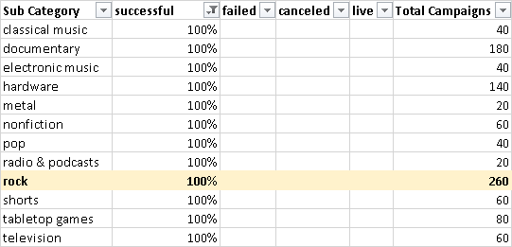

1. Subcategory wise 100% Failed Campaigns

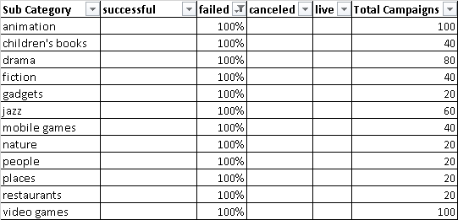

1. Subcategory wise 100% Canceled Campaigns

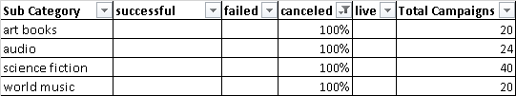

## Outcomes based on Goal – Line Graph

The lower the goal for a campaign, the higher the probability of Success of the campaign. The higher the goal for a campaign, the lower the probability of Success of the campaign. (Relationship between Goal and Success has negative slope trend with R2 = 0.7339 = 73%. The Goal success relationship accounts for 73% of the total variation)

## Outcomes based on Backers Count – Boxplot

Below boxplot shows the outliers of Backers count explaining the reason for the huge difference between mean and median backers count for successful/failed campaigns.

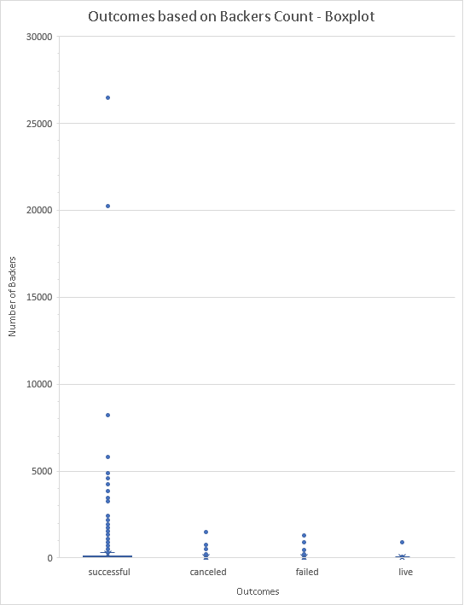

## Outcomes based on Country – Clustered Column Chart

On analyzing the chart below, it could be seen that almost 74% of the campaigns are from US, 15% of the campaigns from GB and the rest of the 11% campaigns are distributed from all other countries of the world. Though the number of campaigns from US is remarkably high, the success percentage of GB (61%) is higher than success percentage of campaigns in US (54%).

# **Bonus Statistical Analysis**

From the summary statistics table below, we could see that there is a huge difference between mean(194.43) & median(62) backers count for successful campaigns and huge difference between mean(17.71) & median(4) backers count for failed campaigns. This is because of the outliers of number of backers as shown in this boxplot. Outliers affect the mean but not the median. So, median summarizes the data more meaningfully.

It could also be noted that the variance is higher for successful campaigns (712840.99) than the failed campaigns (3773.22). This is again due to extremely high number of backers (outliers) for some successful campaigns while the number of backers were very few or none for many failed campaigns. So, it makes sense to have higher variability with successful campaigns.

|  |  |  |
| --- | --- | --- |
|  | **Successful Campaigns** | **Failed Campaigns** |
| **mean_backers** | 194.43 | 17.71 |
| **median_backers** | 62 | 4 |
| **minimum_backers** | 1 | 0 |
| **maximum_backers** | 26457 | 1293 |
| **variance_backers** | 712840.99 | 3773.22 |
| **sd_backers** | 844.3 | 61.43 |