**PyCitySchools**

**Final Report**



# **Observable trends based on the data**

## Conclusions from Scores by School Spending

It could be observed from the table below that the lower the “Per Student Budget”, the “Overall Passing %” is higher and the higher the “Per Student Budget”, “Overall Passing %” is lower. So, this shows that increasing the “Per student budget” is not going to increase the student’s performance.

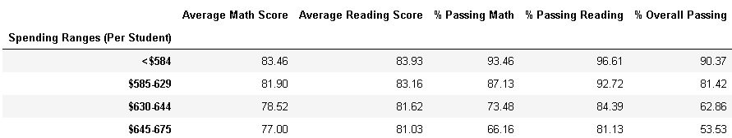

## Conclusions from Scores by School Size

It could be observed from the table below that the Student’s performance in larger schools are worser than Student’s performance in Medium/Small sized schools.

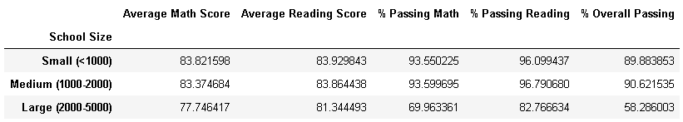

## Conclusions from Scores by School Type

It could be observed from the table below that the Student’s performance in Charter schools are much higher than Student’s performance in District schools.

