**Final Project**

**1.HR Analytics - Predict Employee Attrition**

**Objective:** Use analytics to understand the main causes of employee resignation and predict future attrition.

**Introduction:** HR analytics, also referred to as people analytics, workforce analytics, or talent analytics, involves gathering together, analysing, and reporting HR data. It is the collection and application of talent data to improve critical talent and business outcomes. It enables your organization to measure the impact of a range of HR metrics on overall business performance and make decisions based on data. They are primarily responsible for interpreting and analysing vast datasets.

**Toos Used:**

* Python
* Power BI

**Steps Involved in Building Project:**

This interactive Power BI dashboard provides deep insights into employee attrition trends, helping HR professionals make data-driven decisions. Let's break it down:

Key Metrics:

* Total Employees: 1,480
* Attrition Count: 238
* Attrition Rate: 16.08%
* Average Age: 36.92 years
* Average Salary: $6.50K
* Average Tenure: 7.01 years

Detailed Insights:

* Attrition by Education Field – Life Sciences has the highest attrition at 37%
* Attrition by Age Group – Highest among employees aged 26-35
* Attrition by Salary Slab – Majority of attrition in the Upto 5K range
* Attrition by Job Role – Research Scientists & Sales Executives face the highest attrition Attrition by Business Travel – Frequent travellers vs. non-travellers impact attrition

Filters Available:

* Age Group
* Business Travel
* Department
* Education Field

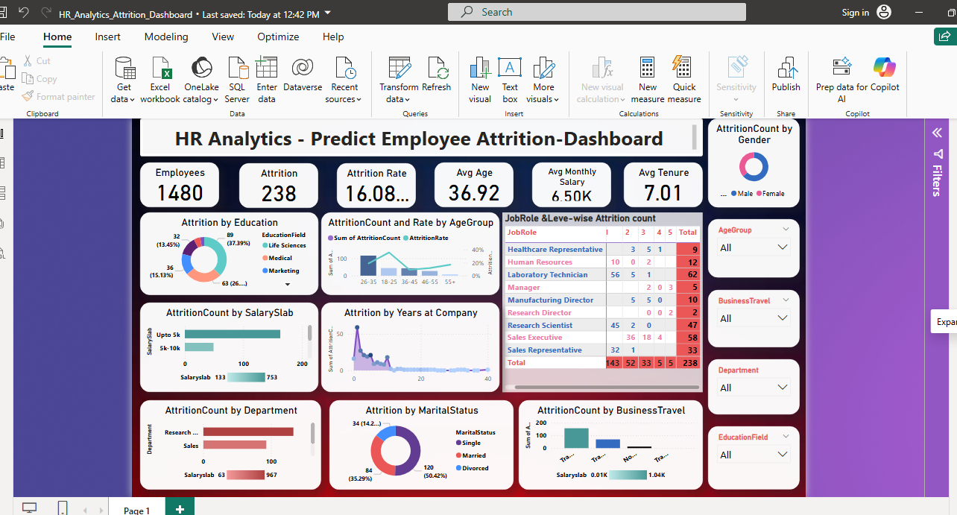

**Conclusion:** This dashboard helps HR teams understand why employees leave, identify high-risk groups, and implement better retention strategies.